SUPPLEMENTARY MATERIAL
Supplementary material S1. Between-Group Comparisons of Behavioral Data in the Distraction Task
To test whether both groups differed in task performance, paired t-tests were performed between patients and healthy controls on mean accuracy and reaction time in the distraction task. Overall, accuracy was high (96.7% ± 2.5) with higher accuracy in the patient (97.5% ± 2.1) than in the healthy control group (95.9% ± 2.7, p = .04). However, reaction time of both groups did not differ significantly from each other (patient group: 706.3ms ± 96.5; healthy control group: 704.5ms ± 70.7; p = .95).

Supplementary material S2. PPI Analysis
For each individual, signal time-series from voxels from left and right amygdala that were maximally activated during the appraisal task (across all picture types) compared to the implicit baseline were extracted. We chose the appraisal minus implicit baseline contrast because this contrast was expected to produce robust amygdala activation that was unbiased to any particular picture type. Left and right amygdalae were structurally defined using the automated anatomical labeling (AAL)-atlas included in the Wake Forest University (WFU) PickAtlas toolbox (http://fmri.wfubmc.edu/software/PickAtlas).
Subsequently, amygdala signal time-series (the physiological parameter) were multiplied with our psychological parameter of interest (presentation of OCD-relevant versus aversive pictures) to generate the PPI interaction term. The reason for including these two conditions is that this contrast best captures specific effects of OCD-relevant stimuli, given that the presentation of generally aversive stimuli serves as an emotional control condition.
Finally, the effect of the interaction term regressor was estimated in a general linear model, which also included the psychological and the physiological parameters as well as six motion parameters as regressors of no interest. By regressing the interaction term on all voxel time-series in the brain, brain regions are identified that are predicted by the psychophysiological interaction, i.e., areas that change coupling with the amygdala due to the change in picture type. For each subject, separate PPIs were computed for the left and right amygdalae in the appraisal and the distraction task, each using presentation of OCD-relevant vs. aversive pictures as the psychological parameter.

Supplementary material S3. Explanatory PPI Analysis
Because the psychological parameter represents a term subtracting one condition from the other (i.e., OCD-relevant = [1] and aversive = [-1]), the interaction regressor identifies voxels that show a difference in the regression slopes of activity in the seed region on activity in the identified brain region dependent on the two different picture types. This evokes challenges in the interpretation of the PPI group analysis, because one does not know the relationships between seed and target areas in both conditions and groups, respectively. Therefore, we calculated four additional explanatory PPIs after modifying the psychological parameter (i.e., OCD-relevant = [1] for both amygdalae; and aversive = [1] for both amygdalae) instead of the two original PPIs (i.e., OCD-relevant = [1] and aversive = [-1]) for both amygdalae) in both the appraisal and distraction task.

Supplementary material S4. Correlation Analysis
Post-hoc correlation analyses were performed to examine potential relationships between connectivity changes in OCD patients and symptom severity in sample 1 and sample 2, in which amygdala connectivity significantly differed between groups. We added Y-BOCS scores as a covariate in a random effects model which included patients' PPI maps, followed by post-hoc Pearson's correlations between the peak of clusters reaching significance and the Y-BOCS score covariate. To ensure that Y-BOCS scores and the peak of clusters surviving significance threshold were normally distributed, Kolmogorov-Smirnov tests were applied using SPSS Statistics 20 (IBM Corp). ROI procedures and statistical thresholds were applied using the same procedures described for PPI group comparisons. No significant relationship was found between symptom severity as measured with the Y-BOCS and amygdala connectivity in sample 1 and sample 2.

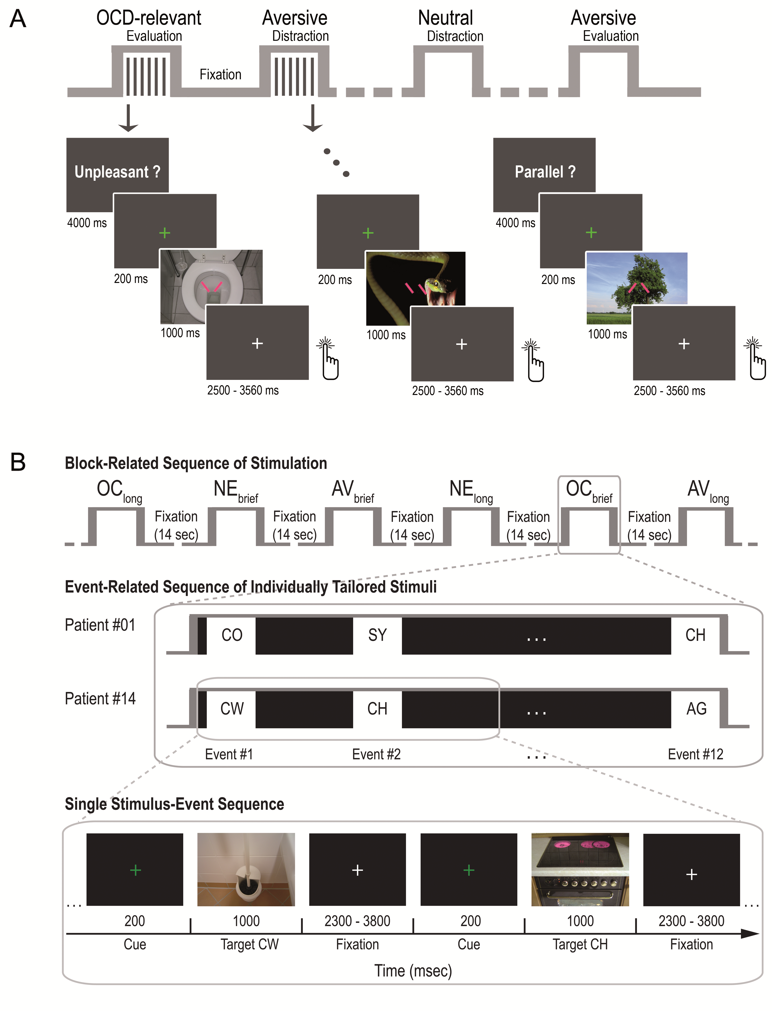
Supplementary Figure S1. Experimental Designs of the Emotion Regulation Task (Sample 1) and the Passive Viewing Task (Sample 2)

(A) The emotion regulation task consisted of two runs containing eighteen blocks (approximately 32s) each separated by a fixation condition (14s). Blocks contained an initial instruction screen (4000ms) indicating the type of condition ("unpleasant?" vs. "parallel?") and six trials of one picture category (OCD-relevant, aversive, or neutral pictures). Each trial started with a green fixation cross (200ms) followed by the target picture (1000ms) and ended with a white fixation cross shown for 2500ms plus variable inter-trial interval (mean: 530ms). Block and picture order was pseudo-randomized. (B) The passive viewing task contained eighteen randomized blocks of brief (1s) and long (6s) stimulation with OCD-relevant (OC), generally aversive (AV), and neutral (NE) pictures interspersed with 14-s blocks presenting a white fixation cross as visual baseline separated in two runs (top panel). The middle panel shows examples of events of individually tailored symptom triggers occurring within an OCD-relevant block. The example displays two patients' short stimulation blocks that consisted of 12 OCD-relevant pictures. According to the individual stimulus selection, patient #01 suffered from counting (CO), symmetry/ordering (SY), and checking obsessions/compulsions (CH); patient #14 suffered from contamination/washing (CW), checking (CH), and aggressive obsessions/compulsions (AG). The lower panel depicts the temporal structure of stimulus presentation. Each trial started with a green fixation cross (200ms) followed by the target picture and ended with a white fixation cross shown for 2300ms plus variable inter-trial interval (mean: 1200ms). Adapted with permission from Simon et al., 2010 and Simon et al., 2014 (6, 16).

Supplementary Table S1: Comparison of demographic and clinical variables between the three patient samples
 | Statistics |  | Bonferroni-corrected pairwise comparisons
Age (years) | F(2,55) = 0.99, p = .38, η²_{P} = .04
Education (years) | F(2,55) = 0.37, p = .69, η²_{P} = .01
Verbal Intelligence | F(2,54) = 0.18, p = .84, η²_{P} = .01
BDI | F(2,54) = 0.70, p = .50, η²_{P} = .03
OCI-R | F(2,54) = 3.43, p = .04, η²_{P} = .11 |  | Sample 1 > Sample 2, p = .08;  Sample 1 > Sample 3, p = .099
MADRS | F(2,55) = 0.11, p = .89, η²_{P} = .04
Y-BOCS | F(2,55) = 0.34, p = .71, η²_{P} = .01
STAI-T | F(2,53) = 0.65, p = .53, η²_{P} = .02
STAI-S | F(2,55) = 0.90, p = .41, η²_{P} = .03

Note. BDI-II was used in samples 1 and 3; BDI-I was used in sample 2. BDI, Beck Depression Inventory; OCI-R, Obsessive-Compulsive Inventory-Revised; MADRS, Montgomery-Asberg Depression Rating Scale; Y-BOCS, Yale-Brown Obsessive Compulsive Scale; STAI-T, Trait version of State-Trait Anxiety Inventory; STAI-S, State version of State-Trait Anxiety Inventory
Supplementary Table S2: Main Effect of appraisal in the combined sample of participants (N=42)
A. Whole-brain effects
Region | MNI_{xyz} | z Score | CS | BA
Cerebellum (culmen) | 28, -44, -14 | > 8 | 44284
Cerebellum (declive) | 38, -58, -12 | > 8
 | 38, -66, -10 | > 8
Cerebellum (tonsil) | -30, -64, -46 | 5.89 | 56
Medial frontal gyrus | -2, 26, 42 | > 8 | 2868 | 6
 | 0, 8, 52 | > 8 |  | 6
Cingulate gyrus | -6, 14, 46 | > 8 |  | 24
Insula | 34, 26, 0 | > 8 | 4582 | 13
Precentral gyrus | 46, 12, 34 | 7.80 |  | 9
Middle frontal gyrus | 54, 14, 36 | 7.75 |  | 9
Orbitofrontal cortex | -20, 54, -10 | 5.74 | 16 | 10
Superior frontal gyrus | 18, 54, 36 | 5.50 | 102 | 8
 | 12, 54, 42 | 5.02 |  | 8
Medial frontal gyrus | 12, 58, 26 | 4.97 |  | 9
Caudate (cluster includes amygdala) | 14, 4, 8 | 6.09 | 390
Thalamus (medial dorsal nucleus) | 12, -12, 10 | 5.61
Putamen | 32, 2, -4 | 4.87

B. Amygdala ROI effects
Region | MNI_{xyz} | z Score | CS | BA
Left amygdala | -20, -4, -12 | 6.36 | 97
 | -20, -2, -26 | 5.20
 | -18, -2, -22 | 5.13
Right amygdala | 28, -2, -22 | 6.02 | 75
 | 32, -4, -28 | 5.94
 | 20, -4, -16 | 5.71

Note. Peaks of significant regional activation across all three conditions of the appraisal task (contrasted against the implicit baseline). A. shows significant whole-brain activations, revealing large clusters that include the amygdala, and B. shows a region of interest search for the amygdala (using a bilateral amygdala mask from the WFU pickatlas) in order to add the exact coordinates and z-values of significant amygdala activation. The peak of significant clusters is indicated in bold, in contrast to sub-clusters, and effects are thresholded at p < 0.05, family-wise error corrected for multiple comparisons. MNI, Montreal Neurological Institute; CS, cluster size; BA, Brodmann area; ROI, region of interest.
Supplementary Table S3: Main Effect of distraction in the combined sample of participants (N=42)
A. Whole-brain effects
Region | MNI_{xyz} | z Score | CS | BA
Cerebellum (culmen) | 28, -44, -16 | > 8 | 38010
Cerebellum (declive) | 38, -58, -12 | > 8
Fusiform Gyrus | 44, -64, -10 | > 8 |  | 37
Medial frontal gyrus | -4, 2, 56 | > 8 | 1353 | 6
Cingulate gyrus | -6, 4, 34 | 5.93 |  | 24
Precentral gyrus | 54, 10, 34 | 7.15 | 1521 | 6
 | 32, -6, 56 | 6.08 | 270 | 6
 | 46, 10, 22 | 6.83 |  | 9
Inferior frontal gyrus | -46, 48, 2 | 5.33 | 21 | 46
 | 52, 12, 14 | 6.16 |  | 44
Putamen | 26, -2, 8 | 5.76 | 237
 | 26, 2, -4 | 5.70
Middle frontal gyrus | 48, 32, 20 | 5.42 | 235 | 46
 | 48, 48, 4 | 5.57 |  | 10
Superior frontal gyrus | 18, 54, 36 | 5.50 | 102 | 8
Uncus | 34, -8, -34 | 5.04 | 21 | 28

B. Amygdala ROI effects
Region | MNI_{xyz} | z Score | CS | BA
Left amygdala | -24, -2, -12 | 5.11 | 7

Note. Peaks of significant regional activation across all three conditions of the distraction task (contrasted against the implicit baseline). A. shows significant whole-brain activations, and B. shows a region of interest search for the amygdala (using a bilateral amygdala mask from the WFU pickatlas). The peak of significant clusters is indicated in bold, in contrast to sub-clusters, and effects are thresholded at p < 0.05, family-wise error corrected for multiple comparisons, using a cluster extent minimum of 15 contiguous voxels. MNI, Montreal Neurological Institute; CS, cluster size; BA, Brodmann area; ROI, region of interest.

Supplementary Table S4. Brain Regions Showing Significant Positive Correlations with Left and Right Amygdalae Seed Regions for Patients with Obsessive-Compulsive Disorder (OCD) and Healthy Control Participants during Rest (Sample 3)
 | Healthy Controls |  |  |  |  |  |  |  | OCD Patients
Brain Region | MNI coordinates |  |  |  | Statistic |  |  |  | MNI coordinates |  |  |  | Statistic
 | x | y | z |  | Z | k_{e} | p_{FWE} |  | x | y | z |  | Z | k_{e} | p_{FWE}
Right amygdala seed
Right Amygdala | 28 | -2 | -20 |  | >8 | 2319 | <.001 |  | 28 | 0 | -20 |  | >8 | 2059 | <.001
Right Insula | 52 | 0 | -16 |  | 5.29 | - | .004
Right Hippocampus |  |  |  |  |  |  |  |  | 28 | -18 | -20 |  | 5.45 | - | .002
Right Hippocampus, dorsal entorhinal area | 22 | 8 | -20 |  | 7.80 | 143 | <.001 |  | 22 | 8 | -20 |  | >8 | 125 | <.001
Right dACC/MPFC | 4 | 54 | -10 |  | 4.40 | 38 | .007 |  | 4 | 52 | -8 |  | 4.12 | 10 | .021
Left Amygdala | -20 | -4 | -20 |  | 6.19 | 380 | <.001 |  | -24 | -4 | -22 |  | 6.61 | 634 | <.001
Left Insula | -42 | -8 | -4 |  | 5.32 | 85 | .004 |  | -40 | -4 | -8 |  | 5.03 | - | .013
Left Hippocampus, dorsal entorhinal area |  |  |  |  |  |  |  |  | -24 | 8 | -16 |  | 5.40 | - | .002
Left Hippocampus, perirhinal area | -18 | -22 | -14 |  | 5.53 | 116 | .001 |  | -18 | -22 | -16 |  | 5.38 | - | .003
Left Putamen |  |  |  |  |  |  |  |  | -22 | 14 | -16 |  | 4.47 | 12 | .005
Left OFC | -34 | 28 | -20 |  | 5.04 | 12 | .013 |  | -22 | 10 | -24 |  | 3.93 | - | .039
Left Inferior Temporal Gyrus | -38 | -20 | -28 |  | 4.79 | 5 | .037
Left Temporal Pole |  |  |  |  |  |  |  |  | -46 | 6 | -16 |  | 6.19 | 248 | <.001
Left amygdala seed
Left Amygdala | -30 | 0 | -18 |  | >8 | 1574 | <.001 |  | -26 | -2 | -22 |  | >8 | 1588 | >.001
Left Hippocampus, dorsal entorhinal area | -22 | 4 | -20 |  | >8 | - | <.001
Left Globus Pallidus | -20 | 0 | -12 |  | >8 | - | <.001
Left Substantia Nigra |  |  |  |  |  |  |  |  | -14 | -20 | -18 |  | 5.67 | - | .001
Left Culmen | -4 | -46 | 4 |  | 5.42 | 33 | .002
Right Amygdala | 22 | -2 | -24 |  | 5.89 | 359 | <.001
Right Hippocampus, dorsal entorhinal area | 20 | -16 | -22 |  | 5.22 | - | .006 |  | 26 | 4 | -22 |  | 6.37 | 365 | <.001
Right Hippocampus, entorhinal area |  |  |  |  |  |  |  |  | 18 | -16 | -22 |  | 4.90 | - | .023
Right Hippocampus, perirhinal |  |  |  |  |  |  |  |  | 24 | -24 | -20 |  | 4.94 | 26 | .020
Right Putamen | 18 | 8 | -16 |  | 4.50 | - | .005
Right OFC | 28 | 10 | -20 |  | 4.73 | 46 | .002 |  | 28 | 10 | -20 |  | 5.34 | 52 | <.001
Right anterior cingulate | 4 | 32 | -4 |  | 4.02 | 14 | .027

Note. Within-group effects were considered significant applying a corrected threshold of p_{FWE} < .05. Significant effects for the whole brain are displayed in regular letters and significant effects in a priori defined regions are italicized. Bold font represents peak voxels of activated clusters while sub-peaks within clusters are signified by regular font. MNI, Montreal Neurological Institute; OFC, orbitofrontal cortex; dACC, dorsal anterior cingulate cortex; k_{e}, cluster extent; FWE, family-wise error.

