Supplementary Table 1. Comparison of schizophrenia PRS of individuals in the UK Biobank sample, split by month of birth. The schizophrenia PRS are generated using schizophrenia risk SNPs at different association p-value thresholds (top row). The base line of the analysis is January and therefore a negative B indicates decrease in risk of schizophrenia in those born in the month, which is shown in the first column as compared to January.
Month | SNP selection  p-value threshold | 10⁻⁴ | 0.001 | 0.01 | 0.05 | 0.1 | 0.2 | 0.3 | 0.4 | 0.5
February | B | 0.001 | 0.001 | -0.013 | -0.011 | -0.011 | -0.011 | -0.010 | -0.009 | -0.011
 | p-value | 0.915 | 0.951 | 0.345 | 0.392 | 0.429 | 0.392 | 0.473 | 0.500 | 0.418
March | B | -0.016 | -0.002 | -0.013 | -0.018 | -0.023 | -0.024 | -0.024 | -0.022 | -0.024
 | p-value | 0.228 | 0.848 | 0.313 | 0.172 | 0.078 | 0.068 | 0.064 | 0.085 | 0.068
April | B | 0.005 | 0.007 | 0.004 | 0.001 | -0.005 | -0.010 | -0.010 | -0.012 | -0.012
 | p-value | 0.726 | 0.606 | 0.737 | 0.918 | 0.708 | 0.467 | 0.444 | 0.358 | 0.376
May | B | -0.024 | -0.025 | -0.015 | -0.009 | -0.011 | -0.016 | -0.018 | -0.019 | -0.020
 | p-value | 0.066 | 0.050 | 0.247 | 0.481 | 0.406 | 0.217 | 0.169 | 0.139 | 0.114
June | B | -0.004 | 0.004 | 0.001 | -0.010 | -0.014 | -0.020 | -0.023 | -0.022 | -0.023
 | p-value | 0.735 | 0.740 | 0.950 | 0.428 | 0.279 | 0.131 | 0.083 | 0.101 | 0.084
July | B | 0.009 | 0.013 | 0.010 | -0.003 | -0.003 | -0.008 | -0.010 | -0.011 | -0.013
 | p-value | 0.481 | 0.323 | 0.451 | 0.805 | 0.799 | 0.547 | 0.457 | 0.409 | 0.328
August | B | 0.011 | 0.012 | 0.010 | 0.010 | 0.002 | 0.001 | -0.001 | -0.003 | -0.004
 | p-value | 0.396 | 0.350 | 0.463 | 0.467 | 0.898 | 0.915 | 0.911 | 0.825 | 0.739
September | B | 0.009 | 0.016 | 0.010 | 0.000 | -0.004 | -0.007 | -0.009 | -0.012 | -0.012
 | p-value | 0.522 | 0.239 | 0.437 | 0.995 | 0.744 | 0.576 | 0.479 | 0.388 | 0.374
October | B | -0.013 | -0.014 | -0.015 | -0.016 | -0.014 | -0.010 | -0.011 | -0.011 | -0.012
 | p-value | 0.328 | 0.284 | 0.261 | 0.230 | 0.279 | 0.467 | 0.423 | 0.410 | 0.371
November | B | 0.007 | 0.017 | 0.016 | 0.012 | 0.009 | 0.008 | 0.006 | 0.004 | 0.003
 | p-value | 0.590 | 0.202 | 0.223 | 0.360 | 0.514 | 0.567 | 0.643 | 0.758 | 0.818
December | B | 0.004 | 0.005 | 0.003 | -0.001 | 0.001 | -0.002 | -0.002 | -0.002 | -0.004
 | p-value | 0.761 | 0.696 | 0.810 | 0.946 | 0.932 | 0.883 | 0.902 | 0.876 | 0.746
Legend: The first row shows the p-value threshold for SNP selection from the discovery GWAS of schizophrenia. The numbers of SNPs, which passed the selection criterion, are the same as in Supplementary Table 1. The following 11 sections of the table present effect sizes (B) and p-values comparing each month with January, estimated simultaneously in a single nominal regression model for each SNP selection threshold. The column in bold represents the primary analysis (P threshold for risk SNPs p≤0.05); other columns are exploratory.

Supplementary Figure 1. Manhattan plot of genome-wide association study of season of birth, comparing allele frequencies of people born in winter-spring with those born in summer-autumn.
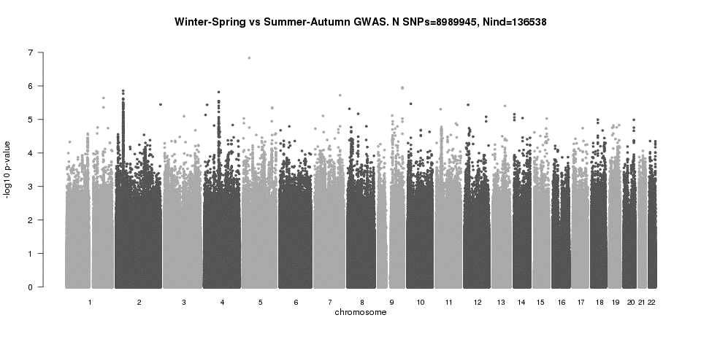

Supplementary Figure 2. QQ plot of genome-wide association study results, comparing allele frequencies of people born in winter-spring with those born in summer-autumn.
