Supplemental Materials

Measures
Child emotional and behavioral problems were assessed using total scores derived from the Strengths and Difficulties Questionnaire (SDQ) (Goodman, 1997, Goodman, 2001). This total score had a greater internal consistency reliability coefficient ($α$=0.82) relative to each individual subscale (Emotional Symptoms Scale $α$=0.69; Conduct Problem Scales $α$=0.59; Hyperactivity Scale $α$=0.80; Peer Problems Scale =0.61).
We controlled for the following covariates, measured at child birth: child race/ethnicity (0=non-White; 1=White); pregnancy size (0=single; 1=multiple); number of previous pregnancies (between 0-3+); maternal marital status (0=never married; 1=widowed/divorced/separated; 2=married); highest level of maternal education (1=less than O-level, 2=O-level, 3=A-level, 4=Degree or above); maternal age (0=ages 15-19, 1=ages 20-35, 2=age>35); homeownership (0=mortgage/own home; 1=rent home; 2=other); and parent social class (i.e. the highest social class of either parent: 1=foreman; 2=manager; 3=supervisor; 4=lending hand; 5=self-employed; 6=none of these/missing). Notably, these latter two indicators of socioeconomic status were measured infrequently and thus were difficult to examine after birth.

Missingness
In the current study, the analytic sample consisted of children that had complete outcome data measured at age 8. Children that had complete data (n=4350) differed from children who were missing on any covariate or exposure (n=3126) with respect to most covariates, including race and socioeconomic status (Supplementary Table 2). Additionally, children missing any data were more likely to have been exposed to adversity at any time (60.21% versus 43.24%; p<0.0001) and had higher scores on the measure of child emotional and behavioral problems, indicating more problems (mean +/- SD: 8.16 +/- 5.29 versus 7.56 +/- 5.07; p<0.0001).

Multiple Imputation and Statistical Analyses
To reduce potential bias and minimize loss of power due to attrition, we performed multiple imputation, separately for each exposure, using logistic regression in 20 datasets with 25 iterations each among all children with complete data on the outcome. Variables were included in the imputation models following the guidance of van Buuren and colleagues (van Buuren et al., 1999, van Buuren and Groothuis-Oudshoorn, 2011) as well as prior research with imputation in the ALSPAC dataset (Ramchandani et al., 2008, Evans et al., 2012). The following variables were allowed to enter the imputation models: all covariates (including maternal depression), later exposures to the same adversity (if available, measured through age 9), exposure to the other adversities, later outcomes (behavior symptoms and internalizing symptoms measured at ages 10, 11, 13, 16, and 18), and other maternal behavior measures (i.e., alcohol intake and smoking behavior). Variables uncorrelated with the missing variable (r<0.10) were excluded from the imputation model (van Buuren et al., 1999, van Buuren and Groothuis-Oudshoorn, 2011). Imputation was performed with chained equations (Azur et al., 2011) with the mice package in R (van Buuren and Groothuis-Oudshoorn, 2011). To reduce noise in estimation of effect estimates, we did not impute the outcome (White et al., 2011). For each adversity, we assessed the convergence of the imputation model and the distribution of imputed data as compared to the observed data.
After imputation, there were 7,476 children in the analytic sample. We then achieved a single dataset for analysis by implementing LARS on the covariance structure among all variables, estimated by averaging the covariance structure across all multiply imputed datasets. This allowed us to avoid potential problems arising from different model selections across multiply imputed datasets (Wood et al., 2008).
After selecting the best fitting models from Stage 1, we performed a linear regression of the theoretical model chosen on each of the 20 multiply imputed datasets and pooled effect estimates (regression coefficients) across datasets using Rubin’s rules (van Buuren and Groothuis-Oudshoorn, 2011, Rubin, 1987). We used the p-value from the covariance test to calculate unbiased confidence intervals for the effect estimates.(Smith et al., 2015, Lockhart et al., 2014)

References
AZUR, M. J., STUART, E. A., FRANGAKIS, C. & LEAF, P. J. 2011. Multiple imputation by chained equations: what is it and how does it work? International Journal of Methods in Psychiatric Research, 20, 40-9.
EVANS, J., MELOTTI, R., HERON, J., RAMCHANDANI, P., WILES, N., MURRAY, L. & STEIN, A. 2012. The timing of maternal depressive symptoms and child cognitive development: a longitudinal study. Journal of Child Psychology and Psychiatry, 53, 632-40.
GOODMAN, R. 1997. The strenghts and difficulties questionnaire: A research note. Journal of Child Psychology and Psychiatry, 38, 581-586.
GOODMAN, R. 2001. Psychometric properties of the strenghts and difficulties questionnaire. Journal of the American Academy of Child and Adolescent Psychiatry, 40, 1337-1345.
LOCKHART, R., TAYLOR, J., TIBSHIRANI, R. J. & TIBSHIRANI, R. 2014. A significance test for the LASSO. Annals of Statistics, 42, 413-468.
RAMCHANDANI, P. G., O'CONNOR, T. G., EVANS, J., HERON, J., MURRAY, L. & STEIN, A. 2008. The effects of pre- and postnatal depression in fathers: a natural experiment comparing the effects of exposure to depression on offspring. Journal of Child Psychology and Psychiatry, 49, 1069-78.
RUBIN, D. B. 1987. Multiple imputation for nonresponse in surveys, New York, NY, J. Wiley & Sons.
SMITH, A. D., HERON, J., MISHRA, G., GILTHORPE, M. S., BEN-SHLOMO, Y. & TILLING, K. 2015. Model Selection of the Effect of Binary Exposures over the Life Course. Epidemiology, 26, 719-26.
VAN BUUREN, S., BOSHUIZEN, H. C. & KNOOK, D. L. 1999. Multiple imputation of missing blood pressure covariates in survival analysis. Statistics in Medicine, 18, 681-94.
VAN BUUREN, S. & GROOTHUIS-OUDSHOORN, K. 2011. mice: Multivariate Imputation by Chained Equations in R. Journal of Statistical Software, 45, urn:issn:1548-7660.
WHITE, I. R., ROYSTON, P. & WOOD, A. M. 2011. Multiple imputation using chained equations: issues and guidance for practice. Statistics in Medicine, 30, 377-399.
WOOD, A. M., WHITE, I. R. & ROYSTON, P. 2008. How should variable selection be performed with multiply imputed data? Statistics in Medicine, 27, 3227-46.

Supplemental Table 1. Distribution of covariates in the total sample and by exposure to any childhood adversity and by levels of child emotional and behavioral problems (N=7476)
 | Total Sample |  | Exposure to any adversity |  |  |  | Child Emotional and Behavioral Problems
 | % | N | % | N | χ² | p-value | Mean | SD | F | p-value
Gender |  |  |  |  | 2.75 | 0.0970 |  |  | 92.48 | < 0.0001
Males | 50.83 | 3800 | 50.37 | 1914 |  |  | 8.34 | 5.41
Females | 49.17 | 3676 | 48.42 | 1780 |  |  | 7.20 | 4.83
Race |  |  |  |  | 6.90 | 0.0086 |  |  | 0.05 | 0.8263
White | 96.49 | 6704 | 49.84 | 3341 |  |  | 7.67 | 5.10
Non-White | 3.51 | 244 | 58.60 | 143 |  |  | 7.75 | 5.37
Maternal Education |  |  |  |  | 64.10 | < 0.0001 |  |  | 19.07 | < 0.0001
less than O-level | 21.51 | 1518 | 58.17 | 883 |  |  | 8.40 | 5.58
O-level | 35.32 | 2493 | 50.42 | 1257 |  |  | 7.81 | 5.03
A-level | 26.58 | 1876 | 48.99 | 919 |  |  | 7.25 | 4.88
Degree or Above | 16.59 | 1171 | 42.95 | 503 |  |  | 7.17 | 4.87
Pregnancy Size |  |  |  |  | 3.18 | 0.0743 |  |  | 0.18 | 0.6747
Single | 97.73 | 7306 | 49.25 | 3598 |  |  | 7.77 | 5.17
Multiple (2+) | 2.27 | 170 | 56.47 | 96 |  |  | 7.94 | 4.76
Maternal Marital Status |  |  |  |  | 138.32 | < 0.0001 |  |  | 24.53 | < 0.0001
Never Married | 13.47 | 957 | 65.10 | 623 |  |  | 8.58 | 5.35
Widowed/Divorced/Separated | 4.98 | 354 | 66.10 | 234 |  |  | 8.59 | 5.13
Married | 81.54 | 5792 | 47.39 | 2745 |  |  | 7.49 | 5.04
Home Ownership |  |  |  |  | 215.12 | < 0.0001 |  |  | 37.54 | < 0.0001
Mortgage/own home | 82.49 | 5821 | 46.78 | 2723 |  |  | 7.46 | 4.99
Rent home | 14.62 | 1032 | 69.86 | 721 |  |  | 8.95 | 5.65
Other | 2.89 | 204 | 69.12 | 141 |  |  | 8.01 | 5.05
Age of Mother at child birth |  |  |  |  | 24.48 | < 0.0001 |  |  | 16.05 | < 0.0001
Ages 15-19 | 1.95 | 141 | 71.63 | 101 |  |  | 10.04 | 5.89
Ages 20-35 | 89.63 | 6489 | 50.61 | 3284 |  |  | 7.72 | 5.14
Age >35 | 8.43 | 610 | 50.49 | 308 |  |  | 7.35 | 4.64
Parental Social Class |  |  |  |  | 56.09 | < 0.0001 |  |  | 18.44 | < 0.0001
Foreman | 13.83 | 1034 | 41.49 | 429 |  |  | 6.84 | 4.70
Manager | 36.50 | 2729 | 47.45 | 2143 |  |  | 7.47 | 4.96
Supervisor | 20.84 | 1558 | 51.93 | 809 |  |  | 7.90 | 5.18
Lending Hand | 5.31 | 397 | 57.43 | 228 |  |  | 8.42 | 5.40
Self-Employed | 1.54 | 115 | 60.00 | 69 |  |  | 8.57 | 4.83
None of these | 21.98 | 1643 | 52.59 | 864 |  |  | 8.56 | 5.56
Number of previous pregnancies |  |  |  |  | 51.10 | < 0.0001 |  |  | 7.02 | 0.0001
0 | 46.49 | 3269 | 47.35 | 1548 |  |  | 8.00 | 5.14
1 | 35.81 | 2518 | 51.43 | 1295 |  |  | 7.38 | 4.93
2 | 13.36 | 939 | 56.44 | 530 |  |  | 7.67 | 5.38
3+ | 4.34 | 305 | 64.59 | 197 |  |  | 7.52 | 5.73
 | Mean | SD | Mean | SD | t | p-value |  |  | Pearson’s r | p-value
Maternal depression | 5.21 | 4.57 | 6.27 | 4.97 | -19.86 | < 0.0001 |  |  | 0.258 | < 0.0001

Supplemental Table 2. Distribution of covariates, exposure, and outcome, stratified by missingness
 | Complete cases |  | Participants with any missing data
 | % | N | % | N | χ² | p-value
Gender |  |  |  |  | 0.55 | 0.4546
Males | 51.17 | 2434 | 50.24 | 1366
Females | 48.83 | 2323 | 49.76 | 1353
Race |  |  |  |  | 10.92 | 0.0010
White | 96.99 | 4614 | 95.39 | 2090
Non-White | 3.01 | 143 | 4.61 | 101
Maternal Education |  |  |  |  | 119.60 | < 0.0001
less than O-level | 18.50 | 880 | 27.73 | 638
O-level | 34.66 | 1649 | 36.68 | 844
A-level | 27.96 | 1330 | 23.73 | 546
Degree or Above | 18.88 | 898 | 11.86 | 273
Pregnancy Size |  |  |  |  | 12.22 | 0.0005
Single | 98.19 | 4671 | 96.91 | 2635
Multiple (2+) | 1.81 | 86 | 3.09 | 84
Maternal Marital Status |  |  |  |  | 121.58 | < 0.0001
Never Married | 10.66 | 507 | 19.18 | 450
Widowed/Divorced/ Separated | 4.27 | 203 | 6.44 | 151
Married | 85.07 | 4047 | 74.38 | 1745
Home Ownership |  |  |  |  | 147.62 | < 0.0001
Mortgage/own home | 86.29 | 4105 | 74.61 | 1716
Rent home | 11.31 | 538 | 21.48 | 494
Other | 2.40 | 114 | 3.91 | 90
Age of Mother at child birth |  |  |  |  | 94.97 | < 0.0001
Ages 15-19 | 0.88 | 42 | 3.99 | 99
Ages 20-35 | 89.76 | 4270 | 89.37 | 2219
Age >35 | 9.35 | 445 | 6.65 | 165
Parental Social Class |  |  |  |  | 554.29 | < 0.0001
Foreman | 16.50 | 785 | 9.16 | 249
Manager | 41.31 | 1965 | 28.10 | 764
Supervisor | 21.69 | 1032 | 19.34 | 526
Lending Hand | 5.15 | 245 | 5.59 | 152
Self-Employed | 1.56 | 74 | 1.51 | 41
None of these | 13.79 | 656 | 36.30 | 987
Number of previous pregnancies |  |  |  |  | 3.40 | 0.3335
0 | 46.71 | 2222 | 46.04 | 1047
1 | 36.16 | 1720 | 35.09 | 798
2 | 12.99 | 618 | 14.12 | 321
3+ | 4.14 | 197 | 4.75 | 108
Exposure to any adversity |  |  |  |  | 198.51 | < 0.0001
No | 56.76 | 2700 | 39.79 | 1082
Yes | 43.24 | 2057 | 60.21 | 1637
 | Mean | SD | Mean | SD | t | p-value
Maternal depression | 5.11 | 4.42 | 5.66 | 4.87 | -5.39 | < 0.0001
Strength and Difficulties Questionnaire | 7.56 | 5.07 | 8.16 | 5.29 | -4.82 | < 0.0001

Supplemental Table 3. Tetrachoric correlations between lifetime adversity exposures (ever exposed vs. never exposed)
Adversity | 1. | 2. | 3. | 4.
1. Caregiver physical or emotional abuse | 1 | --- | --- | ---
2. Sexual or physical abuse by anyone | 0.30 | 1 | --- | ---
3. Financial stress | 0.25 | 0.15 | 1 | ---
4. Parent legal problems | 0.27 | 0.21 | 0.30 | 1

Supplemental Figure 1. Graphical depiction of tetrachoric correlations between adversity exposures and covariates
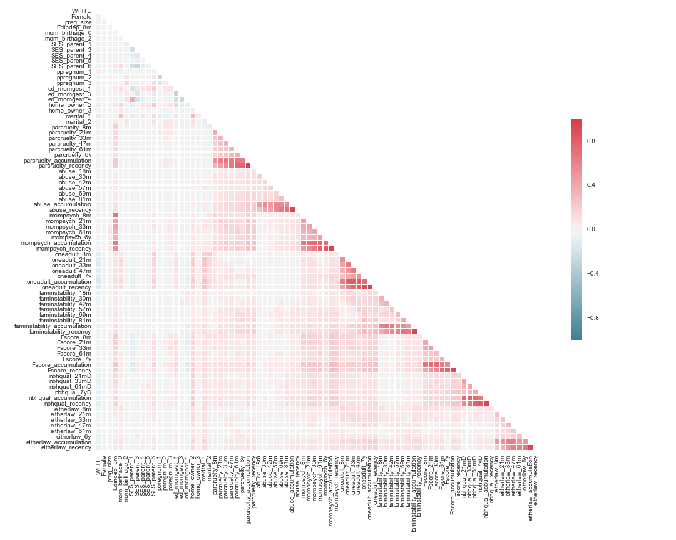
The heat map indicates the strength of the correlations between adversity exposures at each time point and each level of the covariates, with stronger positive correlations denoted in dark red, and stronger negative correlations denoted in dark blue. As shown, most of the heat map is either gray (indicating a correlation close to 0) or pale red (indicating a low- to moderate-strength correlation below r=0.4). The strongest positive correlations were within an adversity type, meaning between models of adversity exposure and measures of that same adversity across time. The weak correlations between socioeconomic status indicators––such as maternal education (“ed_momgest”), home ownership (“home_owner”), and parental social class (“SES_parent”)––and financial stress (“Fscore”) may in part represent greater social security experienced by British citizens.

Supplemental Table 4. Results of LASSO models on multiply imputed data, adjusted for maternal depression, stratified by sex
 | Female (N=3676) |  | Male (N=3800)
 | Model(s) selected | r² explained | Model(s) selected | r² explained
Abuse
Caregiver physical or emotional abuse | Recency | 1.63% | Recency | 0.89%
Sexual or physical abuse | Recency and Sensitive Period 6 (middle childhood) | 1.85% | Recency | 1.08%
Stress
Financial Stress | Accumulation | 0.76% | Accumulation | 0.55%
Parent legal problems | Accumulation | 0.18% | Sensitive Period 1 (very early childhood) | 0.21%
The table indicates the set of theoretical models chosen by the LASSO, after adjusting for covariates.
Sensitive Period 1 (infancy) for financial stress refers to 8 months of age.
Sensitive Period 1 (very early childhood) for parent legal problems refers to age 8 months.

