**SUPPLEMENTARY MATERIAL**

Supplementary Table S1: Correlation matrix of SNPs associated with cannabis initiation.

|  |  |  |  |
| --- | --- | --- | --- |
|  | rs4984460 | rs4984458 | rs8041045 |
| rs4984460 | 1 | 0.18 | 0.12 |
| rs4984458 | 0.18 | 1 | 0.65 |
| Rs8041045 | 0.12 | 0.65 | 1 |

r2 shown; all other SNPs were not correlated with each other.

Supplementary Table S2: List of SNPs associated with schizophrenia (P < 5x10-8).

|  |  |  |  |  |  |  |  |
| --- | --- | --- | --- | --- | --- | --- | --- |
| SNP ID | Chr | SNP ID | Chr | SNP ID | Chr | SNP ID | Chr |
| rs12129573 | 1 | rs4330281 | 3 | rs10503253 | 8 | rs12887734 | 14 |
| rs11210892 | 1 | rs832187 | 3 | rs73229090 | 8 | rs4702 | 15 |
| rs77149735\* | 1 | rs17194490 | 3 | rs36068923 | 8 | rs8042374 | 15 |
| rs10803138 | 1 | rs1106568 | 4 | rs6984242 | 8 | rs12903146 | 15 |
| rs7523273 | 1 | rs35518360 | 4 | rs7819570 | 8 | rs56205728 | 15 |
| rs76869799\* | 1 | rs215411 | 4 | rs11139497 | 9 | rs190065944 | 15 |
| chr1\_8424984\_D\* | 1 | rs10520163 | 4 | rs11191419 | 10 | rs950169 | 15 |
| chr1\_243881945\_I\* | 1 | rs4391122 | 5 | chr10\_104957618\_I\* | 10 | rs12148337 | 15 |
| rs1702294 | 1 | rs111294930 | 5 | rs7893279 | 10 | rs12691307 | 16 |
| rs140505938 | 1 | rs16867576 | 5 | rs7907645 | 10 | rs9922678 | 16 |
| rs4648845 | 1 | rs11740474 | 5 | rs55833108 | 10 | rs8044995 | 16 |
| rs1498232 | 1 | rs12522290 | 5 | rs55661361 | 11 | rs12325245 | 16 |
| rs14403 | 1 | chr5\_140143664\_I\* | 5 | rs75059851 | 11 | rs7405404 | 16 |
| rs6670165 | 1 | rs2973155 | 5 | rs9420 | 11 | rs8082590 | 17 |
| rs59979824 | 2 | rs3849046 | 5 | rs11027857 | 11 | rs4523957 | 17 |
| rs11685299 | 2 | rs1501357 | 5 | rs77502336 | 11 | rs9636107 | 18 |
| rs6704768 | 2 | rs10043984 | 5 | chr11\_46350213\_D\* | 11 | chr18\_52749216\_D\* | 18 |
| rs6434928 | 2 | rs4388249 | 5 | rs2514218 | 11 | rs72934570 | 18 |
| rs3768644 | 2 | rs79212538 | 5 | rs12421382 | 11 | rs715170 | 18 |
| rs6704641 | 2 | rs115329265 | 6 | rs10791097 | 11 | rs78322266\* | 18 |
| rs2909457 | 2 | chr6\_84280274\_D\* | 6 | rs2239063 | 12 | rs2053079 | 19 |
| rs75575209 | 2 | rs117074560 | 6 | rs324017 | 12 | rs2905426 | 19 |
| chr2\_200825237\_I\* | 2 | rs1339227 | 6 | rs679087 | 12 | rs56873913 | 19 |
| chr2\_146436222\_I\* | 2 | rs6466055 | 7 | rs2007044 | 12 | rs6065094 | 20 |
| chr2\_149429178\_D\* | 2 | rs12704290 | 7 | rs2851447 | 12 | rs7267348 | 20 |
| rs11693094 | 2 | rs7801375 | 7 | rs4240748 | 12 | rs9607782 | 22 |
| rs11682175 | 2 | chr7\_2025096\_I\* | 7 | rs4766428 | 12 | chr22\_39987017\_D\* | 22 |
| rs7432375 | 3 | chr7\_24747494\_D\* | 7 | rs10860964 | 12 | rs6002655 | 22 |
| rs9841616 | 3 | rs13240464 | 7 | rs12826178\* | 12 | rs1023500 | 22 |
| chr3\_180594593\_I\* | 3 | rs3735025 | 7 | rs2693698 | 14 | rs12845396\* | 23 |
| rs75968099 | 3 | rs211829 | 7 | rs2332700 | 14 | rs1378559\* | 23 |
| rs2535627 | 3 | rs4129585 | 8 | rs2068012 | 14 | rs5937157\* | 23 |

\* SNPs not in cannabis initiation GWAS. Note: Chr, chromosome.

Supplementary Figure S1: MR Egger regression of cannabis initiation predicting risk of schizophrenia.

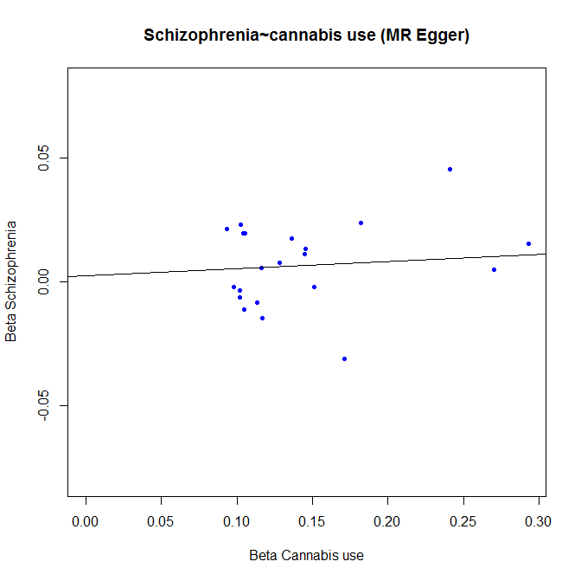

Supplementary Figure S2: MR Egger regression risk of schizophrenia predicting cannabis initiation.

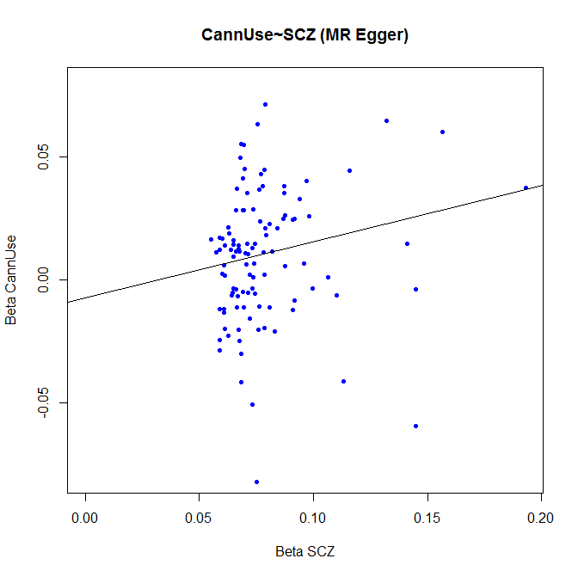

Supplementary Figure S3: Forest plot showing the effect size and confidence intervals of Mendelian randomization associations between cannabis initiation and risk of schizophrenia, systematically removing each cannabis initiation SNP in turn

Macintosh HD:Users:psshg:Downloads:Supp_fig1_nors112.pdf