SUPPLEMENTARY MATERIAL

CONTENTS

- Supplementary material:
  - Methods: Assessment of alcohol use; Smoothing kernel; Confounder analyses.
  - Results: Higher-order interaction analyses; Confounder analyses.
- Supplementary Figure S1: Thresholded p-maps (p < 0.01) using kernel sizes of 10 mm and 20 mm
- Supplementary Figure S2: Distribution of AUDIT-C scores, by group.
- Supplementary Table S1: AUDIT-C scores by gender in schizophrenia, bipolar disorder and healthy control group.
- Supplementary Figure S3: Plot of age and AUDIT-C score in schizophrenia patients, bipolar disorder patients and healthy controls.
- Supplementary Table S2: AUDIT and DUDIT total scores and data on use of illicit drugs.
- Supplementary Figure S4: Cortical clusters. Relative contribution of all independent variables depicted with bar graphs.
- Supplementary Table S3: Cortical clusters. Coordinates and detailed descriptions.

1. Supplementary material:
Methods
Assessment of alcohol use
The quantification of alcohol use in the present study was based on the AUDIT since AUDIT was available for both patients and healthy controls. AUDIT total score has been used previously in studies of the effect of alcohol on brain structure (Nesvag et al., 2007, Thayer et al., 2016). However, in a factor analysis across multiple samples, a one-factor solution for AUDIT did not provide a good fit to the data, whereas there was strong evidence for two related, but distinct dimensions representing alcohol consumption (items 1-3) and alcohol-related consequences (items 4-10) (Doyle et al., 2007). Thayer et al. used AUDIT total score as a continuous measure of alcohol use severity in a study of alcohol-related brain structural changes in a large sample of heavy drinkers (n= 436) and also reported correlations between AUDIT-C score and structural brain measures (Thayer et al., 2016). In addition, two studies on the effect of alcohol on brain structure used items from the AUDIT to estimate weekly alcohol consumption in a community-based sample (Anstey et al., 2006, Sachdev et al., 2008). We chose the AUDIT-C score because we specifically aimed to study the effect of alcohol use at different levels, unbiased by the alcohol-related problems covered in the other domains of the AUDIT. The AUDIT-C provides a composite measure of alcohol use but does not allow separation between effects of binge drinking and regular drinking as the items are highly correlated.

Statistical analyses: smoothing kernel
Surface smoothing increases the overall reliability of comparisons of cortical thickness but can impede the ability to detect highly localized effects, and the appropriate kernel size thus depends on the expected spatial extent of the effect of interest (Liem et al., 2015). For surface smoothing, the most commonly used kernel sizes range from 10mm to 20mm. In this study we did not expect the effect of alcohol on the brain to be concentrated in small regions, and we therefore opted to use a relatively large kernel size of 20mm which would enhance sensitivity to more extensive effects.
For completeness, we performed supplementary analyses of the main effect of alcohol using a smoothing kernel of 10 mm. Results were identical for area and volume. For cortical thickness findings overlap but overall vertex-wise p-values are lower, resulting in less cohesive clusters, and lower robustness to corrections for multiple comparisons. This is consistent with the interpretation that the main effect of alcohol on cortical thickness is not restricted to distinct circumscribed regions.
For comparison, thresholded p-maps (p < 0.01) using kernel sizes of 10 mm and 20 mm are included as Supplementary Figure S1.

Statistical analyses: confounding variables
The effects of using substances other than alcohol and tobacco was explored by entering DUDIT total score, dichotomized into no use (score=0) and use (score>0), and lifetime SUDs (dichotomized). Cannabis was the most commonly used illicit substance and was explored additionally by entering cannabis use the last two years as a dichotomized variable. Current antipsychotic medication, calculated as chlorpromazine equivalents, was entered both as a continuous variable and dichotomized into use/no use. As measures of illness severity, PANSS total score, GAF-S and GAF-F were entered as continuous variables. Years of education was entered as a continuous variable. As heavy drug use was an exclusion criteria in the controls, and collection of data on smoking differed between patient and controls (for details see Jørgensen et al., 2015), analyses of the confounding effects of smoking and last year illicit drug use (DUDIT total score) were conducted both in the full sample (n=609) and in the patient sample only (n=337). Analyses of the effects of lifetime illicit SUDs, cannabis use, antipsychotic medication, GAF-S and GAF-F and duration of illness were limited to the patient sample (n=337).

Results

Higher-order interaction analyses
As the Freesurfer surface analysis-pipeline does not allow for analyses of higher-order interactions, we examined effects of higher-order interactions on mean cortical thickness in the cortical clusters that showed the most significant association with alcohol consumption. Since the focus of this article was to examine differential effects in patients and controls rather than gender differences per se, and to ease the interpretation of the results, analyses were stratified according to gender. As the analyses were performed post-hoc, a Bonferroni-Holm correction for multiple tests (for the eight cortical clusters) was applied on the results (significance level for lowest p-value: 0.05/8= 0.006). Using a full factorial ANOVA, we found no significant Age x AUDIT-C x Group interactions in any cluster. We then tested two-way interactions involving AUDIT-C, and found interactions between schizophrenia and AUDIT-C in left rostral middle frontal cluster (L3; p = 0.0285, B = -0.022) and right parieto-occipital cluster (R1; p = 0.0145, B = -0.018) in males, and left superior frontal cluster (L2; p = 0.0229, B = 0.030) in females. These findings did not survive tests for multiple comparisons, making interpretation difficult. There were no significant Age x AUDIT-C interactions.

Confounding variables
For seven of the cortical clusters, there was a significant main effect of GAF-S, GAF-F or AP on cortical thickness but this did not affect the association between AUDIT-C score and cortical thickness, and there were no interactions between AUDIT-C and GAF-S, GAF-F or AP. None of the other potential confounding variables had significant main effects on structural brain measures.

2. Supplementary Figure S1:
Thresholded p-maps (p < 0.01) using kernel sizes of 10 mm and 20 mm
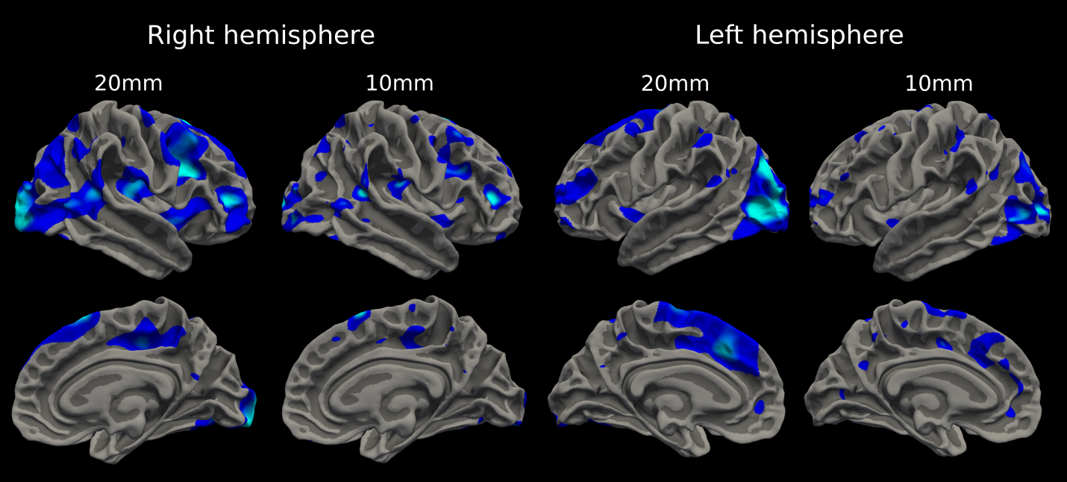

3. Supplementary Figure S2:
Distribution of AUDIT-C scores in 609 participants, percent frequency by group.

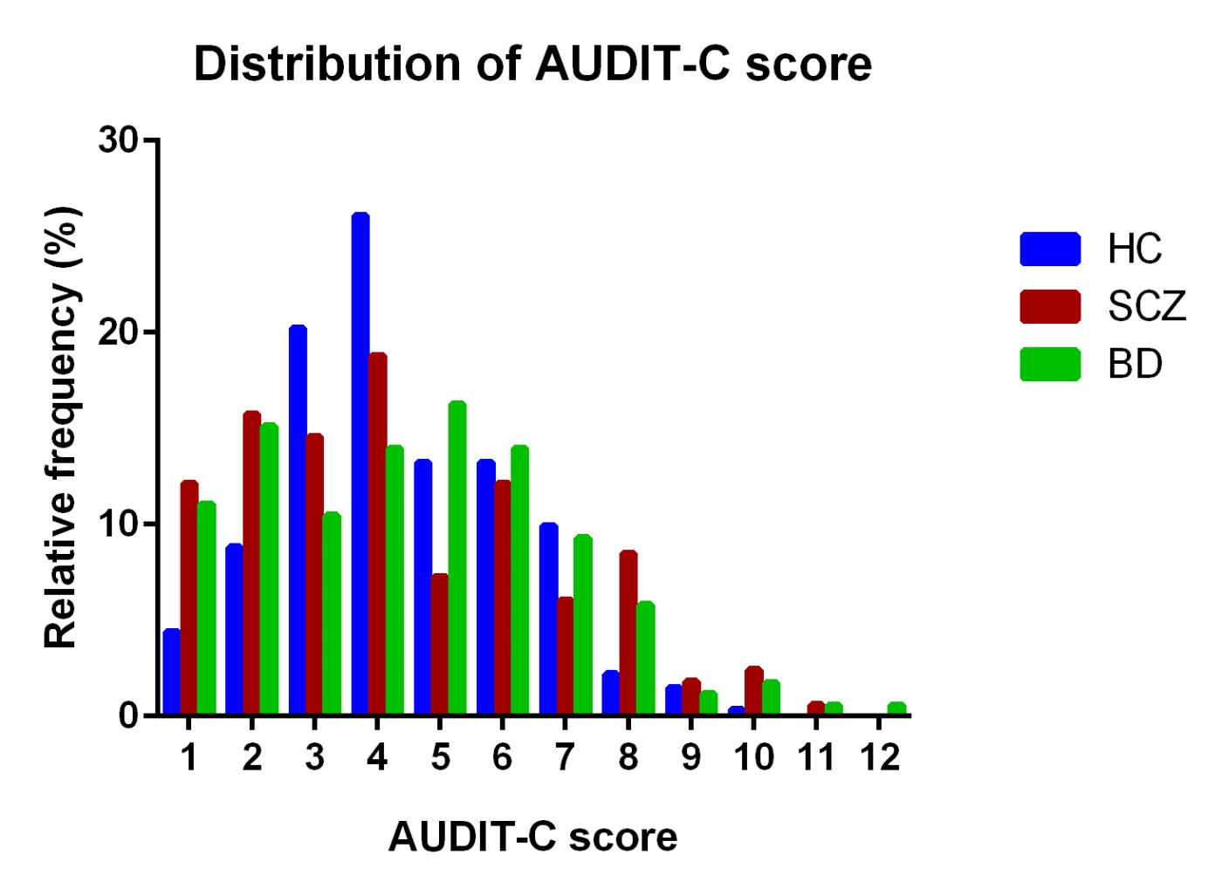

AUDIT-C, Alcohol Use Disorders Identification Test – Consumption part; SCZ, schizophrenia spectrum disorder; BD, bipolar spectrum disorder; HC, healthy controls.

4. Supplementary Table S1:
Supplementary Table S1. AUDIT-C scores by gender in schizophrenia, bipolar disorder and healthy control group.
 | AUDIT-C score |  | Independent t-test
Group (n=men/women) | Men  Mean (SD) | Women  Mean (SD) | t-score | p-value
Schizophrenia (92/73) | 4.6 (2.5) | 3.9 (2.3) | 1.9 | 0.06
Bipolar disorders (74/98) | 5.0 (2.6) | 4.1 (2.1) | 2.4 | 0.02
Healthy controls (149/123) | 4.7 (1.9) | 3.9 (1.5) | 3.8 | <0.01

5. Supplementary Figure S3:
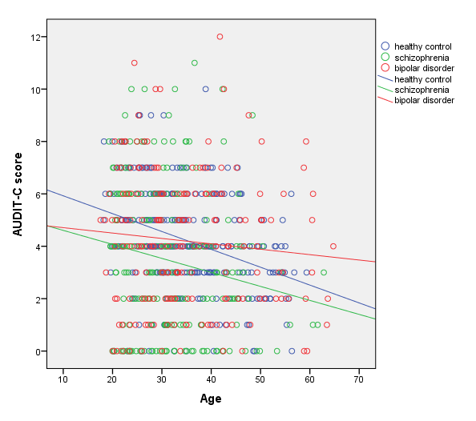

Supplementary Figure S3. Plot of relationship between age and AUDIT-C score in schizophrenia patients, bipolar disorder patients and healthy controls.

6. Supplementary Table S2:
AUDIT and DUDIT total scores and data on use of illicit drugs past month and past 2 years.
Supplementary Table S2. Substance use data, n=609, mean ± SD or number (%) unless otherwise specified.
Characteristics ª | Schizophrenia (n=165) | Bipolar disorder (n=172) | Healthy controls (n=272) | Statistics
 |  |  |  | Test^{c} | p-value | Post-hoc
AUDIT total score^{b} | 7.4 ± 6.2  6 [1-34] | 7.6 ± 6.0  6 [1-36] | 5.2 ± 2.8  4 [1-15] | X²=10.9 | 0.004 | SCZ, BD>HC
DUDIT total score^{b} | 3.3 ± 6.8  0 [0-35] | 2.4 ± 6.2  0 [0-32] | 0.2 ± 0.7  0 [0-6] | X²=59.0 | <0.001 | SCZ>BD>HC
Substance use, past month
Cannabis | 19 (13) | 15 (9) | 4 (2)
Amphetamines | 9 (6) | 2 (1) | 1 (0.4)
Cocaine | 5 (3) | 3 (2) | 2 (1)
Other illicit drugs^{d} | 6 (4) | 2 (1) | 1 (0.4)
Substance use, past 2 yrs
Cannabis | 57 (36) | 53 (31) | -
Amphetamines | 28 (18) | 12 (7) | -
Cocaine | 20 (13) | 16 (9) | -
Heroin | 4 (3) | 1 (1) | -
Ecstasy | 2 (1) | 7 (4) | -
Hallucinogens | 3 (2) | 2 (1) | -
Sedatives | 4 (2) | 7 (4) | -
ª Missing information: DUDIT was missing for 2 controls. Information on last month use of cannabis, cocaine, amphetamines and other drugs was missing for 54 subjects (28 controls, 15 schizophrenia patients, 11 bipolar patients). Information on drug use past 2 years available for patients only, with missing information on amphetamine use for 8 and missing on cannabis, cocaine, ecstacy and opiate use for 7 subjects.
^{b} Mean ± SD and median [range].
^{c} Kruskal-Wallis H test.
^{d} Other illicit drugs: 5 opiates, 3 ecstacy, 1 hallucinogens.

7. Supplementary Figure S4:
Cortical thickness clusters. Relative importance for regression of independent variables.
a
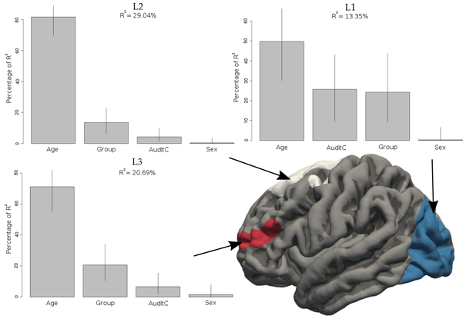
b

Suppl. Fig. S4 a-b: a) left and b) right hemisphere. For the eight cortical clusters where association between AUDIT-C and cortical thickness was most significant, the relative importance of each regressor in the linear model was computed using the lmg metric implemented in the relimpo package in R. This estimation of relative importance is computed by leaving one regressor out and then averaging over the R-square difference of every possible model consisting of any number of the other regressors, with the same model where the regressor of interest is included. This is done for each regressor and a final normalized score of relative importance is given to each of the regressors; age, sex, diagnostic group, and AUDIT-C, with 95% bootstrap confidence intervals.

8. Supplementary Table S3:
Supplementary Table S3. Cortical thickness clusters generated from statistical p-maps: maximum significance, coordinates and description.
Cluster labelª |  |  | Max. sign.^{b}  (p-value) | Cluster size (cm²) | Talairach coordinates for maximum vertex^{c} |  |  | Anatomical description
 |  |  |  |  | X | Y | Z
L1 | Parieto-occipital | 8.7 x10⁻⁷ |  | 73.243 | -24.6 | -77.4 | 18.9 | Large parts of the lateral occipital and inferior parietal gyrus (extends into superior parietal and fusiform gyrus)
R1 | Parieto-occipital | 4.0 x 10⁻⁵ |  | 143.024 | 20.0 | -99.4 | 7.2 | Most of lateral occipital gyrus, extending into inferior and superior parietal and fusiform gyri
L2 | Superior frontal | 1.2 x10⁻⁴ |  | 60.810 | -7.4 | 22.1 | 34.6 | Most of the superior frontal gyrus
R2 | Superior frontal | 8.6 x 10⁻⁵ |  | 31.704 | 9.8 | 20.8 | 59.3 | Parts of the medial aspect of the superior frontal gyrus
L3 | Rostral middle frontal | 0.001 |  | 15.286 | -41.0 | 46.9 | 7.6 | Large parts of the rostral middle frontal gyrus
R3 | Rostral middle frontal | 7.7 x 10⁻⁵ |  | 22.654 | 39.3 | 39.2 | 4.3 | Small part of the rostral middle frontal gyrus
R4 | Caudal middle frontal | 3.2 x 10⁻⁵ |  | 46.476 | 35.5 | 13.2 | 23.3 | Lateral part of caudal middle frontal gyrus, extending into rostral middle frontal, pars opercularis and precentral gyri
R5 | Insula | 1.6 x 10⁻⁴ |  | 23.480 | 36.1 | -20.7 | 14.1 | Parts of the insula
ª L=left, R=right
^{b} The p-value for the effect of AUDIT-C score in the vertex where the association between AUDIT-C and cortical thickness was most significant in each cluster.
^{c} Talairach coordinates for the vertex where the association between AUDIT-C and cortical thickness was most significant in each cluster.

References
Anstey KJ, Jorm AF, Reglade-Meslin C, Maller J, Kumar R, von Sanden C, Windsor TD, Rodgers B, Wen W & Sachdev P (2006). Weekly alcohol consumption, brain atrophy, and white matter hyperintensities in a community-based sample aged 60 to 64 years. Psychosomatic Medicine 68, 778-85.
Doyle SR, Donovan DM & Kivlahan DR (2007). The factor structure of the Alcohol Use Disorders Identification Test (AUDIT). J.Stud.Alcohol Drugs 68, 474-479.
Liem F, Merillat S, Bezzola L, Hirsiger S, Philipp M, Madhyastha T & Jancke L (2015). Reliability and statistical power analysis of cortical and subcortical FreeSurfer metrics in a large sample of healthy elderly. Neuroimage 108, 95-109.
Nesvag R, Frigessi A, Jonsson EG & Agartz I (2007). Effects of alcohol consumption and antipsychotic medication on brain morphology in schizophrenia. Schizophrenia Research 90, 52-61.
Sachdev PS, Chen X, Wen W & Anstey KJ (2008). Light to moderate alcohol use is associated with increased cortical gray matter in middle-aged men: a voxel-based morphometric study. Psychiatry Research 163, 61-9.
Thayer RE, Hagerty SL, Sabbineni A, Claus ED, Hutchison KE & Weiland BJ (2016). Negative and interactive effects of sex, aging, and alcohol abuse on gray matter morphometry. Human Brain Mapping 37, 2276-92.

