Online Supplementary Material
eTable 1. Censoring in the analyses of the rate of remission, recurrence of depression and conversion to bipolar disorder, respectively, after the first lifetime episode of depression
 | N | Censoring
 |  | Remission  (N=301) |  | Recurrence  (N=246) |  |  |  | Conversion to bipolar  (N=301)
 |  | Right censored² | Events (interval censored)³ | Right censored | Events (interval censored)³ | Competing risk⁴ | Excluded⁵ | Right censored | Events
Outcome established by diagnostic interview¹ | 263 | 19 | 244 (115) | 146 | 80 (33) | 18 | 19 | 236 | 27
Non-participants at follow-up  Remission at baseline  No further information  Admitted with depression  Dead  Non-remission at baseline  No further information  Dead | 8  2  7  14  7 | 0  0  0  14  7 | 8 (8)  2 (2)  7 (7)  0  0 | 0  0  0  0  0 | 0  2 (2)  0  0  0 | 0  0  0  0  0 | 8  0  7  14  7 | 8  2  7  14  7 | 0  0  0  0  0
Total | 301 | 40 | 261 (132) | 146 | 82 (35) | 18 | 55 | 274 | 27

1) Two patients developed a manic episode shortly after discharge, which was diagnosed at the baseline-interview; hence the conversion to bipolar disorder was established already at baseline for these 2 patients. One of them died before follow-up.
2) Patients, who did not remit from the first depressive episode during the follow-up period.
3) Patients, who obtained remission in the interval between discharge and baseline assessment and who later had recurrence of depression, are interval censored.
4) Patients who developed bipolar disorder after the first depressive episode.
5) In the analyses of time to recurrence, only patients who obtained remission could be included.

eFig. 1A. Cumulative incidence of remission after onset of the first lifetime episode depression among patients with (green) and without (blue) a comorbid anxiety disorder. N=301.
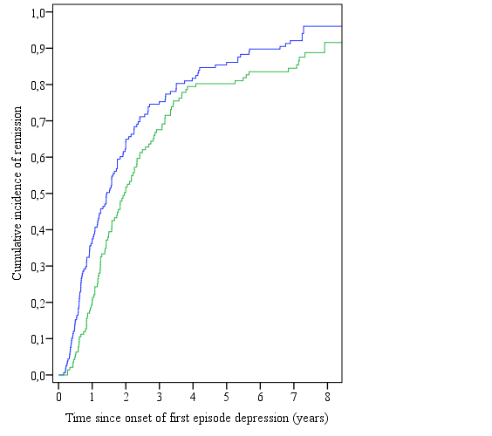
eFig. 1B. Cumulative incidence of remission after onset of the first lifetime episode depression according to age-of-onset (blue: < 30 years, green: 30-60 years, red: > 60 years). N=301.
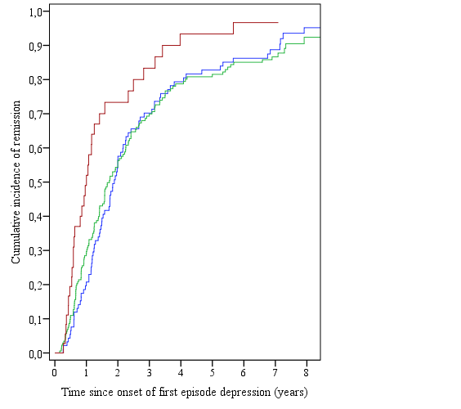

eFig. 1C. Cumulative incidence of remission after onset of the first lifetime episode depression among patients who did (green) or did not (blue) initially show treatment resistance to two or more antidepressant trials. N=301.
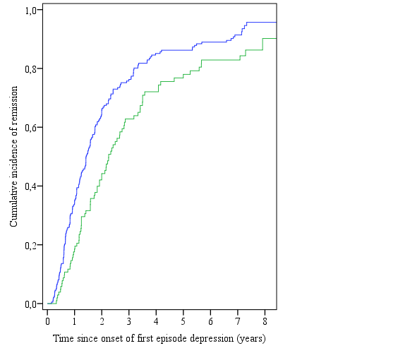
eFig. 1D. Cumulative incidence of remission after onset of the first lifetime episode depression among patients with (green) and without (blue) suicidal ideations or attempts. N=301.
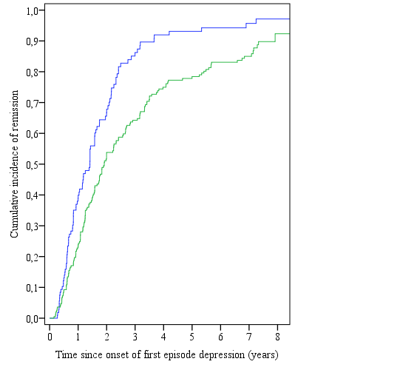

eFig. 2A. Cumulative incidence of recurrence after remission of the first lifetime episode of a mild (blue), moderate (green), and severe (red) single depressive episode, respectively. N=246.

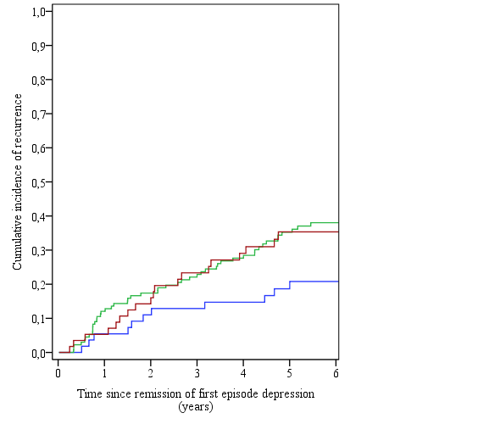

eFig. 2B. Cumulative incidence of recurrence after remission of the first lifetime episode depression among patients who did (green) or did not (blue) initially show treatment resistance to two or more antidepressant trials. N=246.

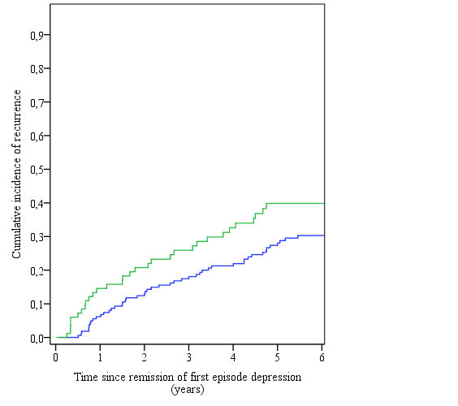

eFig 3A. Cumulative incidence of conversion to bipolar disorder after discharge with a diagnosis of first lifetime episode depression among patients who did (green) or did not (blue) initially show treatment resistance to two or more antidepressant trials. N=301.
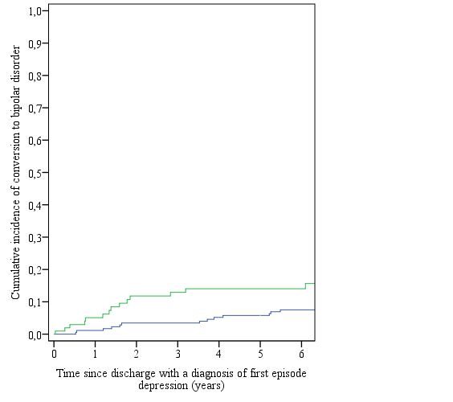
eFig.3B. Cumulative incidence of conversion to bipolar disorder after discharge with a diagnosis of first lifetime episode depression among patient with (green) and without (blue) a family history of affective disorder in first-degree relatives. N=301.
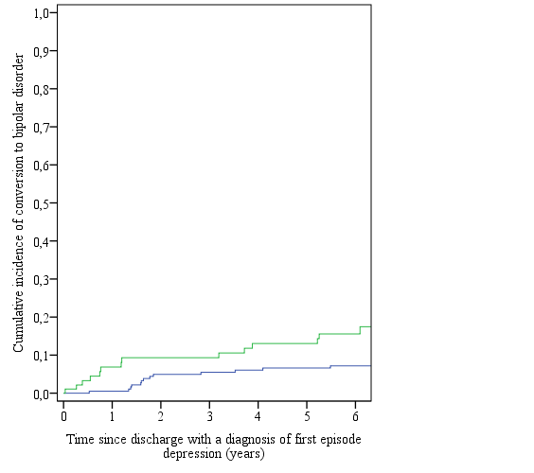
eFig. 3C. Cumulative incidence of conversion to bipolar disorder after discharge with a diagnosis of first lifetime episode depression among patient with (green) and without (blue) comorbid alcohol or drug abuse. N=301.
