Supplementary Fig. S1. Four cross-lagged theoretical regression models for the temporal relationship between depressive symptoms and HbA1c levels
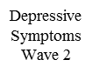
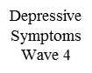
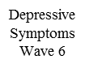
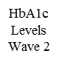
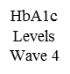
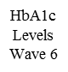
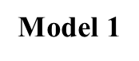
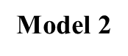
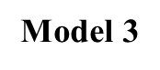
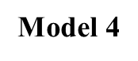
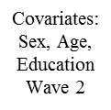

Note: We first specified a stability model without interaction between depressive symptoms and HbA1c levels (without cross-lagged structural paths, Model 1). This is a first-order autoregressive model in which depressive symptoms/ HbA1c levels are represented as ‘causes’ of themselves over the two time points. Three more complex models with cross-lagged structural paths were generated:
Model 2: paths from depressive symptoms at time point t to HbA1c levels at time point t+1 but no paths from HbA1c levels to depressive symptoms.
Model 3: paths from HbA1c levels at time point t to depressive symptoms at time point t+1 but no paths from HbA1c levels to depressive symptoms.
Model 4: paths from HbA1c levels at time point t to depressive symptoms at time point t+1 and paths from HbA1c levels at time point t to depressive symptoms at time point t+1.
Models were compared for fit. The best fitting model (Model 4) was retained for further examination. Depressive symptoms are modeled as a latent variable with 8 binary indicators, indicated by a circle.

