SUPPLEMENTARY ONLINE APPENDIX

Algorithm used to simulate one incongruent trial from the model

Sample RT_{pre} ~ InvGauss(v_{pre}, a) + t
Sample RT_{inhib} ~ InvGauss(v_{inhib,} a) + t
Sample RT_{exec} ~ InvGauss(v_{exec}, a) + t + t_{exec}

if RT_{inhib} < RT_{pre}:
RT_{pre} = inf
if RT_{pre} < RT_{exec}:
error = true
RT = RT_{pre}
else:
error = false
RT = RT_{exec}

Output: error, RT

InvGaussian(µ, lam) is the first-passage-time distribution for a Wiener diffusion process with drift µ and a single upper threshold lam. “t” is a constant corresponding to non-decision time (Ratcliff & McKoon, 2008). “t_{exec}” is a second constant that captures the time needed to implement additional processing on incongruent versus congruent trials (i.e., respond to the central arrow, not the flankers) (Wiecki & Frank, 2013). By running this algorithm 10000 times for each parameter setting and using kernel density estimation on the simulated RTs, we approximated a likelihood function. Congruent trials were fit using only the prepotent accumulator. The parameters “a”, “t” and “v_{pre}” are thus constrained by congruent as well as incongruent trials while the parameters “v_{stop}”, “v_{exec}”, and “t_{exec}” are only constrained by the latter.
Congruency sequence effects
The deployment of cognitive control in the flanker task can have consequences for performance on the next trial, a phenomenon evident in congruency sequence effects (Egner, 2007). Congruency sequence effects typically correspond to higher accuracy and faster RT for incongruent trials immediately preceded by incongruent trials, relative to incongruent trials immediately preceded by congruent trials; this may reflect a “carry-over” of cognitive control elicited by one incongruent trial to the trial that follows it. There is evidence that congruency sequence effects are sensitive to depressive symptoms (Holmes & Pizzagalli, 2007), thus we examined them. We computed the congruency sequence effect as [%Correct Incongruent trials following correct incongruent trials - %Correct Incongruent trials following correct congruent trials] and [Mean RTIncongruent trials following correct congruent trials – Mean RTIncongruent trials following correct incongruent trials]. Higher values suggest more robust or more sustained recruitment of cognitive control in response to incongruent stimuli. Analyses were restricted to incongruent trials preceded by correct responses in order to dissociate sequence effects from post-error adjustments.
As shown in Table S1, the congruency sequence effect on accuracy was positive in both groups (ts > 4.13, ps < 0.001 for one-sample t-tests against zero). However, a between-group t-test did not approach significance, t(127) < 1, p = 0.70. The congruency sequence effect on RT was not significantly different from zero in either group (ts < 1.75, ps > 0.09), and again no group difference was observed, t(127) = -1.39, p = 0.17. Thus, we found evidence of a congruency sequence effect on accuracy but not RT, and neither effect was influenced by depression.
Post-error behavioral adjustments

Healthy controls typically slow down and increase their accuracy on post-error relative to post-correct trials (Dutilh et al., 2012), but this phenomenon appears to be weaker in depressed participants, who may instead display a “catastrophic” response to errors (e.g., Beats et al., 1996; Holmes & Pizzagalli, 2008). On the basis of this prior work, we assessed group differences in post-error behavioral adjustments.
Post-error adjustments were computed as [%Correct Trials following incorrect incongruent trials - %Correct Trials following correct incongruent trials] and [Mean RTTrials following incorrect incongruent trials – Mean RTTrials following correct incongruent trials]. Higher values indicate more robust recruitment of cognitive control following erroneous versus correct responses. Analyses were restricted to trials preceded by incongruent stimuli in order to dissociate post-error adjustments from congruency sequence effects. Finally, electrophysiological research suggests that at least six errors are required to reliably detect markers of error commission (Olvet & Hajcak, 2009). Thus, we enforced a threshold of six errors on incongruent trials for analysis of post-error adjustments. Consequently, the post-error analysis was restricted to data from 81 depressed and 36 healthy participants.
As shown in Table S1, the post-error effects on accuracy were small and did not differ significantly from zero in either group (ts < 1, p > 0.32). By contrast, the post-error effect on RT was significantly different from zero in the depressed participants, t(80) = 2.78, p = 0.006, but not the controls, t(35) = 1.33, p = 0.19. However, between-group t-tests did not approach significance for accuracy or RT (t(127) < 1.20, p > 0.23 in both cases). Thus, we found no evidence of a group difference in post-error behavioral adjustments.
Table S1. Descriptive data (mean±SD) for congruency sequence effects and post-error adjustments

 | Depressed | Healthy
 | Congruency sequence effects
Accuracy | 0.06±0.12 | 0.07±0.10
RT | -0.64±20.00 | -6.18±22.00
 | Post-error adjustments
Accuracy | 0.00±0.04 | 0.01±0.04
RT | 9.13±29.62 | 4.75±21.48

Figure S1. Distribution of executive control and prepotent drift rate parameters
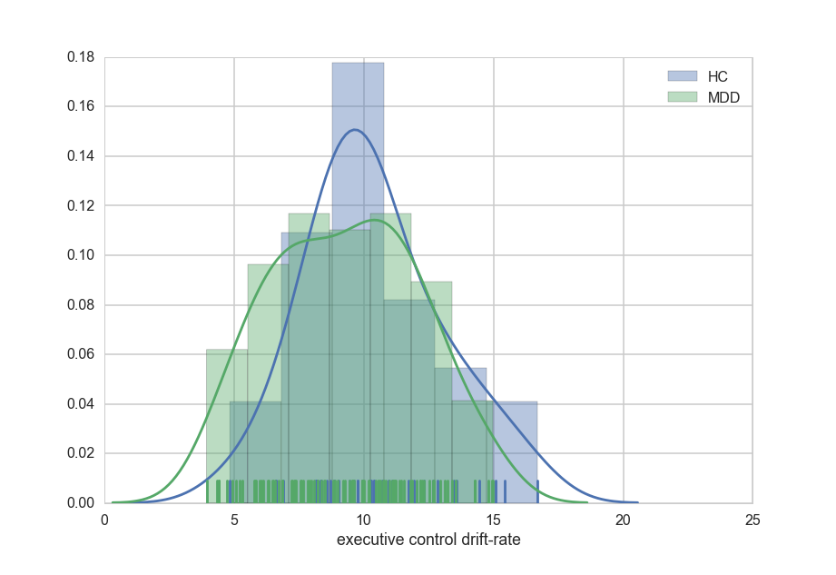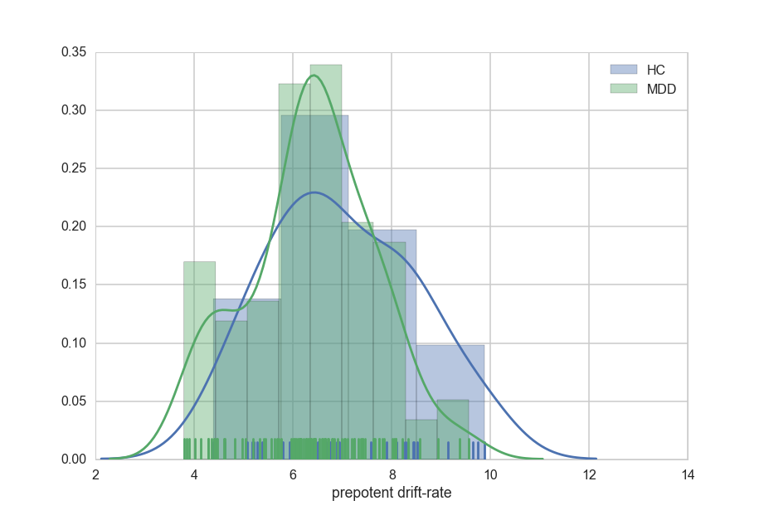

References
Beats BC, Sahakian BJ, Levy R (1996). Cognitive performance in tests sensitive to frontal lobe dysfunction in the elderly depressed. Psychological Medicine 26, 591-603.
Egner T (2007). Congruency sequence effects and cognitive control. Cognitive, Affective and Behavioral Neuroscience 7, 380-390.
Holmes AJ, Pizzagalli DA (2007). Task feedback effects on conflict monitoring and executive control: Relationship to subclinical measures of depression. Emotion 7, 68-76.
Holmes AJ, Pizzagalli DA (2008). Response conflict and frontocingulate dysfunction in unmedicated participants with Major Depression. Neuropsychologia 46, 2904-2913.
Olvet DM, Hajcak G (2009). The stability of error-related brain activity with increasing trials. Psychophysiology 46, 957-961.
Ratcliff R, McKoon G (2008). The diffusion decision model: theory and data for two-choice decision tasks. Neural Computation 20, 873-922.
Wiecki TV, Frank MJ (2013). A computational model of inhibitory control in frontal cortex and basal ganglia. Psychological Review 120, 329-355.

