Supplementary Material

Social neuroscience in psychiatry:
unravelling the neural mechanisms of social dysfunction

by A.K.J. Fett, S.S. Shergill & L. Krabbendam

Supplement 1
Emotion Recognition Figures
(depicting data in Table 1)

Figure 1. SZ < HC SZ > HC
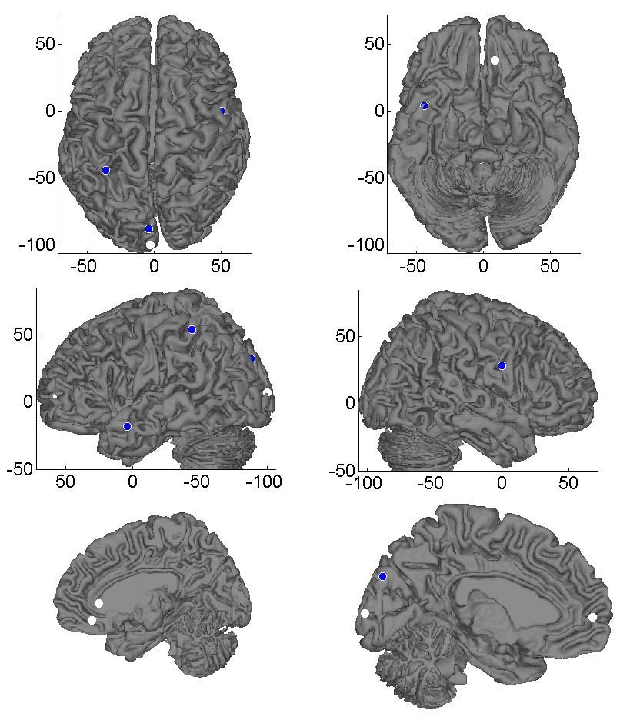
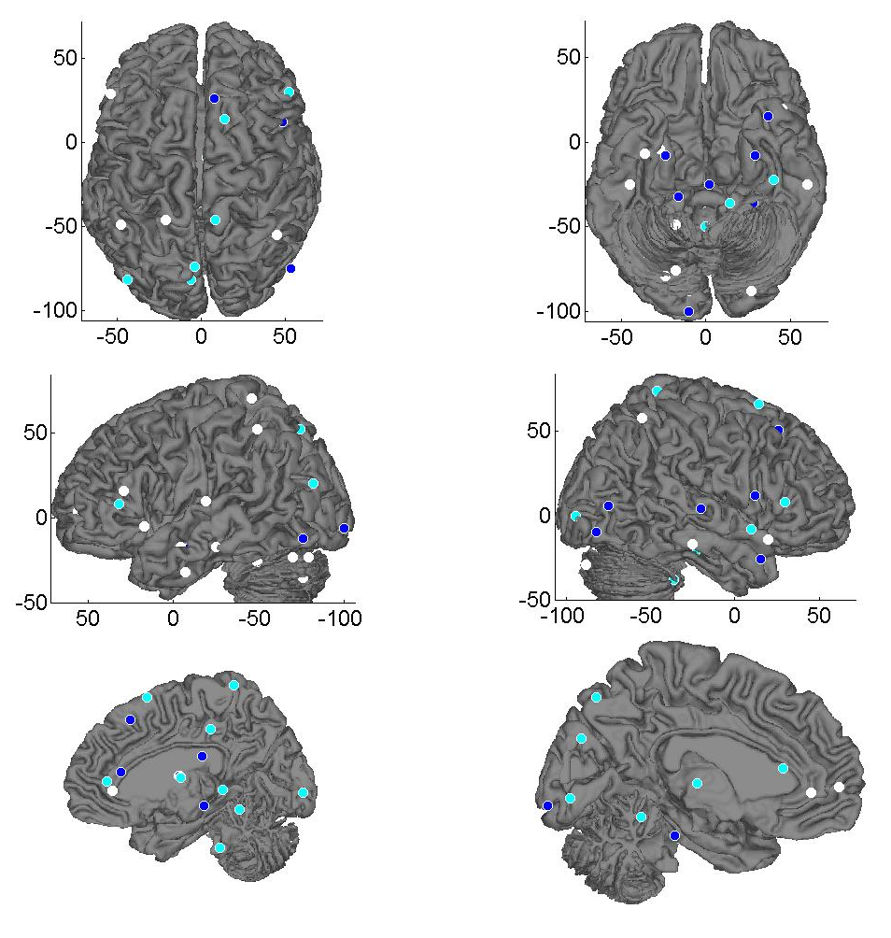

Colour coding: dark blue = meta-analysis, cyan = emotion > control, white = emotion > baseline

Figure 2. ASD < HC ASD > HC
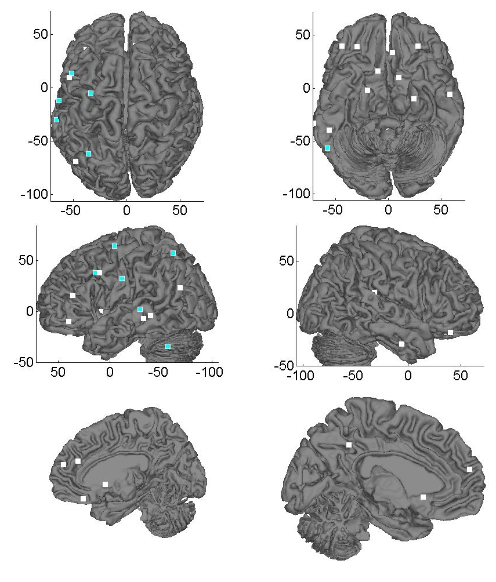
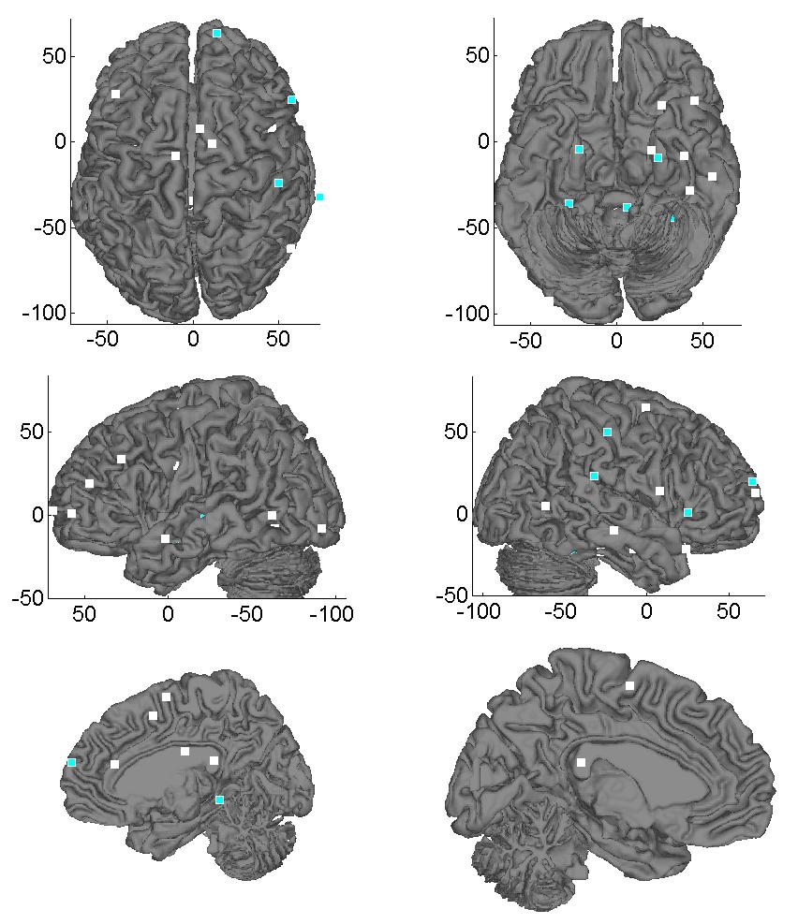

Colour coding: dark blue = meta-analysis, cyan = emotion > control, white = emotion > baseline
Figure 3. SZ vs. ASD
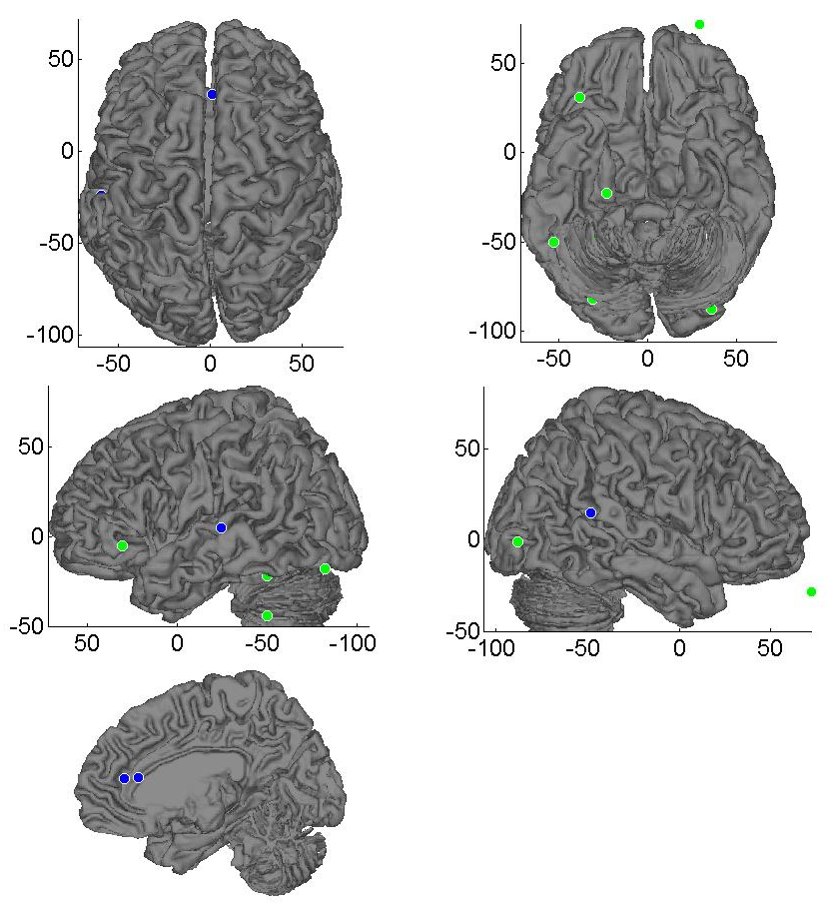

Colour coding: dark blue = ASD > SZ, green = SZ > ASD
Figure 4. PP < HC PP > HC
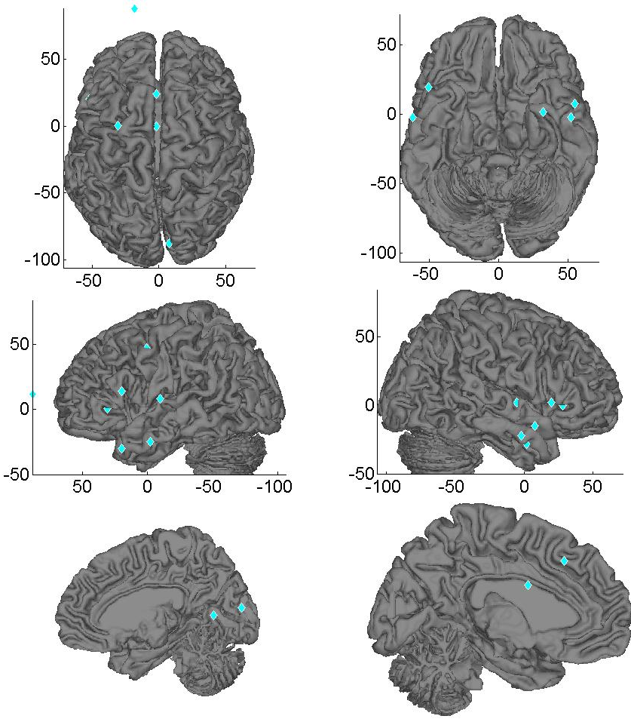
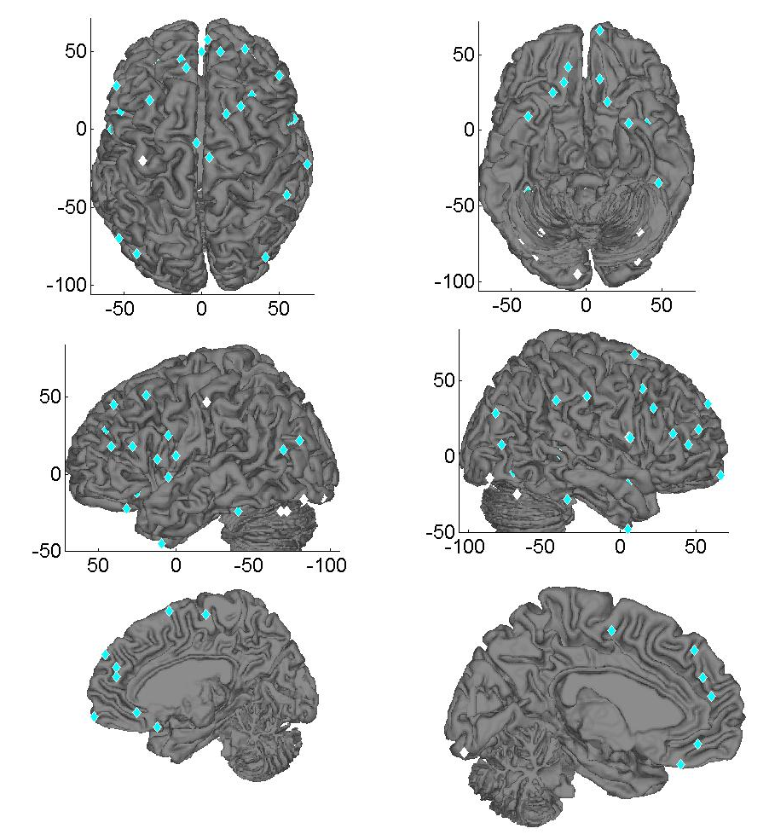

Colour coding: cyan = emotion > control, white = emotion > baseline

Supplement 2
Theory of mind Figures
(depicting data in Table 2)

Figure 1. SZ < HC SZ > HC
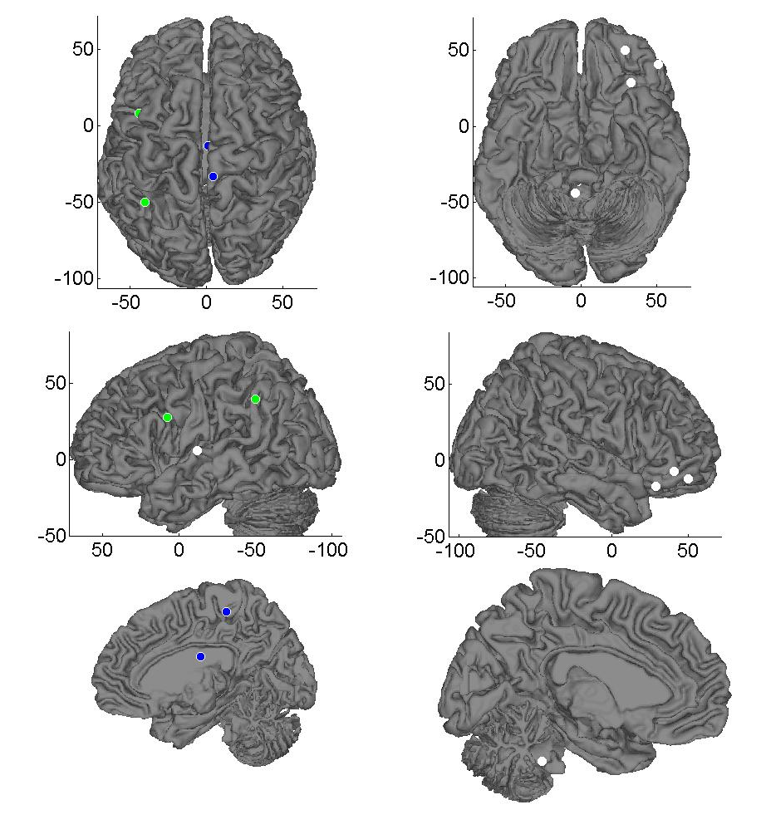
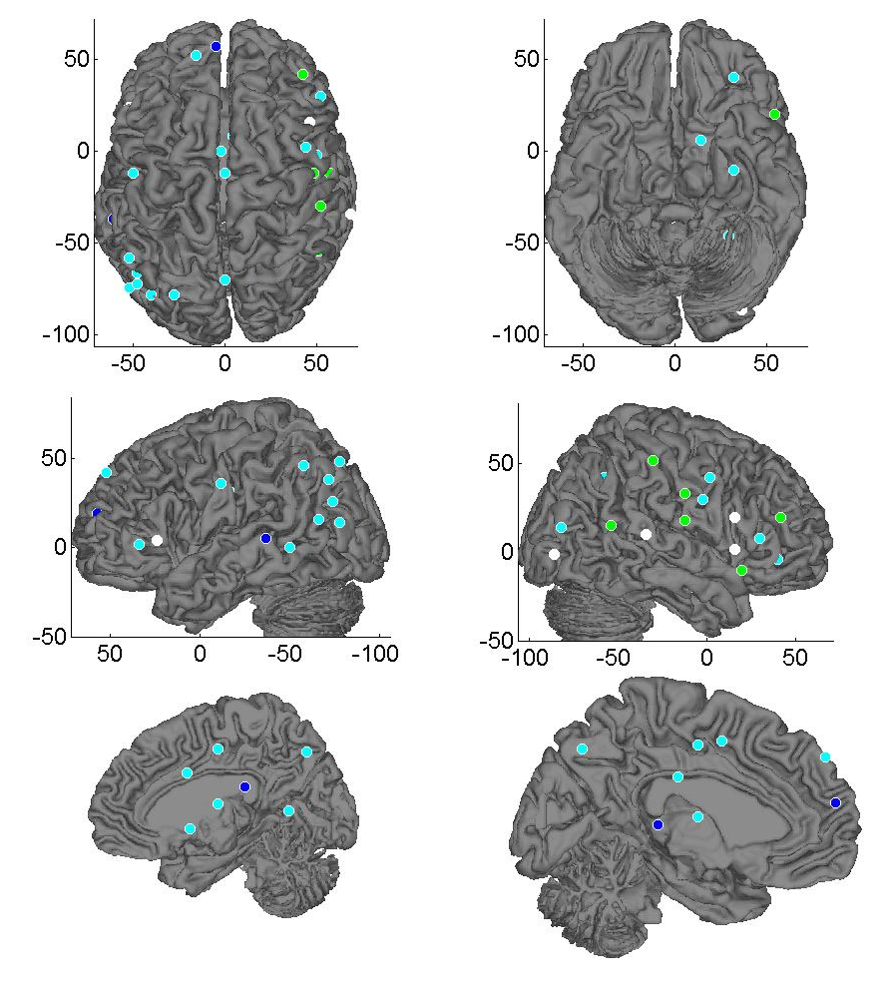

Colour coding: dark blue = meta-analysis, cyan = mental state attribution, green = irony detection, white = moving shapes
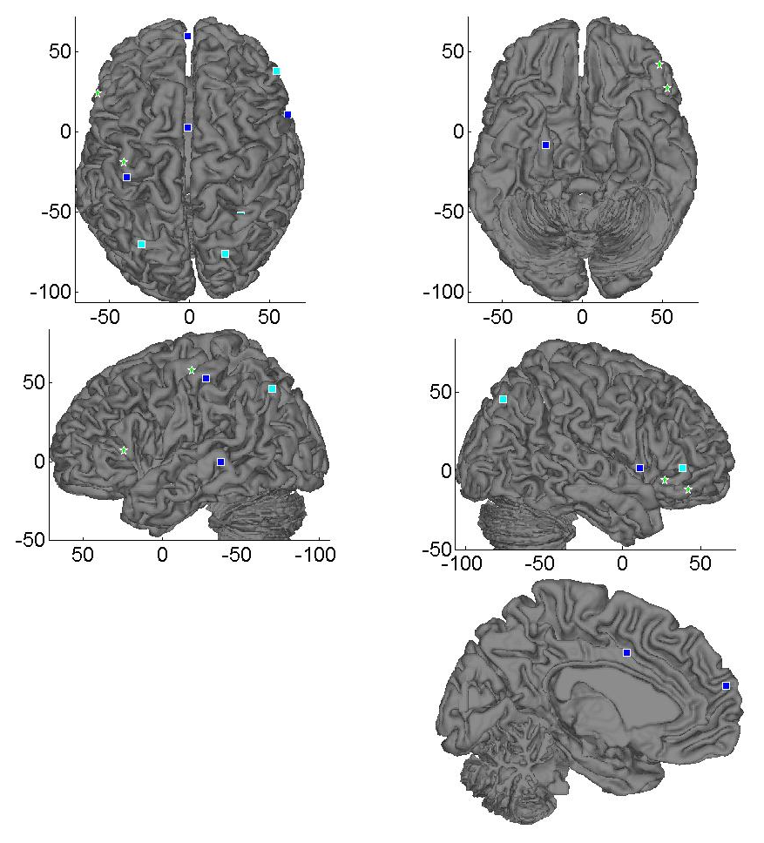
Figure 2. ASD vs. HC

Colour coding: ASD < HC: dark blue = meta-analysis, cyan = mental state attribution, ASD > HC: green stars = irony
Figure 3. ASD vs. SZ
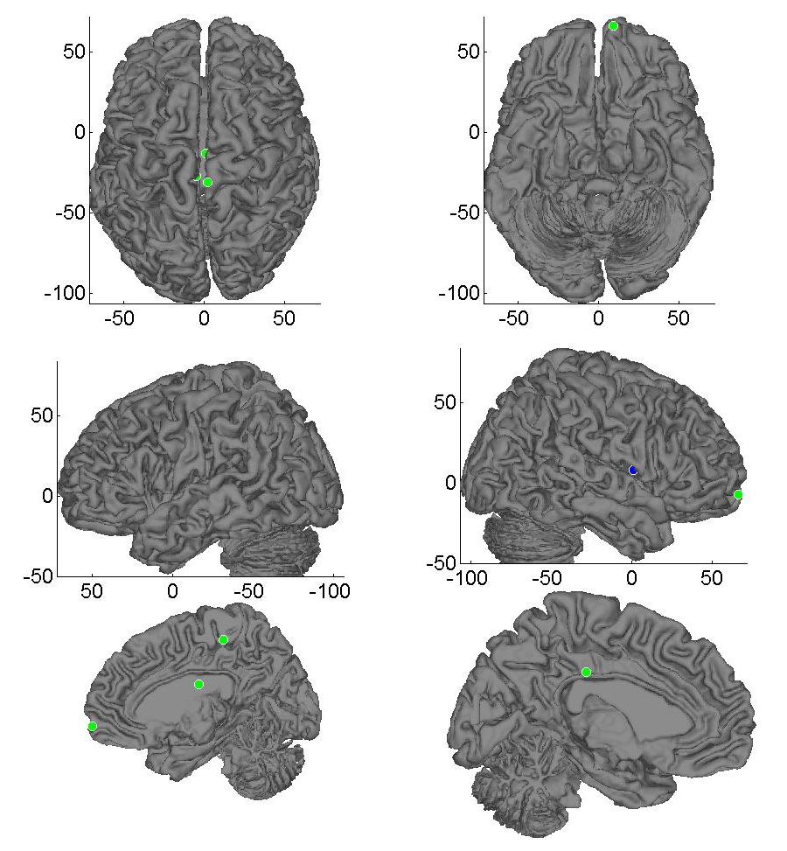

Colour coding: ASD < SZ: dark blue, SZ > ASD: green
Figure 4. PP vs. HC
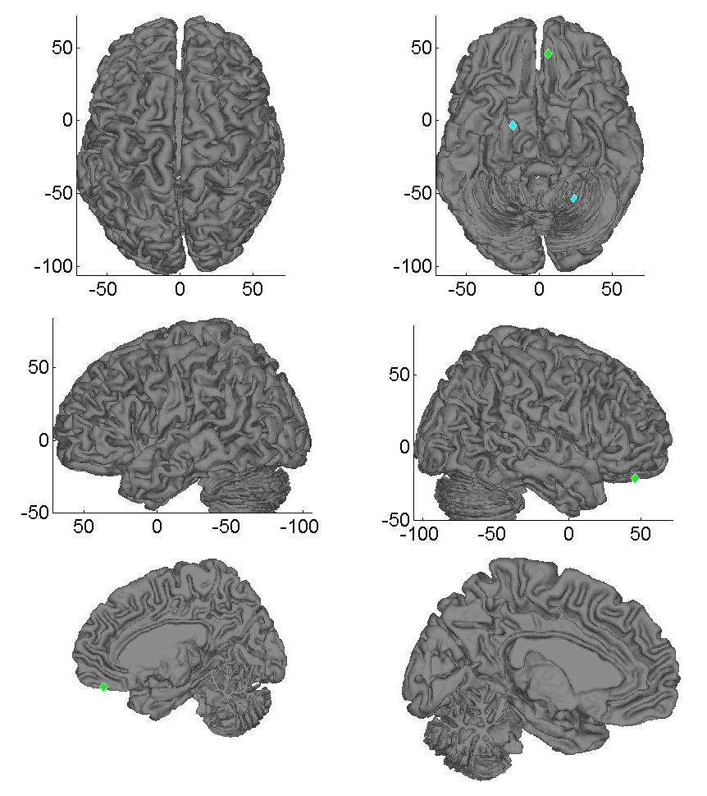
Colour coding: PP < HC= cyan, PP > HC = green

Supplement 3
Empathy Figures
(depicting data in Table 3)

Figure 1. SZ < HC
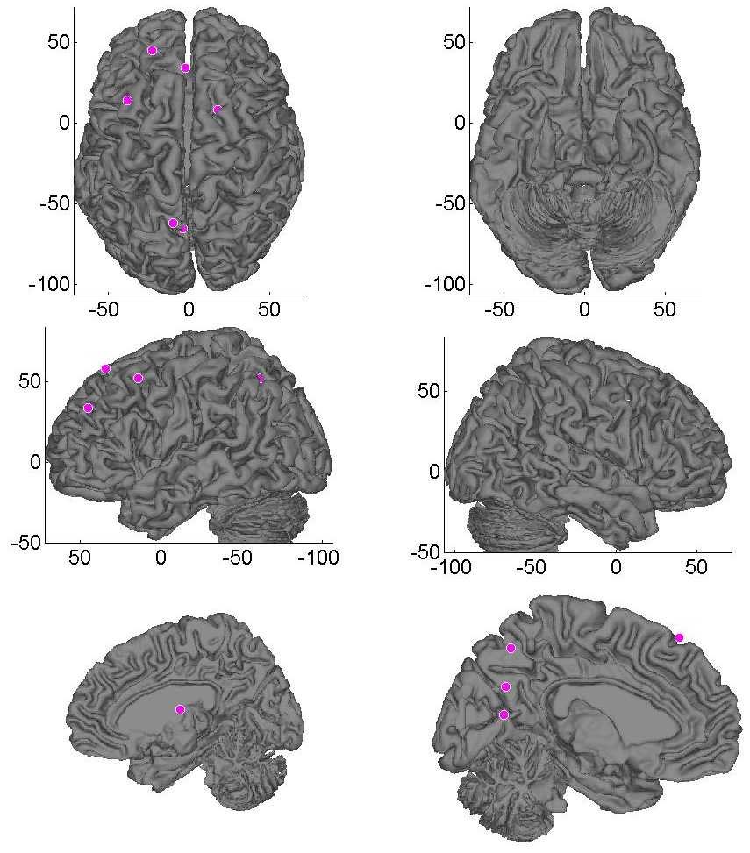

Colour coding: pink = affective response
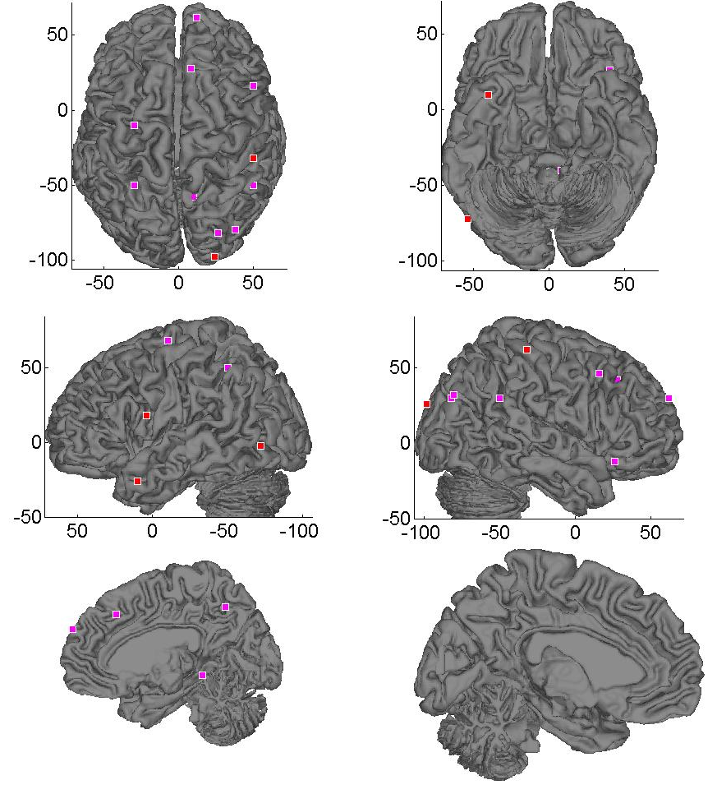
Figure 2. ASD < HC ASD > HC
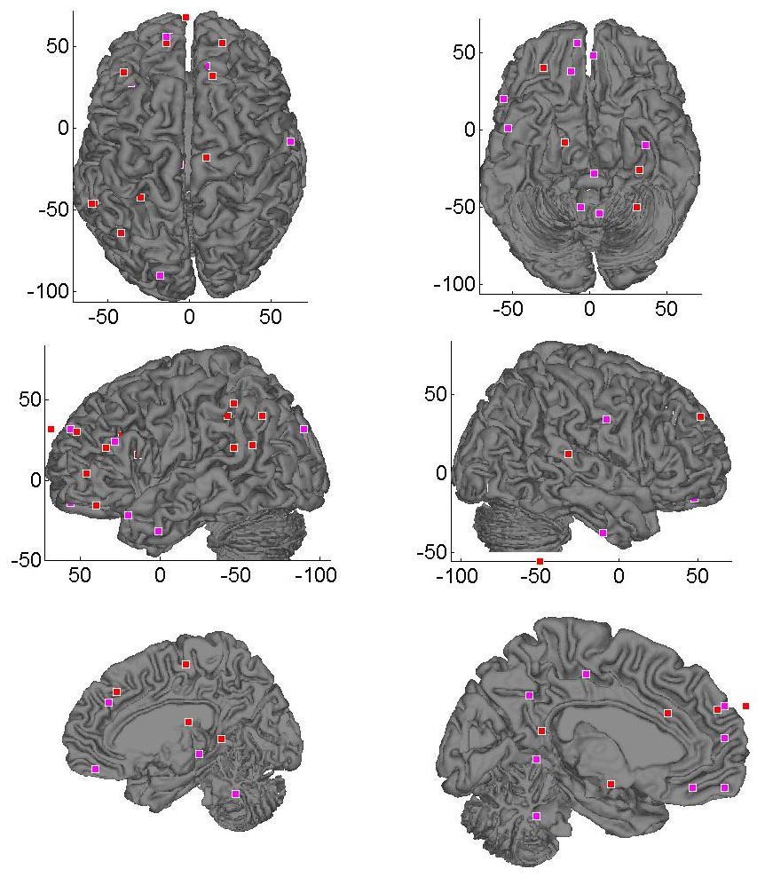
Colour coding: pink = affective response, red = pain
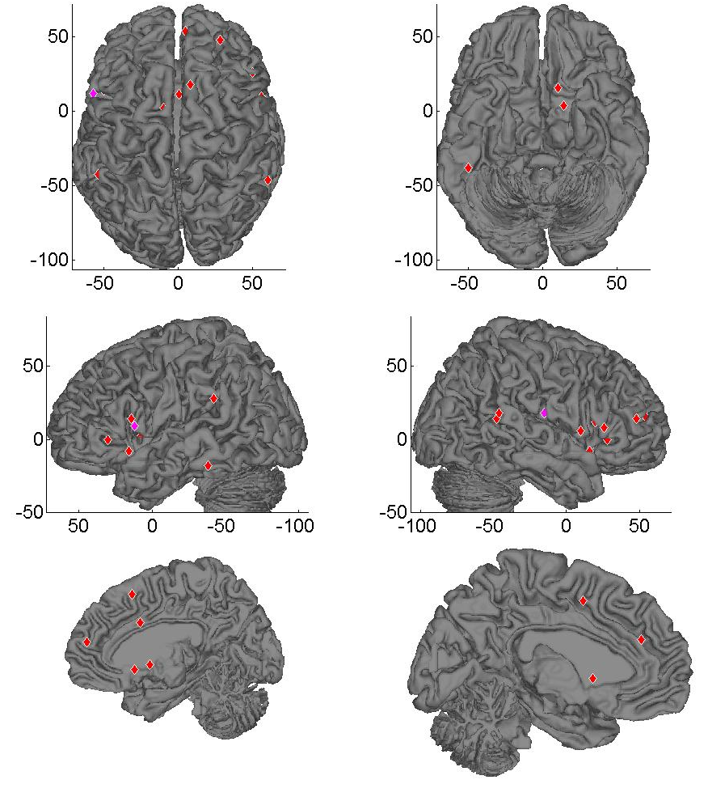
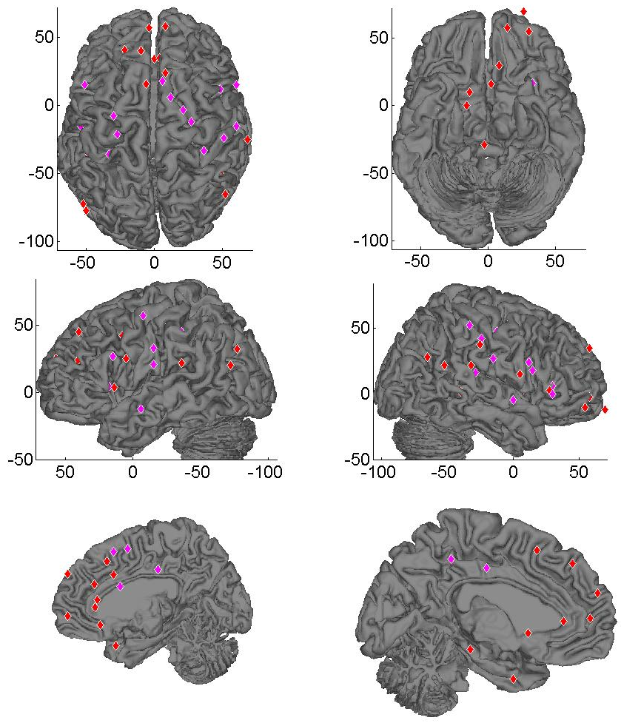
Figure 3. PP < HC PP > HC

Colour coding: pink = affective response, red = pain

