Supplementary Text:

Additional task details
Subjects were given written and verbal instructions prior to scanning. During encoding, 72 images comprising 36 images depicting emotionally neutral scenes and 36 depicting emotionally positive scenes were presented. A further matched 72 images were selected as distracters for post-scan testing. For the post-scan recognition test participants were shown 144 slides on a laptop computer (72 old items and 72 new distracters) and were asked to indicate whether the images were ‘recognised’ or ‘not recognised’ by pressing the appropriate button.
The selection of old and new images and the order of presentation were counterbalanced across subjects. Subjects completed two runs of the task each comprising 3 emotion blocks, 3 neutral blocks (25s duration each) and 7 interleaved blocks of the baseline (12.5s duration).
For the positive stimuli the mean normative control ratings for emotional valence (scored from 1 to 9 for most positive) and emotional arousal (scored from 1 minimum to 9 maximum) were: 7.30 (standard deviation, SD = 0.52) and 5.72 (SD = 0.62) for set 1, and 7.12 (SD = 0.49) and 5.67 (SD = 0.62) for set 2. Emotional valence and emotional arousal ratings for the neutral scenes were 5.05 (SD = 0.47) and 3.07 (SD = 0.49) for set 1 and 5.14 (SD = 0.50) and 3.01 (SD = 0.59) for set 2.

Scanning procedure
Imaging was carried out at the Brain Research Imaging Centre (BRIC) for Scotland on a GE 1.5 T Signa scanner (GE Medical, Milwaukee, USA). The imaging protocol consisted of a localizer scan, followed by a T2-weighted fast spin-echo sequence, two functional imaging paradigms (only one of which will be described here), and finally a structural T1 weighted sequence. Axial gradient-echo planar images (EPI) (TR/TE = 2500/40ms; matrix = 64 x 64; field of view (fov) = 24 cm) were acquired continually over two runs. Thirty contiguous interleaved 5-mm slices aligned to the anterior and posterior commissure were acquired within each TR period. Each acquisition consisted of 99 volumes, of which the first four volumes were discarded. The T1 sequence yielded 128 contiguous 1.2 mm coronal slices (matrix = 192 x 192; fov = 24 cm; flip angle 8°).

Supplementary Tables and Figures:

Supplementary Table S1 p values for pair-wise comparisons of trait-related variables

Variable | Controls v HR Well | Controls v HR MDD | HR Well v HR MDD
HAM-D | n/s | 0.007 | 0.002
Cyclothymia | n/s | 0.001 | <0.001
Depression | n/s | 0.013 | 0.003
Irritability | n/s | 0.017 | 0.072
Hyperthymia | 0.041 | n/s | n/s
Neuroticism | n/s | <0.001 | <0.001
Conscientious | n/s | 0.004 | n/s

Supplementary Table S2 Analysis of potential confounders

 | P value |  |  |  | K_{E} |  |  |  |  | Z |  |  |  | Co-ords |  |  |  | Region
- Diagnostic status at time of scan
 |  | Removing related individuals
 |  | Emotion versus baseline
 |  | HR well < HR MDD
 | 0.047 |  |  |  |  |  | 23 |  |  |  | 3.53 |  |  |  |  | -6 -6 10 |  |  |  |  |  | L thalamus
 | 0.046 |  |  |  |  |  | 24 |  |  |  | 3.68 |  |  |  |  | 10 -24 16 |  |  |  |  |  | R thalamus
 |  | Neutral versus baseline
 | C < HR MDD
 | 0.053 |  |  |  |  |  | 17 |  |  |  | 3.26 |  |  |  |  | -8 -8 8 |  |  |  |  |  | L thalamus
 | 0.061 |  |  |  |  |  | 11 |  |  |  | 3.39 |  |  |  |  | 10 -8 14 |  |  |  |  |  | R thalamus
 | HR Well < MDD
 | 0.015 |  |  |  |  |  | 105 |  |  |  | 4.49 |  |  |  |  | 10 -24 16 |  |  |  |  |  | R thalamus
 | 0.051 |  |  |  |  |  | 19 |  |  |  | 3.29 |  |  |  |  | -6 -8 10 |  |  |  |  |  | L thalamus
 | Removing medicated individuals
 | Main effect of group: Emotion versus baseline
 | HR well < HR MDD:
 | 0.043 |  |  |  |  | 28 |  |  | 3.70 |  |  |  |  |  | -4 -8 10 |  |  |  |  |  | L thalamus
 | Main effect of group: Neutral versus baseline
 | C < HR MDD:
 | n/s |  | - |  |  |  |  | - |  |  |  | - |  |  |  |  |  |  | -
 | HR Well < MDD:
 | 0.049 |  |  | 20 |  |  |  |  | 3.80 |  |  |  | 12 -24 16 |  |  |  |  |  |  |  |  |  | R thalamus
 | Controlling for age and gender
 | Main effect of group: Emotion versus baseline
 | HR well < HR MDD:
 | 0.045 |  |  |  |  | 26 |  |  | 3.58 |  |  |  |  |  | -4 -8 10 |  |  |  |  |  | L thalamus
 | Main effect of group: Neutral versus baseline
 | C < HR MDD:
 | 0.038 |  |  |  |  | 35 |  |  | 3.39 |  |  |  |  |  |  |  | -6 -8 8 |  |  |  | L thalamus
 | HR Well < MDD:
 | 0.021 |  |  | 75 |  |  |  |  | 4.19 |  |  |  | 12 -24 16 |  |  |  |  |  |  | R thalamus
 | Removing subsequently ill individuals
 | Main effect of group: Emotion versus baseline
 | HR well < HR MDD:
 | 0.040 |  |  |  |  | 33 |  | 3.69 |  |  |  |  |  | -4 -8 10 |  |  |  |  | L thalamus
 | Main effect of group: Neutral versus baseline
 | C < HR MDD:
 | n/s |  | - |  |  |  |  | - |  |  |  | - |  |  |  |  |  |  | -
 | HR Well < MDD:
 | 0.045 |  |  | 26 |  |  |  |  | 3.72 |  |  |  | 12 -24 16 |  |  |  |  |  |  | R thalamus
 | - Predictors of illness
 | Controlling for age and gender
 | Main effect of group: Emotion versus Neutral
 | HR well < HR subsequ ill:
 | 0.014 |  |  |  |  | 116 |  |  | 3.56 |  |  |  |  |  | -12 -14 12 |  |  |  |  |  | L thalamus
 | 0.039 |  |  |  |  | 92 |  |  | 3.62 |  |  |  |  |  | 44 16 0 |  |  |  |  |  | R insula
 | 0.009 |  |  |  |  | 195 |  |  | 3.71 |  |  |  |  |  | 6 26 16 |  |  |  |  |  | R anterior cingulate

Supplementary Table S3 Demographic, behavioural and clinical variables for groups separated into HR Well and HR who subsequently become ill.

 | HR Well (n=39) |  |  |  |  | HR Subqu ill (n=11) |  | Significance
 | Mean/median |  |  |  | St dev/ IQR | Mean/median | St dev/ IQR | F/χ² (P value)
Demographics
Mean age (yrs) |  | 23.52 |  | (2.56) |  | 23.80 | (3.75) | 0.06 (0.95)
Gender (M:F) |  | 22:17 |  | - |  | 5:6 | - | 0.41 (0.52)
Handedness (R:Other) |  | 34:5 |  | - |  | 9:2 | - | 0.26 (0.46)
Mean NART IQ |  | 112.39 |  | (7.34) |  | 112.40 | (5.81) | 0.004 (0.99)
Clinical measures*
YMRS |  | 0.00 |  | (0.75) |  | 0.00 | (1.50) | 0.84 (0.40)
HAM-D |  | 1.00 |  | (2.00) |  | 2.00 | (7.00) | 0.17 (0.07)
Within scanner behavioural measures
Accuracy |  | 0.72 | (0.12) |  |  | 0.72 | (0.11) | 0.25 (0.98)
Reaction time |  | 1531 | (323) |  |  | 1493 | (294) | 0.27 (0.98)
Post-scan behavioural measures
Recognition Accuracy* (Emotion) |  | 0.78 | (0.15) |  |  | 0.74 | (0.25) | 0.54 (0.59)
Recognition Accuracy* (Neutral) |  | 0.71 | (0.16) |  |  | 0.65 | (0.20) | 0.94 (0.35)
Emotional Modulation |  | 0.07 | (0.10) |  |  | 0.09 | (0.16) | 0.51 (0.61)
Reaction time (Emotion)(ms) |  | 1267 | (329) |  |  | 1300 | (194) | 0.31 (0.76)
Reaction time (Neutral)(ms) |  | 1229 | (258) |  |  | 1228 | (168) | 0.02 (0.99)
Temperament and personality measures*: (TEMPS-A)
Cyclothymia |  | 1.00 |  | (2.00) |  | 4.00 | (3.25) | 2.94 (<0.01)
Depressive |  | 0.00 |  | (1.00) |  | 1.00 | (3.00) | 1.68 (0.09)
Irritability |  | 1.00 |  | (2.00) |  | 1.00 | (3.50) | 0.75 (0.45)
Hyperthymia |  | 1.50 |  | (2.00) |  | 2.50 | (2.25) | 2.04 (0.04)
Anxious |  | 0.00 |  | (1.00) |  | 1.00 | (1.25) | 0.56 (0.57)
Total score |  | 6.00 |  | (5.00) |  | 10.00 | (8.75) | 3.05 (<0.01)
NEO – Five Factor Inventory:
Neuroticism |  | 18.00 |  | (9.00) |  | 28.00 | (17.00) | 1.86 (0.06)
Extraversion |  | 28.00 |  | (9.00) |  | 30.00 | (5.00) | 0.18 (0.86)
Openness |  | 30.00 |  | (8.00) |  | 28,00 | (11.75) | 0.26 (0.79)
Agreeableness |  | 34.00 |  | (7.50) |  | 31.00 | (5.75) | 1.79 (0.07)
Conscientious-ness |  | 30.00 |  | (13.50) |  | 25.50 | (12.25) | 0.99 (0.32)

Supplementary Figure S1 Post scan behaviour

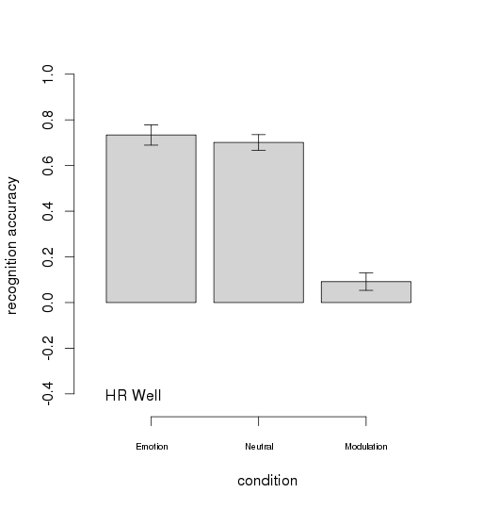
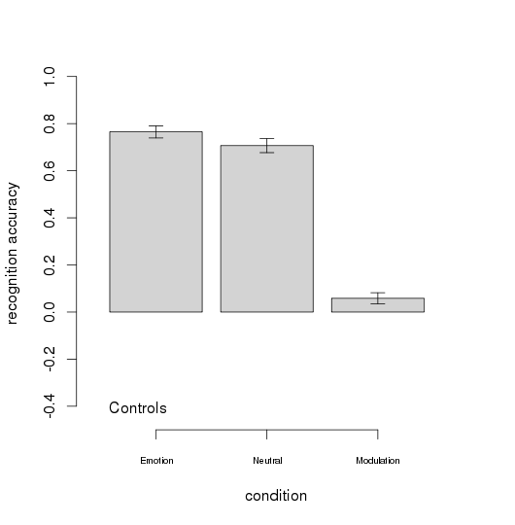

Supplementary Figure S2 Condition effects: emotional versus neutral scenes across groups

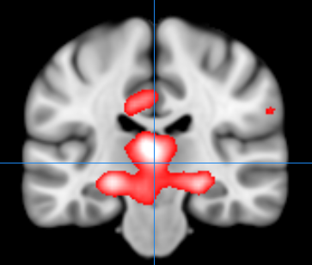

Depicts increased activation across groups in the bilateral medial temporal regions and thalamus for the contrast of emotional scenes versus neutral, see table for full results. For all figures images are overlaid onto standard brain in MNI space using Mango software package (http://ric.uthscsa.edu/mango). Map represents T-statistic images thresholded equivalent to p=0.001 uncorrected and significant clusters corrected for cluster-level significance are presented in Table 2, see methods for further details.

