Supplementary Chart 1: Details results of patient recruitment.

Cases matched for gender, age, diagnosis individually (n = 296)

Interviewed (n = 110)
Interviewed (n = 104)
Deceased
(n = 7)
Refused
(n = 17)
Failed tracing
(n = 14)
Deceased
(n = 16)
Refused
(n = 12)
Failed tracing
(n = 16)
Received early intervention program (EASY) (n = 148)

Received standard care treatment (SC) (n = 148)

Figure 1. Kaplan-Meier Survival analysis of time to first relapse comparing SC and EI group

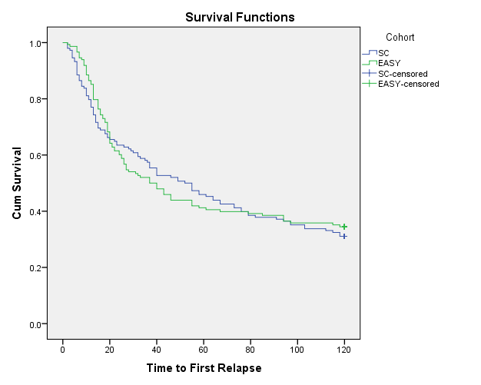
SC: standard care; EI: early intervention

