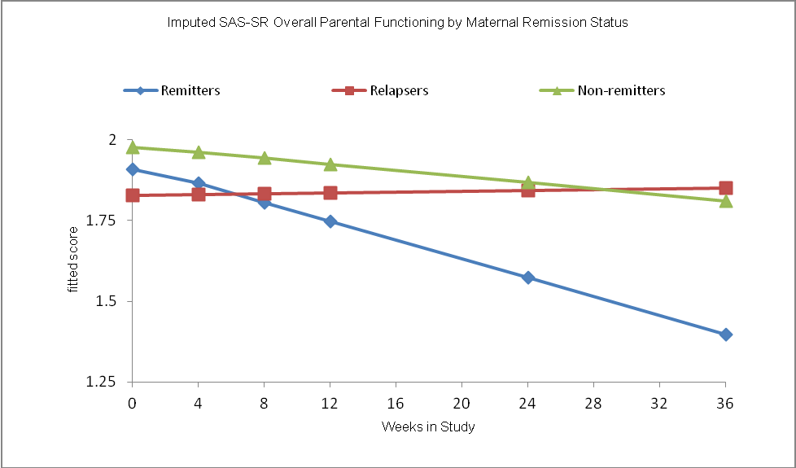
Table S1. Characteristics of Mothers and Children by Completion Status
 | Completed study | Dropped out
Characteristic | (n = 67) | (n = 9) | Statistica
Mother
Age, mean (SD) | 41 (6.4) | 37.6 (5) | 2.44
Education, n (%)
Some High School or Less | 15 (22.4) | 0 (0) | 5.2
High School Graduate | 14 (20.9) | 4 (44.4)
Some College | 18 (26.9) | 1 (11.1)
College Graduate + | 20 (29.9) | 4 (44.4)
Ethnicity, n (%)
White | 32 (47.8) | 5 (55.6) | 0.71
Hispanic | 31 (46.3) | 3 (33.3)
Otherb | 4 (6) | 1 (11.1)
Marital status, n (%)
Married with Spouse | 28 (41.8) | 5 (55.6) | 0.61
Single/Divorced/Separated | 39 (58.2) | 4 (44.4)
Employment Status, n (%)
Employed Full-time/Part-time | 35 (52.2) | 7 (77.8) | 5.76
Homemaker | 3 (4.5) | 0 (0)
Fulltime Student/Unemployed | 23 (34.3) | 0 (0)
Other | 6 (9) | 2 (22.2)
Receiving Public Assistance, n (%) | 27 (40.3) | 1 (11.1) | 3.01
Household Income, n (%)
Under $15K | 24 (35.8) | 2 (22.2) | 3.13
$15-39K | 12 (17.9) | 0 (0)
Over $40K | 29 (43.3) | 6 (66.7)
Children Per Family, mean (SD) | 1.8 (0.9) | 1.6 (1) | 0.55
Clinical Characteristics
HAMD17, mean (SD)  MDD Severity (current), n (%)c | 21.8 (4.5) | 21.7 (3.9) | 0.01
Mild | 3 (4.5) | 1 (11.1) | 0.71

Moderate | 23 (34.3) | 3 (33.3)
Severe | 41 (61.2) | 5 (55.6)
Any Anxiety Disorder, n (%) | 23 (34.3) | 4 (44.4) | 0.35

Child (n = 121) (n = 14)

Age, mean (SD)  Living Status, n (%) | 11.9 (3.4) | 11.6(2.9) | 0.05
Two Parent Householdd | 66 (54.5) | 11 (78.6) | 2.96
Mother Only | 55 (45.5) | 3 (21.4)
Female, n (%) | 54 (44.6) | 8 (57.1) | 0.79
Children Education, n (%)
Grade 1-6 | 57 (47.1) | 7 (50) | 0.04
Above 6th Grade | 64 (52.9) | 7 (50)
Ever received treatment, n (%) | 31 (25.6) | 3 (21.4) | 0.12
* p<0.05, ** p<0.01

Note. Numbers vary due to missing data. HAMD17 = Hamilton Rating Score for Depression 17- item; MDE = Major Depressive Episode; MDD = Major Depressive Disorder.

at statistic for age comparisons, and chi-square statistic or Fisher’s exact test for all other
comparisons.

bIncludes 2 African Americans, 1 American Indian, 1 parent who identified as more than 1 race, and 1 unknown

cSeverity defined as mild: HAMD17<14, moderate: 14≤HAMD17≤21, severe: HAMD17≥22

dIncludes any combination of biological, adopted, or step mother and father

