Supporting material
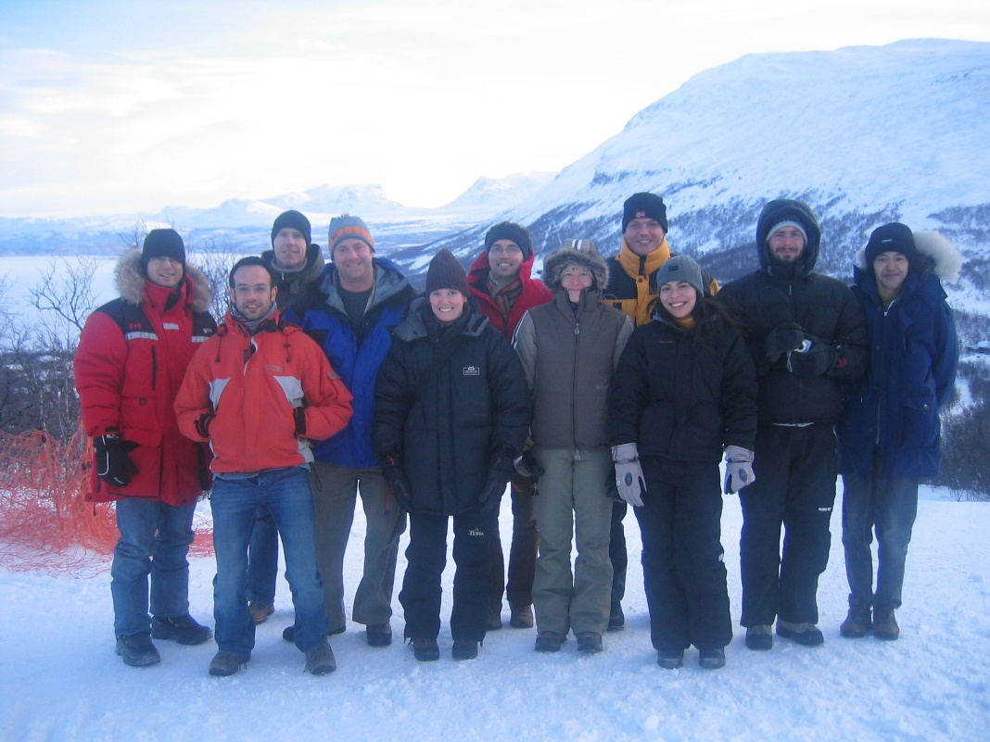
Figure S1. The national representatives that participated at the Permafrost Young Researchers Network Kick-off meeting in Abisko, Sweden from 22-24 February 2007. From left to right: Tim Haltigin (Canada), Hugues Lantuit (Germany), Håvard Juliussen (Norway), Andrew Balser (USA), Margareta Johansson (Sweden), Etienne Cossart (France), Cecile Menard (UK), Michael Avian (Austria), Raquel Melo (Portugal), Pablo Wainstein (Canada), and Tetsuo Sueyoshi (Japan).
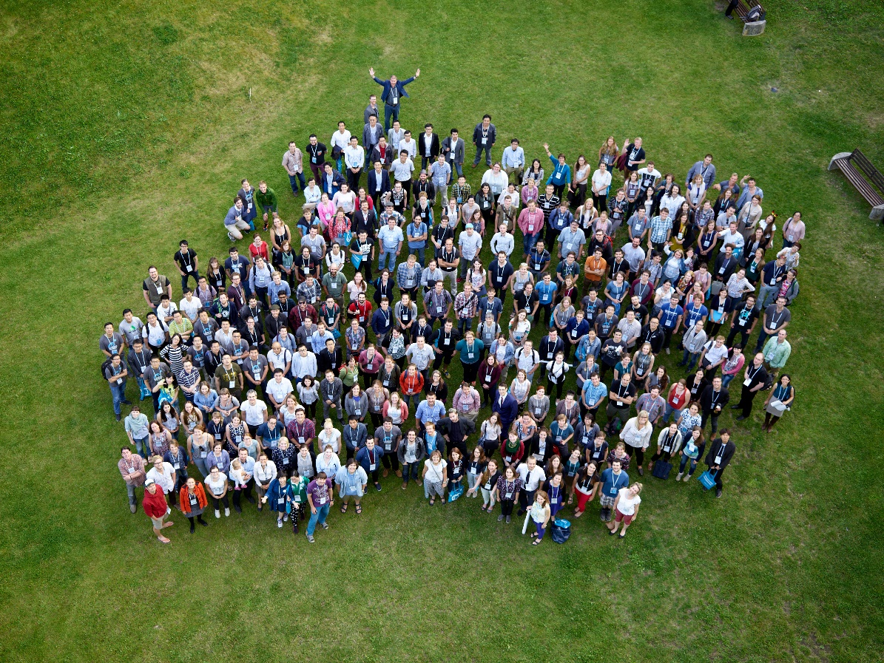
Figure S2. Largest recent PYRN gathering with approximately 280 people at the 11th International Conference on Permafrost (ICOP 2016) in Potsdam, Germany from 22-24 June 2016 (photo credit: Jan Pauls).

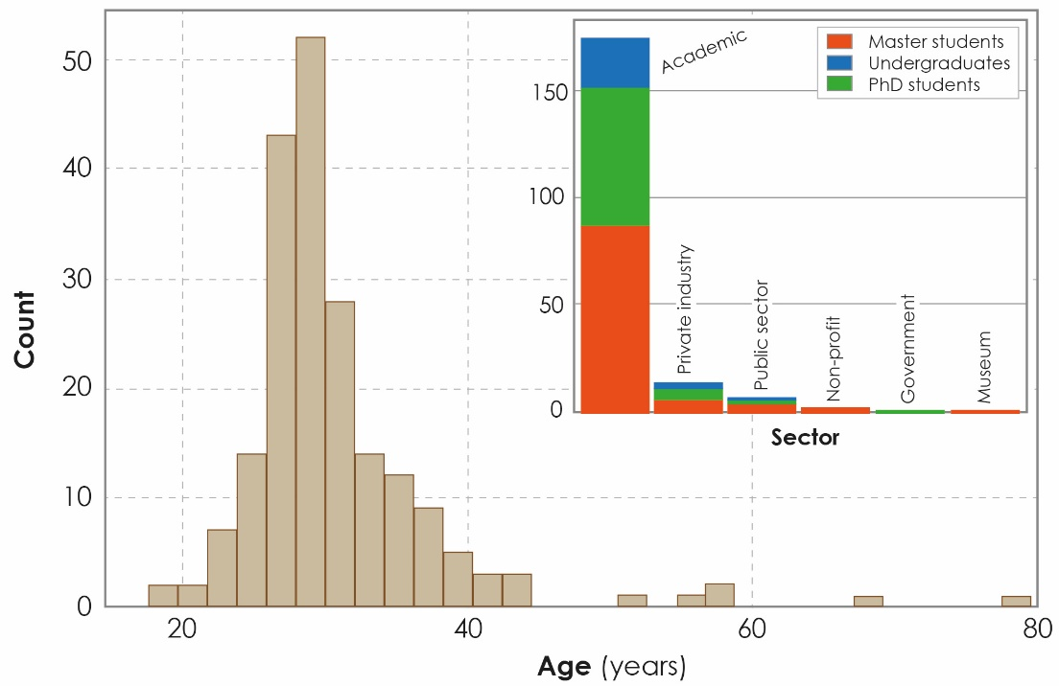
Figure S3. Bar chart showing the distribution of PYRN members by age, and stacked bar-chart showing the distribution of PYRN members by work sector and highest degree completed (n = 200). The charts only show PYRN members that participated in the online survey.

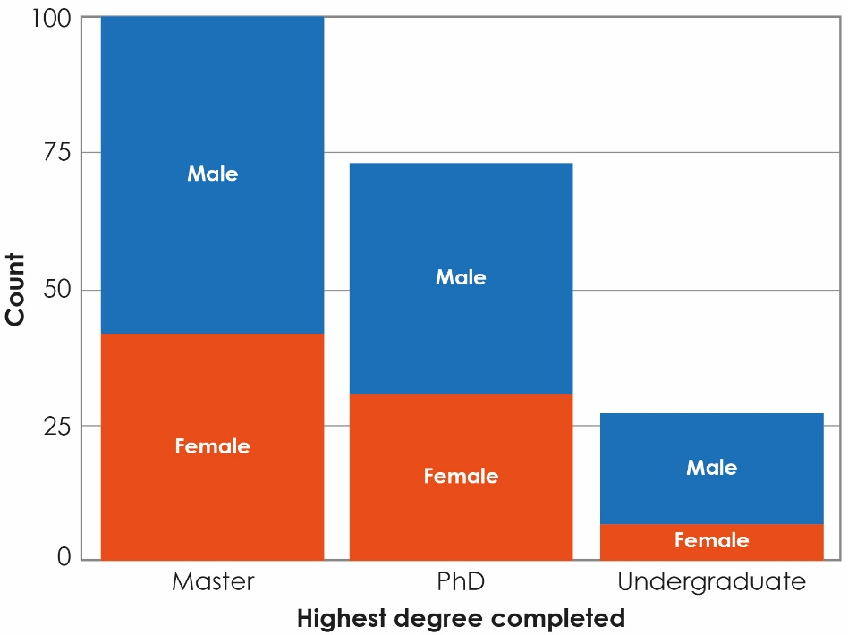
Figure S4. Stacked bar-chart showing the distribution of PYRN members by gender and highest degree completed (n = 200). The chart only shows PYRN members that participated in the online survey.

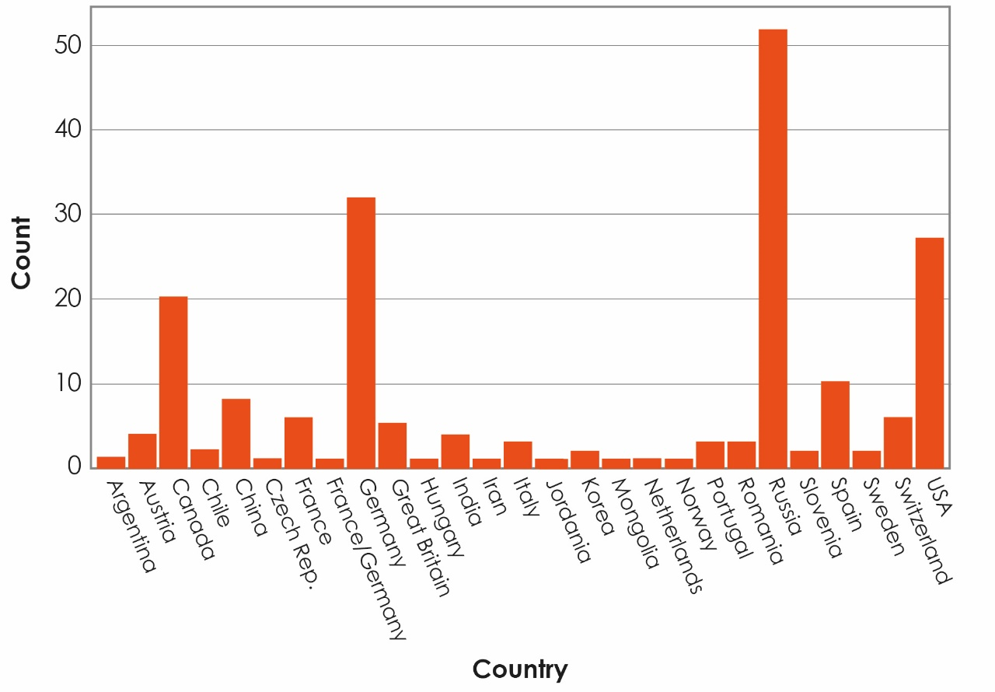
Figure S5. Bar-chart showing the distribution of PYRN members by country (n = 200).
The chart only shows PYRN members that participated in the online survey.

Table S1. Summary of the major activities and events that PYRN co-organized since 2005; see note below the table for list of co-organizing or supporting partners and Table S3 for the definition of abbreviation.
Activity / Event | Date and Year
Establishment of PYRN at ICARP II in Copenhagen, Denmark | 10-12 November 2005
First PYRN awards at the 1st ACOP in Lanzhou, China | 7-16 August 2006
PYRN Kick-off meeting in Abisko, Sweden | 22-24 February 2007
OSL-APECS-PYRN workshop in St. Petersburg, Russia | 29 November - 2 December 2007
Launch of PYRN-TSP project | 2007 and following years
PYRN awards and side events at NICOP 2008 in Fairbanks, Alaska | 28 June-3 July 2008
USPA-PYRN awards at AGU 2008 in San Francisco, USA | 15-19 December 2008
PYRN social event at EGU 2009 in Vienna, Austria | 19-24 April 2009
USPA-PYRN awards and forum at AGU 2009 in San Francisco, USA | 14-18 December 2009
APECS-PYRN workshop at AGU 2010 in San Francisco, USA | 13-17 December 2010
PYRN workshop and awards at TICOP in Salekhard, Russia | 25-29 June 2012
IPA-PYRN TICOP summer school, Polar Ural Mountains, Russia | June / July 2012
PYRN awards at the IV Iberian conference of IPA in Vall de Núria, Spain | 25-27 July 2013
Third forum for young permafrost scientists in Yakutsk, Russia | 24-27 June 2013
PYRN-APECS workshops at EGU 2014 in Vienna, Austria | 27 April - 2 May 2014
PYRN workshop, awards, and side events at EUCOP4 in Évora, Portugal | 18-21 June 2014
PYRN-APECS-ASA social events at Arctic Change in Ottawa, Canada | 8-12 December 2014
PYRN workshop / course at EGU 2015 in Vienna, Austria | 12-17 April 2015
APECS-PYRN panel discussion at the IGU 2015 in Moscow, Russia | 17-21 August 2015
PYRN awards at GeoQuébec 2015 in Québec City, Canada | 20-23 September 2015
ASA-PYRN events at ArcticNet 2015 in Vancouver, Canada | 7-11 December 2015
USPA-PYRN social event at AGU 2015 in San Francisco, USA | 14-18 December 2015
Note. Events and meetings were co-organized or supported by the following partners: IPA, ASA, USPA, PEI, CliC, IASC, GTN-P, Russian Academy of Sciences, Permafrost working group of the Deutsche Gesellschaft für Polarforschung, the Bolin Centre for Climate Reseasrch, and various large research projects such as Nunataryuk, PAGE21, and ADAPT.

Table S1 (continued).
Activity / Event | Date and Year
PYRN workshop and awards at ICOP 2016 in Potsdam, Germany | 20-24 June 2016
PYRN Russia Workshop on Yamal Crater Studies in Moscow, Russia | 16 December 2016
PYRN D-A-CH at the 9th permafrost meeting in Einsiedeln, Switzerland | 9-11 February 2017
PYRN workshop / course and social event at EGU 2017 in Vienna, Austria | 8-13 April 2017
Students in Polar and Alpine Research Conference 2017 in Brno, Czech Rep. | 20-22 April 2017
PYRN event at Earth's Cryosphere Conference in Pushchino, Russia | 4-8 June 2017
PYRN workshop at VI Congreso Ibérico de la International in Mieres, Spain | 21-23 June 2017
PYRN awards and social events at ACOP 2017 in Sapporo, Japan | 2-6 July 2017
PYRN Discussion Panel at AGU 2017 in New Orleans, USA | 11-15 December 2017
PYRN Discussion Panel at OCSNRS 2018 in Sherbrooke, Canada | 15 February 2018
PYRN Discussion Panel at CEN Colloque 2018 in Sherbrooke, Canada | 15-16 February 2018
PYRN workshop, awards, and side events at EUCOP5 in Chamonix, France | 23 June - 1 July 2018

Table S2. Summary of answers from the PYRN membership survey in 2015. Answers (n = 200) refer to mean index values ranging from 1 to 5 with 1 being more and 5 being less important.
Question (How important is/are…?) | Answer
Information about conferences and meetings | 2.4
Offering workshops | 2.6
Information about funding | 2.7
Job postings | 2.7
Pointing out funding opportunities | 2.7
Advertising conferences and meetings | 2.8
News about permafrost-related issues | 2.8
Exchange with young researchers | 2.9
Offering social events | 3.0
More information and news | 3.1
More education and outreach | 3.2
Access to literature, pictures, and videos | 3.3
Activities in social media; YouTube, Twitter | 3.6

Table S3. List of abbreviations and definition.
Abbreviation | Definition
ACOP | Asian Conference on Permafrost
ADAPT | Arctic Development and Adaptation to Permafrost in Transition
AGU | American Geophysical Union
APECS | Association of Polar Early Career Scientists
ASA | ArcticNet Student Association
CliC | Climate and Cryosphere
CNS | Centre d'excellence en Neurosciences de l'Université de Sherbrooke
EGU | European Geosciences Union
EUCOP4 | 4th European Conference on Permafrost
EUCOP5 | 5th European Conference on Permafrost
GTN-P | Global Terrestrial Network on Permafrost
IASC | International Arctic Science Committee
ICARP | International Conference on Arctic Research Planning
ICOP | International Conference on Permafrost
IPA | International Permafrost Association
IPY | International Polar Year
NICOP | Ninth International Conference on Permafrost
OCSNRS | Ottawa-Carleton Student Northern Research Symposium
OSL | Otto Schmidt Laboratory for Polar and Marine Research
PAGE21 | Changing Permafrost in the Arctic and its Global Effects in the 21st Century
PEI | Polar Educators International
PYRN | Permafrost Young Researchers Network
TICOP | Tenth International Conference on Permafrost
TSP | Thermal State of Permafrost
USPA | United States Permafrost Association

