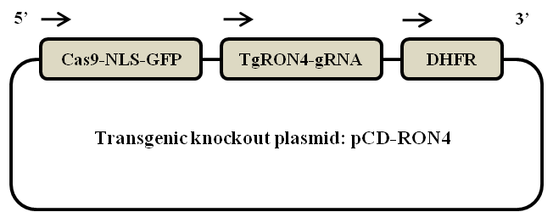
Supplementary Fig. 1 Schematic diagram of the pCD-RON4.

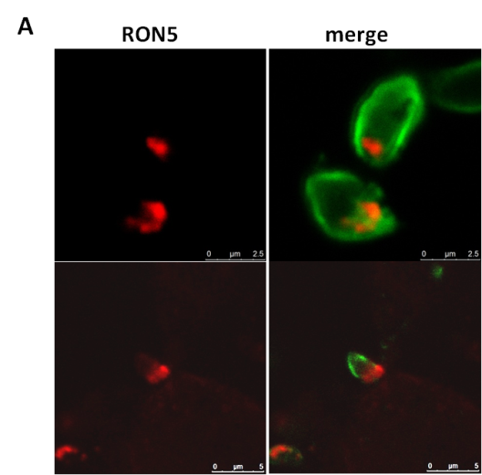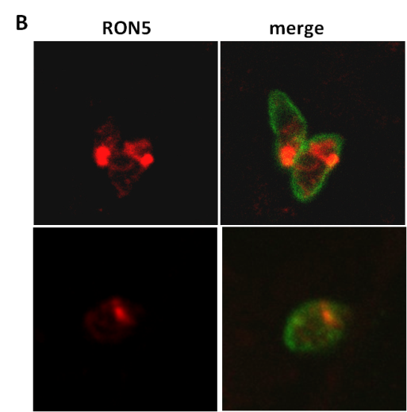

Supplementary Fig. 2 Localization of TgRON5 in wild-type parasites (A) and TgRON4-deficient parasites (B). Red: mouse anti-RON5 antibody detected by Alexa647-anti-mouse IgG. Green: rabbit anti-SAG2 antibody detected by Alexa488-anti-rabbit IgG.

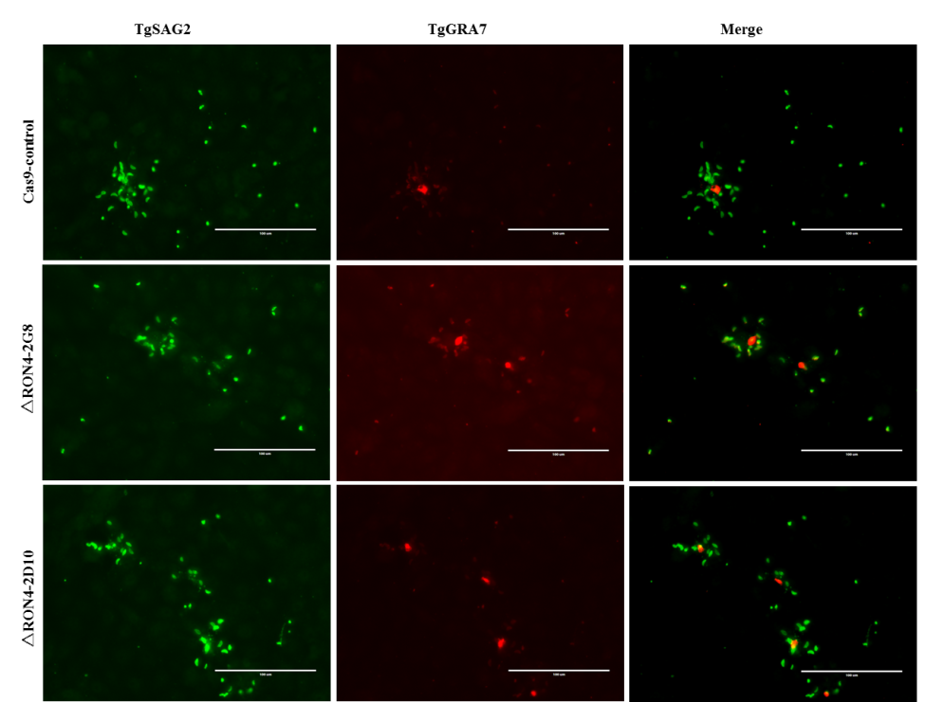
Supplementary Fig. 3 Representative view of egress assay. Red: mouse anti-GRA7 antibody detected by Alexa647-anti-mouse IgG. Green: rabbit anti-SAG2 antibody detected by Alexa488-anti-rabbit IgG.

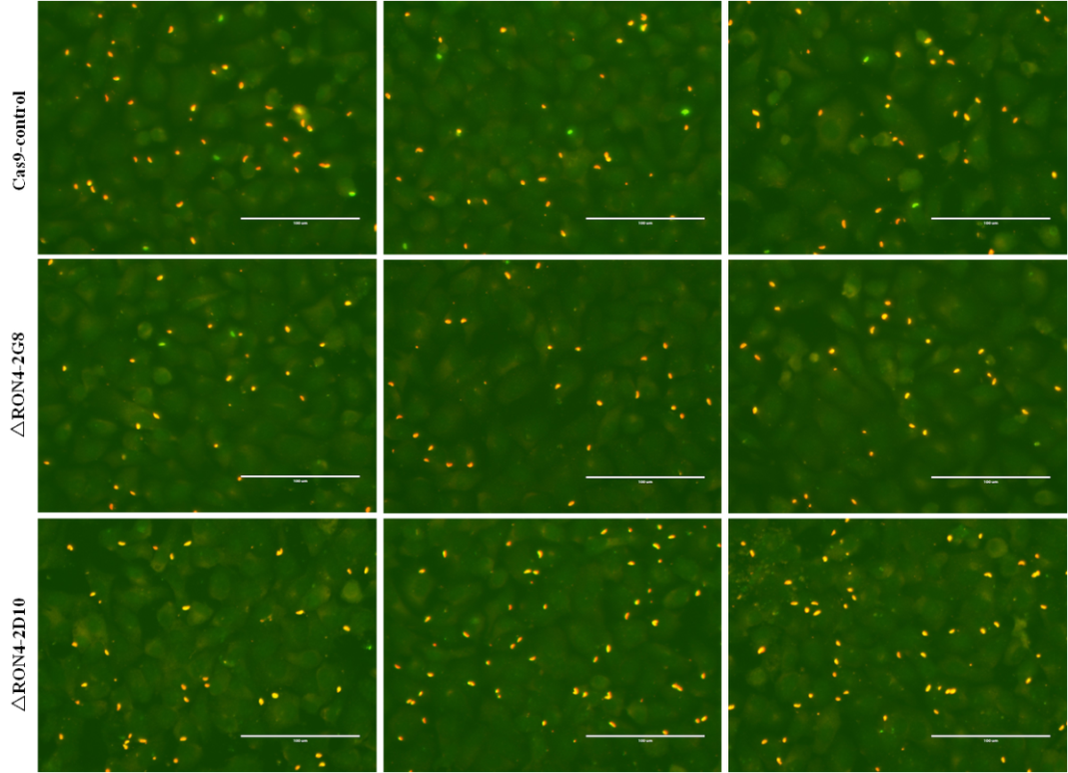
Supplementary Fig. 4 Representative view of invasion assays. Red: rabbit anti-SAG2 antibody detected by Alexa647-anti-rabbit IgG. Green: rabbit anti-SAG2 antibody detected by Alexa488-anti-rabbit IgG.

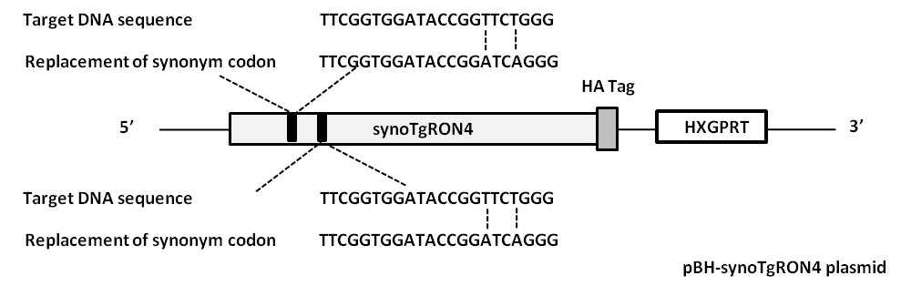
Supplementary Fig. 5 Schematic diagram of the TgRON4 complementary expression plasmid

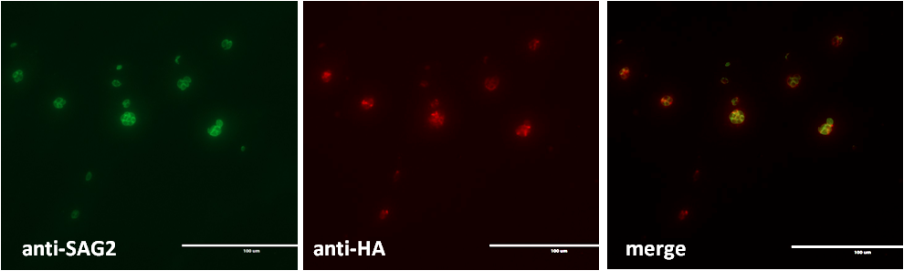
Supplementary Fig. 6 IFAs analysis of complement synoTgRON4 in TgRON4-deficient strains. Green: rabbit anti-SAG2 antibody detected by Alexa488-anti-rabbit IgG. Red: mouse anti-HA antibody detected by Alexa594-anti-mouse IgG.

Table S1. Primers utilized in this study
All primers are in the 5’-3’ orientation.
Name | Primer Sequence
Cas9-control Forward | CCACTAGTTCTAGAGCGGCCGTTTAAACGAGCTCCAAGTAAGCAGAAG
Cas9-control Reverse | CCGTATTACCGCCTTTGAGTGTTTAAACGAGCTGATACCGCTCGCC
ROP16 Forward | CTTTCACCCTCGCATCT
ROP16 Reverse | ACGATGGGACGCTGTAT
Actin Forward | GCGCGACATCAAGGAGAAGC
Actin Reverse | CATCGGGCAATTCATAGGAC
rRON4t- Forward | GATCTGGTTCCGCGTGGATCCAGTCCGCCAACGCCTGCT
rRON4t- Reverse | GTCACGATGCGGCCGCTCGAGTCAAGAAGCAGTTTTCTG
rRON5t- Forward | GATCTGGTTCCGCGTGGATCCGGCAACCTAGTATGTG
rRON5t- Reverse | GTCACGATGCGGCCGCTCGAGCAGATTGTGTCTCGGG
P1 | TTAACGCGTAAAATGTTTGCTTGCCAACAG
P2 | CCAGCTTACCTTCCTGAGTTTGTCGAAGTT
P3 | CAGCTGCTTCATCACTTTGTCGTC
P4 | CATCTTCCGCACGTCGTACACCTT
P5 | CCACCCCGGTGAACAGCTCCTCGC
P6 | GGATCGATCCCCCGGGCTGCAGGA

