Unsustainable Harvest of Water Frogs in Southern Turkey for the European Market
Supplementary File: Questionnaire directed to the harvesters
We interviewed 22 harvesters during our fieldwork. They told us about their incomes, harvesting routines, frog numbers they harvest in a regular night and prices that the companies offer. Questions aimed to understand their livelihood and the routines of a harvest night.

Questions asked:
- How much of your income comes from frog harvesting? How many people are there in your harvest group? And how many of you have a harvest license?
- How many frogs do you capture in one night?
- How much do the companies offer you for one kilo of frogs?
- How do you preserve the captured frogs until you sell them to the company?

Answers:
- Frog harvesting is a main livelihood for some and an additional income source for the others. For those who harvest frogs as an extra job, are seasonal farming workers. They don’t have a regular income and have to move from field to field by reason of the season and the agricultural product (cotton, watermelon, eggplant, parsley, citrus etc.). They hunt with a group of 3-4 harvesters. And only one of them has a license.
- One harvester collects 30 kgs of frogs averagely per night. So, the group manages to harvest 90-120 kgs of frogs per night.
- Companies offer them 1-2 USD per kilo. But in the winter prices go up (2-3 USD/kg), due to the decreasing numbers of frogs.
- Harvesters keep the frogs in air-permeable soft fabric bags. They need to keep the frogs alive since the export companies do not except dead individual. Therefore, harvesters keep a bag of 3-4 kgs in a cool place.

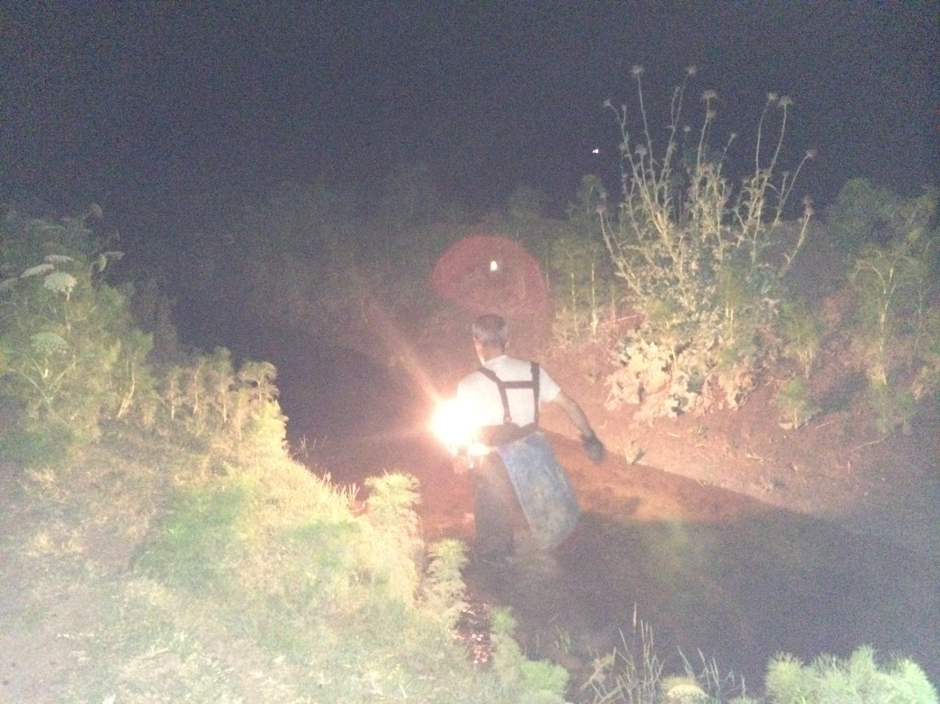
Figure 1. A harvester collects frogs in Adana, Turkey (2015, Photo by Kerim Çiçek)

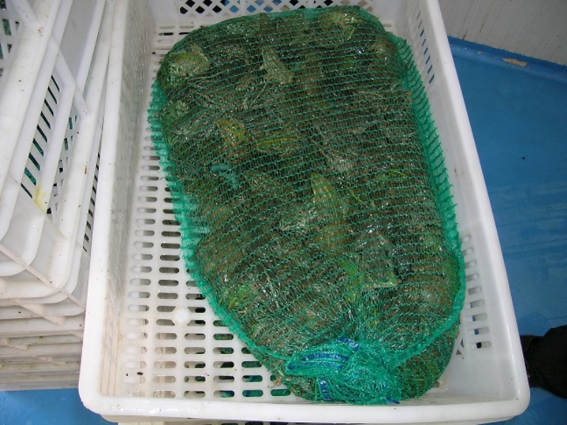
Figure 2. The frogs are kept in air-permeable soft fabric bags in Adana, Turkey (2014, Photo by Kerim Çiçek)
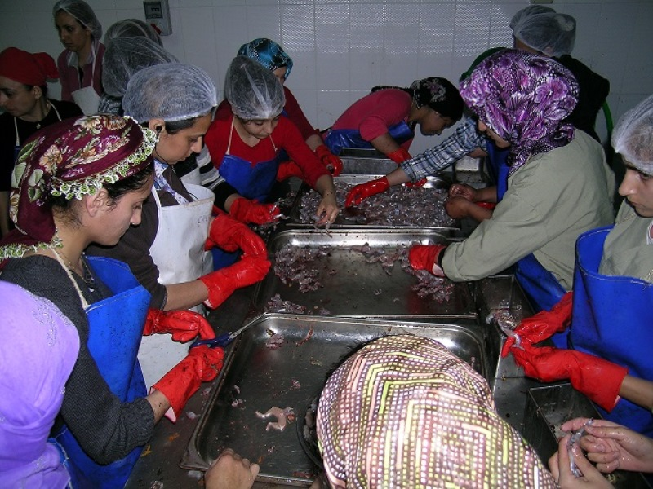
Figure 3a. A company is processing the frogs for market in Adana, Turkey (2014, Photo by Kerim Çiçek)

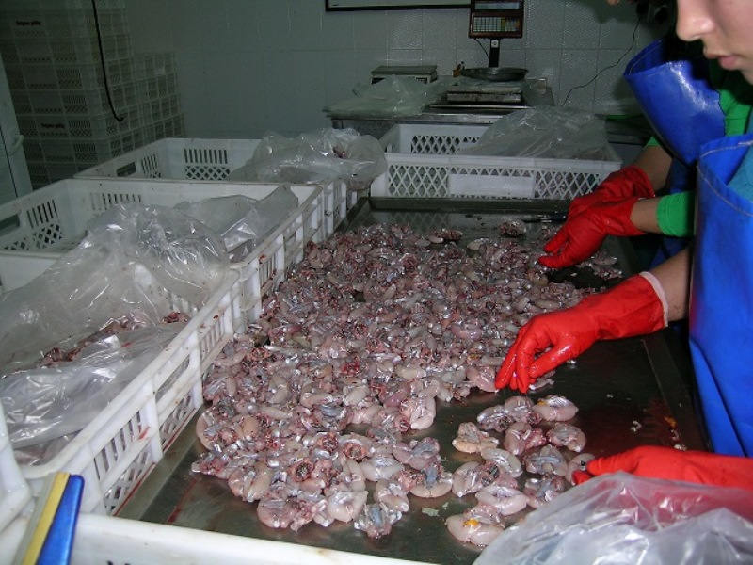
Figure 3b. A company is packing the frogs for market in Adana, Turkey (2014, Photo by Kerim Çiçek)

