Priority areas for jaguar Panthera onca conservation in the Cerrado
Marina Peres Portugal, Ronaldo Gonçalves Morato, Katia Ferraz Flávio Henrique Guimarães Rodrigues and Claudia Maria Jacobi

Supplementary Table 1 Occurrence records of the jaguar Panthera onca in the Cerrado of Brazil for 2000–2009, from the National Predators Research Center (Desbiez et al., 2013), used in species distribution modelling (coordinates are based on SAD69).
ID | Coordinates
1 | 13°36'57" S, 58°37'55" W
2 | 15°39'14" S, 57°11'50" W
3 | 15°17'54" S, 55°53'09" W
4 | 15°30'24" S, 55°15'26" W
5 | 14°37'21" S, 54°22'14" W
6 | 17°41'59" S, 53°22'17" W
7 | 22°13'20" S, 57°01'58" W
8 | 21°16'29" S, 56°41'51" W
9 | 20°49'57" S, 56°44'48" W
10 | 21°30'34" S, 53°10'20" W
11 | 21°14'51" S, 52°07'25" W
12 | 22°23'40" S, 51°08'37" W
13 | 19°02'07" S, 44°30'46" W
14 | 16°01'46" S, 43°04'59" W
15 | 14°57'03" S, 51°55'26" W
16 | 14°54'28" S, 52°16'34" W
17 | 14°23'49" S, 52°14'43" W
18 | 14°23'28" S, 51°41'09" W
19 | 9°18'35" S, 49°57'17" W
20 | 10°26'55" S, 50°06'23" W
21 | 11°10'06" S, 50°30'29" W
22 | 12°14'37" S, 50°45'12" W
23 | 12°12'41" S, 51°19'11" W
24 | 13°03'53" S, 51°16'48" W
25 | 14°59'25" S, 49°57'41" W
26 | 14°47'17" S, 51°33'32" W
27 | 14°45'47" S, 48°55'27" W
28 | 13°38'26" S, 49°49'29" W
29 | 13°52'09" S, 48°19'33" W
30 | 14°04'12" S, 47°39'17" W
31 | 13°50'05" S, 47°25'18" W
32 | 10°55'57" S, 46°45'19" W
33 | 10°24'21" S, 45°50'16" W
34 | 10°16'52" S, 46°10'54" W
35 | 8°51'47" S, 45°18'43" W
36 | 9°53'58" S, 45°30'49" W
37 | 9°04'38" S, 46°21'37" W
38 | 7°42'48" S, 46°00'22" W
39 | 7°34'29" S, 46°17'06" W
40 | 7°01'15" S, 47°02'02" W
41 | 7°00'11" S, 48°00'13" W
42 | 10°26'55" S, 48°30'18" W
43 | 12°33'18" S, 49°07'30" W
44 | 5°29'02" S, 45°14'49" W
45 | 5°45'22" S, 46°22'40" W
46 | 17°36'37" S, 53°17'27" W
47 | 18°06'27" S, 52°54'51" W
48 | 18°15'58" S, 52°53'38" W
49 | 18°04'26" S, 52°43'21" W
50 | 15°16'17" S, 45°47'16" W
51 | 14°58'33" S, 46°19'13" W
52 | 15°37'45" S, 46°25'13" W
53 | 14°33'19" S, 44°37'50" W
54 | 15°04'18" S, 44°28'06" W
55 | 16°00'40" S, 43°02'32" W
56 | 6°22'11" S, 44°53'19" W
57 | 6°28'43" S, 44°43'41" W
58 | 8°51'49" S, 43°31'54" W
59 | 3°42'02" S, 43°22'47" W
60 | 14°19'20" S, 44°22'36" W
61 | 15°07'17" S, 44°14'51" W
62 | 16°15'39" S, 46°39'58" W
63 | 17°48'36" S, 43°46'04" W
64 | 15°26'19" S, 46°37'57" W
65 | 14°25'15" S, 46°10'18" W
66 | 14°57'35" S, 45°50'43" W
67 | 14°58'39" S, 45°50'02" W
68 | 15°38'43" S, 45°38'26" W
69 | 15°00'15" S, 45°27'47" W
70 | 15°21'55" S, 45°29'30" W
71 | 14°49'45" S, 44°57'59" W
72 | 15°13'51" S, 44°58'39" W
73 | 14°49'37" S, 44°58'00" W
74 | 15°13'39" S, 44°58'36" W
75 | 14°36'08" S, 45°15'32" W
76 | 10°24'11" S, 50°05'57" W
77 | 14°01'03" S, 45°13'29" W
78 | 15°01'00" S, 44°25'56" W
79 | 10°25'42" S, 46°41'38" W
80 | 15°22'32" S, 43°57'15" W
81 | 14°47'52" S, 43°44'57" W
82 | 14°23'50" S, 43°55'34" W
83 | 14°44'31" S, 44°24'39" W
84 | 14°28'51" S, 44°28'00" W
85 | 15°02'15" S, 44°36'55" W
86 | 19°53'56" S, 57°13'33" W
87 | 19°48'58" S, 57°08'11" W
88 | 19°49'12" S, 57°01'50" W
89 | 19°57'34" S, 57°17'55" W
90 | 13°13'39" S, 51°39'33" W
91 | 14°29'53" S, 52°28'35" W
92 | 14°27'31" S, 52°24'29" W
93 | 13°51'10" S, 52°23'05" W
94 | 13°49'21" S, 52°22'22" W
95 | 13°49'27" S, 52°14'38" W
96 | 9°04'53" S, 44°21'28" W
97 | 9°34'04" S, 45°28'03" W
98 | 8°49'11" S, 44°08'44" W
99 | 9°20'39" S, 45°26'48" W
100 | 13°30'33" S, 44°27'10" W
101 | 8°55'15" S, 44°08'59" W
102 | 7°13'58" S, 44°38'28" W
103 | 11°05'34" S, 43°08'55" W
104 | 9°49'59" S, 50°10'00" W
105 | 5°49'00" S, 46°07'59" W
106 | 5°30'S S, 13'59"00" W
107 | 6°19'59" S, 45°00'00" W
108 | 7°40'00" S, 46°00'00" W
109 | 9°04'59" S, 46°10'00" W
110 | 9°55'00" S, 45°28'00" W
111 | 12°28'00" S, 49°07'00" W
112 | 7°43'00" S, 46°15'00" W
113 | 9°04'59" S, 46°04'00" W
114 | 7°32'57" S, 44°42'31" W
115 | 7°58'58" S, 45°24'53" W
116 | 7°53'20" S, 45°40'51" W
117 | 7°54'26" S, 45°42'06" W
118 | 7°57'56" S, 45°25'20" W
119 | 20°05'57" S, 56°42'40" W
120 | 20°07'01" S, 56°41'44" W
121 | 20°04'48" S, 56°42'37" W
122 | 20°06'47" S, 56°41'50" W
123 | 20°04'58" S, 56°42'58" W
124 | 20°04'27" S, 56°43'30" W
125 | 9°04'49" S, 43°24'45" W
126 | 8°55'11" S, 43°27'04" W

Supplementary Table 2 Correlation among 13[?]OK environmental variables, selected for their functional relevance for the jaguar’s occurrence. Correlated layers (P ≥ 0.5) are in bold.
Environmental variables | 1 | 2 | 3 | 4 | 5 | 6 | 7 | 8 | 9 | 10 | 11 | 12 | 13
1. EVI_rainy season | 1 | 0.738447 | 0.947235 | 0.57104 | 0.659447 | -0.10395 | -0.00249 | -0.00847 | 0.031876 | 0.044981 | -0.00889 | -0.10379 | 0.261656
2. EVI_maximum | 0.738447 | 1 | 0.645227 | 0.122897 | 0.361414 | 0.000624 | -0.00188 | -0.01581 | 0.027867 | 0.016178 | -0.05225 | 0.000669 | 0.196724
3. EVI_mean | 0.947235 | 0.645227 | 1 | 0.680397 | 0.863029 | -0.17041 | -0.00375 | -0.00394 | 0.022976 | 0.092928 | 0.025164 | -0.17023 | 0.277897
4. EVI_minimum | 0.57104 | 0.122897 | 0.680397 | 1 | 0.699701 | -0.1431 | -0.00173 | 0.003528 | 0.015421 | 0.064452 | 0.066416 | -0.14291 | 0.143673
5. EVI_dry season | 0.659447 | 0.361414 | 0.863029 | 0.699701 | 1 | -0.23679 | -0.00491 | 0.003855 | 0.004325 | 0.147276 | 0.072465 | -0.23661 | 0.243679
6. Slope | -0.10395 | 0.000624 | -0.17041 | -0.1431 | -0.23679 | 1 | 0.003793 | -0.03241 | 0.119849 | -0.15944 | -0.1389 | 0.199684 | -0.21982
7. Euclidean distance from urban areas | -0.00249 | -0.00188 | -0.00375 | -0.00173 | -0.00491 | 0.003793 | 1 | -0.00057 | 0.000445 | 0.003463 | <0.0001 | 0.003794 | 0.004458
8. Density of drainage | -0.00847 | -0.01581 | -0.00394 | 0.003528 | 0.003855 | -0.03241 | -0.00057 | 1 | -0.15937 | 0.021319 | 0.017513 | -0.0324 | 0.008836
9. Euclidean distance from water | 0.031876 | 0.027867 | 0.022976 | 0.015421 | 0.004325 | 0.119849 | 0.000445 | -0.15937 | 1 | -0.11106 | -0.03298 | 0.119837 | -0.09789
10. Mean annual temperature | 0.044981 | 0.016178 | 0.092928 | 0.064452 | 0.147276 | -0.15944 | 0.003463 | 0.021319 | -0.11106 | 1 | 0.12019 | -0.85934 | 0.244497
11. Ruggedness | -0.00889 | -0.05225 | 0.025164 | 0.066416 | 0.072465 | -0.1389 | <0.0001 | 0.017513 | -0.03298 | 0.12019 | 1 | -0.13885 | 0.027584
12. Elevation | -0.10379 | 0.000669 | -0.17023 | -0.14291 | -0.23661 | 0.199684 | 0.003794 | -0.0324 | 0.119837 | -0.85934 | -0.13885 | 1 | -0.21982
13. Mean annual rainfall | 0.261656 | 0.196724 | 0.277897 | 0.143673 | 0.243679 | -0.21982 | 0.004458 | 0.008836 | -0.09789 | 0.244497 | 0.027584 | -0.21982 | 1

Supplementary Table 3 Additional occurrence records of jaguars in the Cerrado for 2007–2017, from the National Predators Research Center, used for validation of species distribution models (datum SAD69).
ID | Coordinates
1 | 18°34'01" S, 52°56'28" W
2 | 9°21'36" S, 50°01'48" W
3 | 19°56'31" S, 56°17'46" W
4 | 9°04'26" S, 44°21'32" W
5 | 10°02'10" S, 45°41'28" W
6 | 9°18'00" S, 50°03'00" W
7 | 9°04'48" S, 43°24'47" W
8 | 18°04'44" S, 52°45'14" W
9 | 14°57'07" S, 45°45'36" W
10 | 15°15'50" S, 45°19'16" W
11 | 14°40'12" S, 45°23'02" W
12 | 19°57'04" S, 56°18'04" W
13 | 19°58'01" S, 56°16'26" W
14 | 19°55'37" S, 56°15'04" W
15 | 19°57'14" S, 56°17'42" W
16 | 22°18'54" S, 49°04'16" W
17 | 14°59'06" S, 45°47'20" W
18 | 14°56'28" S, 45°45'18" W
19 | 15°54'22" S, 48°28'41" W
20 | 16°00'25" S, 48°41'20" W
21 | 16°40'19" S, 49°22'19" W
22 | 13°25'52" S, 50°39'50" W
23 | 15°27'40" S, 47°46'16" W

Supplementary Material 1 Cerrado land-cover map update
The map was based on the map of PROBIO I (MMA, 2004a,b), updated with Landsat images for 2002. The map features 36 land-cover classes (Table 1), with a detailed description of the vegetation according to IBGE (1992). This map was updated in the project PROBIO II (MMA, 2009) for 2009. This updated map was then compared to the new human-use land cover mapped in 2010 (Bayma et al., 2011) in a geographical information system, erasing the vegetation information and updating for new human-use land cover.
Table 1 Land-cover classes in the Cerrado, Brazil.
Category | Land-cover class
Forest | Open evergreen alluvial
 | Seasonal deciduous upper plains
 | Seasonal deciduous highlands
 | Closed evergreen upper plains
 | Closed evergreen alluvial
 | Seasonal semi-deciduous lower plains
 | Seasonal semi-deciduous highlands
 | Open evergreen upper plains
 | Seasonal semi-deciduous alluvial
 | Seasonal semi-deciduous upper plains
 | Seasonal deciduous lower plains
 | Mixed evergreen highlands
Savannah with gallery forest | Forested grassland savannah
 | Shrubland savannah
 | Arboreal savannah
 | Savannah park
 | Grassland savannah
 | Arboreal grassland savannah
 | Forested savannah
Savannah without gallery forest | Shrubland savannah
 | Arboreal savannah
 | Savannah park
 | Grassland savannah
 | Arboreal grassland savannah
 | Forested savannah
Human-use land cover | Cultivated areas
 | Reforestation areas
 | Pastures
 | Mining influence
 | Urban influence
Other | Secondary vegetation
 | Pioneer vegetation type 1
 | Pioneer vegetation type 2
 | Pioneer vegetation type 3
 | Vegetation refuges
 | Water

References
Bayma, A., Mattos, J., Sano, E., Carneiro, C., Freitas, D., Silva, D. et al. (2011) Monitoramento do bioma Cerrado 2009–2010. Ministério do Meio Ambiente/IBAMA, Brazilia, Brazil.
IBGE (Instituto Brasileiro de Geografia e Estatística) (1992) Manual Técnico da Vegetação Brasileira. IBGE, Rio de Janeiro, Brazil.
MMA (Ministério do Meio Ambiente) (2004a) Mapa vegetação Cerrado: PROBIO I. Http://mapas.mma.gov.br/mapas/aplic/probio/datadownload.htm [accessed 8 December 2014].
MMA (Ministério do Meio Ambiente) (2004b) Projeto de conservação e utilização sustentável da diversidade biológica brasileira: PROBIO I. Http://www.mma.gov.br/biodiversidade/projetos-sobre-a-biodiveridade/projeto-de-conservação-e-utilização-sustentável-da-diversidade-biológica-brasileira-probio-i [accessed 8 December 2014].
MMA (Ministério do Meio Ambiente) (2009) Projeto Nacional de Ações Integradas Público–Privadas para Biodiversidade: PROBIO II. Ministério do Meio Ambiente, Brazilia, Brazil.
Supplementary Material 2 Model selection
We generated 24 models (Table 1) with various combinations of uncorrelated layers (c. 250 m resolution) in Maxent to identify the best combination of environmental variables for jaguar occurrence. We set runs with 500 iterations, 10,000 background points, auto features, jackknife to measure variable importance, response curves, and random seed. We generated models with 10 replicates, using bootstrapping methods, with 80% of the points for training and 20% for testing (Blach-Overgaard et al., 2009; Trabucco et al., 2010). We compared the area under the receiver operating curve (AUC), ∆AICc, omission error and binomial probability of three thresholds for all models (Table 2). The 10 percentile training presence logistic threshold was chosen for model comparison (Morato et al., 2014), with the best balance between omission error and an intermediate threshold value. For model selection we ranked models according to AUC and chose the one with the highest AUC, smaller ∆AICc and low omission error (Pearson, 2010). Only six models had an acceptable AUC (≥ 0.75) and a low omission error (< 0.25). Model seven (Table 2 and 3) was considered to be the best because of its higher AUC value and smaller ∆AICc when compared to models with lower omission error.

Table 1 Models used for jaguar distribution in the Cerrado. All models had four fixed environmental layers (land-use cover, vegetation height, Euclidean distance from urban areas, mean annual rainfall).
Model | Complementary environmental layers
1 | EVImax, EVImin, elevation, density of drainage, ruggedness
2 | EVImax, EVImin, elevation, Euclidean distance from water, slope
3 | EVImax, EVImin, elevation, Euclidean distance from water, ruggedness
4 | EVImax, EVImin, elevation, density of drainage, slope
5 | EVImax, EVImin, temperature, density of drainage, ruggedness
6 | EVImax, EVImin, temperature, Euclidean distance from water, slope
7 | EVImax, EVImin, temperature, Euclidean distance from water, ruggedness
8 | EVImax, EVImin, temperature, density of drainage, slope
9 | EVImax, EVIdry, elevation, density of drainage, ruggedness
10 | EVImax, EVIdry, elevation, Euclidean distance from water, slope
11 | EVImax, EVIdry, elevation, Euclidean distance from water, ruggedness
12 | EVImax, EVIdry, elevation, density of drainage, slope
13 | EVImax, EVIdry, temperature, density of drainage, ruggedness
14 | EVImax, EVIdry, temperature, Euclidean distance from water, slope
15 | EVImax, EVIdry, temperature, Euclidean distance from water, ruggedness
16 | EVImax, EVIdry, temperature, density of drainage, slope
17 | EVImax, EVIdry, temperature, density of drainage, slope, ruggedness
18 | EVImax, EVIdry, temperature, Euclidean distance from water, slope, ruggedness
19 | EVImax, EVIdry, elevation, density of drainage, slope, ruggedness
20 | EVImax, EVIdry, elevation, Euclidean distance from water, slope, ruggedness
21 | EVImax, EVImin, elevation, density of drainage, slope, ruggedness
22 | EVImax, EVImin, temperature, Euclidean distance from water, slope, ruggedness
23 | EVImax, EVImin, temperature, density of drainage, slope, ruggedness
24 | EVImax, EVImin, elevation, Euclidean distance from water, slope, ruggedness

Table 2 Statistical model selection indices. Best performance shown in bold.
Model | AUC test | AUC SD | AICc | ∆AICc | Minimum training presence |  |  | 10 percentile |  |  | Maximum sensitivity plus specitivity
 |  |  |  |  | Threshold | Omission | P | Threshold | Omission | P | Threshold | Omission | P
7 | 0.81 | 0.05 | 4,165.00 | 228.50 | 0.06 | 0.01 | 0.12 | 0.27 | 0.21 | < 0.001 | 0.35 | 0.23 | < 0.001
24 | 0.80 | 0.0448 | 4,051.66 | 115.16 | 0.07 | 0.08 | 0.02 | 0.27 | 0.28 | 0.0001 | 0.30 | 0.24 | 0
21 | 0.80 | 0.045 | 6,473.04 | 2536.54 | 0.08 | 0.04 | 0.03 | 0.27 | 0.23 | 0.0003 | 0.32 | 0.20 | 0
22 | 0.79 | 0.0472 | 4,208.02 | 271.52 | 0.08 | 0.08 | 0.04 | 0.29 | 0.28 | 0.005 | 0.37 | 0.28 | 0
9 | 0.79 | 0.05 | 4,304.54 | 368.04 | 0.07 | 0.04 | 0.15 | 0.28 | 0.21 | < 0.001 | 0.33 | 0.21 | < 0.001
13 | 0.78 | 0.05 | 4,257.25 | 320.75 | 0.09 | 0.04 | 0.06 | 0.25 | 0.19 | < 0.001 | 0.36 | 0.24 | < 0.001
11 | 0.78 | 0.05 | 4,536.10 | 599.60 | 0.08 | 0.03 | 0.13 | 0.28 | 0.24 | < 0.001 | 0.34 | 0.23 | < 0.001
23 | 0.78 | 0.0495 | 4,680.44 | 743.94 | 0.07 | 0.08 | 0.06 | 0.28 | 0.29 | 0.0002 | 0.36 | 0.33 | 0
2 | 0.78 | 0.05 | 4,713.10 | 776.60 | 0.07 | 0.05 | 0.18 | 0.25 | 0.24 | 0.01 | 0.37 | 0.29 | < 0.001
20 | 0.78 | 0.05 | 8,856.94 | 4920.44 | 0.07 | 0.04 | 0.11 | 0.31 | 0.31 | < 0.001 | 0.33 | 0.28 | < 0.001
12 | 0.77 | 0.06 | 4,005.42 | 68.92 | 0.10 | 0.06 | 0.11 | 0.28 | 0.25 | < 0.001 | 0.41 | 0.30 | < 0.001
1 | 0.77 | 0.05 | 4,888.71 | 952.21 | 0.09 | 0.03 | 0.20 | 0.29 | 0.29 | 0 | 0.37 | 0.29 | < 0.001
17 | 0.76 | 0.06 | 3,936.50 | 0.00 | 0.10 | 0.06 | 0.06 | 0.28 | 0.31 | 0.01 | 0.38 | 0.31 | < 0.001
8 | 0.76 | 0.06 | 3,948.09 | 11.59 | 0.08 | 0.06 | 0.11 | 0.27 | 0.29 | < 0.001 | 0.33 | 0.28 | < 0.001
14 | 0.76 | 0.05 | 3,986.58 | 50.08 | 0.09 | 0.05 | 0.10 | 0.27 | 0.25 | < 0.001 | 0.35 | 0.27 | < 0.001
6 | 0.76 | 0.05 | 4,082.94 | 146.44 | 0.09 | 0.06 | 0.09 | 0.30 | 0.29 | 0.01 | 0.35 | 0.26 | < 0.001
5 | 0.76 | 0.06 | 4,247.35 | 310.85 | 0.08 | 0.05 | 0.10 | 0.27 | 0.27 | < 0.001 | 0.35 | 0.25 | < 0.001
19 | 0.75 | 0.06 | 4,186.49 | 249.99 | 0.07 | 0.07 | 0.18 | 0.25 | 0.27 | < 0.001 | 0.30 | 0.28 | < 0.001
16 | 0.74 | 0.05 | 3,968.18 | 31.68 | 0.11 | 0.04 | 0.09 | 0.28 | 0.30 | 0.03 | 0.34 | 0.28 | < 0.001
10 | 0.74 | 0.06 | 4,400.31 | 463.81 | 0.09 | 0.05 | 0.18 | 0.27 | 0.34 | 0.03 | 0.43 | 0.35 | < 0.001
3 | 0.74 | 0.06 | 4,596.94 | 660.44 | 0.08 | 0.06 | 0.18 | 0.29 | 0.32 | 0.01 | 0.35 | 0.30 | < 0.001
18 | 0.73 | 0.06 | 4,057.60 | 121.10 | 0.09 | 0.06 | 0.17 | 0.30 | 0.37 | 0.05 | 0.33 | 0.31 | < 0.001
15 | 0.73 | 0.06 | 4,151.96 | 215.46 | 0.09 | 0.07 | 0.22 | 0.27 | 0.30 | 0.02 | 0.38 | 0.31 | < 0.001
4 | 0.71 | 0.06 | 4,059.45 | 122.95 | 0.09 | 0.09 | 0.23 | 0.25 | 0.30 | 0.06 | 0.38 | 0.36 | < 0.001

Table 3[Not cited above. Now cited] Parameter values of models, jaguar core conservation areas (JCCAs) and jaguar conservation units (JCUs).
Parameters | Values
AUC | 0.805 ± SD 0.046
Omission error | 0.209
P value | 0.002
Median suitability value | 0.614
Suitable area (km²) | 687,059
No. of JCCAs | 62
Area of JCCAs (km²) | 555,796
No. of JCUs | 427
Area of JCUs (km²) | 219,100
Area of JCUs inside protected areas (km²) | 23,662

References
Blach-Overgaard, A., Svenning, J.-C. & Balslev, H. (2009) Climate change sensitivity of the African ivory nut palm, Hyphaene petersiana Klotzsch ex Mart. (Arecaceae), a keystone species in Africa. IOP Conference Series: Earth and Environmental Science, 8, 12014.
Morato, R.G., Ferraz, K.M.P.M.B., Paula, R.C. & Campos, C.B. (2014) Identification of priority conservation areas and potential corridors for jaguars in the Caatinga biome. PLoS ONE, 9(4), e92950.
Pearson, R.G. (2010) Species’ distribution modeling for conservation educators and practitioners. Lessons in Conservation, 3, 54–89.
Trabucco, A., Achten, W.M.J., Bowe, C., Aerts, R., Orshoven, J. Van, Norgrove, L. & Muys, B. (2010) Global mapping of Jatropha curcas yield based on response of fitness to present and future climate. GCB Bioenergy, 2, 139–151.
Supplementary Material 3 Relationships between probability of jaguar presence and significant environmental predictors of presence.
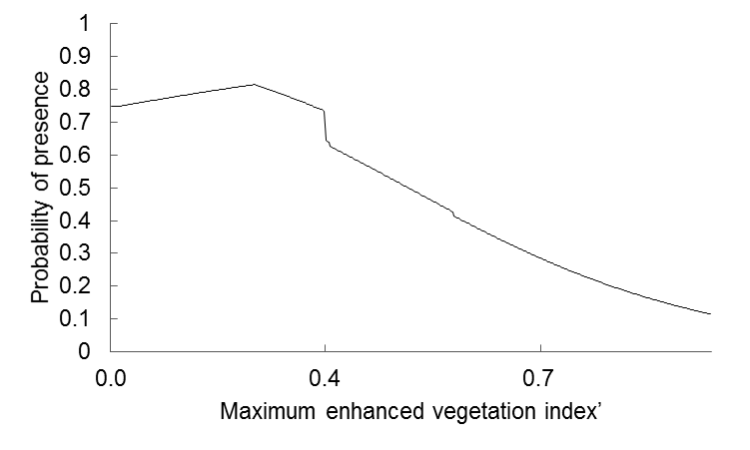
Fig 1 Marginal response curve[Meaning? We explained better in the methods the name of this graph, an output of Maxent] for maximum enhanced vegetation index.
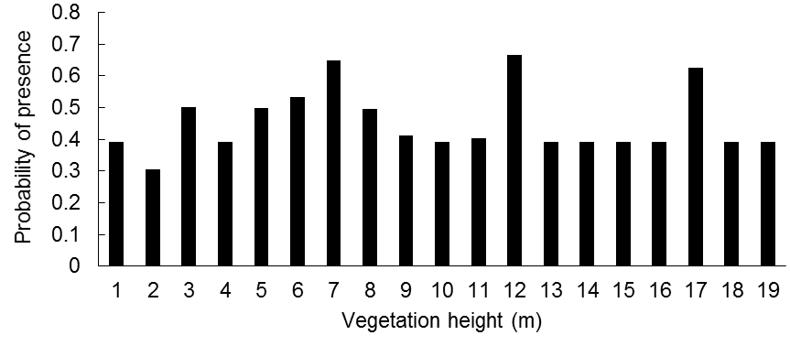
Fig. 2. Relationship between probability of jaguar presence and vegetation height.
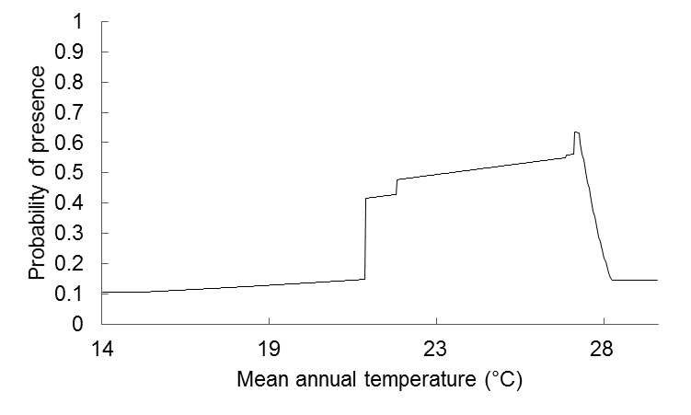
Fig. 3 Marginal response curve We explained better in the methods the name of this graph, an output of Maxent for mean annual temperature.

