**Combining local knowledge and occupancy analysis for a rapid assessment of the forest elephant *Loxodonta cyclotis* in Cameroon’s timber production forests**

Stephanie Brittain, Madeleine Ngo Bata, Paul De Ornellas E. J. Milner-Gulland and Marcus Rowcliffe

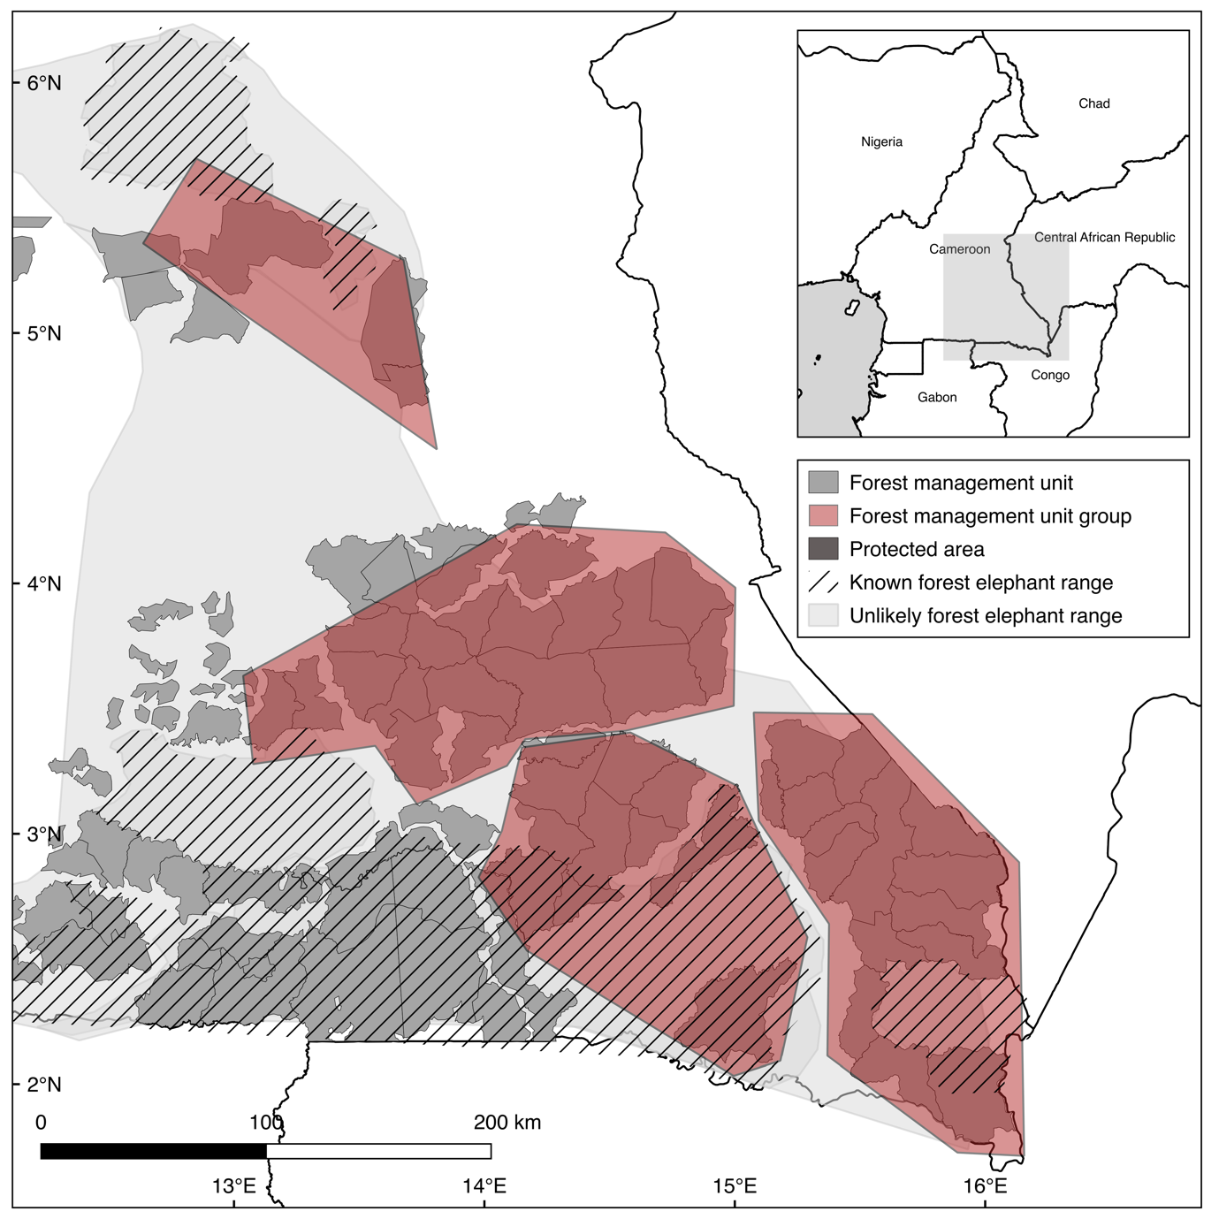

**N**

**C**

**SW**

**SE**

[Would look better with a bounding box and tick mark labels and inset amended as per comments on other figures] **DONE**

Fig. 1Forest management unit groups included in a study of forest elephant *Loxodonta cyclotis* occupancy in eastern Cameroon. N, northern; C, central; SW, south-western; SE, south-eastern.

Fig. 2Process used to select workers in timber concessions in eastern Cameroon (Fig. 1) to participate in interviews to elicit data on their observations of elephants during 20082013.

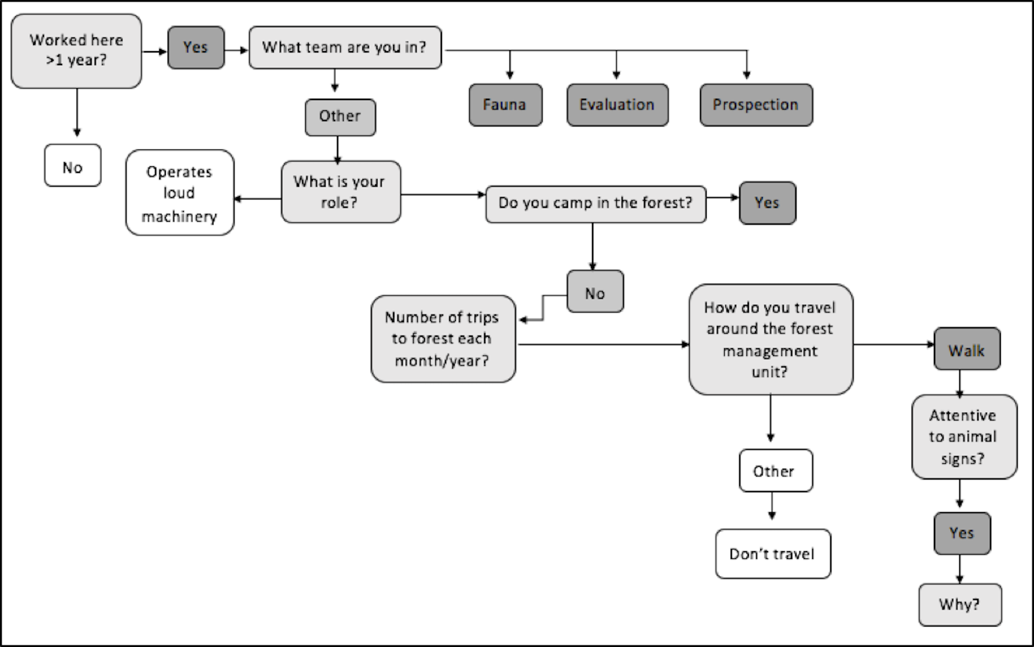

Supplementary Material 1Semi-structured questionnaire administered to timber concession workers and authorities in eastern Cameroon to investigate occupancy of forest elephants *Loxodonta cyclotis* in timber concessions.

**Basic information**

Age: 1626 2737 3848 4959 60+

Gender: Male Female

Where were you born? Urban Rural

Team:

Job position:

What tasks does that involve? (Chainsaw operator/truck driver etc.)

**Detectability**

How long have you worked here? <1 year 15 years 610 years >11 years

How many trips do you make into the forest? 4 per week 24 per week 12 per week 12 per month 12 per year 0 trips

Do you camp in the forest? Yes No

How many nights do you spend in the forest when working? 0 17 814 15+

Are you attentive to animal signs when you see them? Always Sometimes Rarely

**Occupancy**

Have you ever seen an elephant or sign of an elephant? Yes No

What sign(s) have you seen? Describe them to me.

Footprints Dung Actual sighting Heard one Carcass Reports from others Other (please state)

In which annual allowable cut (AAC) did you see it?

In which year?

At what time of year? (Wet/dry season)

Was the AAC active being prepared post evaluation?

Supplementary Material 2Key quotes from informal and semi-structured interviews.

Poaching forest elephants for their ivory can be very financially rewarding, and therefore worth the risk:

*‘Elephant poaching has become harder, but they do it anyway. You have to be secretive or get arrested. All of the elephant is worth money, the meat, the skin, and the tusk.’* (Timber concession worker)

*‘Alternatives how? People look to get rich quick. Even 30 days of work doesn't match the price of ivory…alternatives don’t work.’* (Timber concession worker)

There is a perceived lack of alternatives in the face of the high value of ivory:

*‘I like my work…I have 13 kids; this allows them all to go to school. XXX offered me work but for how much? I prefer poaching.’* (Poacher)

*‘I like elephants, but we can't kill them anymore. People have stopped killing them only because it is illegal…If elephants disappear, people will be a bit sad. But, as elephant meat is illegal I don't see why people will regret the loss of the species.’* (Timber concession worker)

*‘We need to protect elephants for our forests. Elephants are important for other animals too… and move seeds around the forest… Without them our forests wouldn't be the same.’* (Timber concession worker)

*‘When we go to the chef de poste, he says no to culling. People are frustrated… opinions of elephants have gone down because of this.’* (Timber concession worker)

International markets and growing demand is perceived to be having a growing impact on forest elephant poaching in Cameroon:

*‘… opening up of Africa to the Asian market, the price of ivory has gone up and led to an increase in poaching. They say they are doing research for mineral exploitation, or they are here for pangolin scales…they hide behind that to illegally trade ivory.’* (Authority)

*‘…I remember in 2008/2010 a kilo of ivory cost 40,000…But in 20112013 it rose to 120,000140,000 per kilo… At first, it was people within the Cameroonian administration…Since then it's the Asians who lead it, who say, ‘we are in need of ivory, import as much as you can’…’* (Authority)

Lack of law enforcement and high levels of corruption mean that much of the poaching is perceived to be driven by government officials, or permitted to happen:

*‘Gendarmes are involved, the chef de poste is implicated, everyone is implicated.’* (Authority)

*‘It's always the generals, the ministers, the chefs de poste that are behind it and involved. It's them that are behind the poaching. There are road blocks and yet no one gets stopped. There is a lot of money to be made from it…’* (Timber concession worker)

*‘…the authorities use local people, Bakas especially, to go and find them elephants and poach them…What can I say…people capitalize on their positions of power to their advantage. On top of their salary, they can make a lot more by poaching elephants.’* (Authority)

The price of ivory and the level of poverty in the region mean that alternatives to poaching are perceived to be lacking, and a lack of desire to protect elephants further reflects the sentiment. Although some stated that they didn't want to lose the species for future generations, overall the feeling was that elephants are of financial worth, and are a source of large sums of money.

*‘People like elephants because their tusks are worth something. There is no emotional attachment to elephants. If there are no more elephants, people will be sad because there is no more ivory.’* (Authority)

Table 1Spearman’s correlation coefficient results for responder covariates.

The closer the R value is to +1 or −1, the stronger the likely correlation. The R values of 0.976 and 0.909 suggest a strong positive relationship, denoted by ***. Results show a strong positive correlation between the detectability variables age and number of trips (P = 0.976) and years worked and number of trips (P = 0.909) and were therefore eliminated from analysis. (Sample size = 154)

|  |  |  |  |  |
| --- | --- | --- | --- | --- |
|  | Age | Years worked | Nights camped | Number of trips |
| Age |  | 0.002 | 0.180 | 0.976 *** |
| Years worked |  |  | 0.356 | 0.909 *** |
| Nights camped |  |  |  | 0.002 |
| Number of trips |  |  |  |  |

Table 2Analysis of occupancy variable relationships using Pearson’s correlation coefficient (for parametric data). The absolute value of R: 0.400.59 (weak *), 0.600.79 (moderate **), 0.801.0 (strong ***). No R values displayed either a moderate or strong correlation, and therefore none were removed from analysis. (Sample size = 342)

|  |  |  |  |  |  |  |
| --- | --- | --- | --- | --- | --- | --- |
|  | Distance from towns (km) | Distance from road (km) | Elevation (m) | Slope (gradient) | Distance from villages (km) | Distance from river (km) |
| Distance from towns (km) |  | −0.016 | −0.411* | −0.041 | 0.347 | −0.138 |
| Distance from road (km) | −0.012 |  | 0.083 | 0.161 | −0.116 | 0.103 |
| Elevation (m) | −0.410* | 0.083 |  | 0.153 | −0.288 | 0.175 |
| Slope (gradient) | −0.041 | 0.161 | 0.153 |  | 0.132 | 0.074 |
| Distance from villages (km) | 0.347* | −0.116 | −0.288 | 0.132 |  | −0.160 |
| Distance from river (km) | −0.138 | −0.042 | 0.175 | 0.074 | −0.160 |  |

Table 3 Environmental and observer variables considered for use in the modelling process.

|  |  |  |  |
| --- | --- | --- | --- |
| Detectability covariates (measurement unit) | Justification | Expected direction of effort | References |
| Age (years)  1637 years/  3848 years/  49+ years | Loss of perspective about past ecological conditions caused by lack of communication between generations may create shifting baseline syndrome, in which younger generations are less aware of local species diversity or abundance in the recent past (Turvey et al., 2010). | The older the respondent, the better they will be at detecting signs of forest elephants. | Turvey et al. (2010) |
| Gender (male/female) | Although all timber concession workers were male, there were some females from local villages in the pilot study. | None. Gender does not have an effect on the reliability or ability of the respondent to detect the species. |  |
| Where born (local/urban) | Patterns of awareness & experience may be influenced by variation in species status, ecology & distribution, and in socio-cultural factors. People from various backgrounds living in the same landscapes may have varying levels of awareness & experience. | People growing up in rural areas or locally will have been more exposed to nature & biodiversity. They will, therefore, have a greater level of local ecological knowledge. | Turvey et al. (2014) |
| Years worked  (<10 years/10 years) |  | The longer a respondent has worked in that role, the more forest experience they will have & the more experienced they will be at detecting signs of forest elephants. |  |
| Nights camped (nights)  (17 nights/>8 nights) |  | The longer the informants spend in the forest at a time, the more likely they are to detect signs of forest elephants. |  |
| Number of trips  >15 trips per week/  >1 per month2 trips per year |  | Similarly to the nights camped variable, the more time the informants spend in the forest, the more likely they are to detect signs of forest elephants. |  |
| Source of/reason for local ecological knowledge  (job safety/directions learnt from childhood) | To understanding how & why respondents are suitable & reliable, and whether the purpose or source of their local ecological knowledge has an influence on this. | Those observant of signs for reasons of safety or from their childhood will be more reliable than those using them for their job generally. | Turvey et al. (2010)  Turvey et al. (2014) |
| Year  (factor levels for each year 20082013) | To understand any changes in occupancy or detectability over time. | Elephant occupancy/detectability decreases with year. | Maisels et al. (2013) |
| Slope (gradient) | To see if the degree of slope influences the occupancy of forest elephants. | Elephant occupancy decreases with increasing slope. |  |
| Elevation (m) | Areas located at higher elevation differ in soil type, vegetation,  plant biomass, rainfall & temperature, affecting the distribution of elephants (Ngene et al., 2009). | Elephant occupancy decreases with elevation. | Ngene et al. (2009)  de Boer et al. (2013) |
| Distance from river (km) | Riverine habitats are preferable for elephants (Walsh et al., 2000). However, rivers also provide an access point for people (Barnes et al., 1991) & therefore in areas of high hunting pressure elephants may actively avoid rivers. | Elephant occupancy decreases with distance from river. | Barnes et al. (1991) Walsh et al. (2000) |
| Distance from road (km) | To see if roads influence the occupancy of forest elephants. | Elephant occupancy increases with distance from road to avoid sound & human disturbance. | Blake et al. (2008) Stokes et al. (2010) |
| Distance from town (km) | To see if distance from town influences the occupancy of forest elephants. | Elephant occupancy increases with distance from town to avoid sound & human disturbance. | Buij et al. (2007)  de Boer et al. (2013)  Maisels et al. (2013) |
| Distance from village (km) | To see if distance from villages influences the occupancy of forest elephants. | Elephant occupancy increases with distance from village to avoid sound & human disturbance. | Buij et al. (2007)  de Boer et al. (2013) Maisels et al. (2013)  Blake (2002)  Douglas-Hamilton et al. (2005)  Clark et al. (2009) Yackulic et al. (2011) |
| Forest management unit group (northern/south-eastern/south-western/central) | To see if groups of forest management units are supporting different independent elephant populations across the eastern region & if so, what their statuses are. | Forest management unit groups furthest from major roads & large villages will have the highest forest elephant occupancy. |  |

Table 4 Top models showing the best-fit models that account for detectability only (Burnham & Anderson, 2002), with Akaike Information Criterion (AIC) and Akaike difference (AIC).

|  |  |  |  |
| --- | --- | --- | --- |
| Model | Covariates | AIC | ΔAIC |
| 8 | (P(C+YW) Ψ ( ∙) ) | 1,727.91 | 0.00 |
| 7 | P(A+C+YW)Ψ ( ∙) | 1,729.46 | 1.55 |
| 3 | p (C) Ψ ( ∙) | 1,731.91 | 4 |
| 4 | p (A+C) Ψ ( ∙) | 1,734.74 | 6.83 |
| 2 | p(A) Ψ ( ∙) | 1,931.06 | 203.15 |
| 6 | P(A+YW) Ψ ( ∙) | 1,932.94 | 205.03 |
| 5 | p (YW) Ψ ( ∙) | 1,933.62 | 205.71 |

Table 5 Top 10 best-fit models, with AIC, AIC, Akaike weight, standard error in probability of occupancy () and standard error in probability of detection (p)[Please confirm. The best-fit models have ΔAIC of <4 (indicated by grey shading).

|  |  |  |  |  |  |
| --- | --- | --- | --- | --- | --- |
| Model* | AIC | ΔAIC | Akaike weight (%) | Ψ SE | P SE |
| p(C+YW+G+Y) Ψ (V+Ri+Ro+E+G) | 1,349.16 | 0.00 | 24 | 0.73 | 0.42 |
| p(C+YW+G+Y) Ψ(V+Ri+Ro+E+S+G) | 1,349.57 | 0.41 | 20 | 0.7 | 0.4 |
| p(C+YW+G+Y) Ψ(V+Ri+Ro+E+S) | 1,350.16 | 1.00 | 15 | 0.29 | 0.35 |
| p(C+YW+G+Y) Ψ (V+Ri+Ro+E) | 1,350.24 | 1.08 | 14 | 0.28 | 0.36 |
| p(C+YW+G+Y) Ψ(V+Ri+Ro+S) | 1,350.29 | 1.14 | 14 | 0.3 | 0.35 |
| p(C+YW+G+Y) Ψ(T+V+Ri+Ro+S) | 1,350.34 | 1.19 | 13 | 0.3 | 0.35 |
| p(C+YW+G+Y) Ψ (V+Ri+Ro+E+G+Y) | 1,353.83 | 4.67 |  |  |  |
| p(C+YW+G+Y) Ψ (V+Ri+Ro+E+Y) | 1,354.64 | 5.48 |  |  |  |
| p(C+YW+G+Y) Ψ (V+Ri+Ro+E+S+G+Y) | 1,354.66 | 5.50 |  |  |  |
| p(C+YW+G+Y) Ψ (Vi+Ri+Ro+S+Y) | 1,355.21 | 6.05 |  |  |  |

**\***C, nights camped; YW, years worked; G, forest management unit group; Y, year; T, distance from town; V, distance from village; Ri, distance from river; Ro, distance from road; E, elevation; S, slope

Table 6 Summary of the back transformed (psi) detectability (p) and occupancy () estimates from the fixed model.

|  |  |  |  |  |  |
| --- | --- | --- | --- | --- | --- |
|  | Estimate | SE | Z | **P(>|z|)***(The p value computed from the z-values)* | Confidence interval |
| p | 0.58 | 0.01 | 5.64 | 1.66 | 0220.46 |
| Ψ | 0.76 | 0.03 | 7.18 | 6.78 | 0.841.47 |