Supplementary Materials
Arsenic release in arsenopyrite (FeAsS), relgar (As₄S₄) tailings and their mixtures with exogenous Slag Zero Valence Iron (SZVI) under biological oxidation environment: implications for in-situ remediation of arsenic in mine area
Tingting Yue^{1, 2}, Shu Chen², Jing Liu^{1,} *
¹ School of Resources and Environment, Southwest University, Chongqing 400715 China.
² The Key Laboratory of Solid Waste Treatment and Resource, Ministry of Education, Southwest University of Science and Technology, 621010 Mianyang China.
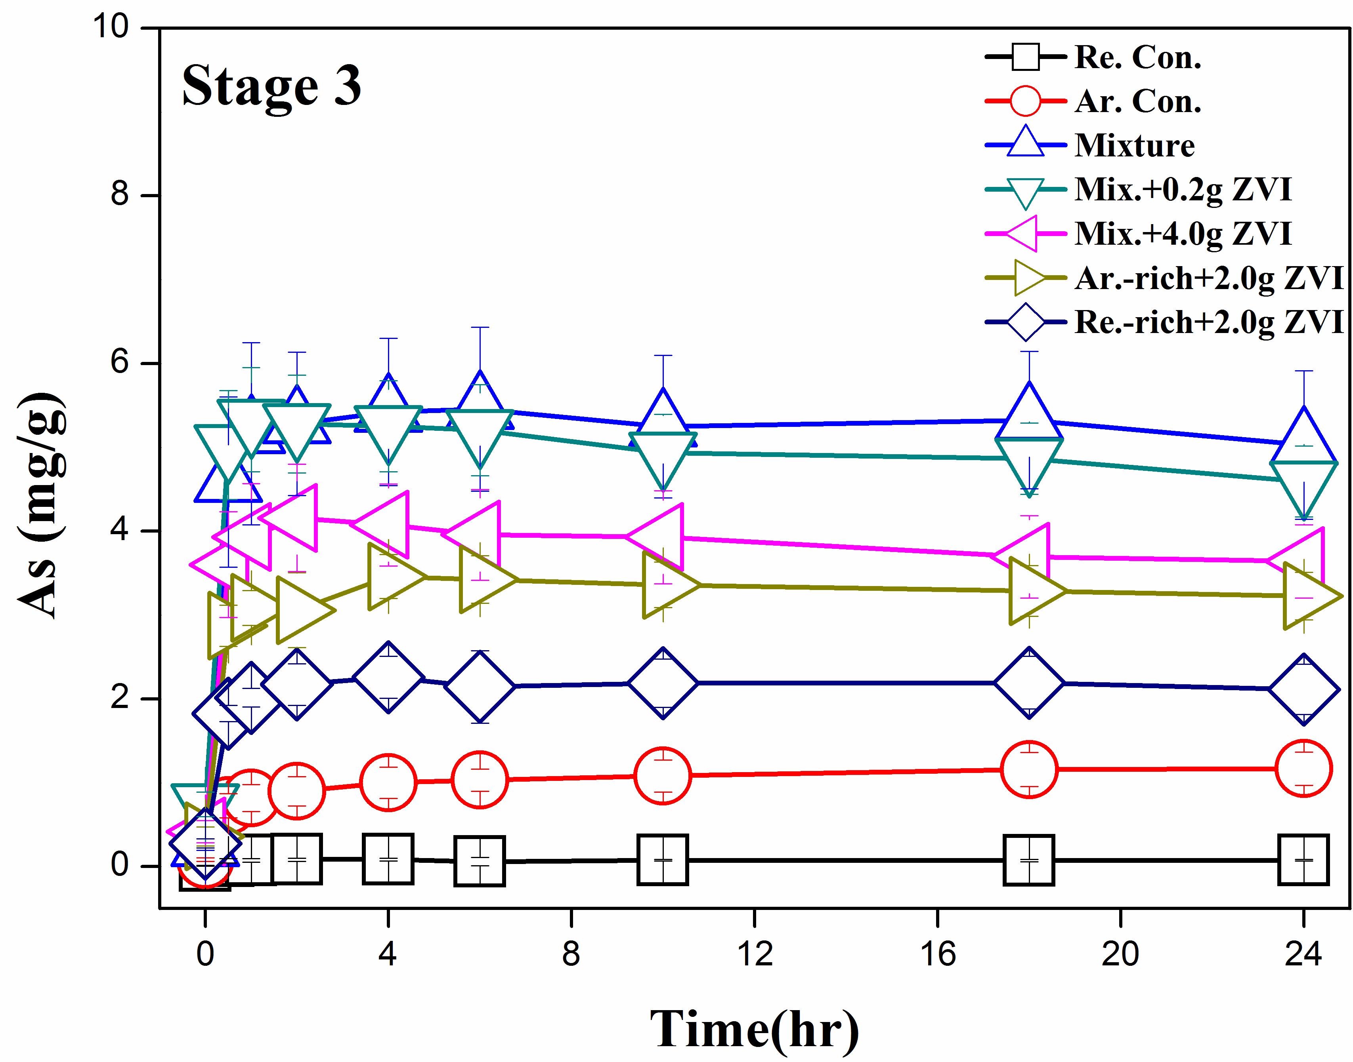
Fig. S1. Arsenic concentration of solid phases from each group and control experiment extracted by oxalate solution (pH = 2.0).

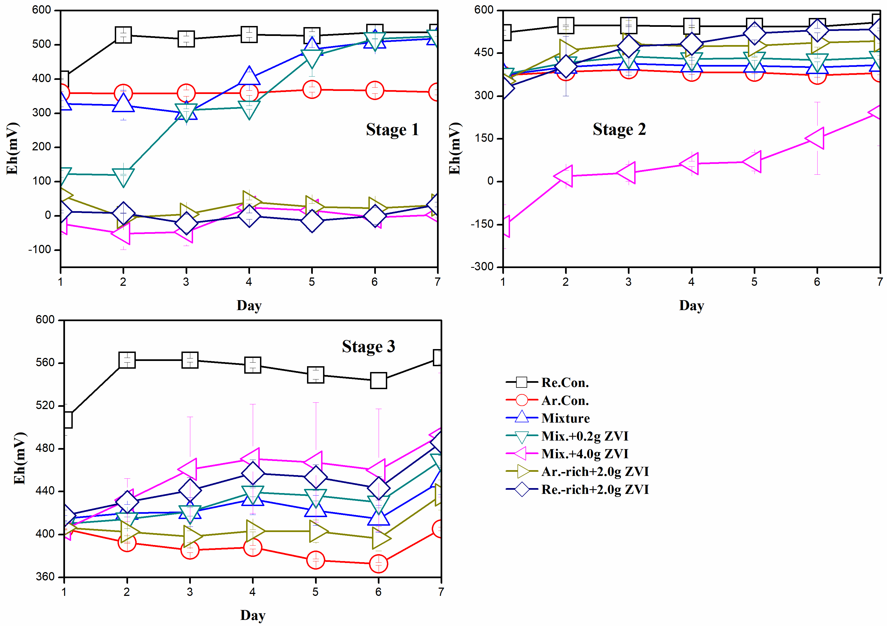Fig. S2. The variation of solution Eh over time.

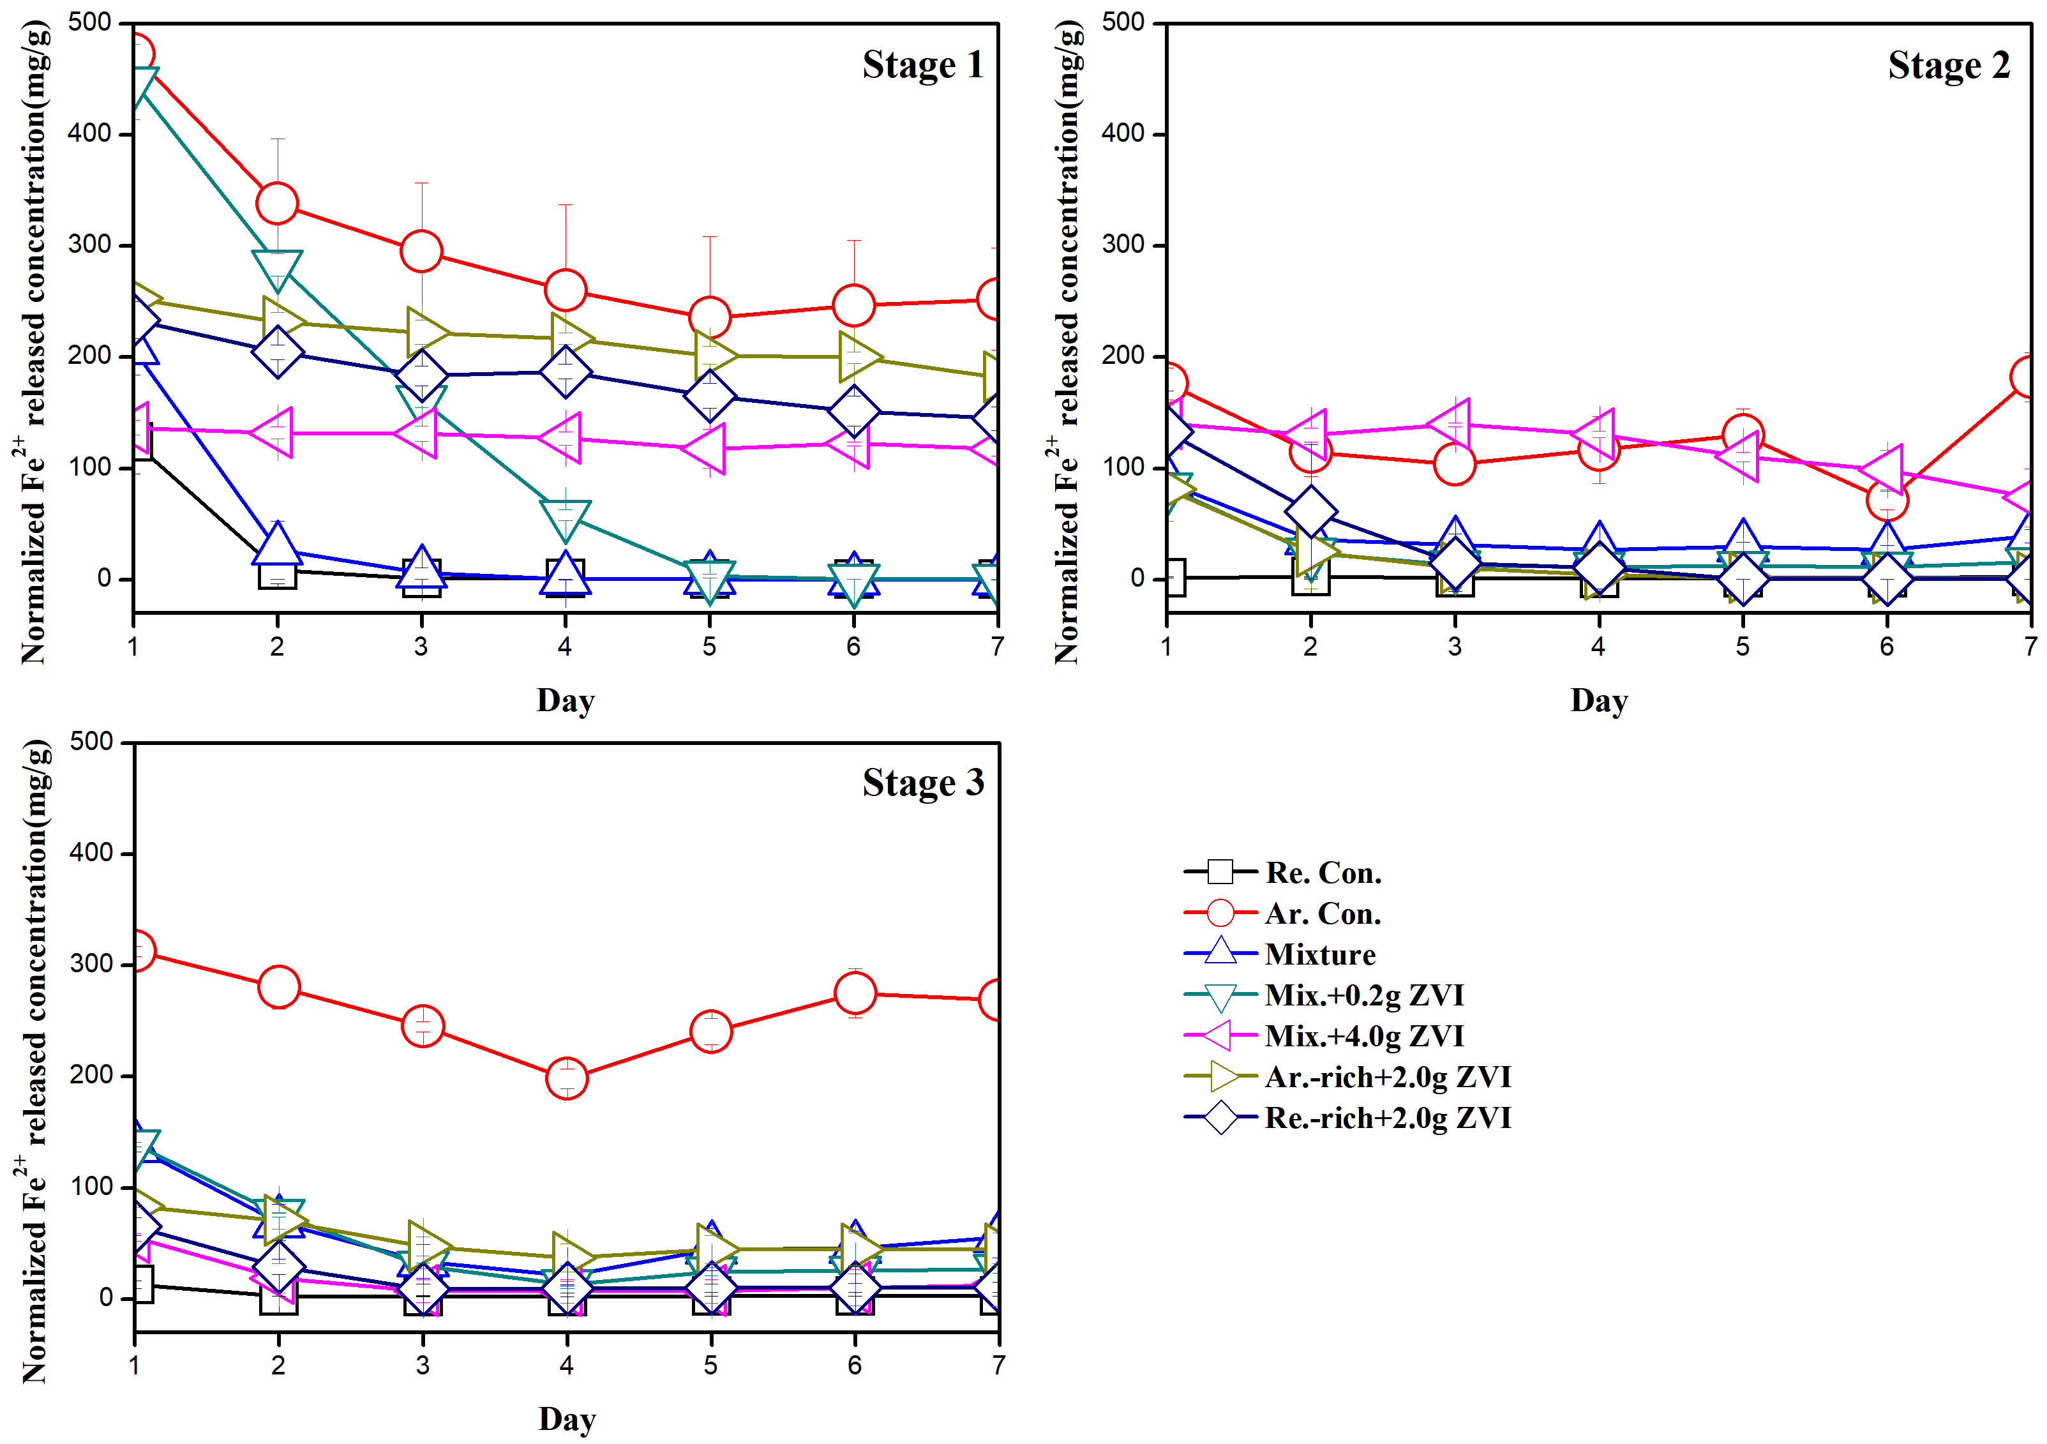
Fig. S3. Variations in Fe²⁺ of solutions of each group for three stages.
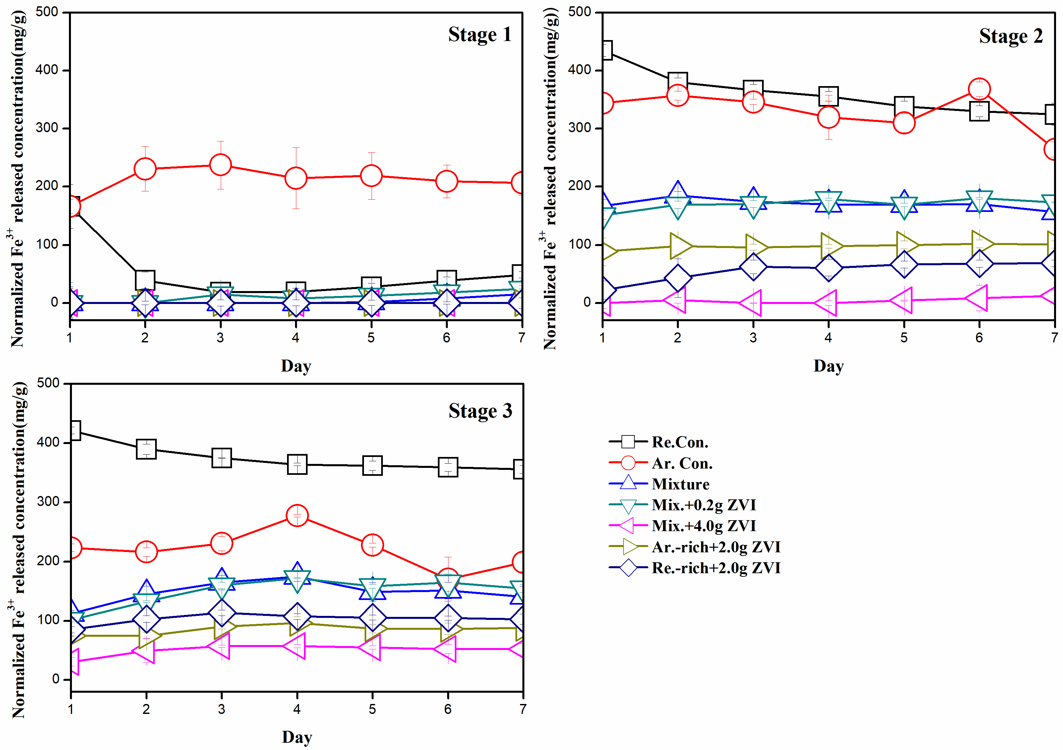
Fig. S4. Variations in Fe³⁺ of solutions of each group for three stages.
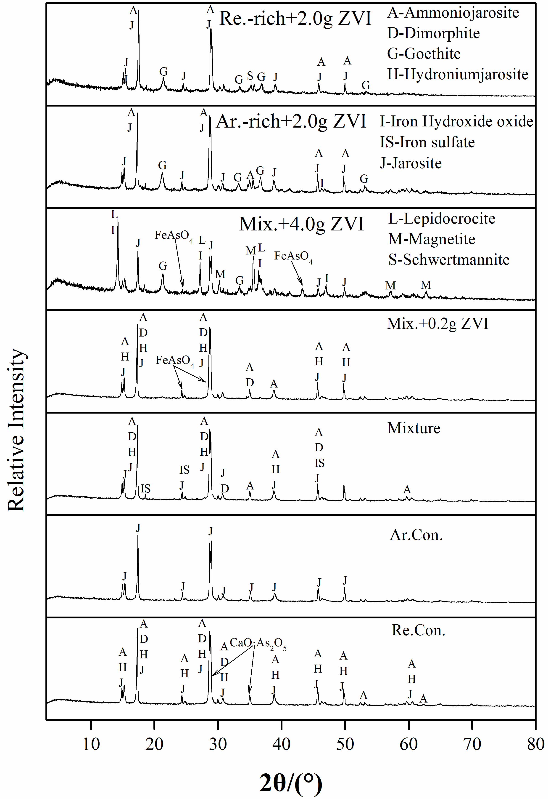
Fig. S5. XRD pattern of various samples after biological dissolution after three stages.

* Corresponding authors. E-mail addresses: Liujing-vip@163.com (Jing Liu)

