Supporting Information

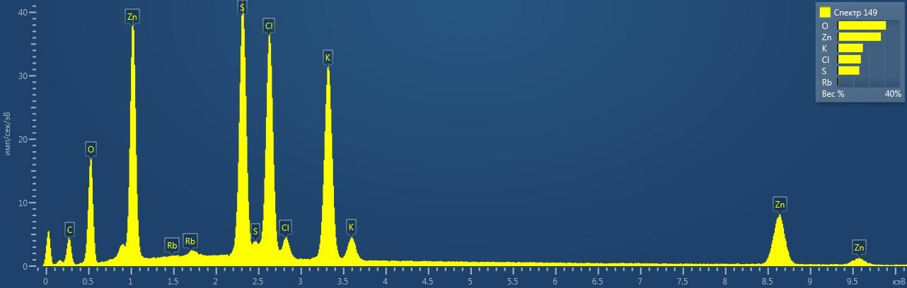

Figure 1S. ED spectrum of belousovite.

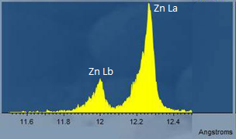

Figure 2S. WD spectrum of belousovite in the range 11.500-12.500 Å.

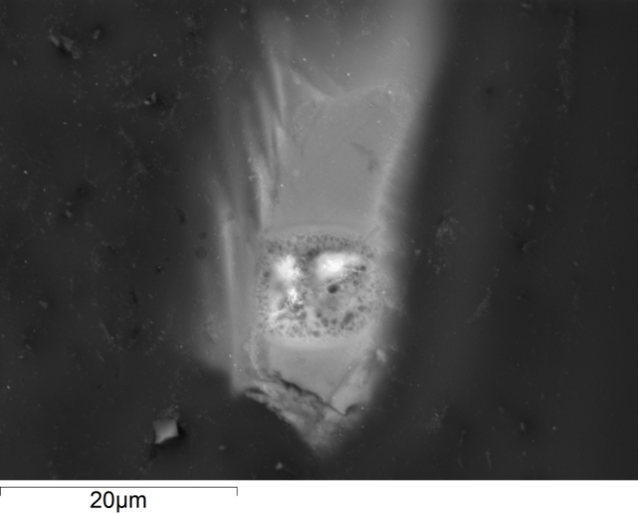
Figure 3S. BSE image of damaged surface of belousovite.
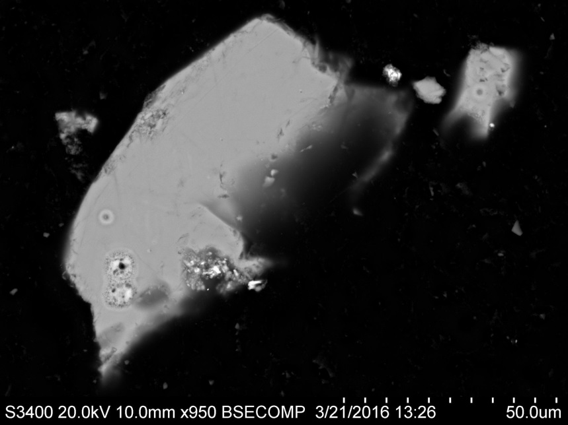
Figure 4S. BSE image of analyzed belousovite crystals. Surface damage can be observed in the lower part of the large crystal and in the central part of the small crystal.

