Supplementary Material – Journal of the Marine Biological Association of the UK

Bolzan et al - Juvenile fish habitats in a tropical estuarine protected area

Table S1. Fish standard length (SL mean and range), mean fish density per 100 m², site where the species was recorded and total fish weight (WT - mean and total) in the São Mateus River estuary, ES.
Family | SL (mm) |  | Mean Density (fish/100 m²) | Site | TW (g)
Species | Mean | Range |  |  | Mean | Total
Elopidae
Elops smithi (McBride, Rocha, Ruiz-Carus & Bowen, 2010) | 31 | 30-32 | < 0.01 | 1 | 0.08 | 0.25
Albulidae
Albula vulpes (Linnaeus, 1758) | 40.4 | 25-58 | 0.08 | 1; 2 | 0.2 | 7.14
Ophichthidae
Ahlia egmontis (Jordan, 1884) | 59 | 59 | < 0.01 | 8 | 0.08 | 0.08
Engraulidae
Cetengraulis edentulus (Cuvier, 1829) | 84.4 | 80-88 | 0.01 | 1 | 8.95 | 62.67
Anchovia clupeoides (Swainson, 1839) | 67.7 | 44-92 | 0.39 | 3; 6; 7; 8 | 3.92 | 674.99
Anchoviella lepidentostole (Fowler, 1911) | 35.6 | 27-74 | 0.05 | 5; 8 | 0.53 | 11.81
Lycengraulis grossidens (Agassiz, 1829) | 44 | 19-139 | 1.91 | All | 2.08 | 1725.22
Anchoa spinifer (Valenciennes, 1848) | 56 | 34-76 | 0.06 | 1; 3; 7 | 2.28 | 66.15
Anchoa januaria (Steindachner, 1879) | 44 | 27-62 | 0.4 | 7; 8 | 0.87 | 153.03
Anchoa tricolor (Spix & Agassiz, 1829) | 66.7 | 65-70 | < 0.01 | 3 | 3.86 | 11.6
Anchoa lyolepis (Evermann & Marsh, 1900) | 36 | 36 | < 0.01 | 1 | 0.51 | 0.51
Non-identified juvenile | 24.4 | 9-42 | 10.56 | All | 0.11 | 498.36
Clupeidae
Rhinosardinia bahiensis (Steindachner, 1879) | 46.6 | 24-80 | 2.25 | 3; 4; 5; 6; 7; 8 | 1.56 | 1525.19
Prochilodontidae
Prochilodus argenteus (Spix & Agassiz, 1829) | 68 | 65-70 | < 0.01 | 1; 4 | 9.6 | 28.82
Characidae
Astyanax lacustris (Lütken, 1875) | 63.7 | 49-80 | < 0.01 | 5; 8 | 7.91 | 23.75
Heptapteridae
Table S1 (continuation):
Family | SL (mm) |  | Mean Density (fish/100 m²) | Site | TW (g)
Species | Mean | Range |  |  | Mean | Total
Pimelodella lateristriga (Lichtenstein, 1823) | 67.3 | 22-105 | 0.08 | 5; 7; 8 | 5.07 | 177.61
Ariidae
Genidens genidens (Cuvier, 1829) | 66.4 | 45-134 | 0.33 | All | 4.47 | 652.52
Aspistor luniscutis (Valenciennes, 1840) | 93.2 | 80-116 | 0.02 | 1 | 11.41 | 125.6
Cathorops spixii (Agassiz, 1829) | 62 | 62 | < 0.01 | 5 | 4.89 | 4.89
Sciades sp. | 82.47 | 68-104 | 0.08 | 1; 2 | 7.52 | 285.75
Synodontidae
Synodus foetens (Linnaeus, 1766) | 72 | 42-133 | 0.02 | 1; 2; 3 | 5.33 | 63.99
Mugilidae
Mugil curema (Valenciennes, 1836) | 28.8 | 12-230 | 2.51 | All | 0.57 | 1557.71
Mugil hospes (Jordan & Culver, 1895) | 21.8 | 15-92 | 0.23 | 1; 2; 4; 7; 8 | 1.43 | 58.15
Atherinopsidae
Atherinella brasiliensis (Quoy & Gaimard, 1825) | 67.2 | 11-118 | 1.51 | 1; 2; 3; 4; 5; 7 | 5.06 | 3316.54
Hemiramphidae
Hemiramphus brasiliensis (Linnaeus, 1758) | 68.6 | 29-123 | 0.04 | 1; 5; 6 | 1.34 | 24.12
Hyporhamphus unifasciatus (Ranzani, 1841) | 96.3 | 57-116 | 0.02 | 3; 4; 5; 6 | 2.58 | 23.27
Belonidae
Strongylura marina (Walbaum, 1792) | 154.2 | 65-259 | 0.01 | 1; 3; 5; 6 | 7.04 | 35.2
Strongylura timucu (Walbaum, 1792) | 142.3 | 52-336 | 0.02 | 1; 4; 5; 6; 7; 8 | 7.41 | 88.96
Strongylura sp. | 41 | 41 | < 0.01 | 6 | 0.02 | 0.02
Rivulidae
Kryptolebias ocellatus (Hensel, 1868) | 22 | 22 | < 0.01 | 3 | 0.13 | 0.13
Syngnathidae
Syngnathus folletti (Herald, 1942) | 76 | 65-78 | < 0.01 | 3; 4 | 0.15 | 0.46
Table S1 (continuation):
Family | SL (mm) |  | Mean Density (fish/100 m²) | Site | TW (g)
Species | Mean | Range |  |  | Mean | Total
Microphis brachyurus (Bleeker, 1854) | 109.4 | 83-169 | 0.04 | 1; 3; 4; 7; 8 | 0.73 | 13.97
Centropomidae
Centropomus undecimalis (Bloch, 1792) | 91 | 26-204 | 0.36 | 1; 2; 3; 5; 6; 7; 8 | 14.71 | 2310.05
Centropomus parallelus (Poey, 1860) | 58.1 | 19-185 | 0.36 | 1; 2; 3; 5; 6; 7; 8 | 4.79 | 753.25
Centropomus spp. | 14.5 | 14-15 | < 0.01 | 8 | 0.03 | 0.06
Carangidae
Caranx hippos (Linnaeus, 1766) | 39.3 | 26-96 | 0.05 | All | 3.41 | 75.11
Caranx latus (Agassiz, 1831) | 65.2 | 27-129 | 0.03 | 1; 2; 3; 7; 8 | 11.57 | 196.68
Caranx sp. | 6 | 6 | < 0.01 | 3 | 0.01 | 0.01
Oligoplites saliens (Bloch, 1793) | 64.8 | 15-109 | 0.01 | 2; 5; 7 | 6.61 | 33.08
Oligoplites saurus (Bloch & Schneider, 1801) | 17.8 | 10-27 | 0.02 | 1; 3; 4; 5; 6; 7; 8 | 0.15 | 1.82
Oligoplites sp. | 9 | 9 | < 0.01 | 7 | 0.01 | 0.01
Trachinotus carolinus (Linnaeus, 1766) | 33.1 | 11-64 | 0.09 | 1; 2 | 1.98 | 77.45
Trachinotus falcatus (Linnaeus, 1758) | 34 | 12-38 | 0.21 | 1; 2; 3; 5; 6 | 3.58 | 337.08
Trachinotus goodei (Jordan & Evermann, 1896) | 80 | 31-113 | 0.02 | 1; 2 | 19.87 | 198.77
Lutjanidae
Lutjanus jocu (Bloch & Schneider, 1801) | 34 | 15-71 | 0.02 | 1; 3; 5; 7 | 2.84 | 25.59
Lobotidae
Lobotes surinamensis (Bloch, 1790) | 54 | 54 | < 0.01 | 2 | 7.1 | 7.1
Gerreidae
Eucinostomus melanopterus (Bleeker, 1863) | 30.8 | 11-81 | 0.17 | 1; 3; 5; 6; 7; 8 | 1.16 | 86.94
Eucinostomus argenteus (Baird & Girard, 1854) | 46.1 | 14-88 | 0.44 | 1; 3; 4; 5; 6; 7; 8 | 3.96 | 765.38
Eucinostomus spp. | 11.4 | 8-19 | 0.21 | All | 0.01 | 1.42
Eugerres brasilianus (Cuvier, 1830) | 37 | 35-39 | < 0.01 | 7; 8 | 1.41 | 2.83
Table S1 (continuation):
Family | SL (mm) |  | Density (fish/100 m²) | Site | TW (g)
Species | Mean | Range |  |  | Mean | Total
Diapterus rhombeus (Cuvier, 1829) | 42.3 | 31-64 | 0.19 | 1; 3; 5; 6; 7; 8 | 2.33 | 196.12
Diapterus auratus (Ranzani, 1842) | 53.5 | 52-55 | < 0.01 | 6; 7 | 4.41 | 8.83
Haemulidae
Pomadasys ramosus (Poey, 1860) | 46.4 | 27-89 | 0.03 | 7;8 | 3.14 | 50.29
Pomadasys crocro (Cuvier,1830) | 67 | 62-77 | < 0.01 | 5 | 8.27 | 24.81
Conodon nobilis (Linnaeus, 1758) | 53 | 53 | < 0.01 | 2 | 3.22 | 3.22
Polynemidae
Polydactylus oligodon (Günthe, 1860) | 96 | 90-100 | < 0.01 | 1 | 18.8 | 56.4
Polydactylus virginicus (Linnaeus, 1758) | 104 | 101-107 | < 0.01 | 1; 3 | 25.42 | 50.84
Sciaenidae
Menticirrhus littoralis (Holbrook, 1860) | 108.4 | 30-182 | 0.03 | 1; 2; 3 | 34.45 | 585.8
Micropogonias furnieri (Desmarest, 1823) | 85.4 | 76-109 | 0.01 | 1; 6; 7 | 11.9 | 59.5
Stellifer rastrifer (Jordan, 1889) | 51 | 51 | < 0.01 | 1 | 2.62 | 2.62
Stellifer naso (Jordan, 1889) | 120 | 120 | < 0.01 | 3 | 38.5 | 38.5
Uranoscopidae
Astroscopus y-graecum (Cuvier, 1829) | 57.5 | 49-65 | < 0.01 | 2; 3; 4 | 6.75 | 27.02
Gobiidae
Ctenogobius boleosoma (Jordan & Gilbert, 1882) | 20 | 8-40 | 1.65 | All | 0.12 | 87.95
Gobionellus oceanicus (Pallas, 1770) | 85.9 | 21-145 | 0.34 | 5; 7; 8 | 8.14 | 1221.72
Evorthodus lyricus (Girard, 1858) | 27 | 27 | < 0.01 | 7 | 0.38 | 0.38
Bathygobius soporator (Valenciennes 1837) | 86 | 86 | < 0.01 | 5 | 14.2 | 14.2
Awaous tajasica (Lichtenstein, 1822) | 48 | 48 | < 0.01 | 8 | 1.53 | 1.53
Ephippidae
Chaetodipterus faber (Broussonet, 1782) | 25 | 25 | < 0.01 | 3 | 1.06 | 1.06
Table S1 (continuation):
Family | SL (mm) |  | Density (fish/100 m²) | Site | TW (g)
Species | Mean | Range |  |  | Mean | Total
Paralichthyidae
Citharichthys arenaceus (Evermann & Marsh, 1900) | 77.1 | 40-113 | 0.03 | 1; 2; 3; 5; 7 | 8.86 | 132.95
Citharichthys macrops (Dresel, 1885) | 46.9 | 13-111 | 0.24 | All | 2.6 | 278.33
Etropus crossotus (Jordan & Gilbert, 1882) | 69.9 | 49-87 | 0.03 | 1; 2; 3 | 7.91 | 134.54
Paralichthys brasiliensis (Ranzani, 1842) | 73 | 8-156 | < 0.01 | 1; 3; 7 | 25.29 | 101.17
Achiridae
Achirus declivis (Chabanaud, 1940) | 19.1 | 12-28 | 0.01 | 8 | 0.33 | 2.67
Achirus lineatus (Linnaeus, 1758) | 27.4 | 9-78 | 0.71 | 1; 3; 4; 5; 6; 7; 8 | 1.33 | 414.5
Achirus sp. | 6 | 6 | < 0.01 | 4 | 0.01 | 0.01
Catathyridium garmani (Jordan, 1889) | 78.5 | 42-115 | < 0.01 | 4; 8 | 37.66 | 75.32
Trinectes microphthalmus (Chabanaud, 1928) | 22.7 | 16-42 | 0.06 | 3; 4; 5; 6; 7; 8 | 0.57 | 16.73
Trinectes paulistanus (Ribeiro, 1915) | 30.9 | 8-59 | 1.19 | 3; 4; 5; 6; 7; 8 | 1.15 | 595.34
Cynoglossidae
Symphurus plagusia (Bloch & Schneider, 1801) | 86 | 86 | < 0.01 | 4 | 5.2 | 5.2
Symphurus tessellatus (Quoy & Gaimard, 1824) | 54 | 54 | < 0.01 | 3 | 1.19 | 1.19
Tetraodontidae
Sphoeroides spengleri (Bloch, 1785) | 35 | 6-67 | 0.74 | 1; 3; 4; 5; 6; 7 | 2.73 | 879
Sphoeroides testudineus (Linnaeus, 1758) | 39.2 | 8-164 | 2.05 | All | 6.95 | 6180.44

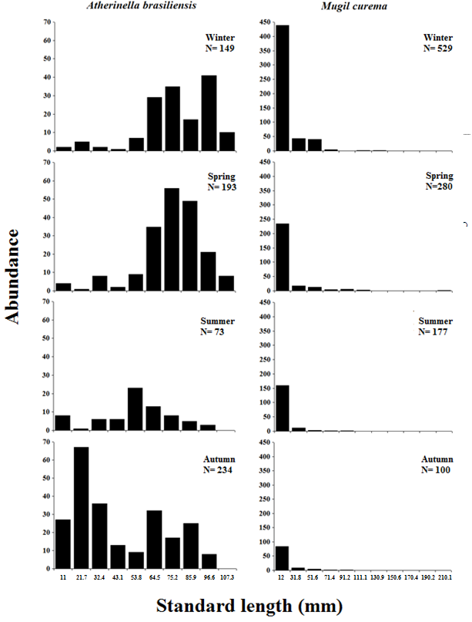

Figure S1. Size histograms (Standard length) of Atherinella brasiliensis and Mugil curema in different sampled seasons in the São Mateus River estuary.

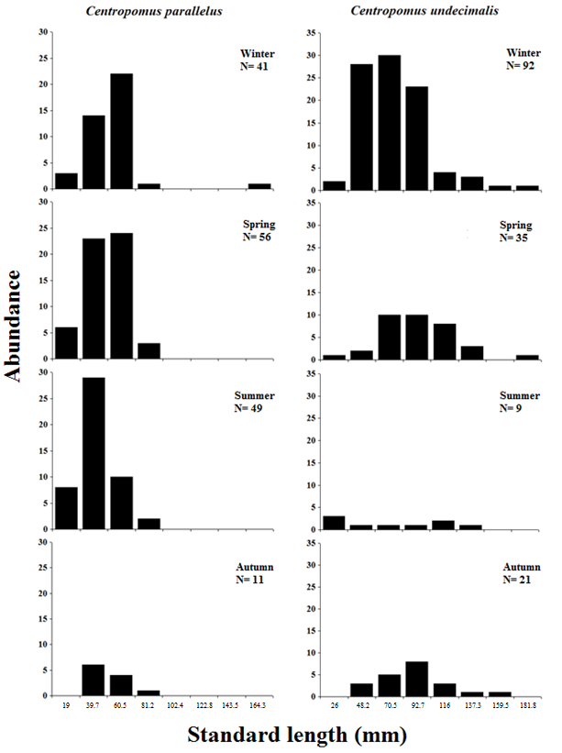

Figure S2. Size histograms (Standard length) of Centropomus undecimalis and Centropomus parallelus in different sampled seasons in the São Mateus River estuary.

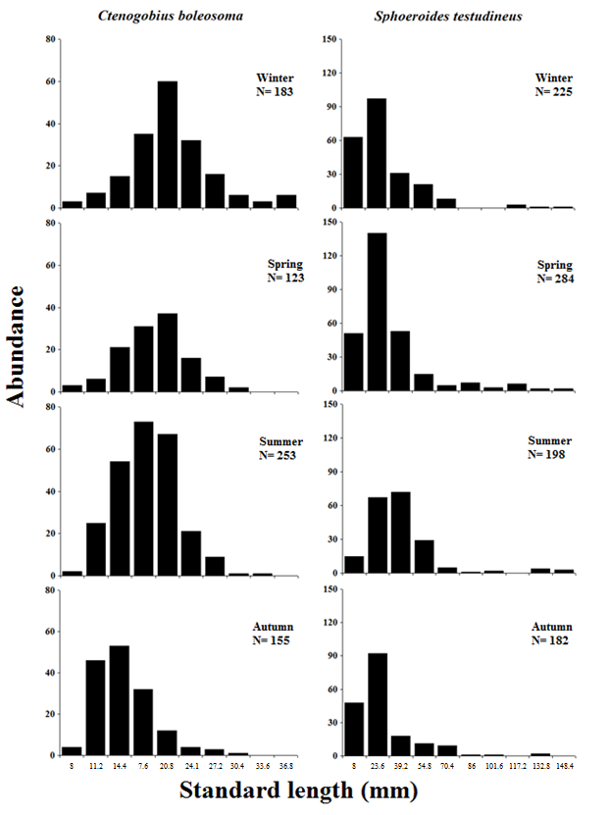

Figure S3. Size histograms (Standard length) of Ctenogobius boleosoma and Sphoeroides testudineus in different sampled seasons in the São Mateus River estuary.

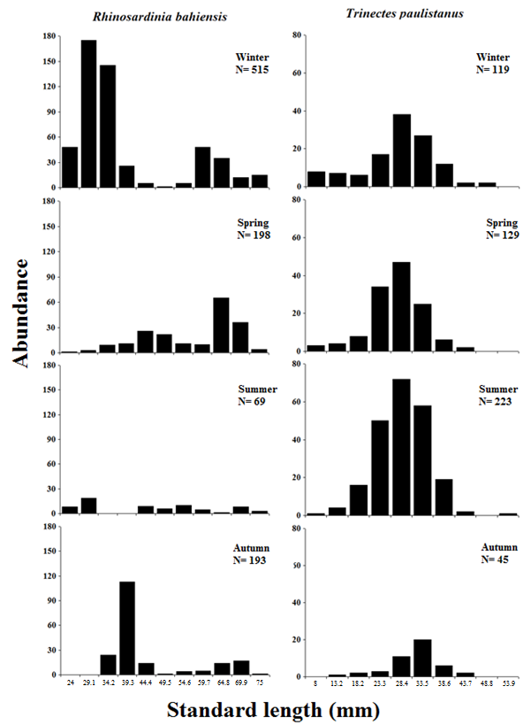
Figure S4. Size histograms (Standard length) of Rhinosardinia bahiensis and Trinectes paulistanus in different sampled seasons in the São Mateus River estuary.

