Supplementary Materials for
Spatio-temporal variations in seasonal ice tongue submarine melt rate at a tidewater glacier in southwest Greenland
A N Moyer¹, P W Nienow¹, N Gourmelen^{1,2}, A J Sole³, D A Slater⁴, M Truffer⁵, and M Fahnestock⁵
¹School of GeoSciences, University of Edinburgh, Edinburgh, UK, ²IPGS UMR 7516, Université de Strasbourg, ³Department of Geography, University of Sheffield, UK, ⁴Scripps Institution of Oceanography, University of California San Diego, La Jolla, CA, ⁵Geophysical Institute, University of Alaska Fairbanks, Fairbanks, AK
INTRODUCTION
This file contains additional details regarding the methods presented in the manuscript, seven supporting figures, and two tables.

ICE TONGUE SURFACE MELT RATES
To assess potential changes in surface mass balance (SMB), ice tongue surface melt rates were estimated using a simple positive degree day approach, using degree day factors for snow and ice of 4.5 and 11.9 mm d⁻¹ °C⁻¹, respectively (Slater and others, 2017b) and a threshold temperature for snow melt of 0 °C. Surface melt rates were averaged over a two week period before the date of each DEM, as surface melt occurring only on the day of the DEM is unlikely to be representative of spring surface melt rates. As the air temperatures at the PROMICE station are recorded 550 m above sea level, we applied a lapse rate of 0.5 °C per 100 m (Slater and others, 2017b) to adjust temperatures to sea level.
Total surface snow melt and precipitation as snow over the ice tongue were low during the two weeks prior to the date of each of our DEMs (see Table S1). We acknowledge that there will be differences between the precipitation recorded in Nuuk (~105 km west) and that falling over the KNS ice tongue. Abermann and others (2017) estimated differences in spring average precipitation between coastal (16 km SE of Nuuk and 7 km from the coast) and inland (75 km from the coast and 34 km NW of the KNS terminus at Kapisillit) weather stations in western Greenland. Using monthly averages from 2008 to 2014, a maximum precipitation gradient of 2 mm per km towards the coast was found for September and a minimum gradient of ~0.3 mm per km was found for February. Gradients between March and June (when we use the Nuuk station data) range from approximately 0.5 to 0.8 mm per km towards the coast. We would therefore expect snowfall to be less over the ice tongue when compared to that recorded in Nuuk, given the low elevation of the ice tongue and the rain shadow effect of the coastal mountains. If anything therefore, we likely overestimate the spring snowfall by using estimates of precipitation from Nuuk. Regardless, the recorded precipitation estimates (in terms of water equivalent) are orders of magnitude smaller than our estimated submarine melt rates, and we do not therefore expect snow to significantly impact estimated changes in ice tongue freeboard. Our estimates of spring surface melt rate, which reach a maximum of 0.050 m d⁻¹ in June 2014, are two orders of magnitude less than our estimated submarine melt rates for the same periods, and thus considered negligible.

ESTIMATING BASAL MELTWATER FLUX FOR THE GROUNDING PORTION OF KNS
To assess the potential influence of basal frictional melting on driving winter and spring plumes, we estimated basal meltwater flux for the entire KNS catchment (approx. 30,700 km², as delineated by hydraulic potential flow routing). We assume that basal drag ($τ$) at KNS is of a similar magnitude to that estimated for Jakobshavn Isbræ, approximately 200 kPa, and as used for Kangerdlugssuaq Glacier by Christoffersen and others (2012). We adopt a simplified equation for estimating basal melt rate,$\dot{m}$ (Christoffersen and others, 2012):

$$\dot{m}= \frac{τU}{ρL}$$

where $U$ (m d⁻¹) is grounded ice velocity, $ρ$ (900 kg m⁻³) is ice density, and $L$ (334 kJ kg⁻¹) is the latent heat of fusion. We use ice velocities in the lower portion of the catchment derived from feature tracking of Landsat 7 imagery for May 2012 (Rosenau and others, 2015), TerraSAR-X imagery for March and May 2013, and Landsat 8 imagery for May 2014 (see below). Ice velocities in the upper portion of the catchment are from the MEaSUREs Greenland Ice Sheet Velocity Map, as derived from InSAR data for the winters of 2012-2013 and 2014-2015 (Joughin and others, 2010; 2015). We merge the different velocity datasets ~13 km up-glacier from the grounding line for 2012 and 2013, and ~50 km up-glacier for 2014, as dependent on the extent of the satellite data used for velocity generation.
For use in estimating catchment-wide basal meltwater flux in 2014, ice motion between 27 May and 12 June 2014 was derived from cross-correlation between a pair of Landsat 8 Operational Land Imager (WRS2 path 6, row 15) band 8, Level-1 Precision and Terrain (L1TP) corrected images. Prior to image cross-correlation, a high pass Gaussian filter with a standard deviation equivalent to three 15 m pixels was used to isolate the surface features that are advected with ice flow (e.g., crevasses). Cross-correlation was carried out using a modified version of the PIVSuite MATLAB code (https://uk.mathworks.com/matlabcentral/fileexchange/45028-pivsuite written by Jiri Vejrazka, Institute of Chemical Process Fundamentals, Academy of Sciences of the Czech Republic, Prague). We used a multi-pass approach with final image Interrogation areas (IAs) of 32 by 32 pixels (480 by 480 m) and a step between IAs of 8 pixels, resulting in velocity postings of 120 m. Sub-pixel displacements were calculated using nonlinear optimization and matrix-multiply discrete Fourier transforms (Guizar-Sicairos and others, 2008). The resulting velocity field was filtered using a signal-to-noise ratio threshold of 5 between the peak correlation and the mean value for areas outside the 3 by 3 cell region of the highest peak. Remaining spurious correlations were filtered using a two-dimensional histogram of the easting and northing displacements (Adrian and Westerweel, 2011) and by removing velocities >3σ greater than the median of a 3 x 3 neighborhood. The geolocation information for Landsat 8 OLI imagery is accurate to approximately half a pixel (Storey and others, 2014); therefore we calculated the mean offset over stationary bedrock regions (Fahnestock and others, 2015) to quantify the residual velocity error for our image pair, deriving a value of ±27 m yr⁻¹.

ADDITIONAL REFERENCES
Abermann J, van As D, Wacker S, and Langley K (2017) Mountain glacier vs Ice sheet in Greenland – learning from a new monitoring site in West Greenland. Geophys. Res. Abstracts 19, EGU General Assembly 2017.
Adrian R J and Westerweel J (2011) Particle Image Velocimetry. Cambridge, UK: Cambridge University Press.
Fahnestock M, Scambos T, Moon T, Gardner A, Haran T and Klinger M (2015) Rapid large-area mapping of ice flow using Landsat 8. Remote Sens. Environ., 185, 84-94. doi: 10.1016/j.rse.2015.11.023.
Guizar-Sicairos M, Thurman S T and Fienup J R (2008) Efficient subpixel image registration algorithms. Optics Lett., 33, 156-8. doi: 10.1364/OL.33.000156.
Joughin I, Smith B, Howat I, Scambos T, and Moon T (2010) Greenland Flow Variability from Ice-Sheet-Wide Velocity Mapping. J. Glaciol., 56, 415-30. doi: 10.3189/002214310792447734.
Joughin I, Smith B, Howat I, and Scambos T (2015) MEaSUREs Greenland Ice Sheet Velocity Map from InSAR Data, Version 2. Boulder, Colorado, USA. NASA National Snow and Ice Data Center Distributed Active Archive Center.
Storey J, Choate M, and Lee K (2014) Landsat 8 operational land imager on-orbit geometric calibration and performance. Remote Sens., 6, 11127–52. doi: 10.3390/rs61111127.
FIGURES
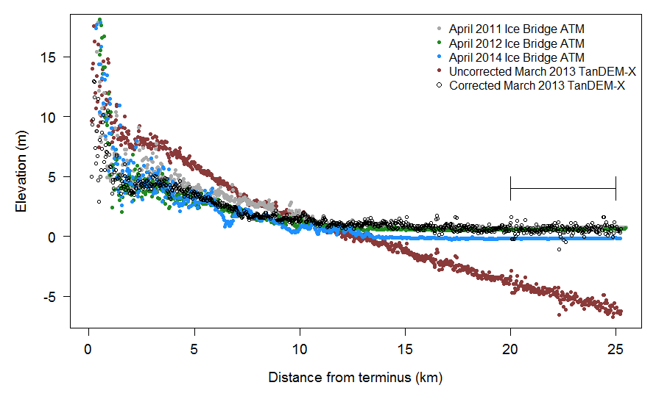
Fig. S1. Ice Bridge ATM (2011, 2012 and 2014) and uncorrected and corrected TanDEM-X elevations for profiles in Kangersuneq Fjord from 17 March 2013. TanDEM-X profiles are detrended using Ice Bridge ATM elevations from 08 April 2011 between 20 and 25 km down-fjord of the KNS terminus (segment line).
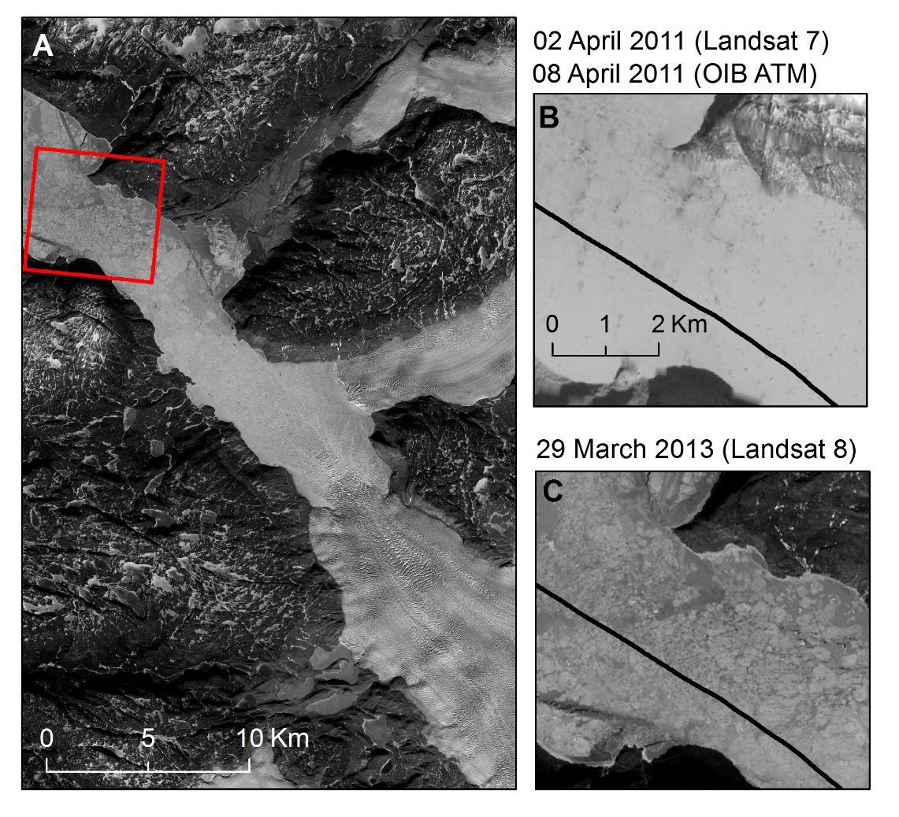
Fig. S2. Sea ice extent in Kangersuneq Fjord over (a) the full-fjord on 29 March 2013 (Landsat 8 band 8) and (b,c) the patch of thin sea ice between 20-25 km down-fjord of the KNS grounding line (over which we correct the DEM tilt using OIB ATM data) for (b) 02 April 2011 (Landsat 7 band 8) and (c) 29 March 2013, both overlain by the 08 April 2011 OIB ATM flight line. The red box in (a) indicates the location of (b,c). Note that the difference in sea ice brightness between scenes is likely due to higher snow cover on 02 April 2011, as compared to 29 March 2013.
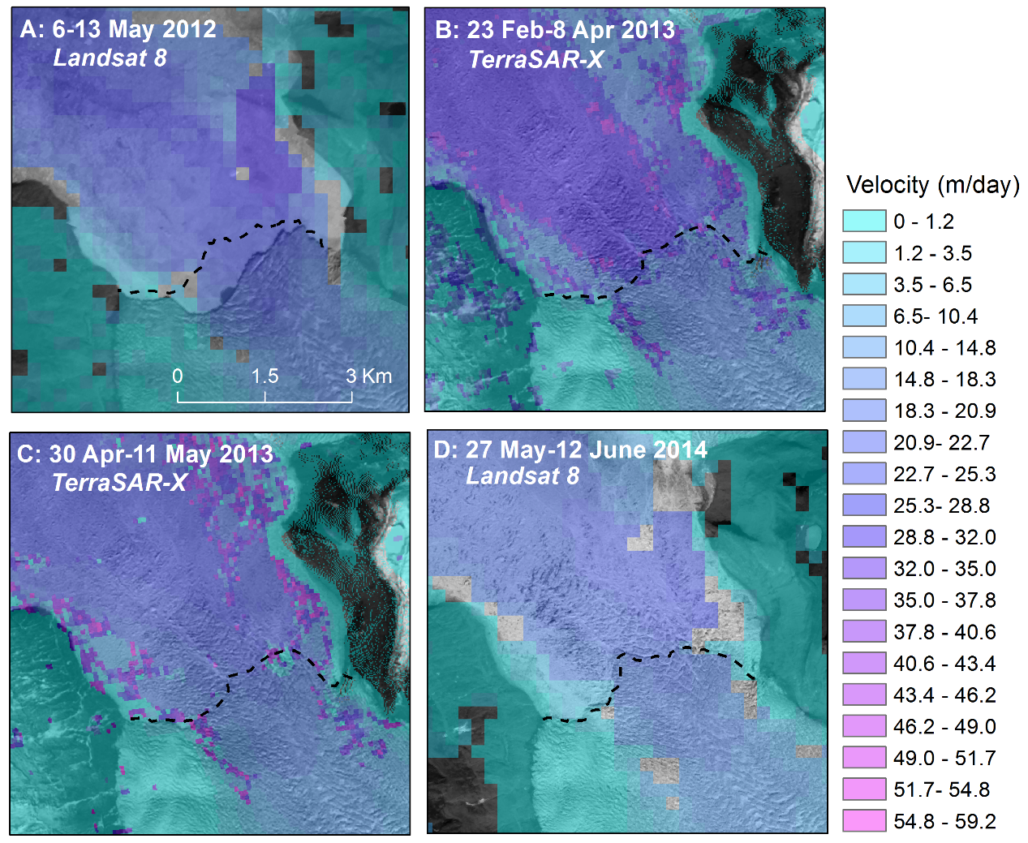
Fig. S3. Ice velocity maps derived from the feature tracking of (a) Landsat 8 image pair: 6 and 13 May 2012 (underlain by Landsat 7 image from 25 July 2012), (b) TerraSAR-X image pairs: 12 and 23 February and 8 and 19 April 2013 (underlain by Landsat 8 image from 1 May 2013), (c) TerraSAR-X image pair: 30 April and 11 May 2013 (underlain by Landsat 8 image from 1 May 2013), and (d) Landsat 8 image pair: 27 May and 12 June 2014 (underlain by Landsat 8 image from 12 June 2014). Black dashed lines are grounding line positions hand-digitized from Landsat 8 imagery.
Fig. S4. Comparison between March (black) and May (blue) 2013 steady state (SS, solid line) and non-steady state (NSS, dashed line) along-fjord submarine melt rate estimates, derived from averaged across-fjord melt rate estimates for the full ice tongue.
Fig. S5. Across-fjord profiles of submarine melt rates (m d⁻¹) 150 m down-fjord from the KNS grounding line, moving from west to east, from May 2012, March and May 2013, and May and June 2014.
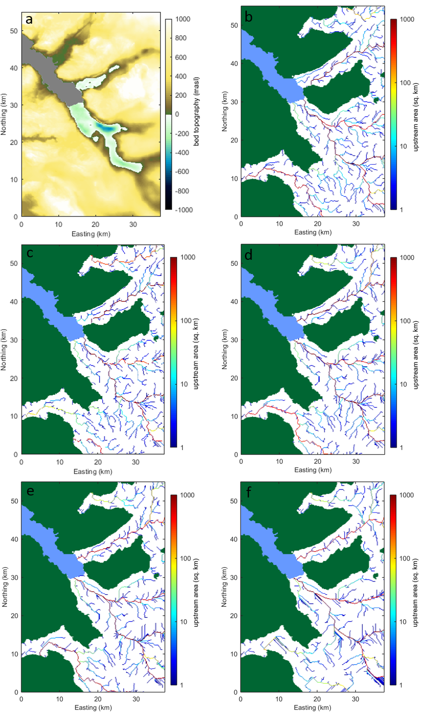

Fig. S6. (a) BedMachine v3 bed topography for KNS, used in hydropotential analyses for predicting subglacial flow routing with f-values of (b) 1.0, (c) 0.9, (d) 0.8, (e) 0.7, and (f) 0.3.

Fig. S7. Grounding line positions for the KNS terminus from June to August 2012, showing the creation of an embayment due to calving on the western side of the ice front. The background image is a Landsat 7 image from 25 July 2012.
TABLES
Table S1. Ice tongue surface melt rates (m d⁻¹) for two weeks prior to the date of each DEM; maximum and mean submarine melt rates (SMR, m d⁻¹) per DEM.
DEM | Surface melt (m d⁻¹) | Max. SMR (m d⁻¹) | Mean SMR (m d⁻¹)
13/05/2012 | 0.048 | 7.3 ± 2.3 | 1.3 ± 0.6
17/03/2013 | 0.0036 | 3.1 ± 0.8 | 0.8 ± 0.3
27/05/2013 | 0.020 | 3.8 ± 1.0 | 0.8 ± 0.3
14/05/2014 | 0.044 | 5.8 ± 1.6 | 0.9 ± 0.4
05/06/2014 | 0.050 | 5.7 ± 1.6 | 1.1 ± 0.4
Table S2. Acquisition dates of satellite imagery used for detecting the surface presence of plumes driven by subglacial discharge (as found in Figure 3a,c).
Acquisition date | Satellite/Sensor
30 June 2012 | Landsat 7
16 July 2012 | Landsat 7
25 July 2012 | Landsat 7
01 August 2012 | Landsat 7
17 August 2012 | Landsat 7
28 July 2013 | Landsat 7
04 August 2013 | Landsat 7

