A Novel Approach to Process Brittle Ice for Continuous Flow Analysis of Stable Water Isotopes
Supplementary Material
Rebecca L. Pyne, Elizabeth D. Keller, Silvia Canessa, Nancy A. N. Bertler, Alex R. Pyne, Darcy Mandeno, Paul Vallelonga, Stefanie Semper, Helle A. Kjær, Ed Hutchinson, W. Troy Baisden
CORE STORAGE IN THE FIELD
Buffer Storage and Snow Cave Specifications
- ~165 m³ total storage volume
- ~four metres below 2012/13 Snow surface
- Enough space for approximately 60 “AWI Type” ICB containing 360 metres of ice
- 256 metres of pre-processed core storage in ice core buffer
- Maintained at a temperature of -23°C or colder with active cooling

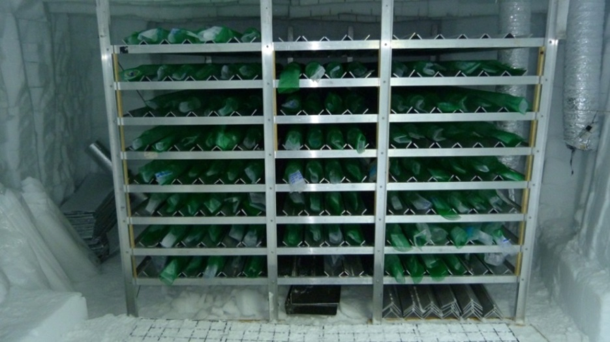
Figure S1. Core rest buffer shelving

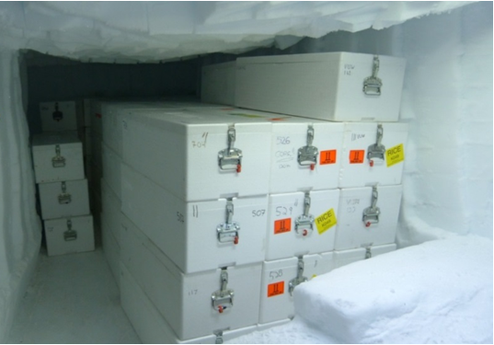
Figure S2. Storage cave containing RICE ice cores in boxes

Refrigeration Unit Specifications:
- Type: Skope UF50AA “mono-block design”
- Expected heat load 0.7 kW
- Unit electrical load 1.8 kW (run from a 3kVa mogas Honda Generator)
- Refrigerant: R404a (HFC blend)
- Manual defrosts
- Manual controlled economiser baffle for fan-only operation
- Electronic controller replaced with lower tech electro-mechanical system
- Plastic Tub Clam shell housing
- Supply air temp -25°C
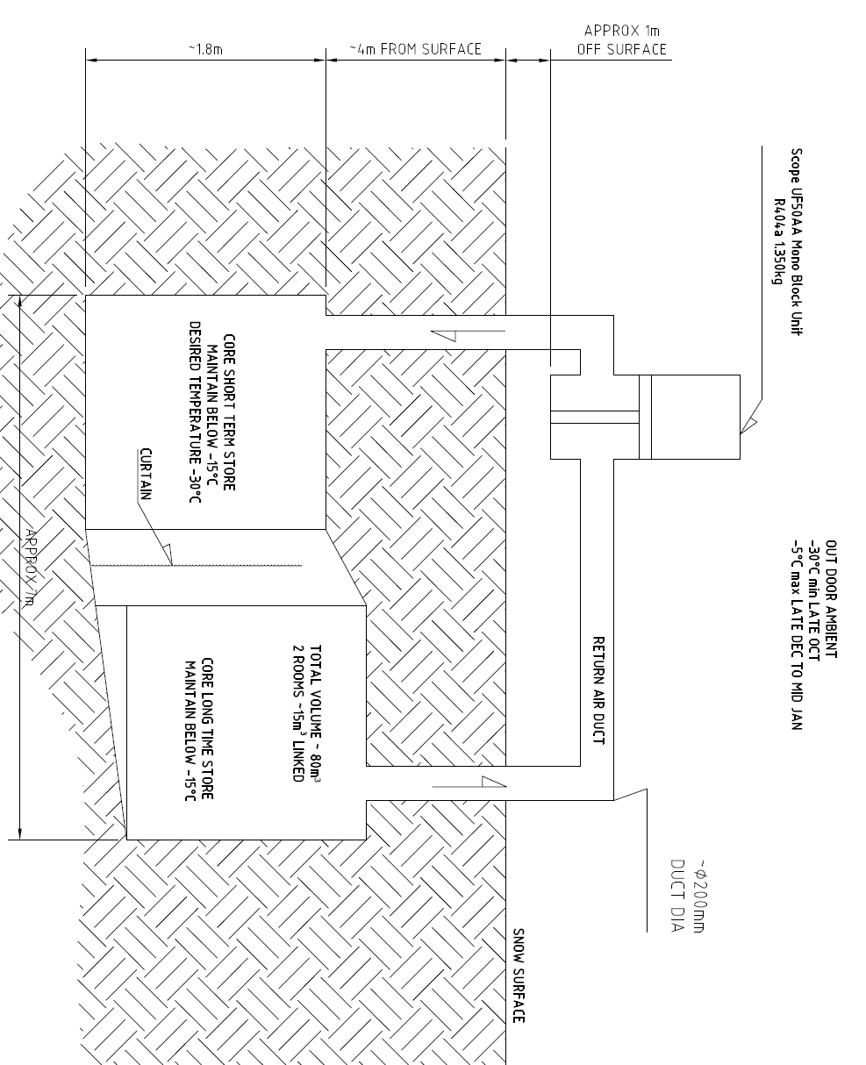
Figure S3. Core buffer and air circulation schematic
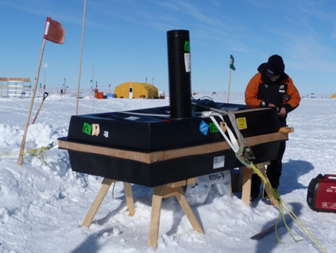
Figure S4. Weather proof housing for refrigerator on surface above cave

CORE SHIPPING AND TRANSPORT
The core boxes were stacked and wrapped in custom-designed thermal blankets and transported with Kenn Borek’s BT-67 Baslers back to Scott Base. The aircraft was flown at a higher altitude to reduce cabin temperature on the 2.5-hour flight. The cores were then stored at -36°C in a ISO 20’ freezer container (RICE reefer). The reefer was shipped to Christchurch, New Zealand and trucked to the National Ice Core Research Facility in Lower Hutt, Wellington, where the boxes were unloaded and stored at -36°C.
During the two drilling campaigns, slightly different storage methods were used. However, some variables such as: core boxes, thermal blankets and snow cave storage stayed the same. In season one drill cuttings were used as packing material to keep the cores secure and to add more cold thermal mass to the boxes. During season two cuttings were replaced with pre-cut polyethylene (PE) foam to the secure the cores. The foam did not add any cold thermal mass to the boxes but it had the benefit of making the boxes lighter than the previous season.
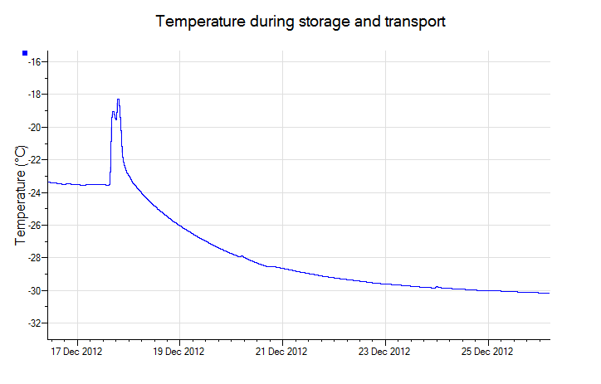
RI
Scott Base
Flight
Figure S5. Typical core box inner temperature

CORE PROCESSING FOR CFA
We used a two-knife procedure: the first knife was used to do the initial cleaning and to even the break surface, and then a second, clean knife was employed to carefully shave a small additional amount of ice from the face of the break. This method was developed to minimize geochemical contamination, for trace element concentrations measured at ppb to ppq levels. After cleaning each segment, the second knife was rinsed by dipping it into 18.2 MΩ Milli Q water and shaken dry to remove excess water to avoid contamination for water stable isotope measurements.
The drop-down saw was employed when the break affected a large area (i.e. more than 2cm) and using ceramic knives might have caused additional damage. The edge of the break was cut to a uniform surface and the extra pieces were labelled and kept for discrete stable isotope analysis. Then the surface was shaved using the two-knife procedure.
Knives were regularly cleaned, checked for nicks and discarded if damaged and the water was exchanged between each stack of cores, which comprised four one meter sections.
Ice controlling tools machined out of a mixture of PTFE and glass were occasionally used to adjust the ice as it melted, rearranging if it became stuck or started to move off its center. Care was taken to only touch the ice on the outer portion of the ice to keep potential contamination low. These tools were cleaned with MQ 18.2 MΩ water (soaked for 24 hours) between each melted stack.

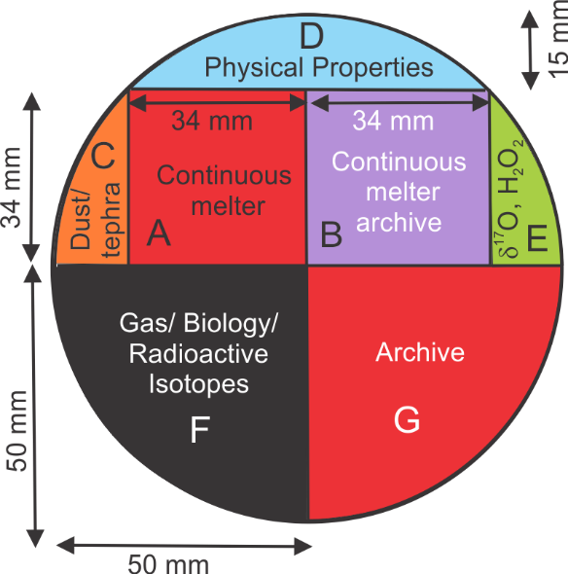
Figure S6. RICE core cutting plan.

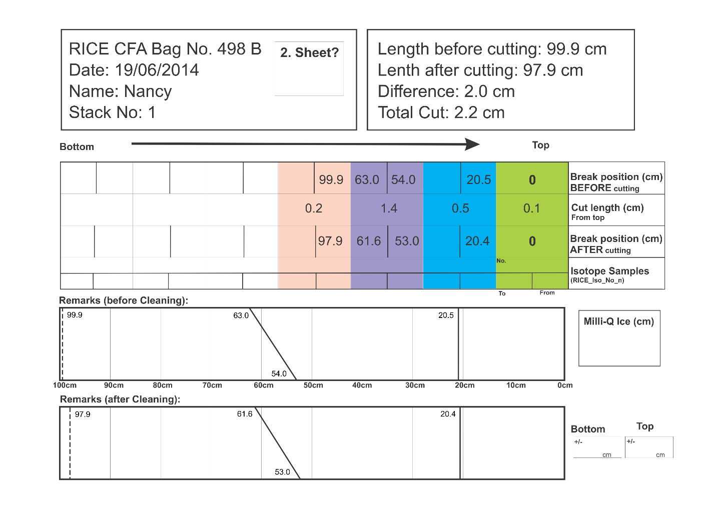
Figure S7. Cutting Log Sheet for core 498 B. Colors correspond to specific break – recording the position before and after cleaning/cutting the core. Green is for the top end of the core (the shallowest depth), cyan is for the first break (a straight break), purple for the second break (a slant break), and peach is for the bottom of the core. A one metre core with no breaks would still record how much material was cleaned off the top and bottom of the core, so there are always breaks recorded in the green and cyan columns. Columns that are not needed are left blank.

CFA SYSTEM
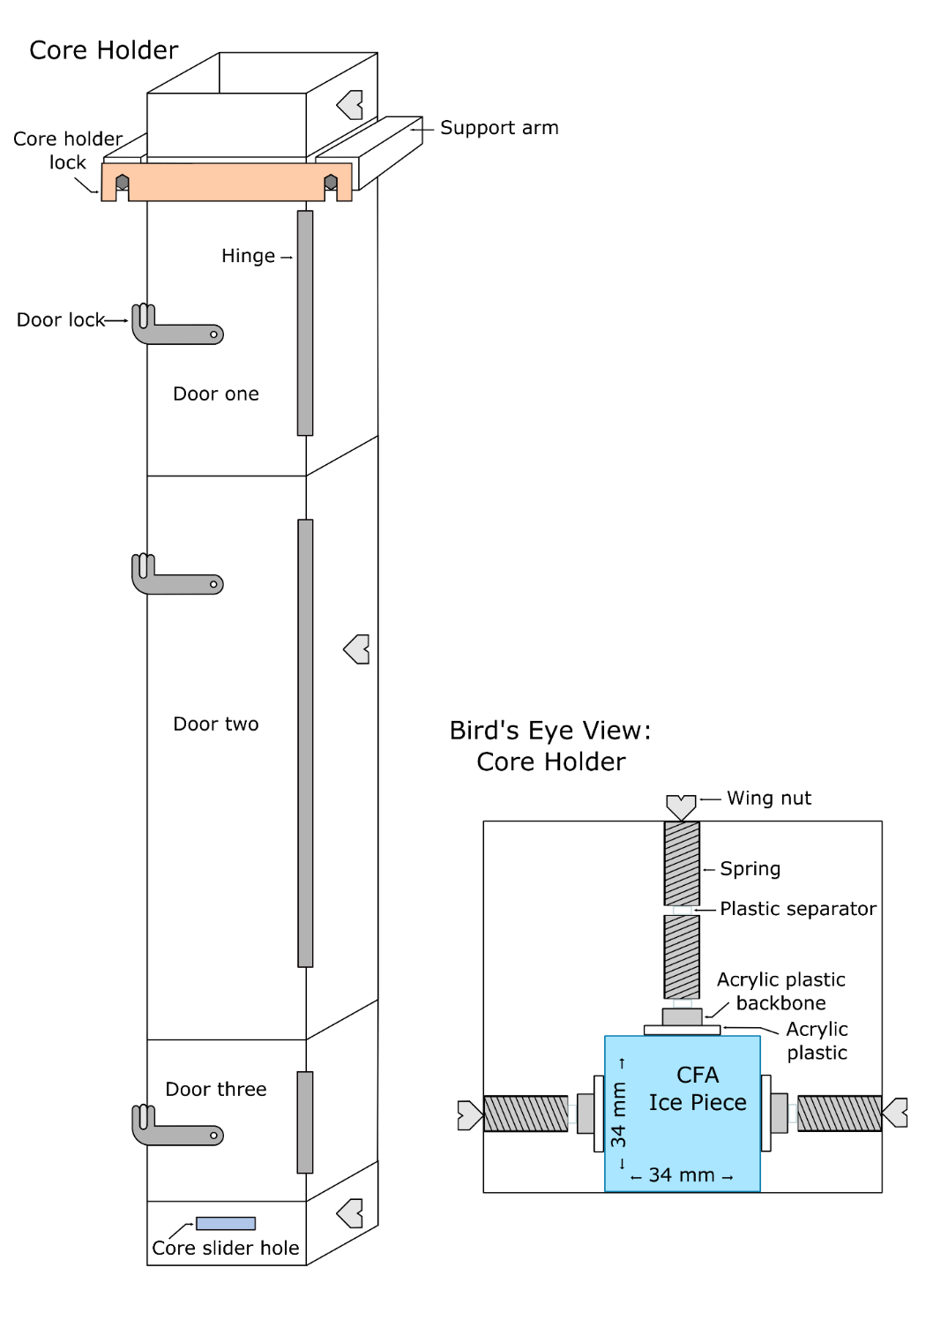
Figure S8. Upright core holder and bird’s eye view looking down into the core holder. Main modifications are three doors that can be opened independently, extra springs to keep the ice pieces together, a backbone added to the acrylic core guiders (acrylic plastic in picture) and a polytetrafluoroethylene (PTFE) coating on the guiders that reduced ice/plastic friction. Figure not drawn to scale.
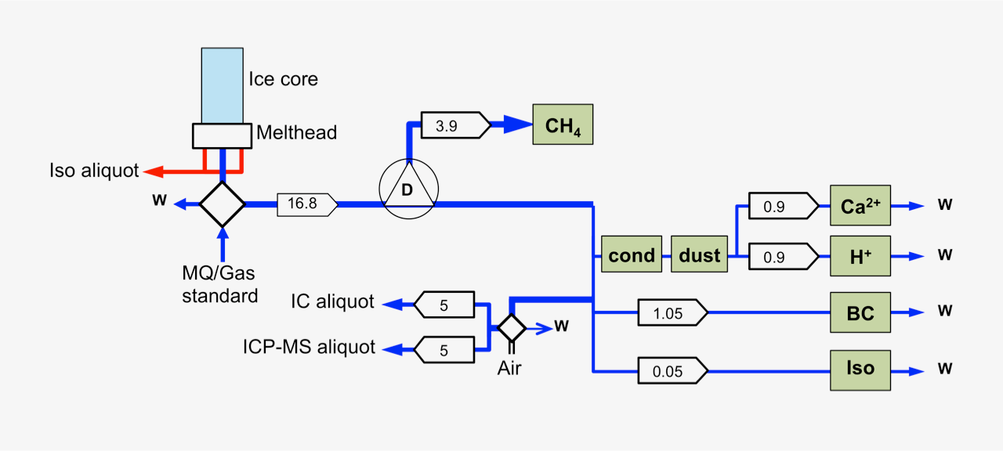
Figure S9. Schematic of RICE CFA setup (reproduced from Winstrup et al, in review). A one metre-long ice-core rod (light blue) is placed on a melt head, which separates melt water from the pristine inner part of the core from that of the more contaminated outer rim. Meltwater from the outer stream (red) is used for discrete measurements of water isotopes, while the melt water stream from the inner core section (dark blue) passes through a debubbler (D), which separates air from the melt water. The air composition is analyzed for methane concentration, while the meltwater stream is channeled to various analytical instruments for continuous impurity analysis of dust, conductivity (cond), calcium (Ca^{2+),} acidity (H⁺), black carbon (BC), and water isotopes (Iso), as well as collected in vials for discrete aliquot sampling by IC and ICP-MS. W denotes waste water. Diamonds represent injection valves used for introduction of air or water standards when the melter system is not in use. Arrow boxes indicate liquid flow rates in mL/minute. Green boxes represent analytical instruments.

RESULTS AND ANALYSIS
a
b
Figure S10. (a) Difference between water isotope data from core sections 498 A and B (B – A) over the slanted segment in section B. Also shown are the approximate combined error for both measurements, δ²H = ±1.13 ‰ and δ¹⁸O = ±0.31 ‰, based on the sum in quadrature of the average error of δ²H = ±0.85 ‰ and δ¹⁸O = ±0.23 ‰ for core section 498 A and an overall average error of δ²H = ±0.74 ‰ and δ¹⁸O = ±0.21 ‰ applied to section 498 B. (b) Difference between core section 498 B (with a real slanted break) and our simulated slanted break using data from 498 A (B – A sim). The error ranges in (b) are the average error for 498 A, δ²H = ±0.85 ‰ and δ¹⁸O = ±0.23 ‰. We do not assign error to the simulated data because it is a theoretical model.

Depth range (m) | Number of pieces recovered (count)
 | 1 | 2 | 3 | 4 | 5
all | 355 | 33 | 9 | 2 | 2
0-100 | 55 | 1 | - | - | -
100-200 | 52 | 3 | - | - | -
200-300 | 47 | 4 | - | - | -
300-400 | 44 | 3 | 3 | - | -
400-500 | 43 | 6 | 1 | 1 | -
500-600 | 41 | 8 | - | - | 1
600-700 | 45 | 4 | 1 | - | 1
700-760 | 25 | 4 | 4 | 1 | -

Table S1. For each drill run (designed to cut a two metre length of ice core), number of pieces of ice recovered and brought to the surface vs. accumulated depth. Most of the cores above 500 m depth were recovered in single 2 m lengths.

File name | Stack | 1 Slant Cut | 1 Break Before One | 1 Cut Length | 1 Break After One | 2 Slant Cut | 2 Break Before One | 2 Cut Length | 2 Break After One | 3 Slant Cut | 3 Break Before One | 3 Break Before Two | 3 Cut Length | 3 Break After One | 3 Break After Two | 3 Isotope Samples | 4 Slant Cut | 4 Break Before One | 4 Cut Length | 4 Break After One | 4 Isotope Samples
RICE_12-13_Deep_497.txt | 1 | n | 0.0 | 0.2 | 0.0 | n | 33.1 | 1.5 | 33.0 | n | 68.4 |  | 8.2 | 66.1 |  | 1,2 | n | 99.8 | 3.1 | 87.3 | 3
RICE_12-13_Deep_S_498.txt | 1 | n | 0.0 | 0.1 | 0.0 | n | 20.5 | 0.5 | 20.4 | y | 54.0 | 63.0 | 1.4 | 53.0 | 61.6 |  | n | 99.9 | 0.2 | 97.9

Table S2. Cutting Log Table showing melt stack 1 and cores 497 A and 498 B with length and break information. Color coding corresponds to Cutting Log Sheet (Fig. S2) and to RICE CFA Core 498 B (Fig. 2).

