### Supplementary Material

**Appendix A: Tables**

### Table A1. Input parameters for the energy-based mass balance model on MZ15 glacier

|  |  |  |
| --- | --- | --- |
| Abbreviation | Parameter | Values |
| MZ15 | |
| *Trate* (ºC/100m) | vertical air temperature gradient | -0.67 | |
| *Prate* (%/m) | vertical precipitation gradient | 0.055 | |
| *Pcorr (%)* | Precipitation correction | 37 | |
| *Pressrate* (hpa/100m) | vertical air pressure gradient | -7.58 | |
| *Zth* (cm) | snowfall event threshold | 8 | |
| *Tsnow* (°C) | phase threshold for snow | 0 | |
| *Train* (°C) | phase threshold for rain | 2 | |
| *PP_snow* | fraction of *Snet* absorbed in snow surface layer | 0.02 | |
| *PP_ice* | fraction of *Snet* absorbed in ice surface layer | 0.04 | |
| *αsnow* | fresh snow albedo | 0.78 | |
| *αfirn* | firn albedo | 0.53 | |
| *t\** (day) | albedo time scale | 4.5 | |
| *d\** (cm) | albedo depth scale | 8 | |
| *aice* (°C-1) | parameter of ice albedo | 0.3 | |
| *C**1* ((K/hPa)*C2*) | parameter of *Lin* | 1.034 | |
| *C2* | parameter of *Lin* | 8.634 | |
| *C3* | parameter of *Lin* | 1.644 | |
| *C4* | parameter of *Lin* | 0.604 | |
| *CS* | snow exchange coefficient of turbulent heat flux | 0.002 | |
| *CL* | ice exchange coefficient of turbulent heat flux | 0.002 | |
| *ρsnow* (kg/m3) | fresh snow density | 200 | |
| *ρice* (kg/m3) | Ice density | 900 | |
| *ρfirn* (kg/m3) | initial snow density | 410 | |
| *Tf* (ºC) | fixed bottom temperature at 10 m | -3.9 | |

**Appendix B: Figures**

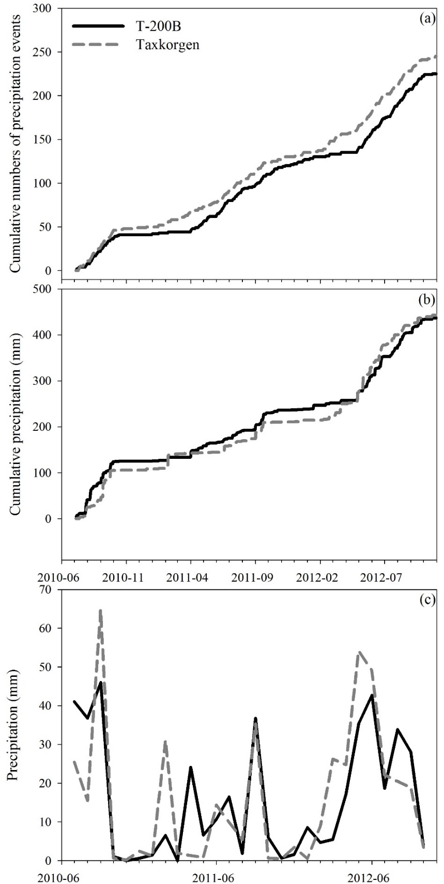

**Figure B1** Comparison of the observed and reconstructed cumulative numbers of precipitation occurrence events, cumulative precipitation amounts and monthly precipitation

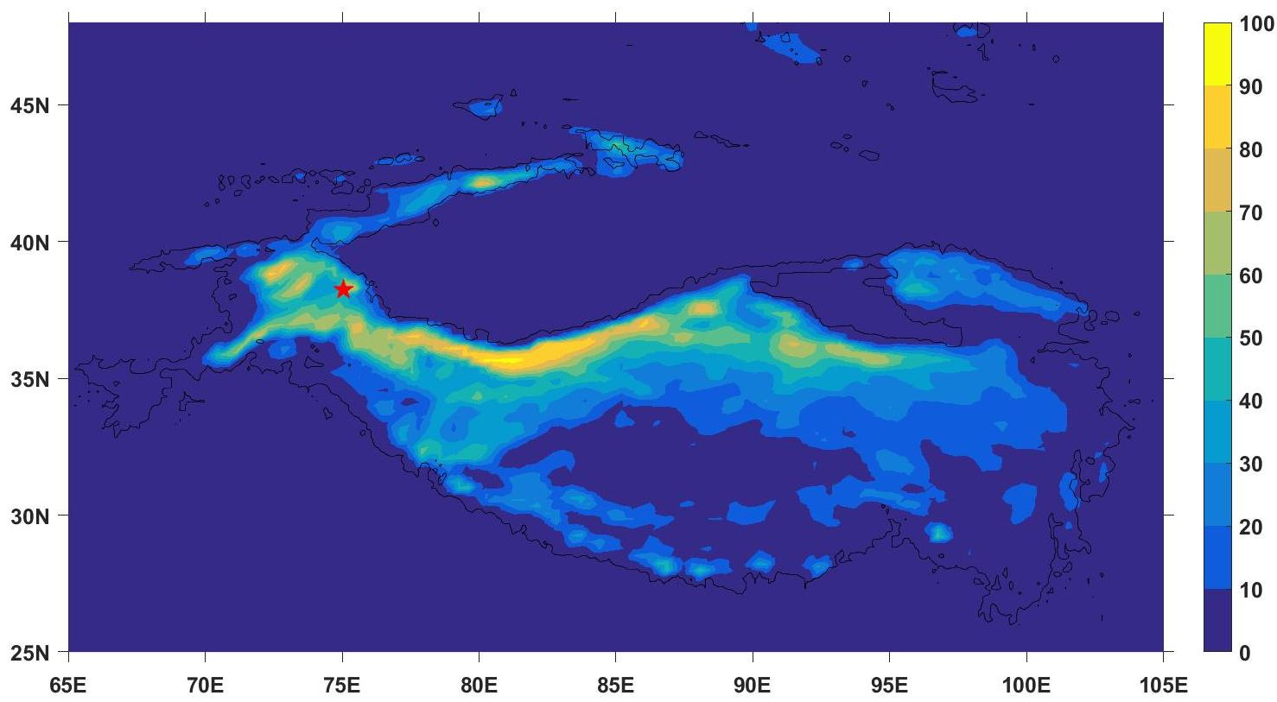

**Figure B2** The mean ratio of snowfall to precipitation in the ablation season from 2001 to 2014 on the TP. Snowfall and precipitation were from the High Asia Refined analysis with 30 km resolution. And red star indicated that the site of MZ15 glacier.

**Appendix C: Parameterizations used in the mass balance model**

C1: Incoming shortwave radiation

The direct component (*I*) of incoming shortwave radiation is calculated as follows:

 (C1)

where *DF* is the diffuse fraction of total incoming shortwave radiation, *Qˈn* is the equivalent radiation received by a surface normal to the sun’s rays, *Z* is the angle of the sun above the horizon, *Z**ˈ* is the angle of the slope from the horizontal (always positive), *A* is the solar azimuth (defined as degrees from due south; positive values indicate west of due south and negative values indicate east of due south), and *Aˈ* is the aspect of the slope (measured as degrees from due south, positive values indicate west of due south and negative values indicated east of due south) (Arnold and others, 1996). *Qˈn* and *DF* are calculated as follows:

 (C2)

 (C3)

where *Smeasured* is the incoming shortwave radiation measured in a horizontal plane at an AWS, and *n* represents the cloud cover. For complete cloud cover, n=1, and 80 percent of global radiation is diffuse, decreasing to 15 percent for a clear sky, when n=0. *n* is calculated as follows:

 (C4)

where *K* is the theoretical maximum incoming shortwave radiation under a cloud-free sky*. K* is calculated as follows:

 (C5)

where *I0* is the solar constant (1368 W/m2), *Ψ* is the atmospheric clear-sky transmissivity (075), *P* is atmospheric pressure, *P0* is mean atmospheric pressure at sea level (100 000 Pa) and *θ* is the solar zenith angle.

The diffuse component (*D*) of incoming shortwave radiation is calculated as follows:

 (C6)

where *aterrain* is the mean albedo of the snowpack or glacier, and *Vsky* is the sky view factor.

The incoming shortwave radiation flux is calculated as:

 (C7)

The influence of topographic shading on incoming shortwave radiation differs widely in its degree of importance between glaciers, ice caps and even between regions of a single ice mass (Arnold et al., 1996). If the grid cell being considered is topographically shaded, the direct radiation is set to zero. Topographic shading is calculated on an hourly basis using the method proposed by Hock and Holmgren (2005). The code can be downloaded from <http://regine.github.io/meltmodel/>. Daily mean incoming shortwave radiation flux are applied to the energy-based mass balance model.

C2: Albedo

Daily albedo (*α*) is calculated by the method recommended by Oerlemans and Knap (1998), as a function of snow fall frequency and depth as follows:

 (C8)

 (C9)

Where *αs* is the fresh snow albedo, *αice* is the ice albedo, *d* is the snow depth, *d\** is the characteristic scale for snow depth, *αfirn* is the firn albedo, *s* is the time since the last snowfall event, *i* is the actual time and *t\** is time scale.

C3: Incoming longwave radiation

The sky longwave radiation in an open environment, *Lo↓* (W/m2), is written as follows:

 (C10)

where *σ* is the Stefan–Boltzmann constant, *e* is the daily mean air vapor pressure (hPa), *Ta* is the daily mean temperature (K), *C1*, *C2*, *C3* and *C4* are constants, and *τ* is the bulk atmospheric transmissivity, which is calculated as follows:

 (C11)

where *STOA* is the extra-terrestrial radiation.

Assuming isotropic sky and terrain radiance, the surface longwave radiation in rugged terrain is simply written as follows:

 (C12)

where *ε* is the terrain emissivity, which is close to unity for most natural surfaces, and *TS* is the temperature of the emitting terrain (*K*), which is computed as follows:

 (C13)

for emitting ice and snow surfaces (which have the highest emissions), and

 (C14)

for emitting rock faces, where *ct* = 0.01 K W-1 m2.

C4: Outgoing longwave radiation

*Lout*is computed conventionally by the Stefan-Boltzmann law from surface temperature (*TS*)

 (C15)

and surface emissivity (*ε* equal to 1).

C5: Turbulent heat exchange

Turbulent heat fluxes are calculated using the bulk method as follows:

 (C16)

 (C17)

Where *Hsen* is the sensible heat flux; *Hlat* is the latent heat flux; *ρair* is the density of air (kg m-3); *cp* is the specific heat of air at constant air pressure (1006 J kg-1 K-1); *Cd* is the bulk coefficient for sensible and latent heat; *u* is the wind speed (m s-1) at the 2 m level; *q* is the specific humidity at the 2 m level; *qs* is the specific humidity at the snow/ice surface.

C6: Subsurface energy, subsurface temperature and Refreezing of water

Subsurface energy, subsurface temperature and Refreezing of water are calculated using the methods of Fujita and Ageta (2000). The detailed formulaes can be seen in Fujita and Ageta (2000).

C7: Snow Accumulation (*Psnow*)

The estimation of *Psnow* considerably affects the glacier mass balance through the snowfall-albedo link (Mölg and Scherer, 2012). Generally, *Psnow* is modeled by the total daily precipitation (*P*) and two critical air-temperature thresholds for rain (*Train*) and snow (*Tsnow*). When air temperature (*Ta*) is above/below *Train*/*Tsnow*, *Psnow* equals to zero or *P*. Within these two temperature ranges, *Psnow* were calculated from linear interpolation with the following equation:

 (C18)