SUPPORTING INFORMATION

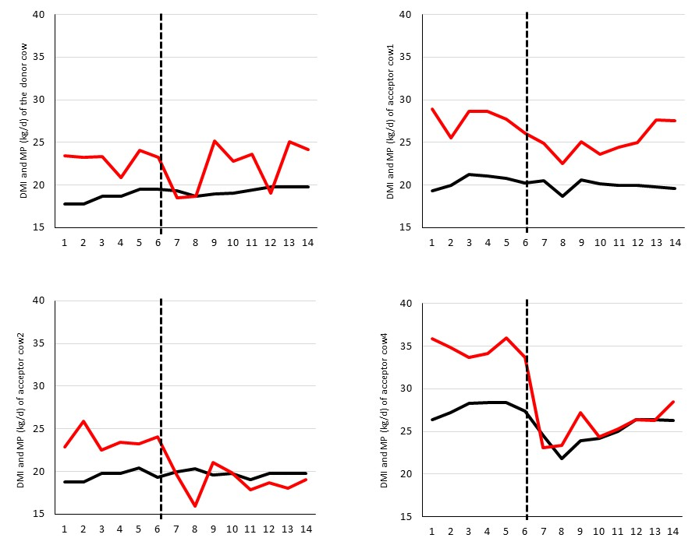

**Figure S1** weekly averages of daily dry matter intake (kg DMI per day – black line) and milk production (kg milk per day – red line). The black dotted line represents the time of rumen content transfer.



**Figure S2** Heatmap of the bacterial OTUs (horizontal) with prior sorting by sample-wide OTU abundance. The samples (vertical) are grouped per individual cow (separated by black lines) and ordered chronologically.