Geological Magazine
Eolian delivery to Ulleung Basin, Korea (Japan Sea) during development of the East Asian Monsoon through the last 12 Ma

C. H. Anderson^{1*}, R. W. Murray¹, A. G. Dunlea^{1, 2}, L. Giosan³,
C. W. Kinsley⁴, D. McGee⁴, and R. Tada⁵
*corresponding author: canderso@bu.edu
¹ Department of Earth and Environment, Boston University, Boston, MA, 02215, USA.
² Now at: Department of Marine Chemistry & Geochemistry, Woods Hole Oceanographic Institution, Woods Hole, MA 02543, USA.
³ Department of Geology & Geophysics, Woods Hole Oceanographic Institution, Woods Hole, MA 02543, USA.
⁴ Department of Earth, Atmospheric and Planetary Sciences, Massachusetts Institute of Technology, Cambridge, MA 02139, USA
⁵ Department of Earth and Planetary Science, Graduate School of Science, University of Tokyo, Bunkyo-ku, Tokyo 113-0033, Japan
Supplemental Materials

Contents of this file

Text S1 to S4
Figures S1 to S5

Additional Supporting Information (Files uploaded separately)

U1430 Data file
End-Member data file

S1. Age Model, Linear Sedimentation Rate, Dry Bulk Density and Accumulation Rates

The age model for Site U1430 is based on shipboard and shore-based micropaleontology and paleomagnetostratigraphy (Kamikuri et al., 2017, Kurokawa et al., 2018; Matsuzaki et al., 2018). Dry bulk densities (DBD, g/cm³) were interpolated from shipboard measurements from Tada et al. (2013). Linear sedimentation rates (LSR, cm/kyr) were determined from the integrated age model. Bulk accumulation rates (BAR, g/cm²/kyr) were calculated from dry bulk density and linear sedimentation rates for each discrete sample (Figure S1).

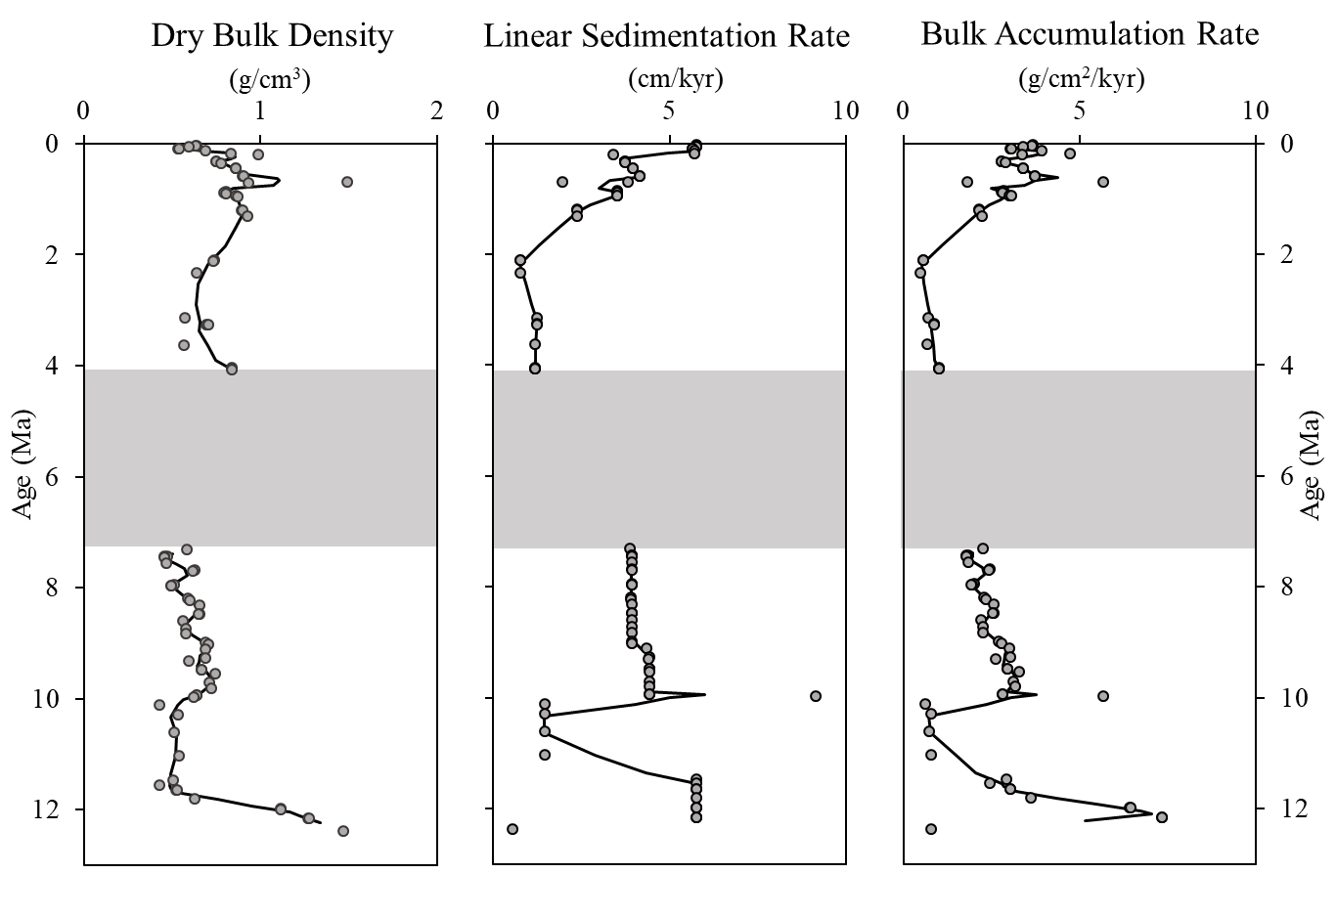

Figure S1. Dry bulk density (DBD, g/cm³), linear sedimentation rate (cm/kyr) and bulk accumulation rates (BAR, g/cm²/kyr) plotted with age (Ma). Shaded region denotes a hiatus (see main text). Discrete samples are represented as open circles, and a solid line denotes a three point moving average.

S2. Geochemical Trends

In addition to the ternary diagrams presented in the main text, other ternary diagrams record notable patterns at Site U1430 (Figure S2).
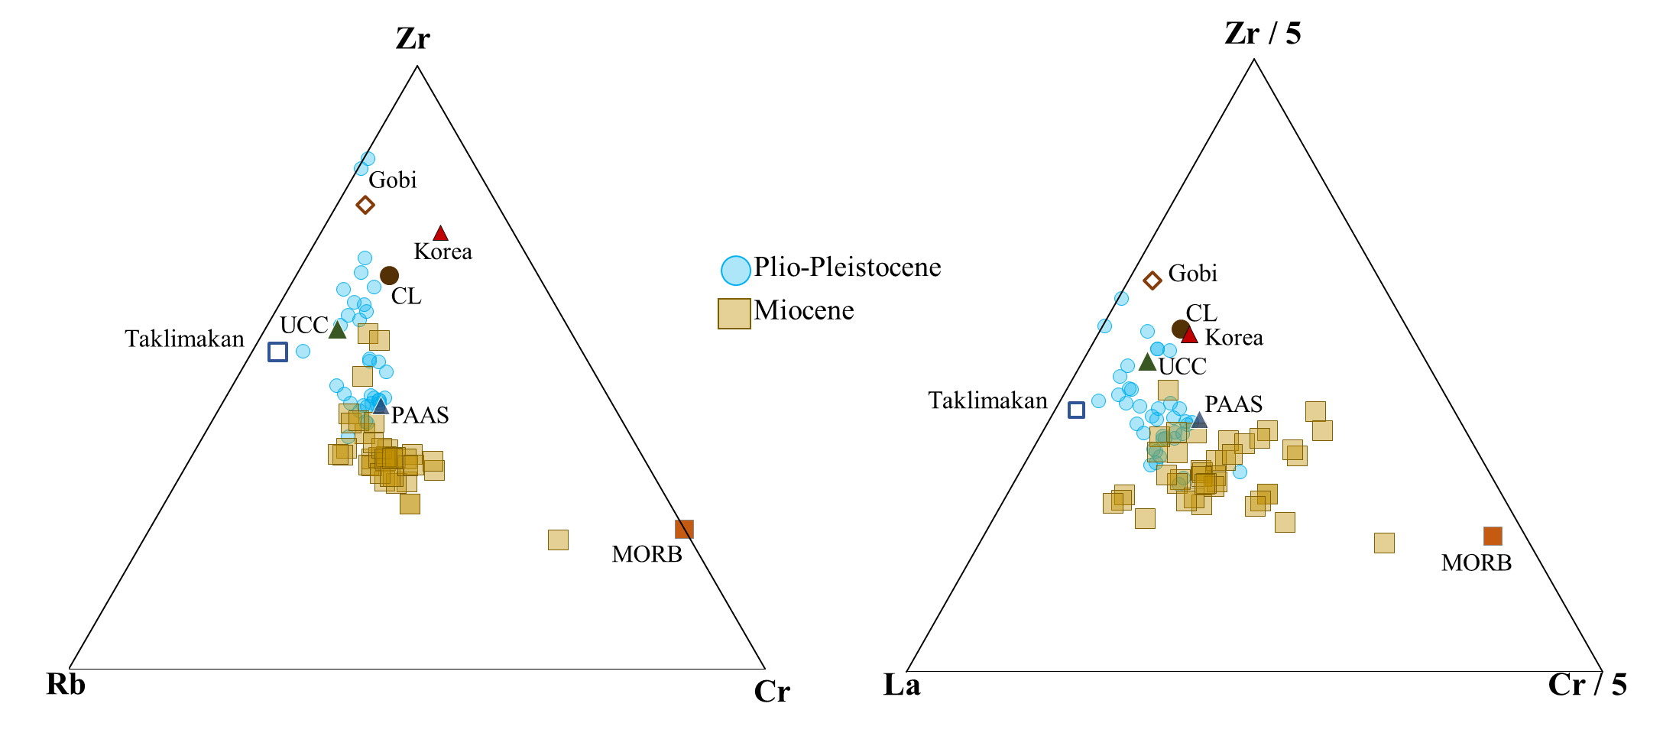

Figure S2. Bulk sediment samples plotted on ternary diagrams with end-member compositions. Left: Zr-Rb-Cr exhibits a “J-shape” mixing scheme, with Plio-Pleistocene data falling in two populations mixing between a cluster of CL, UCC, Taklimakan, and Gobi materials and toward PAAS. Miocene samples form a mixing arc between PAAS and and MORB. Right: In Zr-La-Cr space, Plio-Pleistocene samples contain a higher relative proportion of Zr than Miocene samples, and cluster between CL, PAAS, Taklimakan, and Gobi material, while Miocene samples form an array between Korean Peninsula material and MORB compositions. End-member acronyms are defined in the main text (Figure 3).

S3. Provenance Determination: QFA

To determine provenance, we use Q-mode Factor Analysis (QFA) (e.g., Pisias et al., 2013; Dunlea and Murray, 2015; Scudder et al., 2016; Anderson et al., 2018, and references therein) to quantify the minimum number of compositional factors and explain the maximum variability of the dataset. Each sample is assumed to be the result of mixing between the specific factors that explain the range of variability, and each factor is interpreted to be a representation of the sediment source. The statistical techniques used in the provenance modeling are available as MATLABTM scripts in Pisias et al. (2013) and Dunlea and Murray (2015).

Broad QFA analyses were first conducted using an expanded element suite to characterize the entirety of the bulk sediment, including biogenic components and aluminosilicates. These general QFA analyses were completed using additional major and trace elements (Si, Al, Ti, Ca, P, Sc, Cr, Rb, Sr, Nb, Th, and La) specifically designed to capture the lithologic variation (e.g., Ca and Sr to capture biogenic carbonate). In these tests, four factors explain 99% of the total variability (Figure S3). In the first and fourth factors, Al, Ti and Sc cluster, and Sc, Cr, Nb, Th, and La cluster, respectively. Together these two factors capture the aluminosilicate fraction that is the focus of this paper. In the second factor, Ca and Sr cluster and capture calcium carbonate. Si and Cr co-vary and suggest biogenic opal in the third factor. We conducted additional QFA analysis with Fe and Mn to test for the potential presence of oxides, and they were not a significant component. The results of this broad QFA are consistent with the lithostratigraphy (Tada et al., 2013) and reaffirm our confidence that these statistical approaches are appropriate for this setting.

When focusing on provenance of aluminosilicate materials, previous research (Scudder et al., 2009, Dunlea et al., 2015, Anderson et al., 2018) has generally used a base element menu including Al, Ti, Sc, Cr, Rb, Nb, Th, La, and other classical “terrigenous associated” elements. Sequential QFA analyses were conducted removing one element at a time from this element menu. With each new analysis, the co-varying elements and the fraction (percent) of data variability explained by each factor were compared between all runs. This ensures that the final factors are robust with the full element menu, downsized to the seven element menu. To best constrain the aluminosilicate fraction of the bulk sediment in this study, a specifically focused element suite was used to target only the aluminosilicates and to differentiate various aluminosilicates from each other. As described in the main text, the final aluminosilicate element menu used includes Al, Ti, Sc, Cr, Rb, Th, and La. Multiple iterations of QFA were conducted to ensure that all factors are statistically robust. Our aluminosilicate-targeted QFA, as discussed in the main text, explained 99% of the variability of the dataset.

Additional QFA of the Plio-Pleistocene and Miocene subsets of data resulted in four and three factors, respectively (Figure S4). The four Plio-Pleistocene factors describe 99% of variability in the dataset, as Factor 1 captures Al and Ti (56% of variability), both Factor 2 (4% of variability) and Factor 3 (23% of variability) capture Sc and Cr, and Factor 4 captures Rb, Th, and La (16% of variability). The three Miocene factors describe 98% of the variability in the dataset, as Factor 1 captures Al and Ti (38% of variability), Factor 2 captures Cr (48% of variability) and Factor 3 captures La (12% of variability). Each set of factors for the Plio-Pliestocene and Miocene subset populations broadly agree with the QFA results of the dataset as a whole.
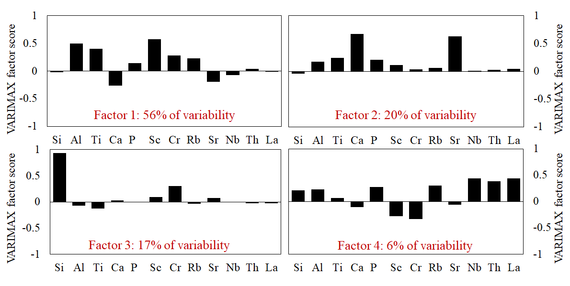Figure S3. VARIMAX-rotated factor scores from an expanded element suite for broad QFA characterization. The height of each bar indicates the VARIMAX-rotated factor score of each element in each factor. The absolute height of the bar indicates the strength of the covariance of the elements within the factor. Elements in these QFA statistical analyses were selected to test the fidelity of the statistical methods with general lithostratigraphy of biogenic components (CaCO₃, Factor 2; Biogenic opal, Factor 3) in addition to the aluminosilicates that are the focus of the study.
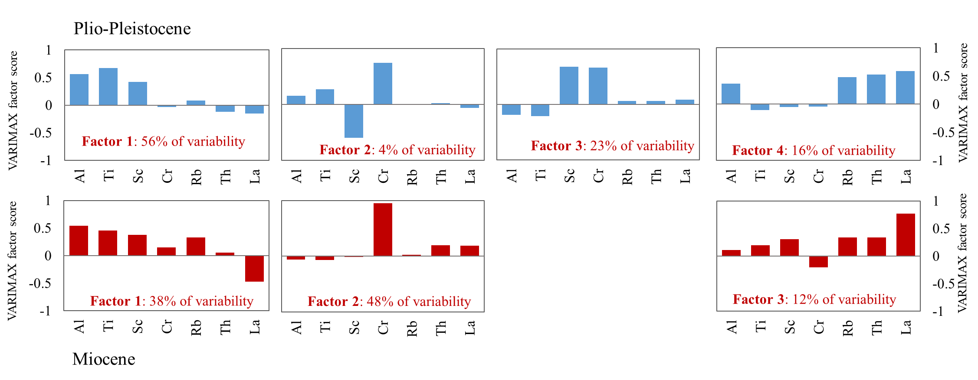
Figure S4. VARIMAX-rotated factor scores from age population QFA characterizations before (Miocene, red histograms) and after (Plio-Pleistocene, blue histograms) the hiatus. The height of each bar indicates the VARIMAX-rotated factor score of each element in each factor. The absolute height of the bar indicates the strength of the covariance of the elements within the factor. Each age population was tested individually to test the fidelity of the QFA analysis of the entire dataset to capture the variability of the data before and after the hiatus.

S4. Provenance Determination: CLS and Best-fit Models

Following the QFA, we use Constrained Least Squares (CLS) multiple linear regression techniques to test possible combinations of end-members. Building on the CLS codes from Pisias et al. (2013), the iterative CLS code from Dunlea and Murray (2015) removes the tedious, labor-intensive process of manually identifying the best-fit end-members. CLS creates multi-dimensional mixing models that calculate the optimal proportion of each end-member while minimizing the sum of the square statistical residuals between the model and sample dataset. Additional discussion of QFA, CLS, and the general model selection process are discussed at length in Anderson et al. (2018).

Potential end-members were geographically constrained during queries in the GeoROC geochemical database (http://georoc.mpch-mainz.gwdg.de/georoc/) to select the most probable samples from GeoROC’s collection of 18+ million data points. Materials included in this geographic search capture the main regions of Asia, including the major deserts in China and Mongolia, Himalaya and Tibetan Plateau crusts, a variety of loess values from the Chinese Loess Plateau, crust and volcanic material from Japan, crust and volcanic material from the Korean Peninsula, as well as generic reference materials such as Upper Continental Crust (UCC; Taylor and McLennan, 1985), Chinese Loess (CL; Taylor et al., 1983), and Mid-Ocean Ridge Basalt (MORB; Gale et al., 2013). Extreme outliers were removed, and data was grouped by geographic region and type and then averaged (e.g., loess sequences, Chinese provinces, specific Japanese Islands, volcanic material from specific Japanese volcanoes, Korean orogenic belts), resulting in 200+ end-members to test.

During iterative CLS tests, the potential end-member list was condensed as end-members not in the 1000 best performing models were removed from additional testing. High-performing end-members of similar composition (e.g. Chinese loess values of similar geochemical composition) and/or of geographic proximity were grouped when possible (e.g., crustal samples of a given Chinese province). The best performing models were determined by the sum of all element coefficients of determination, to maximize the goodness of fit for each element within the CLS model itself. This approach maintains the patterns common in the top performing models as an additional check when selecting the best model, even if differences between individual models of the overall goodness of fit is statistically insignificant. We identified 20 best-fit models from the top 500 models based on their sum of coefficients.

Geochemical values for all components were sourced from the GeoROC database and averaged for regional and geological composition (Figure S5). In CLS tests, formation and basin specific averages were tested, and subsequently combined as geochemical and regional “families” of possible end-members that appeared in similar frequencies in top preforming models. Overall there are meaningful differences between sources, but similar compositional envelopes between sources in single element space reiterates the need for multi element approaches and statistics to tease apart the overlap between aluminosilicates.

Three of the top performing end-members were calculated from published data collated and presented in GeoROC. The Taklimakan desert materials are sourced from the Xinjiang Province, China. This end-member includes 17 plutonic and granitic samples from the Junggar and Tarim basins. The Gobi Desert materials include 33 samples from the Gobi and Mongolian steppe. Samples included in this end-member are many granite formations, peralkaline granites, and dolerites representing the stony desert. The Korean Peninsula end-member includes 23 basalts, andesites, and volcanic belts throughout South Korea. Korean samples were constrained as best as possible to the eastern portion of the peninsula to possibly capture erosion and fluvial transport of volcanic materials into the western Japan Sea near Ulleung Basin. Additional Korean volcanic belts, granitic samples and regional averages did not appear in the best performing models.

Within the best performing models, careful consideration was made of patterns of end-member contributions. Taklimakan materials appeared consistently as the first end-member, Gobi Desert materials as the second end-member, and Chinese Loess values also appeared in most top performing models. We did, however, have two best-fit models that differed in the final end-member, as a primitive, depleted crust, or, alternatively, Korean Peninsula materials. Both geochemically constrain the dataset at Site U1430, but a primitive crust is not geologically probable at this location and given the proximity of Korea, we interpret this source as being the one from the Korean Peninsula.

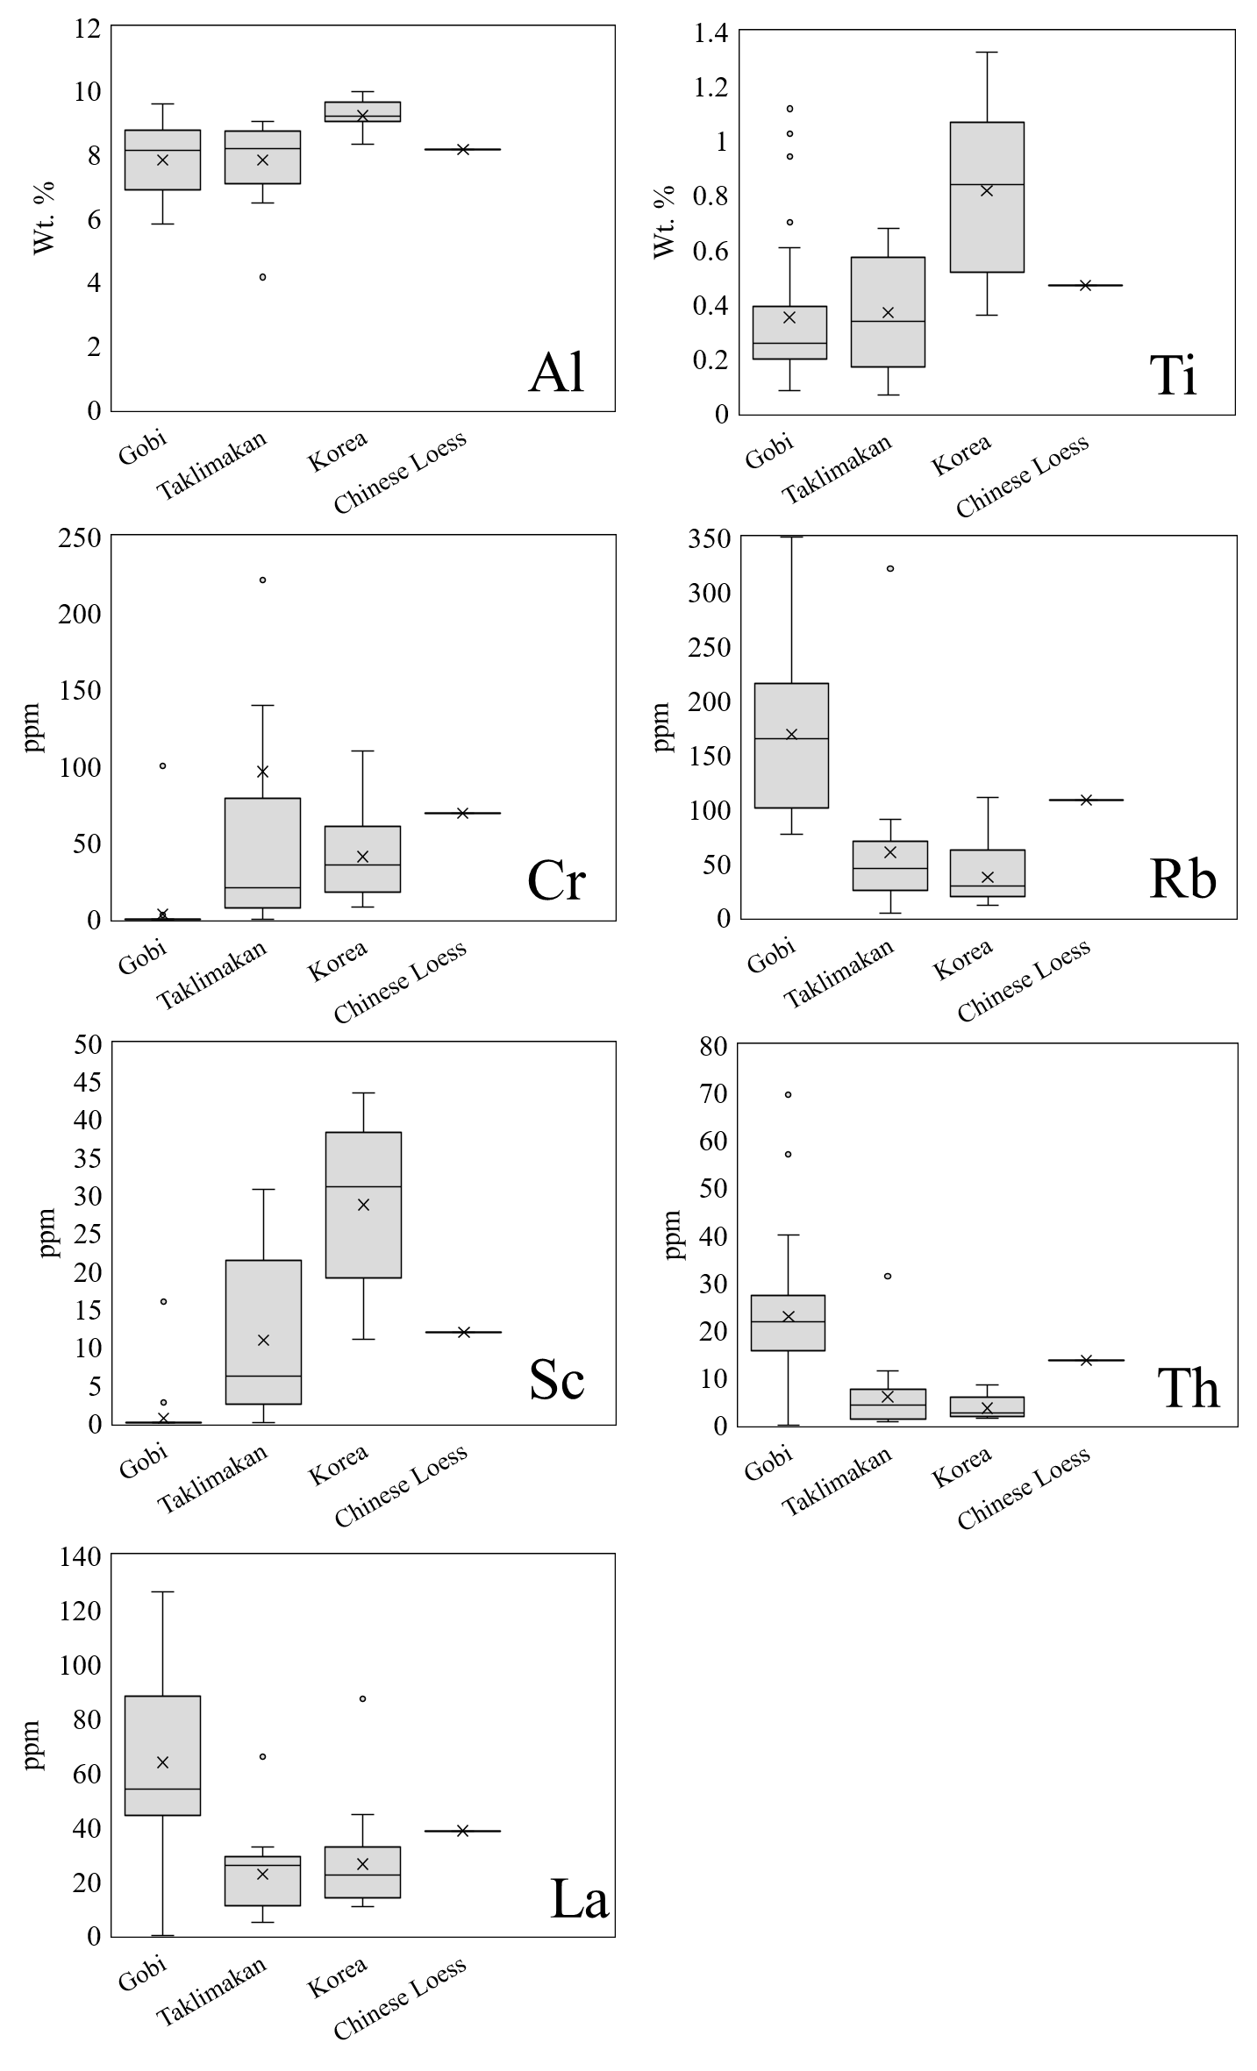

Figure S5. Element concentrations for each end-member as interquartile range (box), median (X), and outliers (circles) removed from final compositional averages. End-members may overlap in concentration range in one element, while covering different concentration ranges in other elements. The slight differences in element specific concentration ranges adds credence to multi-element and statistical approaches to determine aluminosilicate provenance.

