Supplementary information：
Fig. S1. Dietary restriction (DR) mediates lifespan. A representative lifespan experiment in triplicates. DR fed flies live longer than fully fed flies (p-value=0.000004), n=100, compared using the log-rank test.
Fig. S2. The distribution of sequencing coverage over all cytosines on both strands in DR and fully fed flies. (A) Cumulative coverage, more than 90% of cytosines were covered by at least one sequencing read. (B) The proportion distribution of cytosines sites that have a certain level of sequencing depth, approximately 1.5% of cytosine sites have 40X coverage.
Table S1. Information of primers used to perform q-PCR.
Table S2. Cytosine methylation in DR and fully fed flies in CG, CHG, and CHH genomic contexts (H = A, T, or C).
Table S3. Summary of differentially methylated regions (DMRs).
Table S4. Bisulfite sequencing result from Drosophila

-------------------------------------------------------------------------------------------------------

1. Fig. S1.
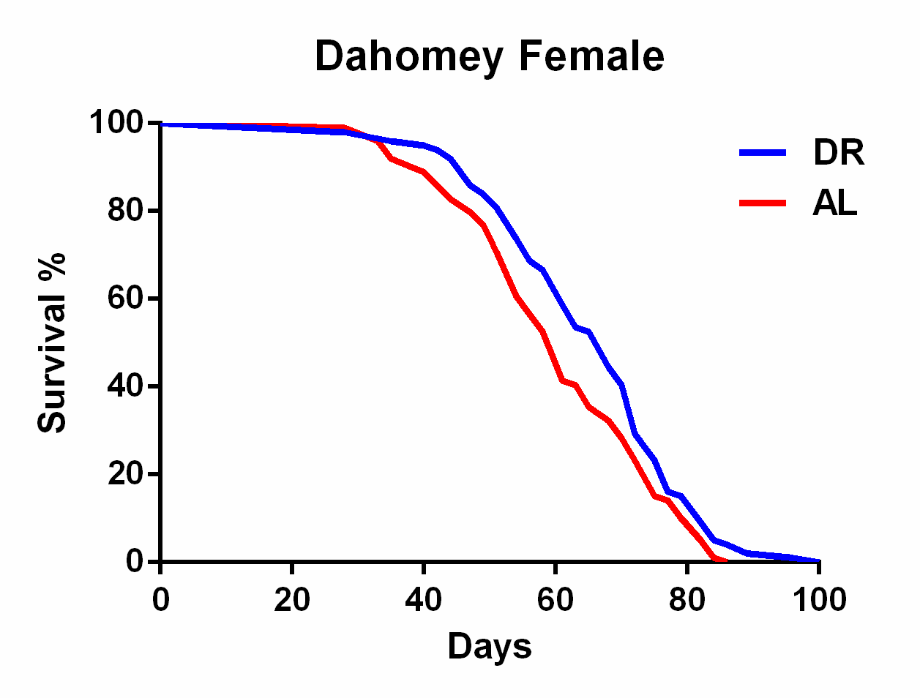

Fig S1. Dietary restriction (DR) mediates lifespan. A representative lifespan experiment in triplicates. DR fed flies live longer than fully fed flies (p-value=0.000004), n=100, compared using the log-rank test.
2. Fig. S2.

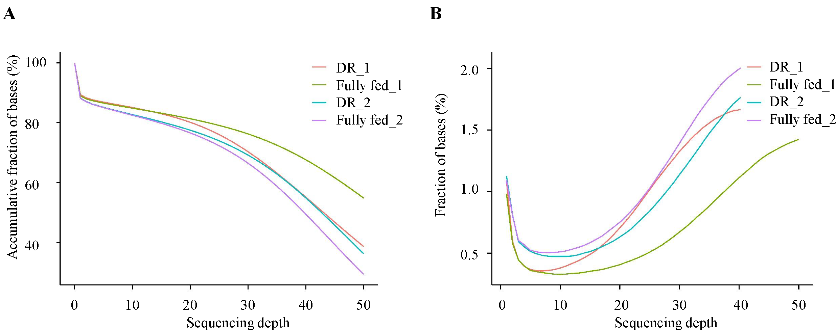

Fig. S2. The distribution of sequencing coverage over all cytosines on both strands in DR and fully fed flies. (A) Cumulative coverage, more than 90% of cytosines were covered by at least one sequencing read. (B) The proportion distribution of cytosines sites that have a certain level of sequencing depth, approximately 1.5% of cytosine sites have 40X coverage.

3. Table S1. Information of primers used to perform q-PCR.
Gene symbol | Primer sequence (5'to3') | Amplicon length/bp | Annealing temperature (℃) | Flybase ID
dsir2-F | CGGCCTCGTGCACCAAGTGT | 91 | 63.3 | FBgn0024291
dsir2-R | CACTGCGGGCACACCGGAAT
grappa-F | GTCTTAGTCACGGTCACAGCA | 148 | 63.3 | FBgn0264495
grappa-R | CCAGACAAAGTCGTGCGAAG
Act5C-F | CTCGCCACTTGCGTTTACAGT | 318 | 63.3 | FBgn0000042
Act5C-R | TCCATATCGTCCCAGTTGGTC

4. Table S2. Cytosine methylation in DR and fully fed flies in CG, CHG, and CHH genomic contexts (H = A, T, or C).

 | raw reads | clean reads | mapping rate(%) | average coverage(X) | C | mC | mC percent(%) | CG | mCG(Mb) | mCG percent(%) | CHG | mCHG | mCHG percent(%) | CHH | mCHH | mCHH percent(%)
DR | 45900184(5.74Gb) | 37121781(4.64Gb) | 61.62 | 32.29 | 8.43E+08 | 3E+06 | 0.00399114 | 1.68E+08 | 610209 | 0.3643 | 1.58E+08 | 620417 | 0.392 | 513679516 | 2133149 | 0.4153
Fully fed | 42642287(5.33Gb) | 34064372(4.26Gb) | 62.49 | 29.63 | 7.86E+08 | 3E+06 | 0.00419988 | 1.56E+08 | 603281 | 0.3861 | 1.48E+08 | 609940 | 0.4133 | 478699870 | 2087179 | 0.436

5. Table S3. Summary of differentially methylated regions (DMRs).

DMR id | chrom | DMR start | DMR end | mC sites | DR methylation Level | Fully fed methylation Level | DR depth | Fully fed depth | P value
DMR_2R_20966699 | 2R | 20966699 | 20966753 | 11 | 0 | 0.1 | 22.73 | 5.45 | 4.26E-05

6. Table S4. Bisulfite sequencing result from Drosophila
Sample | Mapping efficiency (%) | Average sequence coverage | BS Conversion Rate (%) | Reference
w1118,0-2h embryos | 57 | 32.0× | 99.75 | Raddatz et al. 2013
Dnmt2149,0-2h embryos | 52 | 23.6× | 99.42 | Raddatz et al. 2013
7d adult with DR | 61.62 | 34.69× | 99.72 | present result
7d adult with fully fed diets | 62.49 | 36.79× | 99.7 | present result
References
Raddatz, G., P. M. Guzzardo, N. Olova, M. R. Fantappié, M. Rampp et al., 2013 Dnmt2-dependent methylomes lack defined DNA methylation patterns. Proceedings of the National Academy of Sciences 110: 8627-8631.

