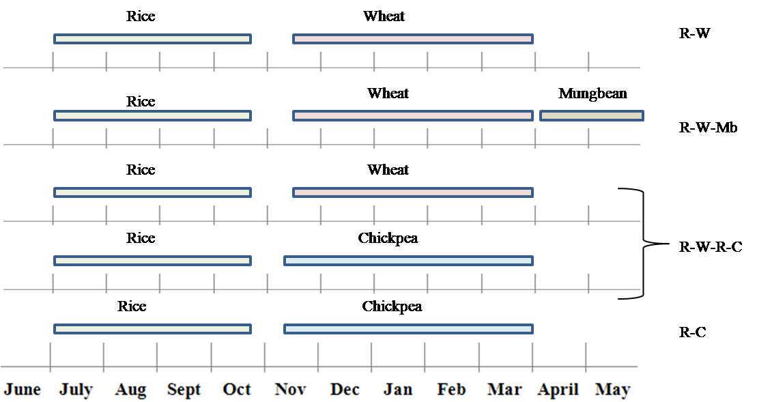
(a)

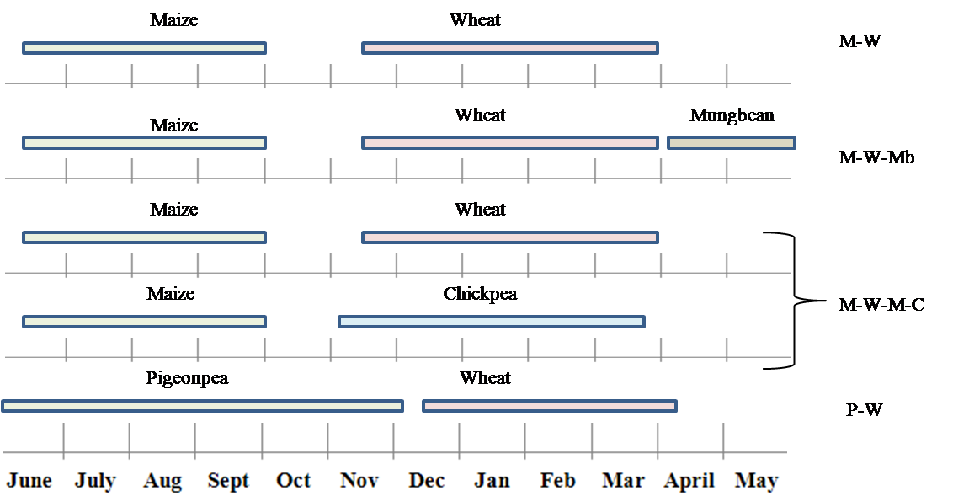
(b)
Figure S1. Temporal distribution of component crops under different crop rotations in lowland (a) and upland (b) production systems. R–W, rice–wheat; R–W–Mb, rice–wheat–mungbean; R–W–R–C, rice–wheat–rice–chickpea (2–year rotation); R–C, rice–chickpea; M–W, maize–wheat; M–W–Mb, maize–wheat–mungbean; M–W–M–C, maize–wheat–maize–chickpea (2–year rotation); P–W, pigeonpea–wheat.

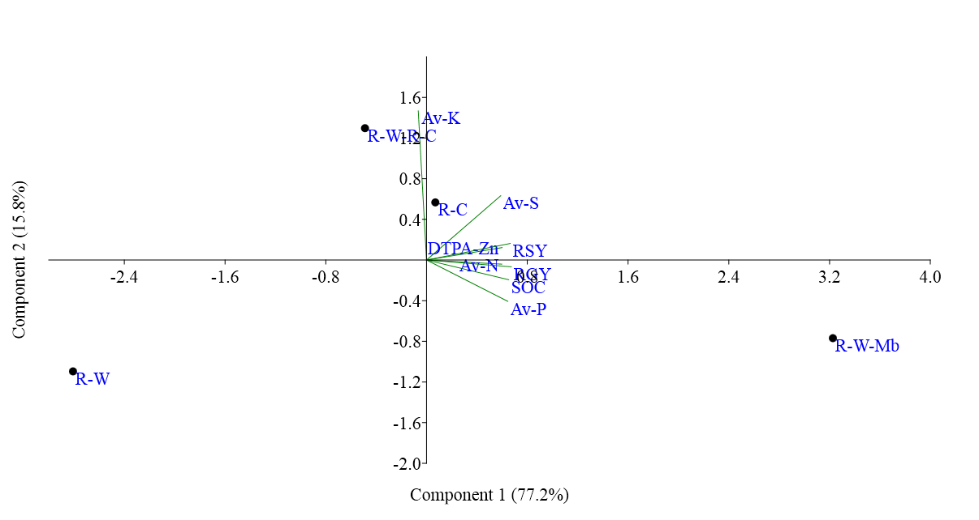(a)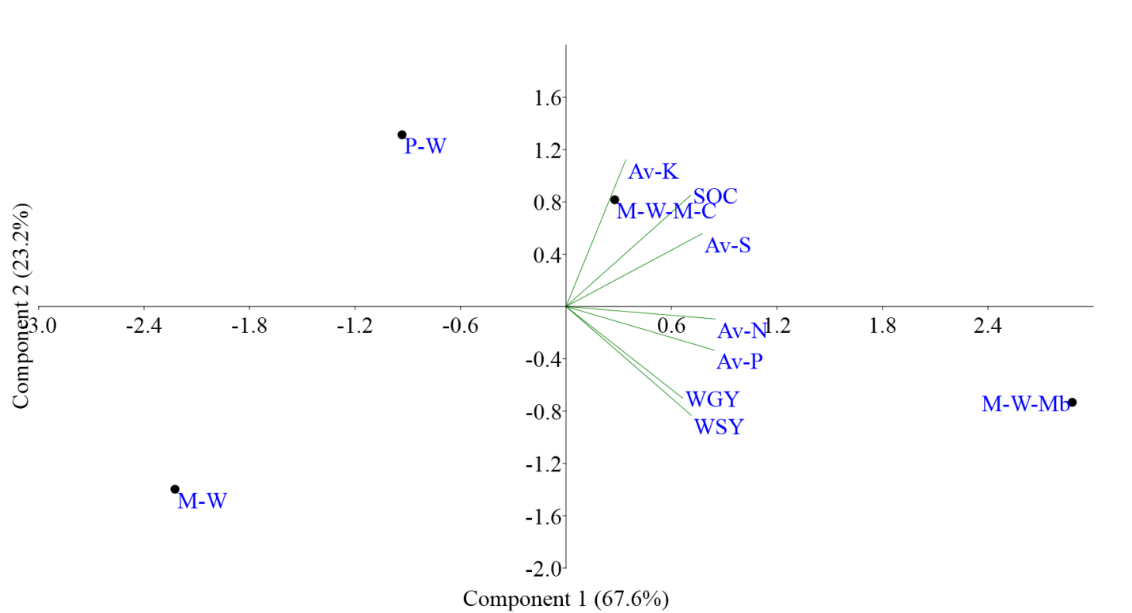(b)
Figure S2. Scatter plot of different cropping rotation treatments of lowland rice–based (a) and upland wheat based production systems (b) on PCA coordinated. R–W, rice–wheat; R–W–Mb, rice–wheat–mungbean; R–W–R–C, rice–wheat–rice–chickpea (2–year rotation); R–C, rice–chickpea; M–W, maize–wheat; M–W–Mb, maize–wheat–mungbean; M–W–M–C, maize–wheat–maize–chickpea (2–year rotation); P–W, pigeonpea–wheat; RGY, rice grain yield; RSY, rice straw yield; WGY, wheat grain yield; WSY, wheat straw yield; SOC, soil organic C; Av–N, available–N; Av–P, available–P; Av–K, available–K; Av–S, available–S.

