Treatment | Description
Swarna+AA1 | Swarna (in presence of AA1)*
Swarna+AA2 | Swarna (in presence of AA2)
Swarna+AA3 | Swarna (in presence of AA3)
Swarna+OA1 | Swarna (in presence of OA1)
Swarna+OA2 | Swarna (in presence of OA2)
Swarna+OA3 | Swarna (in presence of OA3)
Swarna alone | Swarna (in presence of Swarna)
Imposition of competition | Description
Uprooting at 2 weeks | 2 weeks of competition
Uprooting at 4 weeks | 4 weeks of competition
Uprooting at 6 weeks | 6 weeks of competition
Uprooting at 8 weeks | 8 weeks of competition
No uprooting | Competition till full maturity of weedy rice
Supplementary Tables
Table S1. Details of treatments used in the experiment

*Swarna:weedy rice accession :: 4:1

Table S2. Yield attributes, grain yield, straw yield, harvest index of weedy rice (Assam accessions: AA1, AA2, AA3; Odisha accessions: OA1, OA2, OA3) in treatments where both rice and weedy rice were grown till maturity
Weedy rice accession | Number of panicles | 1000 grain weight | No. of grains/ panicle | Grain yield | Straw yield | Harvest Index
AA1 | 4.7 | 20.2 | 99.0 | 9.3 | 17.5 | 0.35
AA2 | 4.3 | 18.0 | 109.7 | 8.6 | 17.6 | 0.33
AA3 | 5.7 | 20.7 | 119.7 | 14.1 | 18.0 | 0.44
OA1 | 6.0 | 21.7 | 121.3 | 16.2 | 18.2 | 0.46
OA2 | 4.7 | 21.5 | 113.3 | 11.3 | 19.8 | 0.36
OA3 | 5.7 | 21.5 | 109.3 | 13.3 | 19.6 | 0.40

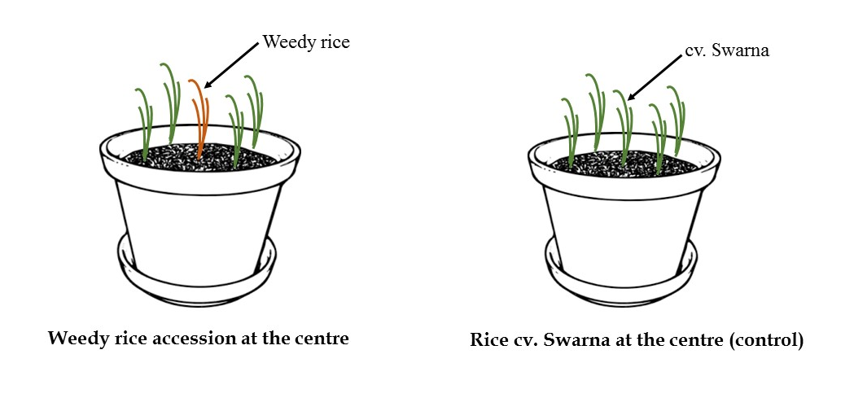Figure S1. Illustration of pots depicting treatment and control (by first author, S.M.)

Weeks after emergence

Figure S2. Tiller number, number of leaves plant⁻¹, leaf area (cm² plant⁻¹), total biomass (g plant⁻¹), and plant height (cm) of Swarna plants in presence of Swarna (control) or in competition with weedy rice (Assam accessions: AA1, AA2, AA3; Odisha accessions: OA1, OA2, OA3)

Plant height (cm)

Weeks after emergence
Figure S3. Tiller number, number of leaves plant⁻¹, leaf area (cm² plant⁻¹), total biomass (g plant⁻¹), and plant height (cm) of weedy rice (Assam accessions: AA1, AA2, AA3; Odisha accessions: OA1, OA2, OA3) in presence of Swarna

