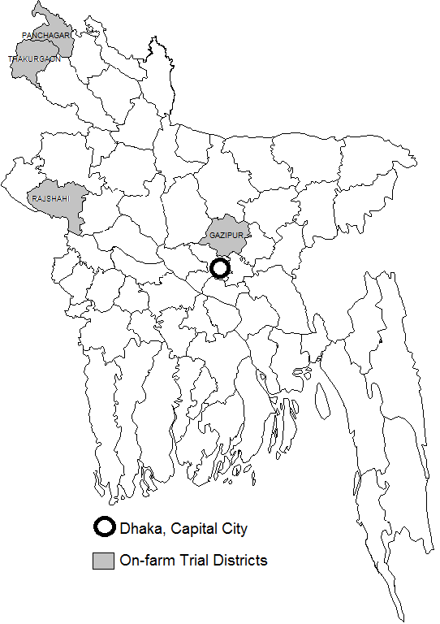

Supplementary material Figure 1: Map of Bangladesh showing experimental sites (grey shaded sites) and black circles location of capital city of Bangladesh

