**Supplementary Information**

Table S1. Characteristics of different waste amendments in this study. Between brackets there are the number of kg ha-1 of each element that represents 8 Mg ha-1 of the corresponding fertilization treatments.

|  |  |  |  |  |  |  |  |  |  |  |  |  |
| --- | --- | --- | --- | --- | --- | --- | --- | --- | --- | --- | --- | --- |
| Treatments | Physical property | Chemical properties | | | | | | | | | | |
| Fe2O3  (%) | Fe  (%) | SO3  (%) | S  (%) | SiO2  (%) | C  (%) | N  (%) | P  (%) | K  (%) | Mg  (%) | Ca  (%) |
| Steel slag | Granular form  (2 mm) | 4.8 | - | - | - | 40.7 | 0.7  (56) | 0.01  (0.8) | 0.01  (0.8) | 0.5  (40) | 0.36  (29) | 24.9  (1992) |
| Biochar | Granular form  (2 mm) | - | 0.2 | - | 0.6 | - | 56.6  (4528) | 1.4  (112) | 1.0  (80) | 1.8  (144) | 1.0  (80) | 0.5  (40) |
| Shells slag | Granular form  (2 mm) | 0.3 | - | 0.2 | - | 2.7 | 12.3  (984) | 0.3  (24) | 0.04  (3.2) | 0.1  (8) | 0.1  (8) | 37.7  (3016) |
| Gypsum slag | Granular form  (2 mm) | 0.4 | - | 54.4 | - | 0.7 | 0.7  (56) | 0.01  (0.8) | 0.01  (0.8) | 0.1  (8) | 0.3  (24) | 30.6  (2448) |
| Silicate and calcium slag | Granular form  (2 mm) | 6.2 | - | 1.3 | - | 27.7 | 0.7  56() | 0.01  (0.8) | 0.04  (3.2) | 2.2  (176) | 2.6  (208) | 25.4  (2032) |

Table S2. Summary of the RM-ANOVAs for the greenhouse-gas emissions for the various amendments.

|  |  |  |  |  |
| --- | --- | --- | --- | --- |
|  | *df* | *MS* | *F* | *P* |
| CO2 |  |  |  |  |
| Steel slag | 1, 4 | 971 987.40 | 60.94 | 0.001 |
| Time | 13, 52 | 3 888 621.81 | 70.40 | <0.001 |
| Steel × Time | 13, 52 | 116 676.42 | 2.11 | 0.029 |
| Biochar | 1, 4 | 1 010 144.70 | 14.87 | 0.018 |
| Time | 13, 52 | 4 257 786.91 | 66.84 | <0.001 |
| Biochar × Time | 13, 52 | 191 762.68 | 3.01 | 0.002 |
| Shell slag | 1, 4 | 681 857.98 | 2.09 | 0.222 |
| Time | 13, 52 | 4 018 988.61 | 58.89 | <0.001 |
| Shell slag × Time | 13, 52 | 182 597.32 | 2.68 | 0.006 |
| Gypsum slag | 1, 4 | 1 483 139.92 | 31.37 | 0.005 |
| Time | 13, 52 | 4 045 259.60 | 115.47 | <0.001 |
| Gypsum slag × Time | 13, 52 | 57 447.00 | 1.64 | 0.104 |
| Silicate and calcium fertilizer | 1, 4 | 1 100 188.81 | 7.62 | 0.049 |
| Time | 13, 52 | 4 341 463.96 | 109.38 | <0.001 |
| Silicate and calcium fertilizer × Time | 13, 52 | 63 784.18 | 1.61 | 0.113 |
| CH4 |  |  |  |  |
| Steel slag | 1, 4 | 412.28 | 8.35 | 0.046 |
| Time | 13, 52 | 81.64 | 9.57 | <0.001 |
| Steel × Time | 13, 52 | 31.72 | 3.72 | <0.001 |
| Biochar | 1, 4 | 480.55 | 8.49 | 0.043 |
| Time | 13, 52 | 60.32 | 6.35 | <0.001 |
| Biochar × Time | 13, 52 | 48.70 | 5.13 | <0.001 |
| Shell slag | 1, 4 | 425.31 | 9.28 | 0.038 |
| Time | 13, 52 | 63.21 | 8.65 | <0.001 |
| Shell slag × Time | 13, 52 | 48.03 | 6.57 | <0.001 |
| Gypsum slag | 1, 4 | 718.25 | 14.70 | 0.019 |
| Time | 13, 52 | 60.75 | 8.74 | <0.001 |
| Gypsum slag × Time | 13, 52 | 39.73 | 5.71 | <0.001 |
| Silicate and calcium fertilizer | 1, 4 | 220.70 | 4.57 | 0.099 |
| Time | 13, 52 | 91.98 | 11.64 | <0.001 |
| Silicate and calcium fertilizer × Time | 13, 52 | 33.43 | 4.23 | <0.001 |
| N2O |  |  |  |  |
| Steel slag | 1, 4 | 4189.01 | 1.75 | 0.256 |
| Time | 13, 52 | 3700.64 | 1.33 | 0.225 |
| Steel × Time | 13, 52 | 1752.89 | 0.63 | 0.816 |
| Biochar | 1, 4 | 30 732.38 | 7.61 | 0.049 |
| Time | 13, 52 | 7576.81 | 2.47 | 0.011 |
| Biochar × Time | 13, 52 | 3142.42 | 1.02 | 0.444 |
| Shell slag | 1, 4 | 15 000.62 | 6.27 | 0.066 |
| Time | 13, 52 | 974.07 | 1.20 | 0.305 |
| Shell slag × Time | 13, 52 | 864.42 | 1.07 | 0.408 |
| Gypsum slag | 1, 4 | 51 808.84 | 2.35 | 0.200 |
| Time | 13, 52 | 5964.84 | 1.08 | 0.393 |
| Gypsum slag × Time | 13, 52 | 2278.31 | 0.41 | 0.958 |
| Silicate and calcium fertilizer | 1, 4 | 36 332.03 | 3.57 | 0.132 |
| Time | 13, 52 | 2259.63 | 0.92 | 0.541 |
| Silicate and calcium fertilizer × Time | 13, 52 | 2223.64 | 0.90 | 0.555 |

Table S3. Summary of the RM-ANOVAs for the soil properties for the various amendments.

|  |  |  |  |  |
| --- | --- | --- | --- | --- |
|  | *df* | *MS* | *F* | *P* |
| **pH** |  |  |  |  |
| Steel slag | 1, 4 | 1.26 | 31.86 | 0.005 |
| Time | 13, 52 | 5.65 | 221.41 | <0.001 |
| Steel × Time | 13, 52 | 0.33 | 12.74 | <0.001 |
| Biochar | 1, 4 | 1.38 | 41.19 | 0.003 |
| Time | 13, 52 | 6.08 | 645.02 | <0.001 |
| Biochar × Time | 13, 52 | 0.16 | 17.38 | <0.001 |
| Shell slag | 1, 4 | 1.12 | 28.26 | 0.006 |
| Time | 13, 52 | 6.21 | 669.21 | <0.001 |
| Shell slag × Time | 13, 52 | 0.14 | 15.08 | <0.001 |
| Gypsum slag | 1, 4 | 0.16 | 3.78 | 0.124 |
| Time | 13, 52 | 5.77 | 194.91 | <0.001 |
| Gypsum slag × Time | 13, 52 | 0.10 | 3.36 | 0.001 |
| Silicate and calcium fertilizer | 1, 4 | 11.46 | 213.84 | <0.001 |
| Time | 13, 52 | 5.80 | 269.79 | <0.001 |
| Silicate and calcium fertilizer × Time | 13, 52 | 1.24 | 57.55 | <0.001 |
| **Eh** |  |  |  |  |
| Steel slag | 1, 4 | 2003.44 | 95.74 | 0.001 |
| Time | 13, 52 | 9145.69 | 89.72 | <0.001 |
| Steel × Time | 13, 52 | 475.57 | 4.67 | <0.001 |
| Biochar | 1, 4 | 3784.17 | 261.73 | <0.001 |
| Time | 13, 52 | 8332.97 | 148.62 | <0.001 |
| Biochar × Time | 13, 52 | 606.72 | 10.82 | <0.001 |
| Shell slag | 1, 4 | 3971.69 | 292.15 | <0.001 |
| Time | 13, 52 | 8856.19 | 157.64 | <0.001 |
| Shell slag × Time | 13, 52 | 639.82 | 11.39 | <0.001 |
| Gypsum slag | 1, 4 | 5982.61 | 22.97 | 0.009 |
| Time | 13, 52 | 9472.70 | 40.39 | <0.001 |
| Gypsum slag × Time | 13, 52 | 1663.69 | 7.09 | <0.001 |
| Silicate and calcium fertilizer | 1, 4 | 3140.30 | 46.36 | 0.002 |
| Time | 13, 52 | 6395.00 | 74.14 | <0.001 |
| Silicate and calcium fertilizer × Time | 13, 52 | 3093.60 | 35.87 | <0.001 |
| **Temperature** |  |  |  |  |
| Steel slag | 1, 4 | 0.03 | 1.15 | 0.344 |
| Time | 13, 52 | 61.60 | 3872.83 | <0.001 |
| Steel × Time | 13, 52 | 0.01 | 0.57 | 0.869 |
| Biochar | 1, 4 | 0.09 | 5.30 | 0.083 |
| Time | 13, 52 | 62.78 | 3615.67 | <0.001 |
| Biochar × Time | 13, 52 | 0.02 | 1.34 | 0.219 |
| Shell slag | 1, 4 | 0.06 | 2.47 | 0.191 |
| Time | 13, 52 | 62.72 | 1860.06 | <0.001 |
| Shell slag × Time | 13, 52 | 0.07 | 2.09 | 0.031 |
| Gypsum slag | 1, 4 | 0.86 | 32.40 | 0.005 |
| Time | 13, 52 | 64.15 | 2253.27 | <0.001 |
| Gypsum slag × Time | 13, 52 | 0.17 | 5.98 | <0.001 |
| Silicate and calcium fertilizer | 1, 4 | 0.53 | 4.04 | 0.115 |
| Time | 13, 52 | 62.06 | 2486.82 | <0.001 |
| Silicate and calcium fertilizer × Time | 13, 52 | 0.17 | 6.93 | <0.001 |
| **Salinity** |  |  |  |  |
| Steel slag | 1, 4 | 0.43 | 14.21 | 0.020 |
| Time | 13, 52 | 0.20 | 35.64 | <0.001 |
| Steel × Time | 13, 52 | 0.01 | 1.10 | 0.377 |
| Biochar | 1, 4 | 0.25 | 2.99 | 0.159 |
| Time | 13, 52 | 0.18 | 13.08 | <0.001 |
| Biochar × Time | 13, 52 | 0.01 | 0.75 | 0.705 |
| Shell slag | 1, 4 | 0.33 | 13.96 | 0.020 |
| Time | 13, 52 | 0.20 | 8.72 | <0.001 |
| Shell slag × Time | 13, 52 | 0.02 | 0.80 | 0.662 |
| Gypsum slag | 1, 4 | 2.42 | 68.20 | 0.001 |
| Time | 13, 52 | 0.26 | 16.59 | <0.001 |
| Gypsum slag × Time | 13, 52 | 0.04 | 2.59 | 0.008 |
| Silicate and calcium fertilizer | 1, 4 | 1.24 | 76.53 | 0.001 |
| Time | 13, 52 | 0.29 | 38.69 | <0.001 |
| Silicate and calcium fertilizer × Time | 13, 52 | 0.03 | 3.55 | 0.001 |
| **Water content** |  |  |  |  |
| Steel slag | 1, 4 | 444.36 | 23.63 | 0.008 |
| Time | 13, 52 | 649.64 | 194.83 | <0.001 |
| Steel × Time | 13, 52 | 15.67 | 4.70 | <0.001 |
| Biochar | 1, 4 | 127.65 | 12.32 | 0.025 |
| Time | 13, 52 | 526.48 | 108.79 | <0.001 |
| Biochar × Time | 13, 52 | 9.35 | 1.93 | 0.048 |
| Shell slag | 1, 4 | 57.75 | 4.88 | 0.092 |
| Time | 13, 52 | 636.61 | 89.86 | <0.001 |
| Shell slag × Time | 13, 52 | 13.35 | 1.88 | 0.054 |
| Gypsum slag | 1, 4 | 7495.74 | 561.03 | <0.001 |
| Time | 13, 52 | 708.13 | 131.41 | <0.001 |
| Gypsum slag × Time | 13, 52 | 13.72 | 2.55 | 0.009 |
| Silicate and calcium fertilizer | 1, 4 | 1087.20 | 84.55 | 0.001 |
| Time | 13, 52 | 753.49 | 132.26 | <0.001 |
| Silicate and calcium fertilizer × Time | 13, 52 | 46.70 | 8.20 | <0.001 |
| **Fe2+ concentration** |  |  |  |  |
| Steel slag | 1, 4 | 5.95 | 124.59 | <0.001 |
| Time | 13, 52 | 6.32 | 30.68 | <0.001 |
| Steel × Time | 13, 52 | 0.53 | 2.56 | 0.008 |
| Biochar | 1, 4 | 4.03 | 17.71 | 0.014 |
| Time | 13, 52 | 5.09 | 20.85 | <0.001 |
| Biochar × Time | 13, 52 | 0.25 | 1.04 | 0.433 |
| Shell slag | 1, 4 | 0.22 | 0.33 | 0.598 |
| Time | 13, 52 | 4.09 | 11.32 | <0.001 |
| Shell slag × Time | 13, 52 | 0.79 | 2.18 | 0.024 |
| Gypsum slag | 1, 4 | <0.001 | 0.01 | 0.934 |
| Time | 13, 52 | 5.20 | 29.03 | <0.001 |
| Gypsum slag × Time | 13, 52 | 0.41 | 2.28 | 0.018 |
| Silicate and calcium fertilizer | 1, 4 | 4.23 | 112.25 | <0.001 |
| Time | 13, 52 | 4.74 | 24.79 | <0.001 |
| Silicate and calcium fertilizer × Time | 13, 52 | 0.74 | 3.89 | <0.001 |
| **Fe3+ concentration** |  |  |  |  |
| Steel slag | 1, 4 | 2.36 | 1.11 | 0.352 |
| Time | 13, 52 | 22.12 | 24.77 | <0.001 |
| Steel × Time | 13, 52 | 1.08 | 1.21 | 0.297 |
| Biochar | 1, 4 | 46.95 | 48.63 | 0.002 |
| Time | 13, 52 | 31.70 | 19.71 | <0.001 |
| Biochar × Time | 13, 52 | 2.19 | 1.36 | 0.211 |
| Shell slag | 1, 4 | 64.06 | 9.63 | 0.036 |
| Time | 13, 52 | 22.63 | 8.61 | <0.001 |
| Shell slag × Time | 13, 52 | 4.45 | 1.69 | 0.091 |
| Gypsum slag | 1, 4 | 15.13 | 47.39 | 0.002 |
| Time | 13, 52 | 21.32 | 39.06 | <0.001 |
| Gypsum slag × Time | 13, 52 | 1.54 | 2.82 | 0.004 |
| Silicate and calcium fertilizer | 1, 4 | 23.11 | 31.57 | 0.005 |
| Time | 13, 52 | 20.93 | 26.48 | <0.001 |
| Silicate and calcium fertilizer × Time | 13, 52 | 1.28 | 1.62 | 0.111 |
| **Total Fe concentration** |  |  |  |  |
| Steel slag | 1, 4 | 15.79 | 6.84 | 0.059 |
| Time | 13, 52 | 46.32 | 37.43 | <0.001 |
| Steel × Time | 13, 52 | 1.86 | 1.51 | 0.147 |
| Biochar | 1, 4 | 78.49 | 89.19 | 0.001 |
| Time | 13, 52 | 56.65 | 26.09 | <0.001 |
| Biochar × Time | 13, 52 | 3.40 | 1.57 | 0.126 |
| Shell slag | 1, 4 | 71.80 | 6.49 | 0.063 |
| Time | 13, 52 | 43.83 | 11.11 | <0.001 |
| Shell slag × Time | 13, 52 | 7.40 | 1.87 | 0.056 |
| Gypsum slag | 1, 4 | 14.92 | 53.83 | 0.002 |
| Time | 13, 52 | 45.19 | 69.93 | <0.001 |
| Gypsum slag × Time | 13, 52 | 1.69 | 2.62 | 0.007 |
| Silicate and calcium fertilizer | 1, 4 | 47.10 | 56.19 | 0.002 |
| Time | 13, 52 | 42.78 | 37.73 | <0.001 |
| Silicate and calcium fertilizer × Time | 13, 52 | 1.75 | 1.55 | 0.133 |

Table S4. Correlations between the soil properties and the greenhouse-gas emissions.

|  |  |  |  |  |  |  |  |  |
| --- | --- | --- | --- | --- | --- | --- | --- | --- |
| **CO2** | pH | Eh | Temperature | Salinity | Water content | Fe2+ | Fe3+ | Total Fe |
| Control | -0.28* | 0.148 | 0.815** | 0.043 | 0.280* | 0.353* | 0.16 | 0.239 |
| Steel slag | -0.176 | 0.208 | 0.867** | 0.038 | 0.280* | 0.241 | 0.122 | 0.18 |
| Biochar | -0.357** | 0.337* | 0.807** | -0.179 | 0.278* | 0.218 | -0.05 | 0.025 |
| Shell slag | -0.306* | 0.287* | 0.883** | -0.185 | 0.027 | 0.081 | 0.005 | 0.027 |
| Gypsum slag | -0.327* | 0.399** | 0.832** | 0.1 | 0.275* | 0.217 | 0.11 | 0.155 |
| Silicate and calcium fertilizer | -0.632** | 0.301* | 0.814** | 0.17 | 0.461** | 0.161 | 0.19 | 0.19 |
| **CH4** |  |  |  |  |  |  |  |  |
| Control | 0.317* | -0.235 | -0.47** | 0.423** | 0.277* | -0.235 | -0.189 | -0.222 |
| Steel slag | 0.244 | -0.23 | -0.114 | 0.652** | 0.401** | -0.09 | -0.146 | -0.136 |
| Biochar | -0.045 | -0.001 | -0.06 | 0.528** | 0.385** | -0.014 | -0.018 | -0.018 |
| Shell slag | 0.288* | -0.149 | -0.015 | 0.309* | 0.601** | 0.286* | 0.208 | 0.238 |
| Gypsum slag | 0.332* | -0.216 | -0.262* | 0.270* | 0.434** | 0.439** | 0.116 | 0.243 |
| Silicate and calcium fertilizer | 0.370** | -0.074 | -0.166 | 0.527** | 0.669** | 0.259* | 0.499** | 0.439** |
| **N2O** |  |  |  |  |  |  |  |  |
| Control | 0.14 | -0.148 | -0.185 | 0.199 | 0.113 | -0.142 | -0.094 | -0.118 |
| Steel slag | 0.152 | -0.226 | -0.097 | 0.021 | 0.012 | 0.172 | 0.299* | 0.273* |
| Biochar | 0.18 | -0.254 | -0.43** | 0.464** | 0.077 | -0.035 | 0.151 | 0.106 |
| Shell slag | 0.189 | -0.088 | -0.234 | -0.078 | -0.192 | -0.021 | 0.028 | 0.015 |
| Gypsum slag | -0.128 | 0.18 | 0.096 | -0.177 | -0.06 | -0.102 | 0.011 | -0.031 |
| Silicate and calcium fertilizer | -0.022 | 0.172 | -0.029 | -0.202 | -0.323* | -0.326* | -0.424** | -0.412** |

*, significant at the 0.05 level; **, significant at the 0.01 level

Table S5. Test statistics for squared Mahalanobis distances among the plots receiving the fertilization treatments with soil pH, Eh, temperature, salinity, water content, Fe2+ concentration, Fe3+ concentration and CO2, CH4 and N2O emissions during the sampling period as independent continuous variables and sampling time as the categorical independent variable. Sq. Mah. = Squared Mahalanobis distances. Bold type indicates a significant effect of the variable in the model (*P*<0.05).

|  |  |  |  |  |  |
| --- | --- | --- | --- | --- | --- |
|  | Steel slag | Biochar | Shell slag | Gypsum slag | Silicate plus calcium fertilizer |
| Control | **Sq. Mah. = 7.68**  ***P*<0.0001** | **Sq. Mah. = 7.43 *P*<0.0001** | **Sq. Mah. = 6.65 *P*<0.0001** | **Sq. Mah. = 47.0 *P*<0.0001** | **Sq. Mah. = 17.9 *P*<0.0001** |
| Steel slag |  | Sq. Mah. = 1.70 *P* = 0.11 | **Sq. Mah. = 3.59 *P*<0.0001** | **Sq. Mah. = 23.1 *P*<0.0001** | **Sq. Mah. = 4.12 *P*<0.0001** |
| Biochar |  | | Sq. Mah. = 0.660 *P* = 0.96 | **Sq. Mah. = 27.7 *P*<0.0001** | **Sq. Mah. = 5.51 *P*<0.0001** |
| Shell slag |  | | | **3 Sq. Mah. = 0.746 *P*<0.0001** | **Sq. Mah. = 7.65 *P*<0.0001** |
| Gypsum slag |  | | | | **Sq. Mah. = 15.9 *P*<0.0001** |

Table S6. Statistical significance of the independent variables in the general discriminant analysis with the fertilization treatments as the dependent categorical grouping variable. Bold type indicates significant differences (*P*<0.05).

|  |  |  |
| --- | --- | --- |
| Variable | Wilks’ lambda Value | *P* |
| **pH** | **0.726** | **<0.00001** |
| **Eh** | **0.946** | **0.027** |
| Temperature | 0.973 | 0.29 |
| **Salinity** | **0.914** | **0.0011** |
| **Water content** | **0.336** | **<0.00001** |
| **Fe2+** | **0.847** | **<0.00001** |
| **Fe3+** | **0.844** | **<0.00001** |
| **CH4 emissions** | **0.823** | **<0.00001** |
| **CO2 emissions** | **0.934** | **0.0090** |
| **N2O emissions** | **0.951** | **0.047** |
| **Time** | **0.263** | **<0.00001** |

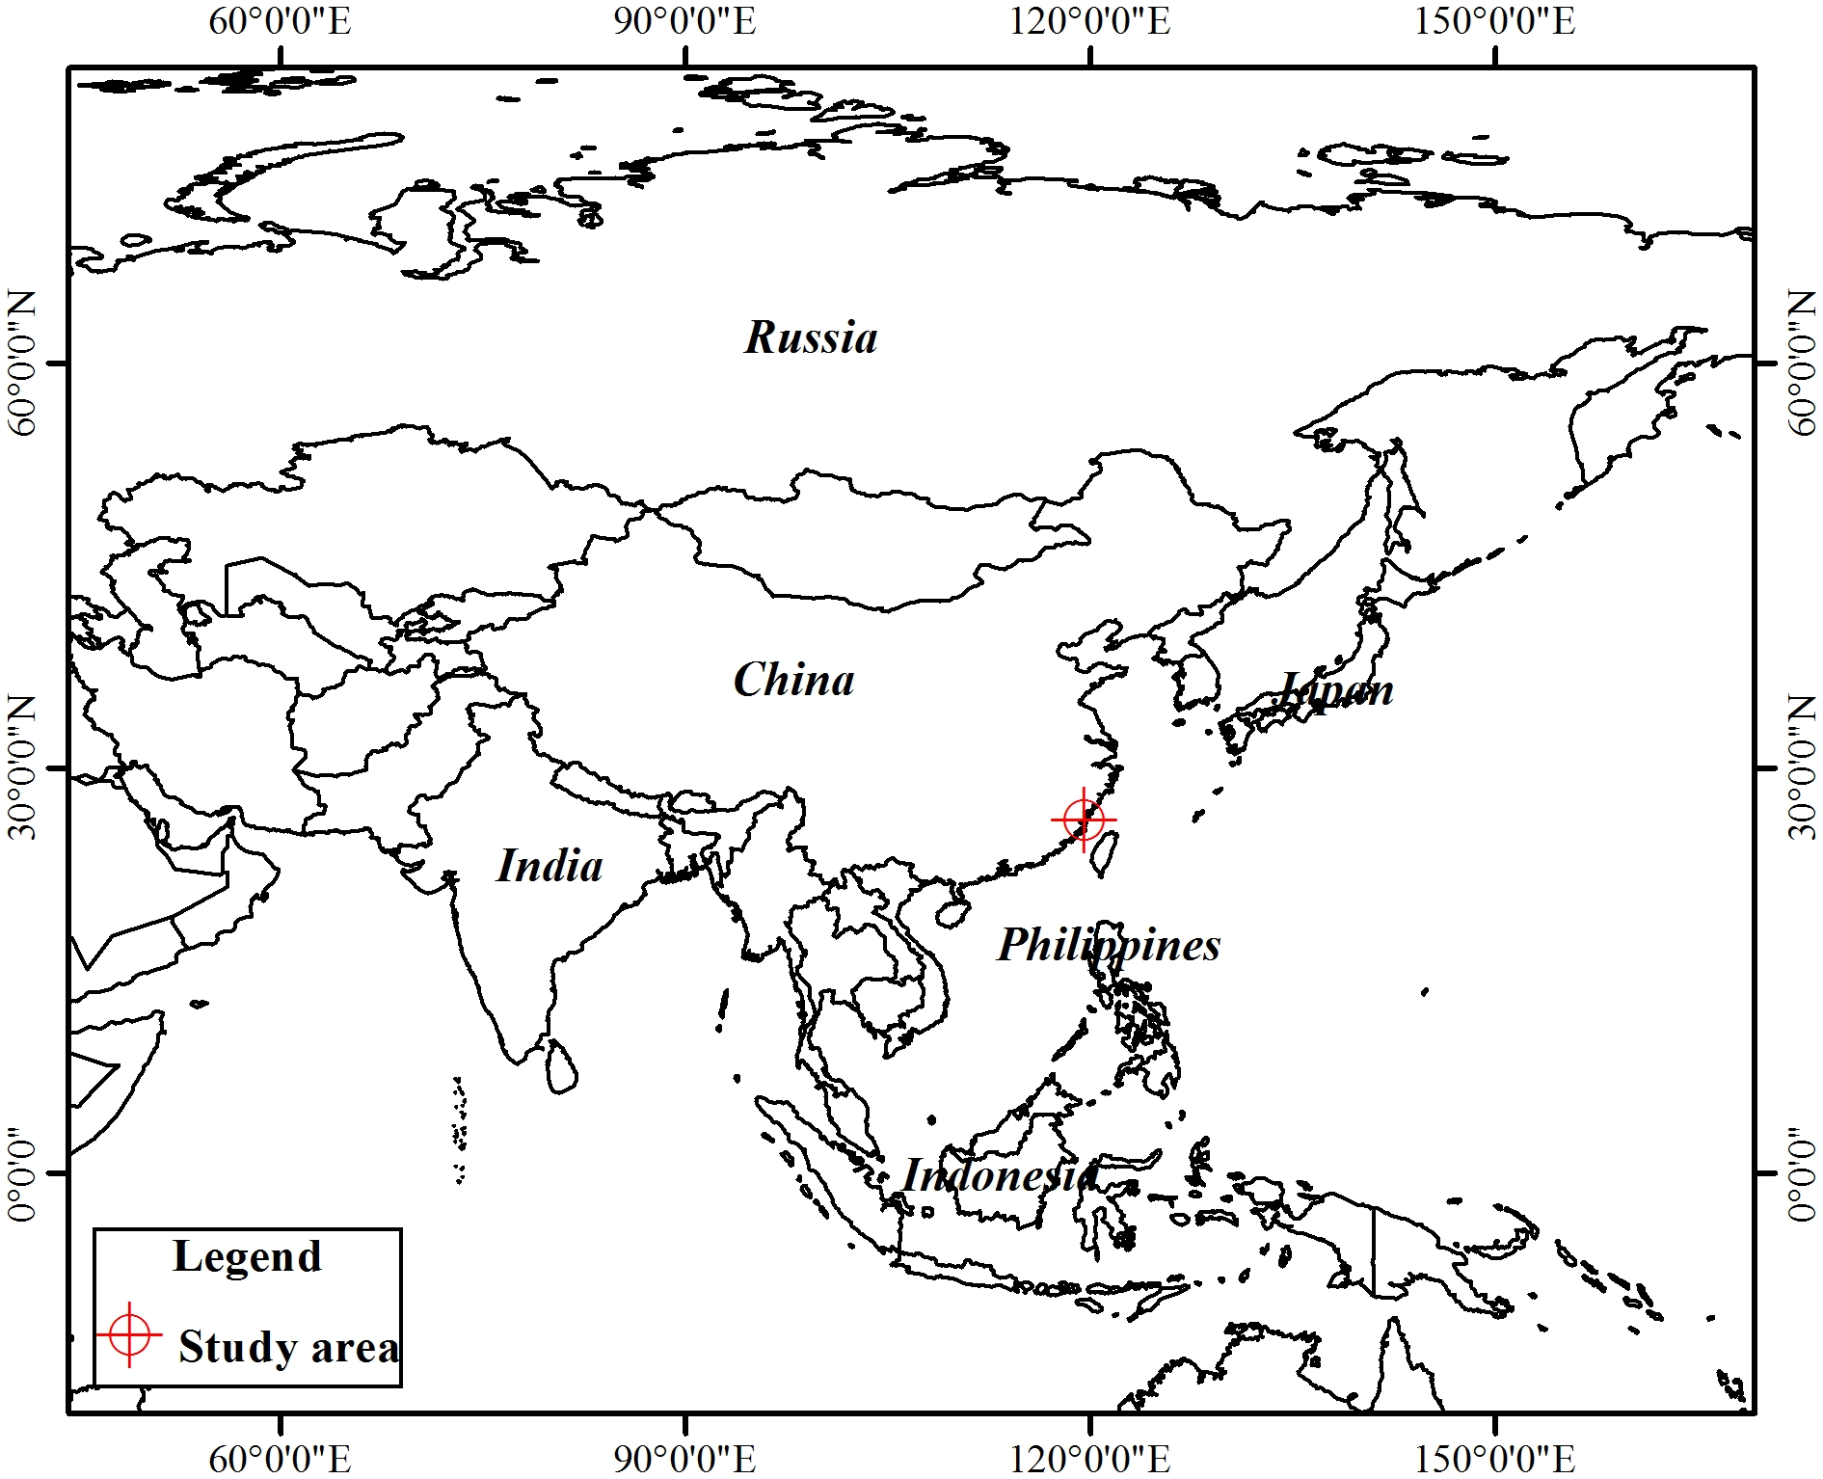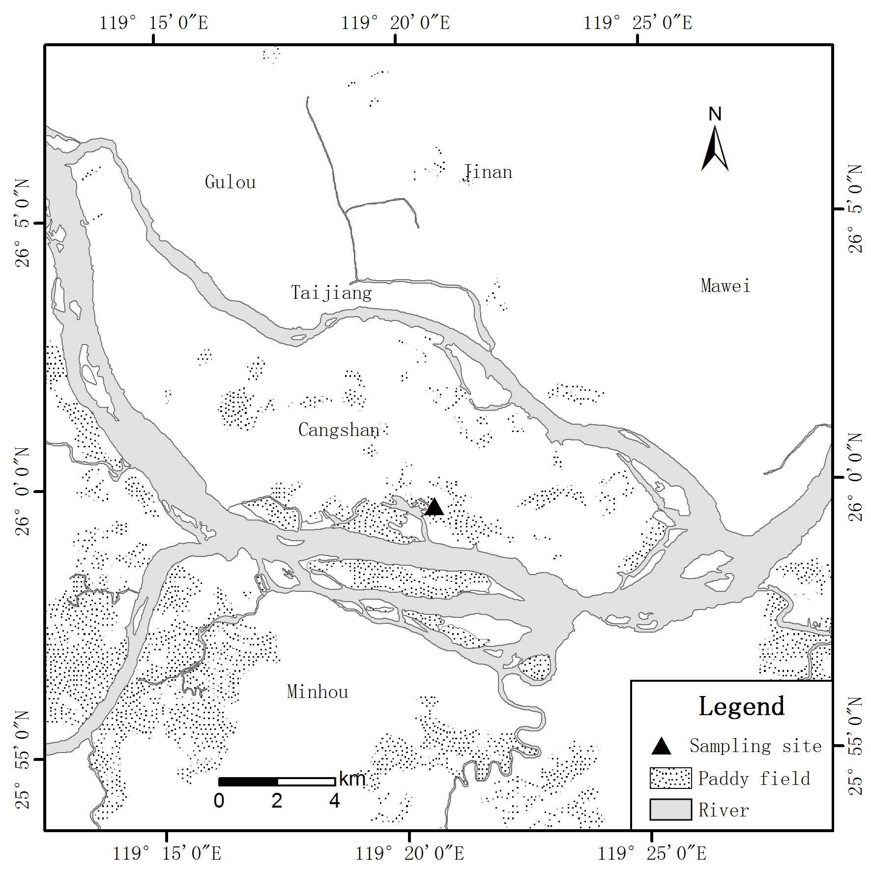

Figure S1. The location of the study area and sampling sites (▲) in Fujian Province, southeastern China.



Figure S2. Temporal variation of air temperature (A) and humidity (B) in the study site.



Fig S3. Diagrams of the structural equation models comparing plots amended with steel slag versus the control plots that best explained the maximum variance of the soil CO2 (A) and CH4 (B) emissions and implying indirect effects from the amendment on the soil variables. Black and red arrows indicate positive and negative relationships, respectively.



Figure S4. Total, direct and indirect effects of exogenous variables (soil variables) of the SEM models of the plots amended with steel slag versus the control plots that best explained the maximum variance of the soil CO2 (A) and CH4 (B) emissions. Black and red columns indicate positive and negative relationships, respectively.



Figure S5. Diagrams of the structural equation models comparing plots amended with biochar versus the control plots that best explained the maximum variance of the soil CO2 (A), CH4 (B) and N2O (C) emissions and rice yields (D) and implying indirect effects from the amendment on the soil variables. Black and red arrows indicate positive and negative relationships, respectively.



Figure S6. Total, direct and indirect effects of exogenous variables (soil variables) of the SEM models of plots amended with biochar versus the control plots that best explained the maximum variance of the soil CO2 (A), CH4 (B) and N2O (C) emissions and rice yields (D). Black and red columns indicate positive and negative relationships, respectively.



Figure S7. Diagrams of the structural equation models comparing plots amended with shell slag versus the control plots that best explained the maximum variance of the soil CH4 emissions and implying indirect effects from the effects of the amendment on the soil variables. Black and red arrows indicate positive and negative relationships, respectively.



Figure S8. Total, direct and indirect effects of exogenous variables (soil variables) of the SEM models comparing plots amended with shell slag versus the control plots that best explained the maximum variance of the soil CH4 emissions. Black and red columns indicate positive and negative relationships, respectively.



Figure S9. Diagrams of the structural equation models comparing plots amended with gypsum slag versus the control plots that best explained the maximum variance of the soil CO2 (A) and CH4 (B) emissions and implying indirect effects from the effects of the amendment on the soil variables. Black and red arrows indicate positive and negative relationships, respectively.



Figure S10. Total, direct and indirect effects of exogenous variables (soil variables) of the SEM models comparing plots amended with gypsum slag versus the control plots that best explained the maximum variance of the soil CO2 (A) and CH4 (B) emissions. Black and red arrows indicate positive and negative relationships, respectively.



Figure S11. Diagrams of the structural equation models comparing plots amended with the silicate and calcium fertilizer versus the control plots that best explained the maximum variance of the soil CO2 (A) and CH4 (B) emissions and implying indirect effects from the effects of the amendment on the soil variables. Black and red arrows indicate positive and negative relationships, respectively.



Figure S12. Total, direct and indirect effects of exogenous variables (soil variables) of the SEM models comparing plots amended with the silicate and calcium fertilizer versus the control plots that best explained the maximum variance of the soil CO2 (A) and CH4 (B) emissions. Black and red arrows indicate positive and negative relationships, respectively.