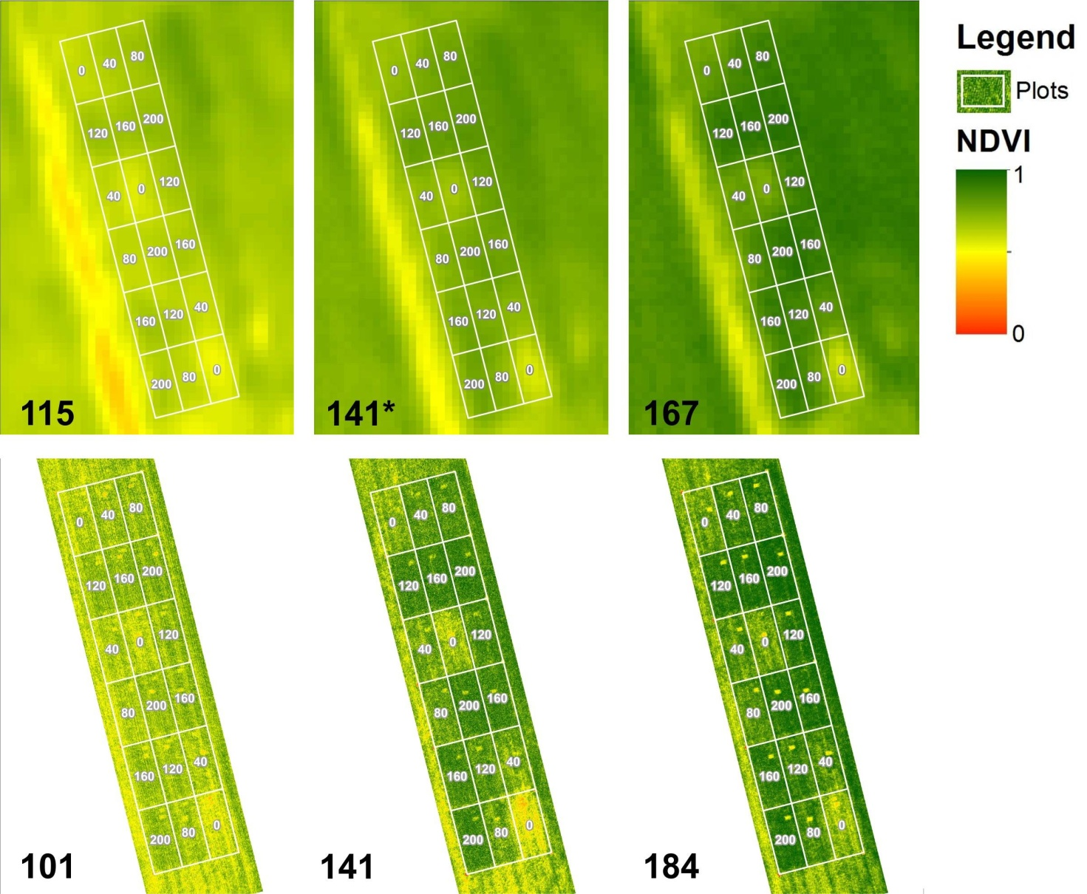

Fig. S1 NDVI from SAT (top) and UAV (bottom) at different Days After Sowing (DAS - bottom-left of each image). *SAT NDVI resulting from linear interpolation of SAT NDVI on March 18th (114 DAS) and May 10th (167 DAS). Numbers in white indicate the total N fertilization rates (kg ha⁻¹).

Fig. S2 Time schedule of cultivation operations and measurements during the wheat growing cycle. DAS are the days after sowing; FW and DW (i.e., the fresh and dry weights of the above-ground biomass) N% (i.e. the N concentration in the above-ground dry matter) and Nupt (i.e, the total above-ground N accumulation) were recorded by plant samplings; SPAD readings express the leaf greenness; PAR stands for the measurement of photosynthetically active radiation fluxes in the crop; SAT and UAV are the measurements of NDVI derived from satellite and unmanned aerial vehicle data. The value of SAT NDVI on April 14th (141 DAS) is calculated by interpolation between the values recorded on March 18th (114 DAS) and May 10th (167 DAS).

