Supplementary Informations
Bulletin of Entomological Research

A simple molecular identification method of the Thrips tabaci (Thysanoptera: Thripidae) cryptic species complex
Péter Farkas¹, Zsuzsanna György², Annamária Tóth^{3,} Annamária Sojnóczki¹, József Fail¹*
¹Department of Entomology, Faculty of Horticultural Science, Szent István University, Budapest, Hungary
²Department of Genetics and Plant Breeding, Faculty of Horticultural Science, Szent István University, Budapest, Hungary
³Department of Plant Pathology, Faculty of Horticultural Science, Szent István University, Budapest, Hungary

* Corresponding author
E-mail: fail.jozsef@kertk.szie.hu

Supplementray Figure 1. Phylogenetic tree of T. tabaci based on 328bp of the mtCOI gene based on the MP analysis using MEGA6 software.
Supplementray Figure 2. Phylogenetic tree of T. tabaci based on 328bp of the mtCOI gene based on the HKY+G model using JModelTest 2.1.10. and BEAST 2.4.8. Software.

Supplementray Figure 1.
Phylogenetic tree of T. tabaci based on 328bp of the mtCOI gene. The tree is generated by the Maximum Parsimony (MP) method using MEGA6 (Tamura et al., 2013). Bootstrap values (percentage of 1000 replicates) are shown above the branches. Accession numbers shows the sequences data of T. tabaci obtained from DNA databases. Thrips palmi (AF378690) and Thrips angusticeps (AF378679) served as outgroups.

Supplementray Figure 2. Phylogenetic tree of T. tabaci based on 328bp of the mtCOI gene. The HKY+G model (Hasegawa et al., 1985) was selected by JModelTest 2.1.10. (Darriba et al., 2012) and phylogenetic tree was generated using BEAST 2.4.8. software (Bouckaert et al., 2014). Thrips palmi (AF378690) and Thrips angusticeps (AF378679) served as outgroups.

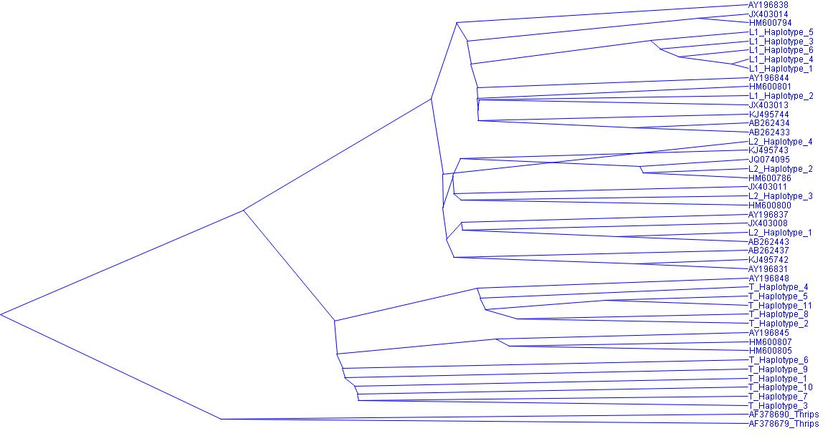

References:

- Bouckaert, R., Heled, J., Kühnert, D., Vaughan, T., Wu, C-H., Xie, D., Suchard, M.A., Rambaut, A. & Drummond, A. J. (2014) BEAST 2: A Software Platform for Bayesian Evolutionary Analysis. PLoS Computational Biology 10(4). e1003537. doi:10.1371/journal.pcbi.1003537
- Darriba, D., Taboada, G.L., Doallo, R. & Posada, D. (2012) JModelTest2: more models, new heuristics and high-performance computing. Nature Methods 9(8), 772. doi: 10.1038/nmeth.2109

Hasegawa, M., Kishino, H. & Yano, T. (1985). Dating the human-ape split by a molecular clock of mitochondrial DNA. Journal of Molecular Evolution 22, 160-174.
- Tamura, K., Stecher, G., Peterson, D., Filipski, A. & Kumar, S. (2013) MEGA6: Molecular Evolutionary Genetics Analysis version 6.0. Molecular Biology and Evolution, 30, 2725-2729. https://doi.org/10.1093/molbev/mst197

