SM1. Raw results from DIYABC software of the 25 first scenarios, presenting a PCA, allowing us to visualize how data sets simulated under each scenario are close or not from the observed data set (yellow dot). The most relevant scenarios chosen were the first 6.

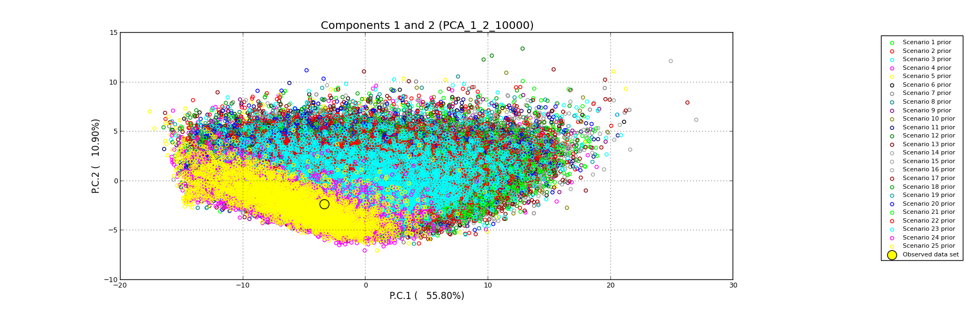

SM 2. Pairwise probability values for linkage disequilibrium among 19 microsatellite loci. None of the test resulted significant (experiment wise a=0.05) after False Discovery Rate correction (Benjamini and Hochberg 1995b).

**p p p p**

H9-F34 0.007 F4-F16 0.203 C3-E43 0.462 E43-F32 0.769

D3-B52 0.009 D3-E34 0.214 G1-C33 0.465 B52-F14 0.777

G1-B52 0.012 E34-E43 0.223 H10-F34 0.487 H9-F16 0.780

E43-G34 0.015 C3-G34 0.228 C3-F32 0.492 G1-H7 0.781

C3-F3 0.022 H10-E43 0.228 C3-H10 0.496 F3-F32 0.783

D11-H9 0.022 F14-F34 0.228 E8-F14 0.503 G1-H10 0.798

G1-G34 0.022 E8-G34 0.239 G1-E43 0.507 E34-F32 0.816

D3-E8 0.024 D11-F16 0.242 F3-E34 0.511 C3-F14 0.822

H10-F16 0.025 D3-G1 0.243 D11-F14 0.512 D3-D11 0.836

E8-H10 0.026 E34-F16 0.252 D3-H7 0.513 E8-H9 0.841

E8-C33 0.035 H10-F32 0.253 H7-C33 0.536 F16-G34 0.843

D3-F32 0.036 F14-G34 0.264 B52-F16 0.551 H9-G34 0.856

F3-E43 0.038 H7-H9 0.273 E8-F3 0.555 C3-B52 0.860

D11-F3 0.040 D11-H10 0.286 F3-G1 0.561 B52-E43 0.866

C3-D3 0.041 B52-F32 0.288 H10-G34 0.564 C33-E43 0.866

F4-E34 0.041 E43-F14 0.288 H9-E34 0.585 F16-F32 0.870

D3-F3 0.044 F34-G34 0.295 F3-H7 0.593 H7-E43 0.873

E34-G34 0.044 C3-D11 0.311 C3-F34 0.595 H9-H10 0.875

D3-C33 0.045 F4-H9 0.311 C33-F16 0.595 F3-F14 0.886

B52-G34 0.051 H7-G34 0.312 E34-F34 0.599 H10-C33 0.890

D3-H9 0.054 F32-F34 0.312 C3-G1 0.605 H9-B52 0.892

D11-B52 0.058 E8-F34 0.316 E8-E43 0.621 E8-F4 0.896

D3-F4 0.065 F3-H10 0.332 H9-F14 0.622 D11-F34 0.907

E8-G1 0.081 D3-F34 0.339 F4-H10 0.630 F4-F34 0.907

D3-H10 0.083 D3-F16 0.341 C3-F4 0.636 G1-E34 0.907

H9-C33 0.101 D3-E43 0.346 F3-F4 0.652 C3-F16 0.914

D3-F14 0.113 F4-C33 0.349 D11-E8 0.675 B52-C33 0.916

F14-F16 0.113 F4-E43 0.358 C33-F32 0.677 H7-F34 0.920

H10-E34 0.144 H10-B52 0.381 F16-F34 0.677 F14-F32 0.926

D11-G1 0.145 G1-H9 0.384 F4-G1 0.678 D11-E34 0.928

D11-H7 0.148 E34-F14 0.389 F4-F14 0.681 F3-H9 0.929

D11-G34 0.148 G1-F16 0.396 H7-F14 0.682 D11-F4 0.946

F4-H7 0.149 E8-F32 0.399 F4-G34 0.685 F3-C33 0.946

F3-F16 0.153 H7-F16 0.400 C3-H7 0.694 E8-F16 0.970

B52-F34 0.157 H10-F14 0.402 E8-B52 0.697 H9-F32 0.984

C33-E34 0.182 F3-B52 0.405 F4-F32 0.707 C3-C33 0.988

E43-F16 0.185 G1-F32 0.406 E8-H7 0.712 H7-H10 0.989

H9-E43 0.188 C3-E8 0.409 E43-F34 0.718 E8-E34 0.990

G1-F34 0.189 C3-H9 0.416 C3-E34 0.721 D11-E43 0.991

H7-B52 0.191 B52-E34 0.422 D11-C33 0.744 D11-F32 1.000

F3-F34 0.195 G1-F14 0.441 C33-G34 0.753 H7-F32 1.000

F4-B52 0.195 C33-F34 0.445 H7-E34 0.759 F32-G34 1.000

C33-F14 0.201 D3-G34 0.458 F3-G34 0.763

FigSM3. Posterior predictive maps of admixture proportions as obtained from the interpolation of co-ancestry coefficients resulting from STRUCTURE (Fig. 2) and the geographic distribution of 332 African specimens of *Z. cucurbitae* (Table 1).

SM 4. Average assignment of log likelihood (–LogL) of individuals from each African populations of fruit flies sampled (n=12) and a putative source population (Asia) as calculated by GENECLASS2 Piry et al. 2004.

|  |  |  |  |  |  |  |  |  |  |  |  |  |  |  |  |
| --- | --- | --- | --- | --- | --- | --- | --- | --- | --- | --- | --- | --- | --- | --- | --- |
|  | **Asia** | **Senegal** | **Guinea** | **Ivory Coast** | **Burkina Faso** | **Togo** | **Benin** | **Congo** | **Sudan** | **Burundi** | **Uganda** | **Kenya** | **Tanzania** | **average** | **SE** |
| **Asia** | **0.72** | 0.05 | 0.02 | 0.03 | 0.11 | 0.04 | 0.02 | 0.01 | 0.02 | 0.01 | 0.01 | 0.06 | 0.00 | 0.03 | 0.01 |
| **Senegal** | 0.40 | **0.66** | 0.46 | 0.59 | 0.62 | 0.61 | 0.58 | 0.09 | 0.52 | 0.23 | 0.20 | 0.40 | 0.18 | 0.41 | 0.05 |
| **Guinea** | 0.46 | 0.62 | **0.62** | 0.61 | 0.64 | 0.62 | 0.59 | 0.11 | 0.56 | 0.26 | 0.31 | 0.47 | 0.23 | 0.46 | 0.05 |
| **Ivory Coast** | 0.40 | 0.58 | 0.39 | **0.72** | 0.65 | 0.54 | 0.56 | 0.07 | 0.39 | 0.18 | 0.14 | 0.40 | 0.13 | 0.37 | 0.06 |
| **Burkina Faso** | 0.59 | 0.61 | 0.39 | 0.63 | **0.77** | 0.56 | 0.54 | 0.10 | 0.46 | 0.22 | 0.30 | 0.44 | 0.19 | 0.42 | 0.05 |
| **Togo** | 0.47 | 0.64 | 0.44 | 0.59 | 0.64 | **0.67** | 0.56 | 0.10 | 0.37 | 0.16 | 0.22 | 0.37 | 0.13 | 0.39 | 0.06 |
| **Benin** | 0.43 | 0.62 | 0.44 | 0.62 | 0.66 | 0.56 | **0.70** | 0.03 | 0.41 | 0.13 | 0.22 | 0.38 | 0.05 | 0.38 | 0.06 |
| **Congo** | 0.76 | 0.69 | 0.59 | 0.74 | 0.76 | 0.70 | 0.58 | **0.73** | 0.54 | 0.24 | 0.35 | 0.53 | 0.22 | 0.56 | 0.06 |
| **Sudan** | 0.52 | 0.69 | 0.54 | 0.62 | 0.68 | 0.57 | 0.55 | 0.09 | **0.61** | 0.28 | 0.34 | 0.57 | 0.21 | 0.47 | 0.06 |
| **Burundi** | 0.49 | 0.70 | 0.52 | 0.63 | 0.66 | 0.65 | 0.59 | 0.05 | 0.55 | **0.71** | 0.22 | 0.62 | 0.44 | 0.51 | 0.06 |
| **Uganda** | 0.61 | 0.55 | 0.45 | 0.58 | 0.67 | 0.56 | 0.58 | 0.07 | 0.46 | 0.23 | **0.60** | 0.59 | 0.13 | 0.46 | 0.06 |
| **Kenya** | 0.48 | 0.47 | 0.39 | 0.54 | 0.58 | 0.49 | 0.47 | 0.09 | 0.41 | 0.19 | 0.29 | **0.71** | 0.11 | 0.37 | 0.05 |
| **Tanzania** | 0.55 | 0.62 | 0.37 | 0.53 | 0.64 | 0.51 | 0.43 | 0.08 | 0.42 | 0.41 | 0.21 | 0.54 | **0.67** | 0.44 | 0.05 |
| **average** | 0.51 | 0.57 | 0.42 | 0.56 | 0.61 | 0.53 | 0.50 | 0.07 | 0.42 | 0.21 | 0.23 | 0.45 | 0.17 |  |  |
| **SE** | 0.03 | 0.05 | 0.04 | 0.05 | 0.05 | 0.05 | 0.05 | 0.01 | 0.04 | 0.03 | 0.03 | 0.04 | 0.03 |  |  |

SM5. Raw results from DIYABC software of the best 6 scenarios, presenting the (above graph) posterior probabilities of scenarios obtained through a logistic regression, computed every 10% (between 10 and 100%) of the number of selected data sets. The below graph is presenting a PCA, allowing us to visualize how data sets simulated under each scenario are close or not from the observed data set (yellow dot). The most relevant scenario chosen was scenario 6.

