Spatiotemporal expression profiling of the farnesyl diphosphate synthase genes in aphids and analysis of their associations with the biosynthesis of alarm pheromone
Yin Jie Cheng* and Zheng Xi Li†
Department of Entomology and MOA Key Laboratory for Monitoring and Environment-Friendly Control of Crop Pests, College of Plant Protection, China Agricultural University, Beijing 100193, China
†Author for correspondence: Prof. Zheng-Xi Li, Department of Entomology, China Agricultural University, 2 Yuanmingyuan West Road, Beijing 100193, China.
E-mail: zxli@cau.edu.cn.

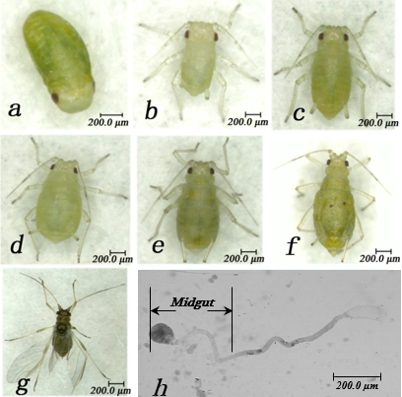
Supplementary Fig. 1 Different developmental stages and the midgut tissue of M. persicae. a, embryo; b, 1st instar; c, 2nd instar; d, 3rd instar; e, 4th instar; f, apterous adult; g, alate adult; h, dissected digestive system of aphid, showing the midgut.

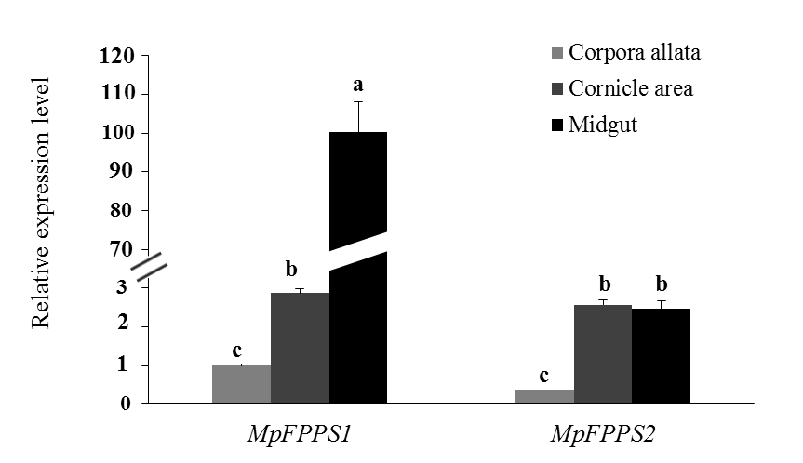
Supplementary Fig. 2 Relative expression level of MpFPPS1/2 in different tissues of the apterous adults of M. persicae with the actin gene as the internal control. Different lowercase letters on the bars indicate significant difference in the expression level of MpFPPS1/2 between different tissues at 5% level by using LSD multiple comparison method.

Supplementary Fig. 3 Ct values of the reference genes actin and 18S in different tissues of the apterous adults of M. persicae. Different lowercase letters on the bars for the same gene indicate significant difference in the expression levels of actin and 18S, respectively, between different tissues at 5% level by using LSD multiple comparison method.

Supplementary Fig. 4 Ct value of the reference gene SDHB during different developmental stages and in different tissues of A. pisum. Different lowercase letters on the bars indicate significant difference in the expression level of SDHB between different stages and tissues at 5% level by using independent sample t test and LSD multiple comparison method, respectively.
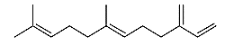
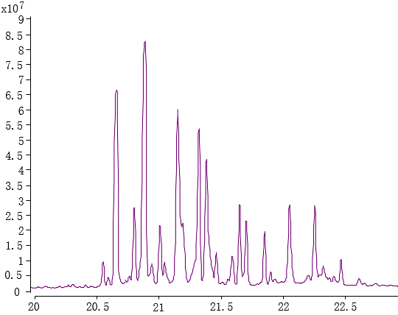
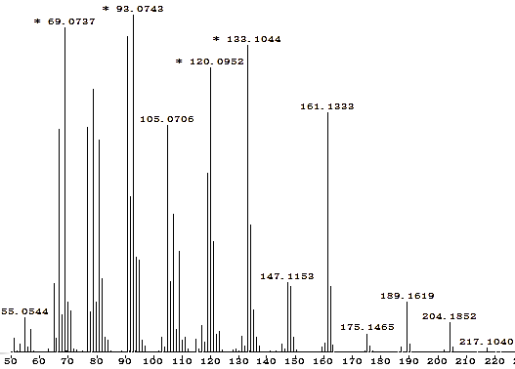
A B
EβF

Supplementary Fig. 5 Analysis of the standard farnesene solution by GC-MS. A: the gas chromatogram of the standard solution (the retention time of EβF is 20.784 min); B: the mass spectrum of EβF (the characteristic ions are 69, 93, 105, 120, 133 and 161).

