Supplementary materials for Deane et al, “Omega 3 and polyunsaturated fat for prevention of depression and anxiety”.

Contents
Supplementary materials for Deane et al, “Omega 3 and polyunsaturated fat for prevention of depression and anxiety”. 1
Supplementary Text 1. Results section in greater detail 3
Characteristics of included studies 3
Does increasing omega-3, omega-6 or total PUFA alter risk of depression or anxiety? 3
Supplementary Table 1. Brief characteristics of included studies 7
Supplementary Table 2. High vs low long-chain omega 3 (primary outcomes) 11
Supplementary Table 3: GRADE assessment: Summary of findings for effects of long-chain omega-3 (LCn3) on depression and anxiety 15
Supplementary Table 4. High vs low ALA (primary outcomes) 18
Supplementary Table 5. High vs low total PUFA (primary outcomes) 19
Supplementary Table 6: GRADE assessment: Summary of findings for effects of total PUFA on depression and anxiety 20
Supplementary Table 7: GRADE assessment: Summary of findings for effects of ALA on depression and anxiety 22
Supplementary Table 8. High vs low long-chain omega 3 (secondary outcomes) 24
Supplementary Table 9. High vs low ALA (secondary outcomes) 25
Supplementary Table 10. Characteristics of ongoing trials that appear to have assessed relevant outcomes for this review 26
Supplementary Figure 1. Study flow diagram. 32
Supplementary Figure 2. Meta-analysis of effects of higher LCn3 vs lower LCn3 on risk of depression symptoms, sub-grouped by LCn3 dose. 33
Supplementary Figure 3. Meta-analysis of effects of higher LCn3 vs lower LCn3 on risk of depression symptoms, sub-grouped by EPA dose. 34
Supplementary Figure 4. Meta-analysis of effects of higher LCn3 vs lower LCn3 on risk of depression symptoms, sub-grouped by DHA dose. 35
Supplementary Figure 5. Funnel plot of the analysis of effects of higher LCn3 vs lower LCn3 on risk of depression. 36
Supplementary Figure 6. Meta-analysis of effects of higher LCn3 vs lower LCn3 on depression symptoms, analysed using SMD, sub-grouped by LCn3 dose. 37
Supplementary Figure 7. Meta-analysis of effects of higher LCn3 vs lower LCn3 on depression symptoms, analysed using SMD, sub-grouped by EPA dose. 38
Supplementary Figure 8. Meta-analysis of effects of higher LCn3 vs lower LCn3 on depression symptoms, analysed using SMD, sub-grouped by DHA dose. 39
Supplementary Figure 9. Funnel plot of the analysis of effects of higher LCn3 vs lower LCn3 on depression symptoms, using SMD, sub-grouped by depression rating scale. 40
Supplementary Figure 10. Forest plot of trials randomising to higher vs lower LCn3 intake and assessing depression symptoms (on a continuous scale) in those without depression at baseline, subgrouping by scale and displayed in native scales. For meta-analysis data were combined using SMD (not shown, SMD 0.01, 95% CI -0.06 to 0.07, I² 46%). 41
Acknowledgements: 42
Supplementary References 43

Supplementary Text 1. Results section in greater detail

Characteristics of included studies
Characteristics of included studies and risk of bias are shown in Supplementary Table 1 and in more detail in our database paper (1), risk of bias is itemised by domain for each study in Figure 1, flow diagram for this review in Supplementary Figure 1. The 32 RCTs (33 comparisons) randomised 46,467 participants, of which twelve were judged to be at low summary risk of bias (2-14), including twelve LCn3 comparisons, and the single ALA assessment (Figure 1). Thirty trials(2-33) (41,470 participants) assessed effects of LCn3, one assessed effects of ALA(2, 34) (4837 participants, these participants were part of a factorial trial so also included in an LCn3 trial) and one assessed effects of higher total PUFA(35) (4997 participants). We found no trials assessing effects of omega-6 fatty acids on depression or anxiety.

Fourteen RCTs assessed risk of serious depression symptoms, seventeen depression symptoms (assessed as a continuous measure in those without depression at baseline), one severity of depression in people with depression at baseline and five assessed anxiety. Participants were recruited with chronic illness or risk factors in 17 trials (6 with CVD, 3 diabetes or impaired glucose tolerance, 1 dyslipidaemia or hypertension, 2 with Huntingdon’s disease, 1 each with multiple sclerosis, non-alcoholic fatty liver disease, macular degeneration, Parkinson’s disease or colorectal tumours), memory deficit, cognitive impairment or Alzheimer’s disease in 6 trials, mental health problems in 4 trials (two with schizophrenia, 1 young people at high risk of psychotic disorders, 1 mild to moderate depression), and healthy participants in 5 trials.

Of the 31 LCn3 trials, most gave supplementary capsules or medicinal oils, but two used supplemental foods (enriched margarine and fish sausages) (2, 21); one provided dietary advice (32); and one a combination.(7) The ALA trial provided enriched margarine (2), and the PUFA trial dietary advice plus nuts.(35) LCn3 doses ranged from 300mg/d (31) to 3360mg/d EPA+DHA (30), with 12 trial arms assessing doses of ≤1000mg/d, 13 arms >1000 to ≤2000mg/d, and seven arms doses of >2000mg/d EPA+DHA (one trial was unclear (32), two trials included two arms with different doses (12, 24)). Ratios of EPA to DHA varied, doses of EPA ranged from 96 to 2250mg/d, DHA from 120 to 1720mg/d. Seven RCTs randomised at least 1000 participants (2-4, 10, 13, 15, 35), so that more than1000 participants were involved in assessments of LCn3, ALA (2) and total PUFA (35). Control groups received olive, corn or sunflower oils, other fats, other 'inert' or ill-defined substances, different dietary advice, foods without omega-3 enrichment, or nothing. Trial authors provided some response to attempted contact for 16 trials.

Does increasing omega-3, omega-6 or total PUFA alter risk of depression or anxiety?
Key evidence is provided in the three GRADE tables summarising evidence on effects of LCn3, ALA and total PUFA on primary outcomes (Supplementary Tables 3, 6 and 7), in forest plots showing meta-analyses (Figures 2 and 3, Supplementary Figures 2-4, 6-8 and 10) and funnel plots (Supplementary Figures 5 and 9).

Risk of depression symptoms
Thirteen RCTs randomised 26,528 participants to higher vs lower LCn3 and reported on 1355 people found to have symptoms of depression (RR 1.01, 95% CI 0.92 to 1.10, I² 0%, 5% incidence, Figure 2). In these trials mean LCn3 dose was 1.4g/d (SD 0.9), median dose was 0.95g/d (range 0.4 to 3.4), mean trial duration was 24.2 months (SD 25.1), median duration was 12 months (range 6 to 89 months). The four largest trials tended to be longer but lower dose than average. This lack of effect of LCn3 on risk of depression did not differ in sensitivity analyses by risk of bias, fixed effects or study size, though retaining only trials with good compliance suggested increased risk of depression diagnosis with increased LCn3 (RR 1.16, 95% CI 0.99 to 1.36, I² 0%, Supplementary Table 2).

Over 90% of meta-analytic weight came from three trials that assessed depression using the Center for Epidemiologic Studies Depression Scale (CESD, score ≥16(3)), Becks Depression Inventory (BDI-II, score ≥14(10)) and General Health Questionnaire (GHQ-30, ≥5(11)). In these three trials the median LCn3 dose was 0.85g/d (range 0.4 to 1.0) and the median duration was 40 months (range 12 to 60 months). In other trials diagnosis resulted from Geriatric Depression scores (GDS-15, >10), reported adverse events or were unclear.

There was no suggestion of publication bias in visual inspection of the funnel plot (Supplementary Figure 5) or using statistical tests (Harbord test p=0.27 , Peters test p=0.29) (36-38). Similarly there were no clearly missing data (although several of the ongoing trials detailed in Supplementary Table 10 would be expected to have finished by the start of 2017, so might be considered to constitute missing data, non-publication is most likely to equate to minimal effect sizes so would be likely to confirm rather than change our findings). The similarity of the random- and fixed-effects meta-analyses, which weight small studies differently (random effects: RR 1.01, 95% CI 0.92 to 1.10; fixed-effects: RR 1.02, 95% CI 0.93 to 1.12) also suggest that little small study bias is present.(39)

Subgrouping by intervention type, replacement nutrients, and LCn3 dose did not suggest important differences by subgroup, but subgrouping by baseline depression risk suggested increased depression risk in healthy adults with increased LCn3, and little or no effect in those with serious illnesses (no trials recruited participants with current depression or where ≥50% took antidepressants, Supplementary Table 2). As pre-specified LCn3 dose subgroupings did not divide included trials effectively, post-hoc we re-ran more even LCn3 dose subgroupings, and subgroupings by EPA and DHA dose. There was no suggestion of LCn3 dose effects (test for subgroup differences p=0.98), EPA (p=0.13) or DHA (p=0.87) effects, Supplementary Figures 2-4. GRADE assessment suggests that increasing LCn3 probably has little or no effect on risk of depression symptoms (moderate-quality evidence, downgraded once for imprecision, Supplementary Table 3).

Data were very limited from trials of ALA (RR 1.11, 95% CI 0.67 to 1.84, 1 trial, 59 people found to have depression symptoms (GDS-15 score >10), not altered in any sensitivity analysis, ALA dose 2g/d, trial duration 40 months, Figure 2 and Supplementary Table 4) and total PUFA (RR 0.75, 95% CI 0.54 to 1.03, 1 trial, 147 depression diagnoses – assessed via diagnosis by usual physician and reported by participants at study follow-up or reported habitual use of antidepressant drugs, total PUFA dose unclear, median duration 56 months, Figure 2 and Supplementary Table 5), and we found no data from trials of omega-6 (Figure 2). GRADE suggests that increasing ALA may increase the risk of depression symptoms very slightly (NNH 1000, low-quality evidence, downgraded twice for imprecision) and effects of increasing total PUFA on risk of depression symptoms are unclear as the evidence is of very low-quality (downgraded once each for risk of bias, indirectness and inconsistency, Supplementary Tables 6 and 7).

Depression severity and remission (in those with existing depression).
A single small trial assessed effects of 1.1g/d LCn3 for 6 months in poor Iranian men with mild or moderate depression symptoms at baseline (GDS-15 mean 7.2).(31) The study was not at low summary risk of bias, and found that GDS score fell by >10% of baseline, suggesting reduced severity of depression, in the higher LCn3 arm compared to control (MD -0.94, 95% CI -2.27 to 0.39, 61 participants) over 6 months. A further small study included participants with Parkinson’s Disease(29), some of whom were depressed at baseline, and reported on remission, suggesting more remission in those on higher LCn3 (Supplementary Table 2). GRADE assessment suggests that effects of increasing LCn3 on depression severity was unclear as the evidence was of very low-quality (downgraded once each for risk of bias, indirectness and imprecision), and effects of increasing LCn3 on risk of remission in depression is unclear as the evidence was of very low-quality (downgraded once for risk of bias and twice for indirectness, Supplementary Table 3).

No trials of ALA, omega-6 or total PUFA included participants with depression at baseline.

Depression symptoms assessed on a continuous scale (in those not selected for depression at baseline)
Fifteen RCTs assessing depression symptoms on several scales (lower scores indicated less depression) were meta-analysed using SMD suggesting little or no effect of increased LCn3 (SMD 0.01, 95% CI -0.06 to 0.07, I² 46%, mean LCn3 dose 1.2g/d, SD 0.6, median LCn3 dose 1.1g/d, range 0.3 to 2.4g/d, mean trial duration 18 months, SD 21, median duration 6 months, range 6 to 75 months, Supplementary Table 2). In the subgroup of seven trials that assessed depression using the Geriatric Depression Scale (GDS, short form scores from 0 to 15, 0-4 indicating no depression, 5-10 mild depression and 11+ severe depression) the mean difference with increased LCn3 was 0.03 (95% CI -0.10 to 0.16, I² 35%, 8307 participants, mean control group GDS 3.4, mean dose 1.0g/d, SD 0.6, mean duration 17 months, SD 18, median duration 6 months, range 6 to 48 months).

There was no effect in any sensitivity analysis, and no differences between subgroups except for subgrouping by duration and depression scale. There was a suggestion of some benefit of LCn3 to depression severity in trials of up to 24 months, no effect in trials of 24 to <48 months, and some harm in trials of at least 48 months. In the single trials using Hamilton, Self-rating and Calgary Depression Scales increasing LCn3 appeared to reduce depression scores (Supplementary Table 2). Post-hoc dose subgrouping using updated cut-offs did not suggest dose effects for LCn3 (test for subgroup differences p=0.36), EPA (p=0.50) or DHA (p=0.23), Supplementary Figures 6-8).

There was some evidence of small study bias. Data from two trials (33, 40) including 2389 participants could not be included in meta-analysis as no variance was provided but suggested similar final scores in both arms using the Beck Depression Inventory (Figure 3). A further three trials that assessed relevant outcomes provided no data (6, 15, 28), and the funnel plot suggests trials showing worsening of depression severity with increased LCn3 may be missing (Supplementary Figure 9). This suggestion of small study bias was confirmed by Egger’s test for small study effects (p=0.029). If such studies were added into the analysis the SMD would tend to increase, suggesting some worsening of depression from increasing LCn3. However, the similarity of the random- and fixed-effects meta-analyses, which weight small studies differently (random effects: SMD 0.01, 95% CI -0.06 to 0.07; fixed-effects: SMD 0.02, 95% CI -0.02 to 0.06) suggest that the small study bias is not a very large problem.(39) Overall we believe that the effect of small study bias is small.

GRADE assessment suggests that increasing LCn3 probably has little or no effect on depression symptoms (moderate-quality evidence, downgraded once for publication bias, Supplementary Table 3).
A single large trial assessed effects of increasing ALA by 2g/d over 40 months on depression symptoms found little or no effect on the GDS (MD -0.02, 95% CI -0.14 to 0.10, 4068 participants, unaltered in sensitivity analyses, Supplementary Table 4). We found no data on effects of omega-6 or total PUFA on depression symptoms. GRADE assessment suggests that increasing ALA may have little or no effect on the severity of depression (low-quality evidence, downgraded once each for imprecision and risk of bias, Supplementary Table 7).

Anxiety incidence and remission. One study at low summary risk of bias provided data on effects of 0.84g/d LCn3 on risk of anxiety symptoms over 74 months, with only 12 evenly distributed cases in 15480 participants (RR 1.00, 95% CI 0.32 to 3.10)(4), none on remission. No studies provided data on effects of ALA, omega-6 or total PUFA on anxiety incidence or remission.

Anxiety symptoms assessed on continuous scales (in those not selected for anxiety at baseline)
Five studies assessed effects of increasing LCn3 on anxiety symptoms using four different scales (SMD 0.15, 95% CI 0.05 to 0.26, I² 0%, 1378 participants, mean does 1.4g/d, SD 0.7, median dose 1.1g/d, range 0.5 to 2.4g/d LCn3, mean trial duration 26 months, SD 30, median 6 months, range 6 to 35 months, Supplementary Figure 10). No included studies were at low summary risk of bias, but other sensitivity analyses reflected the main analysis. Subgrouping and funnel plots were not attempted as there were too few trials, we are not aware of missing data. No trials of ALA, omega-6 or total PUFA reported on anxiety symptoms. GRADE assessment suggests that increasing LCn3 probably has little or no effect on anxiety symptoms (moderate-quality evidence, downgraded once for risk of bias, Supplementary Table 3).

Effects of LCn3 vs omega-6
We assessed effects of LCn3 vs omega-6 to help understand whether omega-3 is helpful, while omega-6 is harmful. If this were the case we would expect to see a greater effect of LCn3 when it replaces omega-6. There was no indication that effects of replacing omega-6 with LCn3 differed from replacement of any other dietary component for depression incidence or severity (Supplementary Table 2).

Secondary outcomes
We found no outcome data on effects of increasing LCn3 on social participation, psychosis, self-harm, costs or fidelity of the intervention. Data on quality of life, carer stress, suicidality, adverse events, drop outs and drop outs due to adverse events are reported in Supplementary Table 8. Data are sparse, often poorly reported and may suffer from reporting bias (we are aware of missing quality of life data for one trial (41)). Drawing conclusions simply on statistical significance of the SMD analyses, one trial suggested improvements in the Life Satisfaction Index with higher LCn3, but another did not suggest changes in SF-36 mental or physical components. Caregiver burden was assessed in two trials, suggesting a reduction in caregiver burden in one small trial, but no change in emotional or economic burden in another. There were no important differences in acceptability of LCn3 or its control when assessed through dropouts, and no effect of increasing LCn3 on dropouts due to adverse effects. Adverse events reported by at least 4 trials suggested no effect on gastrointestinal side effects, respiratory or nervous systems, an increased risk of urogenital problems and bleeding, and reduced risk of skin problems with increased LCn3 but these are based on few reports. We have formally systematically reviewed effects of omega-3, omega-6 and total PUFA on cancer, diabetes, cognition, inflammatory bowel disease, cardiovascular disease, functional outcomes, mortality, adiposity and lipids in sister reviews. (1, 42-49)

There was little or no effect of being randomised to increased ALA on gastrointestinal side effects, but fewer dropouts due to adverse side effects (Supplementary Table 9). Trials of omega-6 and total PUFA did not provide data on secondary outcomes.

Ongoing trials
We identified eleven ongoing trials of polyunsaturated fats that appear likely to have assessed depression or anxiety outcomes (detailed in Supplementary Table 10). Some are overdue for publication and may constitute missing data, others are due to complete and be published over the next few years.

Supplementary Table 1. Brief characteristics of included studies

Study | Population, country | Intervention | Comparison | Participants randomised | Trial Duration
AlphaOmega – Kromhout 2010 ALA(2, 34) | 60-80 year olds with previous myocardial infarction, Netherlands | ALA-rich supplementary margarine, 2 g ALA/d | ALA vs MUFA | 2409 int, 2428 cont | 3.3 years
AlphaOmega – Kromhout 2010 EPA & DHA(2, 34) | 60-80 year olds with previous myocardial infarction, Netherlands | EPA & DHA-rich supplementary margarine, 0.24 g/d EPA & 0.16g/d DHA | LCn3 vs MUFA | 2404 int, 2433 cont | 3.3 years
AREDS2 2014(3) | 50-85 year olds at high risk of progression to advanced age-related macular degeneration, USA | EPA & DHA supplement, 0.65g/d EPA & 0.35 g/d DHA | LCn3 vs nil | 2157 int, 2046 cont | 5 years
ASCEND 2018(4) | Patients with diabetes, without apparent vascular disease, UK | EPA & DHA supplement, 0.46g/d EPA & 0.38 g/d DHA | LCn3 vs MUFA | 7740 int, 7740 cont | 7.4 years
Chiu 2008(15) | Older adults with Alzheimer's Disease or Mild Cognitive Impairment, Taiwan | EPA & DHA supplement, 1.08g/d EPA & 0.72 g/d DHA | LCn3 vs MUFA | 24 int, 22 cont | 0.5 years
DART2 Burr 2003(50) | Men treated for angina, UK | Dietary fish advice or EPA supplement, 2.4 g/week EPA | LCn3 vs nil | 1571 int, 1543 cont | 3-9 years
Derosa 2016(5) | Overweight/obese Caucasians with impaired fasting glucose (IFG) or impaired glucose tolerance (IGT), Italy | EPA & DHA supplement, 0.83g/d EPA & 1.57 g/d DHA | LCn3 vs non-fat | 138 int, 143 cont | 1.5 years
DIPP – Tokudome 2015(17) | Patients previously polypectomised for colorectal tumours, Japan | Dietary advice to increase oily fish & ALA-rich oil & EPA & DHA supplement, unclear EPA & DHA | LCn3 vs non-fat | 104 int, 101 cont | 2 years
DO IT - Einvik 2010(18) | Elderly men with long standing dyslipidaemia or hypertension, Norway | EPA & DHA supplement, 0.84 g/d EPA & 0.48 g/d DHA | LCn3 vs n6 | 282 int, 281 cont | 3 years
EPE-A – Sanyal 2014(19) | People with non-alcoholic steatohepatitis (NASH) & non-alcoholic fatty liver disease (NAFLD), USA | EPA supplement, 0.9 g/d EPA | LCn3 vs unclear | 86 int, 82 cont | 1 year
EPOCH – Danthiir 2011(6) | Healthy older adults with no cognitive impairment, Australia | EPA & DHA supplement, 0.6 g/d EPA & 1.72 g/d DHA | LCn3 vs MUFA | 195 int, 196 cont | 1.5 years
Ferreira 2015(20) | Adults with Huntington's disease, 6 European countries | EPA supplement, 2.0 g/d EPA | LCn3 vs unclear | 147 int, 143 cont | 0.5 years
Hashimoto 2016(21) | Healthy older people, Japan | EPA & DHA supplement, 0.18 g/d EPA & 0.81 g/d DHA | LCn3 vs MUFA | 43 int, 32 cont | 1 year
Jackson 2016(22) | Healthy adults with subjective memory deficit, UK | EPA & DHA supplement, 0.13 g/d EPA & 0.90 g/d DHA | LCn3 vs MUFA | 33 int, 32 cont | 0.5 years
Lee 2012(23) | People aged ≥60 years, low to middle socioeconomic status, Malaysia | EPA & DHA supplement, 0.15 g/d EPA & 0.43 g/d DHA | LCn3 vs n6 | 18 int, 18 cont | 1 year
MAPT – Vellas 2017(14) | People aged ≥70 years with memory complaint, IADL limitation or slow gait speed, France & Monaco | EPA & DHA supplement, 0.23 g/d EPA & 0.80 g/d DHA | LCn3 vs non-fat | 840 int, 840 cont | 3 years
MEMO – Van de Rest 2008(41) | Independently living people aged ≥65 years, Netherlands | EPA & DHA supplement, 1.09 g/d EPA & 0.85 g/d DHA or 0.23 g/d EPA & 0.18 g/d DHA | LCn3 vs MUFA | 196 int, 106 cont | 0.5 years
MIDAS – Yurko-Mauro 2010(8) | Healthy older people with subjective memory complaints, USA | DHA supplement, 0.90 g/d DHA | LCn3 vs n6 | 242 int, 243 cont | 0.5 years
NEURAPRO – McGorry 2017(25) | Young people at ultra-high risk for psychotic disorders, Australia, Switzerland, Germany, China, Austria, Singapore, Netherlands | EPA & DHA supplement, 0.84 g/d EPA & 0.56 g/d DHA | LCn3 vs non-fat | 153 int, 151 cont | 0.5 years
OFAMS – Torkildsen 2012(26) | People with relapsing remitting multiple sclerosis, Norway | EPA & DHA supplement, 1.35 g/d EPA & 0.85 g/d DHA | LCn3 vs n6 | 46 int, 46 cont | 0.5 years
OFFER – Pawelczyk 2015(9) | People with first episode of schizophrenia aged 16–35, Poland | EPA & DHA supplement, 1.32 g/d EPA & 0.88 g/d DHA | LCn3 vs MUFA | 36 int, 35 cont | 0.5 years
OmegaAD – Freund-Levi 2008 (27) | People with mild to moderate Alzheimer's disease, Sweden | EPA & DHA supplement, 0.60 g/d EPA & 1.72 g/d DHA | LCn3 vs n6 | 103 int, 101 cont | 0.5 years
OMEGA – Rauch 2010(10) | People who have had an acute myocardial infarction, Germany | EPA & DHA supplement, 0.46 g/d EPA & 0.39 g/d DHA | LCn3 vs MUFA | 1940 int, 1911 cont | 1 year
OPAL – Dangour 2010(11) | Healthy cognitively normal adults aged 70-79, UK | EPA & DHA supplement, 0.20 g/d EPA & 0.50 g/d DHA | LCn3 vs MUFA | 434 int, 433 cont | 1 year
Palma 2015(28) | People with schizophrenia, Spain | EPA & DHA supplement, 0.84 g/d EPA & 0.47 g/d DHA | LCn3 vs nil | 30 int, 30 cont | 1 year
Pomponi 2014(29) | Adults with mild to moderate Parkinson's disease (some with depression), Italy | EPA & DHA supplement, 0.29 g/d EPA & 0.80 g/d DHA | LCn3 vs n6 | 12 int, 12 cont | 0.5 years
Pratt 2009(30) | Adults with paroxysmal or persistent atrial fibrillation, USA | EPA & DHA supplement, 1.86 g/d EPA & 1.5 g/d DHA | LCn3 vs n6 | 332 int, 331 cont | 0.5 years
PREDIMED – Estruch 2013(35) | Men aged 55 to 80 years and women aged 60 to 80 years, free of CVD but with diabetes or at least 3 CVD risk factors, Spain | Dietary advice and food supplement (mixed nuts), PUFA dose unclear | PUFA vs MUFA | 2454 int, 2543 cont | 5 years
Sinn 2012(12) | Older people with mild cognitive impairment & few comorbidities, Australia | EPA & DHA supplement, 1.67 g/d EPA & 0.16 g/d DHA or 0.4 g/d EPA & 1.55 g/d DHA | LCn3 vs n6 | 36 int, 18 cont | 0.5 years
SUFOLOM3 – Galan 2010(13) | People with a history of MI, unstable angina or ischemic stroke, France | EPA & DHA supplement, 0.4 g/d EPA & 0.2 g/d DHA | LCn3 vs non-fat | 1248 int, 1253 cont | 4 years
Tajalizadekhoob 2011(31) | Elderly poor people with mild or moderate depression, Iran | EPA & DHA supplement, 0.18 g/d EPA & 0.12 g/d DHA | LCn3 vs mixed fat | 33 int, 33 cont | 0.5 years
THIS DIET – Tuttle 2008(32) | Survivors of recent first myocardial infarction, USA | LCn3 dietary advice, dose unclear | LCn3 vs mixed fat | 51 int, 50 cont | 2 years
TREND-HD 2008(33) | People with Huntington's disease, USA & Canada | EPA supplement, 0.95 g/d EPA | LCn3 vs non-fat | 158 int, 158 cont | 0.5 years

Supplementary Table 2. High vs low long-chain omega 3 (primary outcomes)
Outcome  (test for subgroup differences) | SA or Subgroup | Studies | Participants | Effect Estimate (Risk Ratio, M-H, Random, 95% CI)* | I², %
Risk of depression symptoms | Main | 13 | 26528 | 1.01 [0.92, 1.10] | 0
 | Summary risk of bias (SA) | 6 | 24618 | 1.05 [0.90, 1.22] | 33
 | Fixed effects (SA) | 13 | 26528 | 1.02 [0.93, 1.12]  (Risk Ratio, M-H, Fixed, 95% CI) | 0
 | Compliance (SA) | 5 | 7210 | 1.16 [0.99, 1.36] | 0
 | Larger trials (≥100 randomised, SA) | 12 | 26436 | 1.01 [0.92, 1.10] | 0
Intervention type, subgrouping (p=0.68) | Dietary advice | 1 | 101 | 4.90 [0.24, 99.66] | -
 | Supplemental foods | 1 | 4068 | 0.98 [0.59, 1.63] | -
 | Supplement or capsule | 10 | 22154 | 1.00 [0.92, 1.10] | 0
 | Any combination | 1 | 205 | 2.91 [0.12, 70.71] | -
Replacement, subgrouping (p=0.10) | n3 vs SFA | 0 | 0 | Not estimable | -
 | n3 vs MUFA | 5 | 22456 | 1.16 [0.99, 1.36] | 0
 | n3 vs n6 | 2 | 755 | 0.99 [0.10, 9.43] | 0
 | n3 vs non-fat, nil or low n3 | 6 | 3317 | 0.94 [0.84, 1.05] | 0
Dose, subgroup (p=0.68) | LCn3 ≤150mg/d | 0 | 0 | Not estimable | -
 | LCn3 >150 to ≤250mg/d | 0 | 0 | Not estimable | -
 | LCn3 >250 to ≤400mg/d | 1 | 4068 | 0.98 [0.59, 1.63] | -
 | LCn3 >400 to ≤2400mg/d | 10 | 21696 | 1.00 [0.92, 1.10] | 0
 | LCn3 >2.4 to ≤4.4g/d | 1 | 663 | 2.99 [0.12, 73.16] | -
 | LCn3 >4.4g/d | 0 | 0 | Not estimable | -
Duration, subgroup (p=0.12) | Duration 6 to <12 months | 4 | 1361 | 1.15 [0.63, 2.11] | 0
 | Duration 12 to <24 months | 4 | 3331 | 1.18 [1.00, 1.40] | 0
 | Duration 24 to <48 months | 3 | 4374 | 1.05 [0.64, 1.73] | 0
 | Duration ≥48months | 2 | 17462 | 0.93 [0.83, 1.04] | 0
Depression risk, subgroup (p=0.03) | Previous or current depression | 0 | 0 | Not estimable | -
 | Other serious illness | 10 | 25278 | 0.97 [0.88, 1.07] | 0
 | Healthy | 3 | 1250 | 1.35 [1.02, 1.79] | 0
Antidepressant use, subgroup | antidepressants used | 0 | 0 | Not estimable | -
 | no antidepressant use | 13 | 26528 | 1.01 [0.92, 1.10] | 0
Depression severity (participants have depression at baseline) | Main, assessed using GDS (Geriatric Depression Score) | 1 | 61 | -0.94 [-2.27, 0.39]  MD (IV, Random, 95% CI) | -
 | Low summary risk of bias (SA) | 0 | 0 | Not estimable | -
 | Fixed effects (SA) | 1 | 61 | -0.94 [-2.27, 0.39]  MD (IV, Random, 95% CI) | -
 | Compliance (SA) | 1 | 61 | -0.94 [-2.27, 0.39]  MD (IV, Random, 95% CI) | -
 | Larger trials (≥100 randomised, SA) | 0 | 0 | Not estimable | -
Depression symptoms (in those without depression at baseline) | main | 15 | 9908 | 0.01 [-0.06, 0.07]  SMD (IV, Random, 95% CI) | 46
 | Low summary risk of bias (SA) | 6 | 8044 | 0.00 [-0.08, 0.08]  SMD (IV, Random, 95% CI) | 62
 | Fixed effects (SA) | 15 | 9908 | 0.02 [-0.02, 0.06]  SMD (IV, Fixed, 95% CI) | 46
 | Compliance (SA) | 11 | 7832 | -0.01 [-0.10, 0.07]  SMD (IV, Random, 95% CI) | 56
 | Larger trials (≥100 randomised, SA) | 10 | 9697 | 0.03 [-0.01, 0.07]  SMD (IV, Random, 95% CI) | 0
Assessment scale  (p=0.02 in SMD analysis)  Note: all available studies used for each subgroup | GDS (Geriatric Depression Scale) | 7 | 8307 | 0.03 [-0.10, 0.16]  MD (IV, Random, 95% CI) | 35
 | MADRS (Montgomery–Åsberg Depression Rating Scale) | 3 | 698 | -0.12 [-0.61, 0.37]  MD (IV, Random, 95% CI) | 0
 | HAM-D (Hamilton Depression Scale) | 1 | 24 | -2.70 [-6.34, 0.94]  MD (IV, Random, 95% CI) | -
 | HADS (Hospital Anxiety & Depression Scale); depression subscore | 1 | 449 | 0.30 [-0.21, 0.81]  MD (IV, Random, 95% CI) | -
 | GHQ (General Health Questionnaire); depression subscore | 1 | 218 | 0.03 [-0.26, 0.32]  MD (IV, Random, 95% CI) | -
 | SDS (Self-rating Depression Scale) | 1 | 48 | -3.96 [-7.85, -0.07]  MD (IV, Random, 95% CI) | -
 | CDS (Calgary Depression Scale for Schizophrenia) | 1 | 71 | -1.58 [-2.66, -0.50]  MD (IV, Random, 95% CI) | -
 | Derogatis tool | 1 | 392 | 1.55 [-0.42, 3.52]  MD (IV, Random, 95% CI) | -
Intervention type, subgroup (p=0.28) | Dietary advice | 0 | 0 | Not estimable | -
 | Supplemental foods | 2 | 4116 | -0.03 [-0.15, 0.08]  SMD (IV, Random, 95% CI) | 58
 | Supplement or capsule | 12 | 5400 | 0.00 [-0.08, 0.09]  SMD (IV, Random, 95% CI) | 43
 | Any combination | 1 | 392 | 0.16 [-0.04, 0.35]  SMD (IV, Random, 95% CI) | -
Replacement, subgrouping (p=0.15) | n3 vs SFA | 0 | 0 | Not estimable | -
 | n3 vs MUFA | 5 | 4704 | -0.05 [-0.17, 0.07]  SMD (IV, Random, 95% CI) | 61
 | n3 vs n6 | 6 | 1152 | -0.09 [-0.30, 0.13]  SMD (IV, Random, 95% CI) | 56
 | n3 vs non-fat, nil or low n3 | 4 | 4052 | 0.06 [0.00, 0.12]  SMD (IV, Random, 95% CI) | 0
Dose, subgrouping (p=0.81) | LCn3 ≤150mg/d | 0 | 0 | Not estimable  SMD (IV, Random, 95% CI) | -
 | LCn3 >150 to ≤250mg/d | 0 | 0 | Not estimable  SMD (IV, Random, 95% CI) | -
 | LCn3 >250 to ≤400mg/d | 1 | 4068 | -0.01 [-0.08, 0.06]  SMD (IV, Random, 95% CI) | -
 | LCn3 >400 to ≤2400mg/d | 14 | 5840 | 0.00 [-0.08, 0.09]  SMD (IV, Random, 95% CI) | 48
 | LCn3 >2.4 to ≤4.4g/d | 0 | 0 | Not estimable | -
 | LCn3 >4.4g/d | 0 | 0 | Not estimable | -
Duration, subgrouping (p=0.02) | Duration 6 to <12months | 8 | 1481 | -0.11 [-0.28, 0.07]  SMD (IV, Random, 95% CI) | 58
 | Duration 12 to <24 months | 2 | 83 | -0.51 [-0.95, -0.06]  SMD (IV, Random, 95% CI) | 0
 | Duration 24 to <48months | 3 | 5952 | 0.01 [-0.04, 0.06]  SMD (IV, Random, 95% CI) | 0
 | Duration ≥48months | 2 | 2392 | 0.08 [0.00, 0.16]  SMD (IV, Random, 95% CI) | 0
Depression risk, subgrouping (p=0.36) | Previous or current depression | 1 | 61 | -0.35 [-0.86, 0.15]  SMD (IV, Random, 95% CI) | -
 | Other serious illness | 11 | 9077 | 0.01 [-0.06, 0.07]  SMD (IV, Random, 95% CI) | 47
 | Healthy | 4 | 831 | -0.05 [-0.30, 0.21]  SMD (IV, Random, 95% CI) | 55
Antidepressant use, subgrouping | antidepressants used | 0 | 0 | Not estimable | -
 | no antidepressants used | 15 | 9908 | 0.01 [-0.06, 0.07]  SMD (IV, Random, 95% CI) | 46
Depression remission | 50% reduction HAM-D | 1 | 24 | 8.00 [1.17, 54.50]  SMD (IV, Random, 95% CI) | -
 | Summary risk of bias (SA) | 0 | 0 | Not estimable | -
 | Compliance (SA) | 0 | 0 | Not estimable | -
 | Larger trials (≥100 randomised, SA) | 0 | 0 | Not estimable | -
Risk of anxiety symptoms | Main | 1 | 15480 | 1.00 [0.32, 3.10] | -
 | Low summary risk of bias (SA) | 1 | 15480 | 1.00 [0.32, 3.10] | -
 | Fixed effects (SA) | 1 | 15480 | 1.00 [0.32, 3.10] | -
 | Compliance (SA) | 0 | 0 | Not estimable | -
 | Larger trials (≥100 randomised, SA) | 1 | 15480 | 1.00 [0.32, 3.10] | -
Anxiety remission | 50% reduction | 0 | 0 | Not estimable | -
Anxiety severity (participants have anxiety at baseline) |  | 0 | 0 | Not estimable | -
Anxiety symptoms (participants without anxiety at baseline) | Main | 5 | 1378 | 0.15 [0.05, 0.26]  SMD (IV, Random, 95% CI) | 0
 | Summary risk of bias (SA) | 0 | 0 | Not estimable | -
 | Fixed effects (SA) | 5 | 1378 | 0.15 [0.05, 0.26]  SMD (IV, Fixed, 95% CI) | 0
 | Compliance (SA) | 3 | 962 | 0.14 [0.01, 0.27]  SMD (IV, Random, 95% CI) | 0
 | Larger trials (≥100 randomised, SA) | 4 | 1354 | 0.16 [0.05, 0.27]  SMD (IV, Random, 95% CI) | 0
Assessment scale  (p=0.72 in SMD analysis) | HARS (Hamilton Anxiety Rating Scale) | 1 | 24 | -1.20 [-5.58, 3.18]  MD (IV, Random, 95% CI) | -
 | HADS (Hospital Anxiety & Depression Scale) -Anxiety | 2 | 744 | 0.43 [0.06, 0.79]  MD (IV, Random, 95% CI) | 0
 | GHQ (General Health Questionnaire) - Anxiety | 1 | 218 | 0.24 [-0.55, 1.03]  MD (IV, Random, 95% CI) | -
 | Derogatis Stress Profile | 1 | 392 | 1.94 [0.04, 3.84]  MD (IV, Random, 95% CI) | -

Supplementary Table 3: GRADE assessment: Summary of findings for effects of long-chain omega-3 (LCn3) on depression and anxiety
Patient or population: People at any baseline risk of depression and anxiety
Setting: Trials of at least 6 months duration of LCn3 in any country or context
Intervention: Higher LCn3 intake
Comparison: lower LCn3 intake
Outcomes | Anticipated absolute effects* (95% CI) |  | Relative effect  (95% CI) | № of participants  (studies) | Certainty of the evidence  (GRADE) | Comments
 | Risk with low LCn3 (primary outcomes) | Risk with High LCn3
Risk of depression symptoms | 51 per 1,000 | 51 per 1,000  (47 to 56) | RR 1.01  (0.92 to 1.10) | 26528  (13 RCTs) | ⨁⨁⨁◯  MODERATE ^{a,b,c,d,e} | Increasing LCn3 probably has little or no effect on depression diagnosis. Downgraded once for imprecision.
Depression severity in those with depression at baseline assessed with: GDS (Geriatric Depression Scale) | The mean depression severity in those with depression at baseline was 7.2 GDS score | The mean depression severity in those with depression at baseline in the intervention group was 0.94 GDS score lower (2.27 lower to 0.39 higher) | - | 61  (1 RCT) | ⨁◯◯◯  VERY LOW ^{f,g,h} | The effect of increasing LCn3 on depression severity is unclear as the evidence is of very low quality. Downgraded once each for risk of bias, indirectness and imprecision.
Depression remission  assessed with: 50% reduction in HAM-D | 83 per 1,000 | 667 per 1,000  (97 to 1,000) | RR 8.00  (1.17 to 54.50) | 24  (1 RCT) | ⨁◯◯◯  VERY LOW ^{i,j,k} | The effect of increasing LCn3 on risk of remission in depression is unclear as the evidence is of very low quality. Downgraded once for risk of bias and twice for indirectness.
Depression symptoms (in those without depression at baseline) | - | - | - | 9908  (15 RCTs) | ⨁⨁⨁◯  MODERATE ^{b,c,l,m,n} | Increasing LCn3 probably has little or no effect on depression symptoms in people without depression at baseline. Downgraded once for publication bias.
Risk of anxiety symptoms | 1 per 1,000 | 1 per 1,000  (0 to 2) | RR 1.00  (0.32 to 3.10) | 15480  (1 RCT) | ⨁◯◯◯  VERY LOW ^{o,p,q} | The effect of increasing LCn3 on anxiety incidence is unclear as the evidence is of very low quality. Downgraded once for indirectness and twice for imprecision.
Anxiety severity (in those with anxiety at baseline) | Not pooled | Not pooled | not pooled | (0 RCTs) | - | We found no studies that assessed effects of LCn3 on severity of anxiety in those with anxiety at baseline.
Anxiety remission (50% reduction) | not pooled | not pooled | not pooled | (0 RCTs) | - | We found no studies that assessed effects of LCn3 on anxiety remission.
Anxiety symptoms (in those without anxiety at baseline) | - | - | - | 1378  (5 RCTs) | ⨁⨁⨁◯  MODERATE ^{b,r,s,t} | Increasing LCn3 probably has little or no effect on anxiety symptoms in those without anxiety at baseline. Downgraded once for risk of bias.
*The risk in the intervention group (and its 95% confidence interval) is based on the assumed risk in the comparison group and the relative effect of the intervention (and its 95% CI).
CI: Confidence interval; RR: Risk ratio; MD: Mean difference; SMD: Standardised mean difference
GRADE Working Group grades of evidence
High certainty: We are very confident that the true effect lies close to that of the estimate of the effect
Moderate certainty: We are moderately confident in the effect estimate: The true effect is likely to be close to the estimate of the effect, but there is a possibility that it is substantially different
Low certainty: Our confidence in the effect estimate is limited: The true effect may be substantially different from the estimate of the effect
Very low certainty: We have very little confidence in the effect estimate: The true effect is likely to be substantially different from the estimate of effect

Explanations
a. Risk of bias: Main analysis and most sensitivity analyses suggest little or no effect, but limiting to trials at low risk of compliance problems suggests increased risk of depression with increased LCn3. Not downgraded.
b. Inconsistency: I2 <50%, not downgraded.
c. Indirectness: men and women with a variety of baseline health conditions included, from several regions of the world. Not downgraded
d. Imprecision: 95% confidence intervals include increased risk of depression with more LCn3. Downgraded once.
e. Publication bias: funnel plot appears symmetrical, we are not aware of missing data. Not downgraded
f. Risk of bias: the single study was not at low summary risk of bias. Downgraded once.
g. Indirectness: Single trial assessing 61 Iranian men, women and other countries not represented. Downgraded once.
h. Imprecision: 95% CI includes both important benefits and some harm. Downgraded once.
i. Risk of bias: the single trial was not at low summary risk of bias. Downgraded once.
j. Indirectness: single trial in 24 Italians with Parkinson's Disease. Downgraded twice.
k. Imprecision: Although there were only 8 events, the 95% CI included only benefits. Not downgraded.
l. Risk of bias: effect did not differ in trials at low summary risk of bias, or in other sensitivity analyses. Not downgraded.
m. Imprecision: 95% CI included only little or no effect. Not downgraded.
n. Publication bias: Funnel plot suggests that some small studies with higher SMDs may be missing. Adding these back would tend to suggest slightly worse outcomes with LCn3. Downgraded once.
o. Risk of bias: the single study was at large and at low summary risk of bias. Not downgraded.
p. Indirectness: the single trial was conducted in UK diabetics. Downgraded once.
q. Imprecision: the 95% CI included both important harms and important benefits. Downgraded twice.
r. Risk of bias: no included trials were at low summary risk of bias. Downgraded once.
s. Indirectness: included men and women with a variety of health conditions, though mainly from Europe. Not downgraded.
t. Imprecision: 95% CI included only little or no effect. Not downgraded.

Supplementary Table 4. High vs low ALA (primary outcomes)
Outcome | SA or Subgroup | Studies | Participants | Effect Estimate (Risk Ratio, M-H, Random, 95% CI)*
Risk of depression symptoms | Main | 1 | 4068 | 1.11 [0.67, 1.84]
 | Summary risk of bias (SA) | 1 | 4068 | 1.11 [0.67, 1.84]
 | Fixed effects (SA) | 1 | 4068 | 1.11 [0.67, 1.84]  (Risk Ratio, M-H, Fixed, 95% CI)
 | Compliance (SA) | 1 | 4068 | 1.11 [0.67, 1.84]
 | Larger trials (≥100 randomised, SA) | 1 | 4068 | 1.11 [0.67, 1.84]
Depression symptoms (in those without depression at baseline) | Main, GDS | 1 | 4068 | -0.02 [-0.14, 0.10]  MD (IV, Random, 95% CI)
 | Summary risk of bias (SA) | 1 | 4068 | -0.02 [-0.14, 0.10]  MD (IV, Random, 95% CI)
 | Fixed effects (SA) | 1 | 4068 | -0.02 [-0.12, 0.09]  MD (IV, Fixed, 95% CI)
 | Compliance (SA) | 1 | 4068 | -0.02 [-0.14, 0.10]  MD (IV, Random, 95% CI)
 | Larger trials (≥100 randomised, SA) | 1 | 4068 | -0.02 [-0.14, 0.10]  MD (IV, Random, 95% CI)
Depression remission | Main | 0 | 0 | Not estimable
Risk of anxiety symptoms | Symptomatic | 0 | 0 | Not estimable
Anxiety symptoms |  | 0 | 0 | Not estimable
Anxiety remission | 50% reduction | 0 | 0 | Not estimable

Supplementary Table 5. High vs low total PUFA (primary outcomes)
Outcome | SA or Subgroup | Studies | Participants | Effect Estimate (Risk Ratio, M-H, Random, 95% CI)*
Risk of depression symptoms | Main | 1 | 2739 | 0.75 [0.54, 1.03]
 | Summary risk of bias (SA) | 0 | 0 | Not estimable
 | Fixed effects (SA) | 1 | 2739 | 0.75 [0.54, 1.03]  (Risk Ratio, M-H, Fixed, 95% CI)
 | Compliance (SA) | 0 | 0 | Not estimable
 | Larger trials (≥100 randomised, SA) | 1 | 2739 | 0.75 [0.54, 1.03]
Depression symptoms (in those without depression at baseline) | Main | 0 | 0 | Not estimable
Depression remission | Main | 0 | 0 | Not estimable
Risk of anxiety symptoms | Symptomatic | 0 | 0 | Not estimable
Anxiety symptoms | Main | 0 | 0 | Not estimable
Anxiety remission | 50% reduction | 0 | 0 | Not estimable

Supplementary Table 6: GRADE assessment: Summary of findings for effects of total PUFA on depression and anxiety
Patient or population: People at any baseline risk of depression and anxiety
Setting: Trials of at least 6 months duration in any country or context
Intervention: Higher total PUFA intake
Comparison: lower total PUFA intake
Outcomes | Anticipated absolute effects* (95% CI) |  | Relative effect  (95% CI) | № of participants  (studies) | Certainty of the evidence  (GRADE) | Comments
 | Risk with lower total PUFA | Risk with higher total PUFA
Risk of depression symptoms | 61 per 1,000 | 46 per 1,000  (33 to 63) | RR 0.75  (0.54 to 1.03) | 2739  (1 RCT) | ⨁◯◯◯  VERY LOW ^{a b c} | We are uncertain of the effect of increasing total PUFA as the evidence is of very low-quality. Downgraded once each for risk of bias, inconsistency and indirectness.
Depression severity |  |  | - | (0 RCTs) | - | No RCTs assessed this outcome.
Depression remission (50% reduction) |  |  |  | (0 RCTs) | - | No RCTs assessed this outcome.
Depression symptoms (in those without depression at baseline) |  |  |  | (0 RCTs) | - | No RCTs assessed this outcome.
Risk of anxiety symptoms |  |  |  | (0 RCTs) | - | No RCTs assessed this outcome.
Anxiety severity |  | - | - | (0 RCTs) | - | No RCTs assessed this outcome.
Anxiety remission (50% reduction) |  |  |  | (0 RCTs) | - | No RCTs assessed this outcome.
Anxiety symptoms |  |  |  | (0 RCTs) | - | No RCTs assessed this outcome.
*The risk in the intervention group (and its 95% confidence interval) is based on the assumed risk in the comparison group and the relative effect of the intervention (and its 95% CI).
CI: Confidence interval; RR: Risk ratio; MD: Mean difference; SMD: Standardised mean difference
GRADE Working Group grades of evidence
High certainty: We are very confident that the true effect lies close to that of the estimate of the effect
Moderate certainty: We are moderately confident in the effect estimate: The true effect is likely to be close to the estimate of the effect, but there is a possibility that it is substantially different
Low certainty: Our confidence in the effect estimate is limited: The true effect may be substantially different from the estimate of the effect
Very low certainty: We have very little confidence in the effect estimate: The true effect is likely to be substantially different from the estimate of effect

Explanations
- Risk of bias: the included study was not at low summary risk of bias (or at low risk for compliance). Downgraded once.
- Inconsistency: only one trial, downgraded once.
- Indirectness: the single trial that provided data for this assessment compared increased nut intake (high in PUFA) with increased olive oil intake (high in MUFA). However, nuts are also rich sources of many vitamins and minerals including magnesium, selenium, zinc and B vitamins, so it is unclear whether the decrease in depression risk is due to PUFA or other dietary components.

Supplementary Table 7: GRADE assessment: Summary of findings for effects of ALA on depression and anxiety
Patient or population: People at any baseline risk of depression and anxiety
Setting: Trials of at least 6 months duration of ALA in any country or context
Intervention: Higher ALA intake
Comparison: lower ALA intake
Outcomes | Anticipated absolute effects* (95% CI) |  | Relative effect  (95% CI) | № of participants  (studies) | Certainty of the evidence  (GRADE) | Comments
 | Risk with lower ALA | Risk with Higher ALA
Risk of depression symptoms | 14 per 1,000 | 15 per 1,000  (9 to 25) | RR 1.11  (0.67 to 1.84) | 4068  (1 RCT) | ⨁⨁◯◯  LOW ª | Increasing ALA may increase the risk of diagnosis of depression very slightly, NNH 1000. Downgraded twice for imprecision.
Depression severity in those with depression at baseline | not pooled | - |  | (0 RCTs) | - | No RCTs assessed this outcome.
Depression remission (50% reduction) | not pooled | not pooled | not pooled | (0 RCTs) | - | No RCTs assessed this outcome.
Depression symptoms (in those without depression at baseline) - assessed with GDS (Geriatric Depression Scale) | The mean GDS at baseline was 1.49 | The mean GDS in the intervention group was -0.02 lower (0.14 lower to 0.10 higher) | - | 4068  (1 RCT) | ⨁⨁◯◯  LOW ^{b,c} | Increasing ALA may have little or no effect on depression symptoms. Downgraded for imprecision and risk of bias.
Risk of anxiety symptoms | not pooled | not pooled | not pooled | (0 RCTs) | - | No RCTs assessed this outcome.
Anxiety severity in those with anxiety at baseline | not pooled | - | - | (0 RCTs) | - | No RCTs assessed this outcome.
Anxiety remission (50% reduction) | not pooled | not pooled | not pooled | (0 RCTs) | - | No RCTs assessed this outcome.
Anxiety symptoms in those without anxiety at baseline | not pooled | - |  | (0 RCTs) | - | No RCTs assessed this outcome.
*The risk in the intervention group (and its 95% confidence interval) is based on the assumed risk in the comparison group and the relative effect of the intervention (and its 95% CI).
CI: Confidence interval; RR: Risk ratio; MD: Mean difference; SMD: Standardised mean difference
GRADE Working Group grades of evidence
High certainty: We are very confident that the true effect lies close to that of the estimate of the effect
Moderate certainty: We are moderately confident in the effect estimate: The true effect is likely to be close to the estimate of the effect, but there is a possibility that it is substantially different
Low certainty: Our confidence in the effect estimate is limited: The true effect may be substantially different from the estimate of the effect
Very low certainty: We have very little confidence in the effect estimate: The true effect is likely to be substantially different from the estimate of effect

Explanations
a. Imprecision: 95% CI include both important harms and important benefits. Downgraded twice.
b. Risk of bias: the included study was not at low summary risk of bias (or at low risk for compliance). Downgraded once.
c. Imprecision: 95% CI included benefit of over 10% improvement in GDS score. Downgraded once.

Supplementary Table 8. High vs low long-chain omega 3 (secondary outcomes)
Outcome | Subgroup | Studies | Participants | Statistical Method | Effect Estimate
Social participation |  | 0 | 0 | Mean Difference (IV, Random, 95% CI) | Not estimable
Quality of life measures | Life satisfaction index (LSI) | 1 | 352 | Mean Difference (IV, Random, 95% CI) | 1.10 [0.14, 2.06]
 | SF36 - mental | 1 | 91 | Mean Difference (IV, Random, 95% CI) | -0.60 [-3.10, 1.90]
 | SF36 - physical | 1 | 91 | Mean Difference (IV, Random, 95% CI) | 1.10 [-2.12, 4.32]
Carer stress | Caregiver burden (Zarit Burden Interview) | 1 | 48 | Mean Difference (IV, Random, 95% CI) | -3.49 [-7.02, 0.04]
 | Emotional overload | 1 | 174 | Mean Difference (IV, Random, 95% CI) | 0.00 [-0.91, 0.91]
 | Economic overload | 1 | 174 | Mean Difference (IV, Random, 95% CI) | -0.20 [-0.56, 0.16]
Healthcare and patient costs |  | 0 | 0 | Mean Difference (IV, Random, 95% CI) | Not estimable
Psychosis, suicidality, suicide or self-harm | Suicide | 3 | 16433 | Risk Ratio (M-H, Random, 95% CI) | 0.99 [0.13, 7.73]
Fidelity |  | 0 | 0 | Mean Difference (IV, Random, 95% CI) | Not estimable
Adverse events | Any GI side effect | 12 | 11609 | Risk Ratio (M-H, Random, 95% CI) | 0.95 [0.80, 1.12]
 | Nausea | 3 | 651 | Risk Ratio (M-H, Random, 95% CI) | 1.14 [0.64, 2.05]
 | Abdominal pain or discomfort | 3 | 271 | Risk Ratio (M-H, Random, 95% CI) | 1.03 [0.11, 9.21]
 | Diarrhoea | 3 | 849 | Risk Ratio (M-H, Random, 95% CI) | 0.65 [0.43, 1.00]
 | Malignancy | 1 | 2081 | Risk Ratio (M-H, Random, 95% CI) | 0.22 [0.15, 0.32]
 | Urogenital system | 4 | 3063 | Risk Ratio (M-H, Random, 95% CI) | 1.11 [0.83, 1.48]
 | Respiratory system | 5 | 3577 | Risk Ratio (M-H, Random, 95% CI) | 1.01 [0.61, 1.66]
 | Musculoskeletal disorders | 3 | 2997 | Risk Ratio (M-H, Random, 95% CI) | 0.73 [0.45, 1.18]
 | Falls or injuries | 3 | 2687 | Risk Ratio (M-H, Random, 95% CI) | 1.52 [0.88, 2.62]
 | Cardiovascular system | 3 | 2971 | Risk Ratio (M-H, Random, 95% CI) | 1.19 [0.83, 1.68]
 | Bleeding | 4 | 3290 | Risk Ratio (M-H, Random, 95% CI) | 1.35 [0.82, 2.20]
 | Skin problems (itching, rashes) | 4 | 6831 | Risk Ratio (M-H, Random, 95% CI) | 0.80 [0.49, 1.32]
 | Infections | 2 | 2905 | Risk Ratio (M-H, Random, 95% CI) | 0.90 [0.77, 1.06]
 | Brain and Nervous System | 6 | 3834 | Risk Ratio (M-H, Random, 95% CI) | 0.97 [0.80, 1.17]
 | Headache or worsening migraine | 3 | 651 | Risk Ratio (M-H, Random, 95% CI) | 0.77 [0.33, 1.82]
 | Insomnia or fatigue | 3 | 712 | Risk Ratio (M-H, Random, 95% CI) | 1.11 [0.71, 1.73]
 | Sense organs | 2 | 2905 | Risk Ratio (M-H, Random, 95% CI) | 0.96 [0.70, 1.31]
 | Hormonal | 2 | 2385 | Risk Ratio (M-H, Random, 95% CI) | 1.11 [0.73, 1.70]
Drop outs |  | 11 | 5654 | Risk Ratio (M-H, Random, 95% CI) | 0.94 [0.82, 1.09]
Dropouts due to adverse events |  | 6 | 4976 | Risk Ratio (M-H, Random, 95% CI) | 0.99 [0.69, 1.42]

Supplementary Table 9. High vs low ALA (secondary outcomes)
Outcome | Studies | Participants | Statistical Method | Effect Estimate
Any gastrointestinal side effect | 1 | 2433 | Risk Ratio (M-H, Random, 95% CI) | 0.93 [0.38, 2.28]
Dropouts due to adverse events | 1 | 2433 | Risk Ratio (M-H, Random, 95% CI) | 0.89 [0.47, 1.65]

Supplementary Table 10. Characteristics of ongoing trials that appear to have assessed relevant outcomes for this review

Beyond Aging Project (51)
Study name | The Beyond Ageing Project Phase 2: A selective prevention trial using novel pharmacotherapies in an older age cohort at risk for depression
Methods | RCT
Participants | Older adults (60+ years) at risk of depression (K-10 score ranging from 16-29) who initially participated in the first Beyond Ageing Project
Interventions | Each for 12 months:  Arm 1: omega-3 (4 capsules, total 2g/d: 1200mg EPA and 800mg DHA) and placebo microcrystalline cellulose (1 capsule)  Arm 2: paraffin oil placebo (4 capsules) and sertraline hydrochloride (1 capsule, 50mg)  Arm 3: paraffin oil placebo (4 capsules) and placebo microcrystalline cellulose (1 capsule)
Outcomes | Primary: depressive symptoms (PHQ-9)  Secondary: cognitive decline, MMSE, brain metabolism, hippocampal volume, anxiety (GAD-7), disability (WHODAS-II), sleeping problems (PSQI), exercise (Active Australian Survey)
Starting date | Registered on Trials Registry: 12 Jan 2010  Study start date: June 2011  Study completion date est: Main results expected in 2017
Contact information | Ian Hickie (PI), Brain and Mind Centre, University of Sydney, ian.hickie@sydney.adu.au
Notes | ACTRN12610000032055

Cai 2017 (52)
Study name | Omega-3 fatty acid supplementation for symptoms of depression in patients with cardiovascular disease
Methods | RCT, parallel groups. Both the participants and the researchers were blinded to whether they were in the fish oil or placebo groups.
Participants | 91 patients (65 males and 26 females, mean age 59.2 (10.3) years) with heart disease and depressive symptoms (Center for Epidemiological Studies Depression Scale, CES-D) and low fish/fish oil intakes.
Interventions | Intervention: Four 1 gram capsules of eicosapentaenoic acid (EPA)-rich fish oil per day for 6 months. Each capsule will contain 500mg of eicosapentaenoic acid (EPA) and 25 mg of docosahexaenoic acid (DHA).  Placebo: Four 1 gram capsules of soybean/corn oil per day for 6 months. Each capsule will contain 500mg of soybean oil and 500 mg of corn oil.
Outcomes | Primary: Depression (Hamilton Rating Scale For Depression)  Secondary: Quality of Life (Short Form (SF)-36)  Angina frequency (Seattle Angina Questionnaire)  Degree of change in vasodilator function assessed by flow mediated dilatation (FMD) in the brachial artery  Changes in cerebral blood flow measured by transcranial Doppler ultrasound
Starting date | Participants were recruited in 2009-2013. Trial was registered 1/12/2008
Contact information | Alison Coates, School of Health Sciences, Alliance for Research in Exercise, Nutrition and Activity, Sansom Institute for Health Research, University of South Australia, PO Box 2471, Adelaide, South Australia. Alison.coates@unisa.edu.au
Notes | ACTRN12608000598381  The authors confirm that the main outcomes are still being analysed.

Chiang Chiu 2010
Study name | The Assessment for the Effects of Health Products on Depression and Cognitive Function: Fish Oil in Patients With Late-life Depression
Methods | RCT, parallel groups, double-blind
Participants | Older people with major depression
Interventions | Intervention: three capsules of n-3 fatty acids. Each capsule included 600mg eicosapentanoic acid (20:5n-3), 400 mg of docosahexanoic acid (22:6n-3), tertiary-butylhydroquinone 0.2 mg/g and tocopherols 2 mg/g.  Placebo: three identical capsules per day. All capsules included olive oil.
Outcomes | Recurrence of depression  Change of cognitive function
Starting date | Study start date: May 2007  Study Completion Date: September 2010
Contact information | Chih-Chiang Chiu, Department of Psychiatry, Taipei City Psychiatric Center, Taipei City Hospital, No. 309, Sungde Road, Taipei 110, Taiwan.  Email: eric.ccchiu@gmail.com
Notes | NCT01235533

DO Health
Study name | Vitamin D3- Omega3- Home Exercise- Healthy Ageing and Lengevity Trial (DO-HEALTH)
Methods | RCT
Participants | Community dwelling adults 70 years and older, 50% of seniors enrolled based on a fall in the year before enrollment
Interventions | Each for 3 years:  Arm 1: omega 3 (1g/d, ratio EPA:DHA = 1:2) and vitamin D3 (2000 IU/d) capsules and strength home exercise (3x30 mins/week)  Arm 2: omega 3 (1g/d, ratio EPA:DHA = 1:2) and vitamin D3 (2000 IU/d) capsules and flexibility home exercise (3x30 mins/week)  Arm 3: omega 3 (1g/d, ratio EPA:DHA = 1:2) and placebo capsules and strength home exercise (3x30 mins/week)  Arm 4: omega 3 (1g/d, ratio EPA:DHA = 1:2) and placebo capsules and flexibility home exercise (3x30 mins/week)  Arm 5: placebo and vitamin D3 (2000 IU/d) capsules and strength home exercise (3x30 mins/week)  Arm 6: placebo and vitamin D3 (2000 IU/d) capsules and flexibility home exercise (3x30 mins/week)  Arm 7: placebo and placebo capsules and strength home exercise (3x30 mins/week)  Arm 8: placebo and placebo capsules and flexibility home exercise (3x30 mins/week)
Outcomes | Primary: non-vertebral fractures, functional decline, blood pressure, cognitive decline, rate of any infection  Secondary: other fractures, falls, pain in knee osteoarthritis, musculoskeletal changes, gastro-intestinal symptoms, mental and oral health, quality of life, life-expectancy, cardiovascular events, cancer, glucose measures, cost-benefit. All endpoints supported by a DO-HEALTH biomarker study
Starting date | Registered on Trials Registry: 6 Dec 2012  Study start date: Dec 2012  Study completion date est: Nov 2017
Contact information | Heike Bischoff-Ferrari (PI), Centre on Aging and Mobility, University of Zurich
Notes | NCT01745263  EudraCT: 2012-001249-41  www.do-health.eu

InTrePad
Study name | Intervention of Testosterone & Fish Oil for the Prevention of Alzheimer's Disease: InTrePad
Methods | RCT
Participants | PiB-PET (Pittsburgh compound B) positive men aged 60 years and over with Subjective Memory Complaints
Interventions | Each for 56 weeks:  Arm 1: DHA capsules (1720mg/d) and testosterone undecanoate (intramuscular injection 1000mg/4ml every 8 weeks)  Arm 2: placebo DHA and testosterone undecanoate (intramuscular injection 1000mg/4ml every 8 weeks)  Arm 3: placebo DHA and placebo testosterone
Outcomes | Primary: PiB score  Secondary: neuropsychological, mood and daily functioning questionnaires, beta amyloid levels, fluorodeoxyglucose to assess brain glucose metabolism, inflammatory and oxidative biomarkers, hippocampal volume, quality of life, safety and tolerability of treatment
Starting date | Registered on Trials Registry: 14 Jan 2013  Study start date: 28 Feb 2013  Study completion date est: unclear
Contact information | Ralph Martins (PI), Sir James McCusker Alzheimer's Disease Research Unit, Hollywood Medical Centre, Nedlands, Australia, r.martins@ecu.edu.au
Notes | ACTRN12613000034730  Ralph Martins written to in 2016- no response

Irish Omega-3 NCT02848469
Study name | Irish Omega-3 Study
Methods | RCT, 2 arms (LCn3 vs placebo), 6 months
Participants | Participants at ultra high risk of psychosis (aged 13 to 45 years)
Interventions | Int: 200ml juice drink including 1g EPA and 1g DHA  Cont: 200ml juice drink without omega 3 (no fish taste in either)
Outcomes | Primary: transition to psychosis  Secondary: fatty acid changes
Starting date | Registered on Trials Registry: 25 July 2016  Study start date: Sept 2013  Estimated study completion date: February 2018
Contact information | M Rooney (PI), University College Cork
Notes | NCT02848469

n-3 for Vascular Cognitive Aging-NCT01953705 (53)
Study name | n-3 PUFA for Vascular Cognitive Aging
Methods | RCT
Participants | Older adults (80 years and older) at high risk for cognitive decline and dementia of Alzheimer's type
Interventions | Each for 3 years:  Arm 1: omega 3 fish oil (1.65g/d EPA+DHA)  Arm 2: soybean oil placebo (1.65g/d)
Outcomes | Primary: total cerebral white matter volume  Secondary: biomarkers of endothelial health, total brain atrophy, medial temporal lobe atrophy, ventricular expansion, trail making test part B, digit symbol WAIS-R, cerebral blood flow, fractional anisotropy within frontal gyri
Starting date | Registered on Trials Registry: 24 Sept 2013  Study start date: May 2014  Study completion date est: March 2019
Contact information | Alena Borgatti, borgatti@ohsu.edu; James Dursch, dursch@ohsu.edu; Gene Bowman and Lynne Shinto (PIs), Oregon Health and Science University
Notes | NCT01953705

NAYAB Qurashi 2017 (54)
Study name | Minocycline and/or omega-3 fatty acids added to treatment as usual for at-risk mental states (NAYAB)
Methods | RCT (2x2)
Participants | People aged 16 to 35 years with at-risk mental state (ARM)
Interventions | Each for 6 months:  Intervention: 1.2 g/day concentrated marine fish oil (2 capsules/d together providing 720 mg/d EPA & 480 mg/d DHA)  Control: matched soft gel capsules, content unclear  Both plus or minus minocycline tablet (2x2)
Outcomes | Primary: transition to psychotic disorder  Secondary: severity of depression symptoms (Montgomery-Åsberg Depression Rating Scale, MADRS), ARMS symptoms, social and occupational function, cognitive scores, medication, adverse effects
Starting date | Registered on Trials Registry: October 2015  Study start date: October 2015  Study completion date est: December 2018
Contact information | Inti Qurashi, Manchester University, Inti.Qurashi@merseycare.nhs.uk
Notes | NCT02569307

Phosphatidylserine for Mild Cognitive Impairment
Study name | Investigating a phosphatidylserine based dietary approach for the management of mild cognitive impairment
Methods | RCT
Participants | People with mild cognitive impairment (MCI) aged 65 to 85 years
Interventions | Each for 24 months:  Arm 1: phosphatidylserine omega 3 (DHA enriched)  Arm 2: placebo cellulose capsules
Outcomes | Primary: selective reminding test (SRT)  Secondary: mini mental state examination (MMSE), neurological battery test (NBT), dementia (DSM-4 criteria), mini sleep questionnaire (MSQ), Hamilton Anxiety rating scale (HAM-A), safety and adverse events
Starting date | Registered on Trials Registry: 6 Aug 2014  Study start date: Sept 2014  Study completion date est: Sept 2019
Contact information | Nadia Niemerzyanski, nadiaN@enzymotec.com; Yael Richter, yaelr@enzymotec.com
Notes | NCT02211560  Terminated due to difficulties in participant recruitment – not known whether results exist for those participating

Stoll 2001
Study name | Omega 3 fatty acids in bipolar disorder prophylaxis
Methods | RCT
Participants | People aged 18 to 65 with bipolar disorder
Interventions | Each for 12 months:  Arm 1: omega 3  Arm 2: placebo
Outcomes | Prophylactic efficacy
Starting date | Trial Registration entry: 2 Feb 2001  Trial start date: July 2000  Estimated study completion: July 2004
Contact information | Andrew Stoll, Mclean Hospital
Notes | NCT00010868  The PI, Andrew Stoll, appears to have been struck off the medical register in Massachusetts in 2011 (Commonwealth of Massachusetts Board of Registration in Medicine, Adjudicatory Case number 2011-026) so it has not been possible to contact him and no publication of results has been found

VITAL-DEP 2018 (55)
Study name | The VITamin D and OmegA-3 TriaL - Depression Endpoint Prevention (VITAL-DEP)
Methods | RCT
Participants | Multi-ethnic population of apparently healthy adults (men 50 years plus, women 55 years plus) without cancer, cardiovascular disease or depression at baseline
Interventions | Each for mean 5 years:  Arm 1: omega 3 (Omacor fish oil, EPA+DHA 1g/d: 465mg EPA; 375mg DHA) and placebo  Arm 2: placebo and vitamin D3 (1/d, 2000IU)  Arm 3: omega 3 (Omacor fish oil, EPA+DHA 1g/d: 465mg EPA; 375mg DHA) and vitamin D3 (1/d, 2000IU)  Arm 4: placebo and placebo
Outcomes | Patient Health Questionnaire 8 (PHQ8), other self-reported depression measures and health service use measures related to depression (plus additional measures in participants at high risk of depression)
Starting date | Trial Registration entry: 1 Oct 2012  Trial start date: July 2010  Estimated study completion: May 2020
Contact information | Olivia I. Okereke, MD, SM, Principal Investigator, Brigham and Women's Hospital, Brigham and Women's Hospital
Notes | NCT01696435

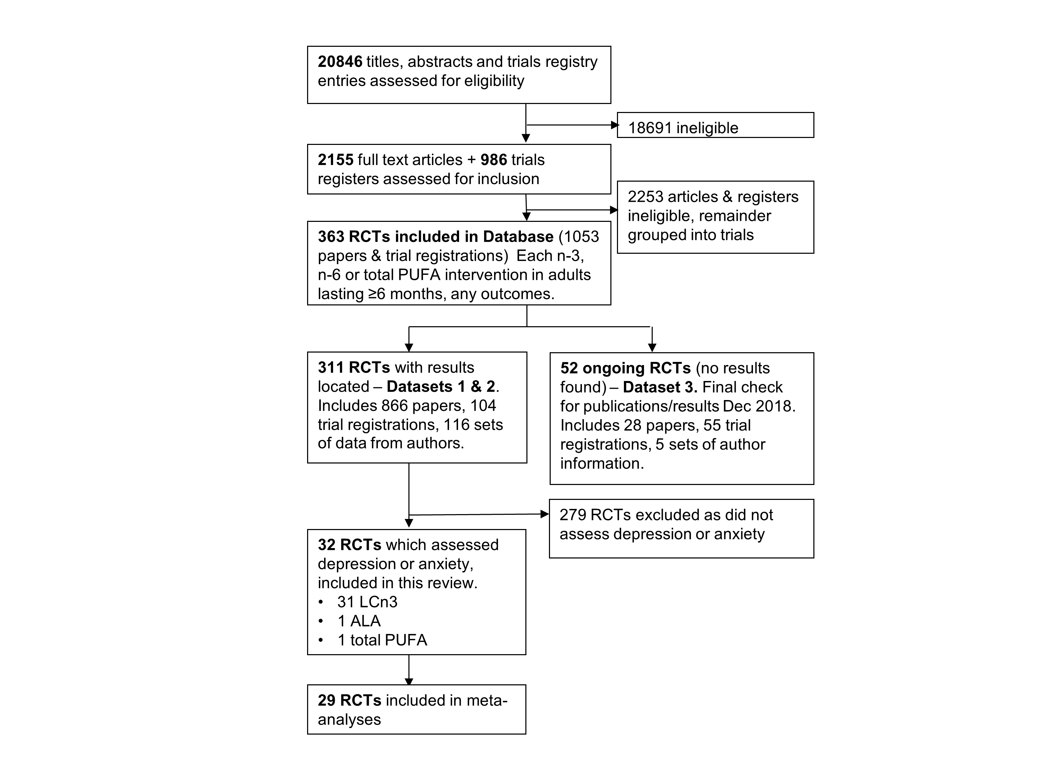

Supplementary Figure 1. Study flow diagram.

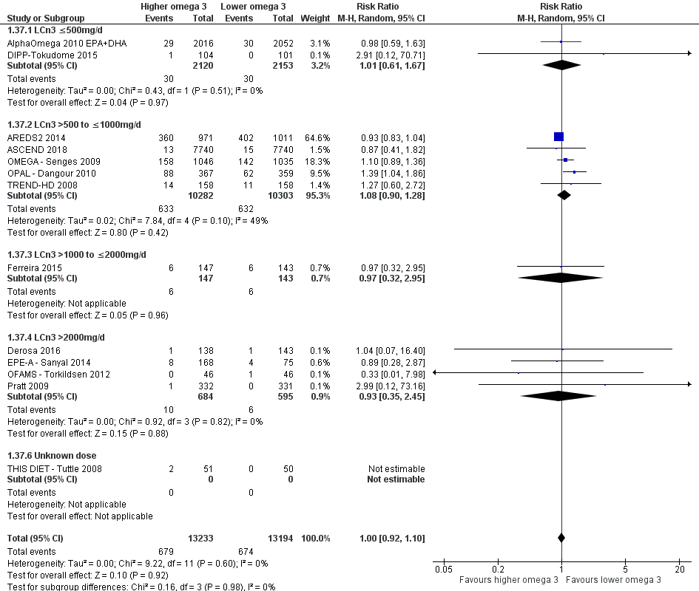

Supplementary Figure 2. Meta-analysis of effects of higher LCn3 vs lower LCn3 on risk of depression symptoms, sub-grouped by LCn3 dose.

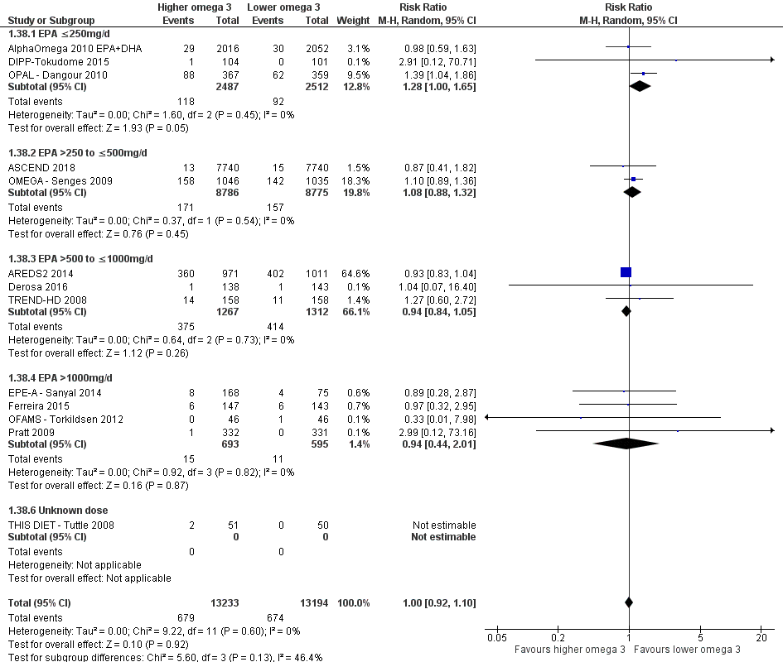

Supplementary Figure 3. Meta-analysis of effects of higher LCn3 vs lower LCn3 on risk of depression symptoms, sub-grouped by EPA dose.

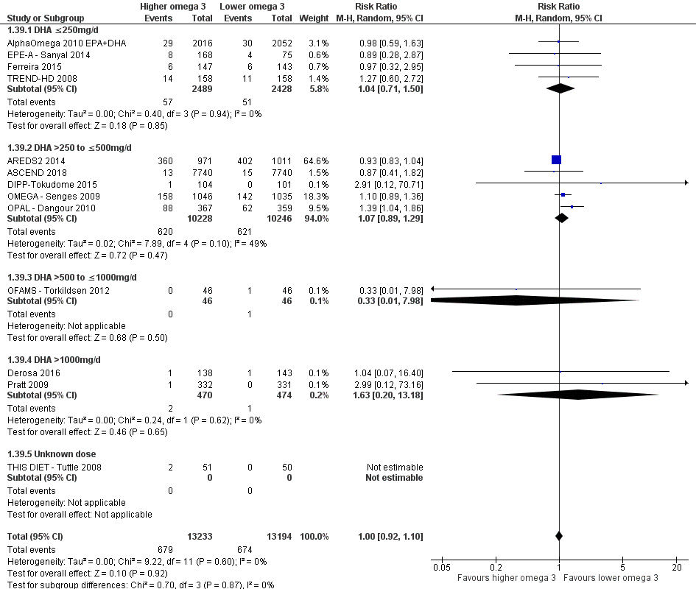

Supplementary Figure 4. Meta-analysis of effects of higher LCn3 vs lower LCn3 on risk of depression symptoms, sub-grouped by DHA dose.

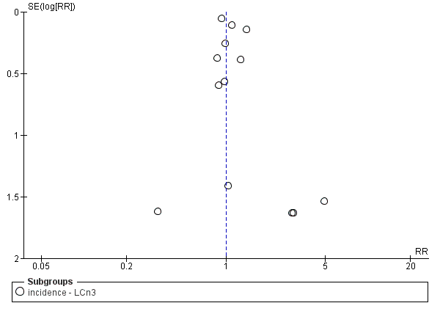

Supplementary Figure 5. Funnel plot of the analysis of effects of higher LCn3 vs lower LCn3 on risk of depression.

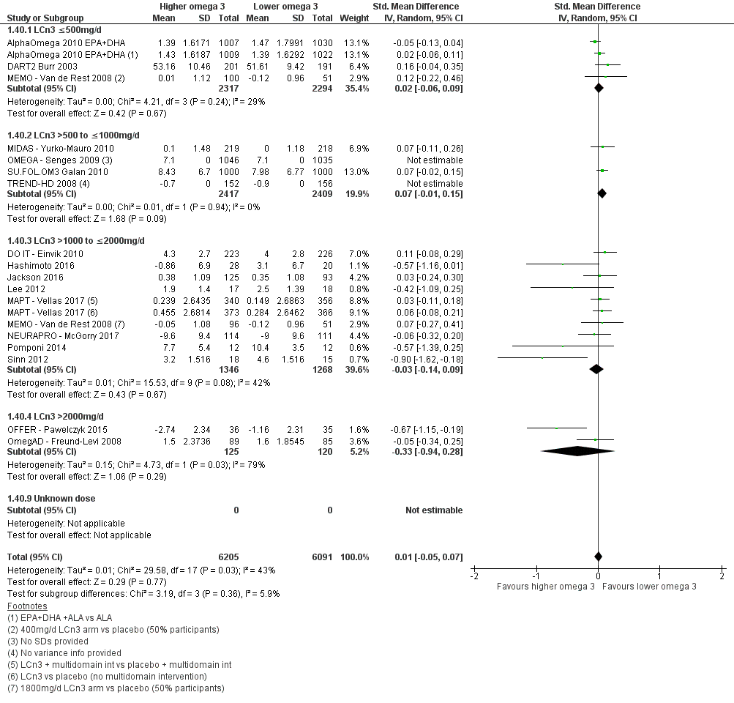

Supplementary Figure 6. Meta-analysis of effects of higher LCn3 vs lower LCn3 on depression symptoms, analysed using SMD, sub-grouped by LCn3 dose.

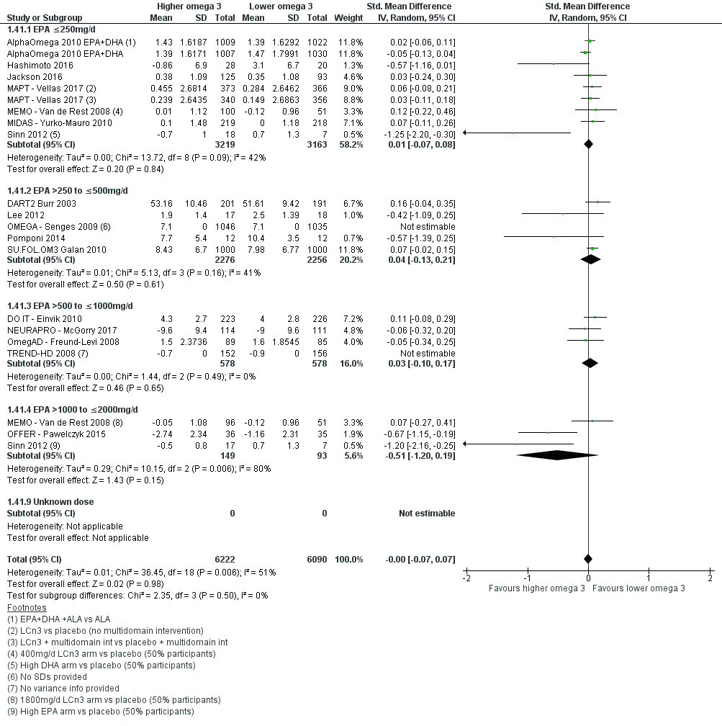

Supplementary Figure 7. Meta-analysis of effects of higher LCn3 vs lower LCn3 on depression symptoms, analysed using SMD, sub-grouped by EPA dose.

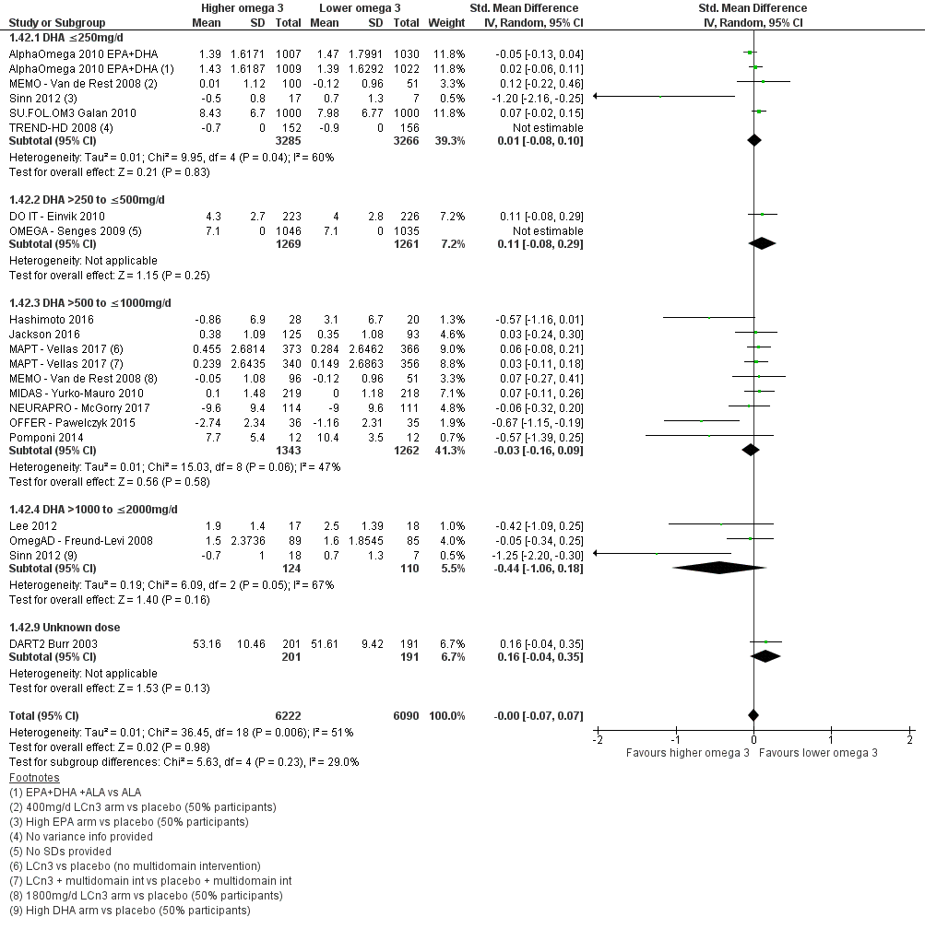

Supplementary Figure 8. Meta-analysis of effects of higher LCn3 vs lower LCn3 on depression symptoms, analysed using SMD, sub-grouped by DHA dose.

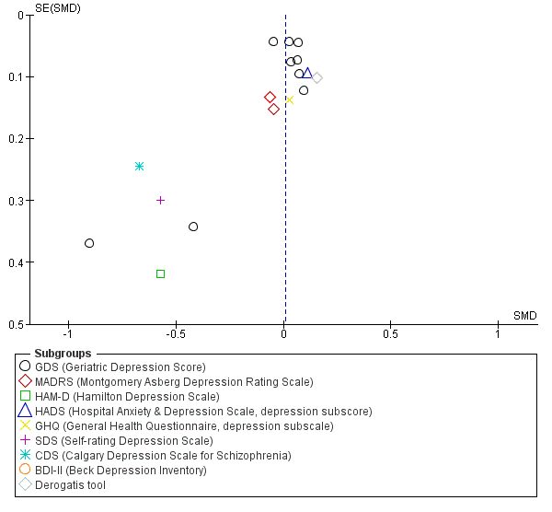

Supplementary Figure 9. Funnel plot of the analysis of effects of higher LCn3 vs lower LCn3 on depression symptoms, using SMD, sub-grouped by depression rating scale.
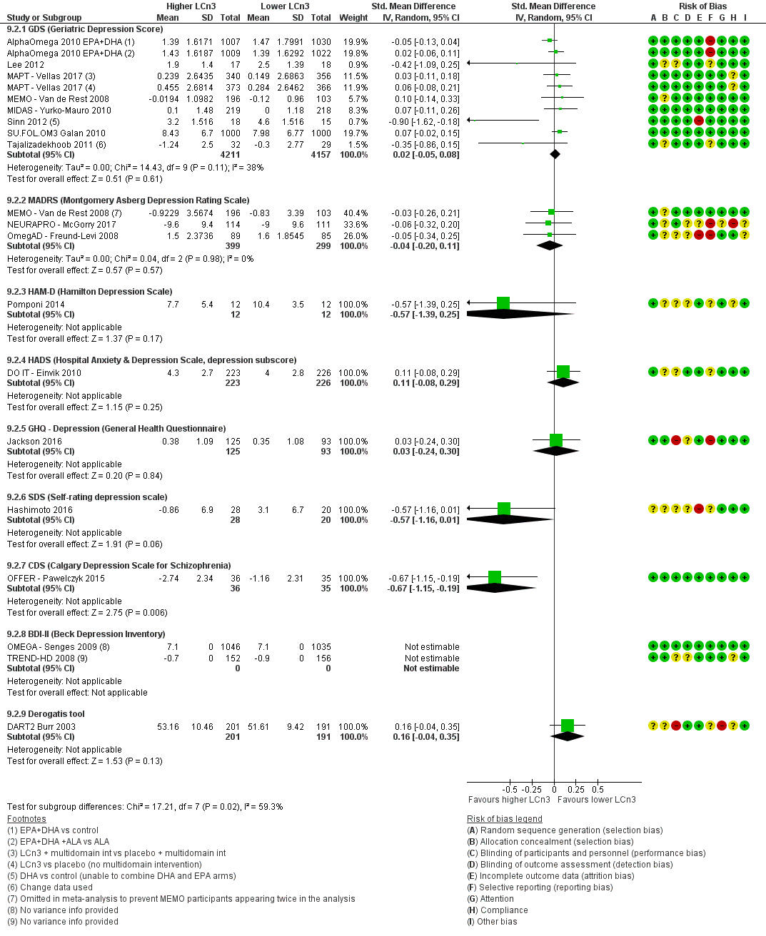

Supplementary Figure 10. Forest plot of trials randomising to higher vs lower LCn3 intake and assessing depression symptoms (on a continuous scale) in those without depression at baseline, subgrouping by scale and displayed in native scales. For meta-analysis data were combined using SMD (not shown, SMD 0.01, 95% CI -0.06 to 0.07, I² 46%).

Acknowledgements:
This review is one of a set of reviews conducted by the PUFAH group. The Polyunsaturated Fats and Health (PUFAH) group includes Asmaa Abdelhamid¹, Sarah Ajabnoor¹, Faye Alabdulghafoor¹, Lena Alkhudairy², Priti Biswas³, Julii Brainard¹, Charlene Bridges⁴, Tracey J Brown¹, Katherine Deane³, Daisy Donaldson¹, Sarah Hanson³, Lee Hooper¹, Oluseyi Florence Jimoh¹, Nicole Martin⁴, Alex O’Brien¹, Karen Rees, Lena Alkhudairy², Fujian Song¹, Gabrielle Thorpe³, Xia Wang¹ and Lauren Winstanley¹.
¹Norwich Medical School, University of East Anglia
²Warwick Medical School, University of Warwick
³ School of Health Sciences, University of East Anglia
⁴Cochrane Heart Group, University College London

Supplementary References
1. Hooper L, Abdelhamid A, Brainard J, Deane KHO, Song F. Creation of a database to assess effects of omega-3, omega-6 and total polyunsaturated fats on health: database and methodology for a set of reviews. BMJ Open. 2019; 9(5): e029554. DOI: 10.1136/bmjopen-2019-029554
2. Kromhout D, Giltay EJ, Geleijnse JM, Alpha Omega Trial Group. n-3 fatty acids and cardiovascular events after myocardial infarction. N Engl J Med. 2010; 363(21): 2015-26.
3. Chew EY, Clemons TE, Agron E, Launer LJ, Grodstein F, Bernstein PS, et al. Effect of Omega-3 Fatty Acids, Lutein/Zeaxanthin, or Other Nutrient Supplementation on Cognitive Function: The AREDS2 Randomized Clinical Trial. JAMA. 2015; 314(8): 791-801.
4. ASCEND Study Collaborative Group. Effects of n−3 Fatty Acid Supplements in Diabetes Mellitus. N Engl J Med. 2018; 379(16): 1540-50. 10.1056/NEJMoa1804989
5. Derosa G, Cicero AF, D'Angelo A, Borghi C, Maffioli P. Effects of n-3 PUFAs on fasting plasma glucose and insulin resistance in patients with impaired fasting glucose or impaired glucose tolerance. BioFactors. 2016; 42(3): 316-22.
6. Danthiir V, Hosking D, Burns NR, Wilson C, Nettelbeck T, Calvaresi E, et al. Cognitive performance in older adults is inversely associated with fish consumption but not erythrocyte membrane n-3 fatty acids. J Nutr. 2014; 144(3): 311-20.
7. Vellas B, Carrie I, Guyonnet S, Touchon J, Dantoine T, Dartigues JF, et al. MAPT (multi-domain Alzheimer's prevention trial): Results at 36 months. Alzheimer's dement. 2015; 1): 331.
8. Yurko-Mauro K, McCarthy D, Rom D, Nelson EB, Ryan AS, Blackwell A, et al. Beneficial effects of docosahexaenoic acid on cognition in age-related cognitive decline. Alzheimer's dement. 2010; 6(6): 456-64.
9. Pawelczyk T, Grancow-Grabka M, Kotlicka-Antczak M, Trafalska E, Pawelczyk A. A randomized controlled study of the efficacy of six-month supplementation with concentrated fish oil rich in omega-3 polyunsaturated fatty acids in first episode schizophrenia. J Psychiatr Res. 2016; 73: 34-44.
10. Rauch B, Schiele R, Schneider S, Diller F, Victor N, Gohlke H, et al. OMEGA, a randomized, placebo-controlled trial to test the effect of highly purified omega-3 fatty acids on top of modern guideline-adjusted therapy after myocardial infarction. Circulation. 2010; 122(21): 2152-9.
11. Dangour AD, Allen E, Elbourne D, Fasey N, Fletcher AE, Hardy P, et al. Effect of 2-y n-3 long-chain polyunsaturated fatty acid supplementation on cognitive function in older people: a randomized, double-blind, controlled trial. Am J Clin Nutr. 2010; 91(6): 1725-32.
12. Sinn N, Milte CM, Street SJ, Buckley JD, Coates AM, Petkov J, et al. Effects of n-3 fatty acids, EPA v. DHA, on depressive symptoms, quality of life, memory and executive function in older adults with mild cognitive impairment: a 6-month randomised controlled trial. Br J Nutr. 2012; 107(11): 1682-93.
13. Galan P, Kesse-Guyot E, Czernichow S, Briancon S, Blacher J, Hercberg S, et al. Effects of B vitamins and omega 3 fatty acids on cardiovascular diseases: a randomised placebo controlled trial. Br Med J. 2010; 341: c6273.
14. Andrieu S, Guyonnet S, Coley N, Cantet C, Bonnefoy M, Bordes S, et al. Effect of long-term omega 3 polyunsaturated fatty acid supplementation with or without multidomain intervention on cognitive function in elderly adults with memory complaints (MAPT): a randomised, placebo-controlled trial. Lancet Neurol. 2017; 16(5): 377-89. DOI: 10.1016/S1474-4422(17)30040-6
15. Chiu CC, Su KP, Cheng TC, Liu HC, Chang CJ, Dewey ME, et al. The effects of omega-3 fatty acids monotherapy in Alzheimer's disease and mild cognitive impairment: a preliminary randomized double-blind placebo-controlled study. Prog Neuropsychopharmacol Biol Psychiatry. 2008; 32(6): 1538-44.
16. Burr ML, Ashfield-Watt PA, Dunstan FD, Fehily AM, Breay P, Ashton T, et al. Lack of benefit of dietary advice to men with angina: results of a controlled trial. Eur J Clin Nutr. 2003; 57(2): 193-200.
17. Tokudome S, Kuriki K, Yokoyama Y, Sasaki M, Joh T, Kamiya T, et al. Dietary n-3/long-chain n-3 polyunsaturated fatty acids for prevention of sporadic colorectal tumors: a randomized controlled trial in polypectomized participants. Prostaglandins Leukot Essent Fatty Acids. 2015; 94: 1-11.
18. Einvik G, Ekeberg O, Lavik JG, Ellingsen I, Klemsdal TO, Hjerkinn EM. The influence of long-term awareness of hyperlipidemia and of 3 years of dietary counseling on depression, anxiety, and quality of life. J Psychosom Res. 2010; 68(6): 567-72.
19. Sanyal AJ, Abdelmalek MF, Suzuki A, Cummings OW, Chojkier M, Group E. No significant effects of ethyl-eicosapentanoic acid on histologic features of nonalcoholic steatohepatitis in a phase 2 trial. Gastroenterology. 2014; 147(2): 377-84.
20. Ferreira JJ, Rosser A, Craufurd D, Squitieri F, Mallard N, Landwehrmeyer B. Ethyl-eicosapentaenoic acid treatment in Huntington's disease: A placebo-controlled clinical trial. Mov Disord. 2015; 30(10): 1426-9.
21. Hashimoto M, Kato S, Tanabe Y, Katakura M, Mamun AA, Ohno M, et al. Beneficial effects of dietary docosahexaenoic acid intervention on cognitive function and mental health of the oldest elderly in Japanese care facilities and nursing homes. Geriatr Gerontol Int. 2016; 17(2): 330-7.
22. Jackson PA, Forster JS, Bell JG, Dick JR, Younger I, Kennedy DO. DHA Supplementation Alone or in Combination with Other Nutrients Does not Modulate Cerebral Hemodynamics or Cognitive Function in Healthy Older Adults. Nutrients. 2016; 8: 86-.
23. Lee SP, Dart AM, Walker KZ, O'Dea K, Chin-Dusting JP, Skilton MR. Effect of altering dietary n-6:n-3 PUFA ratio on cardiovascular risk measures in patients treated with statins: a pilot study. Br J Nutr. 2012; 108(7): 1280-5.
24. Van De Rest O, Geleijnse JM, Kok FJ, van Staveren WA, Dullemeijer C, Olderikkert MG, et al. Effect of fish oil on cognitive performance in older subjects: a randomized, controlled trial. Neurology. 2008; 71(6): 430-8.
25. McGorry PD, Nelson B, Markulev C, Yuen HP, Schäfer MR, Mossaheb N, et al. Effect of ω-3 Polyunsaturated Fatty Acids in Young People at Ultrahigh Risk for Psychotic Disorders: The NEURAPRO Randomized Clinical Trial. JAMA Psychiatry. 2017; 74(1): 19-27.
26. Torkildsen O, Wergeland S, Bakke S, Beiske AG, Bjerve KS, Hovdal H, et al. omega-3 fatty acid treatment in multiple sclerosis (OFAMS Study): a randomized, double-blind, placebo-controlled trial. Arch Neurol. 2012; 69(8): 1044-51.
27. Freund-Levi Y, Basun H, Cederholm T, Faxen-Irving G, Garlind A, Grut M, et al. Omega-3 supplementation in mild to moderate Alzheimer's disease: effects on neuropsychiatric symptoms. Int J Geriatr Psychiatry. 2008; 23(2): 161-9.
28. Palma C. Omega 3 fatty acids supplementation in Schizophrenia. Eur Arch Psychiatry Clin Neurosci. 2015; 265(Supplement 1): S122-S.
29. Pomponi M, Loria G, Salvati S, Di Biase A, Conte G, Villella C, et al. DHA effects in Parkinson disease depression. Basal Ganglia. 2014; 4(2): 61-6.
30. Pratt CM, Reiffel JA, Ellenbogen KA, Naccarelli GV, Kowey PR. Efficacy and safety of prescription omega-3-acid ethyl esters for the prevention of recurrent symptomatic atrial fibrillation: a prospective study. Am Heart J. 2009; 158(2): 163-9.
31. Tajalizadekhoob Y, Sharifi F, Fakhrzadeh H, Mirarefin M, Ghaderpanahi M, Badamchizade Z, et al. The effect of low-dose omega 3 fatty acids on the treatment of mild to moderate depression in the elderly: a double-blind, randomized, placebo-controlled study. Eur Arch Psychiatry Clin Neurosci. 2011; 261(8): 539-49.
32. Tuttle KR, Shuler LA, Packard DP, Milton JE, Daratha KB, Bibus DM, et al. Comparison of low-fat versus Mediterranean-style dietary intervention after first myocardial infarction (from The Heart Institute of Spokane Diet Intervention and Evaluation Trial). Am J Cardiol. 2008; 101(11): 1523-30.
33. Huntington Study Group. Randomized controlled trial of ethyl-eicosapentaenoic acid in Huntington disease: the TREND-HD study. Arch Neurol. 2008; 65(12): 1582-9.
34. Geleijnse J, Giltay E, Kromhout D. Effects of n-3 fattyacids on cognitive decline: A randomized double-blind, placebo-controlled trial in stable myocardial infarction patients. Alzheimer's dement. 2011; 1): S512.
35. Estruch R, Ros E, Salas-Salvadó J, Covas M, Corella D, Arós F et al. Retraction and republication: Primary prevention of cardiovascular disease with a Mediterranean diet. N Engl J Med 2013; 368:1279-90. N Engl J Med. 2018; 378: 25-.
36. Harbord RM, Egger M, Sterne JAC. A modified test for small-study effects in meta-analyses of controlled trials with binary endpoints. Statistics in Medicine. 2006; 25(20): 3443-57. DOI: 10.1002/sim.2380
37. Sterne JAC, Sutton AJ, Ioannidis JPA, Terrin N, Jones DR, Lau J, et al. Recommendations for examining and interpreting funnel plot asymmetry in meta-analyses of randomised controlled trials. Br Med J. 2011; 343: d4002. DOI: 10.1136/bmj.d4002
38. Peters JL, Sutton AJ, Jones DR, Abrams KR, Rushton L. Comparison of Two Methods to Detect Publication Bias in Meta-analysis. JAMA. 2006; 295(6): 676-80. DOI: 10.1001/jama.295.6.676
39. Page MJ, Higgins JPT, Sterne JAC. Chapter 13: Assessing risk of bias due to missing results in a synthesis. Draft version (29 Janaury 2019) for inclusion in. In: Cochrane Handbook for Systematic Reviews of Interventions (eds JPT HIggins, J Thomas, J Chandler, M Cumpston, T Li, MJ Page, et al.). Cochrane, 2019.
40. Rauch B, Schiele R, Schneider S, Diller F, Victor N, Gohlke H, et al. OMEGA, a randomized, placebo-controlled trial to test the effect of highly purified omega-3 fatty acids on top of modern guideline-adjusted therapy after myocardial infarction. Circulation. 2010; 122(21): 2152-9.
41. Van De Rest O, Geleijnse JM, Kok FJ, van Staveren WA, Hoefnagels WH, Beekman AT, et al. Effect of fish-oil supplementation on mental well-being in older subjects: a randomized, double-blind, placebo-controlled trial. Am J Clin Nutr. 2008; 88(3): 706-13.
42. Abdelhamid AS, Brown TJ, Brainard JS, Biswas P, Thorpe GC, Moore HJ, et al. Omega-3 fatty acids for the primary and secondary prevention of cardiovascular disease. Cochrane Database Syst Rev. 2018; 11: CD003177. DOI: 10.1002/14651858.CD003177.pub4
43. Abdelhamid AS, Martin N, Bridges C, Brainard JS, Wang X, Brown TJ, et al. Polyunsaturated fatty acids for the primary and secondary prevention of cardiovascular disease. Cochrane Database Syst Rev. 2018; 11: CD012345. DOI: 10.1002/14651858.CD012345.pub3
44. Hooper L, Al-Khudairy L, Abdelhamid AS, Rees K, Brainard JS, Brown TJ, et al. Omega-6 fats for the primary and secondary prevention of cardiovascular disease. Cochrane Database Syst Rev. 2018; 11: CD011094. DOI: 10.1002/14651858.CD011094.pub4
45. Abdelhamid A, Hooper L, Sivakaran R, Hayhoe RPG, Welch A, The PUFAH Group. The Relationship Between Omega-3, Omega-6 and Total Polyunsaturated Fat and Musculoskeletal Health and Functional Status in Adults: A Systematic Review and Meta-analysis of RCTs. Calcified Tissue International. 2019. DOI: 10.1007/s00223-019-00584-3
46. Brainard J, Jimoh OF, Deane K, Biswas P, Donaldson D, Maas K, et al. Omega-3, omega-6 and total polyunsaturated fat for cognition and dementia: Systematic review and meta-analysis of RCTs. submitted. 2019.
47. Brown TJ, Brainard J, Song F, Wang X, Abdelhamid A, Hooper L. Omega-3, omega-6, and total dietary polyunsaturated fat for prevention and treatment of type 2 diabetes mellitus: systematic review and meta-analysis of randomised controlled trials. Br Med J. 2019; 366: l4697. DOI: 10.1136/bmj.l4697
48. Hanson S, Thorpe G, Winstanley L, Abdelhamid AS, Hooper L. Omega-3, omega-6 and total dietary polyunsaturated fat on cancer incidence: systematic review and meta-analysis of randomised trials. submitted. 2019.
49. Thorpe G, Ajabnoor S, Ahmed Z, Abdelhamid A, Hooper L. Dietary polyunsaturated fat for prevention and treatment of inflammatory bowel disease. PROSPERO. 2017: CRD42017068704.
50. Burr ML, Ashfield-Watt PA, Dunstan FD, Fehily AM, Breay P, Ashton T, et al. Lack of benefit of dietary advice to men with angina: results of a controlled trial. Eur J Clin Nutr. 2003; 57(2): 193-200.
51. Cockayne NL, Duffy SL, Bonomally R, English A, Amminger PG, Mackinnon A, et al. The Beyond Ageing Project Phase 2--a double-blind, selective prevention, randomised, placebo-controlled trial of omega-3 fatty acids and sertraline in an older age cohort at risk for depression: study protocol for a randomized controlled trial. Trials. 2015; 16: 247.
52. Cai S, Coates AM, Buckley JD, Berry NM, Burres L, Beltrame J, et al. There is No Association Between the Omega-3 Index and Depressive Symptomsin Patients With Heart Disease Who Are Low Fish Consumers. Heart Lung Circ. 2017; 26: 276-84.
53. Bowman LG, Silbert CL, Dodge HH, Lahna D, Hagen K, Murchison FC, et al. Randomized Trial of Marine n-3 Polyunsaturated Fatty Acids for the Prevention of Cerebral Small Vessel Disease and Inflammation in Aging (PUFA Trial): Rationale, Design and Baseline Results. Nutrients. 2019; 11(4). DOI: 10.3390/nu11040735
54. Qurashi I, Chaudhry IB, Khoso AB, Farooque S, Lane S, Husain MO, et al. A randomised, double-blind, placebo-controlled trial of minocycline and/or omega-3 fatty acids added to treatment as usual for at-risk mental states (NAYAB): study protocol. Trials. 2017; 18(1): 524. DOI: 10.1186/s13063-017-2275-y
55. Okereke OI, Reynolds CF, III, Mischoulon D, Chang G, Cook NR, Copeland T, et al. The VITamin D and OmegA-3 TriaL-Depression Endpoint Prevention (VITAL-DEP): Rationale and design of a large-scale ancillary study evaluating vitamin D and marine omega-3 fatty acid supplements for prevention of late-life depression. Contemp Clin Trials. 2018; 68: 133-45. DOI: 10.1016/j.cct.2018.02.017

