Supplemental Material
Data sources and genetic instruments: Smoking heaviness and smoking cessation | Page 2
A comparison of each of the MR sensitivity analyses and their assumptions | Page 2
Figures
Legends for all figures | Page 4
Figure S1. Scatter plot of IVW and MR Egger analyses of smoking initiation on bipolar disorder | Page 4
Figure S2. Single SNP analysis of smoking initiation on bipolar disorder | Page 5
Figure S3. Leave-one-out analysis of smoking initiation on bipolar disorder | Page 6
Figure S4. Scatter plot of IVW analyses of bipolar disorder on smoking initiation | Page 7
Figure S5. Single SNP analysis of bipolar disorder on smoking initiation | Page 8
Figure S6. Leave-one-out analysis of bipolar disorder on smoking initiation | Page 9
Figure S7. Scatter plot of IVW analyses of lifetime smoking on bipolar disorder | Page 10
Figure S8. Single SNP analysis of lifetime smoking on bipolar disorder | Page 11
Figure S9. Leave-one-out analysis of lifetime smoking on bipolar disorder | Page 12
Figure S10. Scatter plot of IVW analyses of bipolar disorder on lifetime smoking | Page 13
Figure S11. Single SNP analysis of bipolar disorder on lifetime smoking | Page 15
Figure S12. Leave-one-out analysis of bipolar disorder on lifetime smoking | Page 15
Figure S13. Scatter plot of IVW analyses of bipolar disorder on cigarettes per day | Page 16
Figure S14. Single SNP analysis of bipolar disorder on cigarettes per day | Page 17
Figure S15. Leave-one-out analysis of bipolar disorder on cigarettes per day | Page 18
Figure S16. Scatter plot of IVW analyses of bipolar disorder on smoking cessation | Page 19
Figure S17. Single SNP analysis of bipolar disorder on smoking cessation | Page 20
Figure S18. Leave-one-out analysis of bipolar disorder on smoking cessation | Page 21
Tables
Table S1. Tests of the unweighted and weighted regression dilution I²_{GX}  Table S2. Tests of heterogeneity | Page 22  Page 23
Table S3. Test of directional pleiotropy using the MR Egger Intercept | Page 23
Table S4. Tests to measure instrument strength for MR Egger | Page 23
Table S5. Mendelian randomisation results following Steiger filtering | Page 24

Methods: Smoking heaviness and cessation
Smoking heaviness and cessation could not be used as exposure variables because stratification of the bipolar sample into smokers and nonsmokers was not possible.
For smoking heaviness, we used data from a sample of 337,334 smoking individuals without the 23andMe sub-sample (n=73,380). The effect sizes for smoking heaviness are presented as betas and correspond to the increase of one standard deviation of the number of cigarettes per day. For smoking cessation, we used data from a sample of 547,219 individuals without the 23andMe sub-sample (n=234,398). The effect sizes for smoking cessation are presented as odds ratios and values below one correspond to a higher odds of smoking cessation.
A comparison of each of the MR sensitivity analyses and their assumptions.
Method | Description | Additional Assumptions | Power | Invalid variants allowed
Random effects Inverse‐variance weighted (IVW) | A meta-analysis of the Wald ratios for each SNP ($\frac{ZY}{ZX}$) weighted by the inverse of the variance of the SNP-outcome association. | Any horizontal pleiotropy must be balanced | Has the most power if the assumptions are satisfied. | 0% (or 100% if all horizontal pleiotropy is balanced)
MR‐Egger regression | An extension of the IVW which relaxes the assumption that any pleiotropy must be balanced. A significant intercept term suggests bias from directional pleiotropy, i.e. the average pleiotropic effect is not zero. MR-Egger regression provides consistent estimates even if all genetic instrumental variables are invalid as long as the INSIDE assumption is met. | InSIDEª  NOME^{b} | Has the lowest power | 100%
MR-Egger SIMEX | Simulation extrapolation can be used to correct MR-Egger regression parameters for NOME violation, and in doing so reduce the type I error rate of the MR-Egger test for pleiotropy. The I²GX-statistic is proposed to quantify the strength of NOME violation in the SNP-exposure effects. It lies between 0 and 1, and indicates the expected relative bias (or dilution) of the MR-Egger causal estimate in the two-sample MR context. For values of I² GX < 0.9, MR Egger SIMEX corrections are presented using the highest of the two regression dilution statistics (weighted or unweighted by the SE of the exposure SNPs. For values of I² GX < 0.6, MR Egger and MR Egger SIMEX are both unreliable and so neither are performed. | InSIDEª  NOME^{b} | Similar or lower than MR-Egger | 100%
Weighted median | The weighted median estimate is obtained by first calculating the Wald ratio causal estimate for each SNP and then taking the estimate with the median inverse variance weight. | Consistent when 50% of weight contributed by genetic variants is valid. | Similar to that of IVW method. | 50%
Weighted mode | Finds the largest cluster of Wald ratio estimates. The majority of the genetic instruments can be invalid providing the ZEMPA assumption is satisfied. In the weighted mode method, the mode is calculated using the inverse variance weights of the Wald ratios. | ZEMPA^{c} | Less powerful than IVW and weighted median. | 50%
Robust adjusted profile score (RAPS) | An extension of IVW into a general framework which allows very many weak instruments. Requires no sample overlap in the exposure and outcome SNP effect estimates. | InSIDEª  Pleiotropy is additive.  Pleiotropic effects are balanced (have mean zero). |  | 100%
Note. Where Z = the genetic instrument, X = the exposure and Y = the outcome. Throughout the table, invalid refers to instruments that do not meet the required assumptions for MR. Power of the methods might differ under different models of pleiotropy. ªThe InSIDE assumption = pleiotropic effects of Z are independent of the effects of Z on the exposure. ^{b}The no measurement error assumption (NOME) = assumes that the ZX associations are known, rather than estimated. ^{c}The ZEMPA assumption = the largest subset of genetic instrumental variables with the same ratio estimate will contain the valid instruments.

Legends for all figures:
The grey bars indicate 95% confidence intervals.
Single SNP analysis calculates the individual effects of each SNP.
In the leave-one-out figures, each of the independent SNPs are sequentially omitted from the analyses. It investigates whether one of the genetic variants is an invalid instrumental variable. If so, the causal estimate based on all the variants from a Mendelian randomisation analysis will be biased and type 1 (false positive) error rates will be inflated.
Figure S1. Scatter plot of IVW and MR Egger analyses of smoking initiation on bipolar disorder

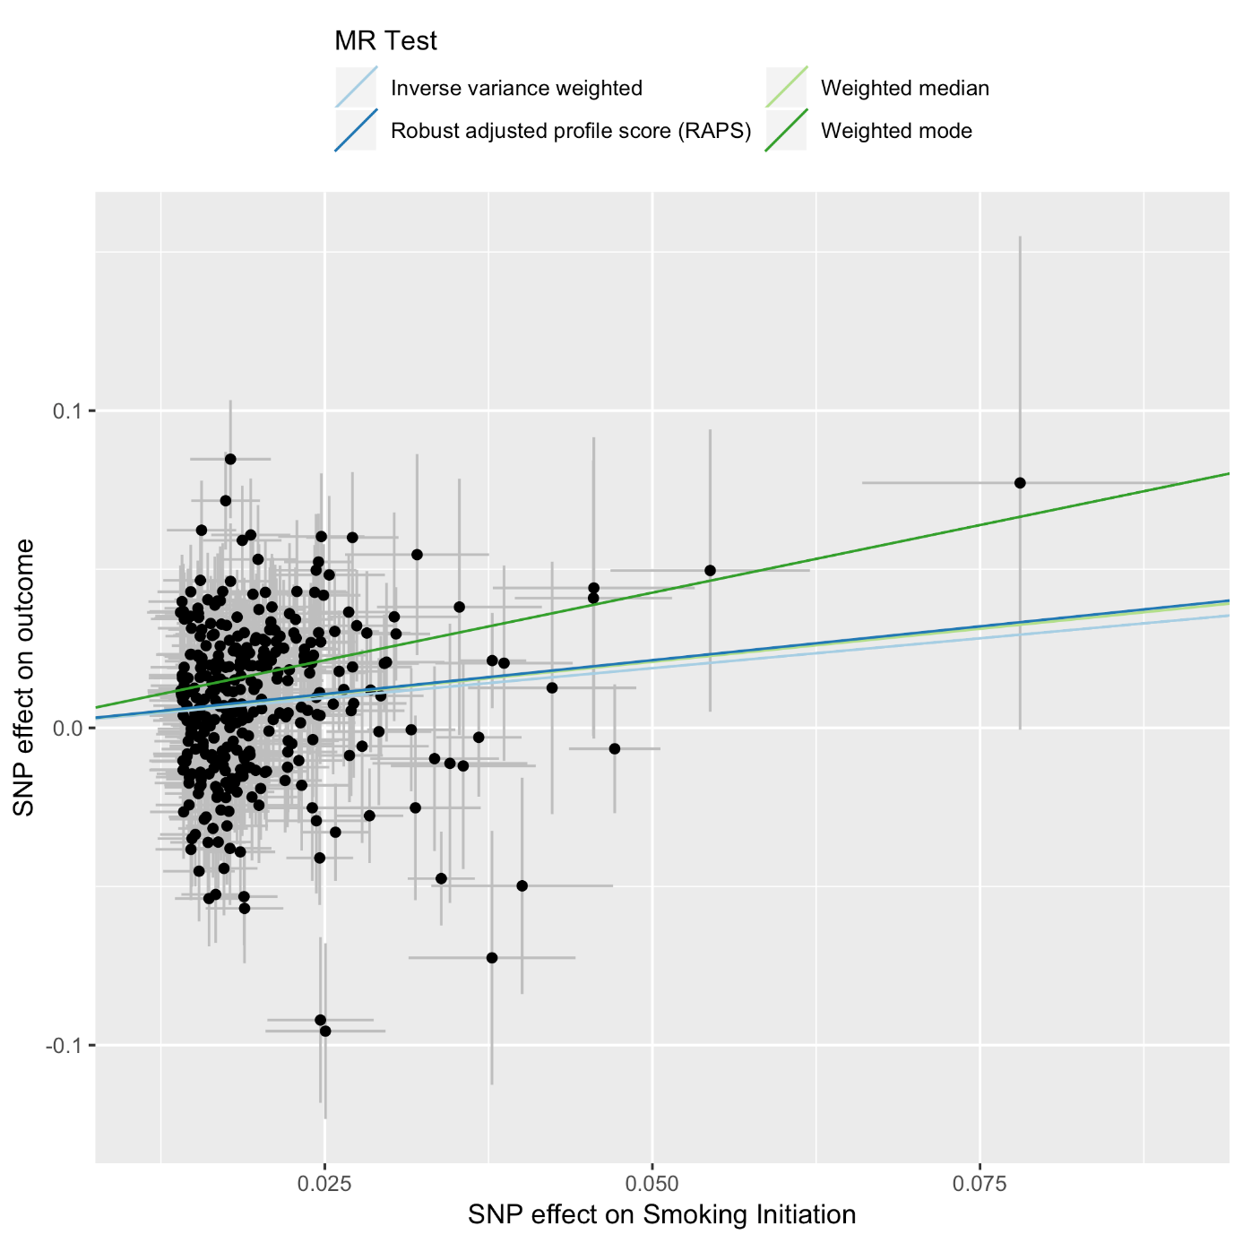

Figure S2. Single SNP analysis of smoking initiation on bipolar disorder
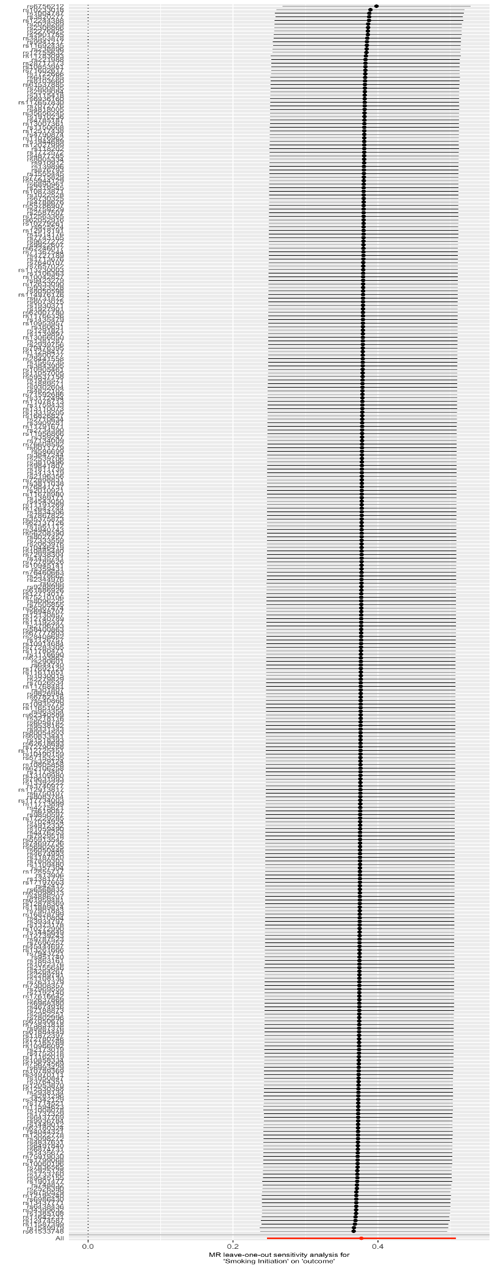
Figure S3. Leave-one-out analysis of smoking initiation on bipolar disorder
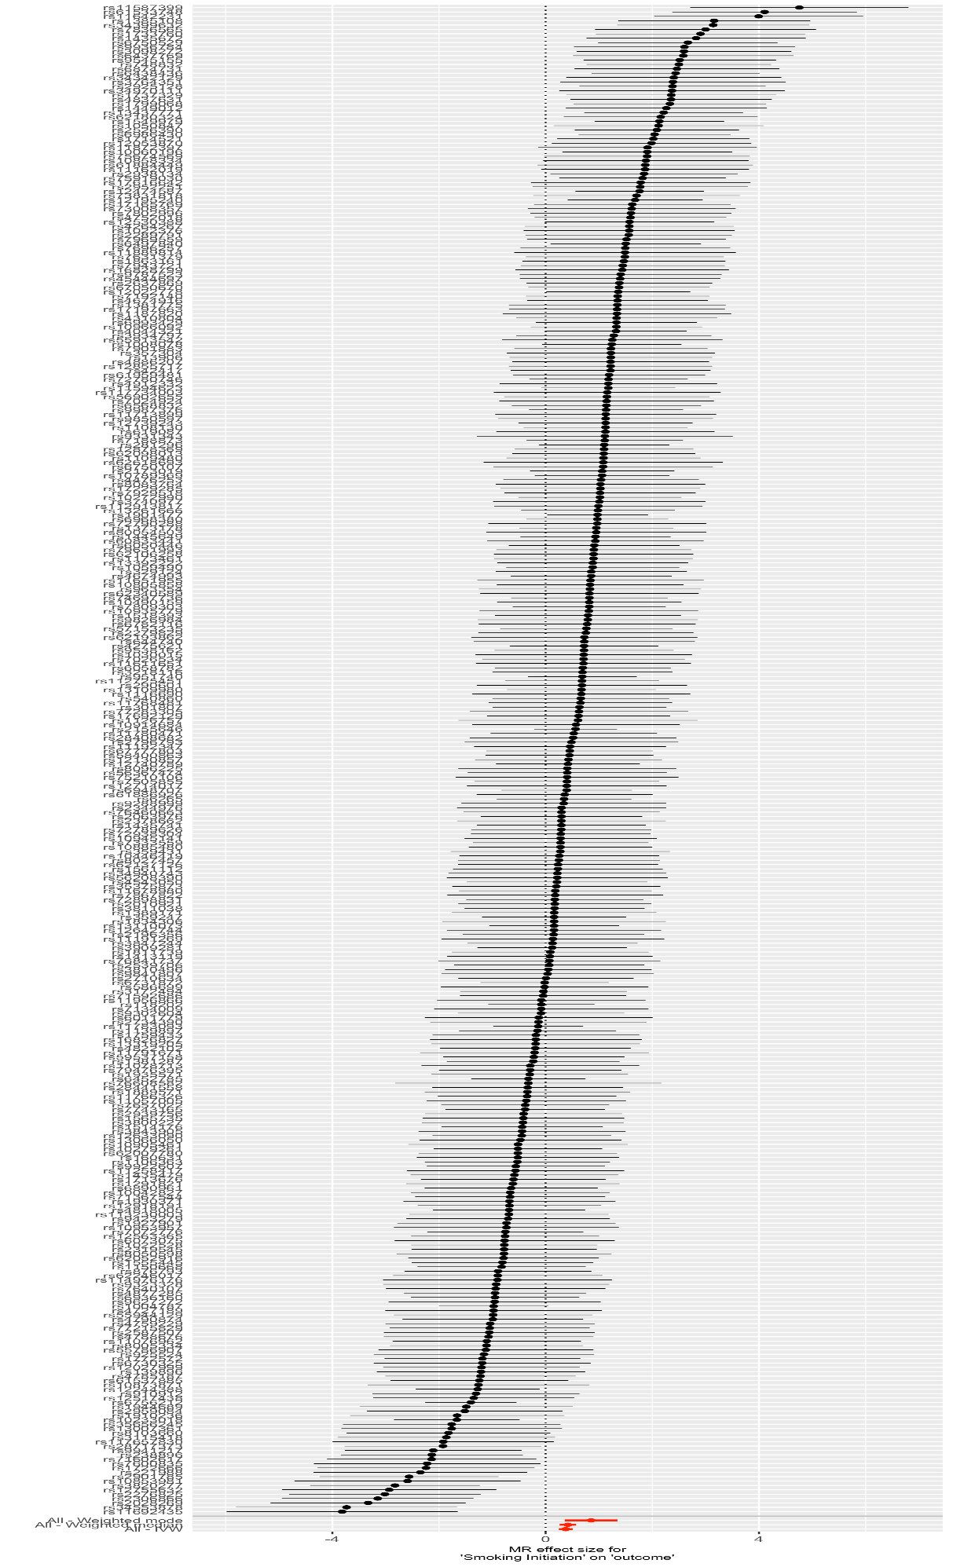
Figure S4. Scatter plot of IVW analyses of bipolar disorder on smoking initiation
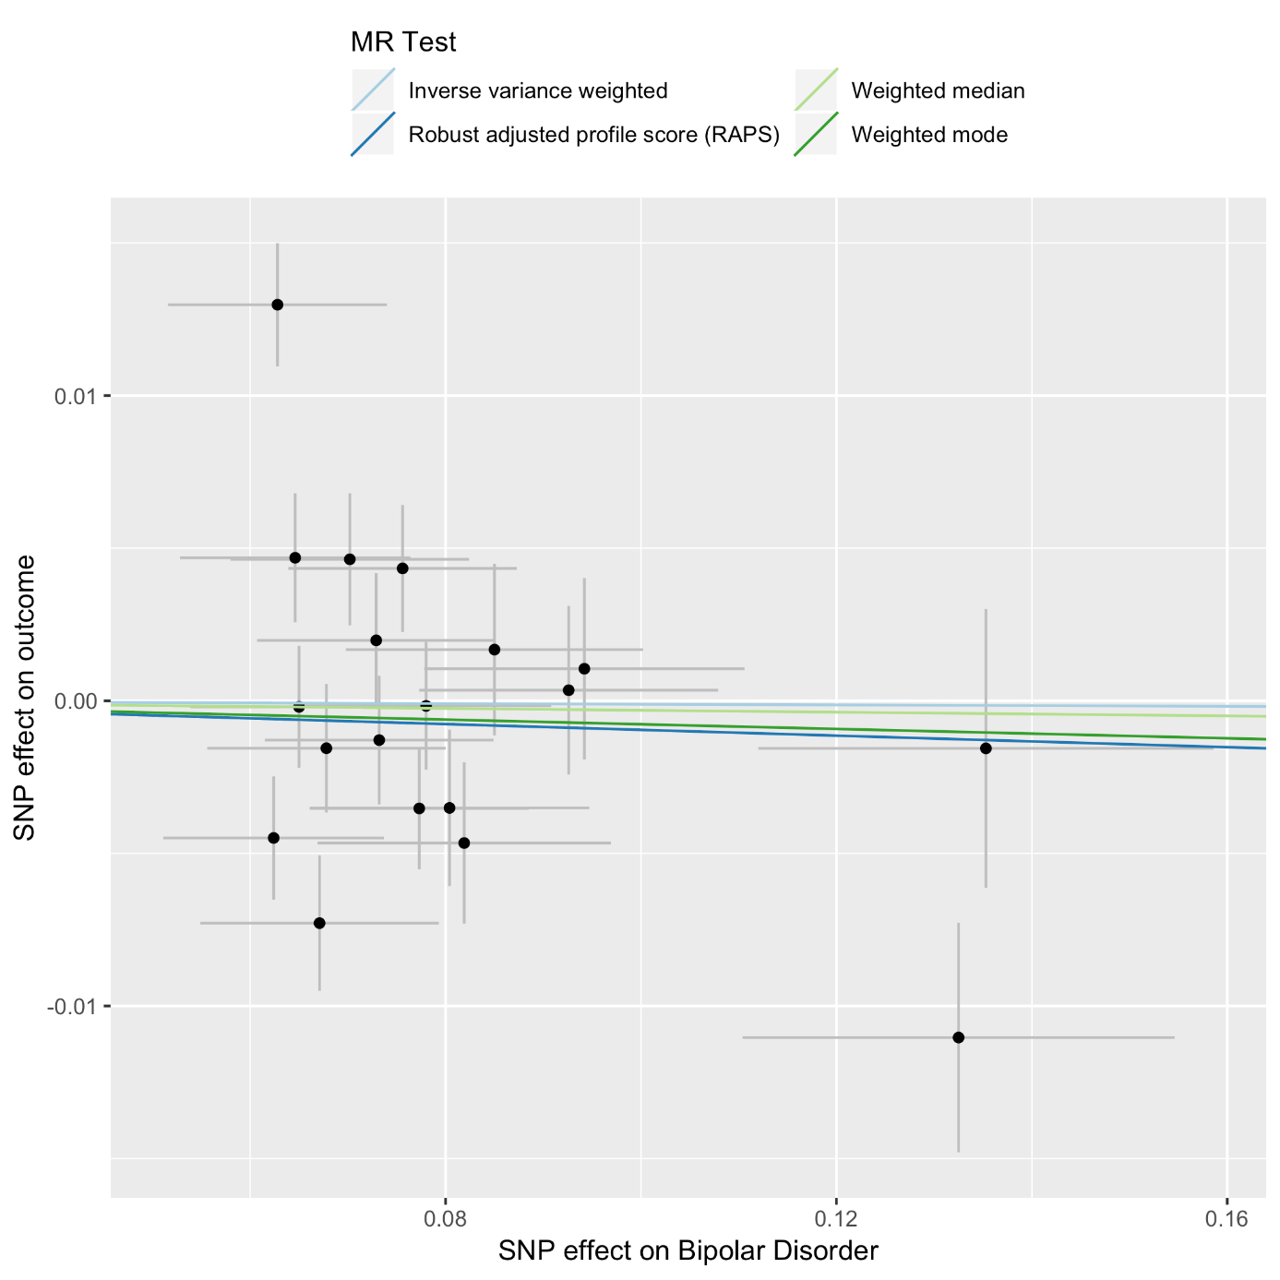

Figure S5. Single SNP analysis of bipolar disorder on smoking initiation
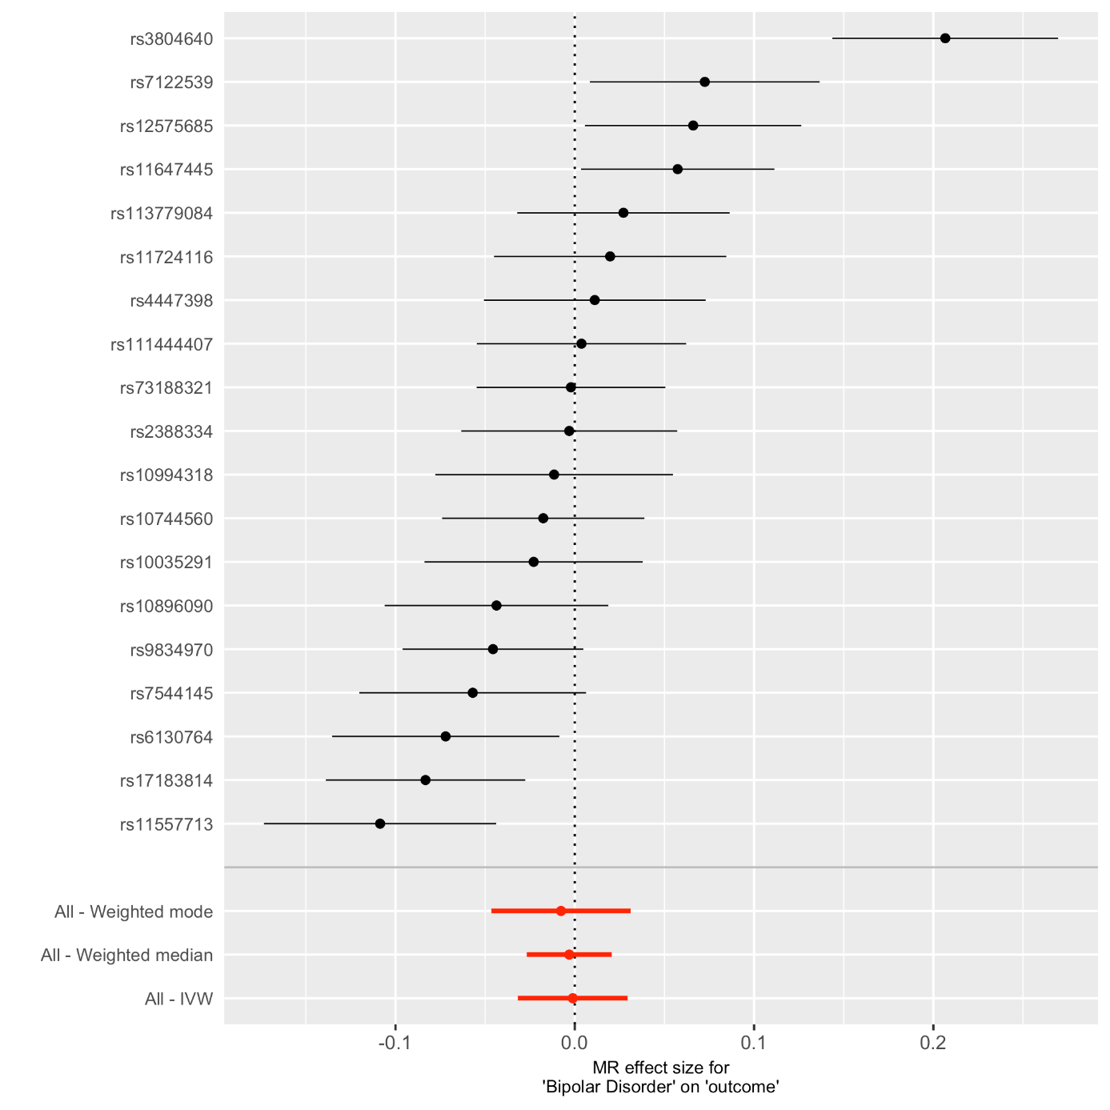
Figure S6. Leave-one-out analysis of bipolar disorder on smoking initiation
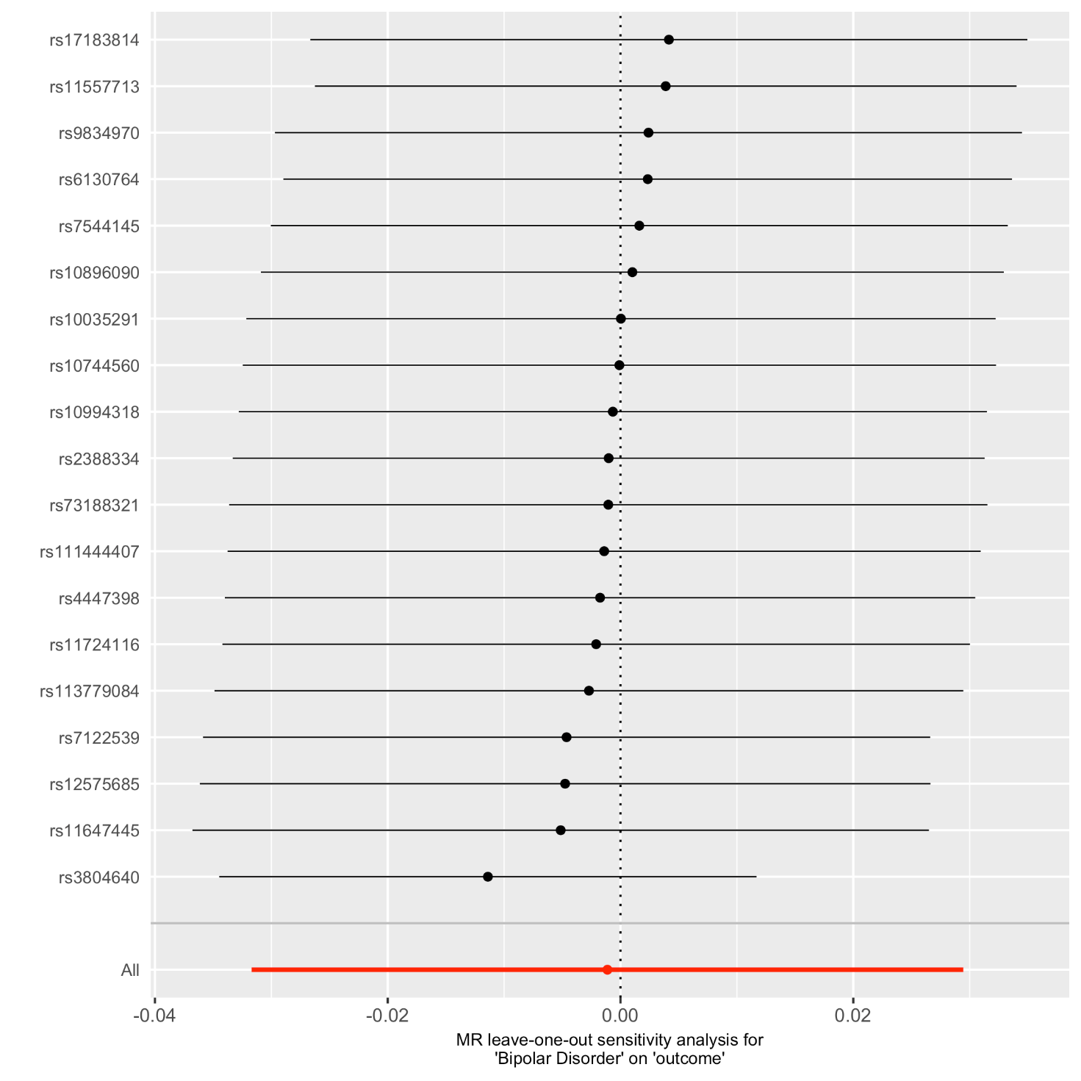
Figure S7. Scatter plot of IVW analyses of lifetime smoking on bipolar disorder

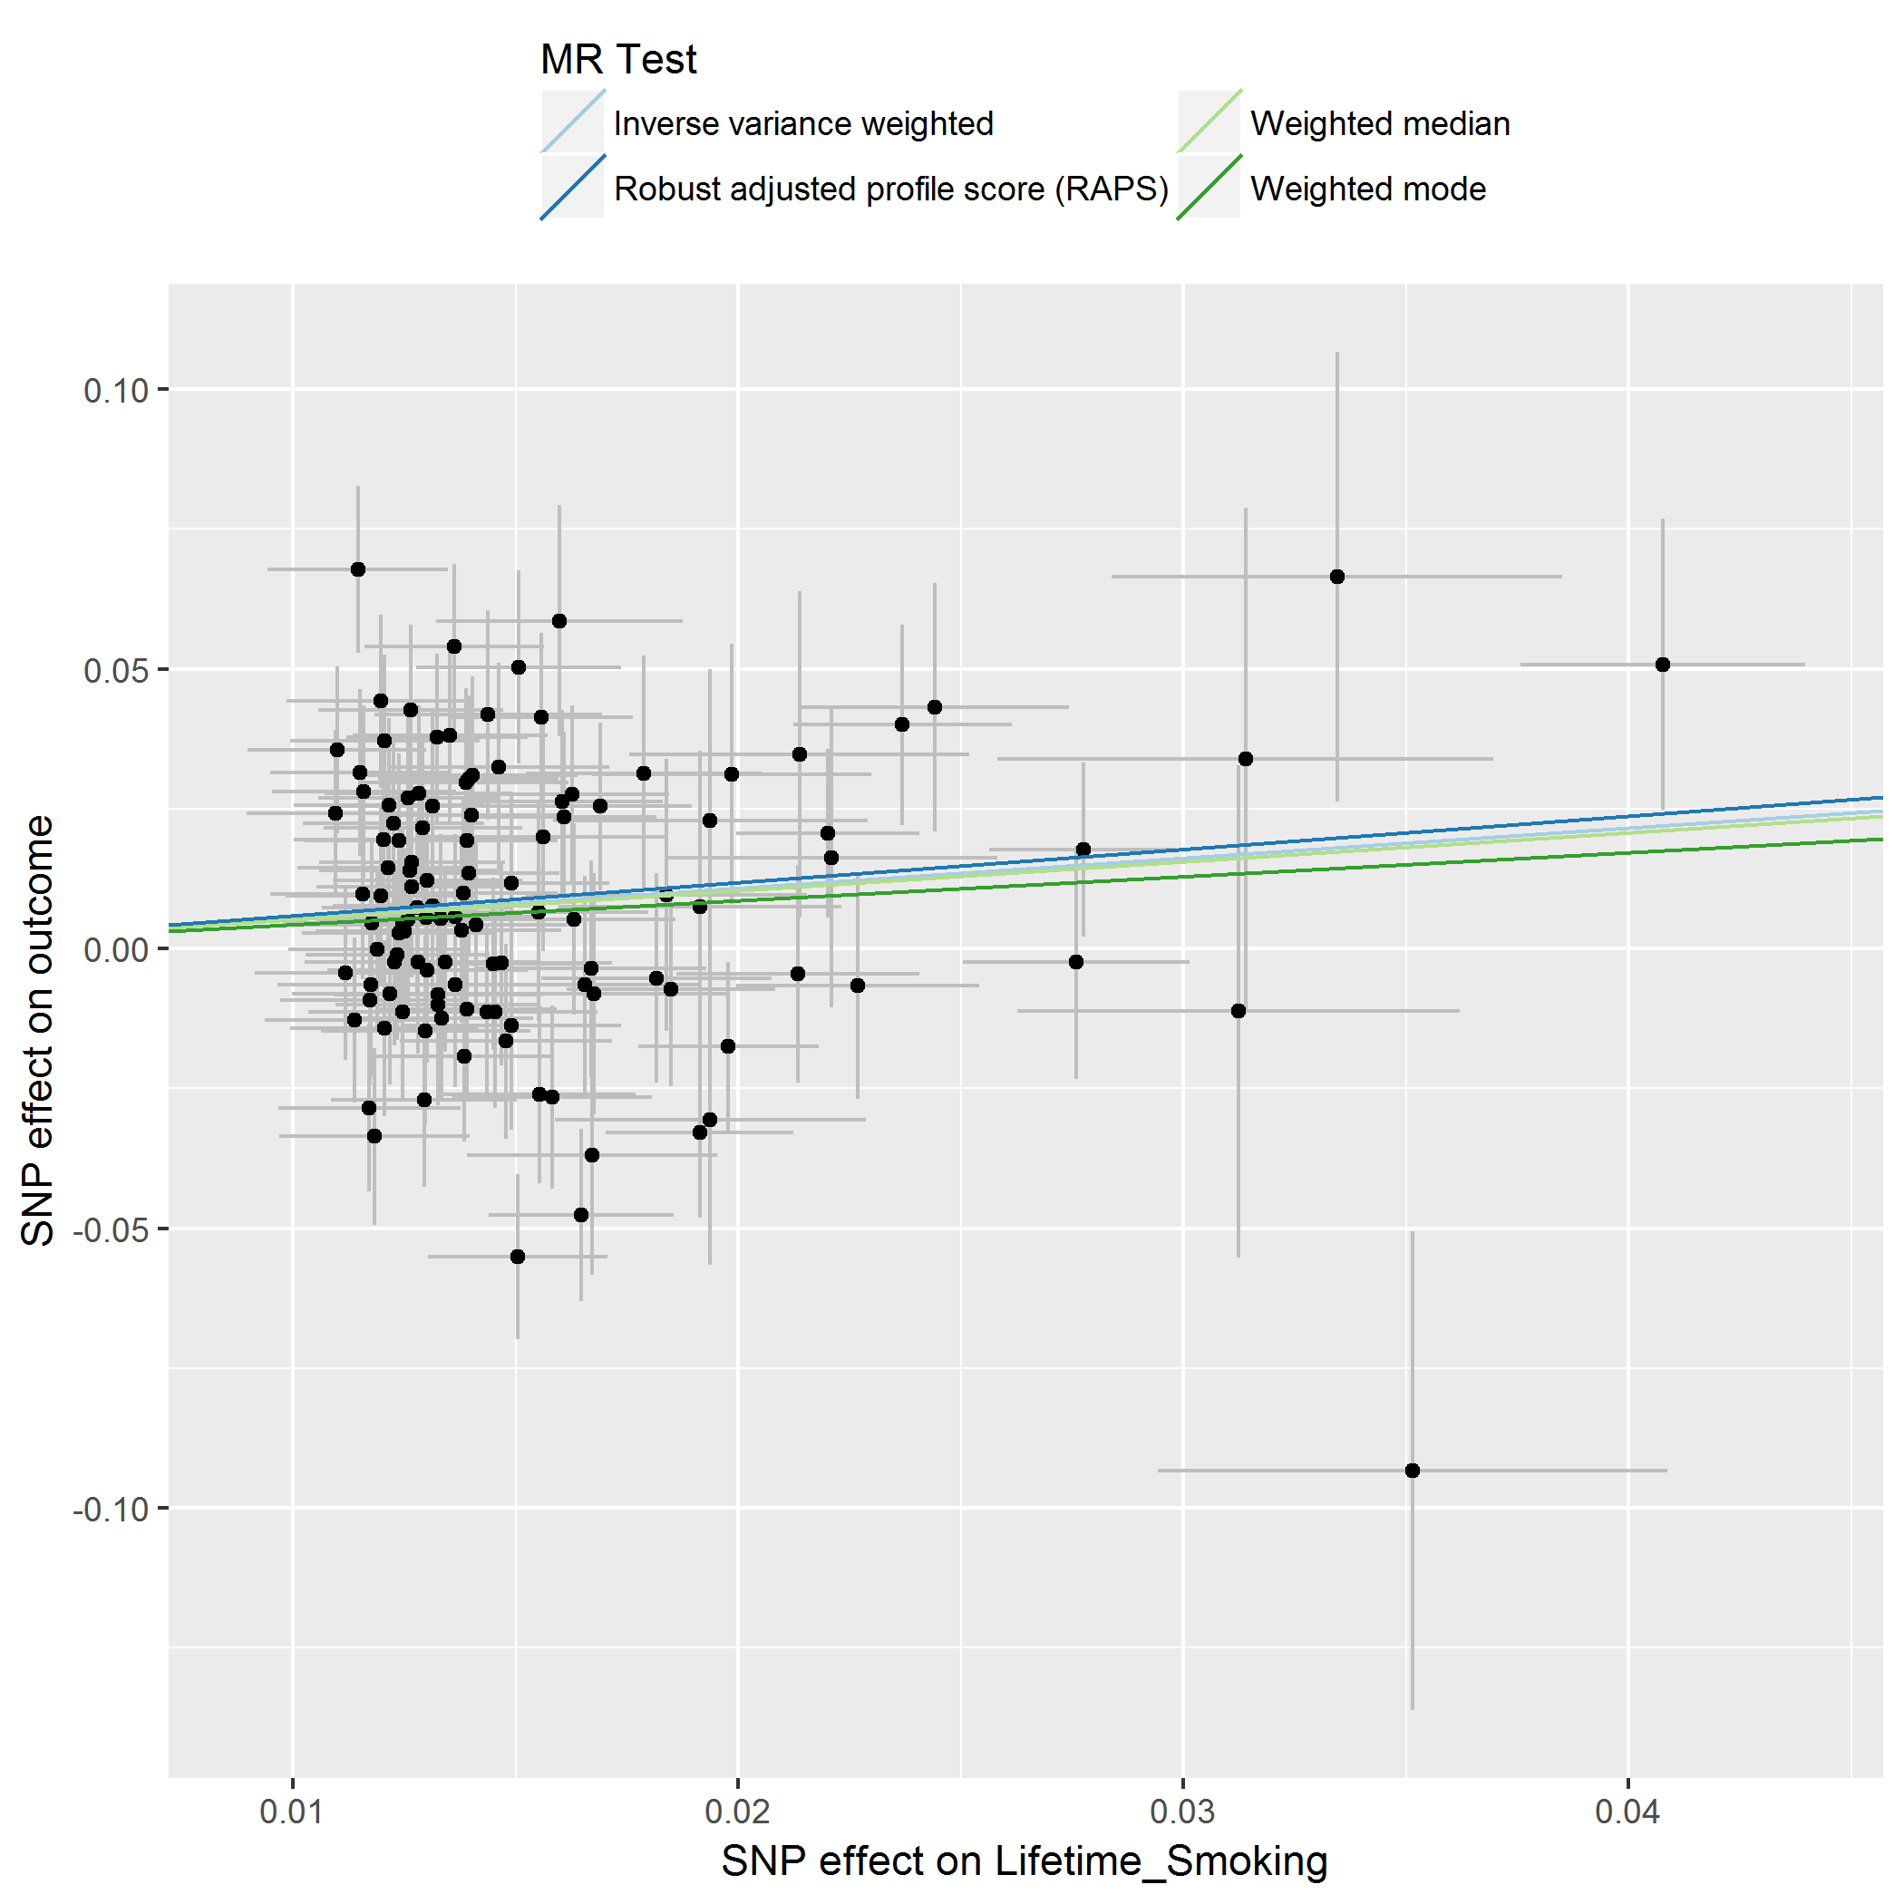
Figure S8. Single SNP analysis of lifetime smoking on bipolar disorder
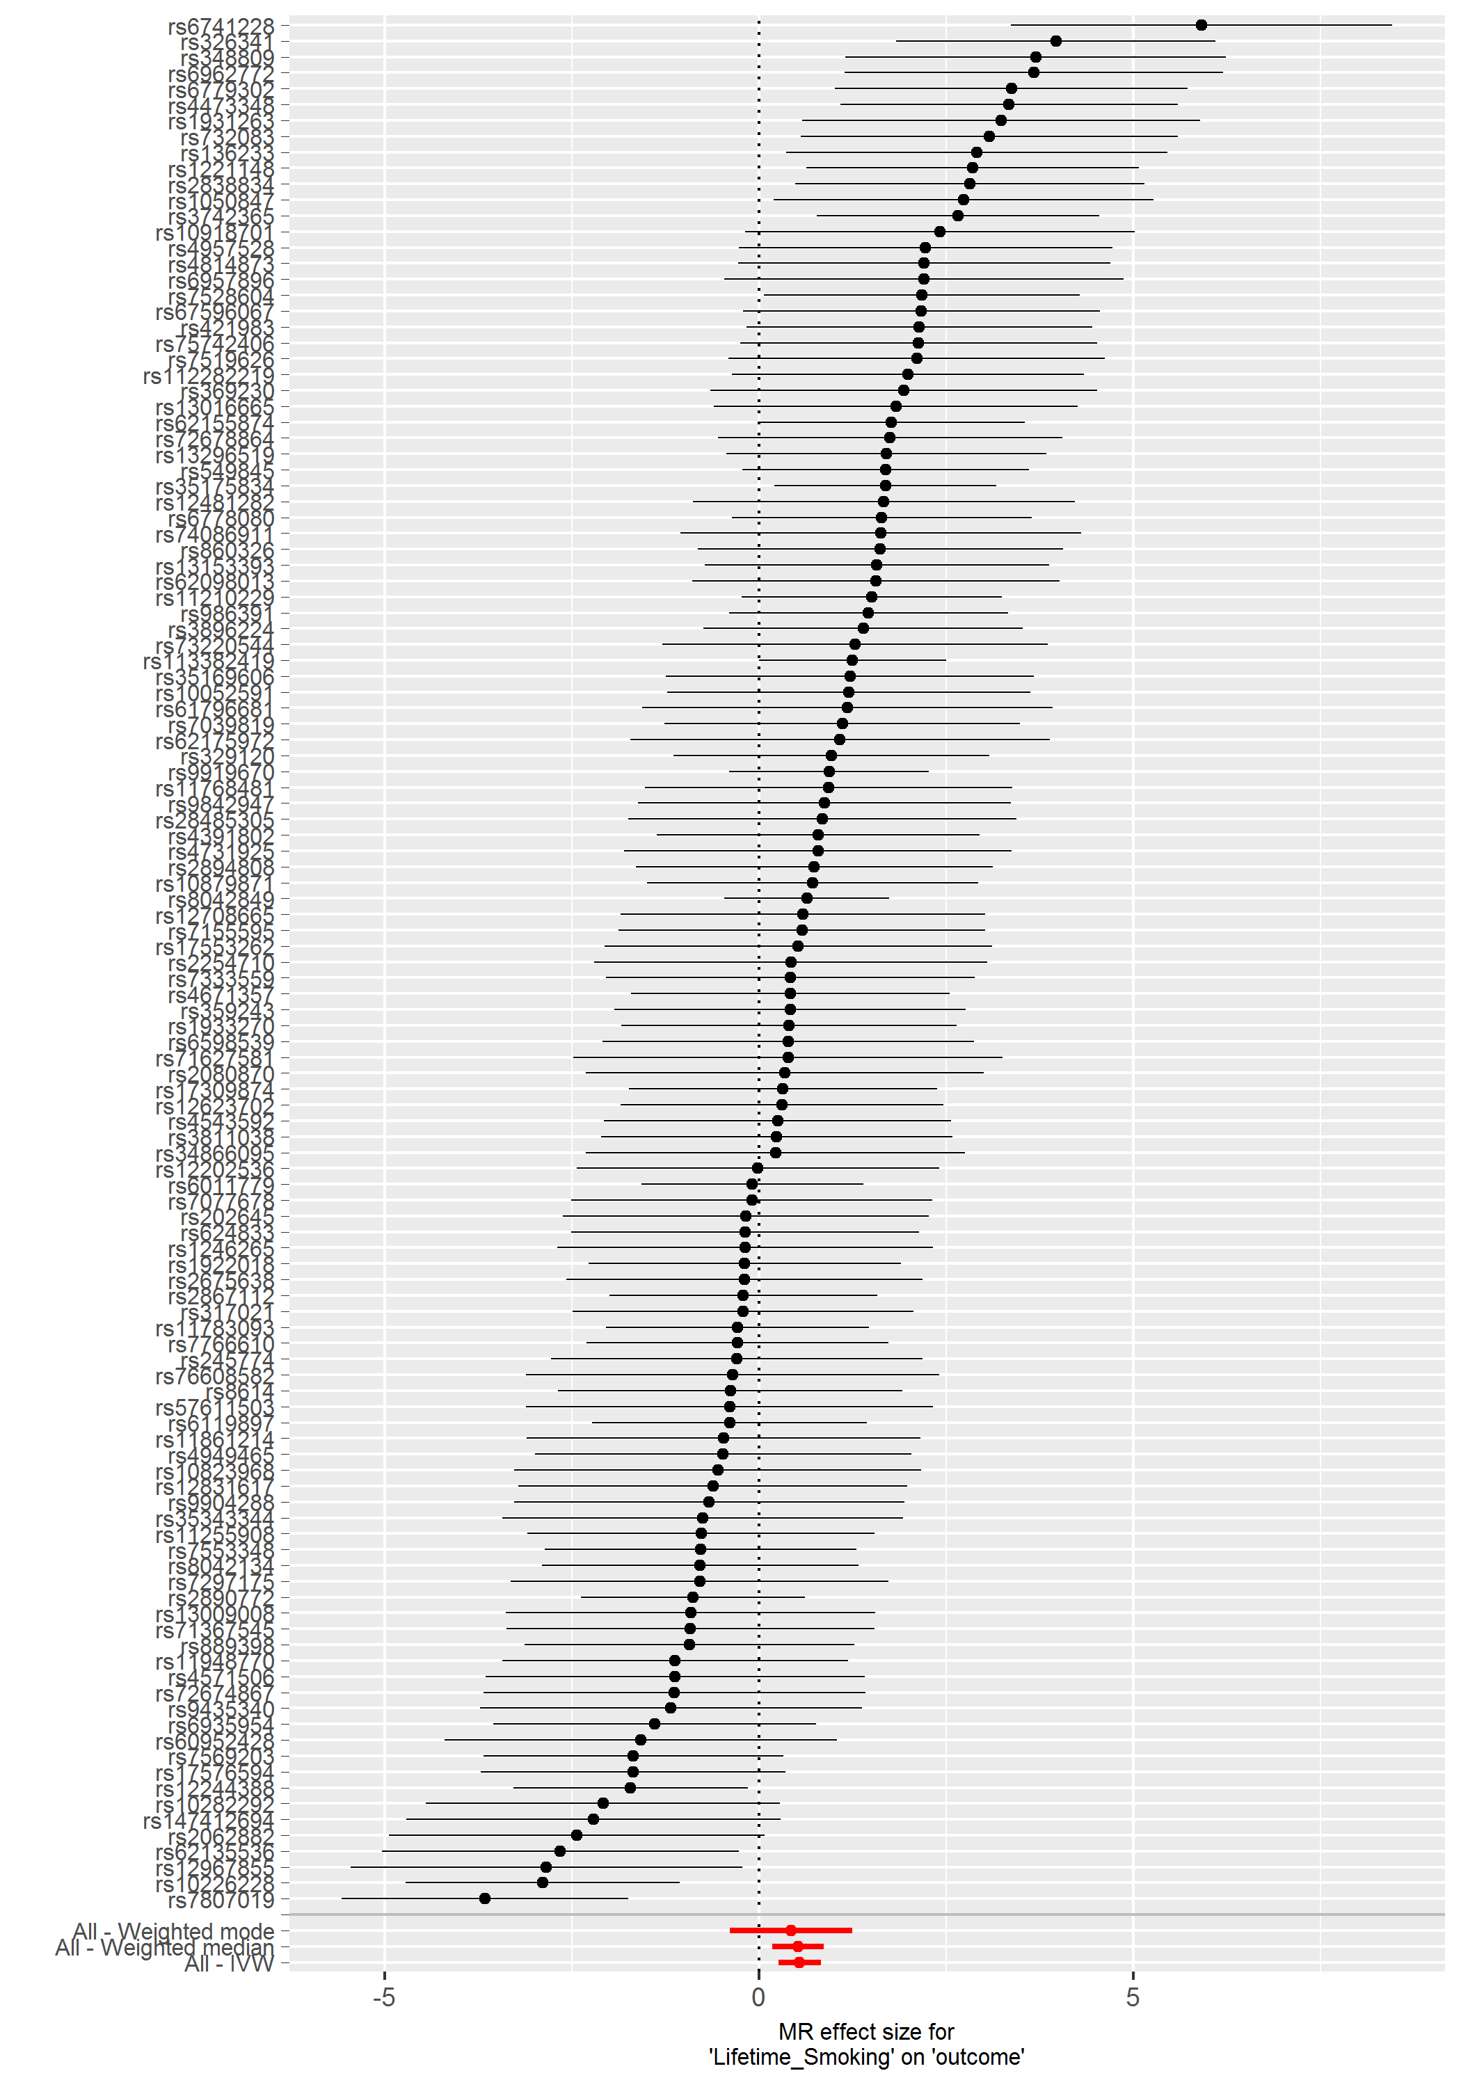
Figure S9. Leave-one-out analysis of lifetime smoking on bipolar disorder
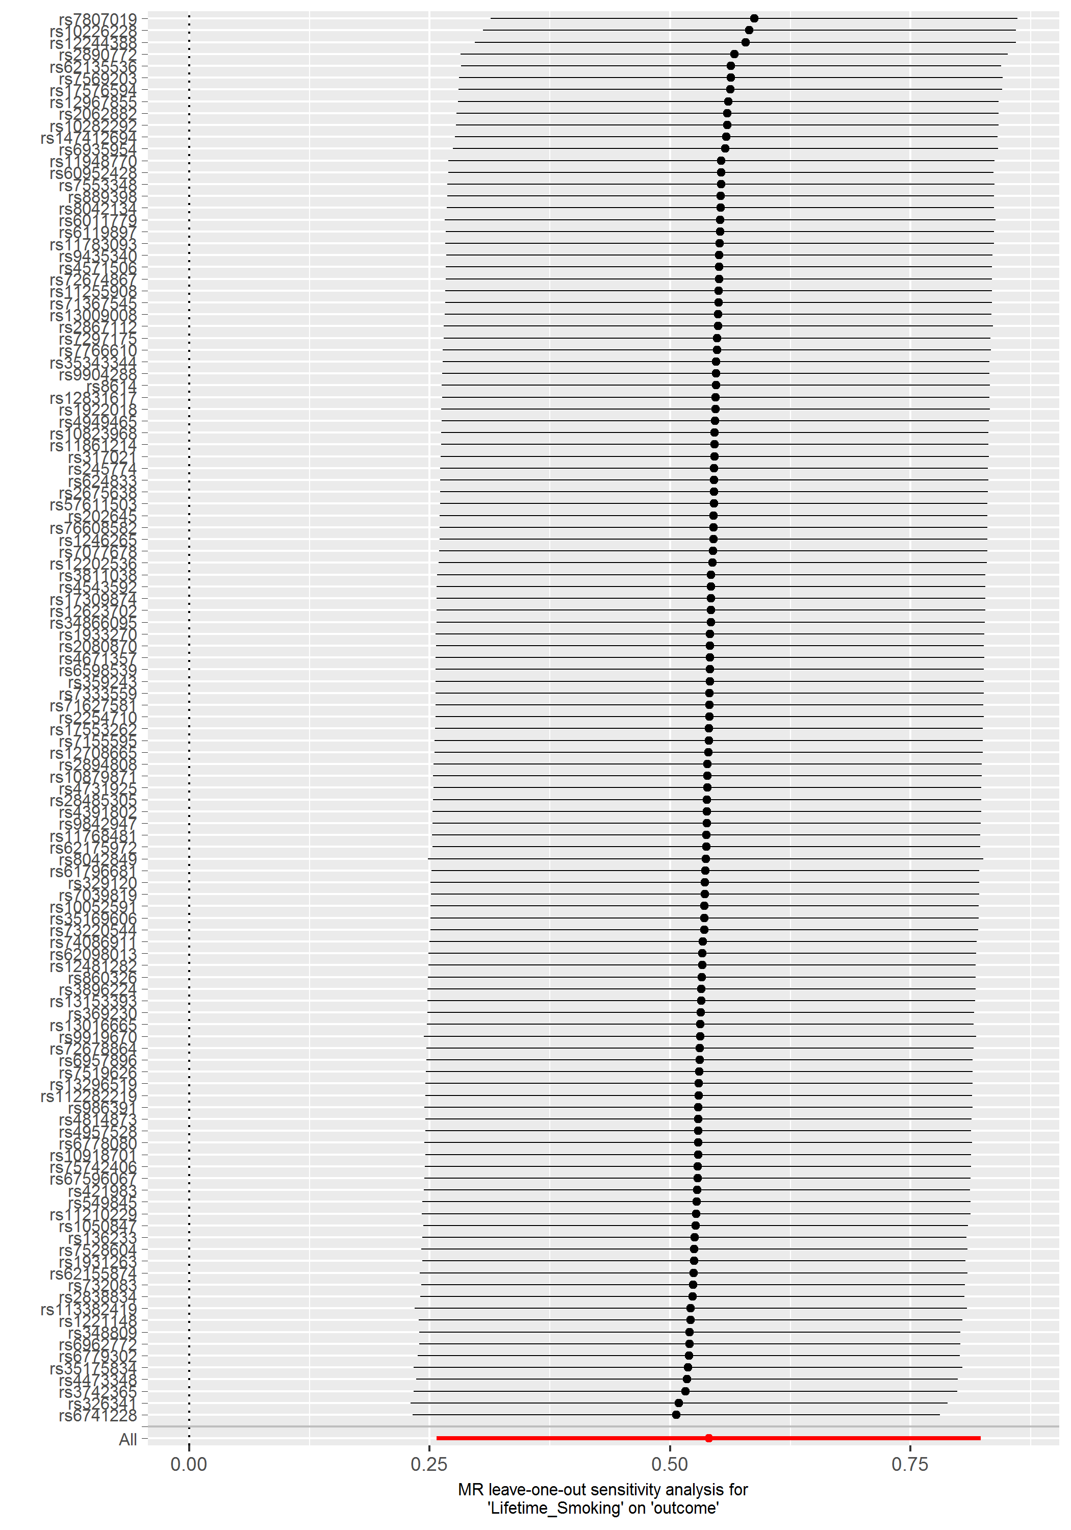

Figure S10. Scatter plot of IVW analyses of bipolar disorder on lifetime smoking
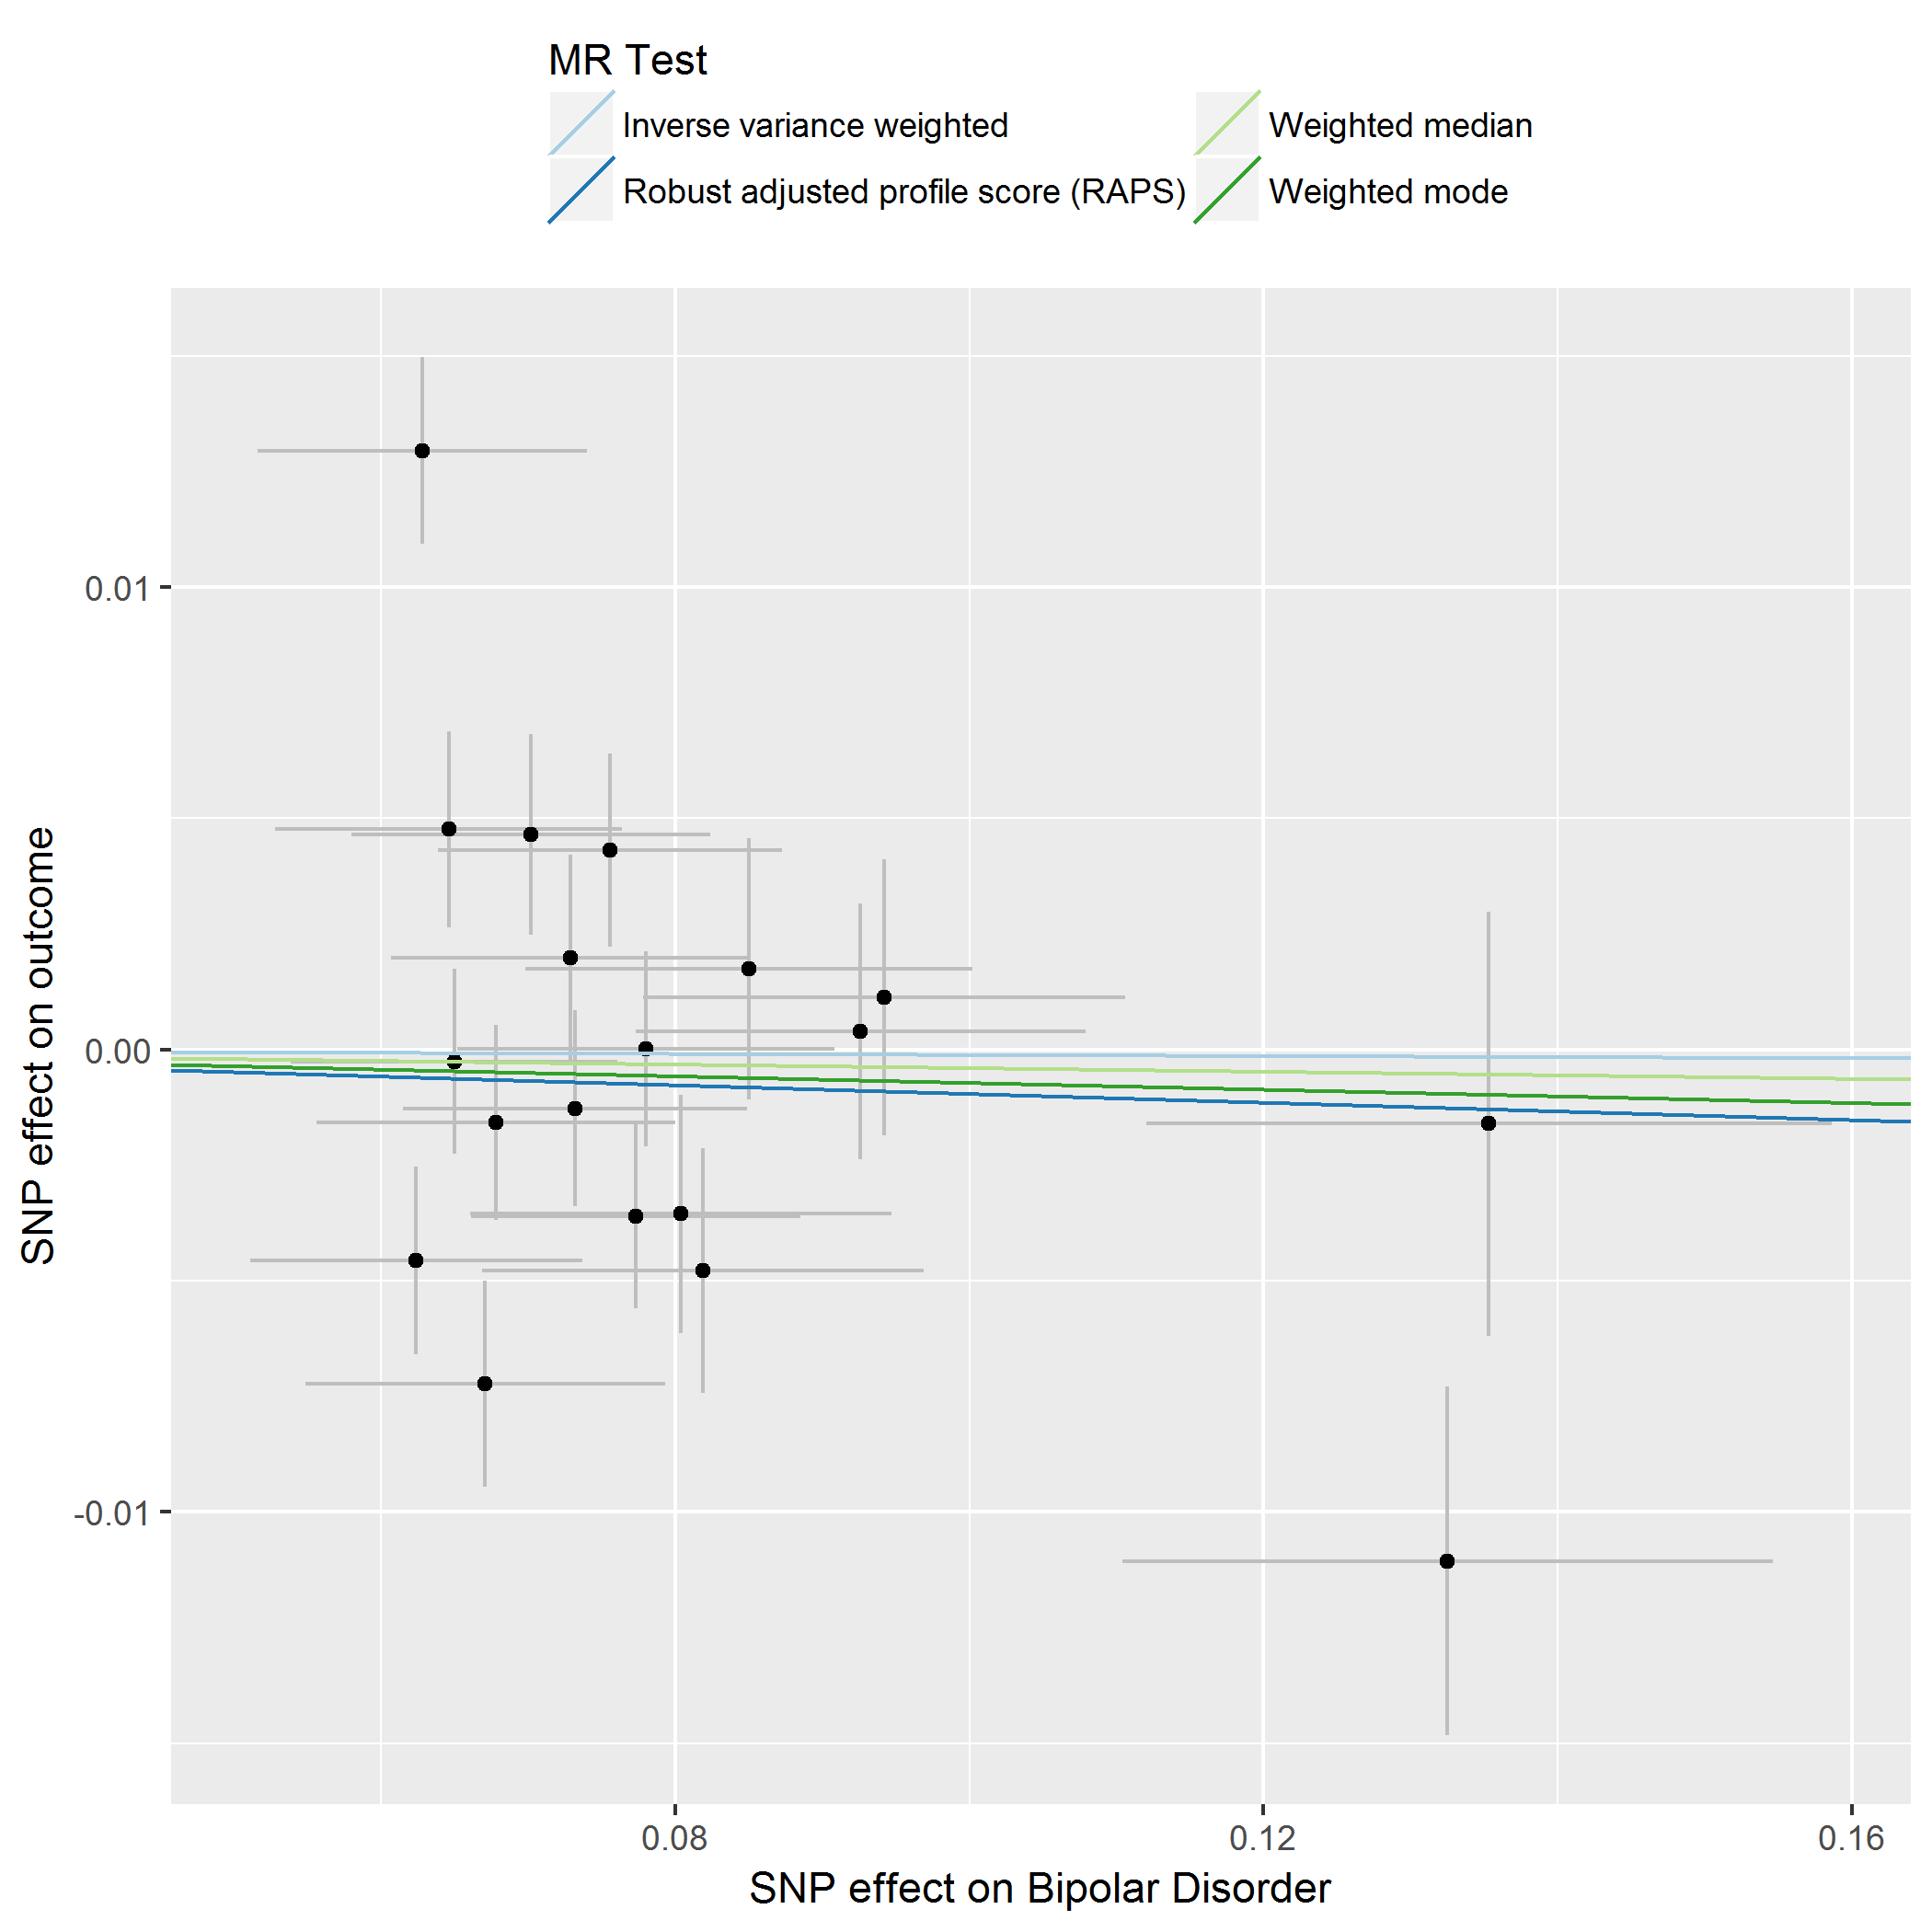
Figure S11. Single SNP analysis of bipolar disorder on lifetime smoking
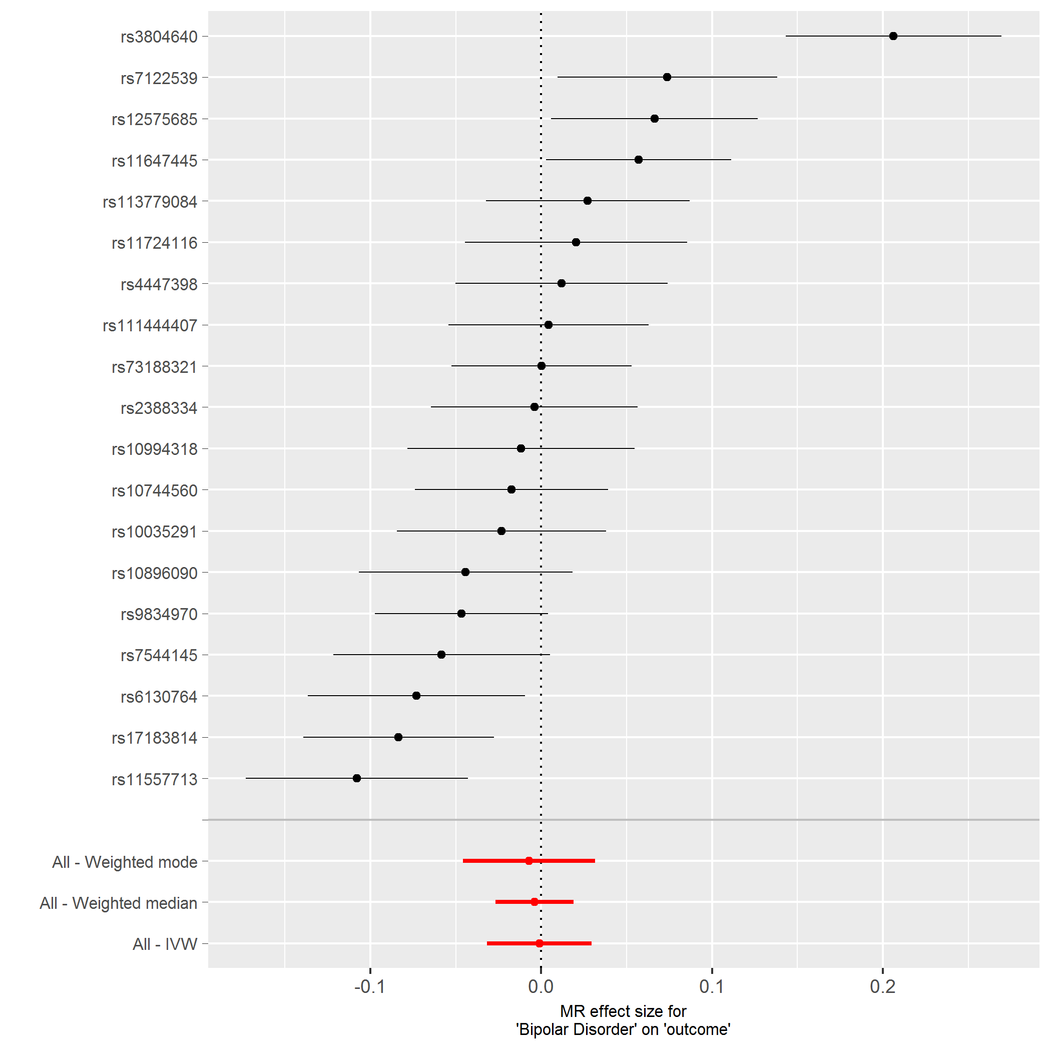
Figure S12. Leave-one-out analysis of bipolar disorder on lifetime smoking

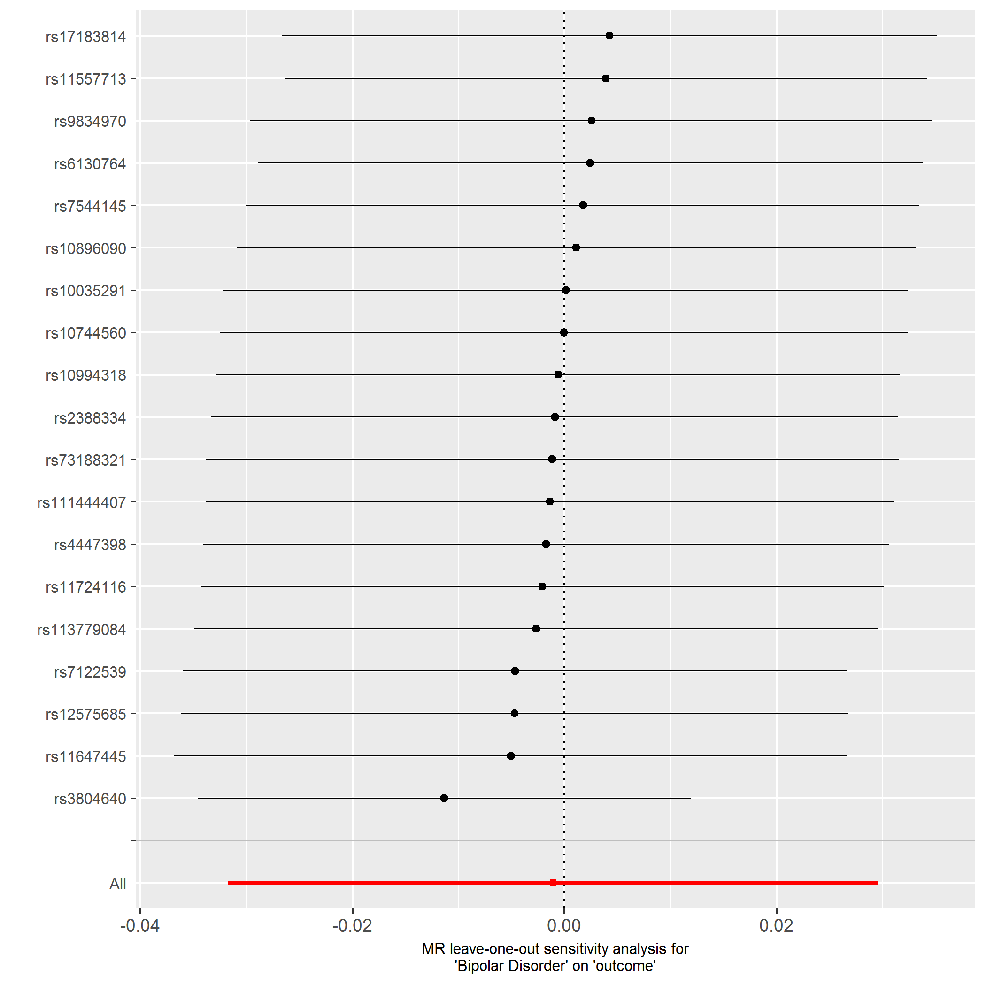
Figure S13. Scatter plot of IVW analyses of bipolar disorder on cigarettes per day
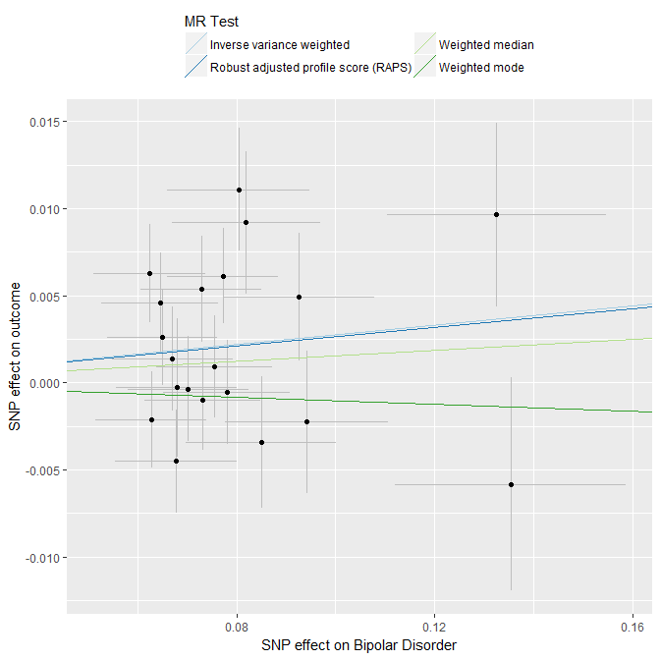
Figure S14. Single SNP analysis of bipolar disorder on cigarettes per day
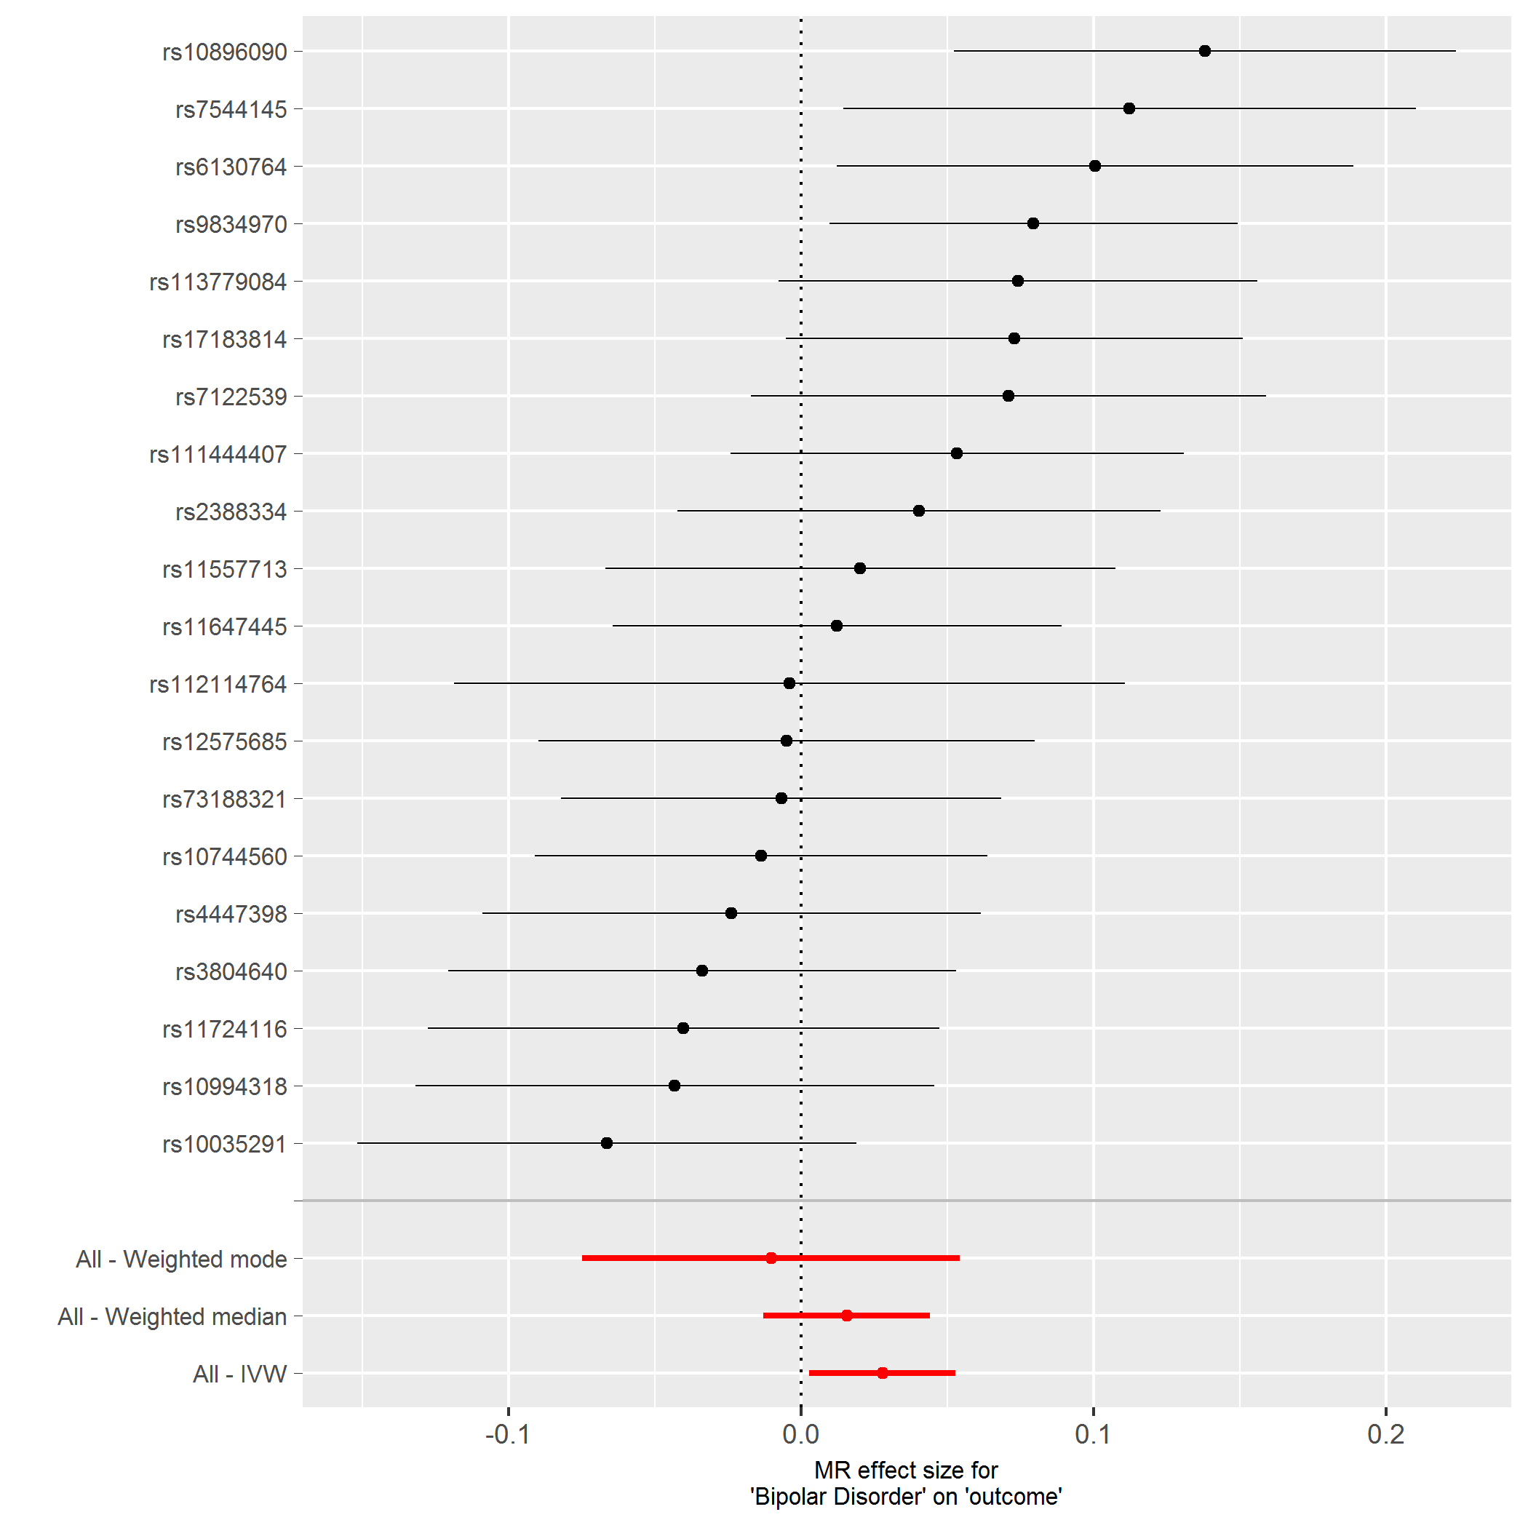

Figure S15. Leave-one-out analysis of bipolar disorder on cigarettes per day
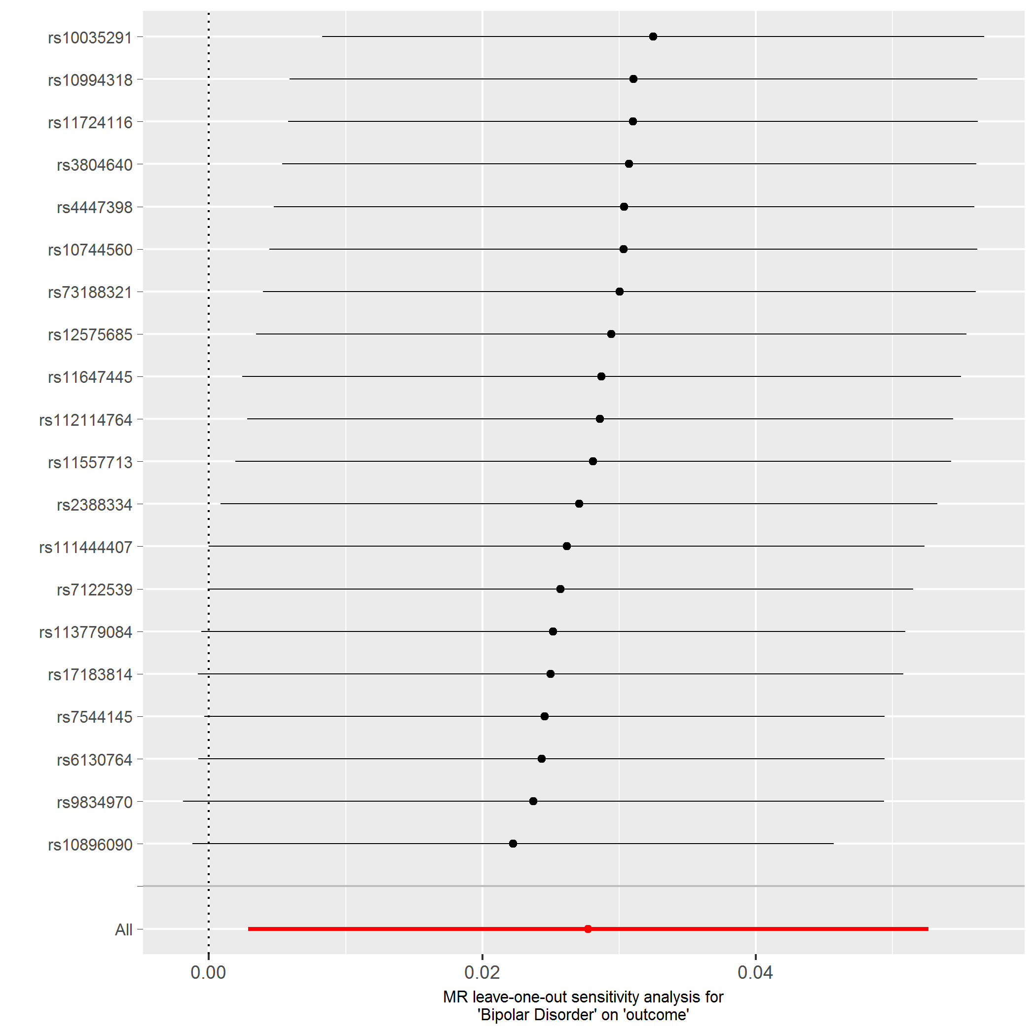
Figure S16. Scatter plot of IVW analyses of bipolar disorder on smoking cessation
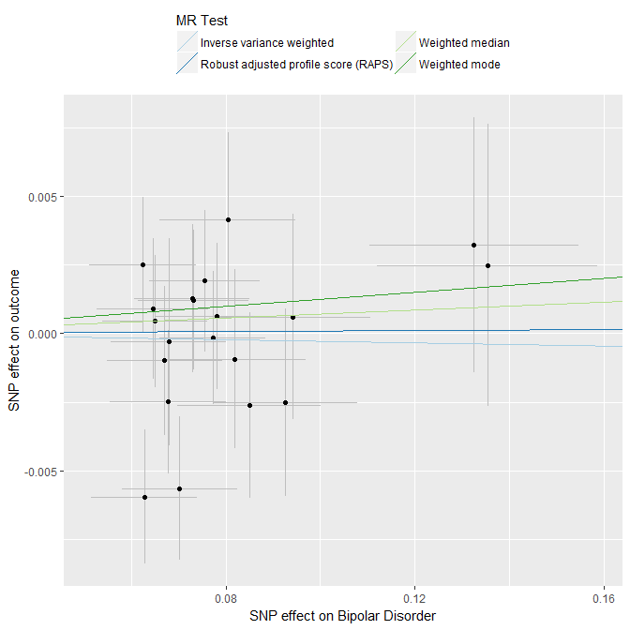
Figure S17. Single SNP analysis of bipolar disorder on smoking cessation
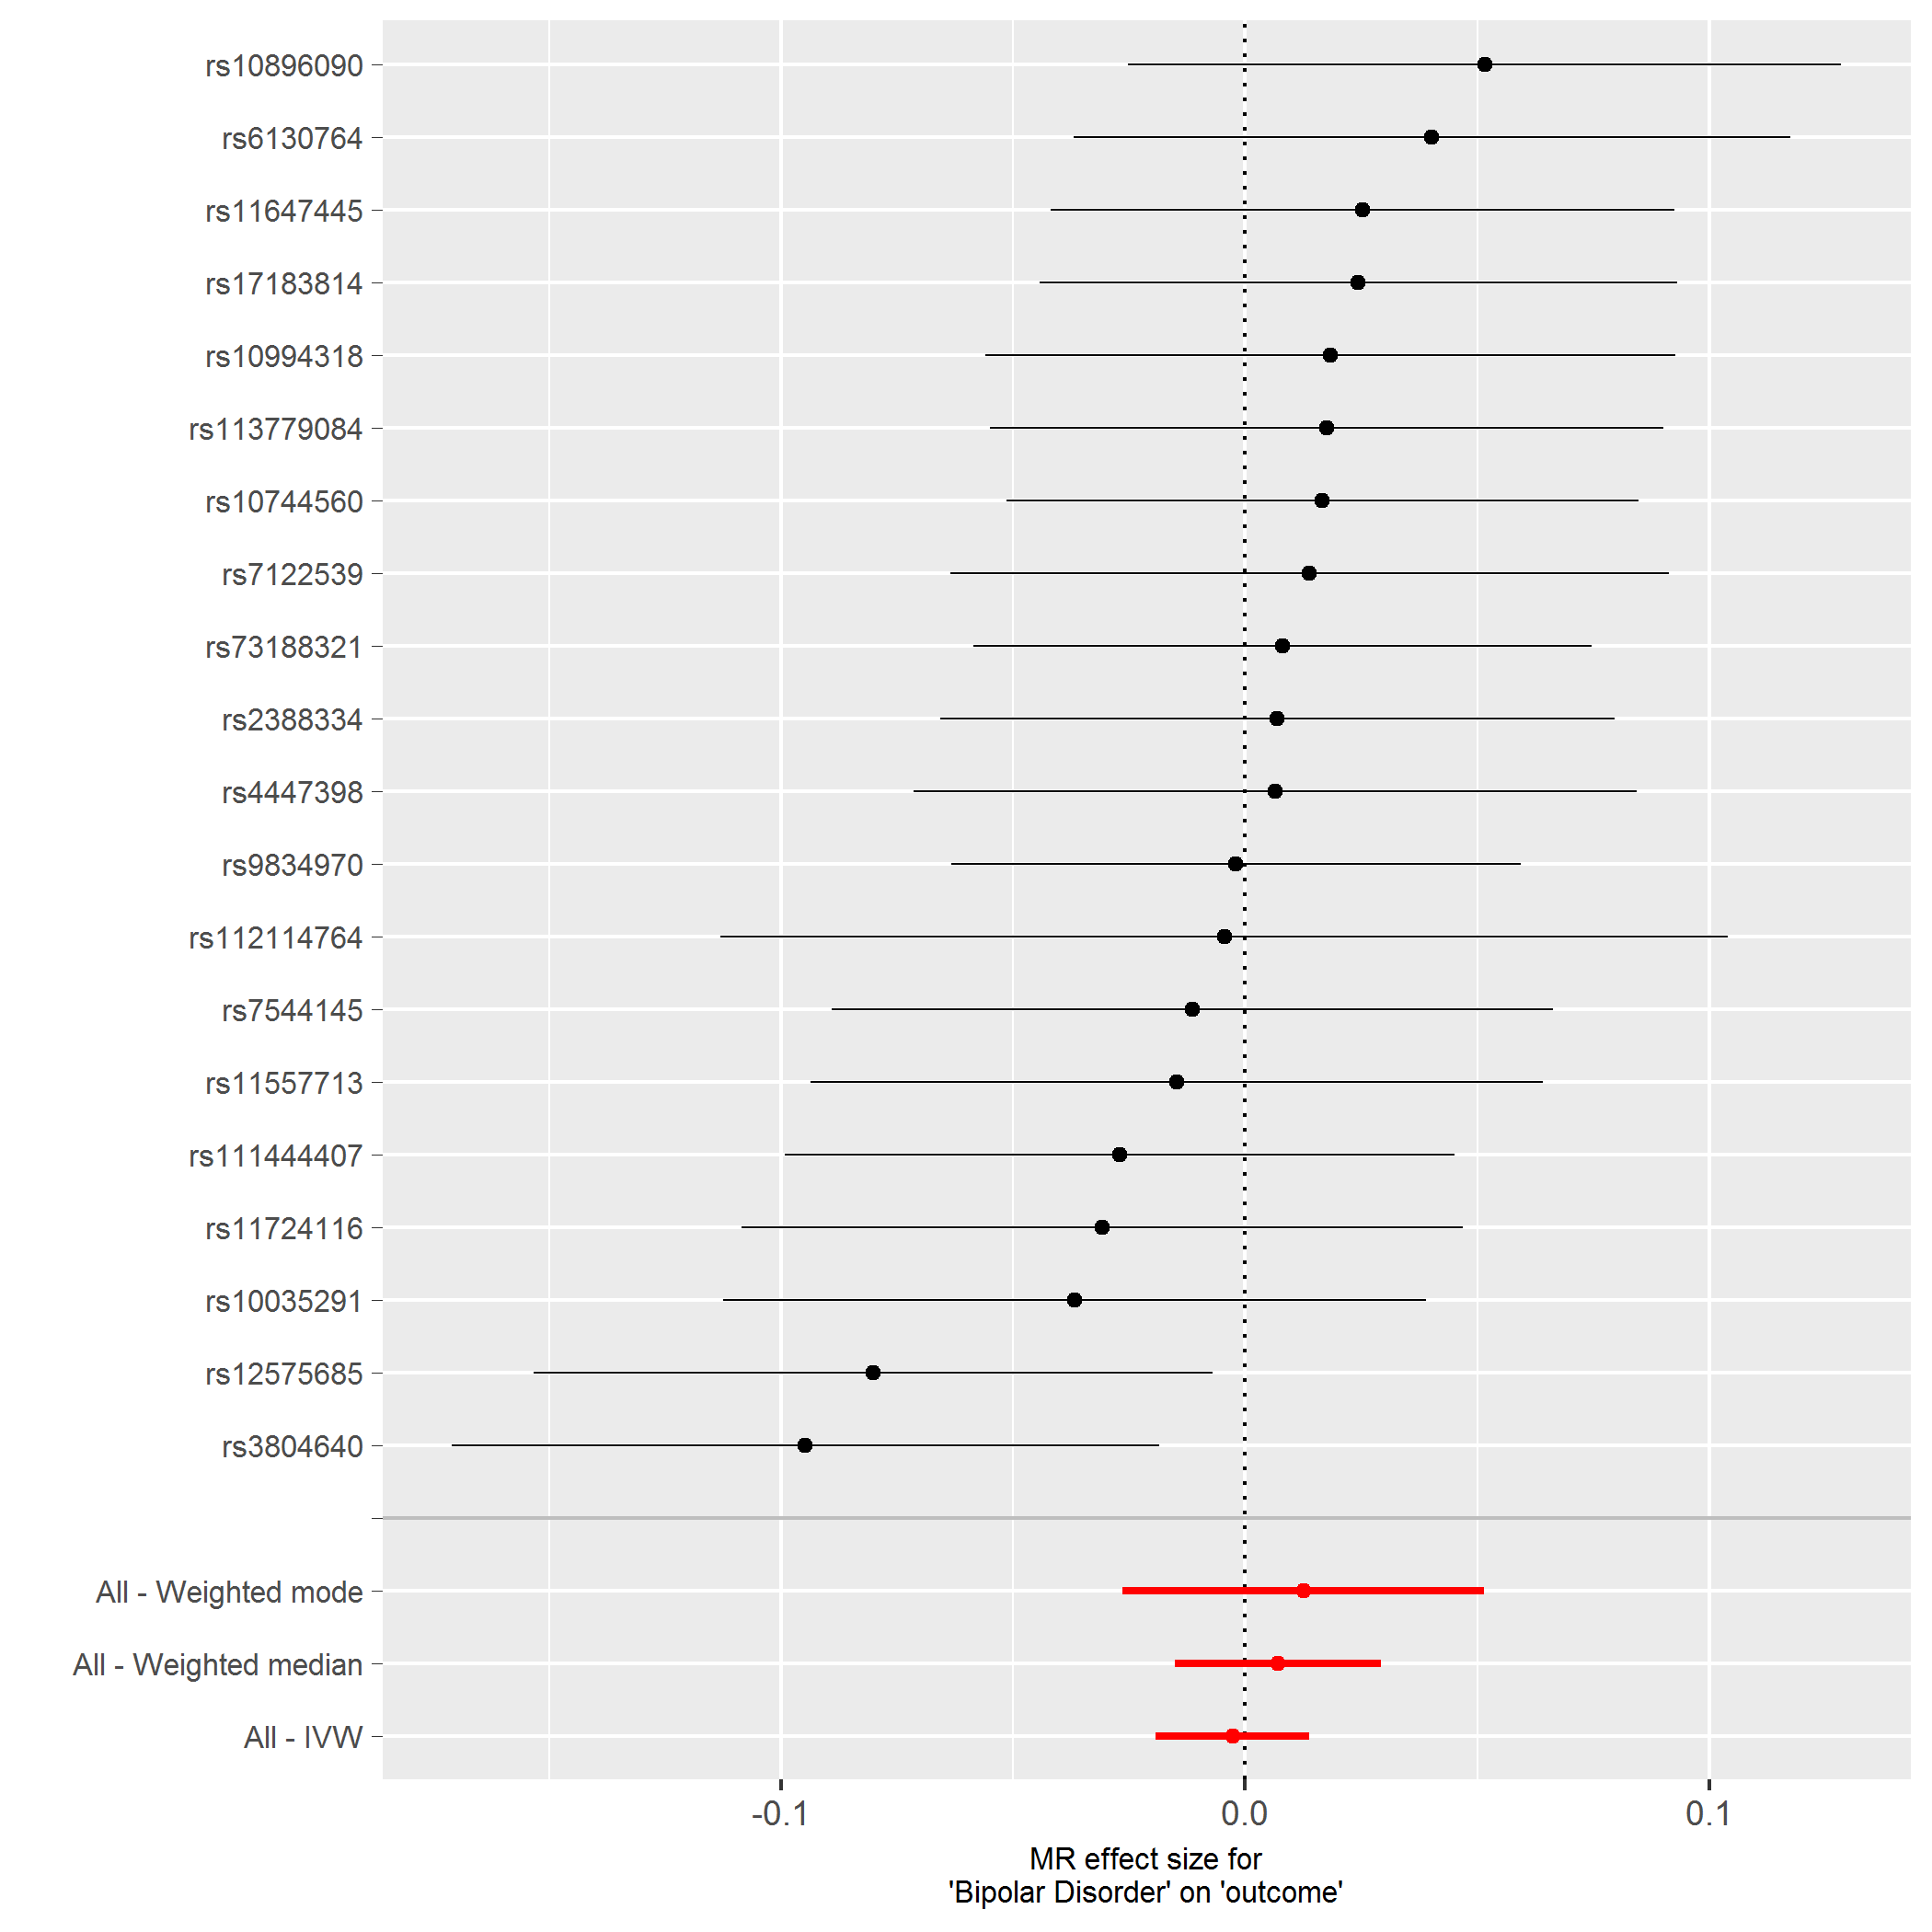

Figure S18. Leave-one-out analysis of bipolar disorder on smoking cessation
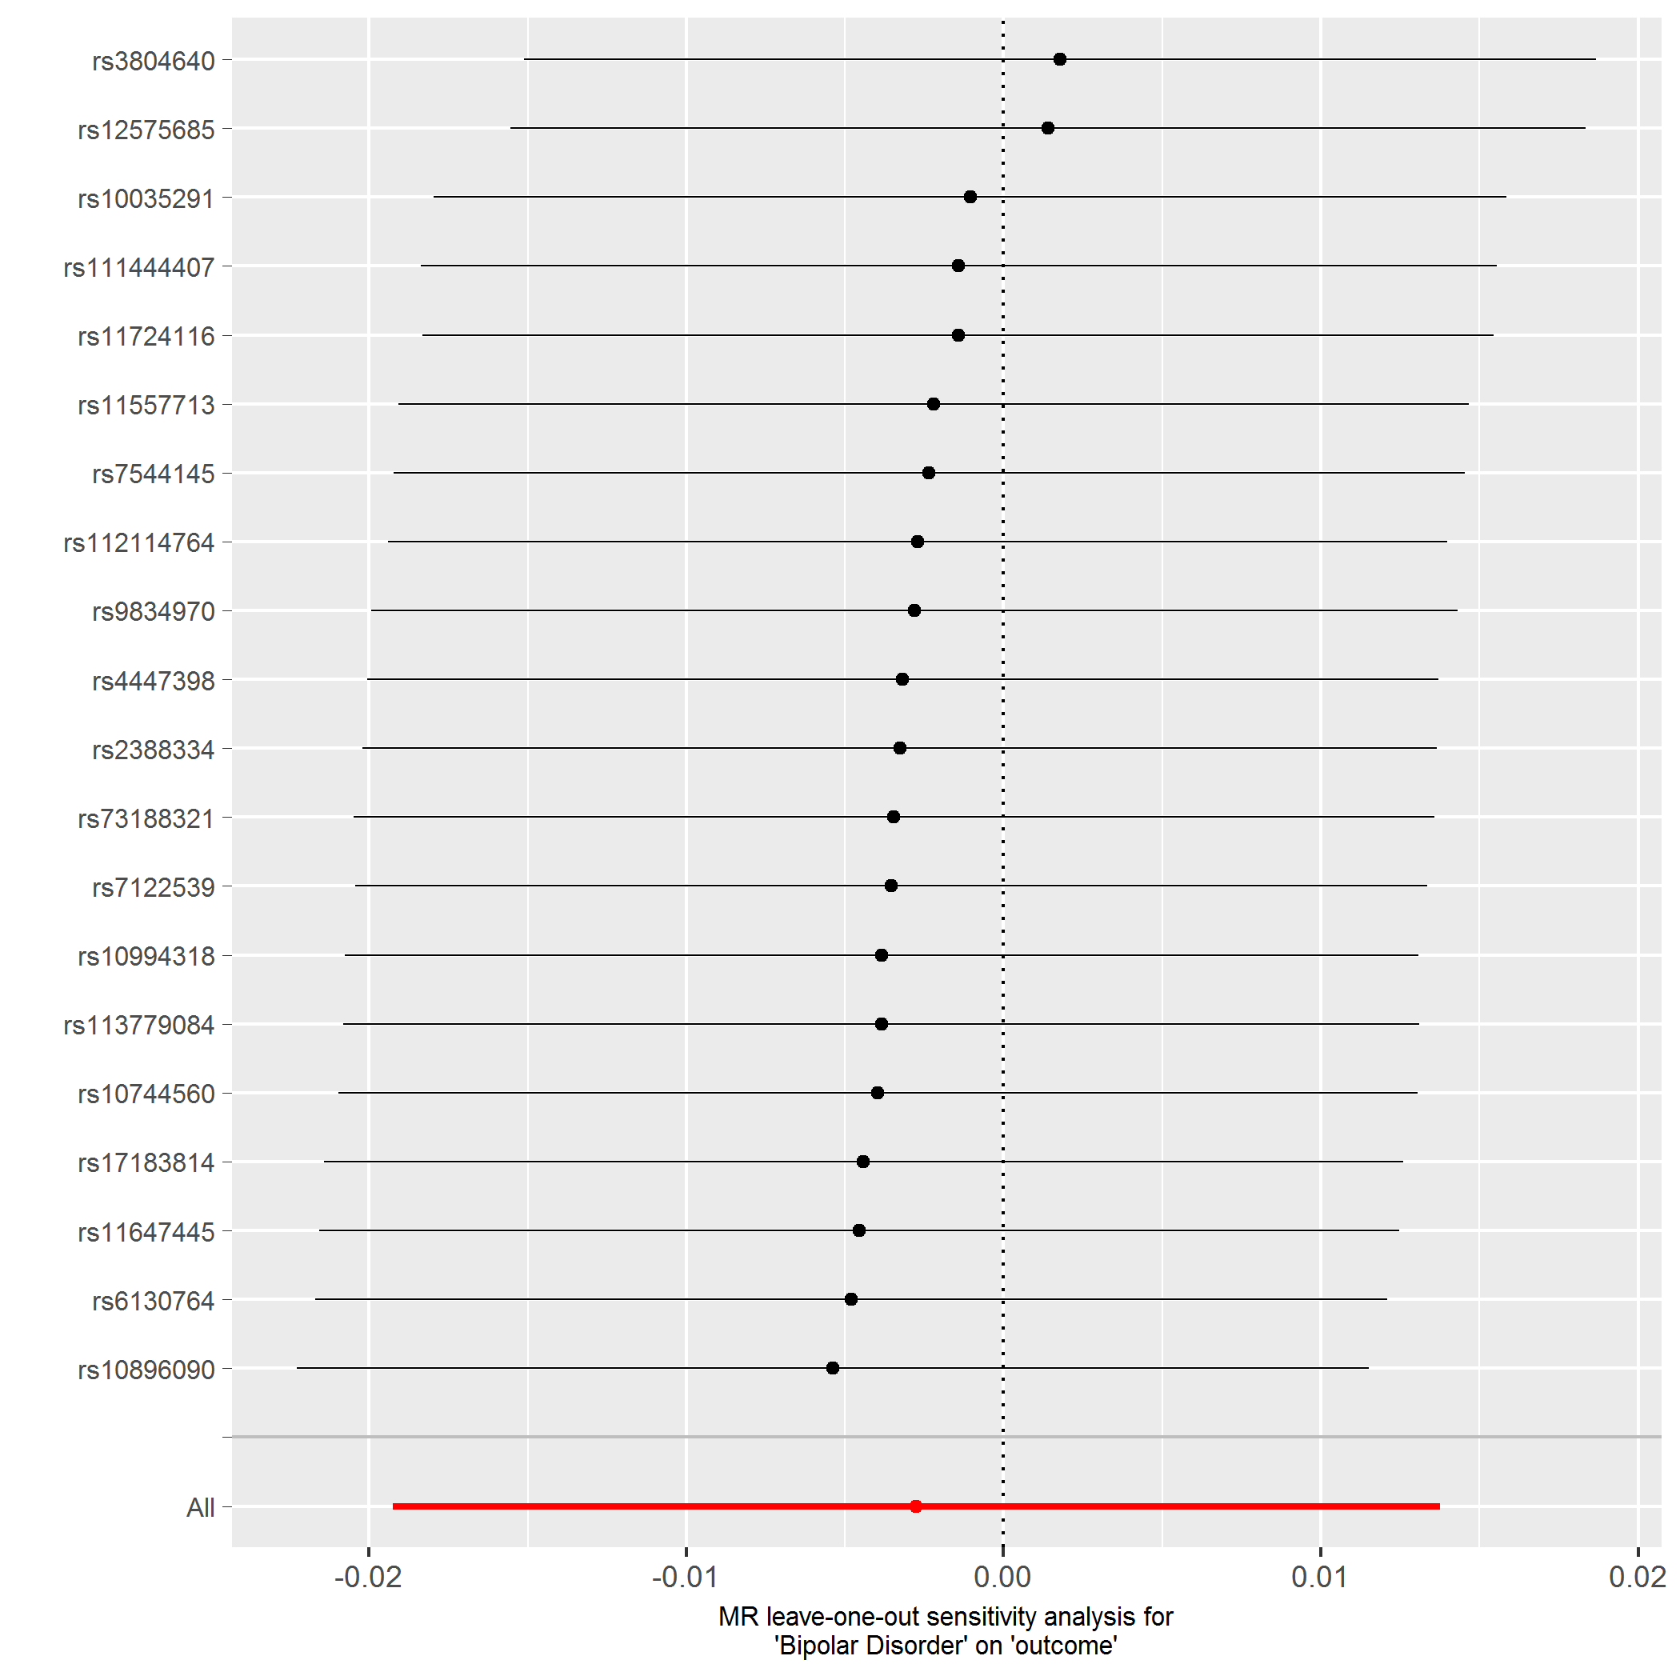

Table S1. Tests of the unweighted and weighted regression dilution I²_{Gx}
 | I²_{GX} Unweighted | I²_{GX} Weighted
Smoking initiation > Bipolar disorder | 0.60 | 0.41
Bipolar disorder > Smoking initiation | 0.11 | 0
Smoking initiation > Bipolar disorder (Steiger filtered) | 0.61 | 0.43
Bipolar disorder > Smoking initiation(Steiger filtered) | - | -
Lifetime smoking > Bipolar Disorder | 0.65 | 0.41
Bipolar disorder > Lifetime smoking | 0.14 | 0
Lifetime smoking > Bipolar Disorder (Steiger filtered) | 0.67 | 0.47
Bipolar disorder > Lifetime smoking (Steiger filtered) | - | -
Bipolar disorder > Cigarettes per day | 0.11 | 0
Bipolar disorder > Cigarettes per day (Steiger filtered) | - | -
Bipolar disorder > Smoking cessation | 0.11 | 0
Bipolar disorder > Smoking cessation (Steiger filtered) | - | -
Unweighted estimates only take into account dilution in the SNP-exposure effects, whereas weighted estimates account for the SE of the SNP-outcome effects (Bowden et al., 2016). The unweighted I² estimates were larger for both positive control outcomes so in Table 1 (main text), unweighted MR Egger SIMEX estimates are presented. For the main analysis unweighted MR Egger SIMEX corrections are presented unless I² estimates < 0.3 which is too low to conduct either MR Egger analysis. All estimates show evidence of high dilution in the SNP-exposure effects, so MR Egger estimates should be interpreted with caution.

Table S2. Tests of Heterogeneity in the SNP-exposure association
 | Method | Q | df | P-value
Smoking initiation > Bipolar disorder | Inverse-variance weighted | 686.75 | 344 | 4.94x10⁻²⁵
 | MR Egger | 686.66 | 343 | 3.55x10⁻²⁵
 | Q’ | 0.09 | 1 | 0.769
Bipolar disorder > Smoking initiation | Inverse-variance weighted | 41.40 | 19 | 0.00213
 | MR Egger | 35.81 | 18 | 0.00746
 | Q’ | 65.59 | 1 | 0.01802
Lifetime smoking > Bipolar Disorder | Inverse-variance weighted | 231.94 | 118 | 1.95x10⁻⁹
 | MR Egger | 230.22 | 117 | 2.12x10⁻⁹
 | Q’ | 1.72 | 1 | 0.190
Bipolar disorder > Lifetime smoking | Inverse-variance weighted | 89.80 | 18 | 1.57x10⁻¹¹
 | MR Egger | 80.39 | 17 | 3.27x10⁻¹⁰
 | Q’ | 9.40 | 1 | 0.00216
Bipolar disorder > Cigarettes per day | Inverse-variance weighted | 33.63 | 19 | 2.03x10⁻²
 | MR Egger | 33.63 | 18 | 1.40x10⁻²
 | Q’ | <0.01 | 1 | 0.976
Bipolar disorder > Smoking cessation | Inverse-variance weighted | 17.46 | 19 | 0.559
 | MR Egger | 16.19 | 18 | 0.579
 | Q’ | 1.27 | 1 | 0.260
Note: df = degrees of freedom where degrees of freedom is equal to the number of SNPs -1. Q = Rucker’s Q¹⁴, a test of heterogeneity or dispersion in the SNP-exposure effects. The Q’ indicates the extent to which MR Egger is a better fit than the inverse-variance weighted method.
Table S3. MR Egger test of directional pleiotropy
Outcome | Intercept (SE) | P-value
Smoking initiation > Bipolar disorder | 0.001 (0.005) | 0.84
Bipolar disorder > Smoking initiation | -0.006 (0.004) | 0.11
Lifetime smoking > Bipolar Disorder | 0.008(0.009) | 0.35
Bipolar disorder > Lifetime smoking | 0.009 (0.006) | 0.18
Bipolar disorder > Cigarettes per day | <0.001 (0.005) | 0.98
Bipolar disorder > Smoking Cessation | -0.004 (0.004) | 0.28
SE=standard error.

Table S4. Tests to measure instrument strength for MR Egger
Outcome | Mean F-statistic
Smoking initiation > Bipolar disorder | 45.01
Bipolar disorder > Smoking initiation | 34.45
Lifetime smoking > Bipolar Disorder | 44.14
Bipolar disorder > Lifetime smoking | 34.62
Bipolar disorder > Cigarettes per day | 34.45
Bipolar disorder > Smoking cessation | 34.45
Table S5. Bi-directional two-sample Mendelian randomisation of smoking initiation and lifetime smoking on bipolar disorder following Steiger filtering.

Exposure | Outcome | Method | N SNP (%) | OR (95% CI) | p-value
Smoking initiation | Bipolar disorder | Inverse-Variance Weighted | 342/362 (94%) | 1.44 (1.29-1.62) | 1.0x10⁻⁰⁴
 |  | MR Egger |  | - | -
 |  | MR Egger SIMEX |  | 2.13 (1.41-3.21) | 3.8x10⁻⁰⁴
 |  | Weighted median |  | 1.50 (1.29-1.75) | 8.3x10⁻⁰⁸
 |  | Weighted mode |  | 2.43 (1.40-4.23) | 1.7x10⁻⁰³
 |  | MR RAPS |  | 1.51 (1.33-1.70) | 4.5x10⁻¹¹
Lifetime Smoking | Bipolar disorder | Inverse-Variance Weighted | 107/119 (90%) | 1.47 (1.17-1.83) | 7.9x10⁻⁰⁴
 |  | MR Egger |  | - | -
 |  | MR Egger SIMEX |  | 4.63 (1.98-10.83) | 6.1x10⁻⁰⁴
 |  | Weighted median |  | 1.52 (1.09-2.11) | 1.4x10⁻⁰²
 |  | Weighted mode |  | 1.75 (0.75-4.09) | 0.2
 |  | MR RAPS |  | 1.57 (1.23-2.00) | 3.0x10⁻⁰⁴
Exposure | Outcome | Method | N SNP | Beta (95% CI) | p-value
Bipolar disorder | Smoking initiation | Inverse-Variance Weighted | 22/22 (100%) | - | -
 |  | MR Egger |  | - | -
 |  | Weighted median |  | - | -
 |  | Weighted mode |  | - | -
 |  | MR RAPS |  | - | -
Bipolar disorder | Lifetime smoking | Inverse-Variance Weighted | 21/21 (100%) | - | -
 |  | MR Egger |  | - | -
 |  | Weighted median |  | - | -
 |  | Weighted mode |  | - | -
 |  | MR RAPS |  | - | -
Bipolar disorder | Cigarettes per day | Inverse-Variance Weighted | 22/22 (100%) | - | -
 |  | MR Egger |  | - | -
 |  | Weighted median |  | - | -
 |  | Weighted mode |  | - | -
 |  | MR RAPS |  | - | -
Bipolar disorder | Smoking cessation | Inverse-Variance Weighted | 22/22 (100%) | - | -
 |  | MR Egger |  | - | -
 |  | Weighted median |  | - | -
 |  | Weighted mode |  | - | -
 |  | MR RAPS |  | - | -
Note: For each SNP in the instrument, Steiger filtering calculates how much of the variance the SNP explains in the exposure and how much it explains in the outcome. The number of SNPs which explain more variance in the exposure are presented in the N SNP column. Analysis is then repeated using only these SNPs to ensure that results are not due to reverse causation. All SIMEX corrections are unweighted due to greater unweighted I²_{GX} (see Supplementary Table S2). Given low I²_{GX}, all MR Egger results should be interpreted with caution. For the effect of bipolar on lifetime smoking, all SNPs comprising the instrument for bipolar disorder were better instruments for bipolar disorder than lifetime smoking, therefore, that analysis was not repeated.

