ONLINE ONLY SUPPLEMENTS

An attempt to explain the bidirectional association between ischemic heart disease, stroke and depression - A cohort and meta-analytic approach

Marie Kim Wium-Andersen MD, PhD, Ida Kim Wium-Andersen MD², Eva Irene Bosano Prescott³, Kim Overvad⁴, Martin Balslev Jørgensen MD, DrMSc^{2,} Merete Osler MD, DrMSc^{1,5}

SUPPLEMENTARY FIGURES 2
Supplementary Figure 1 2
Supplementary Figure 2 3
Supplementary Figure 3 4
Supplementary Figure 4 5
SUPPLEMENTARY TABLES 6
Supplementary Table 1 6
Supplementary Table 2 7
Supplementary Table 3 8

SUPPLEMENTARY FIGURES

Supplementary Figure 1
Bidirectional associations between cardiovascular disease (CVD) and depression stratified on sex. Includes 93,076 individuals from the combined cohorts from Center for Clinical Research and Prevention, the Diet, Cancer and Health Study and the Copenhagen City Heart Study, 2nd examination. All analyses are adjusted for age, gender, cohort, education, civil status, alcohol use, smoking status, body mass index, physical activity, total cholesterol, systolic blood pressure, statin use and stroke or ischemic heart disease. *Individuals counts as unexposed until exposed and thus included twice in the model. aHR=adjusted hazard ratio. CI=confidence interval.
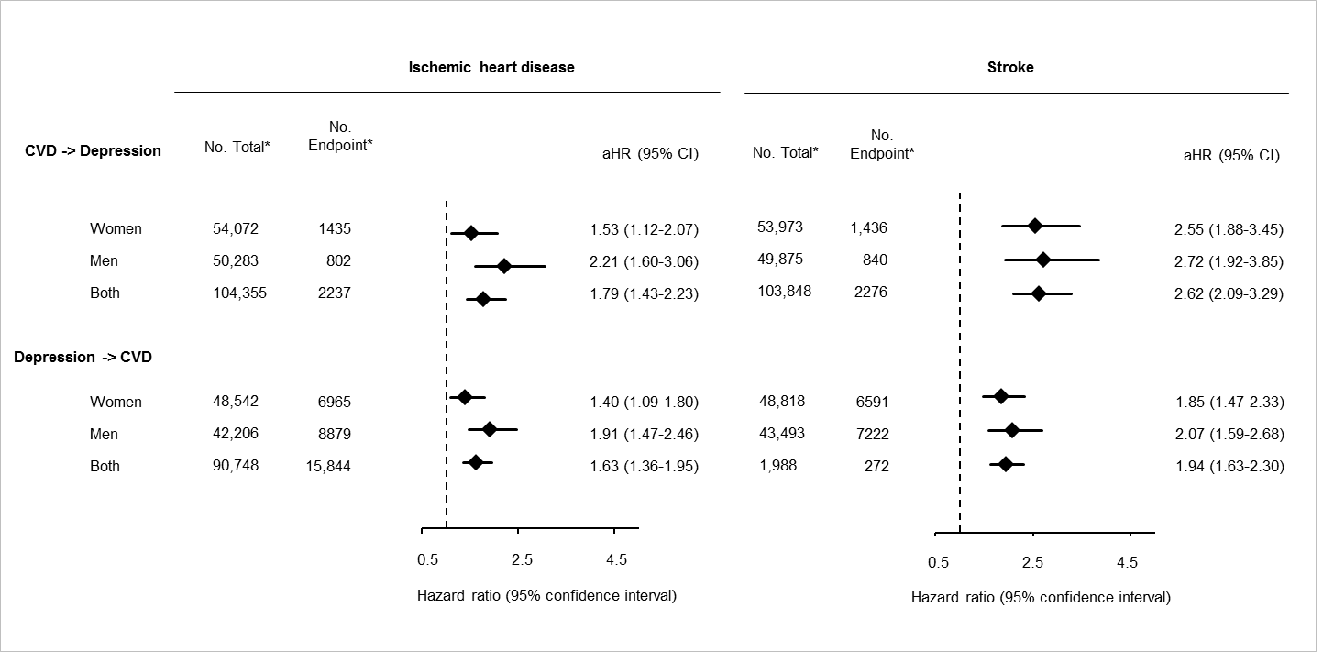

Supplementary Figure 2
Prospective bidirectional associations between ischemic heart disease and depression in 93,076 individuals from the cohorts from Center for Clinical Research and Prevention (CCRP), the Diet, Cancer and Health Study (DCH) and the Copenhagen City Heart Study, 2nd examination (CCHS2) respectively and combined in a meta-analysis. All analyses are adjusted for age, gender, education, civil status, alcohol use, smoking status, body mass index, physical activity, total cholesterol, systolic blood pressure, statin use and stroke. CCRP is further adjusted for cohort, high density lipoprotein cholesterol and triglycerides. aHR = adjusted hazard ratio. CI = confidence interval. *Individuals counts as unexposed until exposed and thus included twice in the model.

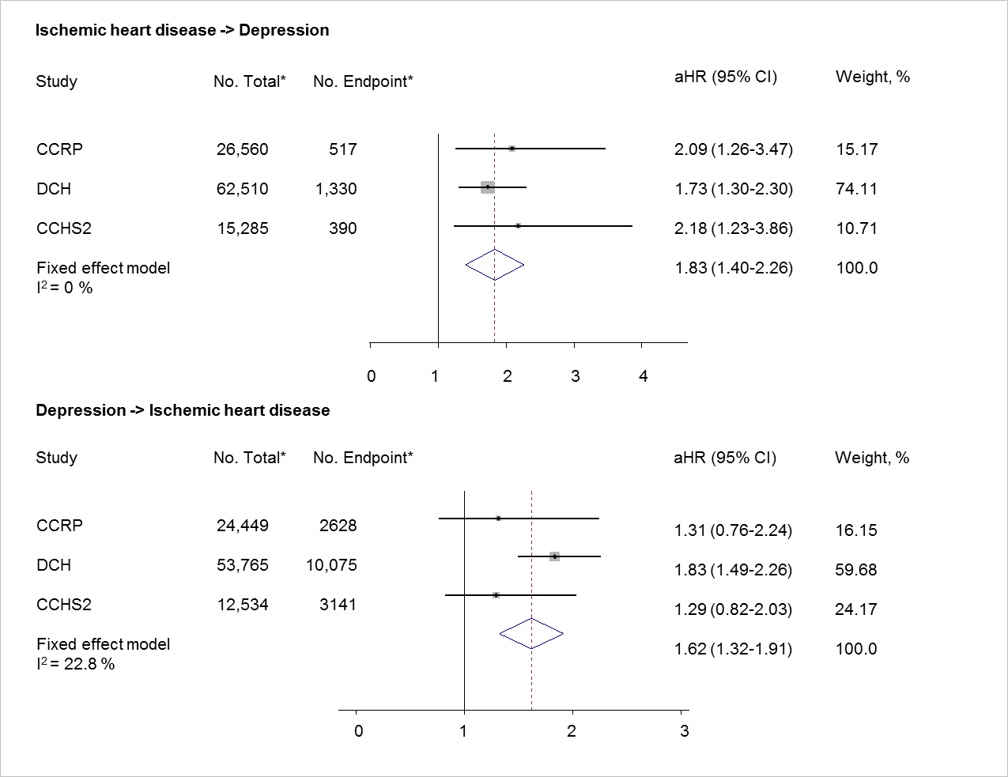

Supplementary Figure 3
Prospective bidirectional associations between cerebrovascular disease and depression in 93,076 individuals from the cohorts from Center for Clinical Research and Prevention (CCRP), the Diet, Cancer and Health Study (DCH) and the Copenhagen City Heart Study, 2nd examination (CCHS2) respectively and combined in a meta-analysis. All analyses are adjusted for age, gender, education, civil status, alcohol use, smoking status, body mass index, physical activity, total cholesterol, systolic blood pressure, statin use and ischemic heart disease. CCRP is further adjusted for cohort, high density lipoprotein cholesterol and triglycerides. aHR = Hazard ratio. CI = confidence interval. *Individuals counts as unexposed until exposed and thus included twice in the model. The proportional hazards assumption for the risk of stroke in individuals with depression in the CCHS2 suggested that the effect was highest in the first years after depression.
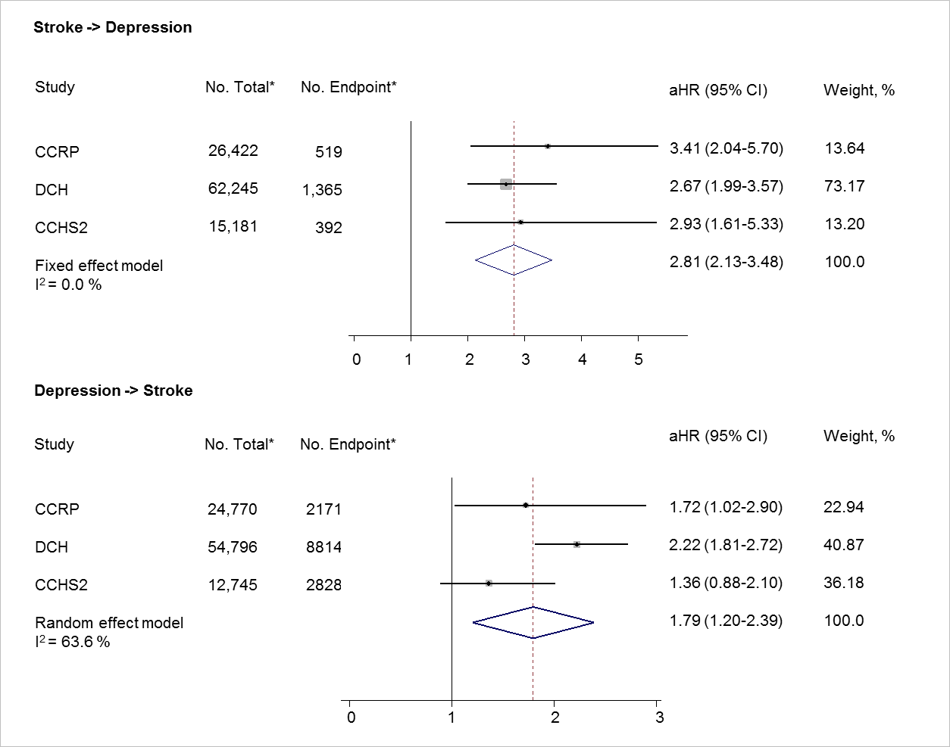

Supplementary Figure 4
Prospective bidirectional associations between cardiovascular disease (CVD) (ischemic heart disease and stroke) and depression in 13,331 individuals with baseline measurements of high density lipoprotein cholesterol (HDL), triglycerides (trig) and high sensitive C-reactive protein (CRP) from the Monica I-II-III and Inter99 studies. Model 6: adjusted for age, sex, cohort, education, marital status, alcohol use, smoking status, physical activity, body mass index, systolic blood pressure, total cholesterol, statin use and stroke or ischemic heart disease (in the relevant analyses). *Individuals counts as unexposed until exposed and thus included twice in the model.
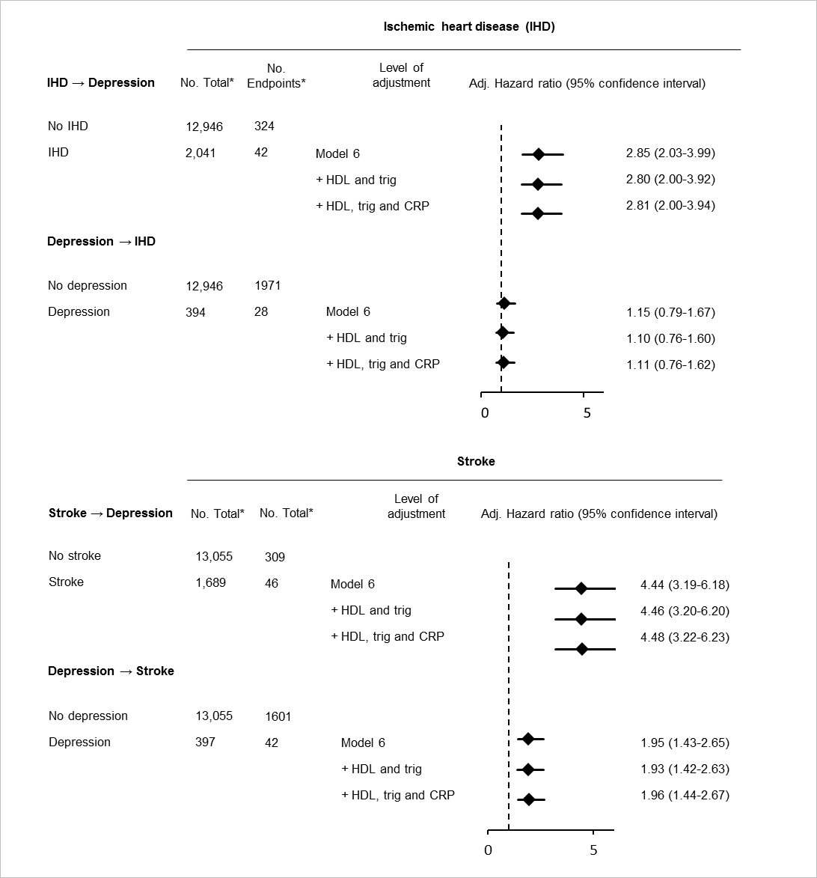

SUPPLEMENTARY TABLES

Supplementary Table 1
Supplementary Table 1. Information on included cohorts.
 | No. | Year  examined | Aim | Inclusion of  participants | Area of Denmark | Question-  naires/  physical exam at baseline | No.  Women | age,  mean  (range)
The cohorts at Center for Clinical Research and Prevention*
1936 cohort | 908 | Apr 1981-  Jun 1982 | To describe health, utilisation of health services and medicine consumption in 40-year old men and women | randomly  selected from the general population | Western part of the Area of Copenhagen | yes/yes | 48% | 45 (44-46)
Monica1 | 3,779 | Nov 1982-  Feb 1984 | To monitor trends of CVD in different countries | randomly  selected from the general population | Western part of the Area of Copenhagen | yes/yes | 51% | 46 (30-62)
Monica2 | 1,501 | Aug 1986-  Apr 1987 | To monitor trends of CVD in different countries | randomly  selected from the general population | Western part of the Area of Copenhagen | yes/yes | 50% | 46 (30-61)
Monica3 | 2,024 | Feb 1991-  May1992 | To monitor trends of CVD in different countries | randomly  selected from the general population | Western part of the Area of Copenhagen | yes/yes | 50% | 50 (30-71)
Inter99 | 6,776 | Mar 1999-  Jan2001 | To evaluate the effect of lifestyle intervention on cardiovascular risk. | randomly  selected from the general population | Western part of the Area of Copenhagen | yes/yes | 49% | 46 (30-61)
Health2006 | 3,233 | Jun 2006-  Jun2008 | To study lifestyle-related  chronic diseases | randomly  selected from the general population | Western part of the Area of Copenhagen | yes/yes | 45% | 49 (19-72)
Danfund | 6,828 | Nov 2012-  Jun2015 | To study functional disorders in the general population | randomly  selected from the general population | Western part of the Area of Copenhagen | yes/yes | 46% | 52 (18-72)
The Diet, Cancer and  Health study* | 55,330 | Apr 1981-  Sep 1983 | To investigate relations between dietary components, lifestyle and cancer | randomly  selected from the general population | Copenhagen and Aarhus | yes/yes | 45% | 56 (21-98)
The Copenhagen City Heart Study, 2nd exam* | 12,697 | Nov 1993-  May1997 | To examine risk factors  of CVD | randomly  selected from the general population | Central Copenhagen | yes/yes | 48% | 57 (50-66)
The Metropolit Study | 6,828 | Sep 2004 | To study intergenerational mobility and differential life chances in boys from early school age | all boys born in 1953 in the Copenhagen area | Copenhagen Area | yes/no | 0% | 51 (50-51)
*Cohorts combined in the analyses. In the main analyses, the cohorts at Center for Clinical Reasearch and Prevention, the Diet, Cancer and Health Study and the Copenhagen City Heart Study was combined. Only data on questionnaire responders in the Metropolit study is included.

Supplementary Table 2

Supplementary Table 2. Number of missing values of covariates in 93,076 individuals.
 | No. Missing (%)
Age | 0 (0.00)
Gender | 0 (0.00)
Education | 5992 (6.44)
Marital status | 0 (0.00)
Smoke status | 237 (0.25)
Alcoholic drinks per week | 1925 (2.07)
Body mass index | 162 (0.17)
Physical activity | 345 (0.37)
Cholesterol | 96 (0.10)
Systolic blood pressure | 24 (0.03)
Statin use | 0 (0.00)
Ischemic heart disease | 0 (0.00)
Cerebrovascular disease | 0 (0.00)
Based on 93,076 individuals from the
combined cohorts from Center for Clinical Research and Prevention, the Diet, Cancer and Health Study and the Copenhagen City Heart Study, 2nd examination.

Supplementary Table 3
Supplementary Table 3. Bidirectional associations in the Metropolit cohort with time-varying exposure.
Association | Unadjusted  HR (95% CI) | Adjusted  HR (95% CI)
IHD → Depression
No | 1 [reference] | 1 [reference]
Yes | 3.09 (1.93-4.92) | 3.01 (1.80-4.85)
Depression → IHD
No | 1 [reference] | 1 [reference]
Yes | 2.54 (1.50-4.33) | 2.32 (1.36-3.96)
Stroke → Depression
No | 1 [reference] | 1 [reference]
Yes | 3.57 (2.00-6.36) | 3.21 (1.80-5.74)
Depression → Stroke
No | 1 [reference] | 1 [reference]
Yes | 4.31 (2.59-7.37) | 3.80 (2.25-6.43)
Based on 6,292 responders in the Metropolit cohort. Analyses in Figure 4 with further adjustment for education.

