Supplementary Material

This file includes appendixes:

Supplementary Fig 1. Prefecture-level spatial distribution of earthquake intensity
Supplementary Fig 2. The destructive zone and felt zone of the Great Tangshan Earthquake on July 28, 1976.
Supplementary Table 1. Prenatal earthquake exposure and risk of schizophrenia in adulthood for robustness analyses.
Supplementary Table 2. Prenatal earthquake exposure and risk of schizophrenia in adulthood, by rural and urban areas.

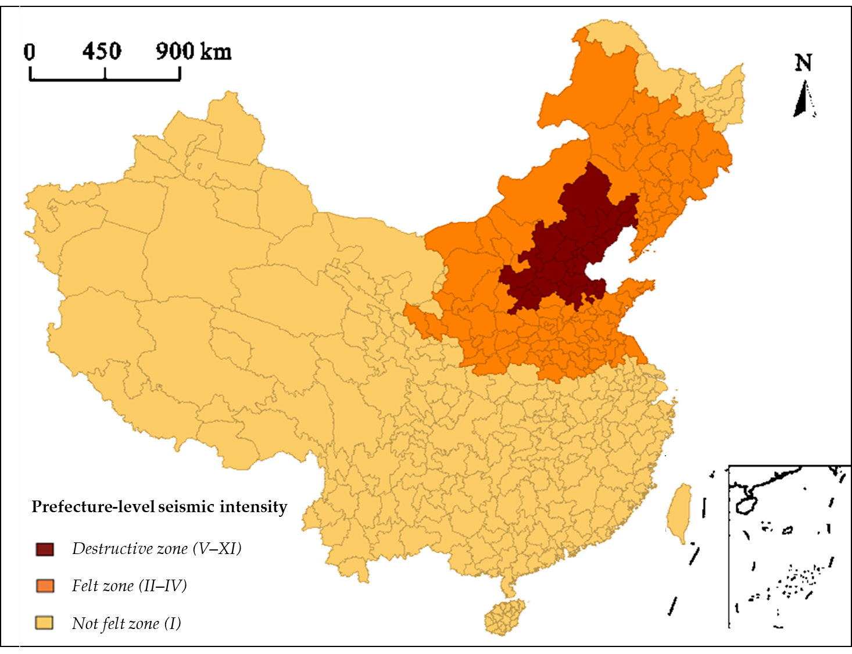
Supplementary Fig 1. Prefecture-level spatial distribution of earthquake intensity

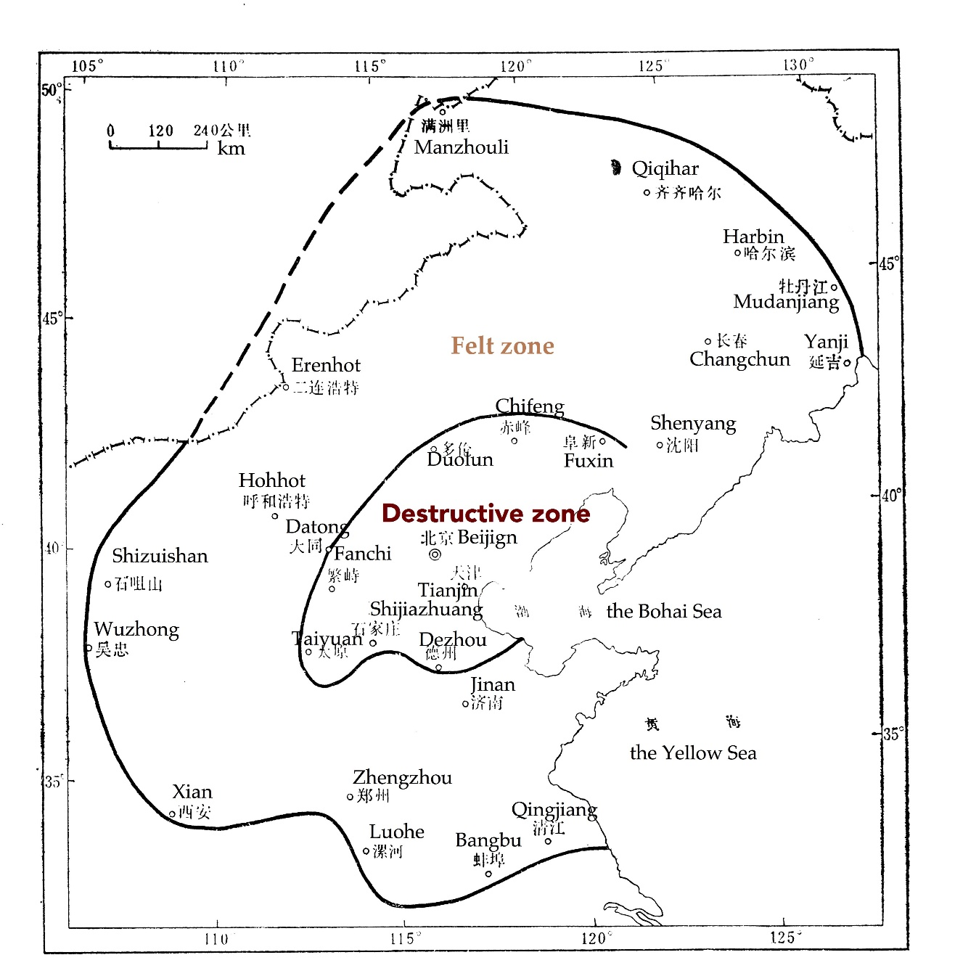
Supplementary Fig 2. The destructive zone and felt zone of the Great Tangshan Earthquake on July 28, 1976.

Supplementary Table 1. Prenatal earthquake exposure and risk of schizophrenia in adulthood for robustness analyses.
Multivariable analysis results | AOR | 95% CI | P-value
Full-term prenatal exposure
Pre-earthquake cohort × Felt | 2.17 | 0.89–5.28 | 0.088
Earthquake cohort × Felt | 2.64 | 1.25–5.58 | 0.011
Post-earthquake cohort × Felt | 1.65 | 0.75–3.64 | 0.216
Pre-earthquake cohort × Destructive | 1.50 | 0.42–5.43 | 0.533
Earthquake cohort × Destructive | 0.96 | 0.28–3.25 | 0.946
Post-earthquake cohort × Destructive | 1.16 | 0.46–2.91 | 0.752
Prenatal exposure by trimester of pregnancy
First trimester × Felt | 5.84 | 2.71–12.57 | <0.001
Second trimester × Felt | 2.18 | 0.76–6.23 | 0.145
Third trimester × Felt | 1.71 | 0.57–5.10 | 0.336
First trimester × Destructive | 0.85 | 0.15–4.78 | 0.850
Second trimester × Destructive | 0.31 | 0.09–1.11 | 0.072
Third trimester × Destructive | 1.75 | 0.31–10.02 | 0.529
Note: Cohort born during Jun. 1978 and Mar. 1979 was used as the reference cohort; the pre-earthquake cohort, earthquake cohort and post-earthquake cohort are the same as used in Table 2 and Table 3.

Supplementary Table 2. Prenatal earthquake exposure and risk of schizophrenia in adulthood, by rural and urban areas.
Birth cohort × intensity | Rural area |  |  |  | Urban area
 | AOR | 95% CI | P-value |  | AOR | 95% CI | P-value
Full-term prenatal exposure
Pre-earthquake cohort × Felt | 3.45 | 1.16–10.29 | 0.026 |  | 1.14 | 0.23–5.62 | 0.871
Earthquake cohort × Felt | 3.35 | 1.06–10.64 | 0.040 |  | 2.22 | 0.65–7.54 | 0.201
Post-earthquake cohort × Felt | 2.51 | 0.94–6.72 | 0.067 |  | 1.03 | 0.21–5.08 | 0.974
Pre-earthquake cohort × Destructive | 1.19 | 0.29–4.8 | 0.808 |  | 1.31 | 0.41–4.26 | 0.649
Earthquake cohort × Destructive | 0.73 | 0.34–1.58 | 0.426 |  | 0.66 | 0.13–3.28 | 0.616
Post-earthquake cohort × Destructive | 0.96 | 0.46–2.01 | 0.915 |  | 0.86 | 0.3–2.46 | 0.777
Prenatal exposure by trimester of pregnancy
First trimester × Felt | 5.29 | 1.36–20.55 | 0.016 |  | 15.86 | 1.88–133.63 | 0.011
Second trimester × Felt | 3.36 | 0.83–13.68 | 0.090 |  | 1.30 | 0.29–5.77 | 0.732
Third trimester × Felt | 2.28 | 0.54–9.61 | 0.261 |  | 1.30 | 0.21–8.06 | 0.777
First trimester × Destructive | 1.25 | 0.28–5.68 | 0.771 |  | ––ª | ––ª | ––ª
Second trimester × Destructive | 0.64 | 0.09–4.57 | 0.654 |  | ––ª | ––ª | ––ª
Third trimester × Destructive | 0.58 | 0.1–3.42 | 0.548 |  | 1.93 | 0.33–11.29 | 0.464
a. No samples in this category.

