**Supplementary material**

1A. Details of available study sample and sample selection process.

Supplementary Figure 1: Flow chart showing available study sample.

Supplementary Table 1: Missing data for each key variable (N=9385).

1B. Additional information on covariates.

1C. Technical details of multiple imputation process.

Supplementary Table 2: Model fit statistics for confirmatory factor analysis of items in Malaise Inventory Scale at ages 23, 33, 42, 50 (N=14,745).

Supplementary Table 3: Supplementary Table 3. Demographic information of the complete case and imputed sample (N = 9,385).

Supplementary Table 4: A structured modelling approach comparing life-course hypotheses of the association between lifetime affective problems and midlife cognitive function (no effect hypothesis, accumulation hypothesis, sensitive period hypothesis) using imputed data (N=9,385).

Supplementary Table 5: Linear regressions of number of time-point with case-level affective symptoms (Range 0-4) on cognitive outcomes at age 50 using imputed data (N=9,385).

Supplementary Table 6: Comparison of 2-class, 3-class, 4-class, and 5-class growth mixture models.

Supplementary Table 7: Unadjusted and partially adjusted structural equation model output for class membership predicting midlife cognitive test scores.

**1A.**

Details of available study sample and sample selection process

During the sweep in 2008 (cohort members aged 50), the target sample was all cohort members in Great Britain, excluding permanent refusals and participants who had been excluded for specific reasons (n = 12,369). It was possible to issue 12,316 of the original 18,558 participants to interviewers. These 12,316 participants either had participated in sweeps in 2000, 2002 or 2004 and were still alive and residing in Great Britain with a known address (n = 11,320), or had not participated in the above sweeps but had confirmed their current address since 2000 (n=387), or had not participated in any of the above but contact details had been obtained through tracing exercises (n = 609). Of the total issued sample in 2008 (n = 12,316), 11,461 (93.1%) were confirmed eligible to take part, as 37 (0.3%) had died, 101 (0.9%) had emigrated, 4 (0.0%) were issued in error (duplication), 676 (5.5%) could not be traced, and 37 (0.3%) were not reissued or traced due to lack of time. Productive interviews were completed for 9,790 cohort members (85.4% of confirmed eligible sample). Of these, 9,385 people had complete information on cognitive assessments (Supplementary Figure 1 & Supplementary Table 1).

**Supplementary Figure 1:** Flow chart showing available study sample.

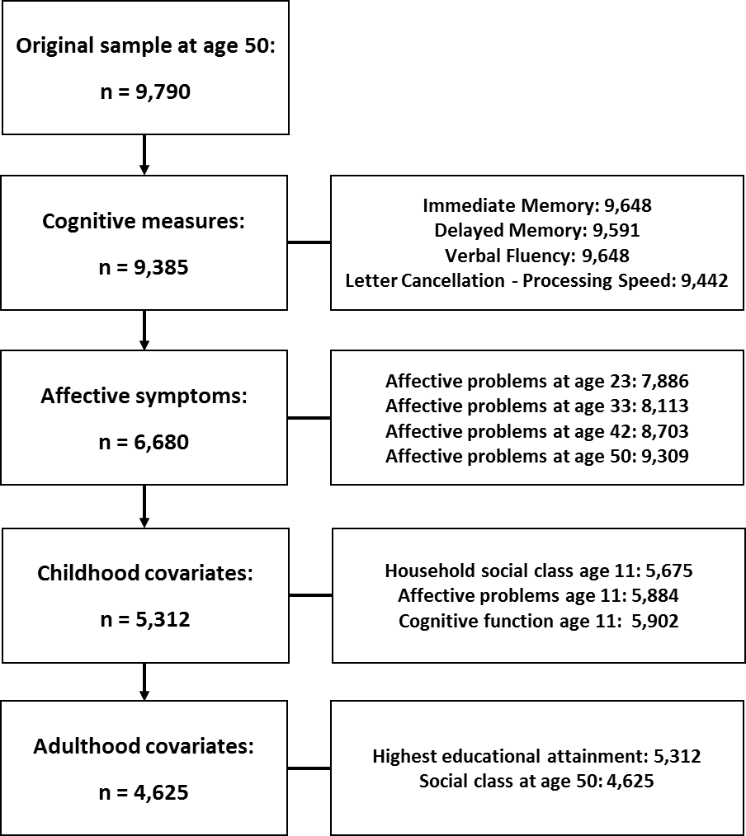

|  |  |  |  |
| --- | --- | --- | --- |
| **Supplementary Table 1: Missing data for each key variable (N=9385)** | | | |
| Measure | | N with data available (%) | N with missing data (%) |
| Affective symptoms | Malaise Score Age 23 | 7886 (84.03) | 1499 (15.97) |
| Malaise Score Age 33 | 8113 (86.45) | 1272 (13.55) |
| Malaise Score Age 42 | 8703 (92.73) | 682 (7.27) |
| Malaise Score Age 50 | 9309 (99.19) | 76 (0.81) |
| Accumulation of Malaise Score | 6680 (71.18) | 2705 (28.82) |
| Covariates | Childhood Affective Symptoms | 8133 (86.66) | 1252 (13.34) |
| Childhood Cognitive Score | 8145 (86.79) | 1240 (13.21) |
| Childhood SEP | 7767 (82.76) | 1618 (17.24) |
| Adulthood SEP | 7972 (84.94) | 1413 (15.06) |
| Education | 9385 (100) | 0 (0) |

* Sample with cognitive data (N = 9385)

**1B**

Additional information on covariates

Childhood cognition was assessed at age 11, using a general ability test administered at the child’s school. This test (Douglas 1964) comprised verbal and non-verbal components, which combined into an overall cognitive score. Childhood mental health also assessed at age 11 using the Bristol Social Adjustment Guides (BSAG) (Mcdermott et al. 2017). This questionnaire was completed by teachers and is designed to assess behaviour which may be indicative of maladjustment and emotional disturbance. Teachers were asked to underline descriptions of the child which they felt to be most accurate. This information was then coded and summed to create a quantitative score of emotional disturbance and adjustment to school at age 11.

A measure of household socio-economic position at age 11 was derived using guidelines from the Centre for Longitudinal Studies (CLS) (Elliott & Lawrence 2014), based on measures of father’s occupation, mother’s occupation, and household tenure. Specifically, cohort members were categorised as being ‘middle class’ if their father was in Registrar General's Social Classes class I or II (professional, managerial, administrative etc.) during the sweep at age 11 (1969), they were not living in rented council accommodation, and their mother was not in a manual occupation while she was pregnant or when the cohort member was age 11. Cohort members were categorised as being ‘intermediate class’ if their father was in Registrar General's Social Classes I or II (professional, managerial, administrative etc.) during the sweep at age 11, but either resided in council accommodation or the mother was working in manual labour either during the pregnancy or once the child was 11 years old. Additionally, children were categorised as being ‘intermediate class’ if their father was in routine non-manual (Class IIIa). Finally, children were also categorised as ‘intermediate class’ if their father was either in manual work when the child was 11, or was in routine service work (class IVa), but were residing in owner occupied accommodation. Finally, cohort members were categorised as ‘working class’ if their father was working in routine service (Class IVa) and at age 11 they were not residing in owner-occupied accommodation, or if their father was working in a manual occupation.

Highest educational attainment was derived by combining education data from 1991, 2000, 2004, and 2008 to ascertain the highest academic qualification the cohort member had achieved by age 50. Adult socio-economic position was derived using the same method as for the age 11 social class variable (Elliott & Lawrence 2014). This was based on occupation, creating three categories (working, intermediate and middle class).

**1C.**

Technical details of multiple imputation process

The process of multiple imputation involves replacing missing cases with plausible values generated from analysing distributions and the relationships between the observed variables within data. Multiple imputation with this data involved 7 stages. Firstly a number of variables from birth (birthweight, mother’s age at birth, husband’s age in years, socioeconomic position of mother’s husband, mother’s father’s socio-economic position, and mother’s education) were imputed. Imputation method used varied depending on the nature of the variable (continuous, ordinal or binary). Next, all birth variables plus sex were used as auxiliary variables to impute variables at age 7 (father’s education, whether parents had mental illness or neurosis, BSAG score, arithmetic score, and reading score). Next, all birth and age 7 variables were used to impute age 11 variables (BSAG score, cognitive score, household socioeconomic position). As a next step, birth, age 7, and age 11 variables were used to impute malaise scores at age 23. Birth, age 7, age 11 variables, plus malaise scores at age 23 were used to impute malaise scores at age 33. Malaise scores at age 42 were then imputed from birth, age 7, and age 11 variables, as well as malaise scores at age 23 and 33. Finally, birth age 7, age 11 variables, as well as malaise scores at age 23, 33, and 42 were used to impute age 50 variables (malaise score, socioeconomic position, and educational attainment).

|  |  |
| --- | --- |
| **Supplementary Table 2:** Model fit statistics for confirmatory factor analysis of items in Malaise Inventory Scale at ages 23, 33, 42, 50 (N=14,745). | |
| Fit statistic | Fit value |
| CFI | .963 |
| TLI | .960 |
| RMSEA | .025 |
| X2 | 5885.35 (588), <.001 |

|  |  |  |
| --- | --- | --- |
| **Supplementary Table 3. Demographic information of the complete case and imputed sample (N = 9,385).** | | |
|  | **Complete Case Sample** | **Imputed Sample** |
| **Characteristics** | **N = 4,625** | **N = 9,385** |
| Sex |  |  |
| Male | 2289 (49.5) | 4614 (49.2) |
| Female | 2336 (50.5) | 4771 (50.8) |
| Highest educational attainment by age 50, N (%)a |  |  |
| No academic qualification | 501 (10.8) | 1772 (18.9) |
| GCSE to A-Level and Scottish equivalent | 2916 (63.1) | 5329 (56.8) |
| Diploma, degree, PGCE, or higher degree | 1208 (26.1) | 2284 (24.3) |
| Childhood social class, N (%) |  |  |
| Middle | 1048 (22.7) | 1994 (21.2) |
| Intermediate | 1788 (38.7) | 3449 (36.8) |
| Working | 1789 (38.7) | 3942 (42.0) |
| Adult social class, N (%) |  |  |
| Middle | 2274 (49.2) | 4320 (46.0) |
| Intermediate | 1429 (30.9) | 2996 (31.9) |
| Working | 921 (19.9) | 2062 (22.0) |
| Childhood cognitive score, Mean (SD) | 47.27 (14.68) | 45.34 (15.39) |
| Mean cognitive scores, Mean (SD) |  |  |
| Immediate Memory | 6.67 (1.42) | 6.55 (1.47) |
| Delayed Memory | 5.55 (1.77) | 5.42 (1.83) |
| Verbal Fluency | 22.71 (6.22) | 22.30 (6.26) |
| Letter cancellation - Processing speed | 336.03 (90.00) | 333.97 (88.81) |
| Letter cancellation - Accuracy | 4.25 (4.03) | 4.41 (4.12) |
| Case-level at each time-point, N (%) |  |  |
| Age 23 | 235 (5.1) | 593 (6.3) |
| Age 33b | 208 (4.5) | 560 (6.0) |
| Age 42 | 431 (9.3) | 1191 (12.7) |
| Age 50 | 542 (11.7) | 1374 (14.6) |
| Malaise scores at each time-point, Mean (SD) |  |  |
| Age 23 | 2.35 (2.59) | 2.58 (2.77) |
| Age 33 | 2.05 (2.57) | 2.32 (2.86) |
| Age 42 | 3.14 (3.08) | 3.54 (3.51) |
| Age 50 | 1.28 (1.74) | 1.48 (1.93) |
| Accumulation of case-level affective symptoms, N (%) |  |  |
| No time-points | 3692 (79.8) | 7025 (74.9) |
| 1 time-point | 597 (12.9) | 1427 (15.2) |
| 2 time-points | 224 (4.8) | 599 (6.4) |
| 3 time-points | 77 (1.7) | 243 (2.6) |
| 4 time-points | 35 (0.8) | 91 (1.0) |

a Frequency data is presented as N (%); Continuous data is presented as Mean (SD).

b In the structured model to compare accumulation and sensitive period hypotheses, malaise data from ages 33 and 43 were merged to create one time-point representing middle adulthood.

|  |  |  |  |  |  |  |  |  |  |  |
| --- | --- | --- | --- | --- | --- | --- | --- | --- | --- | --- |
| **Supplementary Table 4:** A structured modelling approach comparing life-course hypotheses of the association between lifetime affective problems and midlife cognitive function (no effect hypothesis, accumulation hypothesis, sensitive period hypothesis) using imputed data (N=9,385)a. | | | | | | | | | | |
|  | **Immediate Memory** | | **Delayed Memory** | | **Verbal Fluency** | | **Processing Speed** | | **Accuracy** | |
| **F** | ***P*** | **F** | ***P*** | **F** | ***P*** | **F** | ***P*** | **F** | ***P*** |
| Saturated model | *Reference* | *Reference* | *Reference* | *Reference* | *Reference* | *Reference* | *Reference* | *Reference* | *Reference* | *Reference* |
| No effect | 16.07 | <.001 | 15.67 | <.001 | 20.3 | <.001 | **0.59** | **0.77** | 6.21 | <.001 |
| Accumulation | **1.05** | **.39b** | **0.82** | **0.55** | **1.28** | **0.26** | **0.68** | **0.66** | **0.82** | **0.55** |
| Critical period 1 (age 23) | 13.36 | <.001 | 11.8 | <.001 | 18.23 | <.001 | **0.58** | **0.75** | 6.38 | <.001 |
| Critical period 2 (age 33-42) | 8.81 | <.001 | 9.73 | <.001 | 5.67 | <.001 | **0.55** | **0.77** | 3 | 0.01 |
| Critical period 3 (age 50) | 6.34 | <.001 | 5.72 | <.001 | 11.81 | <.001 | **0.68** | **0.67** | **2.01** | **0.06** |
| **Best fitting model** | **Accumulation** | | **Accumulation** | | **Accumulation** | | **Critical Period 2** | | **Accumulation** | |

a Estimates are based on the imputed sample (N = 9,385).

b Bold values represent estimates which are non-significant at the *P* < .05 level. Non-significant *P* values represent a good fit of the data. The hypothesis with the smallest F statistic is taken as the hypothesis with the best fit of the data.

|  |  |  |  |  |  |  |  |  |  |  |  |  |  |  |  |
| --- | --- | --- | --- | --- | --- | --- | --- | --- | --- | --- | --- | --- | --- | --- | --- |
| **Supplementary Table 5:** Linear regressions of number of time-point with case-level affective symptoms (Range 0-4) on cognitive outcomes at age 50 using imputed data (N=9,385)a. | | | | | | | | | | | | | | | |
|  | **Model 1b** | | | **Model 2** | | | **Model 3** | | | **Model 4** | | | **Model 5** | | |
| **b** | **SE** | ***P*** | **b** | **SE** | ***P*** | **b** | **SE** | ***P*** | **b** | **SE** | ***P*** | **b** | **SE** | ***P*** |
| Immediate memory | **-0.2c** | **0.02** | **<.001** | **-0.23** | **0.02** | **<.001** | **-0.12** | **0.02** | **<.001** | **-0.1** | **0.02** | **<.001** | **-0.11** | **0.02** | **<.001** |
| Delayed memory | **-0.24** | **0.02** | **<.001** | **-0.29** | **0.02** | **<.001** | **-0.15** | **0.02** | **<.001** | **-0.13** | **0.02** | **<.001** | **-0.13** | **0.02** | **<.001** |
| Verbal fluency | **-0.92** | **0.08** | **<.001** | **-0.93** | **0.08** | **<.001** | **-0.45** | **0.08** | **<.001** | **-0.36** | **0.08** | **<.001** | **-0.37** | **0.08** | **<.001** |
| Information processing speed | -0.04 | 1.15 | .97 | **-2.41** | **1.15** | **.04** | -0.53 | 1.17 | .65 | 0.14 | 1.17 | .90 | 0.07 | 1.17 | .95 |
| Letter cancellation accuracy | **0.34** | **0.05** | **<.001** | **0.32** | **0.05** | **<.001** | **0.17** | **0.05** | **.002** | **0.17** | **0.05** | **.002** | **0.18** | **0.05** | **.001** |

a Estimates are based on the imputed sample (N = 9,385).

b Results are presented for model 1 (unadjusted estimates), model 2 (estimates adjusted for sex), model 3 (estimates adjusted for sex, childhood socioeconomic status, childhood emotional adjustment, and childhood cognition), and model 4 (estimates adjusted for sex, childhood socioeconomic status, childhood emotional adjustment, childhood cognition, adult socioeconomic status, and highest educational attainment at age 50). Model 5 is a sensitivity analysis, using all the covariates in Model 4, but excluding childhood emotional adjustment.

c Bold values represent estimates significant at the *P* < .05 level.

|  |  |  |  |  |
| --- | --- | --- | --- | --- |
| **Supplementary Table 6:** Comparison of 2-class, 3-class, 4-class, and 5-class growth mixture models. | | | | |
|  | **2-class** | **3-class** | **4-class** | **5-classa** |
| AIC | 7354.32 | 6101.344 | 4899.587 | 4665.861 |
| BIC | 7445.504 | 6215.324 | 5036.362 | 4825.433 |
| Entropy | .815 | .776 | .865 | .764 |
| Sample Proportion | 13; 87 | 16; 75; 10 | 43; 5; 18; 34 | 7; 51; 8; 28; 5 |
| Classification Accuracy | .738 - .98 | .746 - .951 | .875 - .966 | .622 - .911 |
| Lo-Mendel-Rubin Adjusted LRT | <.001 | <.001 | .038 | <.001 |

a 5-class model was selected for subsequent analysis, due to lower AIC, BIC, and significant Lo-Mendel-Rubin Adjusted LRT.

|  |  |  |  |  |  |  |  |  |  |  |  |  |
| --- | --- | --- | --- | --- | --- | --- | --- | --- | --- | --- | --- | --- |
| **Supplementary Table 7:** Unadjusted and partially adjusted structural equation model output for class membership predicting midlife cognitive test scores. | | | | | | | | | | | | |
|  | **Model 1a** | | | **Model 2** | | | **Model 3** | | | **Model 4** | | |
|  | **b** | **SE** | ***P*** | **b** | **SE** | ***P*** | **b** | **SE** | ***P*** | **b** | **SE** | ***P*** |
| Immediate Memory |  | | |  | | |  | | |  | | |
| No affective symptoms | *Reference* | | | *Reference* | | | *Reference* | | | *Reference* | | |
| Mild/moderate affective symptoms | **-0.15** | **0.04** | **<.001b** | **-0.21** | **0.04** | **<.001** | **-0.10** | **0.04** | **.01** | **-0.09** | **0.04** | **.02** |
| Initially low and rapidly increasing affective symptoms | **-0.27** | **0.06** | **<.001** | **-0.30** | **0.06** | **<.001** | **-0.21** | **0.06** | **.001** | **-0.15** | **0.07** | **.03** |
| Initially high and persistently increasing affective symptoms | **-0.47** | **0.06** | **<.001** | **-0.55** | **0.06** | **<.001** | **-0.29** | **0.06** | **<.001** | **-0.25** | **0.07** | **<.001** |
| Initially high and steadily decreasing affective symptoms | **-0.32** | **0.06** | **<.001** | **-0.42** | **0.06** | **<.001** | **-0.16** | **0.07** | **.02** | **-0.14** | **0.07** | **.05** |
| Delayed Memory |  | | |  | | |  | | |  | | |
| No affective symptoms | *Reference* | | | *Reference* | | | *Reference* | | | *Reference* | | |
| Mild/moderate affective symptoms | **-0.05** | **0.04** | **.27** | **-0.15** | **0.05** | **.001** | <.001 | 0.05 | 1.00 | 0.02 | 0.05 | .65 |
| Initially low and rapidly increasing affective symptoms | **-0.35** | **0.07** | **<.001** | **-0.39** | **0.07** | **<.001** | **-0.26** | **0.08** | **<.001** | **-0.23** | **0.09** | **.006** |
| Initially high and persistently increasing affective symptoms | **-0.47** | **0.07** | **<.001** | **-0.60** | **0.07** | **<.001** | **-0.29** | **0.08** | **<.001** | **-0.23** | **0.09** | **.006** |
| Initially high and steadily decreasing affective symptoms | **-0.35** | **0.08** | **<.001** | **-0.51** | **0.08** | **<.001** | **-0.21** | **0.08** | **.01** | -0.17 | 0.09 | .05 |
| Verbal Fluency |  | | |  | | |  | | |  | | |
| No affective symptoms | *Reference* | | | *Reference* | | | *Reference* | | | *Reference* | | |
| Mild/moderate affective symptoms | **-0.91** | **0.15** | **<.001** | **-0.96** | **0.15** | **<.001** | **-0.41** | **0.17** | **.01** | -0.34 | 0.18 | .05 |
| Initially low and rapidly increasing affective symptoms | **-0.98** | **0.25** | **<.001** | **-1.00** | **0.25** | **<.001** | -0.49 | 0.27 | .06 | -0.26 | 0.30 | .39 |
| Initially high and persistently increasing affective symptoms | **-2.09** | **0.24** | **<.001** | **-2.15** | **0.24** | **<.001** | **-0.92** | **0.26** | **<.001** | **-0.82** | **0.30** | **.006** |
| Initially high and steadily decreasing affective symptoms | **-1.82** | **0.26** | **<.001** | **-1.90** | **0.26** | **<.001** | **-0.72** | **0.29** | **.01** | -0.60 | 0.31 | .06 |
| Information Processing Speed |  | | |  | | |  | | |  | | |
| No affective symptoms | *Reference* | | | *Reference* | | | *Reference* | | | *Reference* | | |
| Mild/moderate affective symptoms | 2.16 | 2.19 | .32 | -2.99 | 2.19 | .17 | 0.12 | 2.50 | .96 | 0.81 | 2.65 | .76 |
| Initially low and rapidly increasing affective symptoms | -0.37 | 3.58 | .92 | -2.47 | 3.54 | .49 | 1.44 | 3.96 | .72 | 6.40 | 4.46 | .15 |
| Initially high and persistently increasing affective symptoms | -2.58 | 3.39 | .45 | **-9.16** | **3.39** | **.007** | **-8.03** | **3.85** | **.04** | -2.24 | 4.47 | .62 |
| Initially high and steadily decreasing affective symptoms | **8.78** | **3.75** | **.02** | -1.90 | 3.75 | .93 | 7.56 | 4.26 | .08 | 4.11 | 4.68 | .38 |
| Letter Cancellation Accuracy |  | | |  | | |  | | |  | | |
| No affective symptoms | *Reference* | | | *Reference* | | | *Reference* | | | *Reference* | | |
| Mild/moderate affective symptoms | **0.26** | **0.10** | **.01** | **0.23** | **0.10** | **.02** | 0.08 | 0.12 | .49 | 0.13 | 0.12 | .30 |
| Initially low and rapidly increasing affective symptoms | **0.38** | **0.17** | **.02** | **0.36** | **0.17** | **.03** | 0.31 | 0.18 | .09 | **0.51** | **0.21** | **.01** |
| Initially high and persistently increasing affective symptoms | **0.74** | **0.16** | **<.001** | **0.70** | **0.16** | **<.001** | 0.21 | 0.18 | .24 | 0.22 | 0.21 | .29 |
| Initially high and steadily decreasing affective symptoms | **0.78** | **0.17** | **<.001** | **0.74** | **0.18** | **<.001** | **0.51** | **0.20** | **.009** | 0.28 | 0.22 | .20 |
| N | 9,643 | | | 9,643 | | | 7,423 | | | 6,359 | | |
| Model Fit | X2(2)=102.46 *P*<.001, CFI=.991, TLI=.867, RMSEA=.072 | | | X2(2)=73.53, *P*<.001,  CFI=.994, TLI=.893, RMSEA=.061 | | | X2(2)=8.35, *P*=.02, CFI=.999, TLI=985, RMSEA=.021 | | | X2(2)=1.64, *P*=.44, CFI=1.000, TLI=1.001, RMSEA=.000 | | |

a Results are presented for model 1 (unadjusted estimates), model 2 (estimates adjusted for sex), and model 3 (estimates adjusted for sex, childhood socioeconomic status, childhood emotional adjustment, and childhood cognition). Model 4 is a sensitivity analysis, adjusted for sex, childhood socioeconomic status, childhood cognition, adult socioeconomic status, and highest educational attainment, but excluding childhood emotional adjustment.

b Bold values represent estimates significant at the *P* < .05 level.