SUPPLEMENTARY TABLE 1. Number of samples and mean concentrations of aluminium and fluoride in drinking water sampling sites in Scotland 2005-2012: the Scottish Mental Survey 1932 cohort
 | 2005 | 2006 | 2007 | 2008 | 2009 | 2010 | 2011 | 2012 | Overall
Aluminium
N samples | 5285 | 5367 | 5356 | 5273 | 5232 | 5197 | 5062 | 5096 | 41868
Mean (sd) | 39.2 (44.3) | 38.5 (31.7) | 38.9 (75.8) | 34.0 (29.0) | 31.5 (25.5) | 31.4 (26.9) | 31.3 (28.8) | 28.5 (19.6) | 34.2 (39.4)
Range | 4-1549 | 2-874 | 2-5096 | 4-860 | 4-878 | 4-747 | 4-781 | 9-222 | 2-5096
Quartiles | 22, 32, 46 | 22, 32, 47 | 22, 32, 46 | 18, 28, 42 | 81, 26, 39 | 17, 24, 39 | 16, 25, 38 | 16, 23, 35 | 18, 28, 42
Fluoride
N samples | 1715 | 1771 | 1738 | 1672 | 1652 | 1624 | 1576 | 1556 | 13304
Mean (sd) | 68.2 (62.7) | 44.2 (46.8) | 43.6 (35.6) | 38.7 (48.6) | 36.7 (36.1) | 60.0 (37.7) | 64.5 (67.2) | 80.6 (126.4) | 54.2 (65.0)
Range | 10-1060 | 10-1320 | 10-390 | 10-1200 | 10-540 | 40-610 | 40-1200 | 40-2030 | 10-2030
Quartiles | 30, 60, 100 | 20, 40, 50 | 20, 30, 50 | 20, 30, 40 | 20, 30, 40 | 40, 50, 70 | 40, 40, 70 | 40, 40, 50 | 30, 40, 60

SUPPLEMENTARY TABLE 2. Adjusted hazard ratios and accompanying 95% confidence intervals for the association between mean aluminium and fluoride levels in drinking water and dementia in men and women: the Scottish Mental Survey 1932 cohort
 | Nª | Dementia N | Hazard ratio^{b} (95% confidence interval) |  |  |  |  | HR^{b} (95% CI)  per SD increase | P_{trend}
 |  |  | Q1 (low) | Q2 | Q3 | Q4 (high)
Aluminium
Women: IQ | 4262 | 1350 | 1  (ref.) | 1.37  (1.17, 1.60) | 1.30  (1.11, 1.51) | 1.41  (1.20, 1.64) |  | 1.09  (1.03, 1.15) | <0.001
Women: IQ and SIMD | 4079 | 1345 | 1  (ref.) | 1.30  (1.11, 1.52) | 1.20  (1.03, 1.41) | 1.37  (1.17, 1.60) |  | 1.08  (1.03, 1.14) | 0.002
Men: IQ | 2728 | 622 | 1  (ref.) | 1.28  (1.01, 1.61) | 1.25  (0.99, 1.57) | 1.48  (1.18, 1.85) |  | 1.12  (1.03, 1.21) | 0.004
Men: IQ and SIMD | 2576 | 619 | 1  (ref.) | 1.22  (0.96, 1.54) | 1.17  (0.93, 1.49) | 1.42  (1.14, 1.78) |  | 1.10  (1.01, 1.19) | 0.014
Fluoride
Women: IQ | 4262 | 1350 | 1  (ref.) | 0.92  (0.79, 1.07) | 1.15  (0.99, 1.34) | 2.32  (2.01, 2.68) |  | 1.34  (1.28, 1.41) | <0.001
Women: IQ and SIMD | 4079 | 1345 | 1  (ref.) | 0.88  (0.76, 1.02) | 1.11  (0.95, 1.29) | 2.18  (1.89, 2.53) |  | 1.32  (1.26, 1.38) | <0.001
Men: IQ | 2728 | 622 | 1  (ref.) | 1.05  (0.84, 1.32) | 1.49  (1.19, 1.86) | 2.65  (2.14, 3.29) |  | 1.30  (1.22, 1.39) | <0.001
Men: IQ and SIMD | 2576 | 619 | 1  (ref.) | 1.01  (0.80, 1.27) | 1.46  (1.16, 1.83) | 2.48  (2.00, 3.08) |  | 1.28  (1.20, 1.37) | <0.001
ª SMS1932 participants who survived to 2005 (the start of the exposure period)
^{b} Hazard ratio adjusted for age 11 mental ability (IQ) or age 11 mental ability and SIMD rank (IQ + SIMD)

Cut points for aluminium quartiles were 30.8, 35.5, and 41.1μg/L
Cut points for fluoride quartiles were 44.4, 48.7, and 56.3μg/L

SUPPLEMENTARY FIGURE 1. Location of aluminium (left) and fluoride (right) sampling sites in Scottish Drinking Water Quality Regulator data 2005-2012: the Scottish Mental Survey 1932 cohort
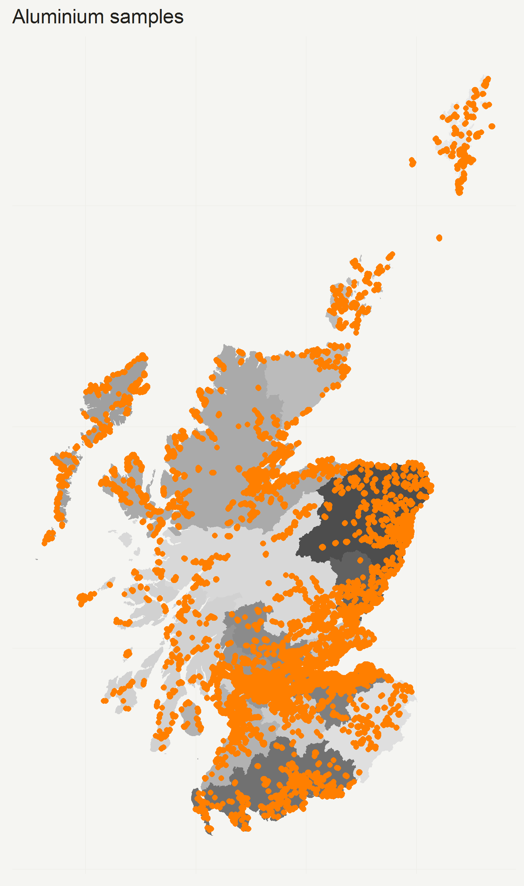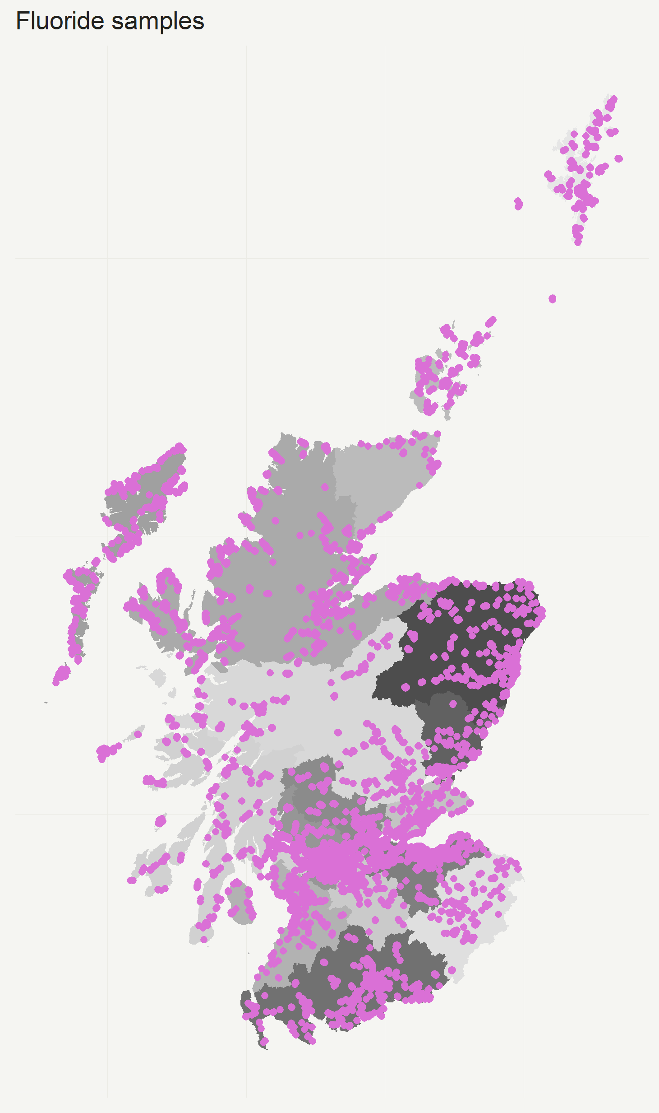

Postcode areas are shown in different shades of grey
SUPPLEMENTARY FIGURE 2. Odds ratio of dementia in the SMS1932 cohort by adult location with individual-level effects (age) removed: the Scottish Mental Survey 1932 cohort
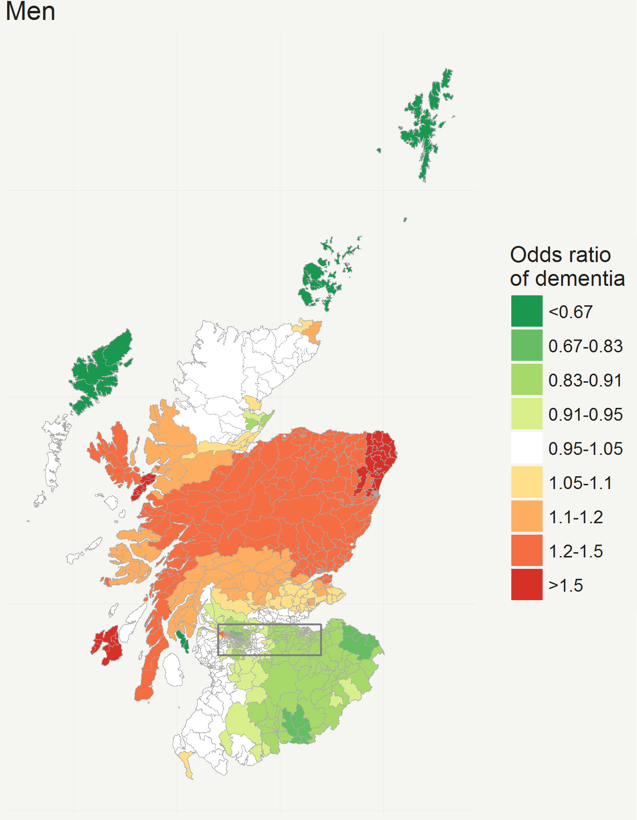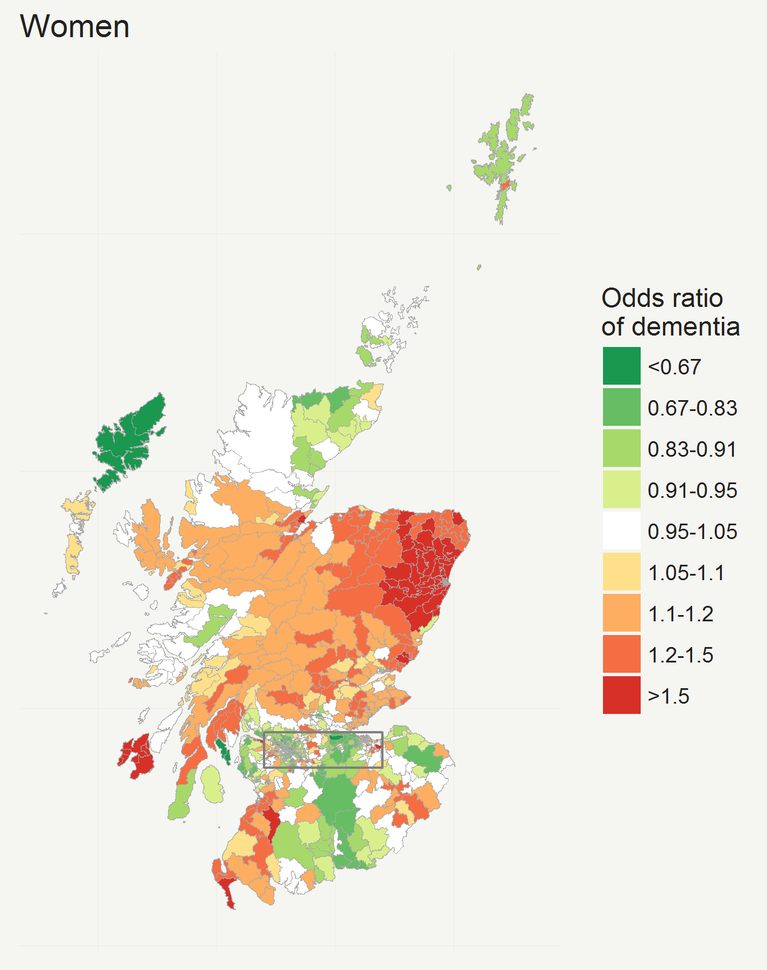
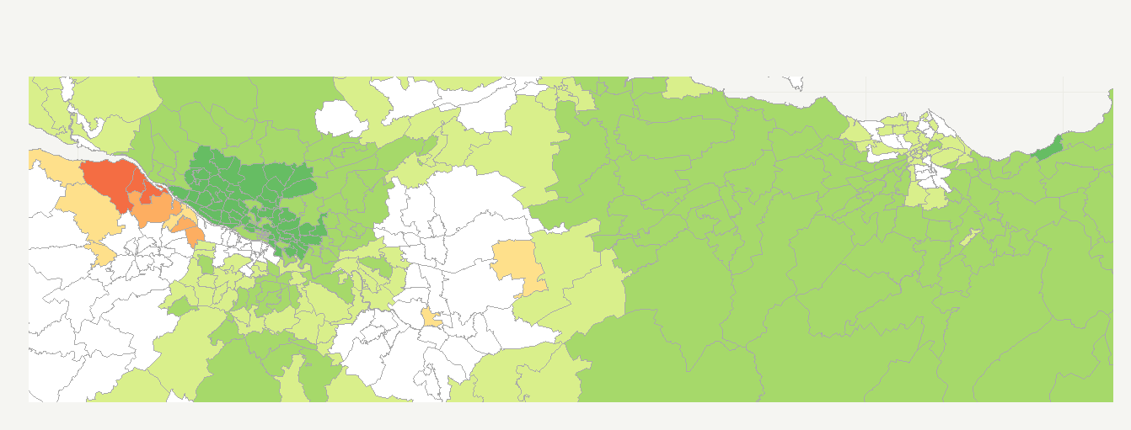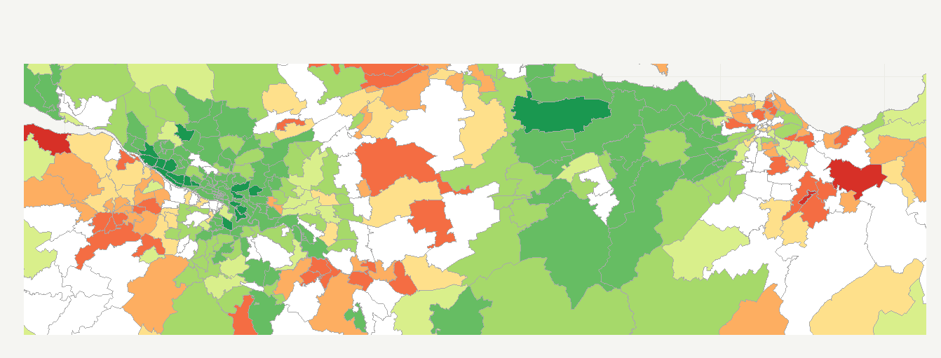

Lower panel shows an enlarged view of the Central Belt of Scotland including Glasgow and Edinburgh

Adapted from Russ TC, Gatz M, Pedersen NL, Hannah J, Wyper G, Batty GD, et al. Geographical variation in dementia: examining the role of environmental factors in Sweden and Scotland. Epidemiology 2015 26(2): 263-70

SUPPLEMENTARY FIGURE 3. Trends in aluminium and fluoride concentrations in drinking water in Scotland from 2005-2012: the Scottish Mental Survey 1932 cohort
