Supplementary Table 1: Sociodemographic characteristics of the two villages at pre-stigma

 | Visit 1 (Pre-Stigma) (N=1576)
 |  | Comparison between two village
 | Total  (N=1576) | Ravulaparru  (N=731) | Vallurupalli  (N=845)
Characteristic | n (%) | n (%) | n (%)
Gender
Female | 929 (58.9%) | 424 (58.0%) | 505 (59.8%)
Male | 647 (41.1%) | 307 (42.0%) | 340 (40.2%)
Occupation
House wife/Retired | 612 (38.8%) | 202 (27.6%) | 410 (48.5%)
Organized Sector | 40 (2.5%) | 16 (2.2%) | 24 (2.8%)
Other | 139 (8.8%) | 68 (9.3%) | 71 (8.4%)
Unorganized Sector | 785 (49.8%) | 445 (60.9%) | 340 (40.2%)
Education
Graduate/Post Graduate | 49 (3.1%) | 18 (2.5%) | 31 (3.7%)
High School | 267 (16.9%) | 94 (12.9%) | 173 (20.5%)
No School | 507 (32.2%) | 293 (40.1%) | 214 (25.3%)
Other | 7 (0.4%) | 2 (0.3%) | 5 (0.6%)
Primary School | 746 (47.3%) | 324 (44.3%) | 422 (49.9%)
Marital Status
Currently Married | 1261 (80.0%) | 592 (81.0%) | 669 (79.2%)
Never Married | 151 (9.6%) | 59 (8.1%) | 92 (10.9%)
Separated/Divorced/Widowed | 164 (10.4%) | 80 (10.9%) | 84 (9.9%)
Age(Years)
Mean (SD) | 42.8 (15.79) | 43.9 (16.21) | 41.8 (15.36)
Range | 18; 90 | 18; 86 | 18; 90
N=Total number of patients in that visit. n=Number of patients with particular characteristic.

Supplementary Table 2: Differences in sociodemographic characteristics amongst those interviewed at pre-stigma and those followed up for subsequent visits

 | Visit 1 (Pre-stigma) (N=1576)
 | Comparison between common subject between all 3 visits and those not followed up
 | Common subjects for all 3 visits  (N=1417) | Remaining subjects  (N=159)
Characteristic | n (%) | n (%) | P-value
Gender |  |  | 0.2861
Female | 829 (58.5%) | 100 (62.9%)
Male | 588 (41.5%) | 59 (37.1%)
Occupation |  |  | 0.8727
House wife/Retired | 553 (39.0%) | 59 (37.1%)
Organized Sector | 35 (2.5%) | 5 (3.1%)
Other | 123 (8.7%) | 16 (10.1%)
Unorganized Sector | 706 (49.8%) | 79 (49.7%)
Education |  |  | 0.0025
Graduate/Post Graduate | 39 (2.8%) | 10 (6.3%)
High School | 228 (16.1%) | 39 (24.5%)
No School | 456 (32.2%) | 51 (32.1%)
Other | 7 (0.5%) | 0 (0.0%)
Primary School | 687 (48.5%) | 59 (37.1%)
Marital Status |  |  | 0.3091
Currently Married | 1141 (80.5%) | 120 (75.5%)
Never Married | 133 (9.4%) | 18 (11.3%)
Separated/Divorced/Widowed | 143 (10.1%) | 21 (13.2%)
Age(Years)
Mean (SD) | 43.1 (15.80) | 40.2 (15.48) | 0.0321
Range | 18; 90 | 18; 80

N=Total number of patients in that visit. n=Number of patients with particular characteristic.

Supplementary Table 3: Change in overall mean Behaviour scores of Knowledge Attitude and Behaviour

Order | Overall Behaviour SCORE | Group 1 | Group 2 | Mean difference (CI) | P-Value
1 | Comparison between Pre-Stigma and Post Intervention
 | N | 1417 | 1417
 | Mean (SD) | 1.98 (0.939) | 1.23 (0.603) | -0.7 (-0.8;-0.7) | <.001
2 | For Pre-Stigma only: comparison between Male and Female
 | N | 569 | 848
 | Mean (SD) | 1.91 (0.896) | 2.02 (0.965) | 0.1 (0.0;0.2) | 0.0320
3 | For Pre-Stigma only: comparison between Up to primary and above primary
 | N | 957 | 460
 | Mean (SD) | 2.02 (0.939) | 1.89 (0.934) | -0.1 (-0.2;-0.0) | 0.0133
4 | For male only: comparison between Pre-Stigma and Post Intervention
 | N | 569 | 569
 | Mean (SD) | 1.91 (0.896) | 1.20 (0.597) | -0.7 (-0.8;-0.6) | <.001
5 | For Female only: comparison between Pre-Stigma and Post Intervention
 | N | 848 | 848
 | Mean (SD) | 2.02 (0.965) | 1.26 (0.607) | -0.8 (-0.8;-0.7) | <.001
6 | For Up to primary only: comparison between Pre-Stigma and Post Intervention
 | N | 957 | 957
 | Mean (SD) | 2.02 (0.939) | 1.25 (0.610) | -0.8 (-0.8;-0.7) | <.001
7 | For above primary only: comparison between Pre-Stigma and Post Intervention
 | N | 460 | 460
 | Mean (SD) | 1.89 (0.934) | 1.20 (0.589) | -0.7 (-0.8;-0.6) | <.001
8 | For Post Intervention only: comparison between Male and Female
 | N | 569 | 848
 | Mean (SD) | 1.20 (0.597) | 1.26 (0.607) | 0.1 (-0.0;0.1) | 0.0917
9 | For Post Intervention only: comparison between Up to primary and above primary
 | N | 957 | 460
 | Mean (SD) | 1.25 (0.610) | 1.20 (0.589) | -0.1 (-0.1;0.0) | 0.1347

For comparison between Visit 1(Pre-Stigma) and Visit 3(Post Intervention) p-value was computed by paired t-test. For comparison between the category for a specific visit p-value was calculated by independent 2 sample t-test.
Analysis was performed on total Behaviour score. This was calculated by summing up all Behaviour scores divided by number of Behavioural question responded by that individual.
For order (1,4,5,6,7) : Group 1 = Visit 1 (Pre-Stigma) and Group 2= Visit 3 (Post Intervention).
For order (2 and 8) : Group 1 = Male and Group 2= Female.
For order (3 and 9) : Group 1 = Up to primary and Group 2= Above primary.

Supplementary Table 4: Change in overall total mean scores of BACE

Order | Overall Behaviours SCORE | Group 1 | Group 2 | Mean difference (CI) | P-Value
1 | Comparison between Pre-Stigma and Post Intervention
 | N | 1417 | 1417
 | Mean (SD) | 0.39 (0.506) | 0.02 (0.125) | -0.4 (-0.4;-0.3) | <.001
2 | For Pre-Stigma only: comparison between Male and Female
 | N | 569 | 848
 | Mean (SD) | 0.37 (0.481) | 0.41 (0.521) | 0.0 (-0.0;0.1) | 0.1030
3 | For Pre-Stigma only: comparison between Up to primary and above primary
 | N | 957 | 460
 | Mean (SD) | 0.42 (0.523) | 0.34 (0.463) | -0.1 (-0.1;-0.0) | 0.0042
4 | For male only: comparison between Pre-Stigma and Post Intervention
 | N | 569 | 569
 | Mean (SD) | 0.37 (0.481) | 0.02 (0.113) | -0.3 (-0.4;-0.3) | <.001
5 | For Female only: comparison between Pre-Stigma and Post Intervention
 | N | 848 | 848
 | Mean (SD) | 0.41 (0.521) | 0.02 (0.133) | -0.4 (-0.4;-0.4) | <.001
6 | For Up to primary only: comparison between Pre-Stigma and Post Intervention
 | N | 957 | 957
 | Mean (SD) | 0.42 (0.523) | 0.02 (0.132) | -0.4 (-0.4;-0.4) | <.001
7 | For above primary only: comparison between Pre-Stigma and Post Intervention
 | N | 460 | 460
 | Mean (SD) | 0.34 (0.463) | 0.02 (0.110) | -0.3 (-0.4;-0.3) | <.001
8 | For Post Intervention only: comparison between Male and Female
 | N | 569 | 848
 | Mean (SD) | 0.02 (0.113) | 0.02 (0.133) | 0.0 (-0.0;0.0) | 0.9514
9 | For Post Intervention only: comparison between Up to primary and above primary
 | N | 957 | 460
 | Mean (SD) | 0.02 (0.132) | 0.02 (0.110) | 0.0 (-0.0;0.0) | 0.3425

For comparison between Visit 1(Pre-Stigma) and Visit 3(Post Intervention) p-value was computed by paired t-test. For comparison between the category for a specific visit P-value was calculated by independent 2 sample t-test.
For order (1,4,5,6,7): Group 1 = Visit 1 (Pre-Stigma) and Group 2= Visit 3 (Post Intervention).
For order (2 and 8): Group 1 = Male and Group 2= Female.
For order (3 and 9): Group 1 = Up to primary and Group 2= Above primary

Supplementary Figure 1: Changes in knowledge across all visits stratified by gender and education
All Subjects | Gender = Male | Gender = Female
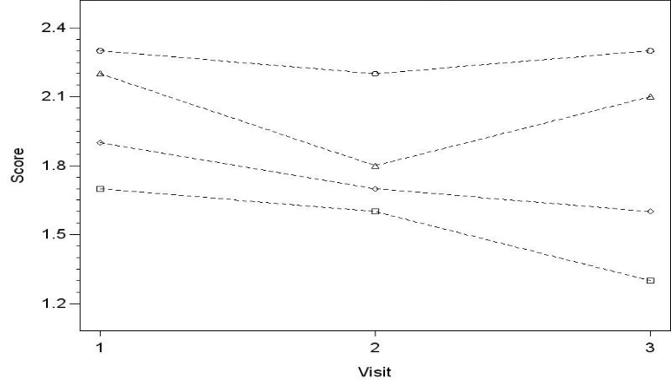 | 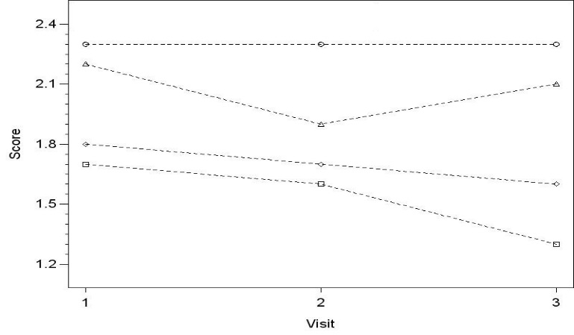 | 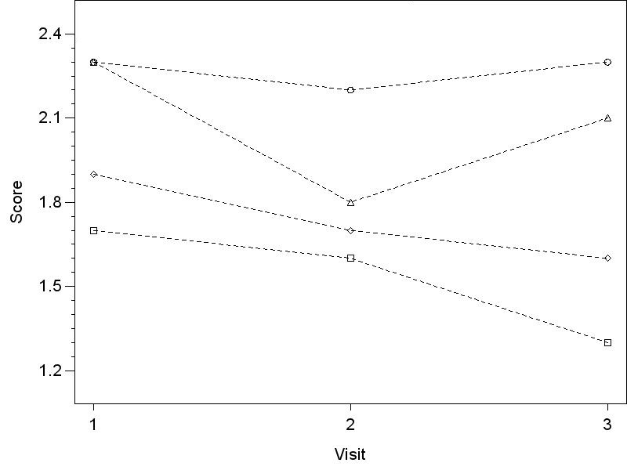
Symbol definition | Education = Up to primary | Education = Above primary
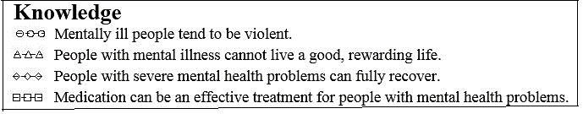 | 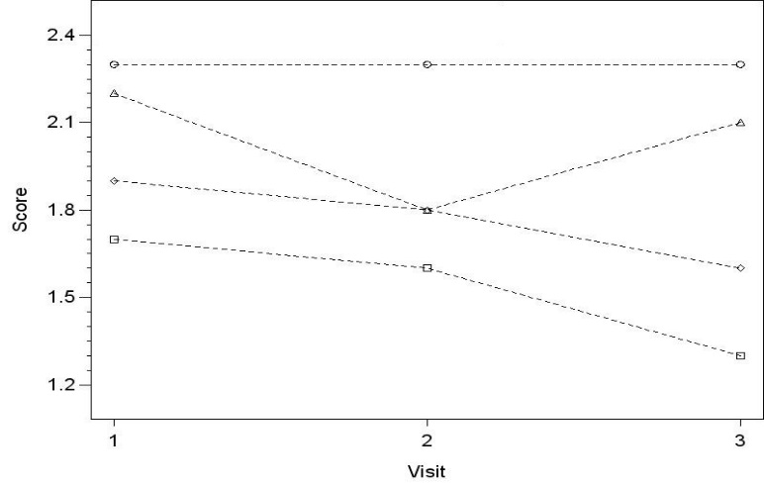 | 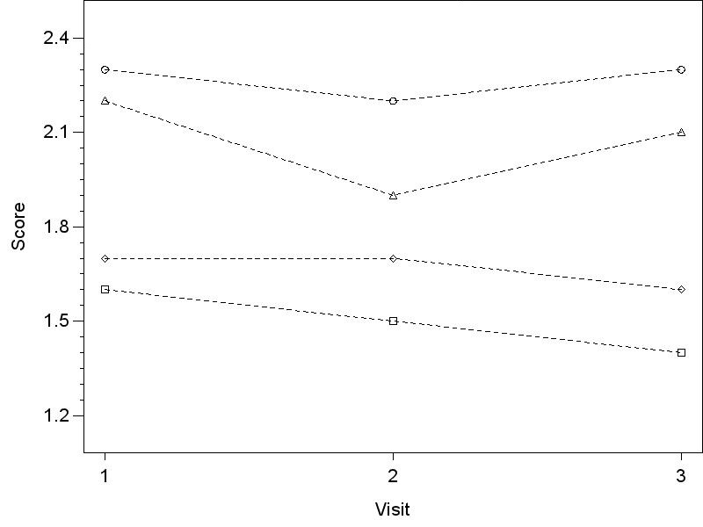
Supplementary Figure 2: Changes in attitude across visits stratified by gender and education
All Subjects | Gender = Male | Gender = Female
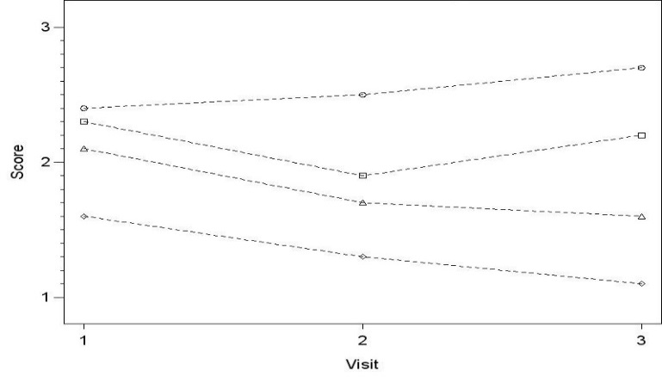 | 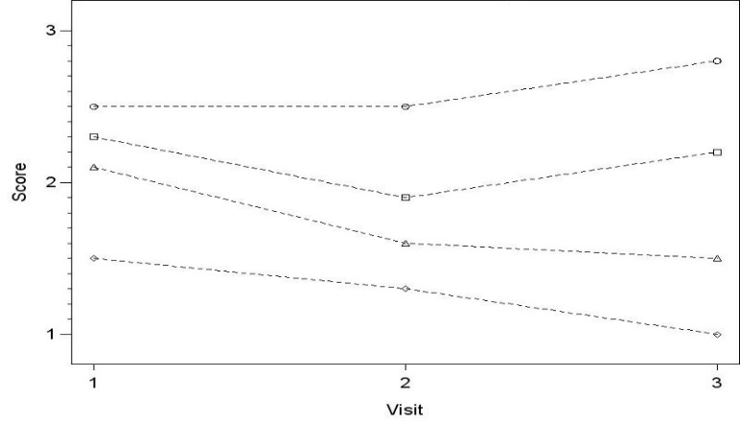 | 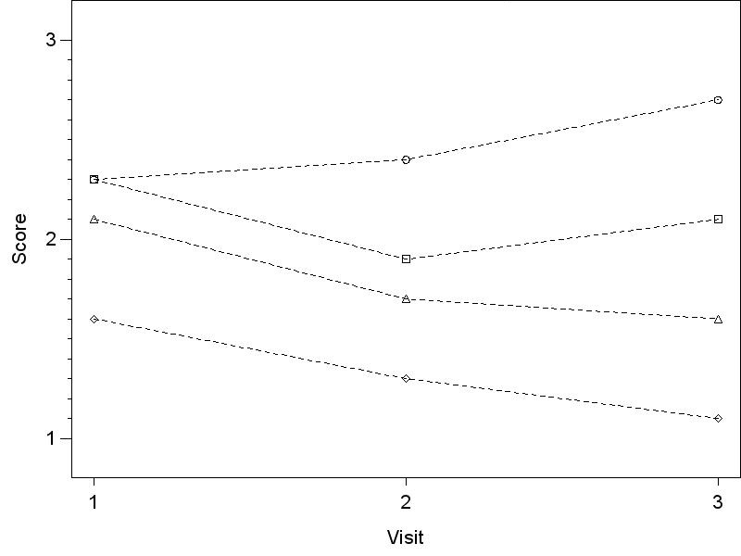
Symbol definition | Education = Up to primary | Education = Above primary
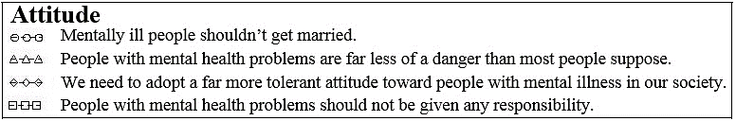 | 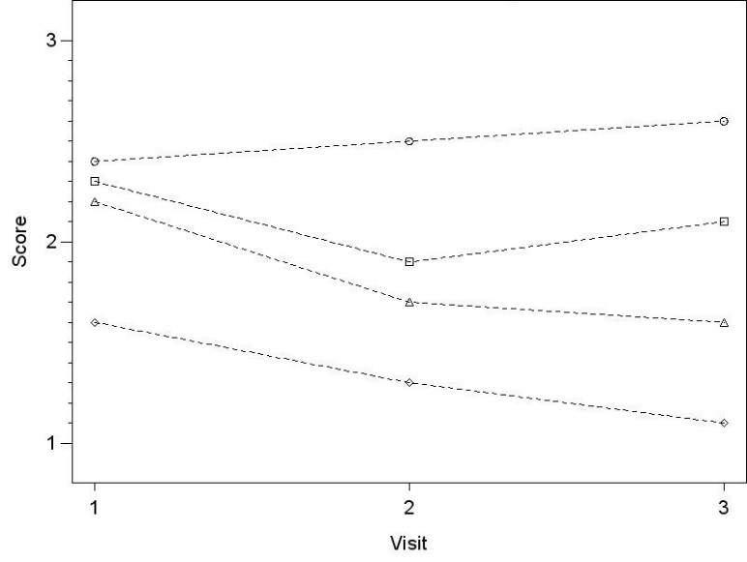 | 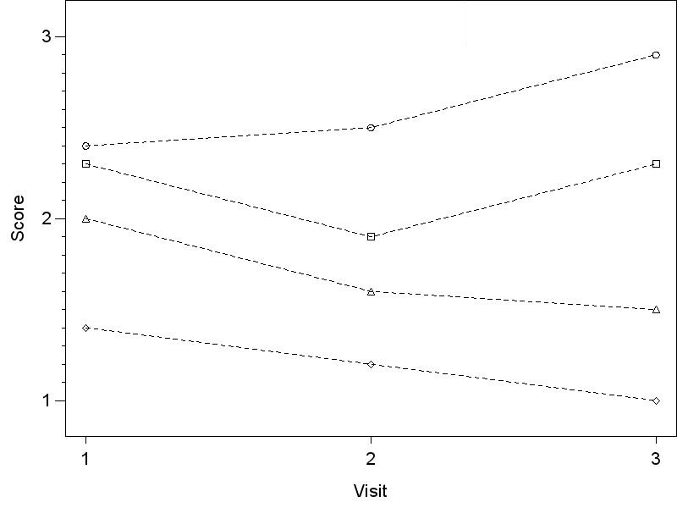

Supplementary Figure 3: Changes in behaviour across visits stratified by gender and education
All Subjects | Gender = Male | Gender = Female
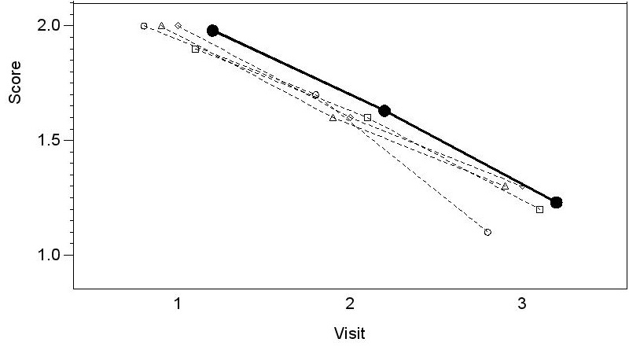 | 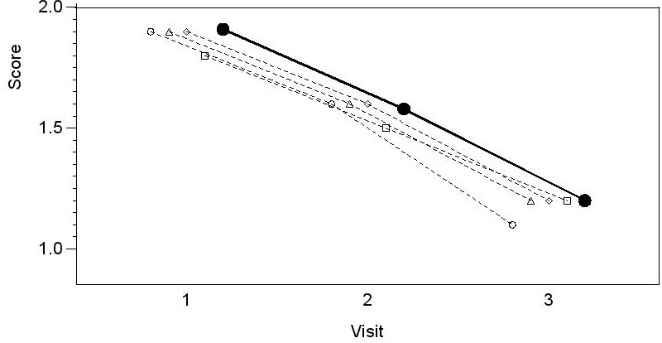 | 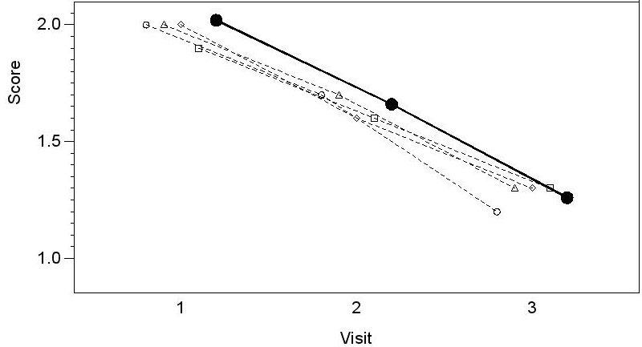
Symbol definition | Education = Up to primary | Education = Above primary
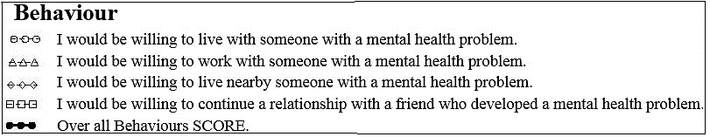 | 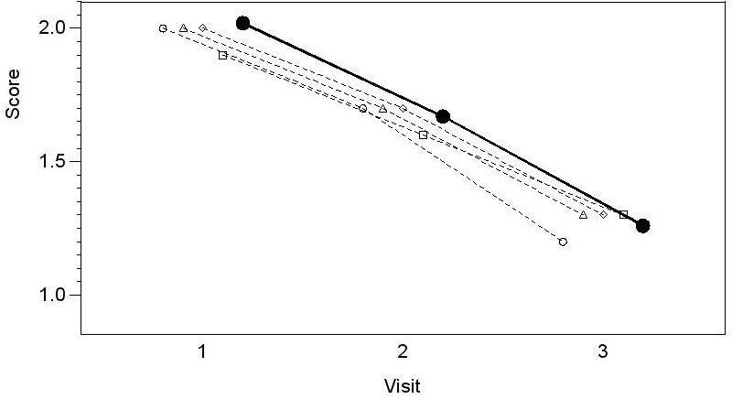 | 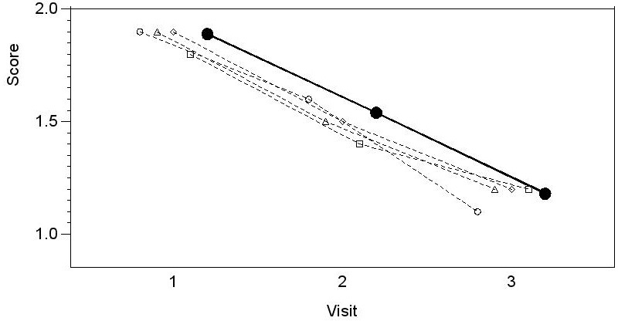

Supplementary Figure 4: Changes in BACE scores across visits stratified by gender and education
All Subjects | Gender = Male | Gender = Female
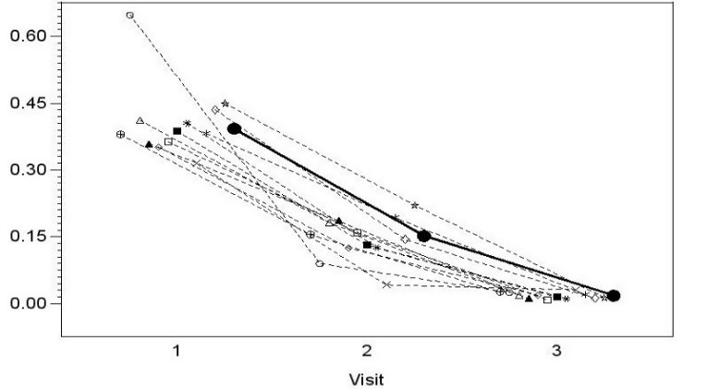 | 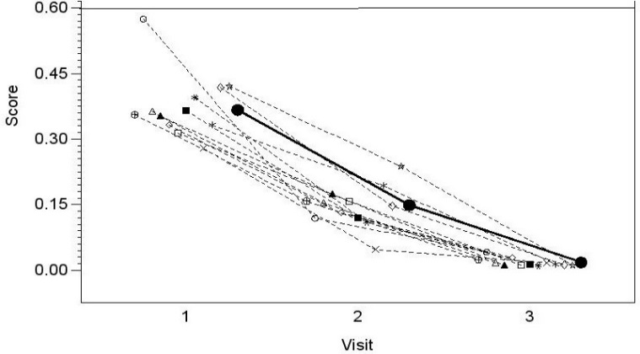 | 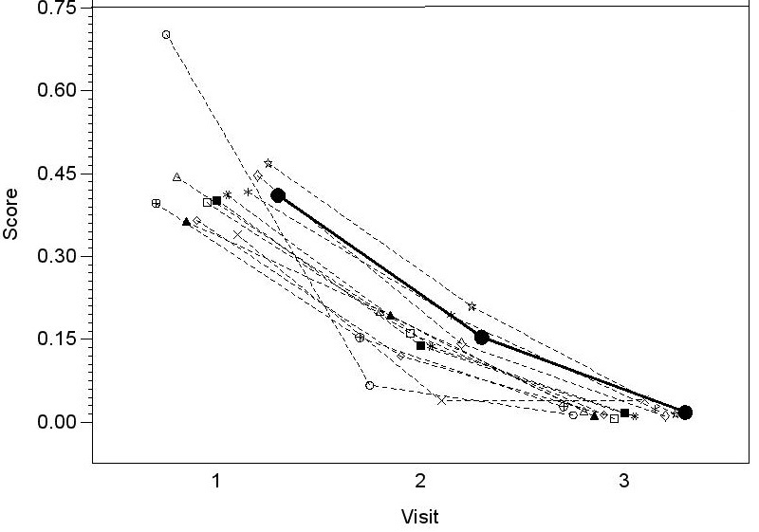
 | Education = Up to primary | Education = Above primary
 | 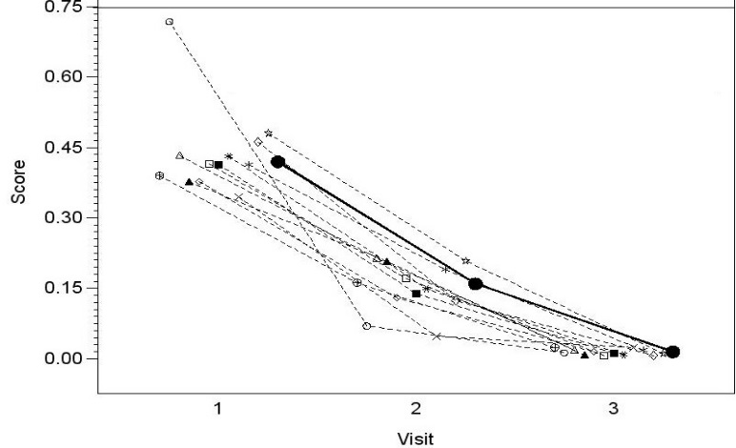 | 