Supplementary Material A: List of studies included in the feed intake regulation analysis
1. Saraiva A, Donzele JL, Oliveira RFMd et al. (2011) Available phosphorus levels in diets for 30 to 60 kg female pigs selected for meat deposition by maintaining calcium and available phosphorus ratio. R Bras Zootec 40, 587-592.
2. Saraiva A, Donzele JL, Oliveira RFMd et al. (2009) Available phosphorus levels in diets for swine from 15 to 30 kg genetically selected for meat deposition. R Bras Zootec 38, 307-313.
3. Baker S, Kim B, Stein H (2013) Comparison of values for standardized total tract digestibility and relative bioavailability of phosphorus in dicalcium phosphate and distillers dried grains with solubles fed to growing pigs. J Anim Sci 91, 203-210.
4. Arouca CLC, Silva FCdO, Fontes DdO et al. (2012) Available phosphorus levels for 95 to 120 kg barrows genetically selected for lean gain. R Bras Zootec 41, 1433-1441.
5. Saraiva A, Donzele J, Oliveira R et al. (2012) Phosphorus requirements for 60-to 100-kg pigs selected for high lean deposition under different thermal environments. J Anim Sci 90, 1499-1505.
6. Zhai H, Adeola O (2015) True digestible phosphorus requirement for forty-to eighty-kilogram pigs. J Anim Sci 93, 5711-5717.
7. Zhai H, Adeola O (2013) True digestible phosphorus requirement of 10-to 20-kg pigs. J Anim Sci 91, 3716-3723.
8. Zhai H, Adeola O (2013) True digestible phosphorus requirement for twenty-to forty-kilogram pigs. J Anim Sci 91, 5307-5313.
9. Alebrante L, Donzele JL, Oliveira RFMd et al. (2011) Available phosphorus for 15-to 30-kg pigs kept in hot environment. R Bras Zootec 40, 2725-2731.
10. Bünzen S, Rostagno HS, Kiefer C et al. (2012) Níveis de fósforo digestível para suínos em fase de crescimento. R Bras Zootec 41, 320-325.
11. Hastad C, Dritz S, Tokach M et al. (2004) Phosphorus requirements of growing-finishing pigs reared in a commercial environment. J Anim Sci 82, 2945-2952.
12. Arouca CLC, Silva FCdO, Fontes DdO et al. (2012) Available phosphorus in diets for 15 to 30 kg pigs genetically selected for meat deposition. R Bras Zootec 41, 65-71.
13. Campos PF, Silva FCdO, Ferreira AS et al. (2012) Available phosphorus in diets with or without ractopamine for late finishing gilts. R Bras Zootec 41, 630-635.
14. Mavromichalis I, Hancock J, Kim I et al. (1999) Effects of omitting vitamin and trace mineral premixes and (or) reducing inorganic phosphorus additions on growth performance, carcass characteristics, and muscle quality in finishing pigs. J Anim Sci 77, 2700-2708.
15. Carter S, Cromwell G (1998) Influence of porcine somatotropin on the phosphorus requirement of finishing pigs: I. Performance and bone characteristics. J Anim Sci 76, 584-595.

Supplementary Material B: List of studies included in the analysis of the relationship between mineral and protein weights
Phosphorus-protein relationship
1. Bikker P, Dekker R, van Diepen JTM et al. (2013) Behoefte en vastlegging van fosfor bij vleesvarkens. Wageningen UR Livestock Research.
2. Columbus D, Niven S, Zhu C et al. (2010) Phosphorus utilization in starter pigs fed high-moisture corn-based liquid diets steeped with phytase. J Anim Sci 88, 3964-3976.
3. Fandrejewski H, Rymarz A (1986) Effect of feeding level on Ca, P, K and Na content in the bodies of growing boars and gilts. Livest Prod Sci 14, 211-215.
4. Fandrejewski H, Weremko D, Raj S et al. (1999) Performance, body and carcass composition and bone characteristics of pigs fed rapeseed and soyabean meal-cereal diets supplemented with microbial phytase. J Anim Feed Sci 8, 533-547.
5. Hendriks W, Moughan P (1993) Whole-body mineral composition of entire male and female pigs depositing protein at maximal rates. Livest Prod Sci 33, 161-170.
6. Jongbloed AW (1987) Phosphorus in the feeding of pigs: effect of diet on the absorption and retention of phosphorus by growing pigs, Instituut voor Veevoedingsonderzoek (I.V.V.O.) Lelystad.
7. Mahan D, Shields Jr R (1998) Macro-and micromineral composition of pigs from birth to 145 kilograms of body weight. J Anim Sci 76, 506-512.
8. Rousseau Xr (2013) Optimisation de l'utilisation de phosphore alimentaire chez le porc et le poulet en croissance, Université de Tours.
9. Rymarz A, Fandrejewski H, Kielanowski J (1982) Content and retention of calcium, phosphorus, potassium and sodium in the bodies of growing gilts. Livest Prod Sci 9, 399-407.
10. Zomeño C, Gispert M, Carabús A et al. (2016) Predicting the carcass chemical composition and describing its growth in live pigs of different sexes using computed tomographys. Animal 10, 172-181.
11. Nielsen AJ (1973) Anatomical and chemical composition of Danish Landrace pigs slaughtered at 90 kilograms live weight in relation to litter, sex and feed composition. J Anim Sci 36, 476-483.

Ash-protein relationship
1. Balfagón-Romeo A (2006) Nutritional Approach to Mineral Over-supplementation in Grow-finish Pigs: Organic Trace Minerals and Phosphorus Body Accretion, University of Kentucky.
2. Barea R, Nieto R, Lara L et al. (2006) Effects of dietary protein content and feeding level on carcass characteristics and organ weights of Iberian pigs growing between 50 and 100 kg live weight. Animal Sci 82, 405-413.
3. Bikker P, Dekker R, van Diepen JTM et al. (2013) Behoefte en vastlegging van fosfor bij vleesvarkens. Wageningen UR Livestock Research.
4. Campbell R, Dunkin A (1983) The influence of protein nutrition in early life on growth and development of the pig: 1. Effects on growth performance and body composition. Br J Nutr 50, 605-617.
5. Campbell RG, Biden RS (1978) The effect of protein nutrition between 5.5 and 20 kg live weight on the subsequent perfromance and carcass quality of pigs. Anim Prod 27, 223-228.
6. Caperna T, Steele N, Komarek D et al. (1990) Influence of dietary protein and recombinant porcine somatotropin administration in young pigs: growth, body composition and hormone status. J Anim Sci 68, 4243-4252.
7. Columbus D, Niven S, Zhu C et al. (2010) Phosphorus utilization in starter pigs fed high-moisture corn-based liquid diets steeped with phytase. J Anim Sci 88, 3964-3976.
8. Conde-Aguilera JA, Aguinaga M, Aguilera J et al. (2011) Nutrient and energy retention in weaned Iberian piglets fed diets with different protein concentrations. J Anim Sci 89, 754-763.
9. Fandrejewski H, Rymarz A (1986) Effect of feeding level on Ca, P, K and Na content in the bodies of growing boars and gilts. Livest Prod Sci 14, 211-215.
10. Fandrejewski H, Weremko D, Raj S et al. (1999) Performance, body and carcass composition and bone characteristics of pigs fed rapeseed and soyabean meal-cereal diets supplemented with microbial phytase. J Anim Feed Sci 8, 533-547.
11. Ferguson N, Gous R (1997) The influence of heat production on voluntary food intake in growing pigs given protein-deficient diets. Animal Sci 64, 365-378.
12. Hendriks W, Moughan P (1993) Whole-body mineral composition of entire male and female pigs depositing protein at maximal rates. Livest Prod Sci 33, 161-170.
13. Jongbloed AW (1987) Phosphorus in the feeding of pigs: effect of diet on the absorption and retention of phosphorus by growing pigs, Instituut voor Veevoedingsonderzoek (I.V.V.O.) Lelystad.
14. Kerr B, Southern L, Bidner T et al. (2003) Influence of dietary protein level, amino acid supplementation, and dietary energy levels on growing-finishing pig performance and carcass composition. J Anim Sci 81, 3075-3087.
15. Kyriazakis I, Leus K, Emmans G et al. (1993) The effect of breed (Large White× Landrace ν. purebred Meishan) on the diets selected by pigs given a choice between two foods that differ in their crude protein contents. Animal Sci 56, 121-128.
16. Mahan D, Shields Jr R (1998) Macro-and micromineral composition of pigs from birth to 145 kilograms of body weight. J Anim Sci 76, 506-512.
17. Martinez-Ramirez H, Jeaurond E, de Lange C (2008) Dynamics of body protein deposition and changes in body composition after sudden changes in amino acid intake: I. Barrows. J Anim Sci 86, 2156-2167.
18. Martinez-Ramirez H, Jeaurond E, De Lange C (2008) Dynamics of body protein deposition and changes in body composition after sudden changes in amino acid intake: II. Entire male pigs. J Anim Sci 86, 2168-2179.
19. Moughan P, Smith W, Stevens E (1990) Allometric growth of chemical body components and several organs in the pig (20–90 kg liveweight). New Zeal J Agr Res 33, 77-84.
20. Rousseau Xr (2013) Optimisation de l'utilisation de phosphore alimentaire chez le porc et le poulet en croissance, Université de Tours.
21. Rymarz A, Fandrejewski H, Kielanowski J (1982) Content and retention of calcium, phosphorus, potassium and sodium in the bodies of growing gilts. Livest Prod Sci 9, 399-407.
22. Shields Jr R, Mahan D, Graham P (1983) Changes in swine body composition from birth to 145 kg. J Anim Sci 57, 43-54.
23. Williams N, Stahly T, Zimmerman D (1997) Effect of chronic immune system activation on the rate, efficiency, and composition of growth and lysine needs of pigs fed from 6 to 27 kg. J Anim Sci 75, 2463-2471.
24. Wyllie D, Speer V, Ewan R et al. (1969) Effects of starter protein level on performance and body composition of pigs. J Anim Sci 29, 433-438.
25. Zomeño C, Gispert M, Carabús A et al. (2016) Predicting the carcass chemical composition and describing its growth in live pigs of different sexes using computed tomographys. Animal 10, 172-181.
Supplementary Material C: List of studies included in the analysis of the allocation of Phosphorus resources - bones
1. Bikker P, Dekker R, van Diepen JTM et al. (2013) Behoefte en vastlegging van fosfor bij vleesvarkens. Wageningen UR Livestock Research.
2. Columbus D, Niven S, Zhu C et al. (2010) Phosphorus utilization in starter pigs fed high-moisture corn-based liquid diets steeped with phytase. J Anim Sci 88, 3964-3976.
3. Fandrejewski H, Rymarz A (1986) Effect of feeding level on Ca, P, K and Na content in the bodies of growing boars and gilts. Livest Prod Sci 14, 211-215.
4. Fandrejewski H, Weremko D, Raj S et al. (1999) Performance, body and carcass composition and bone characteristics of pigs fed rapeseed and soyabean meal-cereal diets supplemented with microbial phytase. J Anim Feed Sci 8, 533-547.
5. Hendriks W, Moughan P (1993) Whole-body mineral composition of entire male and female pigs depositing protein at maximal rates. Livest Prod Sci 33, 161-170.
6. Jongbloed AW (1987) Phosphorus in the feeding of pigs: effect of diet on the absorption and retention of phosphorus by growing pigs, Instituut voor Veevoedingsonderzoek (I.V.V.O.) Lelystad.
7. Mahan D, Shields Jr R (1998) Macro-and micromineral composition of pigs from birth to 145 kilograms of body weight. J Anim Sci 76, 506-512.
8. Rousseau Xr (2013) Optimisation de l'utilisation de phosphore alimentaire chez le porc et le poulet en croissance, Université de Tours.
9. Rymarz A, Fandrejewski H, Kielanowski J (1982) Content and retention of calcium, phosphorus, potassium and sodium in the bodies of growing gilts. Livest Prod Sci 9, 399-407.
10. Zomeño C, Gispert M, Carabús A et al. (2016) Predicting the carcass chemical composition and describing its growth in live pigs of different sexes using computed tomographys. Animal 10, 172-181.
11. Nielsen AJ (1973) Anatomical and chemical composition of Danish Landrace pigs slaughtered at 90 kilograms live weight in relation to litter, sex and feed composition. J Anim Sci 36, 476-483.
Supplementary Material D: Examples of diagnostic plots from the fitted regression models
Phosphorus-protein relationship
- QQ plot of residuals obtained from the weighted least squares regression with Phosphorus weight on protein weight (balanced feeds)
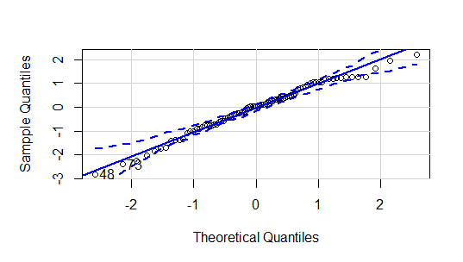
- Plot of residuals vs fitted values obtained from the weighted least squares regression with Phosphorus weight on protein weight (balanced feeds)
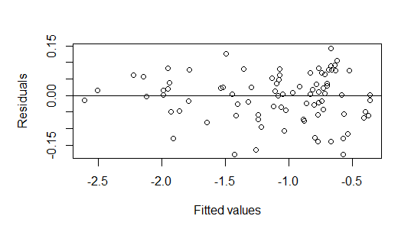

Ash-protein relationship
- QQ plot of residuals obtained from the weighted least squares regression with ash weight on protein weight (balanced feeds)
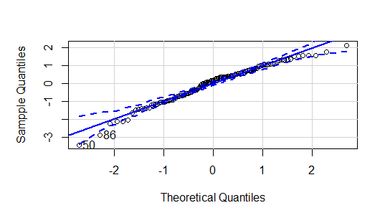
- Plot of residuals vs fitted values obtained from the weighted least squares regression with ash weight on protein weight (balanced feeds)
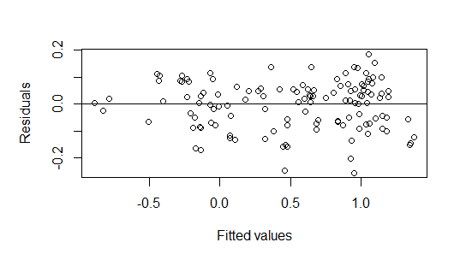
Allocation of Phosphorus resources
- Half normal plot of residuals obtained from the final beta regression model
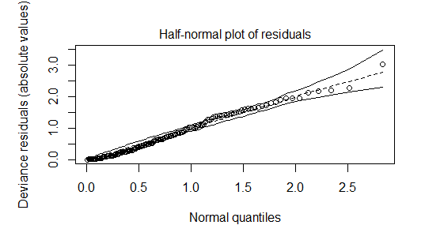
- Plot of residuals vs indices of the observations obtained from the final beta regression model
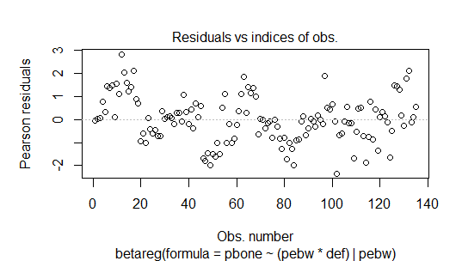

Supplementary Material E:
1) Average daily feed intake (ADFI; kg/d) against feed standardised total tract digestible Phosphorus (P) content (Feed STTD P content; g/kg): individual datapoints (n = 97) represent mean values for each considered dietary treatment reported in 15 studies
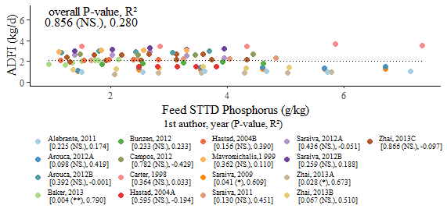
2) The metabolic bodyweight (BW^{0.75})-scaled average daily feed intake (ADFI; kg/kg/d) against feed standardised total tract digestible Phosphorus (P) content (Feed STTD P content; g/kg): individual datapoints (n = 97) represent mean values for each considered dietary treatment reported in 15 studies
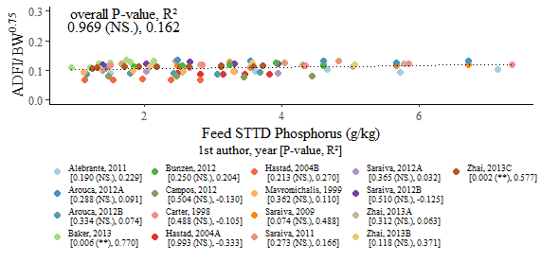
3) The metabolic bodyweight (BW^{0.66})-scaled average daily feed intake (ADFI; kg/kg/d) against feed standardised total tract digestible Phosphorus (P) content (Feed STTD P content; g/kg): individual datapoints (n = 97) represent mean values for each considered dietary treatment reported in 15 studies
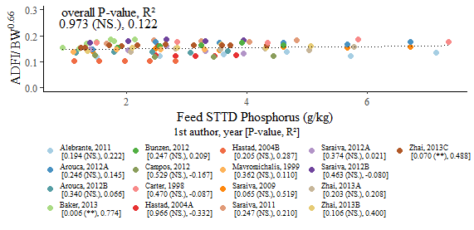
Supplementary Material F: An alternative analysis of the relationships between mineral and protein weight in pig body
Phosphorus-protein relationship
Repeating model fitting using the two variables of interest in reversed roles (e.g. with Phosphorus (P) as the x-axis variable instead)
Parameter | Feed class | Estimate | SE | 95 % CI | Probability | R²
log(a) | Balanced | 3.39 | 0.0180 | [3.36, 3.43] |  | 0.972 (P-deficient)
 | P-deficient | 3.75 | 0.0425 | [3.66, 3.83]
b | Balanced | 1.00 | 0.0141 | [0.974, 1.03] | > 0.05 | 0.982 (Balanced)
 | P-deficient | 1.06 | 0.0237 | [1.01, 1.11] | < 0.01

Repeating model fitting via reduced major axis regression of P weight on protein weight
Parameter | Feed class | Estimate | 95 % CI | Probability | R²
log(a) | Balanced | -3.36 | [-3.43, -3.29] |  | 0.972 (P-deficient)
 | P-deficient | -3.56 | [-3.66, -3.45]
b | Balanced | 0.984 | [0.955, 1.01] | > 0.05 | 0.982 (Balanced)
 | P-deficient | 0.950 | [0.905, 0.997] | < 0.05

Ash-Protein relationship
Repeating model fitting using the two variables of interest in reversed roles (e.g. with ash as the x-axis variable instead)
Parameter | Feed class | Estimate | SE | 95 % CI | Probability | R²
log(a) | Protein-deficient | 1.46 | 0.0113 | [1.43, 1.48] |  | 0.983 (Protein-deficient)
 | Balanced | 1.67 | 0.0104 | [1.65, 1.69]
 | P-deficient | 1.93 | 0.0155 | [1.90, 1.96] |  | 0.972 (Balanced)
b | Protein-deficient | 0.909 | 0.0230 | [0.861, 0.956] | < 0.01
 | Balanced | 0.995 | 0.0143 | [0.967, 1.02] | > 0.05 | 0.956 (P – deficient)
 | P-deficient | 1.09 | 0.0299 | [1.03, 1.15] | < 0.001

Repeating model fitting via reducing major axis regression of ash weight on Protein weight
Parameter | Feed class | Estimate | 95 % CI | Probability | R²
log(a) | Protein-deficient | -1.58 | [-1.68, -1.49] |  | 0.983 (Protein-deficient)
 | Balanced | -1.65 | [-1.72, -1.58]
 | P-deficient | -1.76 | [-1.86, -1.65] |  | 0.975 (Balanced)
b | Protein-deficient | 1.09 | [1.03, 1.15] | < 0.01
 | Balanced | 0.990 | [0.962, 1.02] | > 0.05 | 0.962 (P – deficient)
 | P-deficient | 0.916 | [0.870, 0.965] | < 0.01

Supplementary Material G: A detailed list of equations used to describe the relationships between variables in the mechanistic model
Bodyweight composition at the start of the simulation
The following BW partitioning was assumed to hold for a pig given a balanced, non-limiting feed prior to the start of the simulation:
- The initial empty BW was calculated as:
$$\begin{aligned}eBW\left(t_{0}\right)=α×BW\left(t_{0}\right)\#\left(G.1\right)\end{aligned}$$
where $α=0.95$ ⁽¹⁻³⁾and $BW\left(t_{0}\right)$ was the initial live BW
- Consequently, $BW\left(t\right)$ was expressed as a sum of the four main components, protein ($N^{*}\left(t\right)=6.25×N(t))$, lipid ($L\left(t\right)$), water ($W\left(t\right)$) and ash ($A\left(t\right)$)⁽⁴⁾
$$\begin{aligned}eBW\left(t\right)=N^{*}\left(t\right)+L\left(t\right)+W\left(t\right)+Ash\left(t\right)\#\left(G.2\right)\end{aligned}$$
- The initial protein weight, ($N^{*}\left(0\right)$) was expressed as a percentage of $eBW\left(t_{0}\right)$:
$$\begin{aligned}N^{*}(0)=β×eBW\left(t_{0}\right)\#\left(G.3\right)\end{aligned}$$
where $β=0.16$ ⁽⁵⁾
- The initial weight of ash ($Ash\left(0\right)$), was related to $N^{*}\left(0\right)$ via isometry:
$$\begin{aligned}Ash\left(0\right)=γ×N^{*}\left(0\right)\#\left(G.4\right)\end{aligned}$$
where $γ=0.19$ ⁽⁶⁾
- The initial weight of W ($W\left(0\right)$), was related to $N^{*}\left(0\right)$ via allometry:
$$\begin{aligned}W\left(0\right)=δ×{N^{*}\left(0\right)}^{ϵ} \#\left(G.5\right)\end{aligned}$$
where $δ=3.04× {N_{m}^{*}}^{1-0.855}$, $ϵ=0.855$ ⁽²⁾, with $N_{m}^{*}$ corresponding to the estimated mature protein weight⁽⁷⁾
- The initial L weight ($L\left(0\right)$), was expressed as the difference between $eBW\left(t_{0}\right)$and a sum of the remaining three main body components⁽⁸⁾:
$$\begin{aligned}L\left(0\right)=eBW\left(t_{0}\right)-\left(N^{*}(0)+Ash\left(0\right)+W\left(0\right)\right)\#\left(G.6\right)\end{aligned}$$
- The initial weight of P ($P\left(0\right)$) was related to $N^{*}(0)$ via isometry⁽⁹⁾:
$$\begin{aligned}P\left(t_{0}\right)=ζ×N^{*}(0)\#\left(G.7\right)\end{aligned}$$
where $ζ=0.0351$, estimated on the basis of weighted linear regression of P weight on protein weight described in section 2.3
- Consequently, $P\left(t\right)$ was expressed as a sum of amounts located in soft tissue and bones⁽¹⁰⁾
$$\begin{aligned}P\left(t\right)=P_{soft}\left(t\right)+P_{bone}\left(t\right)\#\left(G.8\right)\end{aligned}$$
- The initial weight of P located in bones ($P_{bone}\left(0\right)$), was expressed as a percentage of $P\left(0\right):$
$$\begin{aligned}P_{bone}\left(0\right)=η×P\left(0\right)\#\left(G.9\right)\end{aligned}$$
- The value of $η$ was calculated on the basis of a mean model of beta regression with a logit link function described in section 2.3:
$$\begin{aligned}η= \frac{\exp\left(0.390+0.122×\frac{P\left(0\right)×1000}{eBW\left(t_{0}\right)}\right)}{\exp\left(0.390+0.122×\frac{P\left(0\right)×1000}{eBW\left(t_{0}\right)}\right)+1} \#\left(G.10\right)\end{aligned}$$
- The initial weight of P located in soft tissue ($P_{soft}\left(0\right)$), was calculated as the difference between $P\left(0\right)$ and $P_{bone}\left(0\right):$
$$\begin{aligned}P_{soft}\left(0\right)=P\left(0\right)-P_{bone}\left(0\right) ∴P_{soft}\left(0\right)=θ×P\left(0\right)\#\left(G.11\right)\end{aligned}$$
where $θ=1-η$
Nutrient requirements estimation
The effective energy (EE)⁽¹¹⁾ was used as the desired energy scale in the model. The EE content of feeds ($E_{feed}$; MJ/kg) was calculated as:
$$\begin{aligned}E_{feed}= 1.17×MEC-4.29×\left(\frac{CPC}{1000}\right)-2.4 \#\left(G.12\right)\end{aligned}$$
where MEC is the metabolisable energy content of the feed (MJ/kg) and CPC is the crude protein content of the feed (g/kg).
- The energy maintenance requirement at time t ($E_{maint}\left(t\right)$), was estimated as a function of the current protein weight at time ($N^{*}(t)$) and mature protein weight ^{(4; 12)}
$$\begin{aligned}E_{maint}\left(t\right)=1.63×\frac{N^{*}\left(t\right)}{{N_{m}^{*}}^{0.27}} \#\left(G.13\right)\end{aligned}$$
- The energy above $E_{maint}\left(t\right)$ needed to reach the maximum protein and L depositions at time t ($N_{max}^{*'}\left(t\right)$; $L_{max}^{'}\left(t\right)$) was calculated as⁽¹²⁾
$$\begin{aligned}E_{growth}\left(t\right)=50×N_{max}^{*'}\left(t\right)+56×L_{max}^{'}\left(t\right)\#\left(G.14\right)\end{aligned}$$
- The P requirement for maintenance at time t (${P'}_{maint}\left(t\right)$; g), was estimated as a function of the current protein weight at time ($N^{*}\left(t\right)$) and mature protein weight ($N_{m}^{*}$) ⁽⁹⁾:
$$\begin{aligned}{P'}_{maint}\left(t\right)=0.1293×\frac{N^{*}\left(t\right)}{{N_{m}^{*}}^{0.27}} \#\left(G.15\right)\end{aligned}$$
- The maximum P retention at time t ($P_{growth_{max}}^{'}\left(t\right)$), was estimated linked to $N_{max}^{*'}\left(t\right)$ ⁽⁹⁾
$$\begin{aligned}P_{growth_{max}}^{'}\left(t\right)=ζ×N_{max}^{*'}\left(t\right)\#\left(G.16\right)\end{aligned}$$
Allocation of nutrient resources
- The protein maintenance requirement at time t ($N_{maint}^{*'}\left(t\right)$), was estimated as a function of the current protein weight at time ($N^{*}\left(t\right)$) and mature protein weight ($N_{m}^{*}$) ⁽¹²⁾:
$$\begin{aligned}N_{maint}^{*'}\left(t\right)=0.004×\frac{N^{*}\left(t\right)}{{N_{m}^{*}}^{0.27}} \#\left(G.17\right)\end{aligned}$$

- The actual protein deposition at time t ($N^{*'}\left(t\right)$), was determined by the actual $FI\left(t\right)$ and calculated as⁽¹²⁾:
$$\begin{aligned}N^{*'}\left(t\right)=\left(FI(t)×CPC×N_{dig}^{*}×v- N_{maint}^{*'}\left(t\right)\right)×N_{eff}^{*} \#\left(G.18\right)\end{aligned}$$
where $N_{dig}^{*}$ is the digestibility coefficient of crude protein, which was set to 0.8 as a default value⁽¹³⁾; v was the biological value of the feed⁽¹⁴⁾, calculated as a proportion of the most limiting amino acid (AA) in the feed relative to the ideal AA profile based on AA distribution in the body⁽¹⁵⁾ with a default value of 0.8⁽¹³⁾; $N_{eff}^{*}$ was the efficiency of protein utilisation for retention set to 0.763 ⁽¹⁶⁾
If the quantity calculated in equation (F.18) exceeded $N_{max}^{*'}\left(t\right)$, then $N^{*'}\left(t\right)= N_{max}^{*'}\left(t\right)$
- The deposition of L at time t ($L^{'}\left(t\right)$), was calculated on the basis of the energy balance, and treated as a sink^{(12; 17)}
$$\begin{aligned}L^{'}\left(t\right)= \frac{FI\left(t\right)×E_{feed}-E_{maint}\left(t\right)-50×N^{*'}(t)}{56}\#\left(G.19\right)\end{aligned}$$
If $L^{'}\left(t\right)<0$, then the denominator of equation (F.19) was replaced with the heat of combustion of lipid and equalled 39.6⁽¹²⁾.
- The deposition of W at time t ($W^{'}\left(t\right)$) was calculated on the basis of the relationship given in equation (F.5)⁽¹²⁾:
$$\begin{aligned}W^{'}\left(t\right)=N^{*'}\left(t\right)×3.04×0.855×{\left(\frac{N^{*}\left(t\right)}{N_{m}^{*}}\right)}^{0.855-1} \#\left(G.20\right)\end{aligned}$$
- The actual deposition within a body of a pig at time t $(P_{growth}^{'}\left(t\right)$), was determined by the actual $FI\left(t\right)$ and calculated as:
$$\begin{aligned}P_{growth}^{'}\left(t\right)=eff_{p}×\left(FI\left(t\right)×P_{feed}-P_{maint}^{'}\left(t\right)\right)\#\left(G.21\right)\end{aligned}$$
where $eff_{p}$ is the efficiency of P utilisation for retention and set to 0.94⁽⁹⁾.
If the quantity calculated in equation (F.21) exceeded$P_{growth_{max}}^{'}\left(t\right)$, then $P_{growth}^{'}\left(t\right)= P_{growth_{max}}^{'}\left(t\right)$
- $P_{growth}^{'}\left(t\right)$ was compartmentalised and allocated to the two pools of P within the body⁽¹⁰⁾:
$$\begin{aligned}P_{growth}^{'}\left(t\right)={P_{growth}^{'}}_{soft}\left(t\right)+{P_{growth}^{'}}_{bone}\left(t\right)\#\left(G.22\right)\end{aligned}$$
- The amount of P needed to support the maximum lean tissue deposition driven by $N_{max}^{*'}\left(t\right)$ at a time t was estimated as:
$$\begin{aligned}{P_{growth}^{'}}_{soft_{max}}\left(t\right)=θ×ζ×N_{max}^{*'}\left(t\right)\#\left(G.23\right)\end{aligned}$$
- Allocation towards ${P_{growth}^{'}}_{bone}\left(t\right)$ was triggered only once both ${P'}_{maint}\left(t\right)$ and ${P_{growth}^{'}}_{soft_{max}}\left(t\right)$ were satisfied first
- The deposition of Ash at time t (${Ash}^{'}\left(t\right)$), was given by:
$$\begin{aligned}{Ash}^{'}\left(t\right)= \left\{\begin{aligned}κ_{b}×N^{*'}\left(t\right), if feed was balanced \\ κ_{N}×λ_{N}×N^{*'}{\left(t\right)}^{λ_{N}-1}, if feed was deficient in protein \\ κ_{P}×λ_{P}×N^{*'}{\left(t\right)}^{λ_{P}-1}, if feed was deficient in P\end{aligned}\right.\#\left(G.24\right)\end{aligned}$$
where $κ_{b}=0.19$ ⁽⁶⁾; $κ_{N}=0.208$; $κ_{P}=0.186$; $λ_{N}=1.08$; $λ_{P}= 0.873$, estimated on the basis of statistical analyses outlined in section 2.3.

References
1. Moughan PJ, Smith WC, Pearson G (1987) Description and validation of a model simulating growth in the pig (20–90 kg liveweight). New Zeal J Agr Res 30, 481-489.
2. Emmans GC, Kyriazakis I (1995) A general method for predicting the weight of water in the empty bodies of pigs. Animal Sci 61, 103-108.
3. Whittemore EC, Emmans GC, Kyriazakis I (2003) The problem of predicting food intake during the period of adaptation to a new food: a model. Br J Nutr 89, 383-399.
4. Emmans GC, Fisher C (1986) Problems in nutritional theory. In Nutrient requirements of poultry and nutritional research, vol. 19, pp. 9-39 [GC Emmans and C Fisher, editors]. London, UK: Butterworths & Co (Publishers) Ltd, .
5. Kyriazakis I, Whittemore CT (2006) Whittemore's Science and Practice of Pig Production. 3 ed. Oxford, UK: Blackwell Publishing
6. Emmans GC, Kyriazakis I (1997) Models of pig growth: problems and proposed solutions. Livest Prod Sci 51, 119-129.
7. Wellock IJ, Emmans GC, Kyriazakis I (2004) Describing and predicting potential growth in the pig. Animal Sci 78, 379-388.
8. Filipe JAN, Leinonen I, Kyriazakis I (2018) The quantitative principles of animal growth. In Feed Evaluation Science, 1 ed. [PJ Moughan and WH Hendriks, editors]. Wageningen: Wageningen Academic Publishers.
9. Symeou V, Leinonen I, Kyriazakis I (2014) Modelling phosphorus intake, digestion, retention and excretion in growing and finishing pigs: model description. Animal 8, 1612-1621.
10. Crenshaw TD (2001) Swine Nutrition. In Calcium, Phosphorous, Vitamin D, and Vitamin K in Swine Nutrition, 2 ed., pp. 187 - 209 [SLL Lewis A.J., editor]. N.W. Corporate Blvd., Boca Raton, Florida, USA: CRC Press.
11. Emmans GC (1994) Effective energy: a concept of energy utilization applied across species. Br J Nutr 71, 801-821.
12. Wellock IJ, Emmans GC, Kyriazakis I (2003) Modelling the effects of thermal environment and dietary composition on pig performance: model logic and concepts. Animal Sci 77, 255-266.
13. Wellock IJ, Emmans GC, Kyriazakis I (2003) Modelling the effects of thermal environment and dietary composition on pig performance: model testing and evaluation. Animal Sci 77, 267-276.
14. Wang TC, Fuller MF (1989) The optimum dietary amino acid pattern for growing pigs: 1. Experiments by amino acid deletion. Br J Nutr 62, 77-89.
15. National Reserach Council (2012) Nutrient Requirements of Swine. 11 ed. Washington, D.C., USA: The National Academies Press.
16. Sandberg FB, Emmans GC, Kyriazakis I (2005) Partitioning of limiting protein and energy in the growing pig: description of the problem, possible rules and their qualitative evaluation. Br J Nutr 93, 205-212.
17. Ferguson NS, Gous RM, Emmans GC (1994) Preferred components for the construction of a new simulation model of growth, feed intake and nutrient requirements of growing pigs. S Afr J Anim Sci 24, 10-17.

Supplementary Material H: Scaled residuals (expressed as the difference between the reported and predicted data scaled by the observed standard deviations) against simulated predictions from the mechanistic model of P utilisation for: 1) daily Phosphorus (P) deposition (g/day); 2) daily protein deposition (g/day); 3) average daily feed intake (ADFI; kg/day). Residuals corresponded to simulations from the three papers: 1) Adeola et al.; 2) Pomar et al.; and 3) Ekpe et al.
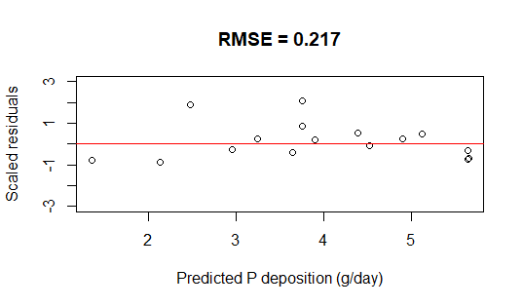 | 