Supplement

eMethod 1. Search Strategies
eTable 1. Risk of bias of included trials evaluated using the Cochrane Risk of Bias tool
eTable 2. Estimated heterogeneity (per-comparison I²) in network of LS BMD
eTable 3. Estimated heterogeneity (per-comparison I²) in network of FN BMD
eTable 4. Cumulative rankings in LS BMD
eTable 5. Cumulative rankings in FN BMD
eTable 6. Surface under the cumulative ranking curve (SUCRA) in sensitivity analysis in LS BMD
eTable 7. Cumulative rankings in sensitivity analysis in FN BMD
eTable 8. Effect size in sensitivity analysis in LS BMD
eTable 9. Effect size in sensitivity analysis in FN BMD
eFigure 1. Transitivity analysis assessing BMI across across the different pairwise comparisons
eFigure 2. Summary of risk of bias evaluated using the Cochrane Risk of Bias tool
eFigure 3. Publication bias assessed via funnel plots
eFigure 4. Node-splitting model in LS BMD assessing incoherence between direct and indirect comparisons
eFigure 5. Node-splitting model in FN BMD assessing incoherence between direct and indirect comparisons
eReferences Included trials

eMethod 1. Search Strategies

Calcium
MEDLINE
("calcium"[MeSH Terms] OR "calcium"[All Fields])
AND
("postmenopausal" [All Fields] OR "post-menopausal" [All Fields] OR ("postmenopause"[MeSH Terms] OR "postmenopause"[All Fields]) OR "post-menopause"[All Fields])
AND
(("bone density"[MeSH Terms] OR "bone density"[All Fields]) OR "bone mineral density"[All Fields] OR "bone mineral densities"[All Fields] OR "bone mass"[All Fields] OR "bone strength"[All Fields] OR "bone mineral content"[All Fields])
AND
("randomized controlled trial"[Publication Type] OR "controlled clinical trials as topic"[MeSH Terms] OR "controlled clinical trial"[All Fields] OR "randomized"[All Fields] OR "randomised"[All Fields] OR "randomly"[All Fields] OR "placebo"[All Fields] OR "trial"[All Fields])
Cochrane
#1 calcium
#2 postmenopausal or "post-menopausal" or postmenopause or "post-menopause"
#3 "bone density" or "bone mineral density" or "bone mineral densities"
#4 "bone mass" or "bone strength"
#5 "bone mineral content"
#6 #3 or #4 or #5
#7 "controlled clinical trial"
#8 MeSH descriptor: [Controlled Clinical Trial] explode all trees
#9 randomised or randomized or randomly or placebo or trial
#10 #7 or #8 or #9
#11 #1 and #2 and #6 and #10
EMBASE
#1 'calcium'/exp or calcium
#2 'postmenopause'/exp
#3 postmenopausal or 'post-menopausal' or postmenopause or 'post-menopause'
#4 #2 or #3
#5 'bone density'/exp or 'bone mineral density'/exp or 'bone mass'/exp or 'bone strength'/exp or 'bone mineral content'/exp
#6 'bone density' or 'bone mineral density' or 'bone mineral densities' or 'bone mass' or 'bone strength' or 'bone mineral content'
#7 #5 or #6
#8 'controlled clinical trial'/exp or 'controlled clinical trial'
#9 randomized or randomly or randomised or placebo or trial
#10 #8 or #9
#11 #1 and #4 and #7 and #10
Vitamin D
MEDLINE
(("vitamin d"[MeSH Terms] OR "vitamin d"[All Fields])
OR
("ergocalciferols"[MeSH Terms] OR "ergocalciferols"[All Fields] OR "ergocalciferol"[All Fields] OR "calciferols"[All Fields] OR "calciferol"[All Fields] OR "vitamin d2"[All Fields])
OR
("cholecalciferol"[MeSH Terms] OR "cholecalciferols"[All Fields] OR "cholecalciferol"[All Fields] OR "calcitriol"[MeSH Terms] OR "calcitriols"[All Fields] OR "calcitriol"[All Fields] OR "vitamin d3"[All Fields]))
AND
("postmenopausal" [All Fields] OR "post-menopausal" [All Fields] OR ("postmenopause"[MeSH Terms] OR "postmenopause"[All Fields]) OR "post-menopause"[All Fields])
AND
(("bone density"[MeSH Terms] OR "bone density"[All Fields]) OR "bone mineral density"[All Fields] OR "bone mineral densities"[All Fields] OR "bone mass"[All Fields] OR "bone strength"[All Fields] OR "bone mineral content"[All Fields])
AND
("randomized controlled trial"[Publication Type] OR "controlled clinical trials as topic"[MeSH Terms] OR "controlled clinical trial"[All Fields] OR "randomized"[All Fields] OR "randomised"[All Fields] OR "randomly"[All Fields] OR "placebo"[All Fields] OR "trial"[All Fields])
Cochrane
#1 "vitamin d"
#2 ergocalciferol or calciferol or "vitamin d2"
#3 cholecalciferol or calcitriol or "vitamin d3"
#4 #1 or #2 or #3
#5 postmenopausal or "post-menopausal" or postmenopause or "post-menopause"
#6 "bone density" or "bone mineral density" or "bone mineral densities"
#7 "bone mass" or "bone strength"
#8 "bone mineral content"
#9 #6 or #7 or #8
#10 "controlled clinical trial"
#11 MeSH descriptor: [Controlled Clinical Trial] explode all trees
#12 randomised or randomized or randomly or placebo or trial
#13 #10 or #11 or #12
#14 #4 and #5 and #9 and #13
EMBASE
#1 'vitamin d'/exp or 'vitamin d'
#2 'ergocalciferol'/exp or ergocalciferol or ergocalciferols
#3 'calciferol'/exp or calciferol or calciferols
#4 'vitamin d2'/exp or 'vitamin d2'
#5 #2 or #3 or #4
#6 'cholecalciferol'/exp or cholecalciferol or cholecalciferols
#7 'calcitriol'/exp or calcitriol or calcitriols
#8 'vitamin d3'/exp or 'vitamin d3'
#9 #6 or #7 or #8
#10 #1 or #5 or #9
#11 'postmenopause'/exp
#12 postmenopausal or 'post-menopausal' or postmenopause or 'post-menopause'
#13 #11 or #12
#14 'bone density'/exp or 'bone mineral density'/exp or 'bone mass'/exp or 'bone strength'/exp or 'bone mineral content'/exp
#15 'bone density' or 'bone mineral density' or 'bone mineral densities' or 'bone mass' or 'bone strength' or 'bone mineral content'
#16 #14 or #15
#17 'controlled clinical trial'/exp or 'controlled clinical trial'
#18 randomized or randomly or randomised or placebo or trial
#19 #17 or #18
#20 #10 and #13 and #16 and #19

Exercise
MEDLINE
("exercise"[MeSH Terms] OR "exercise"[All Fields] OR "exercises"[All Fields] OR "physical activity"[All Fields] OR "physical activities"[All Fields] OR "sports"[MeSH Terms] OR "sports"[All Fields] OR "sport"[All Fields] OR "athletics"[All Fields] OR "athletic"[All Fields])
AND
("postmenopausal" [All Fields] OR "post-menopausal" [All Fields] OR ("postmenopause"[MeSH Terms] OR "postmenopause"[All Fields]) OR "post-menopause"[All Fields])
AND
(("bone density"[MeSH Terms] OR "bone density"[All Fields]) OR "bone mineral density"[All Fields] OR "bone mineral densities"[All Fields] OR "bone mass"[All Fields] OR "bone strength"[All Fields] OR "bone mineral content"[All Fields])
AND
("randomized controlled trial"[Publication Type] OR " controlled clinical trials as topic"[MeSH Terms] OR "controlled clinical trial"[All Fields] OR "randomized"[All Fields] OR "randomised"[All Fields] OR "randomly"[All Fields] OR "placebo"[All Fields] OR "trial"[All Fields])
Cochrane
#1 exercise or sport or athletic
#2 physical activity
#3 #1 or #2
#4 postmenopausal or "post-menopausal" or postmenopause or "post-menopause"
#5 "bone density" or "bone mineral density" or "bone mineral densities"
#6 "bone mass" or "bone strength"
#7 "bone mineral content"
#8 #5 or #6 or #7
#9 "controlled clinical trial"
#10 MeSH descriptor: [Controlled Clinical Trial] explode all trees
#11 randomised or randomized or randomly or placebo or trial
#12 #9 or #10 or #11
#13 #3 and #4 and #8 and #12
EMBASE
#1 'exercise'/exp or exercise or exercises
#2 'physical activity'/exp or 'physical activity' or 'physical activities'
#3 'sport'/exp or sport or sports
#4 'athletics'/exp or athletics or athletic
#5 #1 or #2 or #3 or #4
#6 'postmenopause'/exp
#7 postmenopausal or 'post-menopausal' or postmenopause or 'post-menopause'
#8 #6 or #7
#9 'bone density'/exp or 'bone mineral density'/exp or 'bone mass'/exp or 'bone strength'/exp or 'bone mineral content'/exp
#10 'bone density' or 'bone mineral density' or 'bone mineral densities' or 'bone mass' or 'bone strength' or 'bone mineral content'
#11 #9 or #10
#12 'controlled clinical trial'/exp or 'controlled clinical trial'
#13 randomized or randomly or randomised or placebo or trial
#14 #12 or #13
#15 #5 and #8 and #11 and #14

Estrogen and Isoflavene
MEDLINE
("oestrogen"[All Fields] OR "estrogens"[MeSH Terms] OR "estrogens"[All Fields] OR "estrogen"[All Fields] OR "estrogenic" [All Fields] OR "female hormone"[All Fields] OR estrin[All Fields] or "isoflavones"[MeSH Terms] OR "isoflavones"[All Fields] OR "isoflavone"[All Fields])
AND
("postmenopausal" [All Fields] OR "post-menopausal" [All Fields] OR ("postmenopause"[MeSH Terms] OR "postmenopause"[All Fields]) OR "post-menopause"[All Fields])
AND
(("bone density"[MeSH Terms] OR "bone density"[All Fields]) OR "bone mineral density"[All Fields] OR "bone mineral densities"[All Fields] OR "bone mass"[All Fields] OR "bone strength"[All Fields] OR "bone mineral content"[All Fields])
AND
("randomized controlled trial"[Publication Type] OR "controlled clinical trials as topic"[MeSH Terms] OR "controlled clinical trial"[All Fields] OR "randomized"[All Fields] OR "randomised"[All Fields] OR "randomly"[All Fields] OR "placebo"[All Fields] OR "trial"[All Fields])
Cochrane
#1 oestrogen or estrogen or "female hormone" or estrin or isoflavone
#2 postmenopausal or "post-menopausal" or postmenopause or "post-menopause"
#3 "bone density" or "bone mineral density" or "bone mineral densities"
#4 "bone mass" or "bone strength"
#5 "bone mineral content"
#6 #3 or #4 or #5
#7 "controlled clinical trial"
#8 MeSH descriptor: [Controlled Clinical Trial] explode all trees
#9 randomised or randomized or randomly or placebo or trial
#10 #7 or #8 or #9
#11 #1 and #2 and #6 and #10
EMBASE
#1 'estrogen'/exp or 'estrogens'/exp or estrogen or estrogens or estrin or estrogenic or 'female hormone' or 'isoflavone'/exp or isoflavone or isoflavones
#2 'postmenopause'/exp
#3 postmenopausal or 'post-menopausal' or postmenopause or 'post-menopause'
#4 #2 or #3
#5 'bone density'/exp or 'bone mineral density'/exp or 'bone mass'/exp or 'bone strength'/exp or 'bone mineral content'/exp
#6 'bone density' or 'bone mineral density' or 'bone mineral densities' or 'bone mass' or 'bone strength' or 'bone mineral content'
#7 #5 or #6
#8 'controlled clinical trial'/exp or 'controlled clinical trial'
#9 randomized or randomly or randomised or placebo or trial
#10 #8 or #9
#11 #1 and #4 and #7 and #10

Vitamin K
MEDLINE
("vitamin k"[MeSH Terms] OR "vitamin k"[All Fields] OR "vitamin k 1"[MeSH Terms] OR "vitamin k 1"[All Fields] OR "vitamin k1"[All Fields] OR "vitamin k 2"[MeSH Terms] OR "vitamin k 2"[All Fields] OR "vitamin k2"[All Fields] OR "vitamin k 3"[MeSH Terms] OR "vitamin k 3"[All Fields] OR "vitamin k3"[All Fields])
AND
("postmenopausal" [All Fields] OR "post-menopausal" [All Fields] OR ("postmenopause"[MeSH Terms] OR "postmenopause"[All Fields]) OR "post-menopause"[All Fields])
AND
(("bone density"[MeSH Terms] OR "bone density"[All Fields]) OR "bone mineral density"[All Fields] OR "bone mineral densities"[All Fields] OR "bone mass"[All Fields] OR "bone strength"[All Fields] OR "bone mineral content"[All Fields])
AND
("randomized controlled trial"[Publication Type] OR "controlled clinical trials as topic"[MeSH Terms] OR "controlled clinical trial"[All Fields] OR "randomized"[All Fields] OR "randomised"[All Fields] OR "randomly"[All Fields] OR "placebo"[All Fields] OR "trial"[All Fields])
Cochrane
#1 "vitamin K" or "vitamin K1" or "vitamin K2" or "vitamin K3"
#2 postmenopausal or "post-menopausal" or postmenopause or "post-menopause"
#3 "bone density" or "bone mineral density" or "bone mineral densities"
#4 "bone mass" or "bone strength"
#5 "bone mineral content"
#6 #3 or #4 or #5
#7 "controlled clinical trial"
#8 MeSH descriptor: [Controlled Clinical Trial] explode all trees
#9 randomised or randomized or randomly or placebo or trial
#10 #7 or #8 or #9
#11 #1 and #2 and #6 and #10
EMBASE
#1 'vitamin k'/exp OR 'vitamin k' OR 'vitamin k1'/exp OR 'vitamin k1' or 'vitamin k2'/exp OR 'vitamin k2' or 'vitamin k3'/exp OR 'vitamin k3'
#2 'postmenopause'/exp
#3 postmenopausal or 'post-menopausal' or postmenopause or 'post-menopause'
#4 #2 or #3
#5 'bone density'/exp or 'bone mineral density'/exp or 'bone mass'/exp or 'bone strength'/exp or 'bone mineral content'/exp
#6 'bone density' or 'bone mineral density' or 'bone mineral densities' or 'bone mass' or 'bone strength' or 'bone mineral content'
#7 #5 or #6
#8 'controlled clinical trial'/exp or 'controlled clinical trial'
#9 randomized or randomly or randomised or placebo or trial
#10 #8 or #9
#11 #1 and #4 and #7 and #10

eTable 1. Risk of bias of included trials evaluated using the Cochrane Risk of Bias tool
序号 | Author | Publication Year | random sequence generation (selection bias) | allocation concealment (selection bias) | blinding of participants and personnel (performance bias) | blinding of outcome assessment (detection bias) | incomplete outcome data (attrition bias) | selective reporting (reporting bias) | other bias
1 | Lau(1) | 1992 | low | unclear | unclear | unclear | high | unclear | low
2 | Reid(2) | 1993 | unclear | low | low | unclear | unclear | unclear | low
3 | Hatori(3) | 1993 | unclear | unclear | unclear | low | unclear | unclear | low
4 | Nelson(4) | 1994 | unclear | unclear | unclear | unclear | low | unclear | low
5 | Ushiroyama(5) | 1995 | unclear | unclear | unclear | unclear | high | unclear | low
6 | Ooms(6) | 1995 | unclear | low | low | unclear | high | unclear | low
7 | Prince(7) | 1995 | low | low | unclear | unclear | low | unclear | low
8 | Pruitt(8) | 1995 | unclear | unclear | unclear | unclear | high | unclear | low
9 | Haines(9) | 1995 | unclear | unclear | unclear | unclear | high | unclear | low
10 | Taaffe(10) | 1996 | unclear | unclear | unclear | unclear | unclear | unclear | low
11 | PEPI(11) | 1996 | unclear | unclear | low | unclear | unclear | unclear | low
12 | Lord(12) | 1996 | unclear | unclear | unclear | unclear | high | unclear | low
13 | Mizunuma(13) | 1997 | unclear | unclear | high | low | high | unclear | low
14 | Naessen(14) | 1997 | low | low | unclear | unclear | high | unclear | low
15 | Chen(15) | 1997 | unclear | unclear | high | low | low | unclear | low
16 | Dawson-Hughes(16) | 1997 | unclear | unclear | low | unclear | high | unclear | low
17 | Gambacciani(17) | 1997 | unclear | unclear | unclear | unclear | high | unclear | low
18 | Riggs(18) | 1998 | unclear | low | low | unclear | high | unclear | low
19 | Storm(19) | 1998 | unclear | low | low | low | low | unclear | low
20 | Castelo-Branco(20) | 1999 | low | unclear | high | unclear | unclear | unclear | high
21 | Adami(21) | 1999 | high | unclear | unclear | unclear | low | unclear | low
22 | Gorai(22) | 1999 | low | unclear | high | unclear | high | unclear | low

eTable 1. Risk of bias of included trials evaluated using the Cochrane Risk of Bias tool (continued)
序号 | Author | Publication Year | random sequence generation (selection bias) | allocation concealment (selection bias) | blinding of participants and personnel (performance bias) | blinding of outcome assessment (detection bias) | incomplete outcome data (attrition bias) | selective reporting (reporting bias) | other bias
23 | Iwamoto(23) | 1999 | unclear | unclear | unclear | unclear | unclear | unclear | low
24 | Ruml(24) | 1999 | unclear | low | unclear | unclear | high | unclear | low
25 | Rhodes(25) | 2000 | unclear | unclear | unclear | unclear | low | unclear | low
26 | Shiraki(26) | 2000 | unclear | unclear | unclear | unclear | high | unclear | low
27 | Iwamoto(27) | 2000 | unclear | unclear | unclear | unclear | high | unclear | low
28 | Ongphiphadhanakul(28) | 2000 | low | unclear | unclear | unclear | unclear | unclear | low
29 | Kerr(29) | 2001 | low | unclear | unclear | unclear | high | unclear | low
30 | Iwamoto(30) | 2001 | unclear | unclear | unclear | unclear | unclear | unclear | low
31 | Chailurkit(31) | 2001 | unclear | unclear | unclear | unclear | unclear | unclear | low
32 | Iwamoto(32) | 2001 | unclear | unclear | unclear | unclear | unclear | unclear | low
33 | Son(33) | 2001 | unclear | unclear | unclear | unclear | unclear | unclear | low
34 | Arrenbrecht(34) | 2002 | unclear | unclear | low | unclear | low | unclear | low
35 | Hans(35) | 2002 | unclear | unclear | unclear | unclear | high | unclear | low
36 | Ushiroyama(36) | 2002 | high | unclear | unclear | unclear | high | unclear | low
37 | Haines(37) | 2003 | low | low | low | unclear | low | unclear | low
38 | Going(38) | 2003 | unclear | unclear | unclear | unclear | high | unclear | low
39 | Jessup(39) | 2003 | unclear | unclear | low | low | low | unclear | low
40 | Cooper(40) | 2003 | unclear | unclear | low | unclear | high | unclear | low
41 | Grados(41) | 2003 | unclear | unclear | low | unclear | unclear | unclear | low
42 | Uesugi(42) | 2003 | unclear | unclear | unclear | unclear | low | unclear | low
43 | Verschueren(43) | 2004 | low | unclear | unclear | low | unclear | unclear | low
44 | Chan(44) | 2004 | unclear | unclear | unclear | unclear | high | unclear | low

eTable 1. Risk of bias of included trials evaluated using the Cochrane Risk of Bias tool (continued)
序号 | Author | Publication Year | random sequence generation (selection bias) | allocation concealment (selection bias) | blinding of participants and personnel (performance bias) | blinding of outcome assessment (detection bias) | incomplete outcome data (attrition bias) | selective reporting (reporting bias) | other bias
45 | Ishida(45) | 2004 | unclear | unclear | unclear | low | low | unclear | low
46 | Harwood(46) | 2004 | low | low | high | unclear | high | unclear | high
47 | Inanir(47) | 2004 | unclear | unclear | unclear | unclear | low | unclear | low
48 | Englund(48) | 2005 | unclear | unclear | unclear | unclear | low | unclear | low
49 | Moschonis(49) | 2006 | low | unclear | unclear | unclear | low | unclear | low
50 | Yasui(50) | 2006 | high | unclear | high | unclear | unclear | unclear | low
51 | Korpelainen(51) | 2006 | low | low | unclear | low | low | unclear | low
52 | Huang(52) | 2006 | unclear | unclear | high | unclear | low | unclear | low
53 | Wu(53) | 2006 | unclear | unclear | low | unclear | low | unclear | low
54 | Nuti(54) | 2006 | unclear | unclear | low | unclear | unclear | unclear | low
55 | Maddalozzo(55) | 2007 | unclear | unclear | unclear | unclear | high | unclear | low
56 | Woo(56) | 2007 | low | low | unclear | unclear | low | unclear | low
57 | Bolton-Smith(57) | 2007 | low | low | low | unclear | high | unclear | low
58 | Bergström(58) | 2008 | low | unclear | unclear | unclear | low | unclear | low
59 | Park(59) | 2008 | low | unclear | unclear | unclear | low | unclear | low
60 | Bocalini(60) | 2009 | unclear | unclear | unclear | low | high | unclear | low
61 | Beck(61) | 2010 | low | unclear | unclear | unclear | low | unclear | low
62 | Tolomio(62) | 2010 | unclear | unclear | unclear | unclear | high | unclear | low
63 | Yoo(63) | 2010 | unclear | unclear | unclear | unclear | low | unclear | low
64 | Chailurkit(64) | 2010 | unclear | unclear | low | unclear | high | unclear | low
65 | Kärkkäinen(65) | 2010 | unclear | high | high | unclear | high | unclear | low
66 | Verschueren(66) | 2011 | low | unclear | unclear | low | low | unclear | low

eTable 1. Risk of bias of included trials evaluated using the Cochrane Risk of Bias tool (continued)
序号 | Author | Publication Year | random sequence generation (selection bias) | allocation concealment (selection bias) | blinding of participants and personnel (performance bias) | blinding of outcome assessment (detection bias) | incomplete outcome data (attrition bias) | selective reporting (reporting bias) | other bias
67 | Choquette(67) | 2011 | unclear | unclear | low | unclear | high | unclear | low
68 | Marques(68) | 2011 | low | unclear | unclear | unclear | high | unclear | low
69 | Marques(69) | 2011 | low | unclear | unclear | unclear | high | unclear | low
70 | Tartibian(70) | 2011 | unclear | unclear | unclear | unclear | low | unclear | low
71 | Je(71) | 2011 | unclear | unclear | high | unclear | high | unclear | low
72 | Karakiriou(72) | 2012 | unclear | unclear | unclear | low | unclear | unclear | low
73 | Macdonald(73) | 2013 | unclear | low | low | unclear | low | unclear | low
74 | Basat(74) | 2013 | low | unclear | unclear | unclear | low | unclear | low
75 | Chilibeck(75) | 2013 | low | low | low | low | high | unclear | low
76 | Rajatanavin(76) | 2013 | low | low | low | unclear | unclear | unclear | low
77 | Lai(77) | 2013 | low | unclear | unclear | unclear | low | unclear | low
78 | Leung(78) | 2014 | low | low | low | low | high | unclear | low
79 | Jiang(79) | 2014 | low | low | low | unclear | low | unclear | low
80 | Koitaya(80) | 2014 | low | unclear | low | unclear | low | unclear | low
81 | Moreira(81) | 2014 | low | low | high | unclear | high | high | low
82 | Nicholson(82) | 2015 | low | unclear | unclear | low | high | unclear | low
83 | Santin-Medeiros(83) | 2015 | low | unclear | unclear | unclear | high | unclear | low
84 | Tankisheva(84) | 2015 | low | unclear | unclear | low | low | unclear | low
85 | Wang(85) | 2015 | unclear | unclear | unclear | unclear | low | unclear | low
86 | Wen(86) | 2017 | unclear | unclear | unclear | unclear | low | unclear | low
87 | Shin(87) | 2018 | low | unclear | high | low | low | low | low
88 | Oliveira(88) | 2018 | low | low | high | low | low | low | low
89 | Aboarrage Junior(89) | 2018 | unclear | unclear | unclear | low | low | unclear | low
90 | Bislev(90) | 2018 | low | low | low | unclear | low | low | low

eTable 2. Estimated heterogeneity (per-comparison I²) in network of LS BMD
 | Intervention1 | Intervention2 | I²-pair | I²-network | P of inconsistency assessment
1 | No Treatment | Ca | 0.00 | 0.00 | 0.683
2 | No Treatment | D | 82.35 | 78.60 | 0.551
3 | No Treatment | K | 67.52 | 65.04 | 0.340
4 | No Treatment | Est | 61.53 | 41.17 | 0.560
5 | No Treatment | Iso | NA | 23.80 | 0.313
6 | No Treatment | Ex | 90.85 | 90.33 | 0.697
7 | No Treatment | Ca+D | 84.50 | 93.05 | 0.072
8 | No Treatment | D+K | NA | 76.53 | 0.276
9 | No Treatment | D+Est | NA | 0.00 | 0.546
10 | Placebo | Ca | 6.55 | 50.17 | 0.037
11 | Placebo | D | 99.76 | 99.82 | 0.214
12 | Placebo | Est | 90.89 | 88.26 | 0.871
13 | Placebo | Iso | 0.00 | 0.00 | 0.481
14 | Placebo | Ex | NA | 0.00 | 0.855
15 | Placebo | Ca+D | 38.81 | 0.00 | 0.958
16 | Placebo | Ca+Ex | NA | 0.00 | 0.957
17 | Placebo | Iso+Ex | 59.77 | 62.39 | 0.128
18 | Ca | D | 0.00 | 0.00 | 0.730
19 | Ca | K | NA | 0.00 | 0.947
20 | Ca | Ex | NA | 0.00 | 0.780
21 | Ca | Ca+D | 91.23 | 94.72 | 0.031
22 | Ca | Ca+K | NA | 0.00 | 0.781
23 | Ca | Ca+Est | NA | 22.05 | 0.410
24 | Ca | Ca+Ex | 0.00 | 0.00 | 0.950
25 | Ca | D+K | NA | 13.88 | 0.526
26 | D | K | 0.00 | 0.00 | 0.727
27 | D | Est | NA | 0.00 | 0.882
28 | D | Ca+D | 89.65 | 89.70 | 0.352
29 | D | D+K | 1.78 | 43.19 | 0.349
30 | D | D+Est | NA | 0.00 | 0.685
31 | K | D+K | 78.98 | 74.22 | 0.598
32 | Est | Ca+Est | NA | 39.19 | 0.418
33 | Est | D+Est | NA | 0.00 | 0.857
34 | Est | Iso+Ex | NA | 83.06 | 0.058
35 | Iso | Iso+Ex | NA | 0.00 | 0.982
36 | Ex | Ca+Ex | NA | 0.00 | 0.877
37 | Ca+D | Ca+K | NA | 0.00 | 0.787
38 | Ca+D | Ca+D+K | NA | NA | NA
39 | Ca+D | Ca+D+Ex | 79.89 | 79.77 | NA
40 | Ca+D+Ex | Ca+D+Iso+Ex | NA | NA | NA

Global I²-pair=94.79; Global I²-network=95.94; τ=0.021.
Abbreviations: Ca=calcium; D=vitamin D; Est=estrogen; Ex=exercise; K=vitamin K; Iso= isoflavone; NA=not available.

eTable 3. Estimated heterogeneity (per-comparison I²) in network of FN BMD
 | Intervention1 | Intervention2 | I²-pair | I²-network | P of inconsistency assessment
1 | No Treatment | Ca | NA | 0.00 | 0.748
2 | No Treatment | D | 97.02 | 97.45 | 0.556
3 | No Treatment | Est | 85.46 | 70.66 | 0.726
4 | No Treatment | Iso | NA | 0.00 | 0.778
5 | No Treatment | Ex | 98.93 | 98.49 | 0.149
6 | No Treatment | Ca+D | 92.26 | 96.57 | 0.422
7 | No Treatment | D+Est | NA | 0.00 | 0.730
8 | Placebo | Ca | 46.51 | 38.44 | 0.995
9 | Placebo | D | 99.67 | 97.28 | 0.472
10 | Placebo | K | NA | 0.00 | 0.996
11 | Placebo | Est | NA | 47.91 | 0.639
12 | Placebo | Iso | NA | 0.00 | 0.910
13 | Placebo | Ex | NA | 46.10 | 0.354
14 | Placebo | Ca+D | 17.35 | 56.79 | 0.698
15 | Placebo | Ca+Ex | 32.54 | 64.40 | 0.671
16 | Placebo | Iso+Ex | 76.75 | 34.70 | 0.924
17 | Placebo | Ca+D+K | NA | 0.00 | 1.000
18 | Ca | D | NA | 0.00 | 0.800
19 | Ca | Ex | NA | 0.00 | 0.774
20 | Ca | Ca+D | 92.95 | 90.60 | 0.995
21 | Ca | Ca+Ex | 13.19 | 23.45 | 0.801
22 | D | Est | NA | 0.00 | 0.766
23 | D | Ca+D | NA | 70.60 | 0.813
24 | D | D+Est | NA | 0.00 | 0.993
25 | K | Ca+D | NA | 0.00 | 0.999
26 | K | Ca+D+K | NA | 0.00 | 0.997
27 | Est | Ca+Est | NA | NA | NA
28 | Est | D+Est | NA | 0.00 | 0.722
29 | Est | Iso+Ex | NA | 0.00 | 0.707
30 | Iso | Iso+Ex | NA | 33.53 | 0.672
31 | Ex | Ca+D | NA | 84.25 | 0.760
32 | Ex | Ca+Ex | NA | 54.33 | 0.292
33 | Ca+D | Ca+D+K | 0.00 | 0.00 | 0.991
34 | Ca+D | Ca+D+Ex | NA | NA | NA
35 | Ca+D+Ex | Ca+D+Iso+Ex | NA | NA | NA

Global I²-pair=98.37; Global I²-network=96.59; τ=0.019.
Abbreviations: Ca=calcium; D=vitamin D; Est=estrogen; Ex=exercise; K=vitamin K; Iso= isoflavone; NA=not available.

eTable 4. Cumulative rankings in LS BMD
Intervention | Cumulative ranking
 | 1 | 2 | 3 | 4 | 5 | 6 | 7 | 8 | 9 | 10 | 11 | 12 | 13 | 14 | 15 | 16 | 17 | 18
No Treatment | 0.000 | 0.000 | 0.000 | 0.000 | 0.000 | 0.000 | 0.000 | 0.000 | 0.000 | 0.000 | 0.001 | 0.007 | 0.031 | 0.101 | 0.248 | 0.470 | 0.739 | 1.000
Placebo | 0.000 | 0.000 | 0.000 | 0.000 | 0.000 | 0.000 | 0.000 | 0.000 | 0.001 | 0.002 | 0.006 | 0.023 | 0.079 | 0.230 | 0.503 | 0.780 | 0.950 | 1.000
Ca | 0.000 | 0.000 | 0.000 | 0.000 | 0.000 | 0.002 | 0.009 | 0.031 | 0.086 | 0.200 | 0.386 | 0.623 | 0.837 | 0.953 | 0.990 | 0.999 | 1.000 | 1.000
D | 0.000 | 0.000 | 0.000 | 0.000 | 0.002 | 0.017 | 0.067 | 0.170 | 0.331 | 0.527 | 0.712 | 0.851 | 0.940 | 0.982 | 0.996 | 0.999 | 1.000 | 1.000
K | 0.000 | 0.000 | 0.003 | 0.024 | 0.093 | 0.297 | 0.519 | 0.686 | 0.809 | 0.890 | 0.938 | 0.968 | 0.986 | 0.995 | 0.998 | 1.000 | 1.000 | 1.000
Est | 0.024 | 0.280 | 0.523 | 0.807 | 0.949 | 0.989 | 0.998 | 0.999 | 1.000 | 1.000 | 1.000 | 1.000 | 1.000 | 1.000 | 1.000 | 1.000 | 1.000 | 1.000
Iso | 0.000 | 0.000 | 0.000 | 0.001 | 0.004 | 0.013 | 0.027 | 0.044 | 0.066 | 0.093 | 0.129 | 0.175 | 0.241 | 0.338 | 0.461 | 0.591 | 0.767 | 1.000
Ex | 0.000 | 0.000 | 0.000 | 0.001 | 0.005 | 0.024 | 0.070 | 0.153 | 0.269 | 0.416 | 0.570 | 0.720 | 0.849 | 0.937 | 0.977 | 0.994 | 1.000 | 1.000
Ca+D | 0.000 | 0.000 | 0.000 | 0.002 | 0.018 | 0.103 | 0.300 | 0.542 | 0.742 | 0.870 | 0.943 | 0.978 | 0.993 | 0.998 | 1.000 | 1.000 | 1.000 | 1.000
Ca+K | 0.000 | 0.004 | 0.013 | 0.034 | 0.080 | 0.166 | 0.266 | 0.359 | 0.443 | 0.522 | 0.598 | 0.678 | 0.761 | 0.839 | 0.894 | 0.936 | 0.971 | 1.000
Ca+Est | 0.001 | 0.005 | 0.019 | 0.047 | 0.103 | 0.197 | 0.294 | 0.375 | 0.450 | 0.519 | 0.588 | 0.660 | 0.739 | 0.818 | 0.872 | 0.918 | 0.960 | 1.000
Ca+Ex | 0.000 | 0.001 | 0.003 | 0.011 | 0.031 | 0.075 | 0.135 | 0.200 | 0.268 | 0.339 | 0.419 | 0.508 | 0.615 | 0.730 | 0.813 | 0.881 | 0.942 | 1.000
D+K | 0.006 | 0.076 | 0.228 | 0.457 | 0.772 | 0.926 | 0.973 | 0.990 | 0.996 | 0.998 | 0.999 | 1.000 | 1.000 | 1.000 | 1.000 | 1.000 | 1.000 | 1.000
D+Est | 0.729 | 0.876 | 0.959 | 0.985 | 0.994 | 0.998 | 0.999 | 1.000 | 1.000 | 1.000 | 1.000 | 1.000 | 1.000 | 1.000 | 1.000 | 1.000 | 1.000 | 1.000
Iso+Ex | 0.000 | 0.000 | 0.000 | 0.000 | 0.002 | 0.006 | 0.014 | 0.026 | 0.041 | 0.061 | 0.089 | 0.128 | 0.187 | 0.279 | 0.403 | 0.546 | 0.743 | 1.000
Ca+D+K | 0.018 | 0.066 | 0.116 | 0.187 | 0.281 | 0.401 | 0.484 | 0.545 | 0.596 | 0.641 | 0.685 | 0.729 | 0.778 | 0.826 | 0.863 | 0.898 | 0.935 | 1.000
Ca+D+Ex | 0.081 | 0.357 | 0.645 | 0.826 | 0.928 | 0.968 | 0.984 | 0.991 | 0.994 | 0.996 | 0.998 | 0.999 | 0.999 | 1.000 | 1.000 | 1.000 | 1.000 | 1.000
Ca+D+Iso+Ex | 0.140 | 0.335 | 0.490 | 0.619 | 0.740 | 0.816 | 0.860 | 0.889 | 0.909 | 0.925 | 0.939 | 0.953 | 0.965 | 0.975 | 0.983 | 0.989 | 0.994 | 1.000

Abbreviations: Ca=calcium; D=vitamin D; Est=estrogen; Ex=exercise; K=vitamin K; Iso= isoflavone.
eTable 5. Cumulative rankings in FN BMD
Intervention | Cumulative ranking
 | 1 | 2 | 3 | 4 | 5 | 6 | 7 | 8 | 9 | 10 | 11 | 12 | 13 | 14 | 15 | 16
No Treatment | 0.000 | 0.000 | 0.000 | 0.000 | 0.000 | 0.001 | 0.002 | 0.006 | 0.013 | 0.029 | 0.060 | 0.126 | 0.245 | 0.455 | 0.733 | 1.000
Placebo | 0.000 | 0.000 | 0.002 | 0.007 | 0.021 | 0.051 | 0.105 | 0.194 | 0.319 | 0.470 | 0.637 | 0.790 | 0.908 | 0.973 | 0.996 | 1.000
Ca | 0.002 | 0.020 | 0.072 | 0.171 | 0.309 | 0.468 | 0.619 | 0.748 | 0.844 | 0.911 | 0.953 | 0.979 | 0.992 | 0.998 | 1.000 | 1.000
D | 0.001 | 0.007 | 0.024 | 0.060 | 0.119 | 0.199 | 0.298 | 0.406 | 0.518 | 0.627 | 0.730 | 0.825 | 0.906 | 0.961 | 0.992 | 1.000
K | 0.007 | 0.023 | 0.050 | 0.085 | 0.128 | 0.174 | 0.223 | 0.277 | 0.331 | 0.390 | 0.459 | 0.540 | 0.638 | 0.751 | 0.871 | 1.000
Est | 0.007 | 0.050 | 0.140 | 0.256 | 0.383 | 0.499 | 0.598 | 0.680 | 0.751 | 0.812 | 0.866 | 0.914 | 0.953 | 0.981 | 0.996 | 1.000
Iso | 0.010 | 0.035 | 0.071 | 0.116 | 0.168 | 0.222 | 0.279 | 0.335 | 0.394 | 0.455 | 0.523 | 0.600 | 0.692 | 0.800 | 0.910 | 1.000
Ex | 0.003 | 0.017 | 0.054 | 0.123 | 0.226 | 0.351 | 0.480 | 0.600 | 0.707 | 0.797 | 0.872 | 0.928 | 0.969 | 0.991 | 1.000 | 1.000
Ca+D | 0.000 | 0.001 | 0.005 | 0.015 | 0.040 | 0.086 | 0.160 | 0.263 | 0.393 | 0.544 | 0.693 | 0.826 | 0.922 | 0.976 | 0.996 | 1.000
Ca+Est | 0.411 | 0.548 | 0.652 | 0.716 | 0.760 | 0.791 | 0.816 | 0.837 | 0.855 | 0.873 | 0.890 | 0.909 | 0.928 | 0.949 | 0.970 | 1.000
Ca+Ex | 0.109 | 0.298 | 0.498 | 0.667 | 0.785 | 0.859 | 0.906 | 0.937 | 0.958 | 0.973 | 0.983 | 0.990 | 0.995 | 0.998 | 1.000 | 1.000
D+Est | 0.152 | 0.363 | 0.531 | 0.664 | 0.752 | 0.812 | 0.854 | 0.887 | 0.913 | 0.934 | 0.952 | 0.968 | 0.980 | 0.990 | 0.997 | 1.000
Iso+Ex | 0.003 | 0.010 | 0.024 | 0.045 | 0.070 | 0.100 | 0.135 | 0.175 | 0.217 | 0.269 | 0.327 | 0.400 | 0.498 | 0.626 | 0.788 | 1.000
Ca+D+K | 0.007 | 0.026 | 0.059 | 0.107 | 0.164 | 0.226 | 0.293 | 0.361 | 0.431 | 0.506 | 0.585 | 0.673 | 0.767 | 0.861 | 0.943 | 1.000
Ca+D+Ex | 0.134 | 0.318 | 0.449 | 0.534 | 0.596 | 0.645 | 0.684 | 0.719 | 0.752 | 0.782 | 0.813 | 0.846 | 0.881 | 0.920 | 0.976 | 1.000
Ca+D+Iso+Ex | 0.155 | 0.285 | 0.370 | 0.433 | 0.479 | 0.517 | 0.548 | 0.576 | 0.604 | 0.630 | 0.657 | 0.688 | 0.726 | 0.770 | 0.833 | 1.000

Abbreviations: Ca=calcium; D=vitamin D; Est=estrogen; Ex=exercise; K=vitamin K; Iso= isoflavone.
eTable 6. Surface under the cumulative ranking curve (SUCRA) in sensitivity analysis in LS BMD
rank | Primary analysis |  | Analysis adjusted for intervention duration |  | Analysis using minimal  correlation value |  | Analysis using maximal  correlation value |  | Analysis using studies with sample size≥15
 | Intervention | SUCRA (%) | Intervention | SUCRA(%) | Intervention | SUCRA (%) | Intervention | SUCRA (%) | Intervention | SUCRA (%)
1 | D+Est | 97.29 | Ca+D+Ex | 90.86 | D+Est | 97.46 | D+Est | 94.86 | D+Est | 90.70
2 | Ca+D+Ex | 86.86 | D+Est | 83.97 | Est | 87.73 | Ca+D+Ex | 92.28 | Est | 82.87
3 | Est | 85.70 | Ca+D+Iso+Ex | 83.64 | Ca+D+Ex | 84.42 | Ca+D+Iso+Ex | 86.35 | Ca+D+Ex | 81.18
4 | Ca+D+Iso+Ex | 79.54 | Est | 77.82 | D+K | 80.10 | Est | 81.46 | D+K | 80.71
5 | D+K | 78.95 | Ex | 71.12 | Ca+D+Iso+Ex | 76.79 | D+K | 75.90 | Ca+D+Iso+Ex | 71.54
6 | K | 60.04 | D+K | 63.25 | K | 60.25 | K | 57.94 | K | 67.51
7 | Ca+D | 55.81 | Ca+D | 58.61 | Ca+D | 55.30 | Ca+D | 57.17 | Ca+D | 57.70
8 | Ca+D+K | 53.21 | Ca+D+K | 56.70 | Ca+D+K | 53.42 | Ca+D+K | 53.37 | Ca+D+K | 56.78
9 | D | 44.68 | K | 50.29 | D | 44.63 | Ca+K | 46.25 | D | 48.63
10 | Ca+Est | 44.50 | Ca+K | 43.11 | Ca+Est | 44.38 | Ca+Est | 44.73 | Ca+K | 47.78
11 | Ca+K | 44.49 | Ca+Ex | 39.40 | Ca+K | 43.90 | D | 43.08 | Ex | 47.47
12 | Ex | 41.08 | D | 36.62 | Ex | 42.74 | Ca | 38.37 | Ca+Ex | 39.17
13 | Ca | 35.98 | Ca | 34.94 | Ca | 34.98 | Ex | 37.82 | Ca | 38.53
14 | Ca+Ex | 35.12 | Ca+Est | 29.90 | Ca+Ex | 34.79 | Ca+Ex | 35.46 | Ca+Est | 25.25
15 | Iso | 17.36 | Iso | 26.59 | Iso | 17.79 | Iso | 17.11 | Iso | 17.16
16 | Placebo | 15.14 | Placebo | 25.72 | Iso+Ex | 15.76 | Placebo | 15.42 | Placebo | 16.39
17 | Iso+Ex | 14.86 | No Treatment | 16.52 | Placebo | 15.36 | Iso+Ex | 14.82 | No Treatment | 15.99
18 | No Treatment | 9.39 | Iso+Ex | 10.94 | No Treatment | 10.22 | No Treatment | 7.63 | Iso+Ex | 14.64

Abbreviations: Ca=calcium; D=vitamin D; Est=estrogen; Ex=exercise; K=vitamin K; Iso= isoflavone.
eTable 7. Cumulative rankings in sensitivity analysis in FN BMD
rank | Primary analysis |  | Analysis adjusted for intervention duration |  | Analysis using minimal  correlation value |  | Analysis using maximal  correlation value |  | Analysis using studies with sample size≥15
 | Intervention | SUCRA (%) | Intervention | SUCRA (%) | Intervention | SUCRA (%) | Intervention | SUCRA (%) | Intervention | SUCRA (%)
1 | Ca+Ex | 79.71 | Ca+Ex | 72.67 | Ca+Est | 79.03 | Ca+Ex | 83.47 | D+Est | 95.29
2 | Ca+Est | 79.38 | D+Est | 63.48 | D+Est | 78.05 | Ca+Est | 79.30 | Ca+Est | 78.27
3 | D+Est | 78.33 | Ca+Est | 60.83 | Ca+Ex | 77.17 | D+Est | 78.02 | Ca+D+Ex | 77.94
4 | Ca+D+Ex | 67.00 | Ex | 60.70 | Ca+D+Ex | 66.48 | Ca+D+Ex | 67.54 | Ca+Ex | 71.60
5 | Ca | 60.58 | Est | 58.15 | Ca | 60.60 | Ca | 60.73 | Ex | 66.92
6 | Est | 59.23 | Ca | 54.76 | Est | 59.72 | Est | 58.51 | Ca | 63.58
7 | Ca+D+Iso+Ex | 55.13 | Ca+D+Ex | 51.74 | Ex | 57.03 | Ca+D+Iso+Ex | 55.15 | Ca+D+Iso+Ex | 61.09
8 | Ex | 54.12 | Ca+D+Iso+Ex | 50.43 | Ca+D+Iso+Ex | 54.72 | Ex | 49.22 | D | 44.50
9 | D | 44.47 | Placebo | 48.95 | D | 44.39 | D | 44.64 | Est | 43.15
10 | Ca+D+K | 40.06 | Ca+D+K | 46.43 | Ca+D+K | 39.92 | Ca+D+K | 40.62 | Ca+D | 42.51
11 | Ca+D | 39.47 | K | 45.91 | Ca+D | 39.40 | Ca+D | 39.20 | Ca+D+K | 36.80
12 | Iso | 37.39 | Ca+D | 44.53 | Iso | 37.55 | Placebo | 38.53 | No Treatment | 26.05
13 | Placebo | 36.47 | D | 44.48 | Placebo | 35.81 | Iso | 37.44 | Placebo | 25.77
14 | K | 32.97 | Iso | 44.06 | K | 32.84 | K | 33.59 | Iso | 25.07
15 | Iso+Ex | 24.57 | Iso+Ex | 34.12 | Iso+Ex | 24.90 | Iso+Ex | 24.58 | K | 25.03
16 | No Treatment | 11.13 | No Treatment | 18.76 | No Treatment | 12.38 | No Treatment | 9.45 | Iso+Ex | 16.43

Abbreviations: Ca=calcium; D=vitamin D; Est=estrogen; Ex=exercise; K=vitamin K; Iso= isoflavone.
eTable 8. Effect size in sensitivity analysis in LS BMD
 | Mean Difference (g/cm², 95% CrI)
 | Primary analysis | Analysis adjusted for intervention duration | Analysis using minimal  correlation value | Analysis using maximal  correlation value | Analysis using studies with sample size≥15
Compared with No Treatment
Ca | 0.015 (0.0024, 0.028) | 0.011 (-0.0057, 0.028) | 0.014 (0.00079, 0.028) | 0.018 (0.0055, 0.030) | 0.014 (-0.0013, 0.029)
D | 0.019 (0.0078, 0.031) | 0.012 (-0.0032, 0.028) | 0.018 (0.0068, 0.030) | 0.020 (0.0086, 0.032) | 0.019 (0.0049, 0.033)
K | 0.027 (0.012, 0.042) | 0.020 (-0.00067, 0.040) | 0.026 (0.011, 0.042) | 0.028 (0.012, 0.044) | 0.029 (0.012, 0.046)
Est | 0.050 (0.033, 0.067) | 0.038 (0.017, 0.060) | 0.051 (0.033, 0.069) | 0.049 (0.033, 0.065) | -
Iso | 0.0029 (-0.023, 0.029) | 0.0014 (-0.043, 0.045) | 0.0021 (-0.026, 0.030) | 0.0046 (-0.020, 0.029) | -
Ex | 0.018 (0.010, 0.025) | 0.033 (0.021, 0.044) | 0.017 (0.010, 0.025) | 0.018 (0.0100, 0.026) | 0.018 (0.0084, 0.028)
Ca+D | 0.024 (0.011, 0.038) | 0.024 (0.0057, 0.042) | 0.023 (0.0098, 0.037) | 0.027 (0.013, 0.041) | 0.023 (0.0081, 0.038)
D+K | 0.042 (0.025, 0.059) | 0.027 (0.0047, 0.050) | 0.042 (0.025, 0.059) | 0.043 (0.025, 0.060) | 0.038 (0.019, 0.058)
D+Est | 0.072 (0.045, 0.100) | 0.047 (0.015, 0.079) | 0.073 (0.042, 0.10) | 0.072 (0.048, 0.097) | 0.061 (0.012, 0.11)
Compared with Placebo
Ca | 0.011 (0.00052, 0.022) | 0.0050 (-0.0100, 0.020) | 0.010 (-0.00026, 0.021) | 0.012 (0.0015, 0.023) | 0.014 (0.0016, 0.026)
D | 0.015 (0.0028, 0.027) | 0.0060 (-0.011, 0.024) | 0.015 (0.0024, 0.027) | 0.015 (0.0018, 0.027) | 0.019 (0.0045, 0.033)
Est | 0.046 (0.031, 0.060) | 0.032 (0.012, 0.052) | 0.047 (0.032, 0.062) | 0.043 (0.029, 0.058) | 0.041 (0.022, 0.059)
Iso | -0.0010 (-0.025, 0.023) | -0.0047 (-0.048, 0.038) | -0.0013 (-0.027, 0.024) | -0.00097 (-0.023, 0.021) | -0.0033 (-0.034, 0.027)
Ex | 0.014 (-0.0020, 0.029) | 0.027 (0.0051, 0.048) | 0.014 (-0.0024, 0.030) | 0.012 (-0.0029, 0.027) | -
Ca+D | 0.020 (0.0068, 0.033) | 0.018 (-0.00072, 0.037) | 0.020 (0.0064, 0.033) | 0.021 (0.0074, 0.035) | 0.023 (0.0085, 0.038)
Ca+Ex | 0.010 (-0.015, 0.035) | 0.0068 (-0.027, 0.041) | 0.0094 (-0.017, 0.036) | 0.011 (-0.011, 0.032) | -
Iso+Ex | -0.0024 (-0.024, 0.019) | -0.020 (-0.060, 0.020) | -0.0023 (-0.025, 0.020) | -0.0024 (-0.023, 0.019) | -0.0038 (-0.027, 0.019)
Compared with Ca
D | 0.0038 (-0.0082, 0.016) | 0.0010 (-0.016, 0.018) | 0.0044 (-0.0078, 0.016) | 0.0022 (-0.010, 0.015) | 0.0051 (-0.0084, 0.018)
K | 0.012 (-0.0041, 0.028) | 0.0087 (-0.013, 0.030) | 0.012 (-0.0036, 0.028) | 0.010 (-0.0064, 0.027) | 0.015 (-0.0026, 0.033)
Ex | 0.0023 (-0.012, 0.017) | 0.021 (0.0012, 0.042) | 0.0034 (-0.012, 0.018) | -0.00025 (-0.015, 0.014) | -
Ca+D | 0.0090 (-0.0029, 0.021) | 0.013 (-0.0033, 0.029) | 0.0092 (-0.0026, 0.021) | 0.0089 (-0.0035, 0.021) | 0.0093 (-0.0033, 0.022)
Ca+K | 0.0043 (-0.021, 0.030) | 0.0041 (-0.032, 0.040) | 0.0043 (-0.020, 0.029) | 0.0043 (-0.024, 0.033) | 0.0046 (-0.023, 0.032)
Ca+Est | 0.0042 (-0.024, 0.033) | -0.0055 (-0.044, 0.032) | 0.0045 (-0.025, 0.034) | 0.0036 (-0.025, 0.032) | -
Ca+Ex | -0.0014 (-0.024, 0.021) | 0.0018 (-0.030, 0.034) | -0.0011 (-0.026, 0.024) | -0.0019 (-0.022, 0.018) | -
D+K | 0.027 (0.0092, 0.044) | 0.016 (-0.0069, 0.040) | 0.028 (0.010, 0.046) | 0.025 (0.0065, 0.043) | 0.024 (0.0047, 0.044)
Abbreviations: Ca=calcium; D=vitamin D; Est=estrogen; Ex=exercise; K=vitamin K; Iso= isoflavone.
eTable 8. Effect size in sensitivity analysis in LS BMD (continued)
 | Mean Difference (g/cm², 95% CrI)
 | Primary analysis | Analysis adjusted for intervention duration | Analysis using minimal  correlation value | Analysis using maximal  correlation value | Analysis using studies with sample size≥15
Compared with D
K | 0.0079 (-0.0061, 0.022) | 0.0076 (-0.012, 0.027) | 0.0080 (-0.0061, 0.022) | 0.0080 (-0.0069, 0.023) | 0.010 (-0.0054, 0.026)
Est | 0.031 (0.014, 0.047) | 0.026 (0.0043, 0.048) | 0.033 (0.015, 0.050) | 0.029 (0.012, 0.045) | -
Ca+D | 0.0051 (-0.0080, 0.018) | 0.012 (-0.0066, 0.030) | 0.0048 (-0.0082, 0.018) | 0.0067 (-0.0073, 0.021) | 0.0043 (-0.0100, 0.019)
D+K | 0.023 (0.0071, 0.039) | 0.015 (-0.0060, 0.037) | 0.024 (0.0076, 0.040) | 0.022 (0.0056, 0.039) | 0.019 (0.0013, 0.037)
D+Est | 0.053 (0.026, 0.080) | 0.035 (0.0032, 0.067) | 0.054 (0.024, 0.084) | 0.052 (0.027, 0.076) | -
Compared with K
D+K | 0.015 (-0.00086, 0.031) | 0.0078 (-0.014, 0.029) | 0.016 (-0.00022, 0.032) | 0.014 (-0.0025, 0.031) | 0.0093 (-0.0099, 0.028)
Compared with Est
Ca+Est | -0.030 (-0.058, -0.0022) | -0.033 (-0.071, 0.0052) | -0.032 (-0.061, -0.0032) | -0.027 (-0.056, 0.0010) | -
D+Est | 0.022 (-0.0064, 0.051) | 0.0089 (-0.024, 0.042) | 0.022 (-0.011, 0.054) | 0.023 (-0.0024, 0.049) | -
Iso+Ex | -0.048 (-0.072, -0.024) | -0.053 (-0.096, -0.010) | -0.050 (-0.075, -0.024) | -0.046 (-0.069, -0.022) | -0.045 (-0.071, -0.017)
Compared with Iso
Iso+Ex | -0.0012 (-0.027, 0.025) | -0.016 (-0.063, 0.032) | -0.0010 (-0.028, 0.026) | -0.0014 (-0.027, 0.024) | -0.00043 (-0.030, 0.029)
Compared with Ex
Ca+Ex | -0.0037 (-0.030, 0.023) | -0.020 (-0.057, 0.018) | -0.0044 (-0.033, 0.024) | -0.0017 (-0.025, 0.022) | -
Compared with Ca+D
Ca+K | -0.0047 (-0.030, 0.020) | -0.0087 (-0.045, 0.027) | -0.0049 (-0.029, 0.020) | -0.0047 (-0.033, 0.023) | -0.0047 (-0.032, 0.022)
Ca+D+K | 0.0017 (-0.038, 0.041) | 0.0040 (-0.070, 0.079) | 0.0019 (-0.035, 0.039) | 0.0018 (-0.043, 0.046) | 0.0016 (-0.040, 0.043)
Ca+D+Ex | 0.028 (0.0044, 0.053) | 0.036 (-0.0014, 0.075) | 0.025 (0.00040, 0.050) | 0.040 (0.016, 0.064) | 0.018 (-0.0093, 0.045)
Compared with Ca+D+Ex
Ca+D+Iso+Ex | -0.0040 (-0.037, 0.029) | -0.0025 (-0.051, 0.046) | -0.0040 (-0.035, 0.027) | -0.0039 (-0.043, 0.035) | -0.0040 (-0.040, 0.032)

Abbreviations: Ca=calcium; D=vitamin D; Est=estrogen; Ex=exercise; K=vitamin K; Iso= isoflavone.
eTable 9. Effect size in sensitivity analysis in FN BMD
 | Mean Difference (g/cm², 95% CrI)
 | Primary analysis | Analysis adjusted for intervention duration | Analysis using minimal  correlation value | Analysis using maximal  correlation value | Analysis using studies with sample size≥15
Compared with No Treatment
Ca | 0.031 (0.0058, 0.058) | 0.033 (-0.013, 0.081) | 0.031 (0.0036, 0.058) | 0.033 (0.0090, 0.057) | 0.015 (-0.0027, 0.033)
D | 0.023 (-0.0042, 0.050) | 0.025 (-0.025, 0.076) | 0.022 (-0.0063, 0.050) | 0.024 (-0.0017, 0.050) | 0.0074 (-0.012, 0.027)
Est | 0.032 (-0.00043, 0.065) | 0.038 (-0.021, 0.098) | 0.032 (-0.0023, 0.066) | 0.033 (0.0021, 0.064) | -
Iso | 0.017 (-0.027, 0.061) | 0.022 (-0.058, 0.10) | 0.016 (-0.030, 0.062) | 0.019 (-0.024, 0.061) | -
Ex | 0.028 (0.014, 0.042) | 0.039 (0.014, 0.066) | 0.029 (0.015, 0.043) | 0.027 (0.014, 0.040) | 0.018 (0.0090, 0.027)
Ca+D | 0.020 (-0.0042, 0.045) | 0.025 (-0.019, 0.070) | 0.019 (-0.0056, 0.044) | 0.022 (-0.0013, 0.045) | 0.0065 (-0.0083, 0.022)
D+Est | 0.050 (0.0080, 0.092) | 0.046 (-0.032, 0.13) | 0.049 (0.0053, 0.093) | 0.050 (0.0098, 0.091) | 0.059 (0.021, 0.097)
Compared with Placebo
Ca | 0.013 (-0.0062, 0.032) | 0.0048 (-0.030, 0.040) | 0.013 (-0.0062, 0.033) | 0.012 (-0.0064, 0.030) | 0.015 (0.0041, 0.026)
D | 0.0040 (-0.022, 0.029) | -0.0041 (-0.052, 0.043) | 0.0044 (-0.022, 0.031) | 0.0031 (-0.022, 0.028) | 0.0072 (-0.0079, 0.023)
K | -0.0049 (-0.046, 0.036) | -0.0036 (-0.081, 0.074) | -0.0046 (-0.046, 0.037) | -0.0052 (-0.046, 0.035) | -0.0020 (-0.024, 0.020)
Est | 0.014 (-0.020, 0.047) | 0.0093 (-0.053, 0.070) | 0.015 (-0.021, 0.050) | 0.012 (-0.021, 0.044) | 0.0068 (-0.027, 0.041)
Iso | -0.0017 (-0.044, 0.041) | -0.0064 (-0.084, 0.070) | -0.0013 (-0.045, 0.043) | -0.0027 (-0.044, 0.038) | -0.0036 (-0.032, 0.025)
Ex | 0.0096 (-0.017, 0.036) | 0.0098 (-0.038, 0.058) | 0.012 (-0.016, 0.039) | 0.0055 (-0.019, 0.030) | -
Ca+D | 0.0012 (-0.021, 0.023) | -0.0034 (-0.044, 0.037) | 0.0016 (-0.021, 0.024) | 0.00025 (-0.021, 0.021) | 0.0064 (-0.0060, 0.019)
Ca+Ex | 0.029 (-0.00093, 0.060) | 0.025 (-0.029, 0.080) | 0.028 (-0.0039, 0.060) | 0.031 (0.0040, 0.059) | 0.021 (0.0016, 0.040)
Iso+Ex | -0.012 (-0.053, 0.029) | -0.018 (-0.088, 0.052) | -0.011 (-0.054, 0.030) | -0.012 (-0.052, 0.027) | -0.0082 (-0.035, 0.017)
Ca+D+K | 0.00062 (-0.037, 0.038) | -0.0029 (-0.072, 0.066) | 0.00090 (-0.036, 0.038) | -7.7e-05 (-0.037, 0.037) | 0.0038 (-0.016, 0.024)
Compared with Ca
D | -0.0089 (-0.037, 0.019) | -0.0090 (-0.061, 0.042) | -0.0090 (-0.038, 0.020) | -0.0085 (-0.035, 0.018) | -0.0079 (-0.024, 0.0091)
Ex | -0.0033 (-0.031, 0.024) | 0.0051 (-0.044, 0.055) | -0.0018 (-0.031, 0.027) | -0.0061 (-0.031, 0.019) | -
Ca+D | -0.012 (-0.034, 0.011) | -0.0081 (-0.050, 0.033) | -0.012 (-0.035, 0.011) | -0.011 (-0.033, 0.010) | -0.0087 (-0.022, 0.0042)
Ca+Ex | 0.016 (-0.012, 0.045) | 0.020 (-0.030, 0.071) | 0.014 (-0.015, 0.044) | 0.020 (-0.0059, 0.046) | 0.0058 (-0.012, 0.024)
Compared with D
Est | 0.0097 (-0.026, 0.045) | 0.013 (-0.051, 0.077) | 0.010 (-0.027, 0.047) | 0.0087 (-0.025, 0.042) | -
Ca+D | -0.0028 (-0.031, 0.026) | 0.00073 (-0.052, 0.053) | -0.0028 (-0.032, 0.026) | -0.0029 (-0.030, 0.025) | -0.00084 (-0.017, 0.015)
D+Est | 0.027 (-0.016, 0.070) | 0.022 (-0.058, 0.10) | 0.028 (-0.017, 0.071) | 0.026 (-0.015, 0.067) | -
Abbreviations: Ca=calcium; D=vitamin D; Est=estrogen; Ex=exercise; K=vitamin K; Iso= isoflavone.
eTable 9. Effect size in sensitivity analysis in FN BMD (continued)
 | Mean Difference (g/cm², 95% CrI)
 | Primary analysis | Analysis adjusted for intervention duration | Analysis using minimal  correlation value | Analysis using maximal  correlation value | Analysis using studies with sample size≥15
Compared with K
Ca+D | 0.0061 (-0.035, 0.047) | 2.9e-05 (-0.076, 0.077) | 0.0062 (-0.035, 0.047) | 0.0055 (-0.035, 0.046) | 0.0085 (-0.014, 0.030)
Ca+D+K | 0.0054 (-0.039, 0.050) | 0.00047 (-0.083, 0.083) | 0.0055 (-0.039, 0.050) | 0.0053 (-0.039, 0.049) | 0.0058 (-0.018, 0.030)
Compared with Est
Ca+Est | 0.030 (-0.041, 0.10) | 0.011 (-0.11, 0.13) | 0.030 (-0.043, 0.10) | 0.030 (-0.039, 0.099) | 0.030 (-0.014, 0.075)
D+Est | 0.017 (-0.027, 0.061) | 0.0083 (-0.073, 0.090) | 0.017 (-0.029, 0.063) | 0.017 (-0.025, 0.060) | -
Iso+Ex | -0.025 (-0.073, 0.023) | -0.027 (-0.11, 0.054) | -0.026 (-0.076, 0.024) | -0.024 (-0.071, 0.021) | -0.015 (-0.054, 0.024)
Compared with Iso
Iso+Ex | -0.0099 (-0.057, 0.037) | -0.011 (-0.096, 0.074) | -0.0099 (-0.058, 0.038) | -0.0097 (-0.056, 0.036) | -0.0045 (-0.033, 0.024)
Compared with Ex
Ca+D | -0.0083 (-0.034, 0.017) | -0.013 (-0.061, 0.034) | -0.010 (-0.037, 0.017) | -0.0052 (-0.030, 0.019) | -0.011 (-0.028, 0.0052)
Ca+Ex | 0.020 (-0.016, 0.056) | 0.015 (-0.048, 0.079) | 0.016 (-0.022, 0.055) | 0.026 (-0.0060, 0.058) | -
Compared with Ca+D
Ca+D+K | -0.00067 (-0.036, 0.035) | 0.00031 (-0.066, 0.066) | -0.00071 (-0.036, 0.035) | -0.00036 (-0.035, 0.035) | -0.0026 (-0.022, 0.016)
Ca+D+Ex | 0.024 (-0.042, 0.091) | 0.0077 (-0.12, 0.13) | 0.024 (-0.044, 0.093) | 0.024 (-0.041, 0.088) | 0.024 (-0.012, 0.060)
Compared with Ca+D+Ex
Ca+D+Iso+Ex | -0.0098 (-0.075, 0.055) | -0.0016 (-0.12, 0.12) | -0.0099 (-0.076, 0.056) | -0.010 (-0.074, 0.055) | -0.0099 (-0.044, 0.024)

Abbreviations: Ca=calcium; D=vitamin D; Est=estrogen; Ex=exercise; K=vitamin K; Iso= isoflavone.

eFigure 1. Transitivity analysis assessing BMI across across the different pairwise comparisons
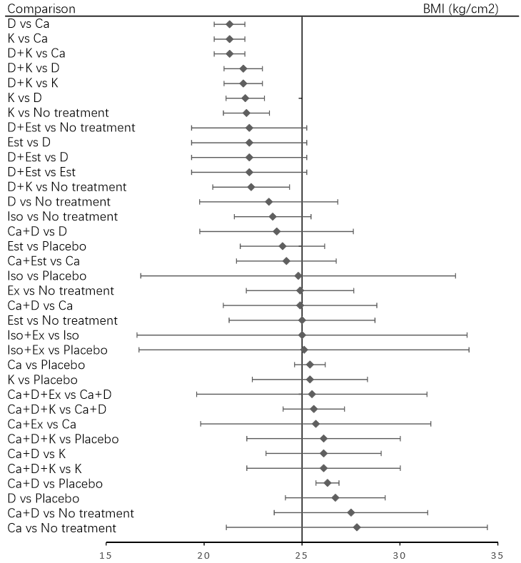
Abbreviations: Ca=calcium; D=vitamin D; Est=estrogen; Ex=exercise; K=vitamin K; Iso= isoflavone.

eFigure 2. Summary of risk of bias evaluated using the Cochrane Risk of Bias tool
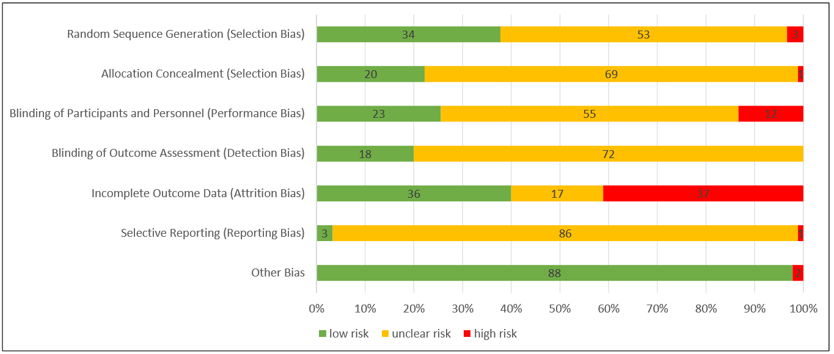
eFigure 3. Publication bias assessed via funnel plots
Standard error of effect size in LS BMD

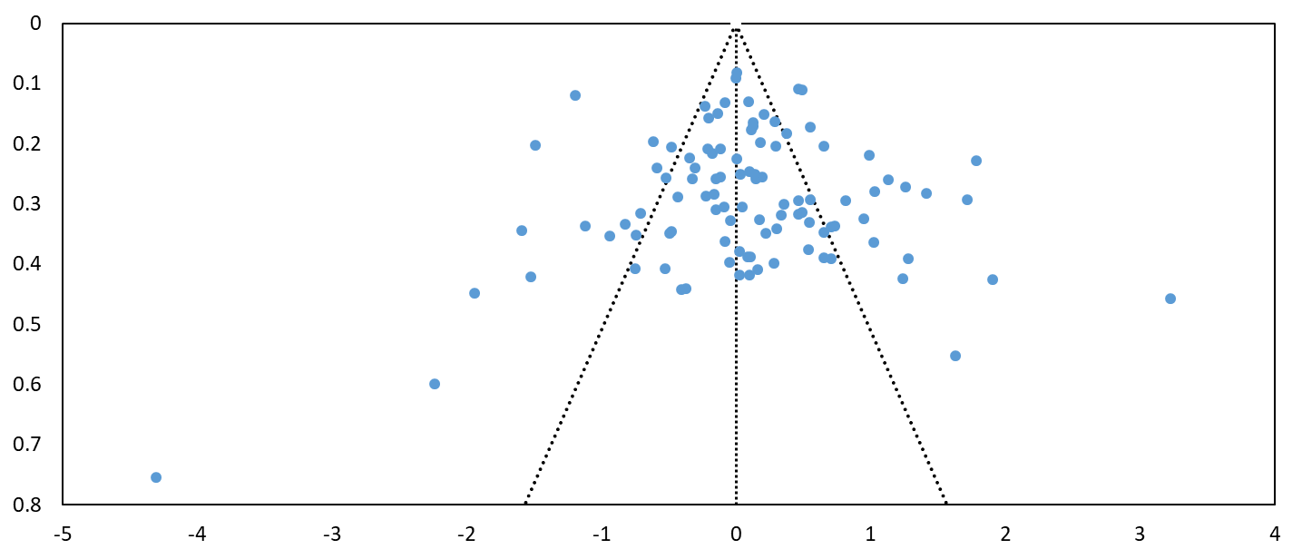

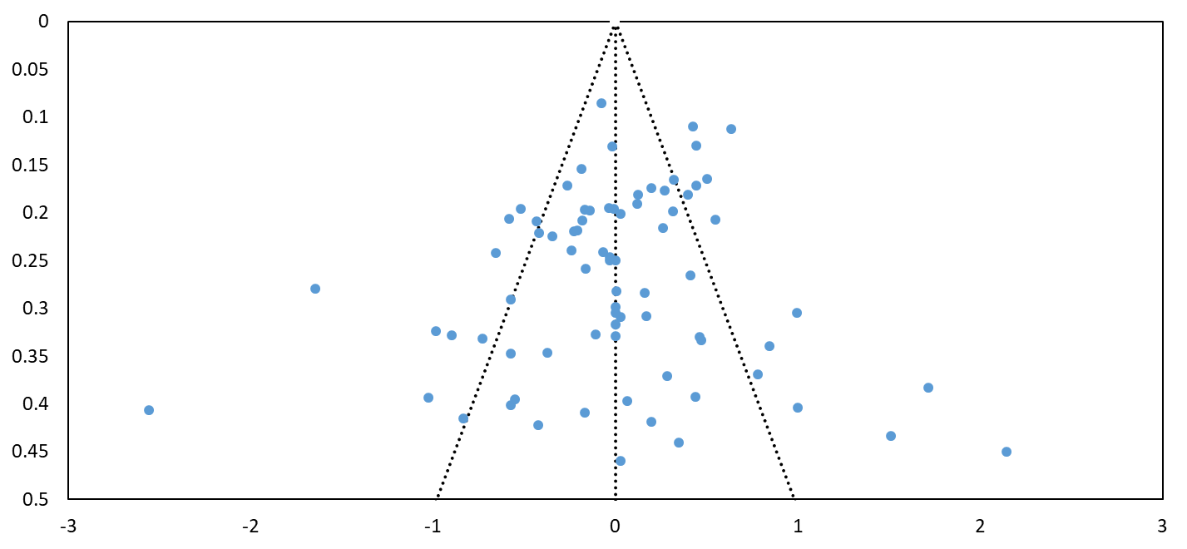
Effect size in FN BMD centred at comparison-specific pooled effect
Effect size in LS BMD centred at comparison-specific pooled effect
Standard error of effect size in FN BMD
eFigure 4. Node-splitting model in LS BMD assessing incoherence between direct and indirect comparisons

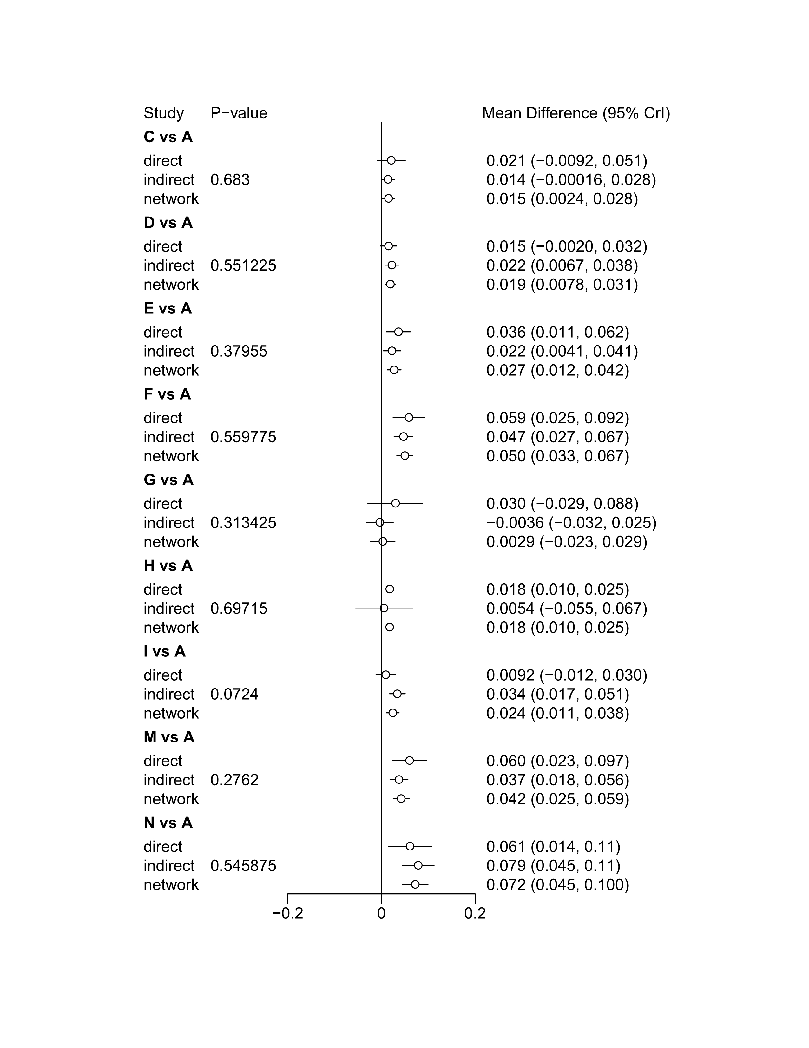

Abbreviations: A=No Treatment; B=Placebo; C=calcium; D=vitamin D; E=vitamin K; F=estrogen; G=isoflavene; H=exercise; I=calcium + vitamin D; J=calcium + vitamin K; K= calcium + estrogen; L=calcium + exercise; M=vitamin D + vitamin K; N=vitamin D + estrogen; O= isoflavene + exercise; P=calcium+ vitamin D+ vitamin K; Q=calcium + vitamin D+ exercise; R= calcium + vitamin D+ isoflavene + exercise.

eFigure 4. Node-splitting model in LS BMD assessing incoherence between direct and indirect comparisons (continued)

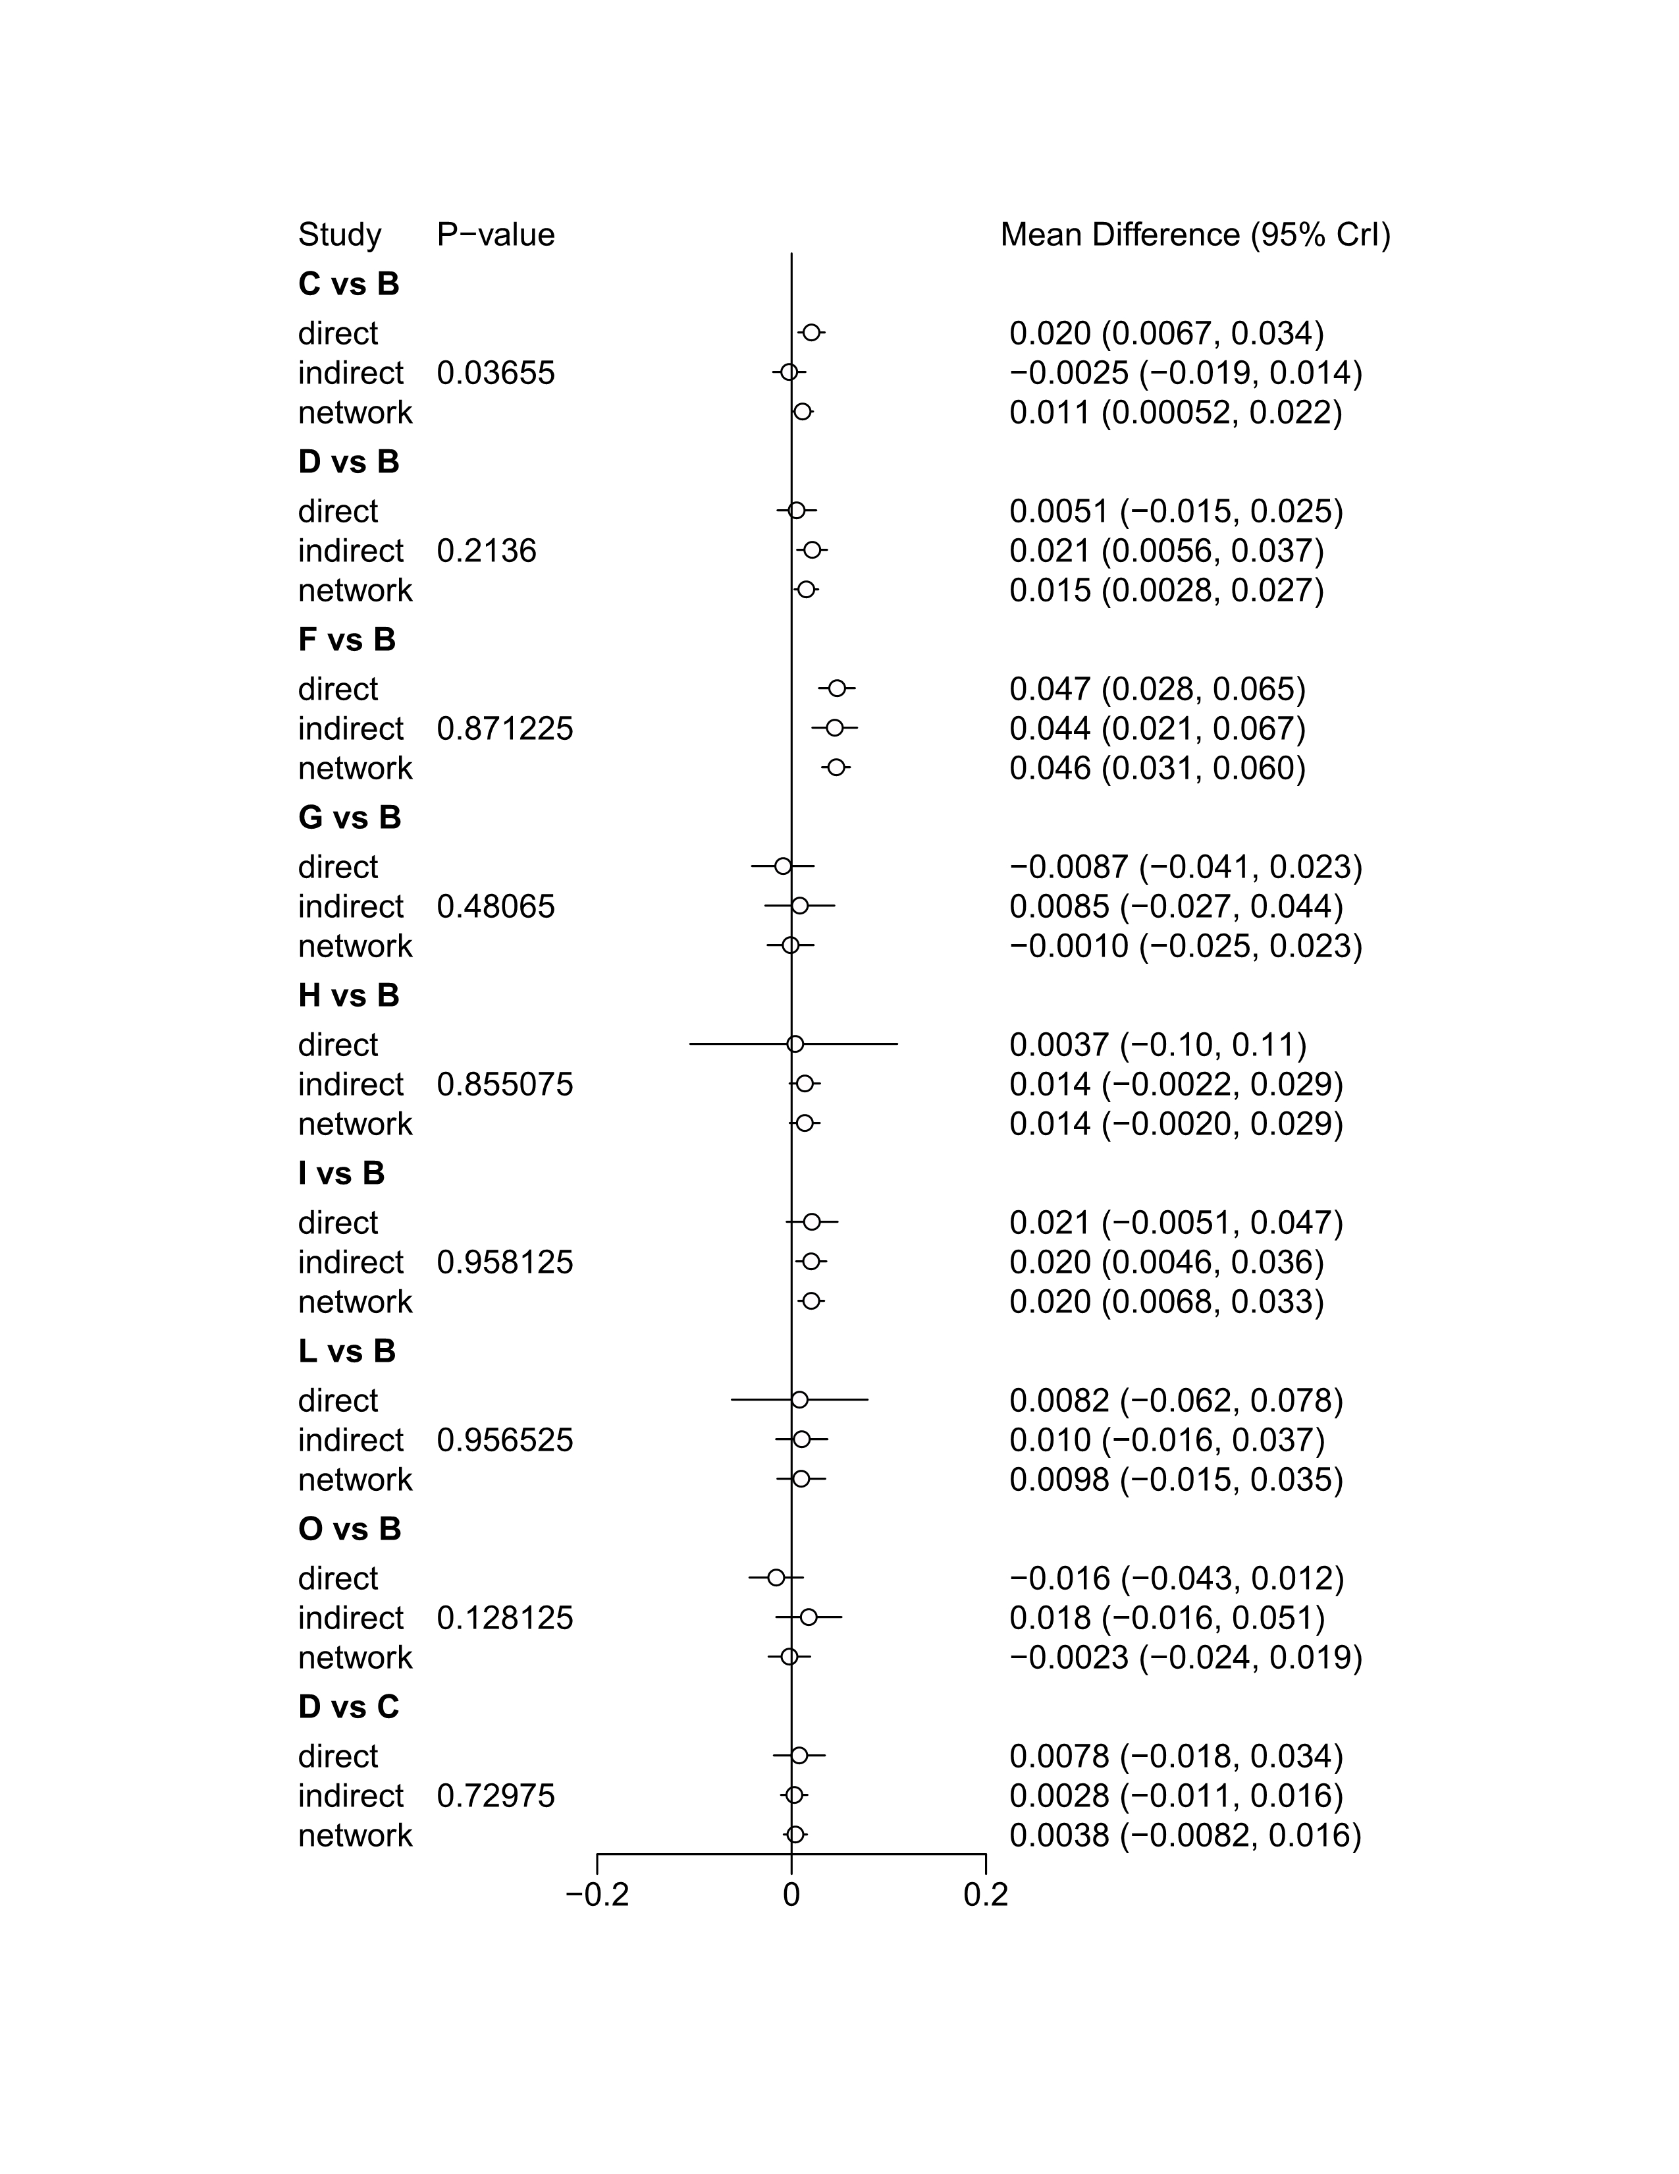

Abbreviations: A=No Treatment; B=Placebo; C=calcium; D=vitamin D; E=vitamin K; F=estrogen; G=isoflavene; H=exercise; I=calcium + vitamin D; J=calcium + vitamin K; K= calcium + estrogen; L=calcium + exercise; M=vitamin D + vitamin K; N=vitamin D + estrogen; O= isoflavene + exercise; P=calcium+ vitamin D+ vitamin K; Q=calcium + vitamin D+ exercise; R= calcium + vitamin D+ isoflavene + exercise.

eFigure 4. Node-splitting model in LS BMD assessing incoherence between direct and indirect comparisons (continued)

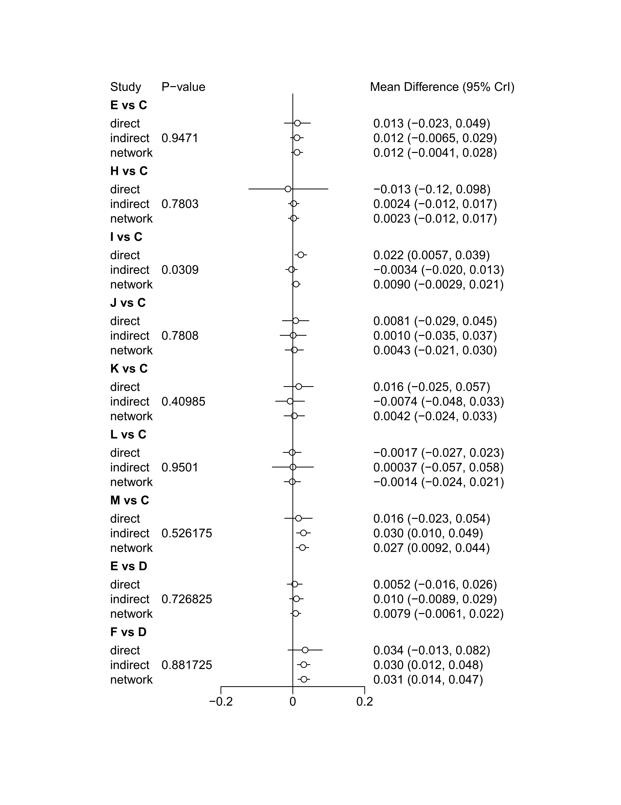
Abbreviations: A=No Treatment; B=Placebo; C=calcium; D=vitamin D; E=vitamin K; F=estrogen; G=isoflavene; H=exercise; I=calcium + vitamin D; J=calcium + vitamin K; K= calcium + estrogen; L=calcium + exercise; M=vitamin D + vitamin K; N=vitamin D + estrogen; O= isoflavene + exercise; P=calcium+ vitamin D+ vitamin K; Q=calcium + vitamin D+ exercise; R= calcium + vitamin D+ isoflavene + exercise.

eFigure 4. Node-splitting model in LS BMD assessing incoherence between direct and indirect comparisons (continued)
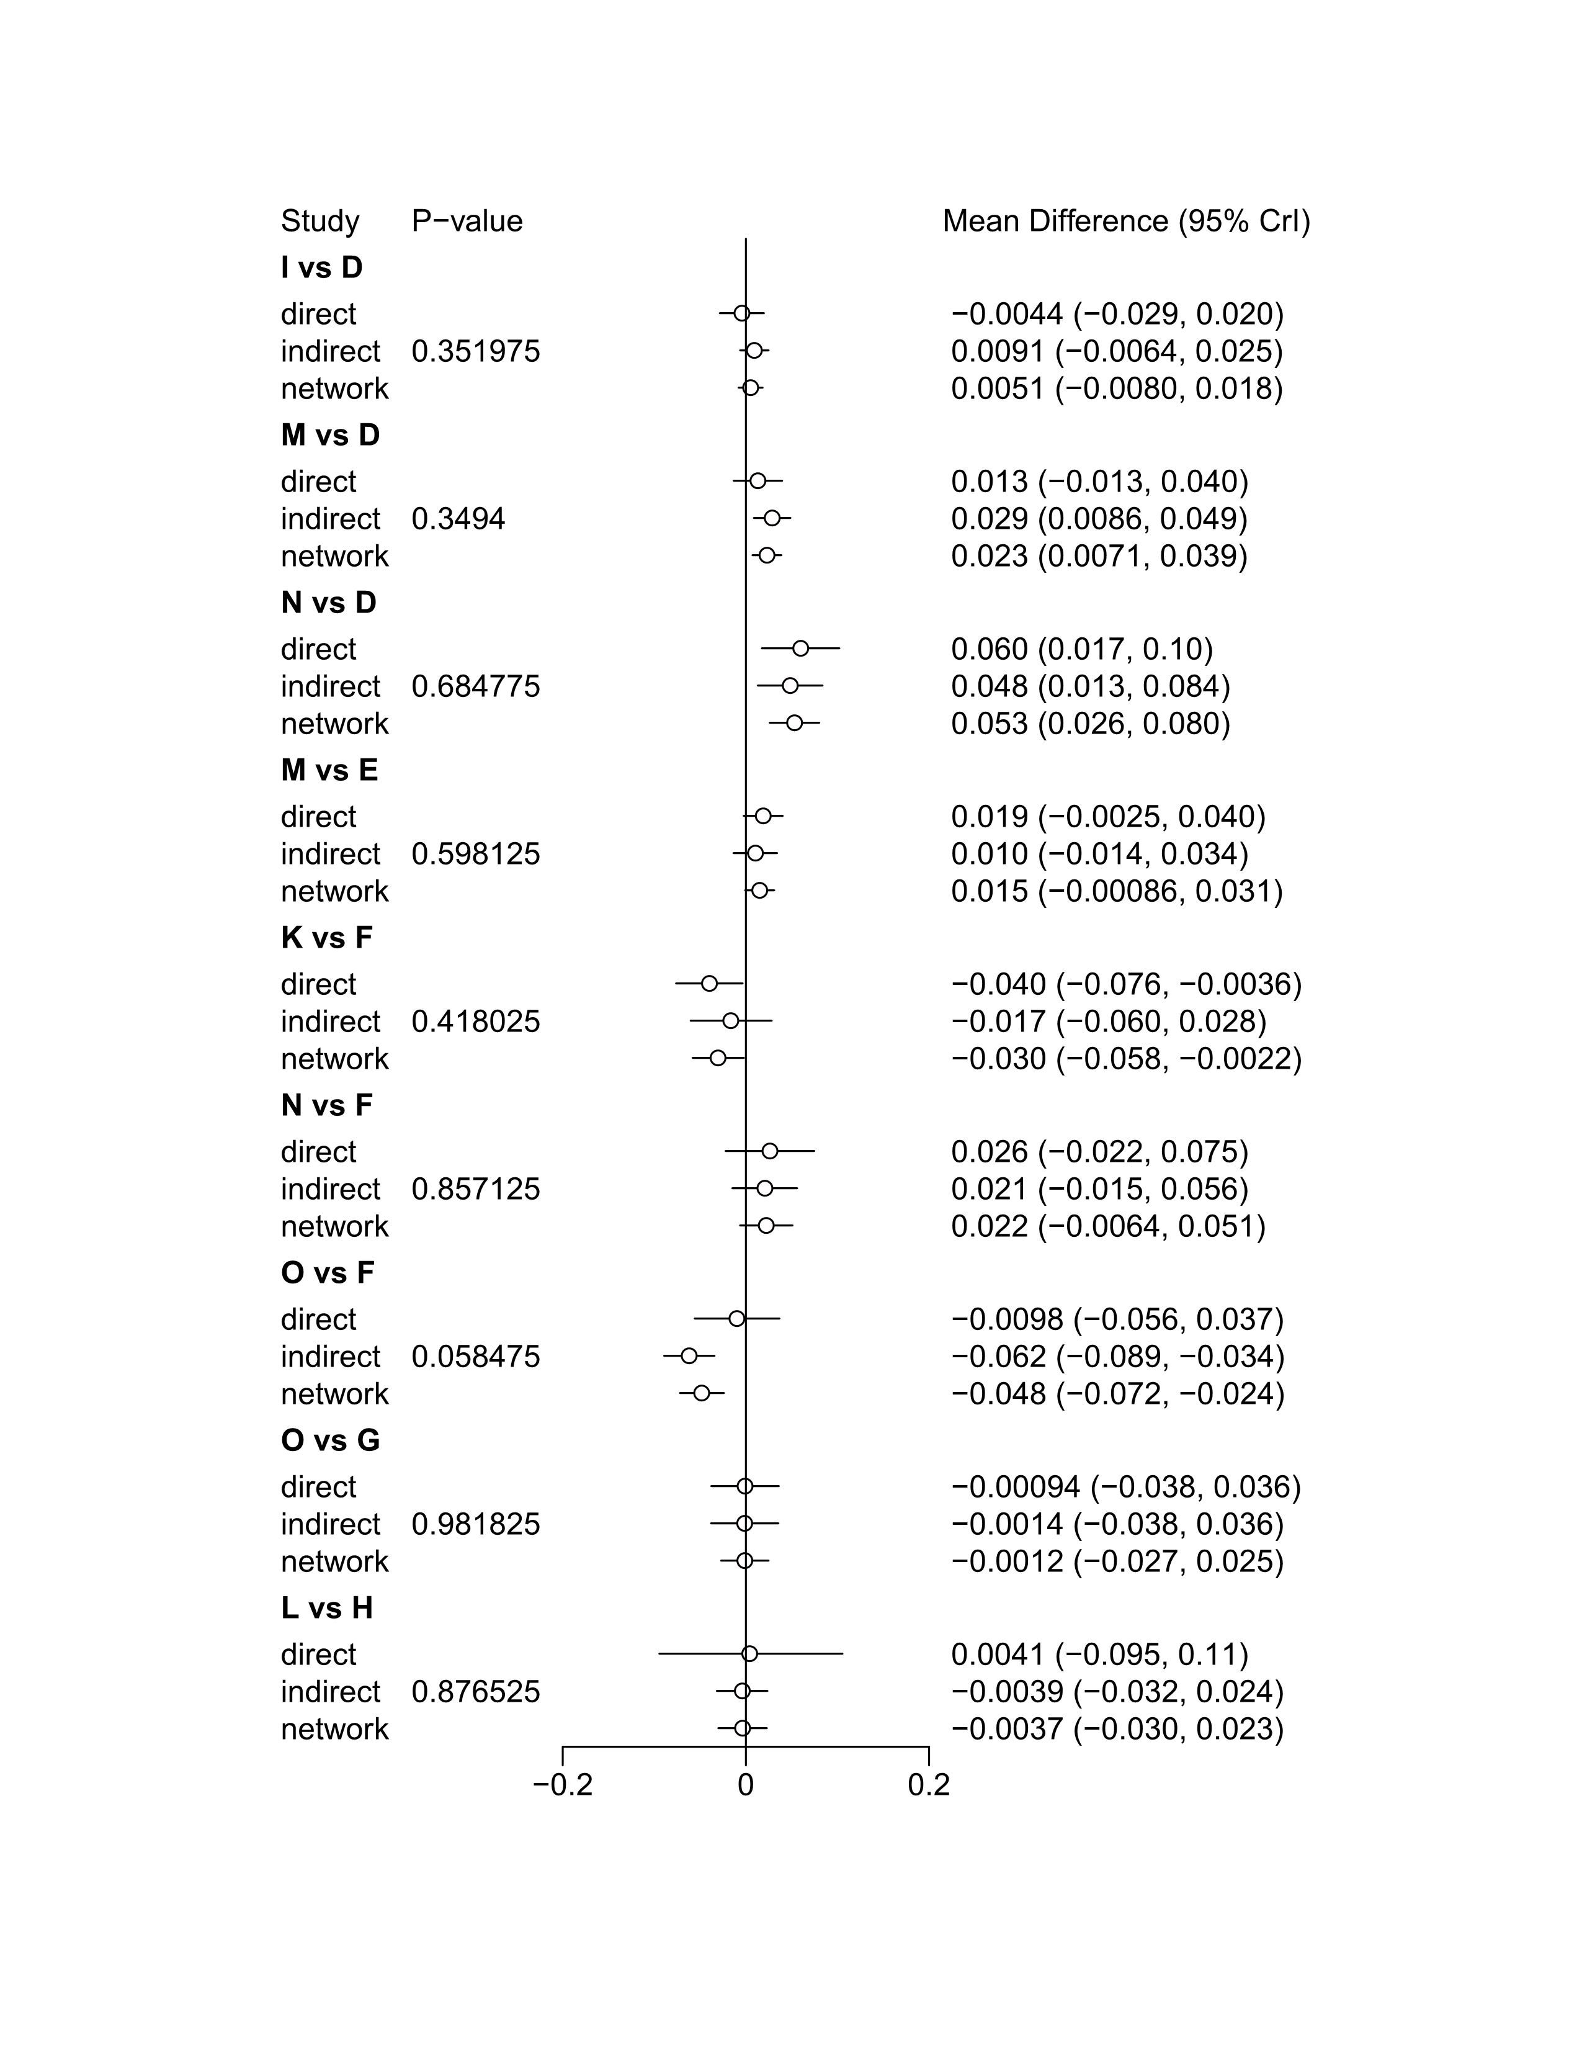

Abbreviations: A=No Treatment; B=Placebo; C=calcium; D=vitamin D; E=vitamin K; F=estrogen; G=isoflavene; H=exercise; I=calcium + vitamin D; J=calcium + vitamin K; K= calcium + estrogen; L=calcium + exercise; M=vitamin D + vitamin K; N=vitamin D + estrogen; O= isoflavene + exercise; P=calcium+ vitamin D+ vitamin K; Q=calcium + vitamin D+ exercise; R= calcium + vitamin D+ isoflavene + exercise.

eFigure 4. Node-splitting model in LS BMD assessing incoherence between direct and indirect comparisons (continued)
Abbreviations: A=No Treatment; B=Placebo; C=calcium; D=vitamin D; E=vitamin K; F=estrogen; G=isoflavene; H=exercise; I=calcium + vitamin D; J=calcium + vitamin K; K= calcium + estrogen; L=calcium + exercise; M=vitamin D + vitamin K; N=vitamin D + estrogen; O= isoflavene + exercise; P=calcium+ vitamin D+ vitamin K; Q=calcium + vitamin D+ exercise; R= calcium + vitamin D+ isoflavene + exercise.

eFigure 5. Node-splitting model in FN BMD assessing incoherence between direct and indirect comparisons
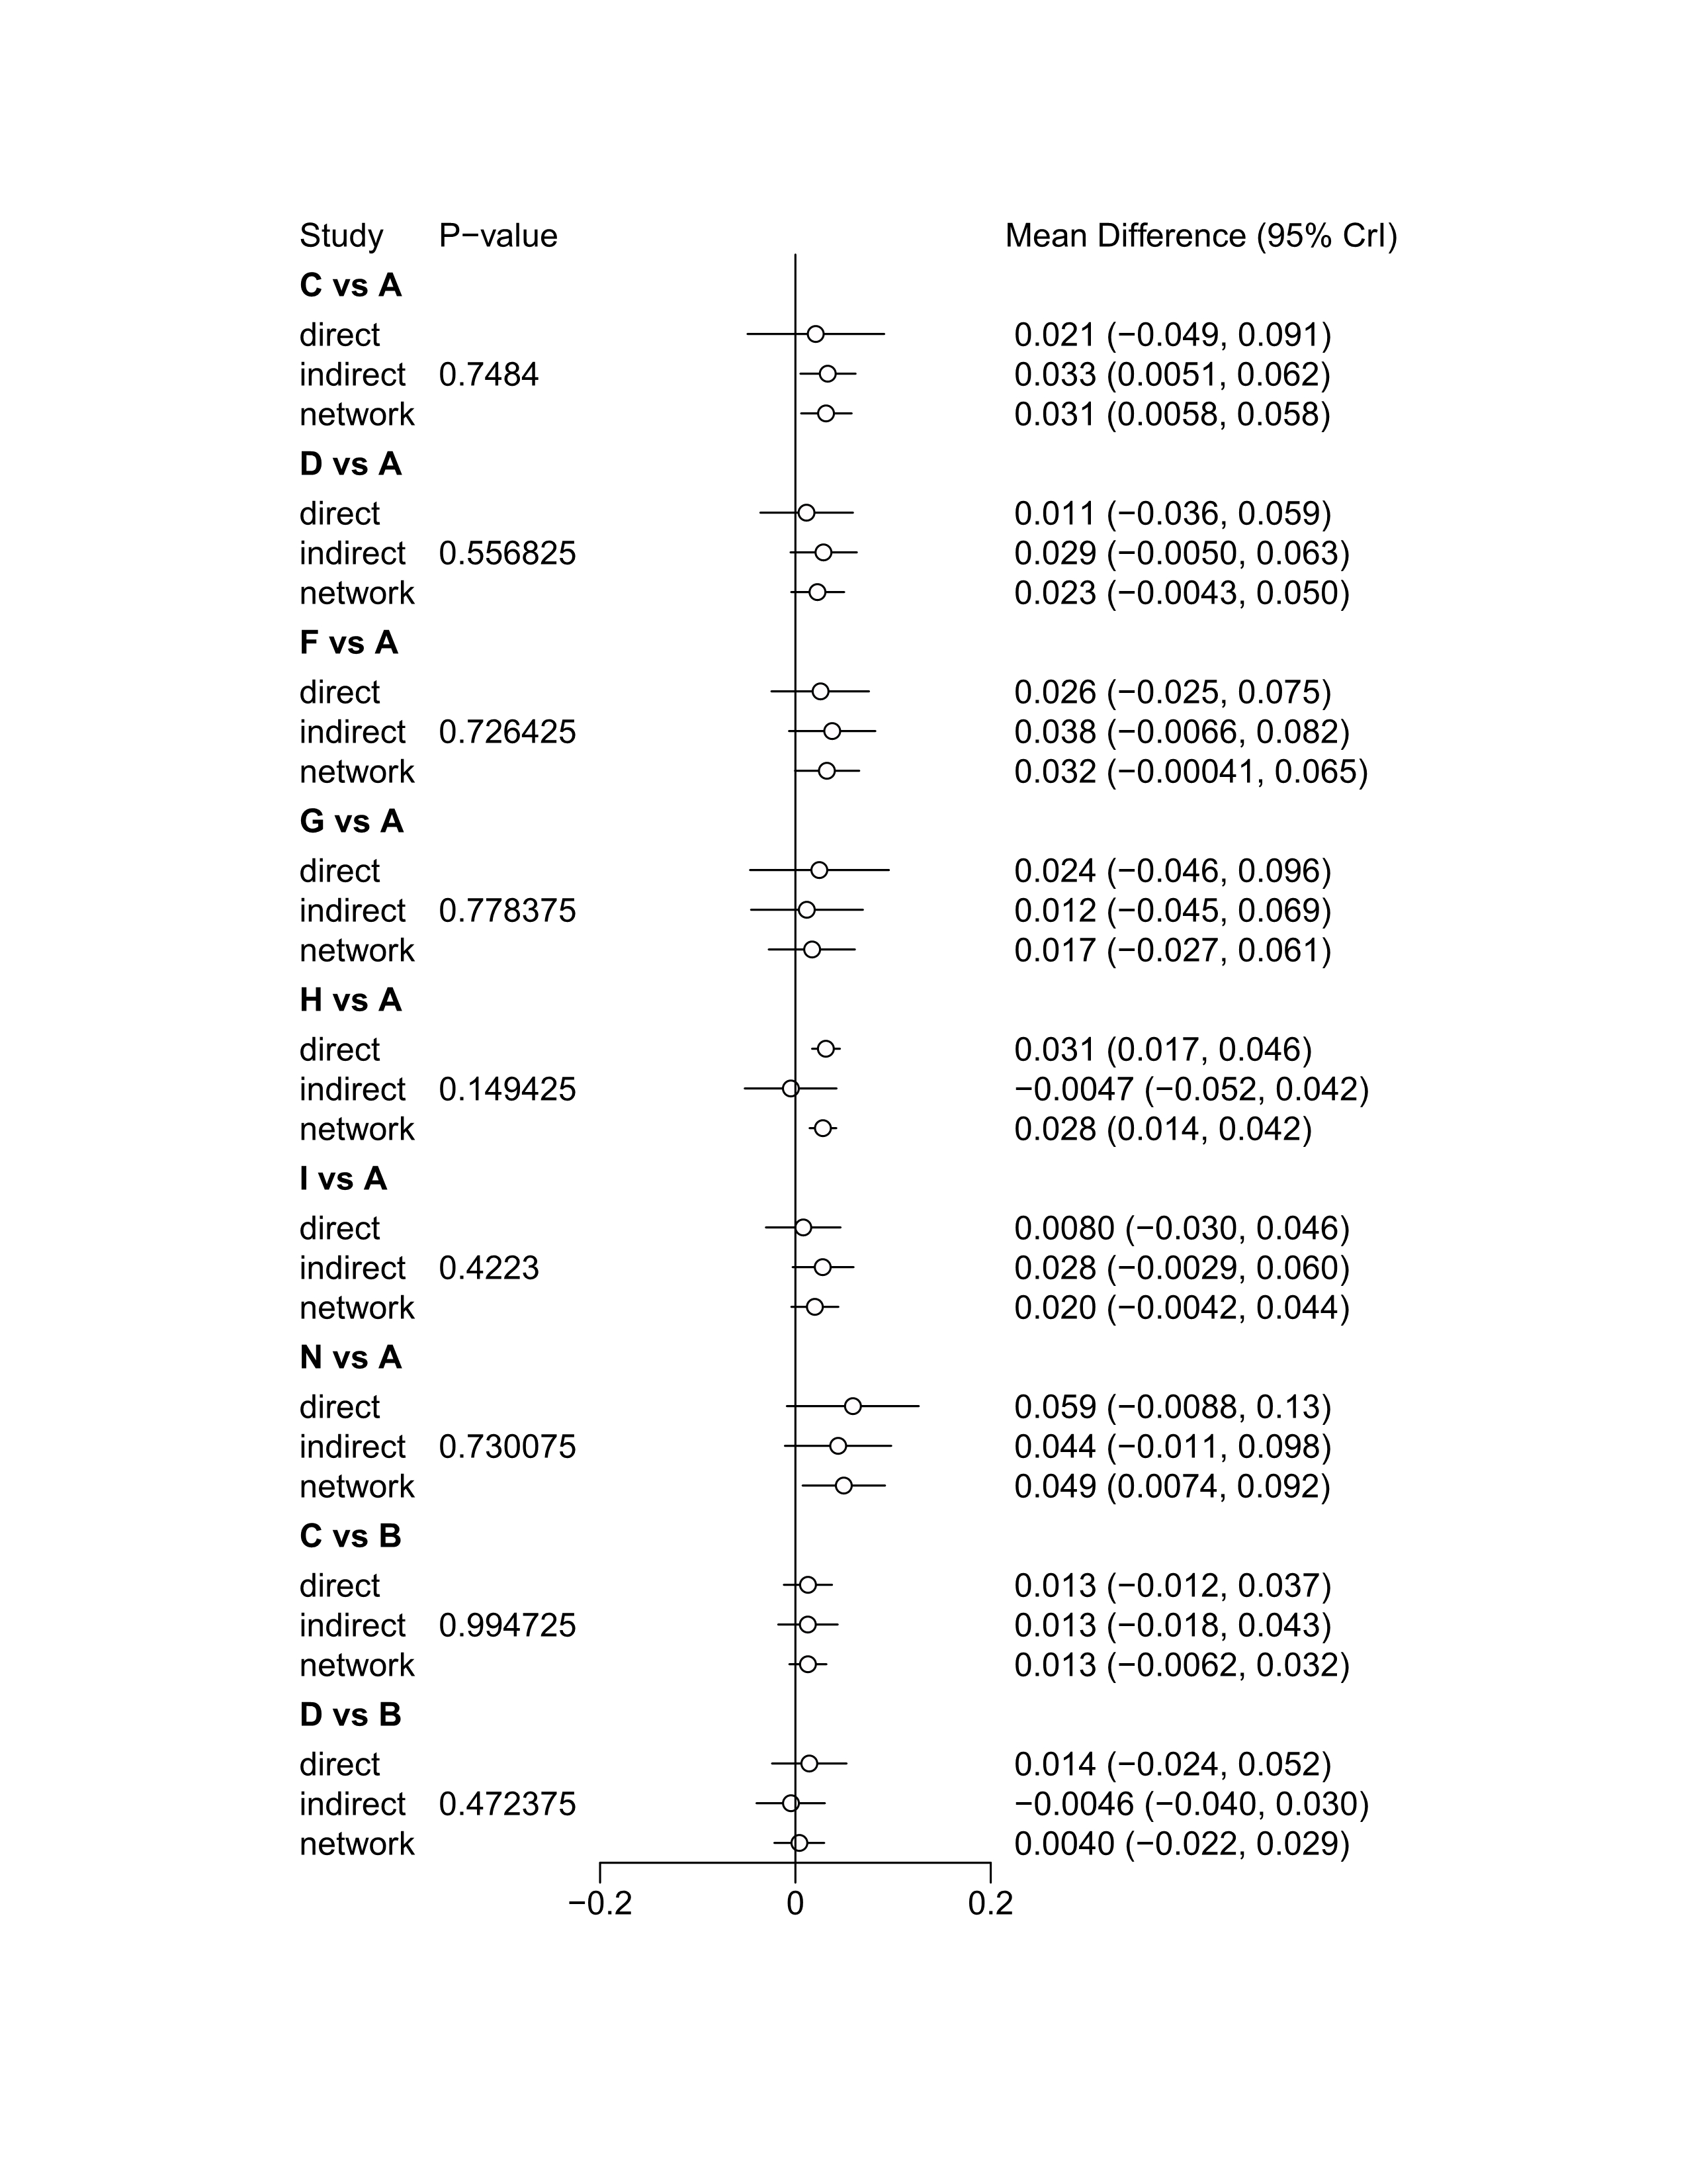
Abbreviations: A=No Treatment; B=Placebo; C=calcium; D=vitamin D; E=vitamin K; F=estrogen; G=isoflavene; H=exercise; I=calcium + vitamin D; K= calcium + estrogen; L=calcium + exercise; N=vitamin D + estrogen; O= isoflavene + exercise; P=calcium+ vitamin D+ vitamin K; Q=calcium + vitamin D+ exercise; R= calcium + vitamin D+ isoflavene + exercise.

eFigure 5. Node-splitting model in FN BMD assessing incoherence between direct and indirect comparisons (continued)
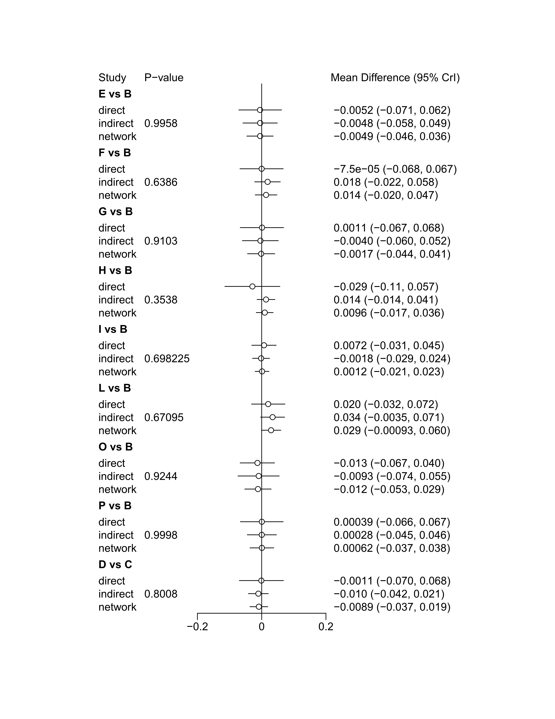
Abbreviations: A=No Treatment; B=Placebo; C=calcium; D=vitamin D; E=vitamin K; F=estrogen; G=isoflavene; H=exercise; I=calcium + vitamin D; K= calcium + estrogen; L=calcium + exercise; N=vitamin D + estrogen; O= isoflavene + exercise; P=calcium+ vitamin D+ vitamin K; Q=calcium + vitamin D+ exercise; R= calcium + vitamin D+ isoflavene + exercise.

eFigure 5. Node-splitting model in FN BMD assessing incoherence between direct and indirect comparisons (continued)
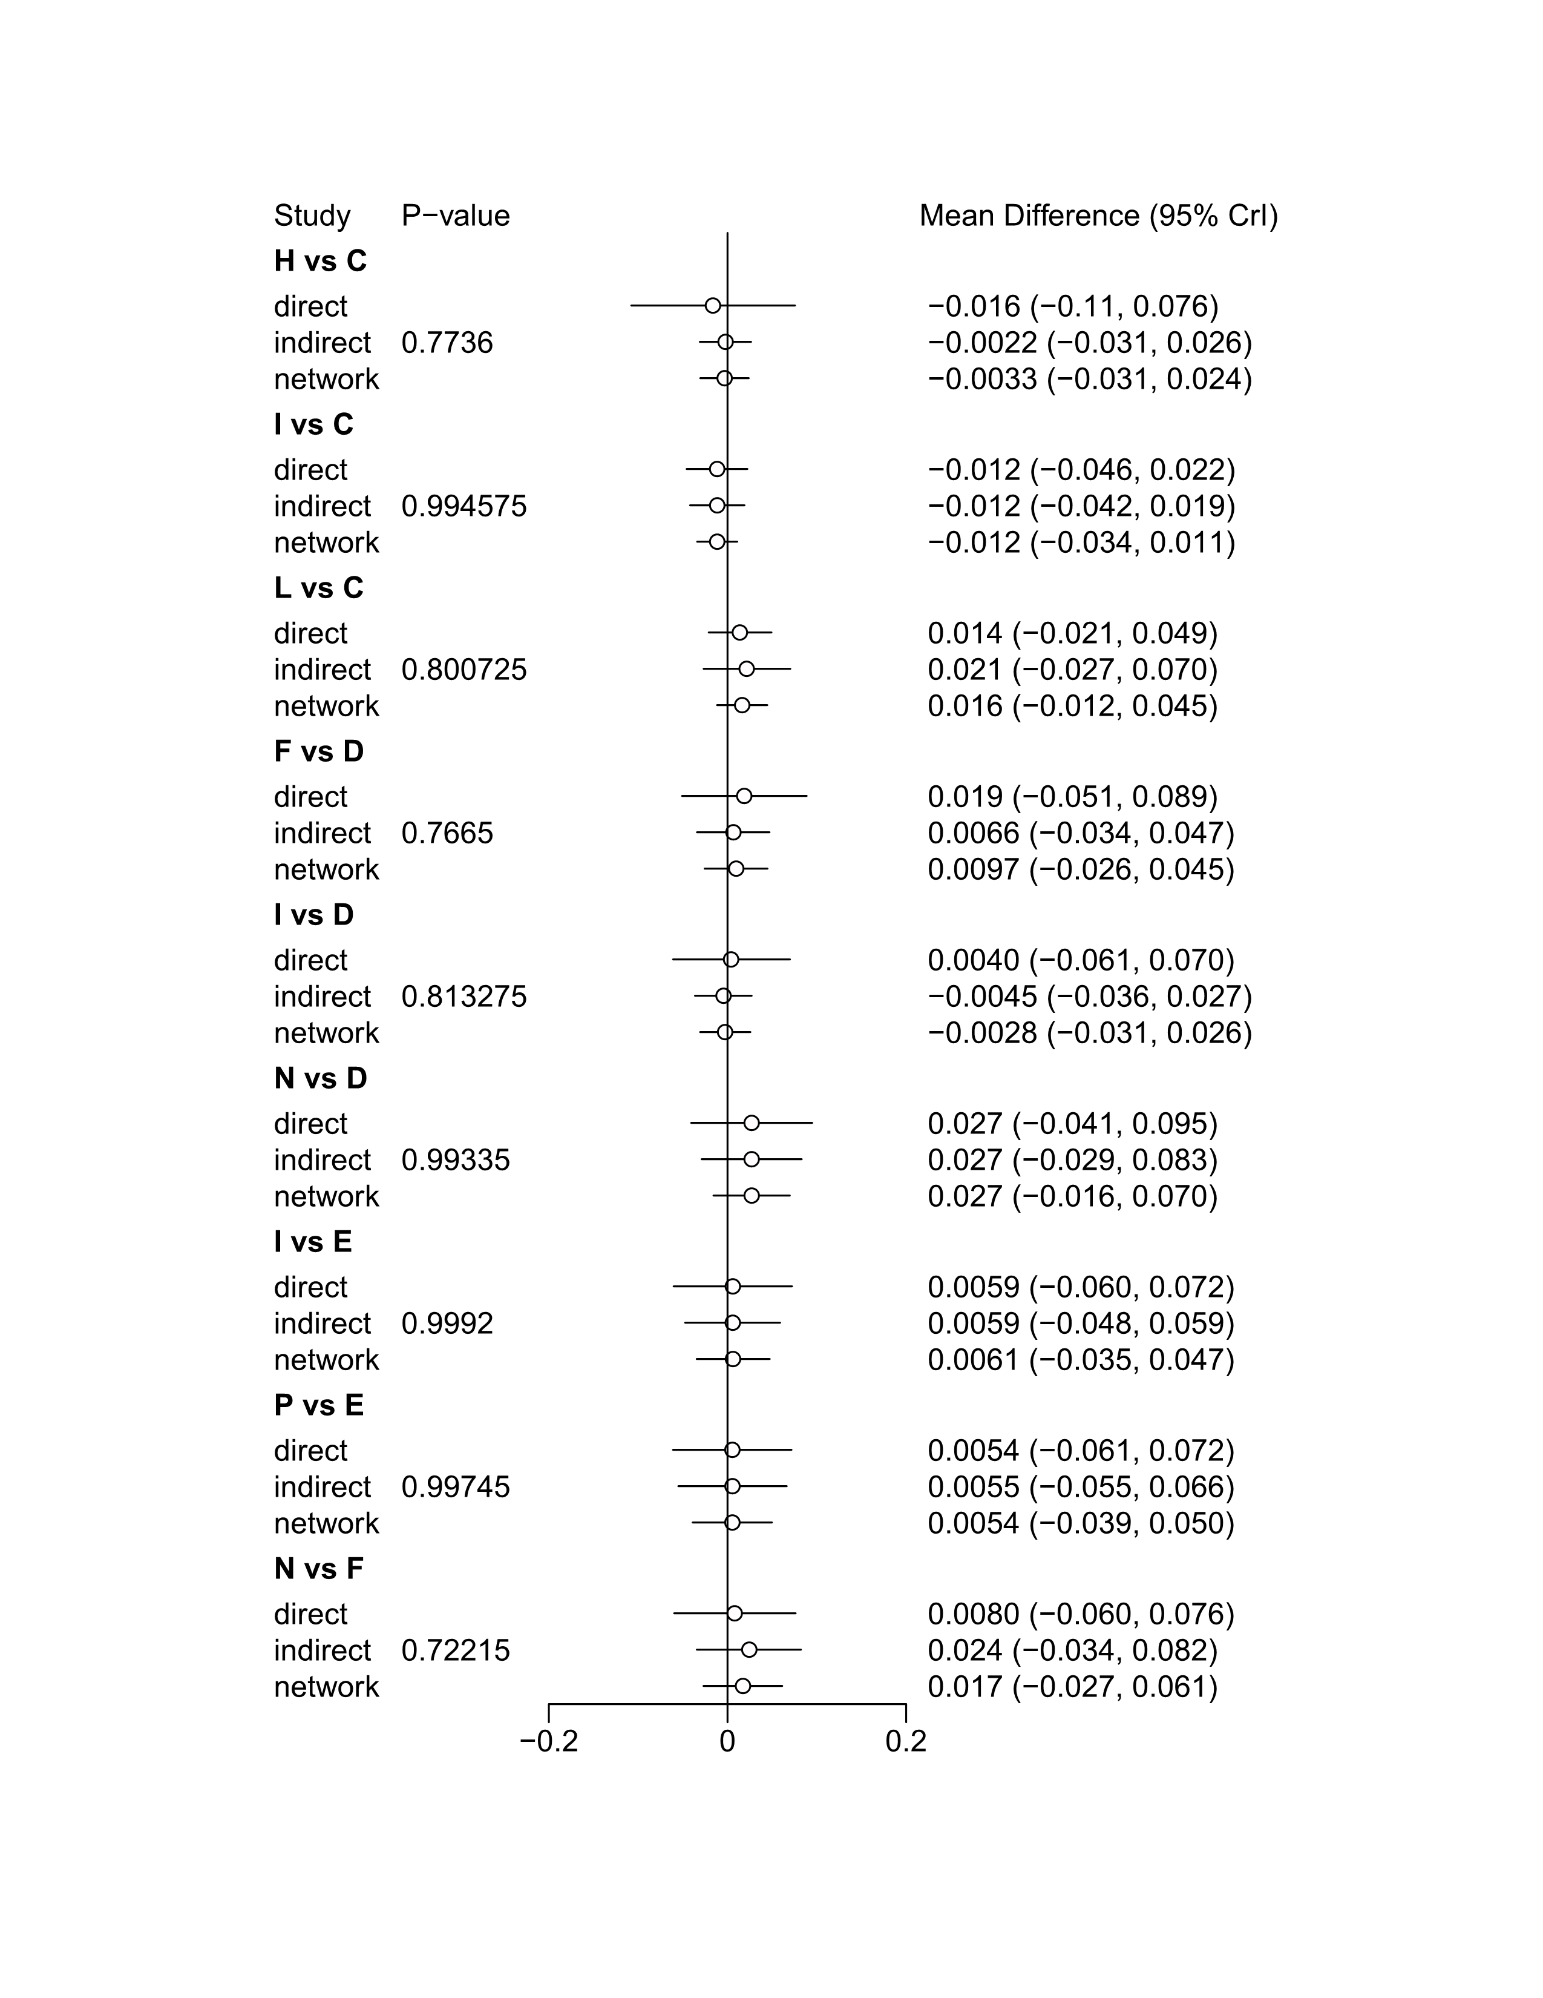
Abbreviations: A=No Treatment; B=Placebo; C=calcium; D=vitamin D; E=vitamin K; F=estrogen; G=isoflavene; H=exercise; I=calcium + vitamin D; K= calcium + estrogen; L=calcium + exercise; N=vitamin D + estrogen; O= isoflavene + exercise; P=calcium+ vitamin D+ vitamin K; Q=calcium + vitamin D+ exercise; R= calcium + vitamin D+ isoflavene + exercise.

eFigure 5. Node-splitting model in FN BMD assessing incoherence between direct and indirect comparisons (continued)
Abbreviations: A=No Treatment; B=Placebo; C=calcium; D=vitamin D; E=vitamin K; F=estrogen; G=isoflavene; H=exercise; I=calcium + vitamin D; K= calcium + estrogen; L=calcium + exercise; N=vitamin D + estrogen; O= isoflavene + exercise; P=calcium+ vitamin D+ vitamin K; Q=calcium + vitamin D+ exercise; R= calcium + vitamin D+ isoflavene + exercise.

eReferences Included trials

1. Lau EM, Woo J, Leung PC et al. (1992) The effects of calcium supplementation and exercise on bone density in elderly Chinese women. Osteoporos Int 2, 168-173.
2. Reid IR, Ames RW, Evans MC et al. (1993) Effect of calcium supplementation on bone loss in postmenopausal women. NEJM 328, 460-464.
3. Hatori M, Hasegawa A, Adachi H et al. (1993) The effects of walking at the anaerobic threshold level on vertebral bone loss in postmenopausal women. Calcif Tissue Int 52, 411-414.
4. Nelson ME, Fiatarone MA, Morganti CM et al. (1994) Effects of high-intensity strength training on multiple risk factors for osteoporotic fractures. A randomized controlled trial. JAMA 272, 1909-1914.
5. Ushiroyama T, Okamura S, Ikeda A et al. (1995) Efficacy of ipriflavone and 1 alpha vitamin D therapy for the cessation of vertebral bone loss. Int J Gynaecol Obstet 48 283-288.
6. Ooms ME, Roos JC, Bezemer PD et al. (1995) Prevention of bone loss by vitamin D supplementation in elderly women: a randomized double-blind trial. J Clin Endocrinol Metab 80, 1052-1058.
7. Prince R, Devine A, Dick I et al. (1995) The effects of calcium supplementation (milk powder or tablets) and exercise on bone density in postmenopausal women. J Bone Miner Res 10, 1068-1075.
8. Pruitt LA, Taaffe DR, Marcus R. (1995) Effects of a one-year high-intensity versus low-intensity resistance training program on bone mineral density in older women. J Bone Miner Res 10, 1788-1795.
9. Haines CJ, Chung TK, Leung PC et al. (1995) Calcium supplementation and bone mineral density in postmenopausal women using estrogen replacement therapy. Bone 16, 529-531.
10. Taaffe DR, Pruitt L, Pyka G et al. (1996) Comparative effects of high- and low-intensity resistance training on thigh muscle strength, fiber area, and tissue composition in elderly women. Clin Physiol 16, 381-392.
11. The Writing Group for the PEPI. (1996) Effects of hormone therapy on bone mineral density: results from the postmenopausal estrogen/progestin interventions (PEPI) trial. JAMA 276, 1389-1396.
12. Lord SR, Ward JA, Williams P et al. (1996) The effects of a community exercise program on fracture risk factors in older women. Osteoporos Int 6, 361-367.
13. Mizunuma H, Okano H, Soda M et al. (1997) Prevention of postmenopausal bone loss with minimal uterine bleeding using low dose continuous estrogen/progestin therapy: a 2-year prospective study. Maturitas 27, 69-76.
14. Naessen T, Berglund L, Ulmsten U. (1997) Bone loss in elderly women prevented by ultralow doses of parenteral 17beta-estradiol. Am J Obstet Gynecol 177, 115-119.
15. Chen JT, Shiraki M, Hasumi K et al. (1997) 1-alpha-Hydroxyvitamin D3 treatment decreases bone turnover and modulates calcium-regulating hormones in early postmenopausal women. Bone 20, 557-562.
16. Dawson-Hughes B, Harris SS, Krall EA et al. (1997) Effect of calcium and vitamin D supplementation on bone density in men and women 65 years of age or older. NEJM 337, 670-676.
17. Gambacciani M, Ciaponi M, Cappagli B et al. (1997) Effects of combined low dose of the isoflavone derivative ipriflavone and estrogen replacement on bone mineral density and metabolism in postmenopausal women. Maturitas 28, 75-81.
18. Riggs BL, O'Fallon WM, Muhs J et al. (1998) Long-term effects of calcium supplementation on serum parathyroid hormone level, bone turnover, and bone loss in elderly women. J Bone Miner Res 13, 168-174.
19. Storm D, Eslin R, Porter ES et al. (1998) Calcium supplementation prevents seasonal bone loss and changes in biochemical markers of bone turnover in elderly New England women: a randomized placebo-controlled trial. J Clin Endocrinol Metab 83, 3817-3825.
20. Castelo-Branco C, Pons F, Vicente JJ et al. (1999) Preventing postmenopausal bone loss with ossein-hydroxyapatite compounds. Results of a two-year, prospective trial. J Reprod Med 44, 601-605.
21. Adami S, Gatti D, Braga V et al. (1999) Site-specific effects of strength training on bone structure and geometry of ultradistal radius in postmenopausal women. J Bone Miner Res 14, 120-124.
22. Gorai I, Chaki O, Taguchi Y et al. (1999) Early postmenopausal bone loss is prevented by estrogen and partially by 1alpha-OH-vitamin D3: therapeutic effects of estrogen and/or 1alpha-OH-vitamin D3. Calcif Tissue Int 65, 16-22.
23. Iwamoto I, Kosha S, Noguchi S et al. (1999) A longitudinal study of the effect of vitamin K2 on bone mineral density in postmenopausal women a comparative study with vitamin D3 and estrogen-progestin therapy. Maturitas 31, 161-164.
24. Ruml LA, Sakhaee K, Peterson R et al. (1999) The effect of calcium citrate on bone density in the early and mid-postmenopausal period: a randomized placebo-controlled study. J Reprod Med 6, 303-131.
25. Rhodes EC, Martin AD, Taunton JE et al. (2000) Effects of one year of resistance training on the relation between muscular strength and bone density in elderly women. Br J Sports Med 34, 18-22.
26. Shiraki M, Shiraki Y, Aoki C et al. (2000) Vitamin K2 (menatetrenone) effectively prevents fractures and sustains lumbar bone mineral density in osteoporosis. J Bone Miner Res 15, 515-521.
27. Iwamoto J, Takeda T, Ichimura S. (2000) Effect of combined administration of vitamin D3 and vitamin K2 on bone mineral density of the lumbar spine in postmenopausal women with osteoporosis. J Orthop Sci 5, 546-551.
28. Ongphiphadhanakul B, Piaseu N, Tung SS et al. (2000) Prevention of postmenopausal bone loss by low and conventional doses of calcitriol or conjugated equine estrogen. Maturitas 34, 179-184.
29. Kerr D, Ackland T, Maslen B et al. (2001) Resistance training over 2 years increases bone mass in calcium-replete postmenopausal women. J Bone Miner Res 16, 175-181.
30. Iwamoto J, Takeda T, Ichimura S. (2001) Effect of menatetrenone on bone mineral density and incidence of vertebral fractures in postmenopausal women with osteoporosis: a comparison with the effect of etidronate. J Orthop Sci 6, 487-492.
31. Chailurkit LO, Ongphiphadhanakul B, Piaseu N et al. (2001) Biochemical markers of bone turnover and response of bone mineral density to intervention in early postmenopausal women: an experience in a clinical laboratory. Clin Chem 47, 1083-1088.
32. Iwamoto J, Takeda T, Ichimura S. (2001) Effect of exercise training and detraining on bone mineral density in postmenopausal women with osteoporosis. J Orthop Sci 6, 128-132.
33. Son SM, Chun YN. (2001) Effect of oral therapy with alphacalcidol or calcium in Korean elderly women with osteopenia and low dietary calcium. Nutr Res 21, 1347-1355.
34. Arrenbrecht S, Boermans AJ. (2002) Effects of transdermal estradiol delivered by a matrix patch on bone density in hysterectomized, postmenopausal women: a 2-year placebo-controlled trial. Osteoporos Int 13, 176-183.
35. Hans D, Genton L, Drezner MK et al. (2002) Monitored impact loading of the hip: initial testing of a home-use device. Calcif Tissue Int 71, 112-120.
36. Ushiroyama T, Ikeda A, Ueki M. (2002) Effect of continuous combined therapy with vitamin K(2) and vitamin D(3) on bone mineral density and coagulofibrinolysis function in postmenopausal women. Maturitas 41, 211-221.
37. Haines CJ, Yim SF, Chung TK et al. (2003) A prospective, randomized, placebo-controlled study of the dose effect of oral estradiol on bone mineral density in postmenopausal Chinese women. Maturitas 45, 169-173.
38. Going S, Lohman T, Houtkooper L et al. (2003) Effects of exercise on bone mineral density in calcium-replete postmenopausal women with and without hormone replacement therapy. Osteoporos Int 14, 637-643.
39. Jessup JV, Horne C, Vishen RK et al. (2003) Effects of exercise on bone density, balance, and self-efficacy in older women. Biol Res Nurs 4, 171-180.
40. Cooper L, Clifton-Bligh PB, Nery ML et al. (2003) Vitamin D supplementation and bone mineral density in early postmenopausal women. Am J Clin Nutr 77, 1324-1329.
41. Grados F, Brazier M, Kamel S et al. (2003) Prediction of bone mass density variation by bone remodeling markers in postmenopausal women with vitamin D insufficiency treated with calcium and vitamin D supplementation. J Clin Endocrinol Metab 88, 5175-5179.
42. Uesugi T, Toda T, Okuhira T et al. (2003) Evidence of estrogenic effect by the three-month-intervention of isoflavone on vaginal maturation and bone metabolism in early postmenopausal women. Endocr J 50, 613-619.
43. Verschueren SM, Roelants M, Delecluse C et al. (2004) Effect of 6-month whole body vibration training on hip density, muscle strength, and postural control in postmenopausal women: a randomized controlled pilot study. J Bone Miner Res 19, 352-359.
44. Chan K, Qin L, Lau M et al. (2004) A randomized, prospective study of the effects of Tai Chi Chun exercise on bone mineral density in postmenopausal women. Arch Phys Med Rehabil 85, 717-722.
45. Ishida Y, Kawai S. (2004) Comparative efficacy of hormone replacement therapy, etidronate, calcitonin, alfacalcidol, and vitamin K in postmenopausal women with osteoporosis: The Yamaguchi Osteoporosis Prevention Study. Am J Med 117, 549-555.
46. Harwood RH, Sahota O, Gaynor K et al. (2004) A randomised, controlled comparison of different calcium and vitamin D supplementation regimens in elderly women after hip fracture: The Nottingham Neck of Femur (NONOF) Study. Age Ageing 33, 45-51.
47. Inanir A, Ozoran K, Tutkak H et al. (2004) The effects of calcitriol therapy on serum interleukin-1, interleukin-6 and tumour necrosis factor-alpha concentrations in post-menopausal patients with osteoporosis. J Int Med Res 32, 570-582.
48. Englund U, Littbrand H, Sondell A et al. (2005) A 1-year combined weight-bearing training program is beneficial for bone mineral density and neuromuscular function in older women. Osteoporos Int 16, 1117-1123.
49. Moschonis G, Manios Y. (2006) Skeletal site-dependent response of bone mineral density and quantitative ultrasound parameters following a 12-month dietary intervention using dairy products fortified with calcium and vitamin D: the Postmenopausal Health Study. Br J Nutr 96, 1140-1148.
50. Yasui T, Miyatani Y, Tomita J et al. (2006) Effect of vitamin K2 treatment on carboxylation of osteocalcin in early postmenopausal women. Gynecol Endocrinol 22, 455-459.
51. Korpelainen R, Keinanen-Kiukaanniemi S, Heikkinen J et al. (2006) Effect of impact exercise on bone mineral density in elderly women with low BMD: a population-based randomized controlled 30-month intervention. Osteoporos Int 17, 109-118.
52. Huang HY, Yang HP, Yang HT et al. (2006) One-year soy isoflavone supplementation prevents early postmenopausal bone loss but without a dose-dependent effect. J Nutr Biochem 17, 509-517.
53. Wu J, Oka J, Higuchi M et al. (2006) Cooperative effects of isoflavones and exercise on bone and lipid metabolism in postmenopausal Japanese women: a randomized placebo-controlled trial. Metabolism 55, 423-433.
54. Nuti R, Bianchi G, Brandi ML et al. (2006) Superiority of alfacalcidol compared to vitamin D plus calcium in lumbar bone mineral density in postmenopausal osteoporosis. Rheumatol Int 26, 445-453.
55. Maddalozzo GF, Widrick JJ, Cardinal BJ et al. (2007) The effects of hormone replacement therapy and resistance training on spine bone mineral density in early postmenopausal women. Bone 40, 1244-1251.
56. Woo J, Hong A, Lau E et al. (2007) A randomised controlled trial of Tai Chi and resistance exercise on bone health, muscle strength and balance in community-living elderly people. Age Ageing 36, 262-268.
57. Bolton-Smith C, McMurdo ME, Paterson CR et al. (2007) Two-year randomized controlled trial of vitamin K1 (phylloquinone) and vitamin D3 plus calcium on the bone health of older women. J Bone Miner Res 22, 509-519.
58. Bergstrom I, Landgren B, Brinck J et al. (2008) Physical training preserves bone mineral density in postmenopausal women with forearm fractures and low bone mineral density. Osteoporos Int 19, 177-183.
59. Park H, Kim KJ, Komatsu T et al. (2008) Effect of combined exercise training on bone, body balance, and gait ability: a randomized controlled study in community-dwelling elderly women. J Bone Miner Metab 26, 254-259.
60. Bocalini DS, Serra AJ, dos Santos L et al. (2009) Strength training preserves the bone mineral density of postmenopausal women without hormone replacement therapy. J Aging Health 21, 519-527.
61. Beck BR, Norling TL. (2010) The effect of 8 mos of twice-weekly low- or higher intensity whole body vibration on risk factors for postmenopausal hip fracture. Am J Phys Med Rehabil 89, 997-1009.
62. Tolomio S, Ermolao A, Lalli A et al. (2010) The effect of a multicomponent dual-modality exercise program targeting osteoporosis on bone health status and physical function capacity of postmenopausal women. J Women Aging 22, 241-254.
63. Yoo EJ, Jun TW, Hawkins SA. (2010) The effects of a walking exercise program on fall-related fitness, bone metabolism, and fall-related psychological factors in elderly women. Res Sports Med 18, 236-250.
64. Chailurkit LO, Saetung S, Thakkinstian A et al. (2010) Discrepant influence of vitamin D status on parathyroid hormone and bone mass after two years of calcium supplementation. Clin Endocrinol 73, 167-172.
65. Karkkainen M, Tuppurainen M, Salovaara K et al. (2010) Effect of calcium and vitamin D supplementation on bone mineral density in women aged 65-71 years: a 3-year randomized population-based trial (OSTPRE-FPS). Osteoporos Int 21, 2047-2055.
66. Verschueren SM, Bogaerts A, Delecluse C et al. (2011) The effects of whole-body vibration training and vitamin D supplementation on muscle strength, muscle mass, and bone density in institutionalized elderly women: a 6-month randomized, controlled trial. J Bone Miner Res 26, 42-49.
67. Choquette S, Riesco E, Cormier E et al. (2011) Effects of soya isoflavones and exercise on body composition and clinical risk factors of cardiovascular diseases in overweight postmenopausal women: a 6-month double-blind controlled trial. Br J Nutr 105, 1199-1209.
68. Marques EA, Mota J, Machado L et al. (2011) Multicomponent training program with weight-bearing exercises elicits favorable bone density, muscle strength, and balance adaptations in older women. Calcif Tissue Int 88, 117-129.
69. Marques EA, Wanderley F, Machado L et al. (2011) Effects of resistance and aerobic exercise on physical function, bone mineral density, OPG and RANKL in older women. Exp Gerontol 46, 524-532.
70. Tartibian B, Hajizadeh Maleki B, Kanaley J et al. (2011) Long-term aerobic exercise and omega-3 supplementation modulate osteoporosis through inflammatory mechanisms in post-menopausal women: a randomized, repeated measures study. Nutr Metab 8, 71.
71. Je SH, Joo NS, Choi BH et al. (2011) Vitamin K supplement along with vitamin D and calcium reduced serum concentration of undercarboxylated osteocalcin while increasing bone mineral density in Korean postmenopausal women over sixty-years-old. J Korean Med Sci 26, 1093-1098.
72. Karakiriou SK, Douda HT, Smilios IG et al. (2012) Effects of vibration and exercise training on bone mineral density and muscle strength in post-menopausal women. Eur J Sport Sci 12, 81-88.
73. Macdonald HM, Wood AD, Aucott LS et al. (2013) Hip bone loss is attenuated with 1000 IU but not 400 IU daily vitamin D3: a 1-year double-blind RCT in postmenopausal women. J Bone Miner Res 28, 2202-2213.
74. Basat H, Esmaeilzadeh S, Eskiyurt N. (2013) The effects of strengthening and high-impact exercises on bone metabolism and quality of life in postmenopausal women: a randomized controlled trial. J Back Musculoskelet Rehabil 26, 427-435.
75. Chilibeck PD, Vatanparast H, Pierson R et al. (2013) Effect of exercise training combined with isoflavone supplementation on bone and lipids in postmenopausal women: a randomized clinical trial. J Bone Miner Res 28, 780-793.
76. Rajatanavin R, Chailurkit L, Saetung S et al. (2013) The efficacy of calcium supplementation alone in elderly Thai women over a 2-year period: a randomized controlled trial. Osteoporos Int 24, 2871-2877.
77. Lai CL, Tseng SY, Chen CN et al. (2013) Effect of 6 months of whole body vibration on lumbar spine bone density in postmenopausal women: a randomized controlled trial. Clin Interv Aging 8, 1603-1609.
78. Leung KS, Li CY, Tse YK et al. (2014) Effects of 18-month low-magnitude high-frequency vibration on fall rate and fracture risks in 710 community elderly--a cluster-randomized controlled trial. Osteoporos Int 25, 1785-1795.
79. Jiang Y, Zhang ZL, Zhang ZL et al. (2014) Menatetrenone versus alfacalcidol in the treatment of Chinese postmenopausal women with osteoporosis: a multicenter, randomized, double-blinded, double-dummy, positive drug-controlled clinical trial. Clin Interv Aging 9, 121-127.
80. Koitaya N, Sekiguchi M, Tousen Y et al. (2014) Low-dose vitamin K2 (MK-4) supplementation for 12 months improves bone metabolism and prevents forearm bone loss in postmenopausal Japanese women. J Bone Miner Metab 32, 142-150.
81. Moreira LD, Fronza FC, Dos Santos RN et al. (2014) The benefits of a high-intensity aquatic exercise program (HydrOS) for bone metabolism and bone mass of postmenopausal women. J Bone Miner Metab 32, 411-419.
82. Nicholson VP, McKean MR, Slater GJ et al. (2015) Low-Load Very High-Repetition Resistance Training Attenuates Bone Loss at the Lumbar Spine in Active Post-menopausal Women. Calcif Tissue Int 96, 490-499.
83. Santin-Medeiros F, Santos-Lozano A, Rey-Lopez JP et al. (2015) Effects of eight months of whole body vibration training on hip bone mass in older women. Nutr Hosp 31, 1654-1659.
84. Tankisheva E, Bogaerts A, Boonen S et al. (2015) Effects of a Six-Month Local Vibration Training on Bone Density, Muscle Strength, Muscle Mass, and Physical Performance in Postmenopausal Women. J Strength Cond Res 29, 2613-2622.
85. Wang H, Yu B, Chen W et al. (2015) Simplified Tai Chi Resistance Training versus Traditional Tai Chi in Slowing Bone Loss in Postmenopausal Women. Evid Based Complement Alternat Med 2015, 379451.
86. Wen HJ, Huang TH, Li TL et al. (2017) Effects of short-term step aerobics exercise on bone metabolism and functional fitness in postmenopausal women with low bone mass. Osteoporos Int 28, 539-547.
87. Shin S, Lee K, Song C. (2018) Effects of Whole Body Vibration with Load Stimulation in Postmenopausal Women. pp 4-12. http://dx.doi.org/10.12659/MST.907893
88. de Oliveira LC, de Oliveira RG, de Almeida Pires-Oliveira DA. (2018) Effects of Whole-Body Vibration Versus Pilates Exercise on Bone Mineral Density in Postmenopausal Women: A Randomized and Controlled Clinical Trial. J Geriatr Phys Ther. http://dx.doi.org/10.1519/JPT.0000000000000184
89. Aboarrage Junior AM, Teixeira CVS, Dos Santos RN et al. (2018) A High-Intensity Jump-Based Aquatic Exercise Program Improves Bone Mineral Density and Functional Fitness in Postmenopausal Women. Rejuvenation Res 21, 535-540.
90. Bislev LS, Langagergaard Rødbro L, Rolighed L et al. (2019) Bone Microstructure in Response to Vitamin D3 Supplementation: A Randomized Placebo-Controlled Trial. Calcif Tissue Int 104, 160-170.

