Supplementary material
Supplementary Figure 1: Subjective appetite ratings VAS.

I am not hungry at all | How hungry do you feel?  _______________________________________________ | I have never been more hungry
I am completely empty | How satisfied do you feel?  _______________________________________________ | I cannot eat another bite
Not at all  Very weak | How full do you feel?  _______________________________________________  How strong is your desire to eat?  ______________________________________________ | Totally full  Very strong
Nothing at all | How much do you think you can eat?  _______________________________________________ | A lot

Supplementary Figure 2. Plot of hunger with time for healthy participants after they consumed two different breakfast porridge test meals. , Scottish oats porridge (SOP) and , pearl millet porridge (PMP). The arrow on the horizontal axis indicates the meal start time. Values are mean ± SEM, n = 26.
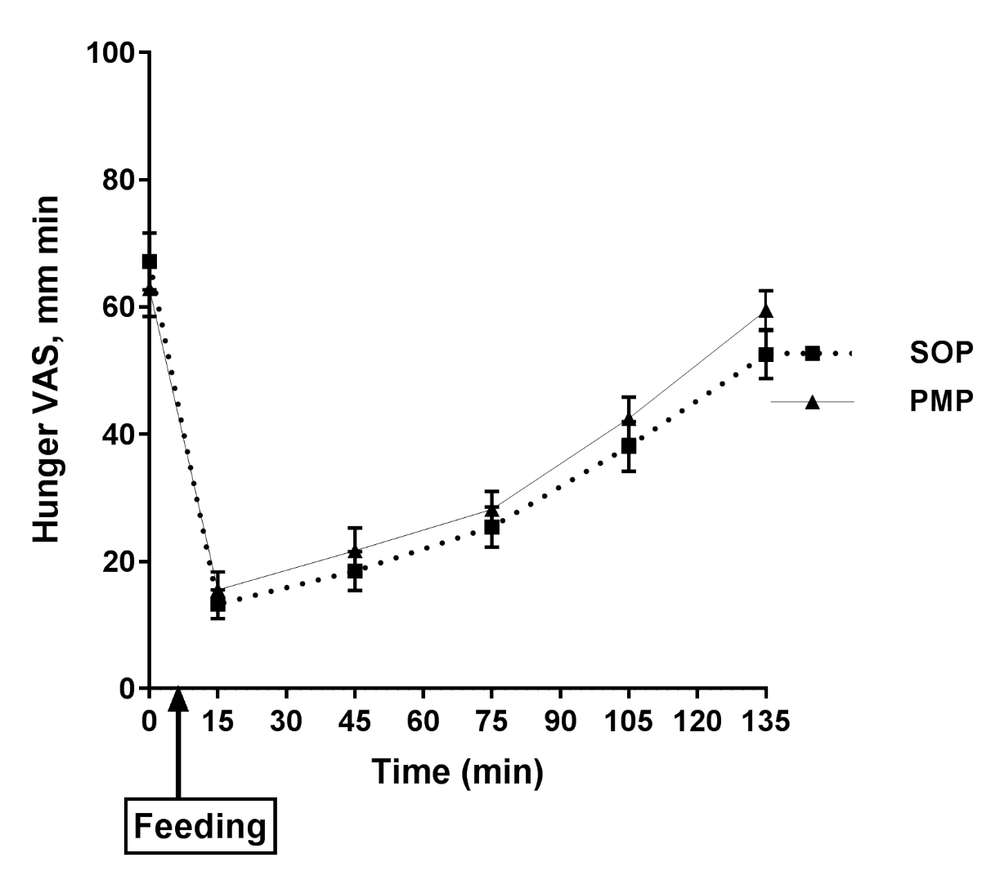

Supplementary Figure 3. Plot of satisfaction with time for healthy participants after they consumed two different breakfast porridge test meals. , Scottish oats porridge (SOP) and , pearl millet porridge (PMP). The arrow on the horizontal axis indicates the meal start time. Values are mean ± SEM, n = 26.
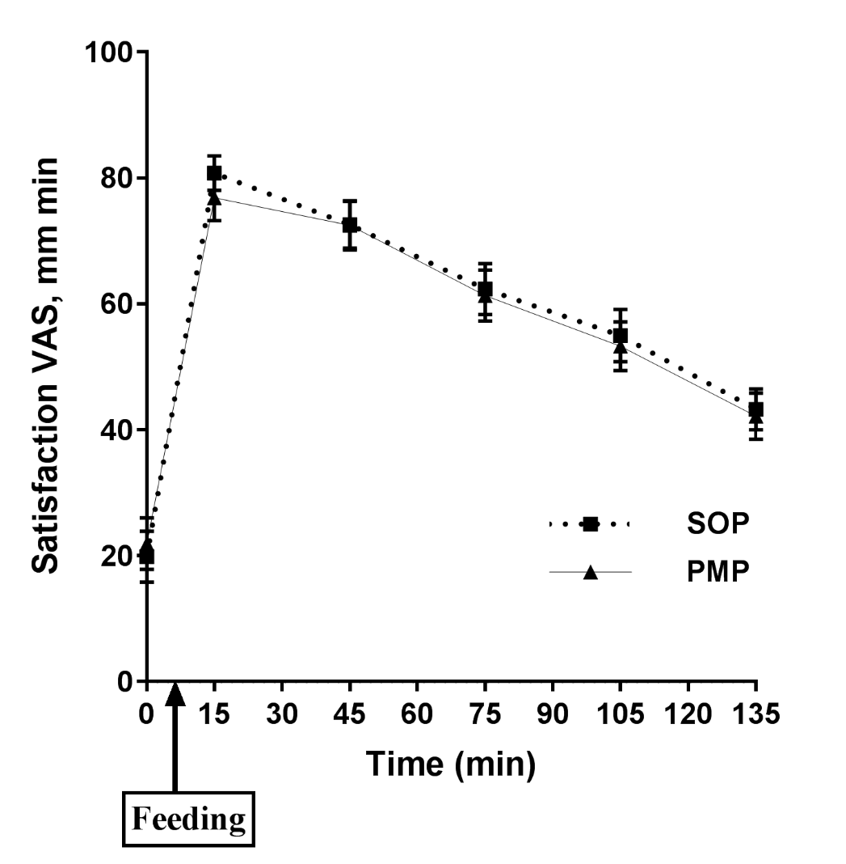

Supplementary Figure 4. Plot of fullness with time for healthy participants after they consumed two different breakfast porridge test meals. , Scottish oats porridge (SOP) and , pearl millet porridge (PMP). The arrow on the horizontal axis indicates the meal start time. Values are mean ± SEM, n = 26.
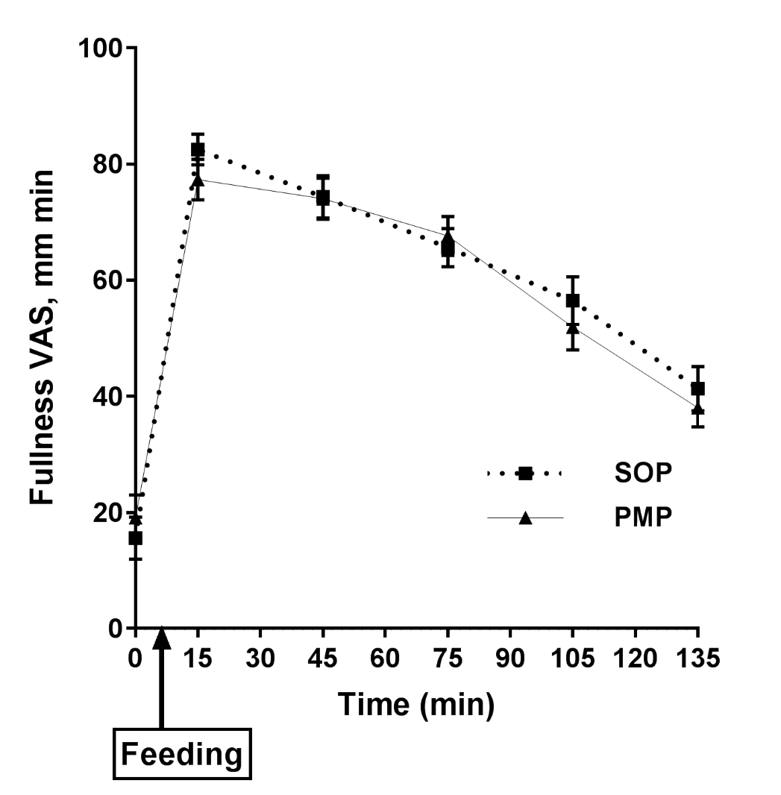

Supplementary Figure 5. Plot of desire to eat with time for healthy participants after they consumed two different breakfast porridge test meals. , Scottish oats porridge (SOP) and , pearl millet porridge (PMP). The arrow on the horizontal axis indicates the meal start time. Values are mean ± SEM, n = 26.
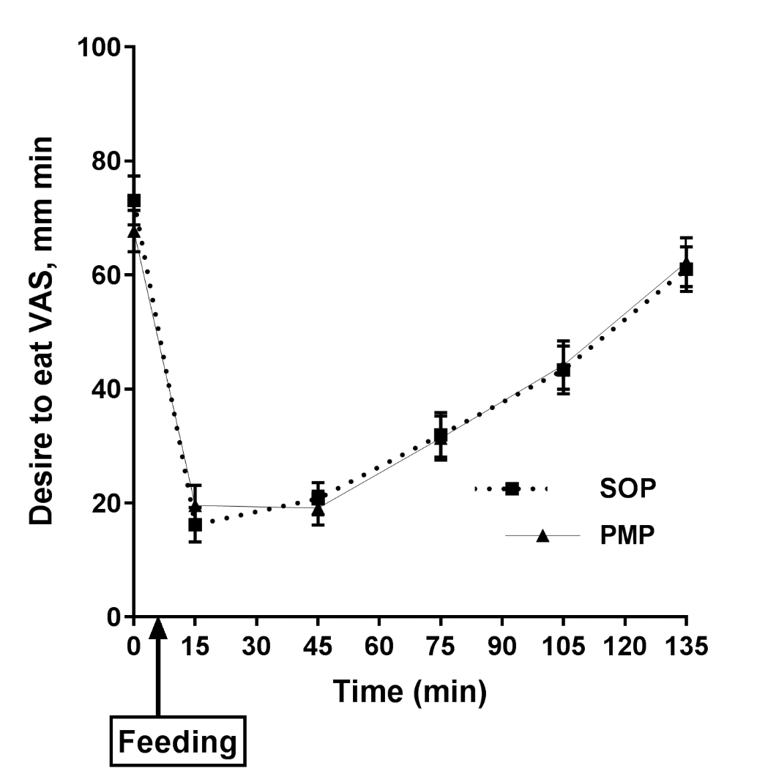

Supplementary Figure 6. Plot of prospective to food consumption with time for healthy participants after they consumed two different breakfast porridge test meals. , Scottish oats porridge (SOP) and , pearl millet porridge (PMP). The arrow on the horizontal axis indicates the meal start time. Values are mean ± SEM, n = 26.

