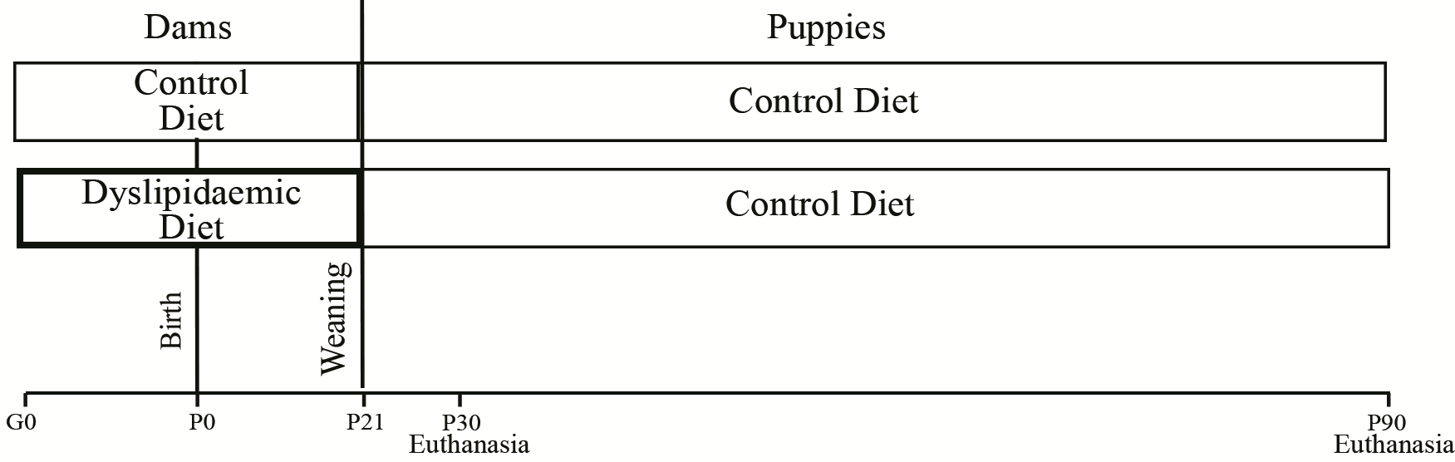

Fig. S1. Outline of the experimental design.

(a)
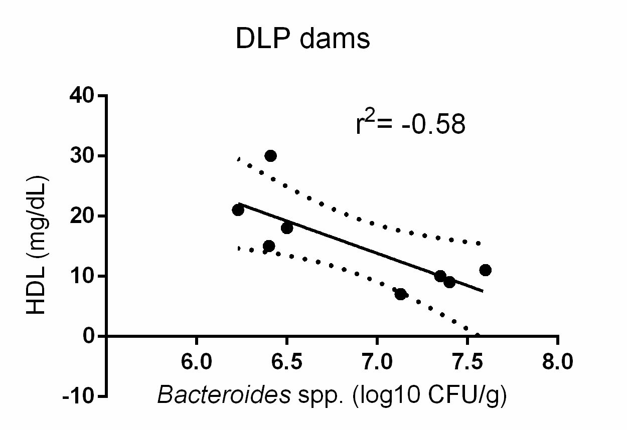
(c)
(b)
(e)
(d)

Fig. S2. Correlation between the lipid profile and faecal microbiota of dams fed a dyslipidaemic diet (DLP) (a) and that of their respective offspring (b-e) at 30 days of age. Pearson correlation test, in which the correlations were classified as low (r² = 0.10 to 0.29), moderate (r² = 0.30 to 0.49), significant (r² = 0.5 to 0.69) or very high (r² > 0.70). HDL= high-density lipoprotein, VLDL= very low-density lipoprotein, TG= triglycerides.

