SUPPLEMENTARY MATERIAL

 | Supplemental Table 1. Fecal microbiota populations of prebiotic-supplemented dogs using qPCR (LS means)
 |  |  | Treatment
 | Taxa |  | Control | Low | High | SEM |  |  | p-value
 | Universal |  | 12.12 | 12.16 | 12.11 | 0.02 |  |  | 0.35
 | Genera
 | Faecalibacterium |  | 8.29 | 8.42 | 8.30 | 0.09 |  |  | 0.42
 | Turicibacter |  | 6.68ª | 6.76ª | 7.34^{b} | 0.24 |  |  | 0.04
Streptococcus |  | 5.26 |  | 5.50 | 5.31 | 0.30 |  |  | 0.82
E. coli |  | 5.64 |  | 5.60 | 5.42 | 0.40 |  |  | 0.80
Blautia |  | 9.77 |  | 9.90 | 9.88 | 0.11 |  |  | 0.68
Fusobacterium |  | 10.17 |  | 10.11 | 10.16 | 0.06 |  |  | 0.48
C. hiranonis |  | 6.45 |  | 6.55 | 6.42 | 0.06 |  |  | 0.12
 | Lactobacillus |  | 5.70 | 6.08 | 6.12 | 0.45 |  |  | 0.71
 | Bifidobacterium |  | 6.52 | 6.50 | 6.41 | 0.23 |  |  | 0.88
C. perfringens |  | 4.85 |  | 4.61 | 4.77 | 0.32 |  |  | 0.84
 | Families
 | Ruminococcaceae |  | 8.02 | 8.07 | 7.97 | 0.11 |  |  | 0.79
^{a,b} Means within a row with unlike superscripts were different (P<0.05).

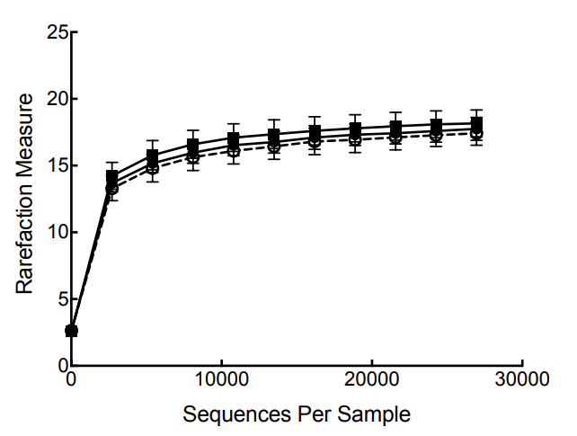

Supplemental Figure 1. Rarefaction plot of fecal microbial communities of prebiotic-supplemented dogs. Microbial species richness (alpha diversity) among treatment groups was not different. Control: closed circles, solid line; Low-dose prebiotic: closed squares, solid line; High-dose prebiotic: open circles, dashed line.

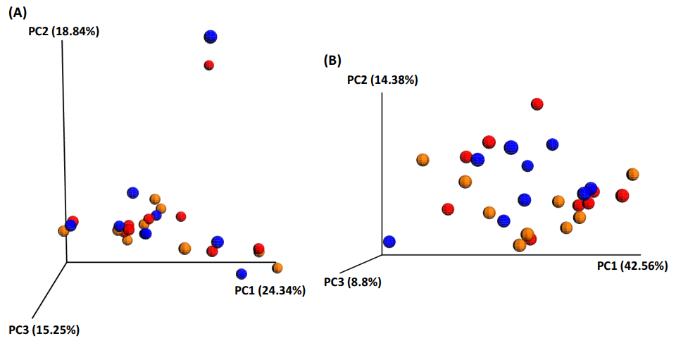
Supplemental Figure 2. Unweighted (A) and weighted (B) principal coordinates analysis (PCoA) plots of fecal microbial communities of prebiotic-supplemented dogs. Neither unweighted nor weighted UniFrac distances of fecal microbial communities performed on the 97% OTU abundance matrix revealed any differences among treatments. Control: red, Low-dose prebiotic: orange, High-dose prebiotic: blue.

