TableS1 Effects of ethanolamine on alpha diversity and abundance of colonic microbiota
 | Control | Increased Ethanolamine
Indices | A(0μM) | B(250μM) | C(500μM) | D(1000μM) | P-value
Observed_species | 1157.6±12.54 | 1151.4±11.45 | 1148.9±10.13 | 1151.6±24.22 | 0.982
Shannon | 7.96±0.03 | 7.98±0.03 | 7.83±0.07 | 7.89±0.10 | 0.335
Simpson | 0.9903±0.000ª | 0.9905±0.001ª | 0.9867±0.002^{b} | 0.9869±0.002^{bc} | 0.072
Chao1 | 1250.2±15.28 | 1227.5±14.67 | 1236.0±11.48 | 1229.51±25.56 | 0.805
ACE | 1247.82±15.02 | 1230.72±14.06 | 1238.45±10.85 | 1230.92±26.21 | 0.887
All indices were analyzed by Wilcox test and presented with least squares means ± SEM.Within a row, values without same small letter superscripts differ significantly (P < 0.05).

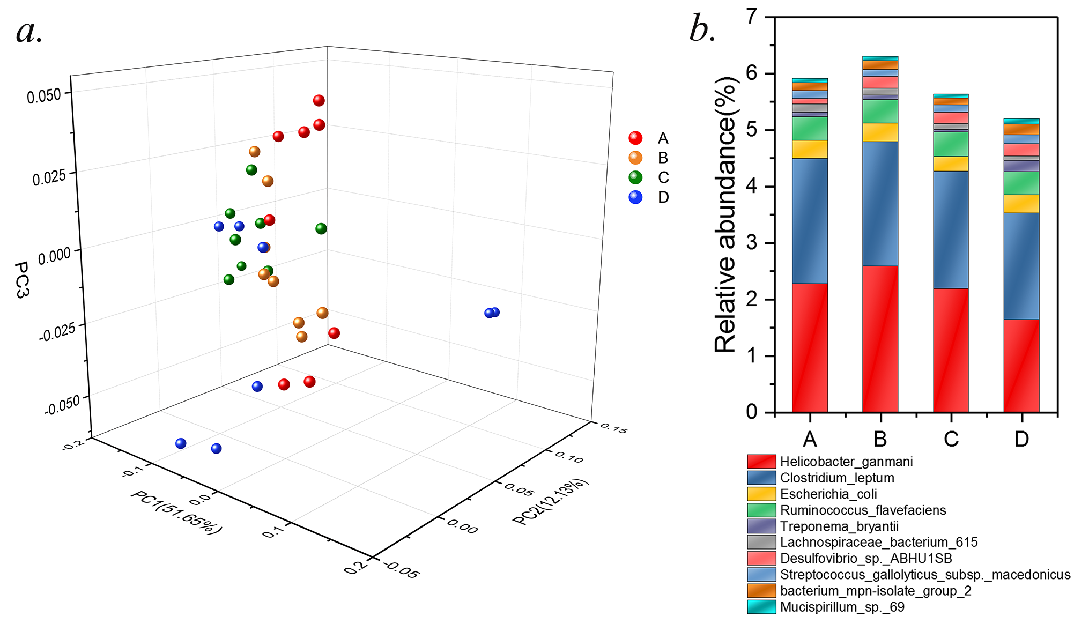
Fig.S1 Dose-effects of ethanolamine in altering the composition of colonic microbiota of weaning rats.
a.Weighted principal coordinate analyses (PCoA) plot of sample Bray Curtis distance. b.The most abundant top 10 species of colonic microbiota driven by ethanolamine in the weaning model.

Table S2 Results of Adonis analysis of colonic microbiota driven by different level of ethanolamine

Vs_group | Df | SumsOfSqs | MeanSqs | F.Model | R2 | Pr(>F)
B-A | 1(14) | 0.05773(0.34622) | 0.057728(0.024730) | 2.3343 | 0.14291(0.85709) | 0.008
B-C | 1(14) | 0.03609(0.38416) | 0.03609(0.02744) | 1.3152 | 0.08588(0.91412) | 0.16
B-D | 1(14) | 0.09585(0.54752) | 0.095854(0.039108) | 2.451 | 0.14899(0.85101) | 0.002
A-C | 1(14) | 0.10098(0.35846) | 0.100980(0.025604) | 3.9439 | 0.21979(0.78021) | 0.001
A-D | 1(14) | 0.13555(0.52181) | 0.135552(0.037272) | 3.6368 | 0.20621(0.79379) | 0.001
C-D | 1(14) | 0.05147(0.55975) | 0.051470(0.039982) | 1.2873 | 0.08421(0.91579) | 0.331
Data were analyzed by R software with related packages.
TableS3 Compositional changes of colonic microbiota driven by ethanolamine treatments at species level
 |  | Control |  | Ethanolamine
Taxonomy (%) |  | A(0μM) |  | B(250μM) |  | C(500μM) |  | D(1000μM) |  | P-value
Helicobacter_ganmani | 0.022721 |  | 0.025855 |  | 0.021833 |  | 0.016341 |  | 0.423
Clostridium_leptum | 0.022166 |  | 0.021989 |  | 0.020779 |  | 0.018854 |  | 0.094
Escherichia_coli | 0.003216 |  | 0.003334 |  | 0.002585 |  | 0.003236 |  | 0.877
Ruminococcus_flavefaciens | 0.004193 |  | 0.004157 |  | 0.004368 |  | 0.004148 |  | 0.986
Treponema_bryantii | 0.000775 |  | 0.000751 |  | 0.000487 |  | 0.001913 |  | 0.153
Lachnospiraceae_bacterium_615 | 0.001483 |  | 0.001277 |  | 0.001003 |  | 0.000799 |  | 0.472
Desulfovibrio_sp._ABHU1SB | 0.000941 |  | 0.0021 |  | 0.002059 |  | 0.002259 |  | 0.214
Streptococcus_gallolyticus_subsp._macedonicus | 0.001397 |  | 0.001205 |  | 0.001239 |  | 0.001517 |  | 0.914
bacterium_mpn-isolate_group_2 | 0.00138 |  | 0.001515 |  | 0.001289 |  | 0.001937 |  | 0.374
Mucispirillum_sp._69 | 0.000787 |  | 0.000814 |  | 0.000691 |  | 0.000946 |  | 0.857
Clostridium_sp._ASF356 | 0.001699ª |  | 0.001543ª |  | 0.001416^{ab} |  | 0.000989^{b} |  | 0.001
Eubacterium_sp._14-2 | 0.001236ª |  | 0.000396^{b} |  | 0.000406^{b} |  | 0.000682^{ab} |  | 0.003
bacterium_ic1340 | 0.000943 |  | 0.000869 |  | 0.00096 |  | 0.000953 |  | 0.965
Lactobacillus_amylovorus | 0.000703 |  | 0.000523 |  | 0.000643 |  | 0.000526 |  | 0.807
Helicobacter_ganmani | 0.022721 |  | 0.025855 |  | 0.021833 |  | 0.016341 |  | 0.228
Data were analyzed by One-way ANOVA followed by Turkey multiple comparison test and present with the relative abundance of specific taxonomy. Within a row, values without same small letter superscripts differ significantly (P < 0.05).

Table S4 Ethanolamine altered microbial functions of microbiota in weaning rats’ colons.
 | Control | Increased Ethanolamine
Observation Ids | A(0μM) | B(250μM) | C(500μM) | D(1000μM) | Effect size | p-values
Amino sugar and nucleotide sugar metabolism | 1.3577 | 1.3709 | 1.3803 | 1.3820 | 0.4755 | 0.0110
Arginine and proline metabolism | 1.2311 | 1.2309 | 1.2264 | 1.2149 | 0.3739 | 0.0482
Starch and sucrose metabolism | 0.9116 | 0.9375 | 0.9307 | 0.9403 | 0.3954 | 0.0355
Galactose metabolism | 0.6633 | 0.6905 | 0.6932 | 0.6944 | 0.5223 | 0.0043
Propanoate metabolism | 0.5256 | 0.5084 | 0.4997 | 0.4985 | 0.5903 | 0.0042
Fatty acid biosynthesis | 0.4880 | 0.4763 | 0.4728 | 0.4673 | 0.4336 | 0.0189
Drug metabolism - other enzymes | 0.3274 | 0.3370 | 0.3426 | 0.3435 | 0.4822 | 0.0113
Sulfur relay system | 0.2323 | 0.2219 | 0.2150 | 0.2139 | 0.4706 | 0.0114
Benzoate degradation | 0.2310 | 0.2267 | 0.2188 | 0.2169 | 0.3935 | 0.0355
Plant-pathogen interaction | 0.1804 | 0.1784 | 0.1736 | 0.1752 | 0.3977 | 0.0389
Naphthalene degradation | 0.1366 | 0.1366 | 0.1349 | 0.1335 | 0.3814 | 0.0427
Tetracycline biosynthesis | 0.1365 | 0.1298 | 0.1245 | 0.1202 | 0.5504 | 0.0075
Lysine degradation | 0.1337 | 0.1269 | 0.1251 | 0.1226 | 0.5395 | 0.0069
Glycosphingolipid biosynthesis - globo series | 0.1171 | 0.1278 | 0.1327 | 0.1291 | 0.4475 | 0.0175
Limonene and pinene degradation | 0.1028 | 0.0970 | 0.0959 | 0.0948 | 0.5370 | 0.0044
Nitrotoluene degradation | 0.0998 | 0.0921 | 0.0883 | 0.0882 | 0.3967 | 0.0378
Insulin signaling pathway | 0.0803 | 0.0816 | 0.0791 | 0.0777 | 0.3959 | 0.0367
Butirosin and neomycin biosynthesis | 0.0756 | 0.0780 | 0.0785 | 0.0781 | 0.5365 | 0.0038
Ethylbenzene degradation | 0.0531 | 0.0513 | 0.0511 | 0.0492 | 0.4577 | 0.0146
Electron transfer carriers | 0.0282 | 0.0262 | 0.0246 | 0.0249 | 0.3729 | 0.0475
N-Glycan biosynthesis | 0.0243 | 0.0245 | 0.0269 | 0.0273 | 0.3917 | 0.0355
Primary bile acid biosynthesis | 0.0224 | 0.0243 | 0.0240 | 0.0234 | 0.4340 | 0.0199
Secondary bile acid biosynthesis | 0.0224 | 0.0242 | 0.0240 | 0.0233 | 0.4397 | 0.0185
Metabolism of xenobiotics by cytochrome P450 | 0.0201 | 0.0183 | 0.0162 | 0.0165 | 0.4413 | 0.0189
Drug metabolism - cytochrome P450 | 0.0198 | 0.0181 | 0.0161 | 0.0162 | 0.4316 | 0.0188
Renal cell carcinoma | 0.0098 | 0.0086 | 0.0080 | 0.0075 | 0.5380 | 0.0054
alpha-Linolenic acid metabolism | 0.0085 | 0.0073 | 0.0067 | 0.0061 | 0.5271 | 0.0042
G protein-coupled receptors | 0.0001 | 0.0001 | 0.0001 | 0.0001 | 0.4761 | 0.0119
Data were analyzed by One-way ANOVA followed by Turkey multiple comparison test and p-values were corrected with Benjamin FDR to filter out potential false positive results and improve the veracity.

