**The influence of juicing on the appearance of blueberry metabolites 2 h following consumption: a metabolite profiling approach.**

Swen Langer, Aileen Kennel and John K Lodge#

**Supplementary Information**

Figure 1. Representative principle component analysis score plot of urine and QC samples in negative ionisation mode.

Figure 2. Principle component analysis score plots of urine samples of all treatments in (a) negative ionisation and (b) positive ionisation modes.

Figure 3. Principle component analysis score plots of plasma samples of all treatments in (a) negative ionisation and (b) positive ionisation modes.

Figure 4. Representative permutation plot for the two-component PLS-DA model of urine samples post treatment in negative ionisation mode.

Figure 5. PLS-DA score plots of post treatment samples only following whole versus juiced blueberry treatment. Parameters shown in Table 2.

Table 1. Classification data of the two-component models.

Figure 1.





Figure 2.

(a)

(b)



Figure 3

(a)

(b)



Figure 4

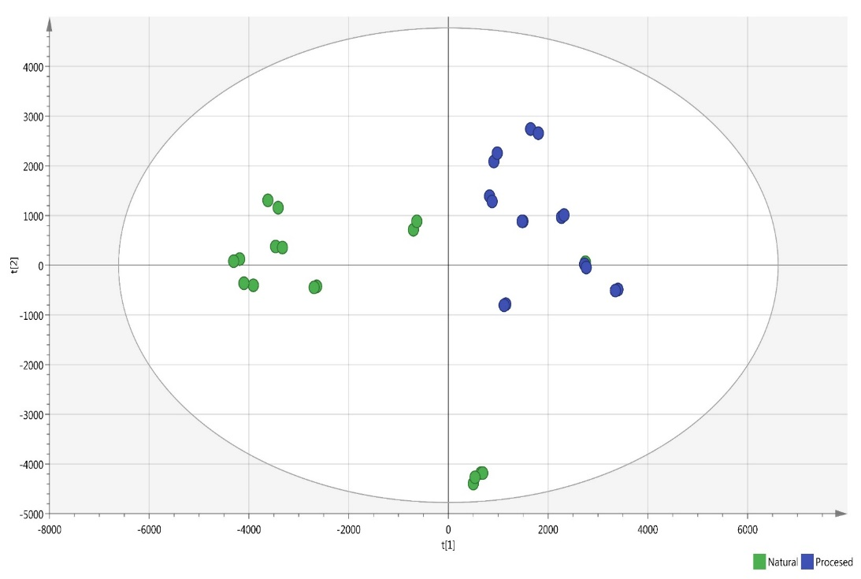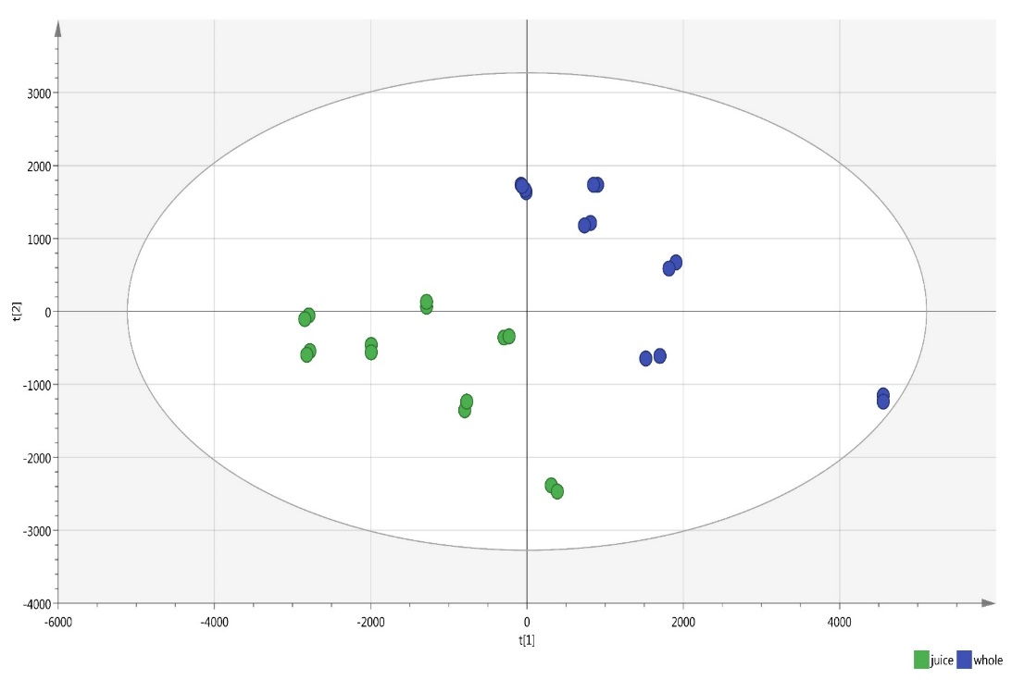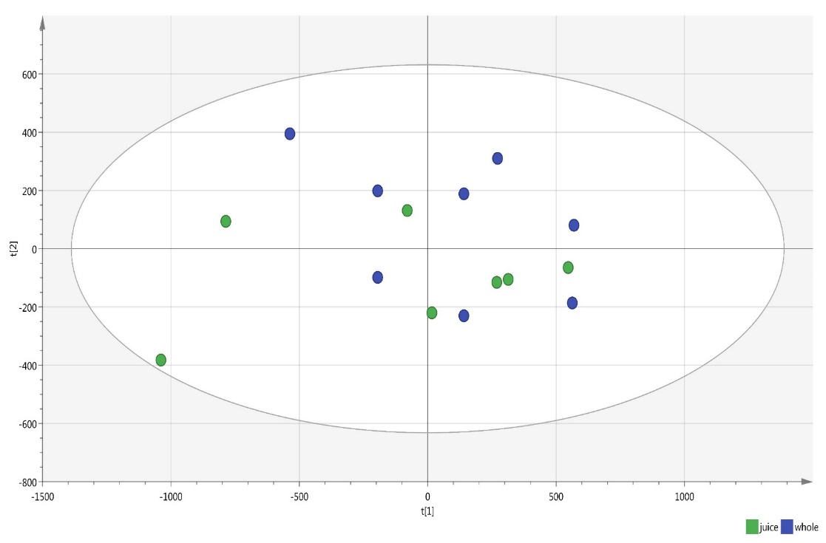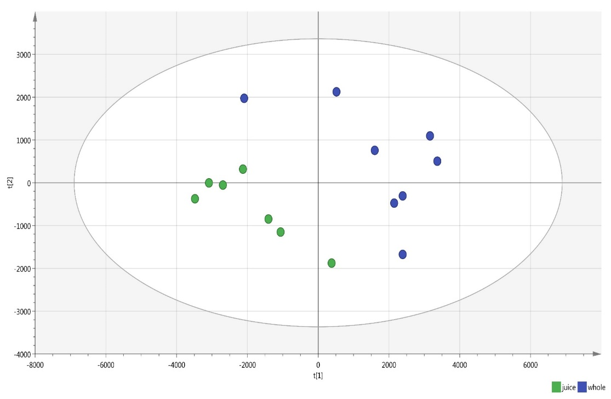

a) Urine: negative mode

b) Urine: positive mode

c) Plasma: negative mode

d) Plasma: positive mode

whole

juice

Figure 5.

Table 1.

|  |  |  |  |  |  |
| --- | --- | --- | --- | --- | --- |
| **Urine. Negative ionisation.** | | | | | |
|  | **Members** | **Correct** | **Natural** | **Procesed** | **No class (YPred <= 0)** |
| **whole** | 18 | 88.89% | 16 | 2 | 0 |
| **juice** | 16 | 100% | 0 | 16 | 0 |
| **No class** | 0 |  | 0 | 0 | 0 |
| Total | 34 | 94.12% | 16 | 18 | 0 |
| Fisher's prob. | 6.90E-08 |  |  |  |  |
| **Urine. Positive ionisation.** | | | | | |
|  | **Members** | **Correct** | **juice** | **whole** | **No class (YPred <= 0)** |
| **juice** | 14 | 100% | 14 | 0 | 0 |
| **whole** | 14 | 100% | 0 | 14 | 0 |
| **No class** | 0 |  | 0 | 0 | 0 |
| Total | 28 | 100% | 14 | 14 | 0 |
| Fisher's prob. | 2.50E-08 |  |  |  |  |
| **Plasma. Negative ionisation.** | | | | | |
|  | **Members** | **Correct** | **juice** | **whole** | **No class (YPred <= 0)** |
| **juice** | 7 | 57.14% | 4 | 3 | 0 |
| **whole** | 8 | 62.50% | 3 | 5 | 0 |
| **No class** | 0 |  | 0 | 0 | 0 |
| Total | 15 | 60% | 7 | 8 | 0 |
| Fisher's prob. | 0.4 |  |  |  |  |
| **Plasma. Positive ionisation.** | | | | | |
|  | **Members** | **Correct** | **juice** | **whole** | **No class (YPred <= 0)** |
| **juice** | 7 | 100% | 7 | 0 | 0 |
| **whole** | 8 | 100% | 0 | 8 | 0 |
| **No class** | 0 |  | 0 | 0 | 0 |
| Total | 15 | 100% | 7 | 8 | 0 |
| Fisher's prob. | 0.00016 |  |  |  |  |