Supplementary Table
Table S1. Composition of experimental diets*
Ingredient (g/kg) | NC | BC | LD | HD
Corn starch | 529.50 | 489.50 | 389.50 | -
WHLB | - | - | 100.00 | 489.50
Soybean oil | 70.00 | - | - | -
Lard | - | 100.00 | 100.00 | 100.00
Cholesterol | - | 10.00 | 10.00 | 10.00
Casein (99% protein) | 200.00 | 200.00 | 200.00 | 200.00
Sucrose | 100.00 | 100.00 | 100.00 | 100.00
Cellulose | 50.00 | 50.00 | 50.00 | 50.00
L-cystine | 3.00 | 3.00 | 3.00 | 3.00
Choline chloride | 2.50 | 2.50 | 2.50 | 2.50
AIN-93G mineral mixture | 35.00 | 35.00 | 35.00 | 35.00
AIN-93G vitamin mixture | 10.00 | 10.00 | 10.00 | 10.00
Content (g/100g)
Fat | 7.00 | 11.00 | 11.09 | 11.46
Protein | 20.10 | 20.10 | 21.65 | 27.70
β-glucan | 0.00 | 0.00 | 0.53 | 2.58
Total dietary fiber | 5.00 | 5.00 | 6.74 | 13.49
Insoluble dietary fiber | 5.00 | 5.00 | 6.06 | 10.20
Soluble dietary fiber | 0.00 | 0.00 | 0.85 | 4.15
“*”: Prepared according to the AIN-93G⁽²⁵⁾. “-”: not added. Abbreviations: NC, normal control group; BC, blank control group; LD, low-dose group; HD, high-dose group; WHLB, whole-grain highland hull-less barley.

Supplementary Figures

Fig. S1. Effect of diet with different doses of WHLB on fecal water content (A) and pH (B) of HFD SD rats. Values are presented as the mean ± standard deviation (n = 18 for 1–4 weeks, n = 9 for 5–8 weeks). Abbreviations: NC, normal control group; BC, blank control group; LD, low-dose group; and HD, high-dose group, HFD, high-fat diet; SD rats, Sprague–Dawley rats.

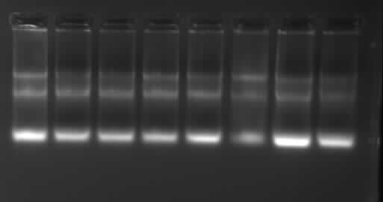
28S
5S
18S
Fig. S2. Agarose gel (1.2%, w/v) electrophoresis of total RNA extracted from liver. Gel was stained by 1 × GeneGreen nucleic acid dye (Tiangen Biotech Co., Ltd., Beijing, China) and visualized using a Syngene GeneGenius Imaging System (Synoptics Ltd., Cambridge, UK).

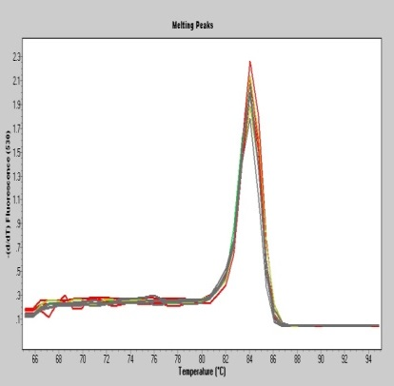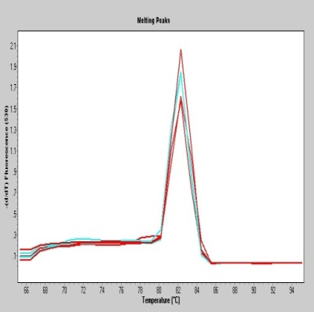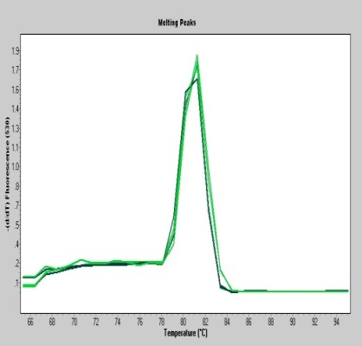
ApoB
β-actin
AMPK
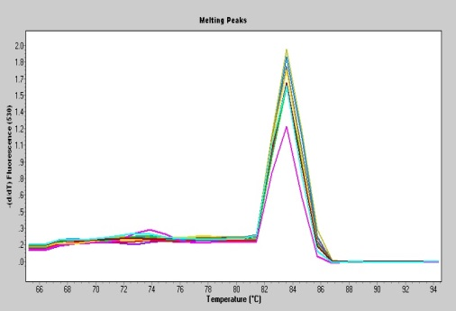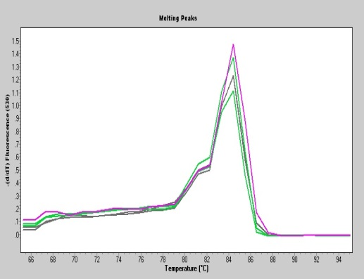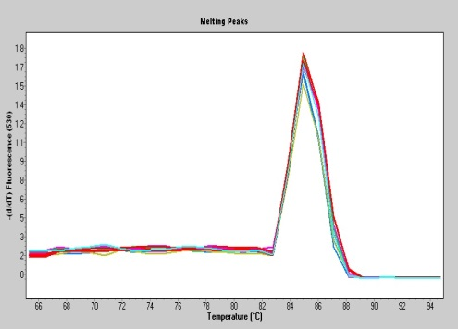
HMG-CoAr
FXR
CYP7A1
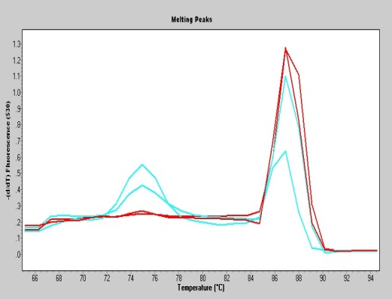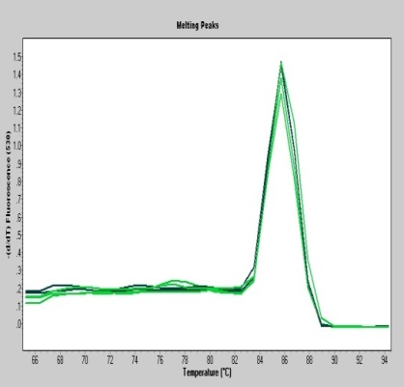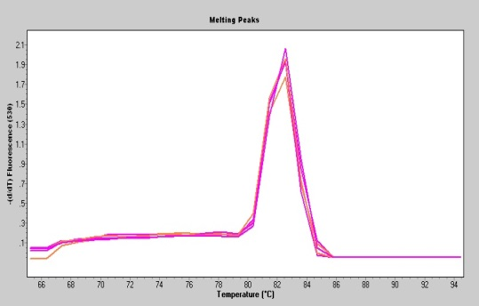
PPARα
LXR
LDL-R
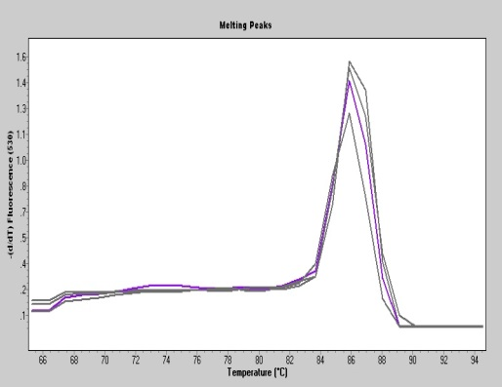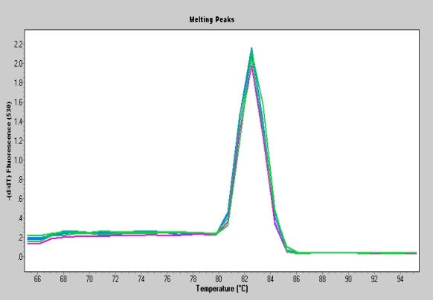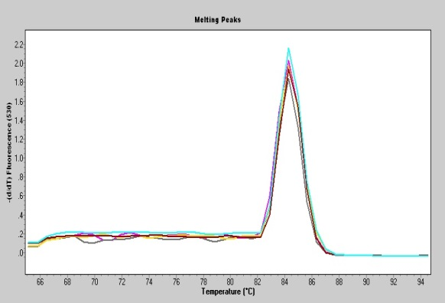
SREBP-1c
IBABP
ASBT
Fig. S3. Melting curves of primers used for RT-PCR. Abbreviations: AMPKα, AMP-activated protein kinase α; ApoB, apolipoprotein B; CYP7A1, cholesterol 7α-hydroxylase; FXR, farnesoid X receptor; HMG-CoAr, 3-hydroxy-3-methylglutaryl coenzyme A reductase; LDL-R, low-density lipoprotein receptor; LXR, liver X receptor; PPARα, peroxisome proliferator-activated receptor α; SREBP-1c, sterol regulatory element-binding protein-1c; ASBT, apical sodium-dependent bile acid transporter; IBABP, ileal bile acid-binding protein.

