ONLINE SUPPORTING MATERIAL

Dietary patterns within educational groups and their association with coronary heart disease and stroke in the EPIC-NL cohort

Sander Biesbroek¹, Mirjam C Kneepkens¹, Saskia W. van den Berg¹, Heidi P. Fransen², Joline W. Beulens^{2,3}, Petra H.M. Peeters^{2,4}, and Jolanda M.A. Boer¹.

- National Institute for Public Health and the Environment, Bilthoven, the Netherlands
- Julius Center for Health Sciences and Primary Care, University Medical Center Utrecht, Utrecht, the Netherlands.
- Department of Epidemiology & Biostatistics, EMGO+ Institute for Health and Care Research, VU University Medical Center, Amsterdam, The Netherlands
- School of Public Health, Imperial College London, London, United Kingdom

Correspondence:
Sander Biesbroek, Centre for Nutrition, Prevention and Health Services, National Institute for Public Health and the Environment (RIVM), PO Box 1, 3720BA Bilthoven, The Netherlands, E-mail: sander.biesbroek@rivm.nl.

Supplemental Figure 1. Scree plot of Eigen values of the Principal Component Analyses by educational level (a. whole population, b. low education, c. medium education, d. high education).
A.
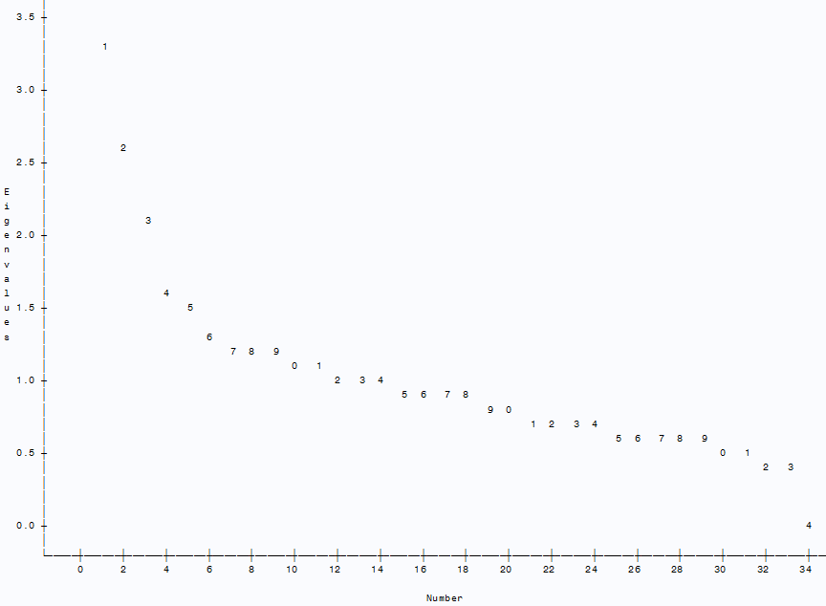

B.
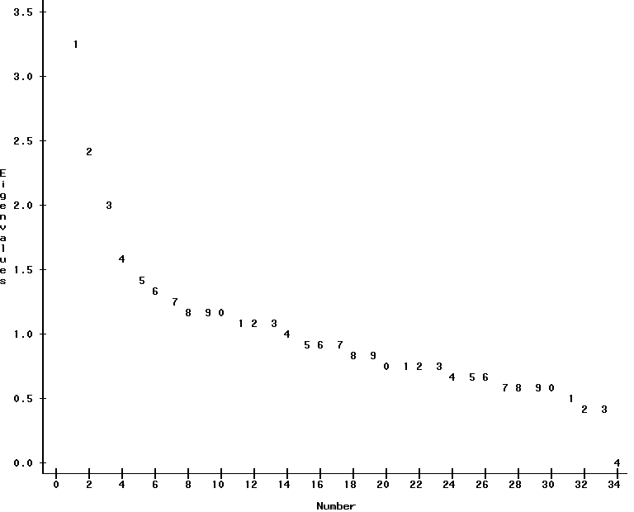
C.
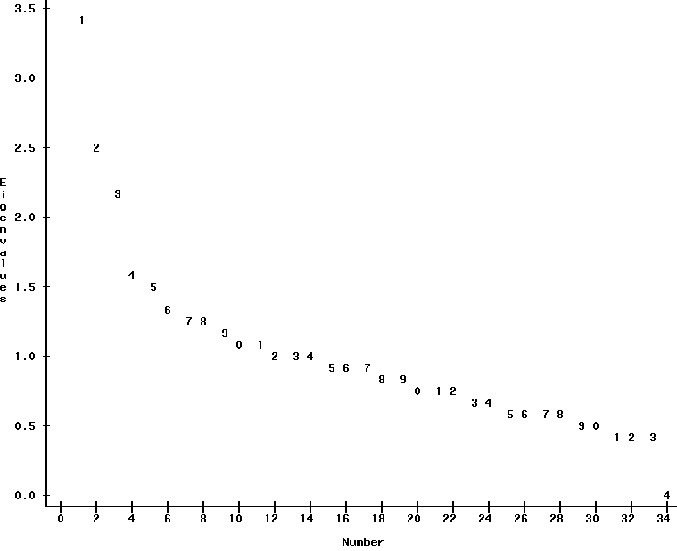

D.
